Supplementary

Table 1. Factors and levels for response surface design of tea saponin extraction.
Factor | Levels
Factor | -1 | 0 | 1
A Trisodium citrate dosage (g/10 mL) | 0.8 | 1.1 | 1.4
B Extraction temperature (℃) | 70 | 75 | 80
C Extraction time (min) | 30 | 35 | 40
Table 2. Factors and levels for response surface design of purification using AB-8 resin.
Factor |  | Levels
Factor | -1 | 0 | 1
A Loading pH | 5 | 6 | 7
B Loading flow rate (BV/h) | 1.0 | 1.5 | 2.0
C Elution volume (BV) | 3 | 4 | 5
Table 3. Analysis of variance for the extraction response surface model (after removing AB and BC).
Source | Sum of Squares | Df | Mean square | F-value | P-value | Significance
Model | 2.0030 | 7 | 0.2900 | 45.19 | < 0.0001 | ***
A | 0.4870 | 1 | 0.4870 | 75.93 | < 0.0001 | ***
B | 0.0134 | 1 | 0.0134 | 2.08 | 0.1830 | ns
C | 0.0008 | 1 | 0.0008 | 0.13 | 0.7290 | ns
AC | 0.0426 | 1 | 0.0426 | 6.65 | 0.0298 | *
A² | 0.7820 | 1 | 0.7820 | 122.17 | ＜0.0001 | ***
B² | 0.4590 | 1 | 0.4590 | 71.60 | ＜0.0001 | ***
C² | 0.1110 | 1 | 0.1110 | 17.40 | 0.0024 | **
Residual | 0.0577 | 9 | 0.0064
Lack of fit | 0.0499 | 5 | 0.0100 | 5.10 | 0.0699 | ns
Pure error | 0.0078 | 4 | 0.0020
Total | 2.0900 | 16
Note: * P<0.05,** P<0.01, *** P<0.001; ns = not significant. R²=0.9721, Adjusted R² = 0.951, Predicted R² = 0.846.
Table 4. Validation results of the optimized extraction process.
Experiment No. | 1 | 2 | 3 | Mean | RSD/%
Tea saponin yield (%) | 22.834 | 22.903 | 22.949 | 22.895 | 0.253

Table 5. Static adsorption-desorption performance of AB-8 and D101 resins.
Resin type | Average pore size (nm) | Polarity | Specific surface area | Adsorption rate (%) | Static desorption rate (%)
AB-8 | 13-14 | Weakly polar | 500 ± 20 | 85.3 ± 1.2 | 92.4 ± 1.5
D101 | 20-22 | Non-polar | 650 ± 50 | 86.2 ± 1.1 | 87.5 ± 1.3
Note:Data are presented as mean ± SD (n = 3). The desorption rate of AB-8 was significantly higher than that of D101 (P < 0.05).
Table 6. Nonlinear regression parameters for the adsorption kinetics of tea saponin on AB-8 resin.
Model | Qe,cal (mg/g) | k | R² | Adjusted R² | SSE | AIC | BIC
Pseudo-first-order | 43.47 | 0.5889 h⁻¹ | 0.9991 | 0.9987 | 1.45 | -9.66 | -9.50
Pseudo-second-order | 54.22 | 0.01124 g/(mg·h) | 0.9927 | 0.9898 | 11.52 | 6.92 | 7.08
Note: Data were fitted by nonlinear regression (Origin 2021). Qe,cal, calculated equilibrium adsorption capacity; k₁, pseudo-first-order rate constant; k₂, pseudo-second-order rate constant; SSE, sum of squared errors; AIC, Akaike Information Criterion; BIC, Bayesian Information Criterion.
Table 7. Analysis of variance for the purification response surface model (after removing AB).
Source | Sum of Squares | Df | Mean square | F-value | P-value | Significance
Model | 11.8043 | 8 | 1.4689 | 221.14 | ＜0.001 | ***
A | 0.4823 | 1 | 0.4823 | 72.3 | ＜0.001 | ***
B | 0.1890 | 1 | 0.1890 | 28.5 | 0.0007 | ***
C | 0.1568 | 1 | 0.1568 | 14.2 | 0.0054 | **
AC | 0.1605 | 1 | 0.1605 | 24.1 | 0.0012 | **
BC | 0.1891 | 1 | 0.1891 | 28.5 | 0.0007 | ***
A² | 5.7309 | 1 | 5.7309 | 863 | ＜0.001 | ***
B² | 2.5914 | 1 | 2.5914 | 390 | ＜0.001 | ***
C² | 1.3197 | 1 | 1.3197 | 198 | ＜0.001 | ***
Residual | 0.0531 | 8 | 0.0066
Lack of fit | 0.0238 | 4 | 0.0060 | 0.813 | 0.5570 | ns
Pure error | 0.0293 | 4 | 0.0073
Total | 11.8043 | 16
Note: * P<0.05, ** P<0.01, ***P<0.001; ns = not significant. R² = 0.9949, Adjusted R² = 0.9912 Predicted R² = 0.9720.
Table 8. Validation results of the optimized purification process.
Experiment No. | 1 | 2 | 3 | Mean | RSD/%
Tea saponin purity (%) | 92.34 | 92.28 | 92.01 | 92.21 | 0.191
Table 9. Summary of antioxidant activity parameters of tea saponin and vitamin C.
Antioxidant indicator | Sample | IC₅₀/EC₅₀ (mg/mL) | 95%CI (mg/mL) | R²
DPPH radical scavenging | Tea saponin | 0.42 | 0.35~0.49 | 0.996
DPPH radical scavenging | Vitamin C | 0.09 | 0.07~0.11 | 0.998
Hydroxyl radical scavenging | Tea saponin | 0.56 | 0.48~0.64 | 0.994
Hydroxyl radical scavenging | Vitamin C | 0.21 | 0.18~0.24 | 0.997
Total reducing power | Tea saponin | 0.22 | 0.18~0.25 | 0.994
Total reducing power | Vitamin C | 0.09 | 0.07~0.11 | 0.998

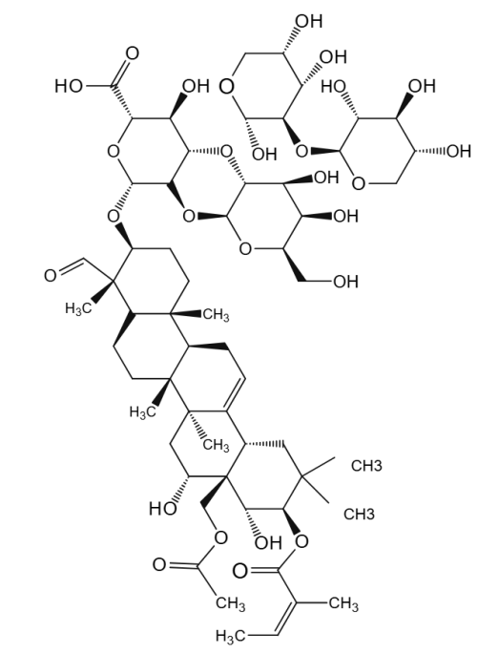
Fig. 1. Chemical structure of tea saponin.

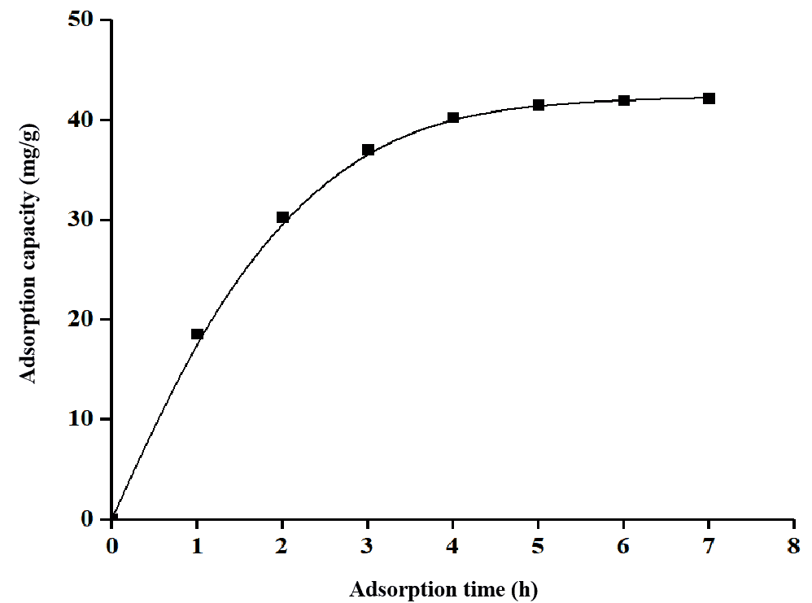
Fig. 2. Static adsorption kinetics curve of AB-8 resin.

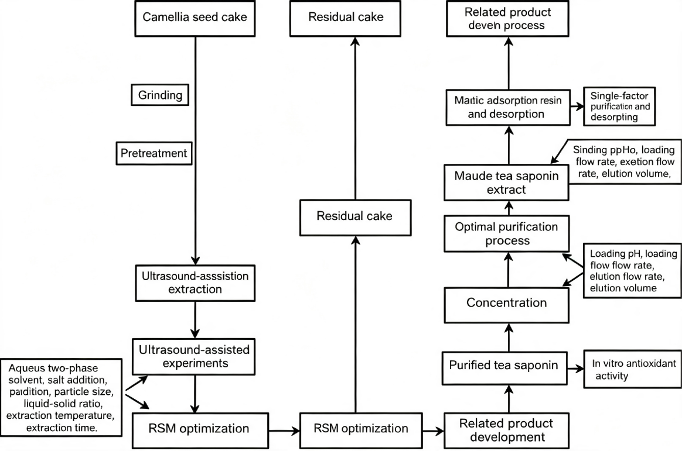
Fig. 5. Graphica bstract

