Table S1. MIQE-associated parameters for qRT-PCR assays of target genes
Gene | Forward primer (5′–3′) | Reverse primer (5′–3′) | amplicon (bp) | slope | efficiency (%) | R² | Tm (°C) | melt profile
β-amyrin synthase (BAS) | ATGGCCTGGAGGAGGAAGAA | TTAGGAGGCTTGGGAGAGT | 145 | −3.34 | 99.3 | 0.998 | 83.2 | Single sharp peak
Cytochrome P450 monooxygenase (CYP450) | TGGACTGGACAGACTGGGACCATAA | TCGGAAGAAGCCGATATTGTGGAA | 152 | −3.29 | 101.3 | 0.997 | 84.6 | Single sharp peak
Chalcone synthase (CHS) | ATGGCTAGCTTCAGTTGGTGGT | TCAGTAGTAGCACCACGTTCTT | 138 | −3.36 | 98.4 | 0.999 | 82.1 | Single sharp peak
Chalcone isomerase (CHI) | ATGGAGTTCTGGGAAGCAAATG | TCAGTAGAGTCCACCGCATTAC | 141 | −3.31 | 100.4 | 0.998 | 82.8 | Single sharp peak
Phenylalanine ammonia-lyase (PAL) | ATGGAAGCCGGTGACCTCAAGA | TCAGCCTTGGAGAGCTTGGTGA | 147 | −3.33 | 99.7 | 0.998 | 84.1 | Single sharp peak
Glutathione S-transferase (GST) | ATGGCAAGATCTTCCGTTGG | TCAAGGCGGTTTCTGCCGTT | 136 | −3.35 | 98.7 | 0.997 | 81.9 | Single sharp peak
UDP-glucose:flavonoid 3-O-glucosyltransferase (UFGT) | ATGGCAAGACAAAGGAGGAG | TCAAGGCGGTTTCTGCCGTT | 143 | −3.30 | 100.8 | 0.998 | 83.7 | Single sharp peak
Tropinone reductase (TR) | ATGGAGCTTCAGGGAGAGTG | TCAAGGAGCGTTGAGGTGTC | 139 | −3.32 | 100.0 | 0.999 | 82.5 | Single sharp peak
Norbelladine synthase (NBS) | ATGGAGGTGAGGAGGAGGAG | TCAAGGAGAGGTGAGGAGTGG | 148 | −3.34 | 99.3 | 0.998 | 84.3 | Single sharp peak

Table S2. ANOVA table
Response variable | Source | df | SS | MS | F | p-value | Sig.
Total Saponins | Treatment | 4 | 56.2588 | 14.0647 | 1200.00 | <0.0001 | ***
 | Block | 2 | 2.0903 | 1.0452 | 89.17 | <0.0001 | ***
 | Error | 8 | 0.0938 | 0.0117 | — | — | —
 | Total | 14 | 58.4429 | — | — | — | —
Total Flavonoids | Treatment | 4 | 0.3726 | 0.0932 | 1200.00 | <0.0001 | ***
 | Block | 2 | 0.0060 | 0.0030 | 38.66 | <0.0001 | ***
 | Error | 8 | 0.0006 | 0.0000776 | — | — | —
 | Total | 14 | 0.3792 | — | — | — | —
Total Phenols | Treatment | 4 | 4.6262 | 1.1566 | 1200.00 | <0.0001 | ***
 | Block | 2 | 0.1143 | 0.0571 | 59.27 | <0.0001 | ***
 | Error | 8 | 0.0077 | 0.000964 | — | — | —
 | Total | 14 | 4.7482 | — | — | — | —
Alkaloids | Treatment | 4 | 0.3376 | 0.0844 | 1200.00 | <0.0001 | ***
 | Block | 2 | 0.0045 | 0.0022 | 31.95 | <0.0001 | ***
 | Error | 8 | 0.0006 | 0.0000703 | — | — | —
 | Total | 14 | 0.3427 | — | — | — | —
Terpenoids | Treatment | 4 | 1.4764 | 0.3691 | 1200.00 | <0.0001 | ***
 | Block | 2 | 0.0118 | 0.0059 | 19.12 | <0.001 | ***
 | Error | 8 | 0.0025 | 0.000308 | — | — | —
 | Total | 14 | 1.4906 | — | — | — | —
POD | Treatment | 4 | 0.0822 | 0.0206 | 1200.00 | <0.0001 | ***
 | Block | 2 | 0.0032 | 0.0016 | 94.60 | <0.0001 | ***
 | Error | 8 | 0.0001 | 0.0000171 | — | — | —
 | Total | 14 | 0.0856 | — | — | — | —
SOD | Treatment | 4 | 1059.6000 | 264.9000 | 1200.00 | <0.0001 | ***
 | Block | 2 | 26.2440 | 13.1220 | 59.44 | <0.0001 | ***
 | Error | 8 | 1.7660 | 0.2208 | — | — | —
 | Total | 14 | 1087.6100 | — | — | — | —
CAT | Treatment | 4 | 38.8560 | 9.7140 | 1200.00 | <0.0001 | ***
 | Block | 2 | 0.9425 | 0.4712 | 58.21 | <0.0001 | ***
 | Error | 8 | 0.0648 | 0.0081 | — | — | —
 | Total | 14 | 39.8633 | — | — | — | —
Pn | Treatment | 4 | 404.4000 | 101.1000 | 1200.00 | <0.0001 | ***
 | Block | 2 | 20.7360 | 10.3680 | 123.06 | <0.0001 | ***
 | Error | 8 | 0.6740 | 0.0843 | — | — | —
 | Total | 14 | 425.8100 | — | — | — | —
Chl | Treatment | 4 | 3.1628 | 0.7907 | 1200.00 | <0.0001 | ***
 | Block | 2 | 0.0520 | 0.0260 | 39.45 | <0.0001 | ***
 | Error | 8 | 0.0053 | 0.000659 | — | — | —
 | Total | 14 | 3.2201 | — | — | — | —
Significance: *** p < 0.001; ** p < 0.01; * p < 0.05; ns = not significant.

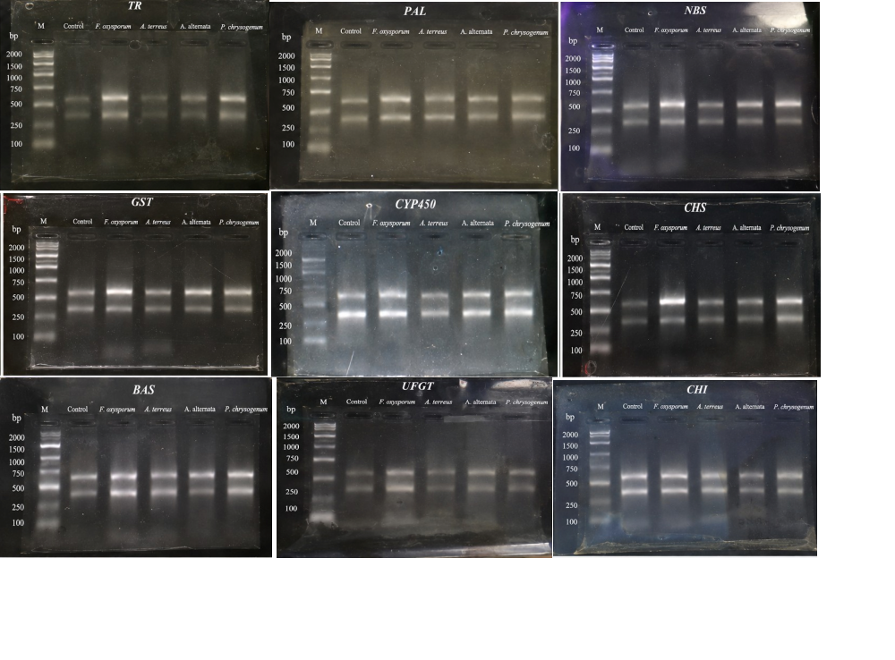
Figure 1S. RNA integrity
Figure 2S.