Table S1. Conventional activity metrics and standardised log-transformed MRI-derived fat outcomes
Activity metric | β (95% CI) | P value | N
ASAT
WHO-weighted MVPA, per +10 min/week | -0.010 (-0.013 to -0.006) | <0.001 | 239
150 to <300 vs <150 min/week | -0.257 (-0.629 to 0.115) | 0.175 | 239
≥300 vs <150 min/week | -0.615 (-0.964 to -0.266) | <0.001 | 239
VAT
WHO-weighted MVPA, per +10 min/week | -0.010 (-0.015 to -0.006) | <0.001 | 239
150 to <300 vs <150 min/week | 0.017 (-0.489 to 0.523) | 0.947 | 239
≥300 vs <150 min/week | -0.404 (-0.879 to 0.070) | 0.095 | 239
Liver PDFF
WHO-weighted MVPA, per +10 min/week | -0.003 (-0.008 to 0.002) | 0.216 | 234
150 to <300 vs <150 min/week | 0.297 (-0.229 to 0.823) | 0.267 | 234
≥300 vs <150 min/week | 0.135 (-0.358 to 0.628) | 0.591 | 234
Values are β coefficients with 95% confidence intervals from age- and sex-adjusted linear regression models.
WHO-weighted MVPA was calculated as moderate-intensity activity + 2 × vigorous-intensity activity.
The reference category for categorical analyses was <150 min/week. ASAT and VAT were height²-normalised before natural-log transformation; liver fat was analysed as PDFF.

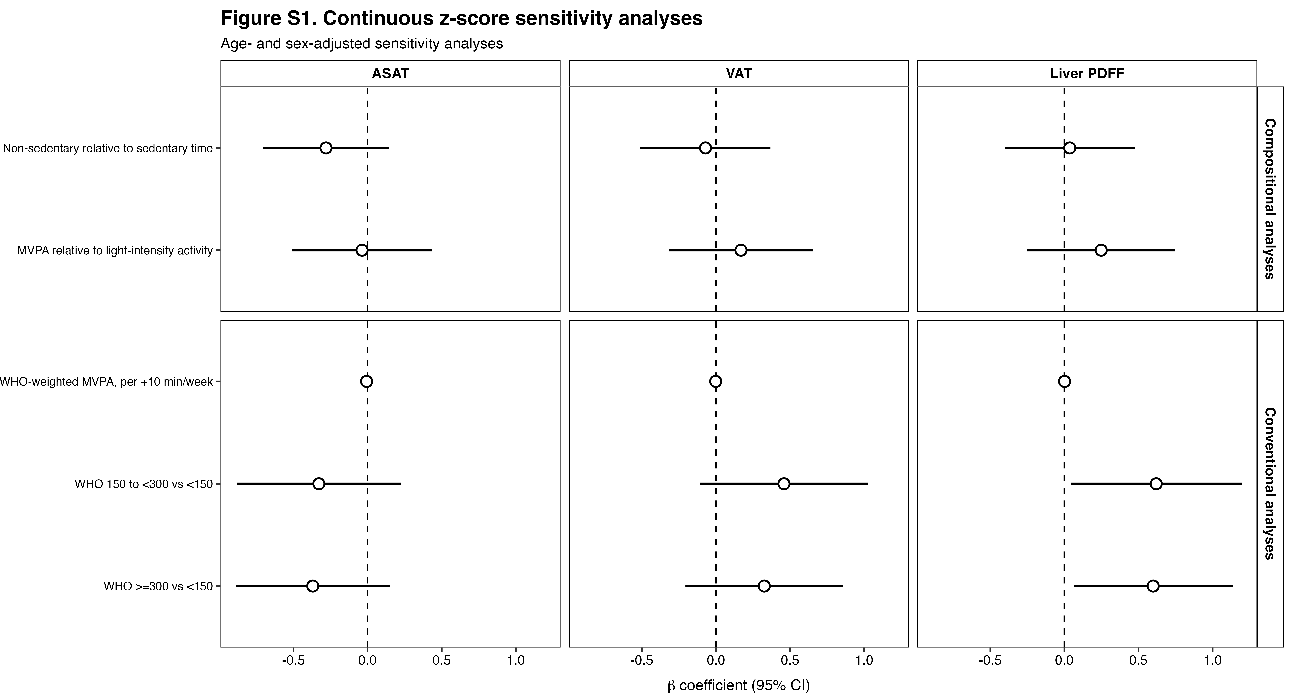

Figure S1. Sensitivity analyses using sex and BMI-referenced MRI-derived adiposity z-scores. Points show β coefficients with 95% confidence intervals from age- and sex-adjusted models; the dashed line indicates β = 0. ILR1 contrasts non-sedentary with sedentary time, and ILR2 contrasts MVPA with light intensity activity. Conventional analyses include WHO- weighted MVPA and WHO activity categories. Z-LF is distingt from the main liver outcome

Table S2. Compositional models and continuous sex- and BMI-referenced z-score outcomes
Compositional contrast | β (95% CI) | P value | N
ASAT z-score
ILR1: non-sedentary relative to sedentary time | -0.280 (-0.704 to 0.144) | 0.194 | 239
ILR2: MVPA relative to light-intensity activity | -0.037 (-0.507 to 0.434) | 0.878 | 239
VAT z-score
ILR1: non-sedentary relative to sedentary time | -0.071 (-0.510 to 0.367) | 0.750 | 239
ILR2: MVPA relative to light-intensity activity | 0.168 (-0.318 to 0.655) | 0.496 | 239
Liver-fat z-score (z-LF)
ILR1: non-sedentary relative to sedentary time | 0.036 (-0.402 to 0.475) | 0.870 | 223
ILR2: MVPA relative to light-intensity activity | 0.249 (-0.251 to 0.748) | 0.328 | 223
Values are β coefficients with 95% confidence intervals from age- and sex-adjusted linear regression models.
ILR1 contrasts non-sedentary time (the geometric mean of light-intensity activity and MVPA) with sedentary time; ILR2 contrasts MVPA with light-intensity activity.
z-ASAT, z-VAT and z-LF are sex- and BMI-referenced AMRA-derived sensitivity outcomes. z-LF is distinct from the primary liver PDFF outcome.

Table S3. Sensitivity analyses with additional covariate adjustment using standardised log-transformed MRI-derived fat outcomes
Exposure / contrast | β (95% CI) | P value | N
ASAT
ILR1: non-sedentary relative to sedentary time | -0.594 (-1.004 to -0.185) | 0.005 | 154
ILR2: MVPA relative to light-intensity activity | -0.068 (-0.472 to 0.336) | 0.739 | 154
WHO-weighted MVPA, per +10 min/week | -0.010 (-0.014 to -0.006) | <0.001 | 154
150 to <300 vs <150 min/week | -0.107 (-0.599 to 0.385) | 0.668 | 154
≥300 vs <150 min/week | -0.486 (-0.959 to -0.013) | 0.044 | 154
VAT
ILR1: non-sedentary relative to sedentary time | -0.699 (-1.248 to -0.151) | 0.013 | 154
ILR2: MVPA relative to light-intensity activity | 0.238 (-0.303 to 0.779) | 0.385 | 154
WHO-weighted MVPA, per +10 min/week | -0.010 (-0.016 to -0.005) | <0.001 | 154
150 to <300 vs <150 min/week | 0.379 (-0.262 to 1.020) | 0.245 | 154
≥300 vs <150 min/week | -0.014 (-0.630 to 0.603) | 0.965 | 154
Liver PDFF
ILR1: non-sedentary relative to sedentary time | -0.672 (-1.264 to -0.079) | 0.027 | 149
ILR2: MVPA relative to light-intensity activity | 0.556 (-0.035 to 1.147) | 0.065 | 149
WHO-weighted MVPA, per +10 min/week | -0.005 (-0.011 to 0.001) | 0.117 | 149
150 to <300 vs <150 min/week | 0.561 (-0.134 to 1.255) | 0.113 | 149
≥300 vs <150 min/week | 0.341 (-0.320 to 1.001) | 0.310 | 149
Models were adjusted for age, sex, smoking status, weekly alcohol consumption, binge-drinking frequency, and food habits.
The outcome-specific complete-case sample sizes were N = 154 for ASAT, N = 154 for VAT, and N = 149 for liver PDFF.
ASAT and VAT were height²-normalised before natural-log transformation; liver fat was analysed as PDFF.

Table S4. Model-based estimates for reallocating sedentary time to non-sedentary time
Sedentary time reallocated | β (95% CI) | N
ASAT
10 min/day | -0.019 (-0.032 to -0.006) | 239
30 min/day | -0.056 (-0.094 to -0.017) | 239
60 min/day | -0.107 (-0.181 to -0.033) | 239
VAT
10 min/day | -0.025 (-0.043 to -0.007) | 239
30 min/day | -0.072 (-0.124 to -0.019) | 239
60 min/day | -0.138 (-0.240 to -0.037) | 239
Liver PDFF
10 min/day | -0.008 (-0.027 to 0.011) | 234
30 min/day | -0.023 (-0.078 to 0.032) | 234
60 min/day | -0.044 (-0.151 to 0.062) | 234
Estimates represent changes in standard deviation units from the age- and sex-adjusted three-part compositional model.
For each reallocation, sedentary time was reduced by the stated number of minutes and redistributed proportionally between light-intensity activity and MVPA according to their shares of non-sedentary time at the mean composition.
The mean waking-time composition used as the reference was approximately 750.4 min/day sedentary time, 159.7 min/day light-intensity activity, and 61.1 min/day MVPA.
Negative values indicate a lower adiposity outcome.

Table S5. Model-specific sample sizes
Analysis | ASAT, N | VAT, N | Liver, N
Main compositional analysis | 239 | 239 | 234
Table S1: WHO-weighted MVPA | 239 | 239 | 234
Table S1: WHO activity categories | 239 | 239 | 234
Table S2: three-part z-score sensitivity analysis | 239 | 239 | 223
Figure S1: WHO-weighted MVPA with z-score outcomes | 239 | 239 | 223
Figure S1: WHO categories with z-score outcomes | 239 | 239 | 223
Table S3: additionally adjusted three-part model | 154 | 154 | 149
Table S3: additionally adjusted WHO-weighted MVPA | 154 | 154 | 149
Table S3: additionally adjusted WHO categories | 154 | 154 | 149
Table S4: time-reallocation analysis | 239 | 239 | 234
Sample sizes correspond to the observations actually used in each fitted model (nobs in R).
For analyses using the main outcomes, 'Liver' refers to liver PDFF. For z-score sensitivity analyses, 'Liver' refers to the AMRA-derived liver-fat z-score (z-LF).

