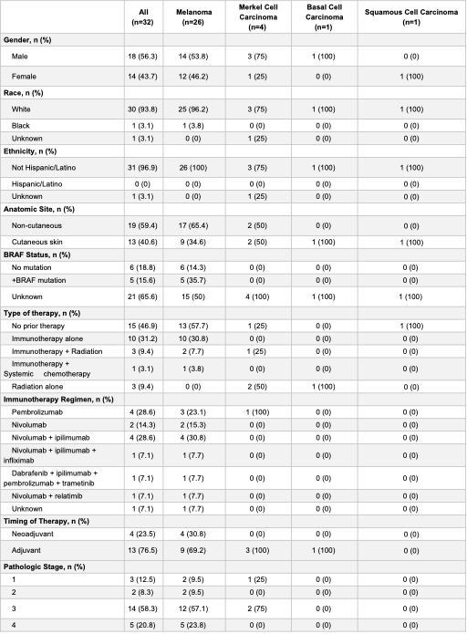
Table 1. Characteristics of patients whose samples were included in human TIL experiments.

