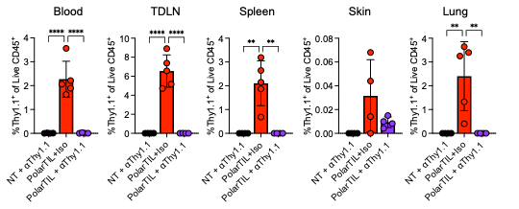
Figure S1. Detection of Thy1.1⁺ donor TIL in blood, tumor draining inguinal lymph nodes, spleen, skin of the original tumor site, and lungs from no treatment+⍺Thy1.1 depleting antibody control mice (black, n=4), PolarTIL survivor+Isotype mice (red, n=5) and PolarTIL survivor+⍺Thy1.1 depleting antibody mice (purple, n=4) For each organ, one-way ANOVA with Holm-Šídák’s multiple comparisons test. ** = p<0.01, **** = p<0.0001.

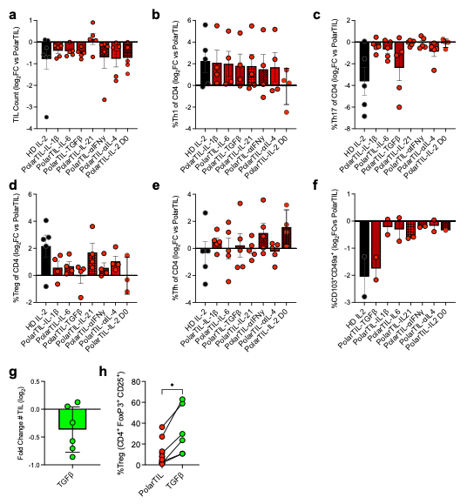
Figure S2. Systematic removal of individual cytokines influences PolarTIL phenotype. a, Log₂fold change (FC) in final TIL count at the end of culture compared to PolarTIL (n=4). b, Log₂FC in percent Th1 (CXCR3⁺ CCR6⁻) of CD4⁺ compared to PolarTIL (n=4). c, Log₂FC in percent Th17 (CXCR3⁻ CCR6⁺) of CD4⁺ compared to PolarTIL (n=4). d, Log₂FC in percent Treg (FoxP3⁺ CD25⁺) of CD4⁺ compared to PolarTIL (n=4). e, Log₂FC in percent Tfh (CXCR5⁺) of CD4⁺ compared to PolarTIL (n=4). f, Log₂FC in percent CD103⁺ CD49a⁺ of CD8⁺ compared to PolarTIL (n=2). g, Log₂FC in final TIL count at the end of culture compared to PolarTIL (n=6). h, Percent Treg (FoxP3⁺ CD25⁺) of CD4⁺ (n=5, Wilcoxon matched-pairs signed rank test). * = p<0.05.

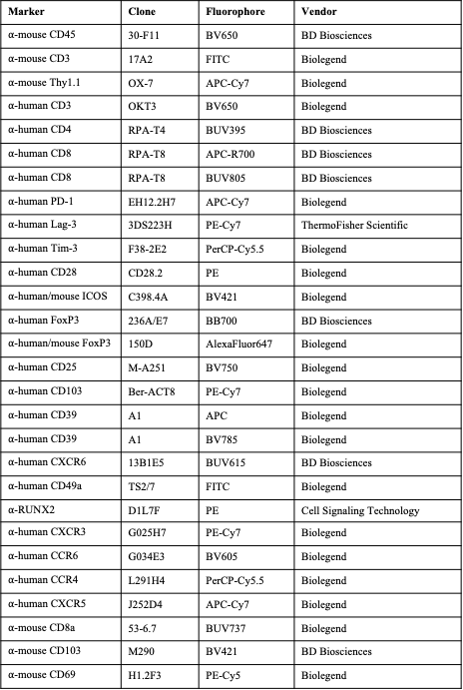
Table S1. Flow cytometry antibodies used in this study.

