Facile Synthesis of Multi-channel Surface Modified Amorphous Iron Oxide Nanospheres as a High-performance Anode Material for Lithium-ion Batteries
Shijin Yuª, Wenzhen Zhuª, Zhuohao Xiaoª, Jiahao Tongª, Quanya Weiª, Tianrui Chenª, Xuannan Heª, Hua Zhu^{a*}, Qiuyun Fu^{b*}, Ling Bing Kong^{c*}, Fajun Wang^{d*}

ª School of Mechanical and Electrical Engineering, Jingdezhen Ceramic University, Jingdezhen 333001, Jiangxi, China
^{b} School of Optical and Electronic Information, Engineering Research Center for Functional Ceramics of the Ministry of Education, Huazhong University of Science and Technology, Wuhan, 430074, Hubei, China
^{c} College of New Materials and New Energies, Shenzhen Technology University, Shenzhen 518118, Guangdong, China
^{d} School of Materials Engineering, Jiangsu University of Technology, Changzhou 213001, Jiangsu, China

* Corresponding author’s e-mail: zwchua@163.com (H. Zhu), fuqy@hust.edu.cn (Q. Fu), lbkongntunus@126.com (L. B. Kong), jjbxsjz@foxmail.com (F. Wang)

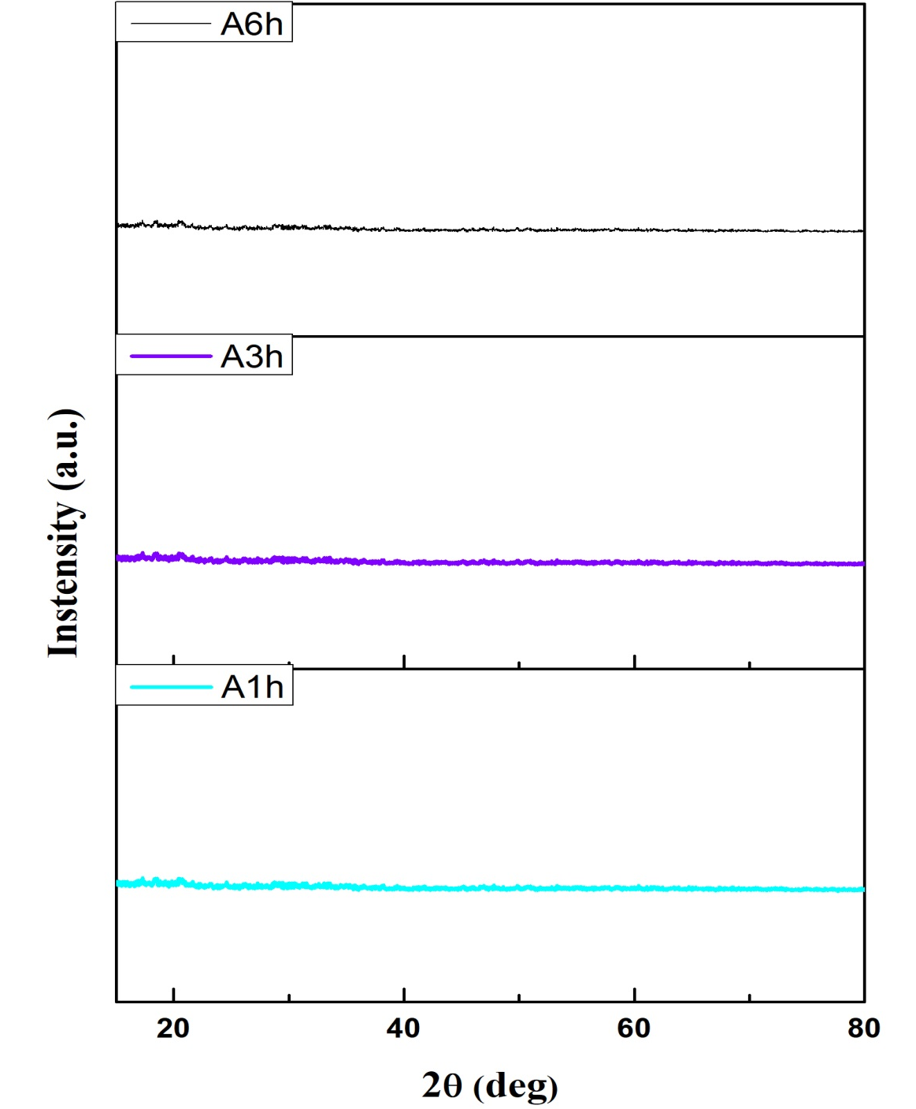
Fig. S1. XRD patterns of the samples after hydrothermal treatment for different times (A1h, A3h, A6h).

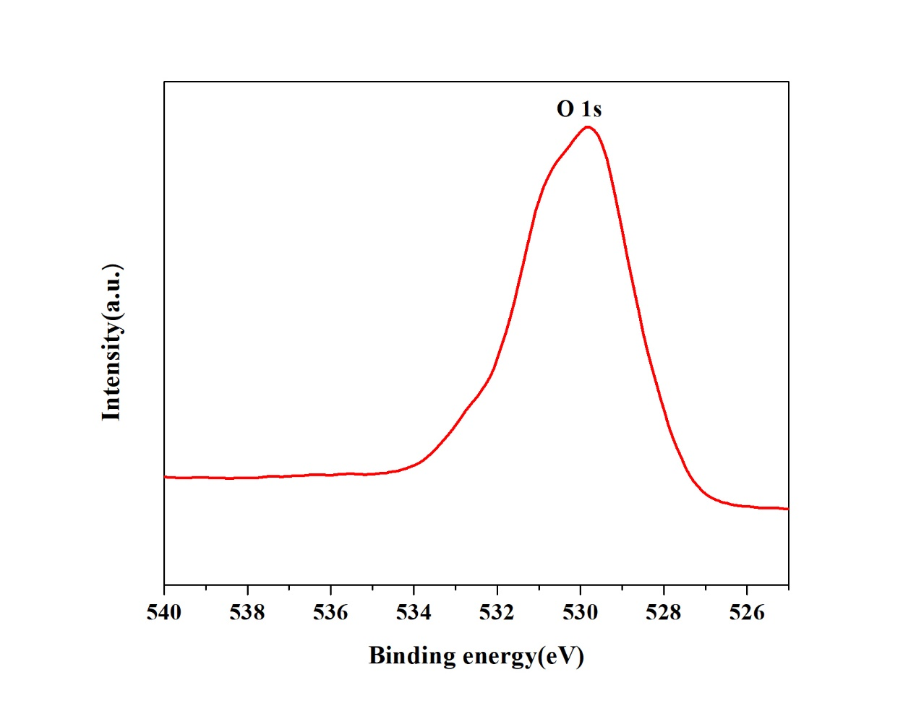
Fig. S2. XPS spectrum (O 1s spectrum) of the amorphous Fe₂O₃.

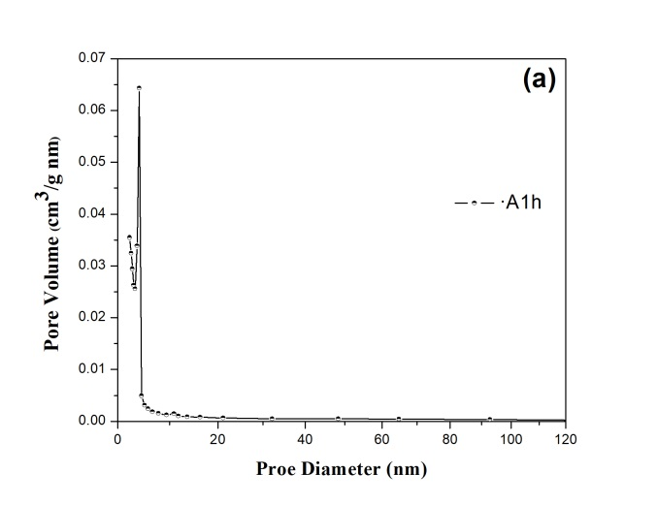
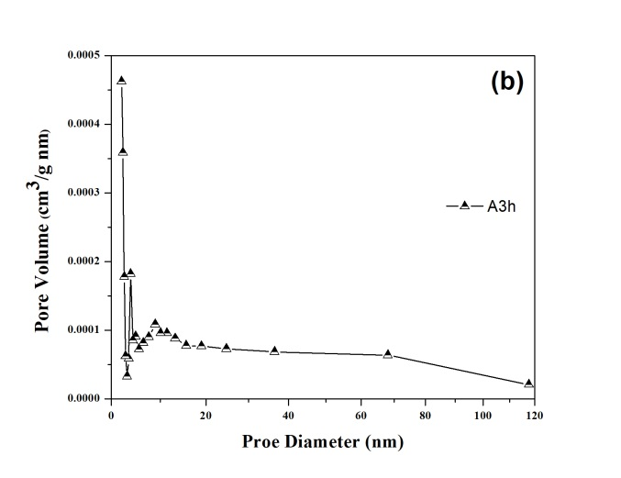
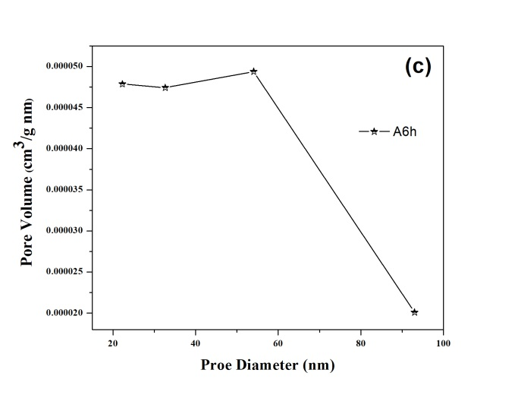

Fig. S3. Pore-size distributions of the amorphous Fe₂O₃ samples: (a) A1h, (b) A3h and (c) A6h.

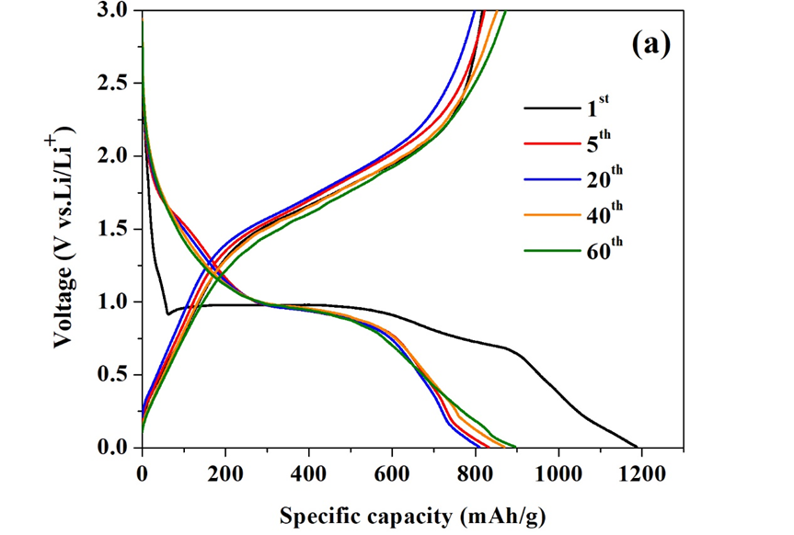
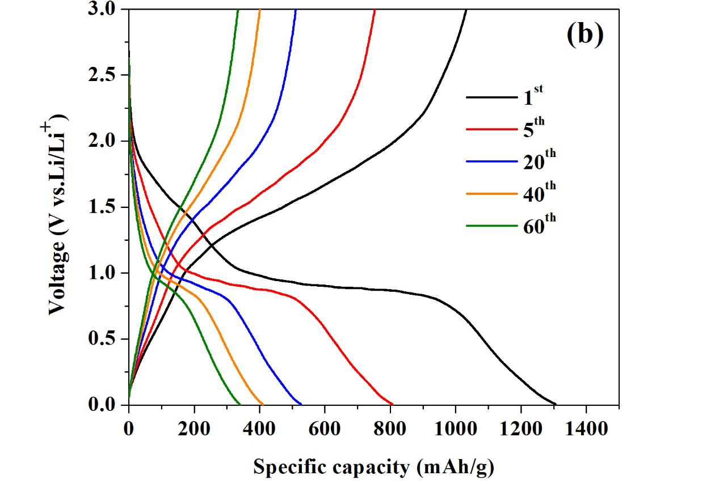

Fig. S4. Representative charge/discharge curves of the amorphous (a) and crystalline (b) Fe₂O₃ electrodes.

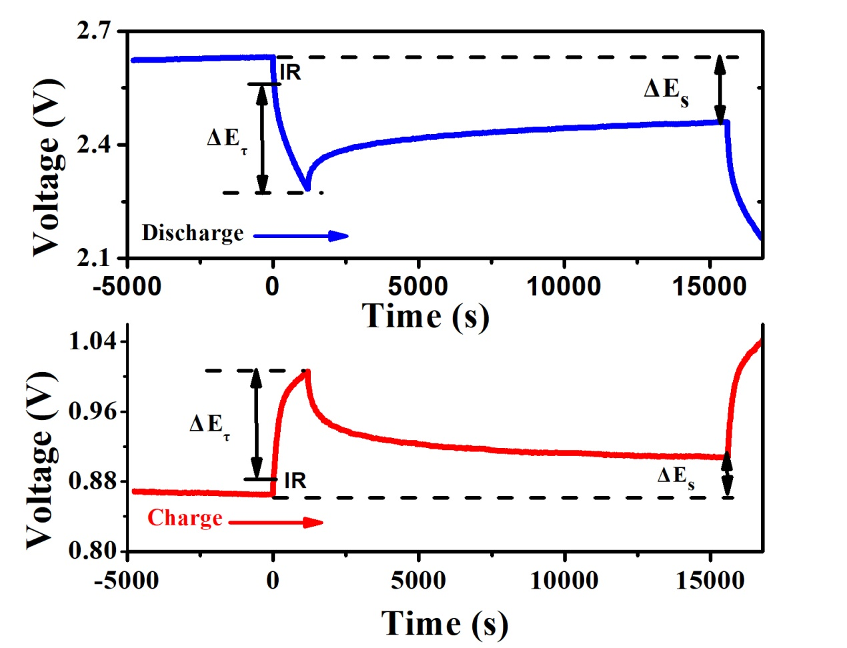
Fig. S5. Close-up views of the GITT curves of the amorphous Fe₂O₃ electrode.

