Appendices
Best Practices Whiplash (BPW) – Recommended WAD I-II claim handling,
Acute WAD I-II treatment flowchart
Chronic WAD I-II treatment flowchart.

Best Practices Whiplash (BPW) – Recommended WAD I-II claim handling
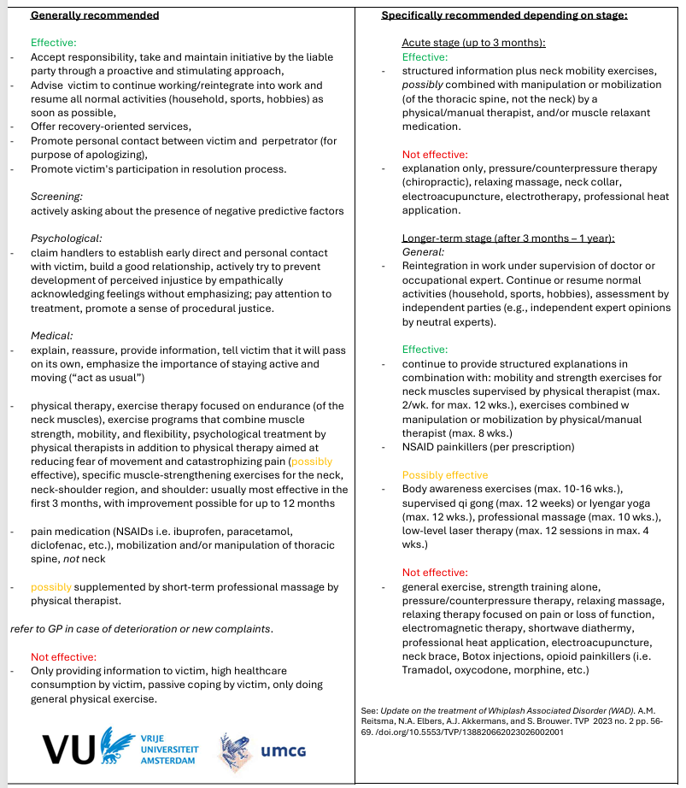

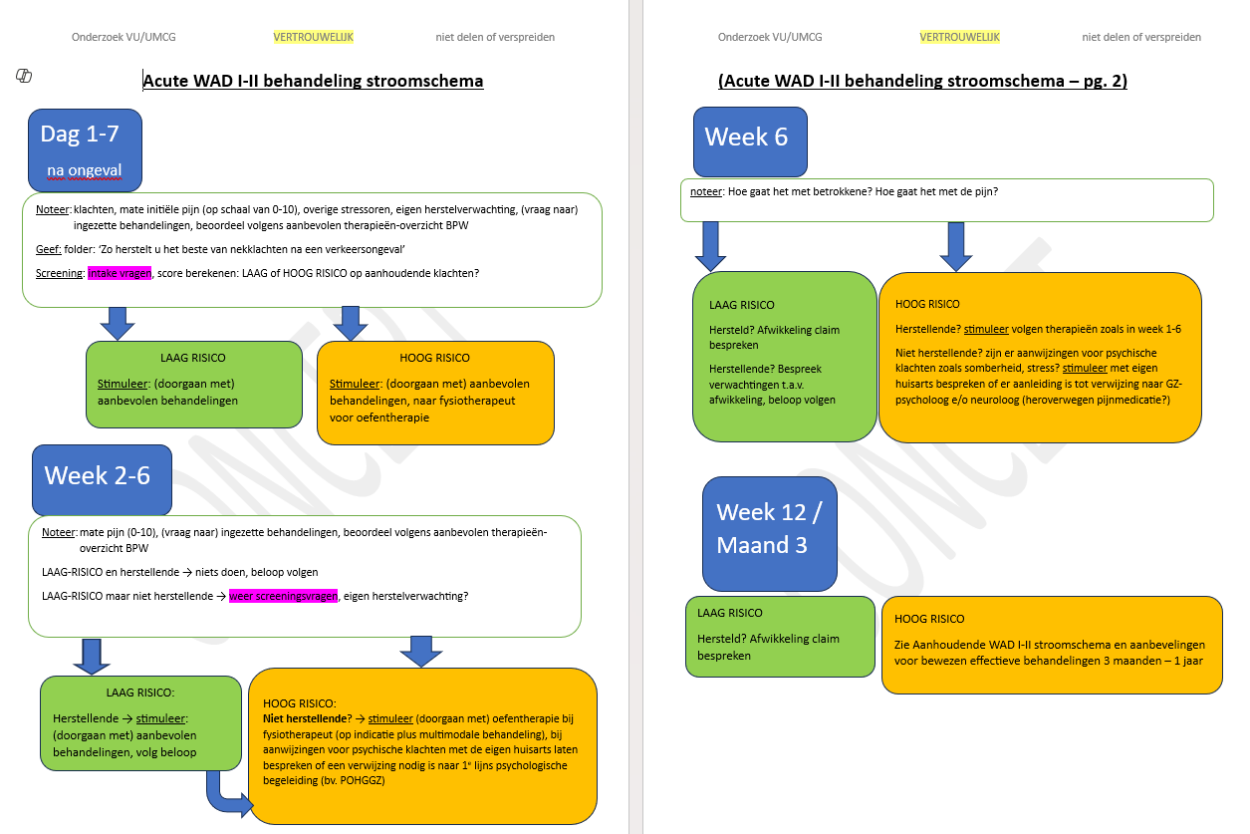
Acute WAD I-II treatment flowchart

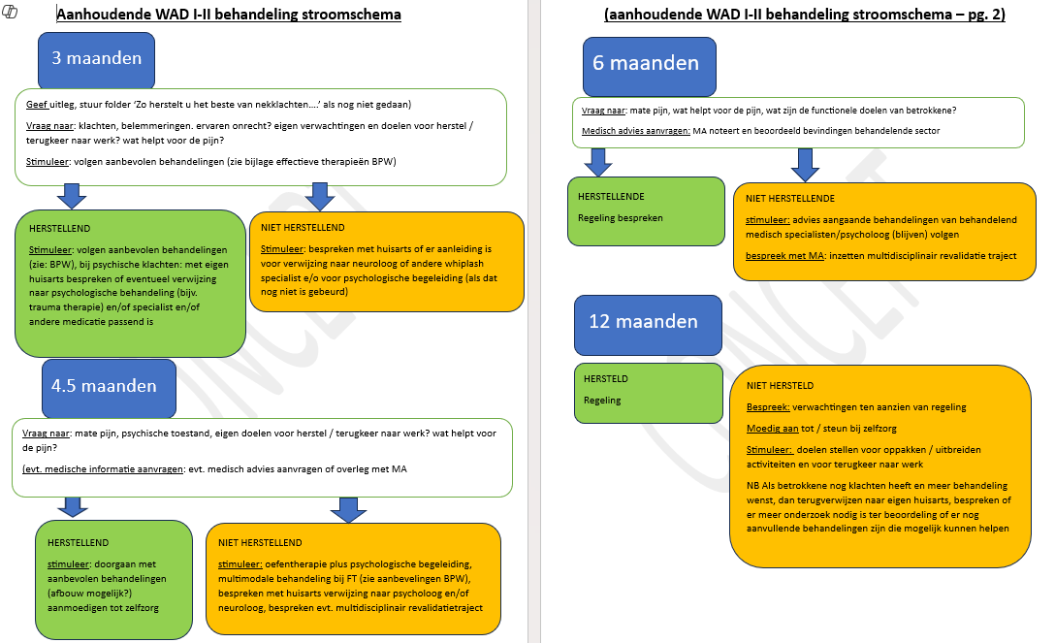
Chronic WAD I-II treatment flowchart

