Supplementary Information

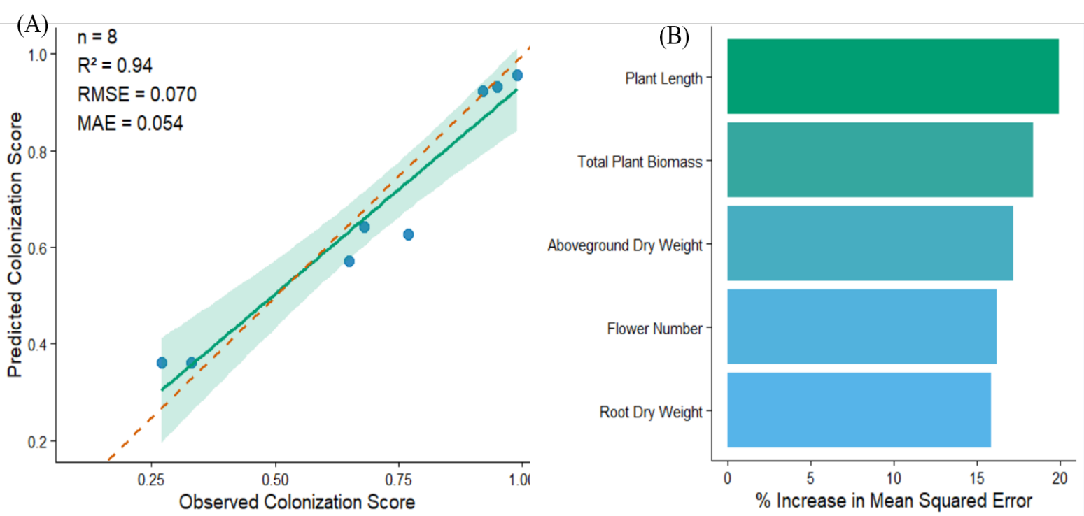
Fig. S1
Figure S1. Observed versus predicted AMF colonization scores from the supplementary Random Forest validation model based on plant growth traits.

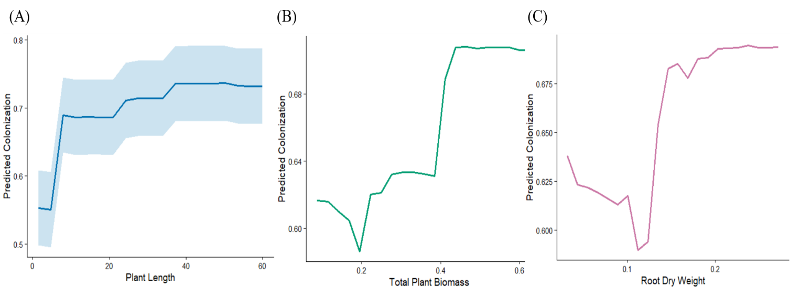
Fig. S2
Figure S2. Variable importance ranking for predictors of AMF colonization in the supplementary validation model.

Fig. S3
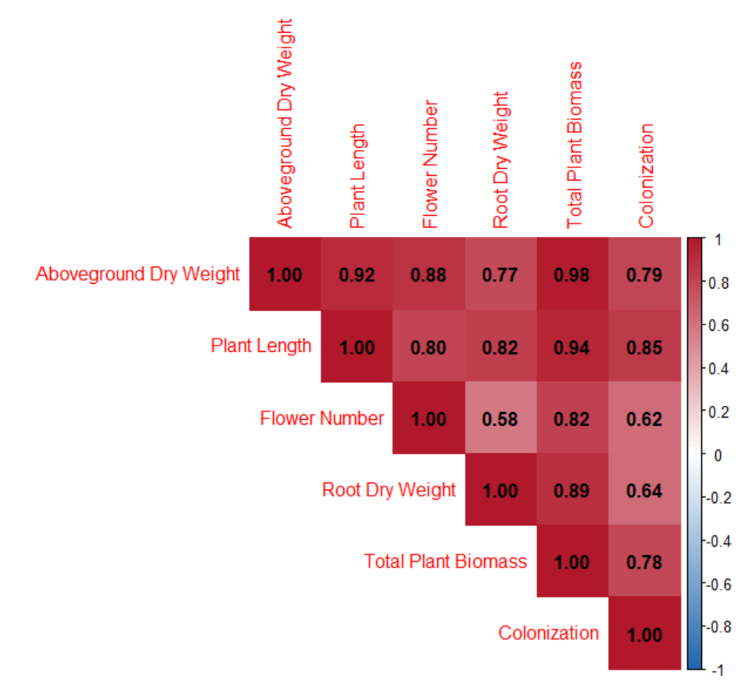
Figure S3. Partial dependence plots illustrating the effects of plant length, total biomass, and root biomass on predicted AMF colonization.
Fig. S4
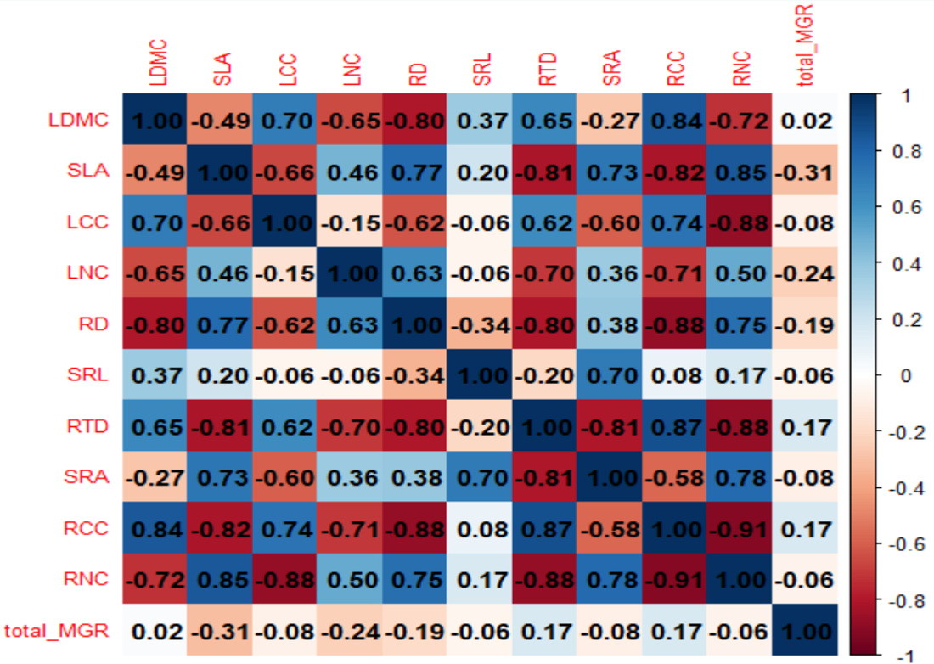
Figure S4. Correlation matrix of plant functional traits and mycorrhizal growth response used in the Trait2Myco framework.
Fig. S5
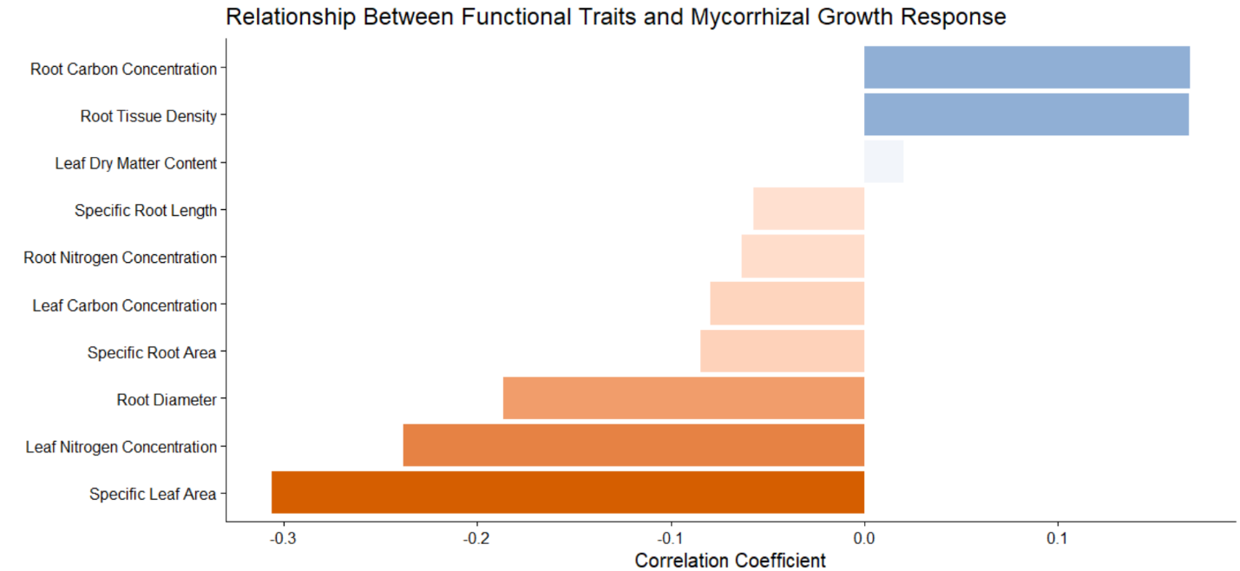
Figure S5. Relationships among plant growth traits and AMF colonization intensity in the independent validation dataset.

