Supplementary Appendix 1
Raw count matrices of cartilage single-cell transcriptomes were imported into the R environment (v4.3.1) and processed with the Seurat package (v5.0.3). Cell filtering criteria: Mitochondrial gene proportion < 15%;Ribosomal gene proportion < 50%; Detected gene number (nFeature_RNA): 200 < nFeature_RNA < 8000; log10GenesPerUMI > 0.80. Contamination & doublet removal: DecontX (R package) was applied to eliminate ambient RNA contamination within individual cells. The DoubletFinder algorithm was used to computationally detect and remove potential doublet cells. Cell cycle: cell-cycle phase scores were calculated using canonical cell-cycle gene sets. After preprocessing, dimensional reduction, cell clustering and annotation were performed following standard Seurat workflow.

Supplementary Tables
 | Normal | KOA
GSE220243 | GSM6797148  GSM6797149  GSM6797150  GSM6797151  GSM6797152  GSM6797153 | GSM6797154  GSM6797155  GSM6797156  GSM6797157  GSM6797158  GSM6797159
GSE255460 | GSM8072834  GSM8072835  GSM8072836 | GSM8072837  GSM8072839  GSM8072841
Supplementary Table 1. Information of human cartilage scRNA-seq datasets downloaded from the GEO database. GSM serial numbers corresponding to each group are listed separately.
Name | Forward primer(5’to 3’） | Reverse primer（5’ to 3’）
Col2a1 | GAAGGATGGCTGCACGAAAC | TGAGGGGAGGACGGTTGG
Mmp9 | TTCACCGGCTAAACCACCTC | TAACGCCCAGTAGAGAGCCT
Mmp13 | GGAGCCCTGATGTTTCCCAT | TAGGGCTGGGTCACACTTCT
Trpv4 | GCCGAGCCCCTGTCATAAGATGA | ATTGTTTGGGTTTCCGCTTTC
Sirt3 | GCTACATGCACGGTCTGTCGAA | GCTACATGCACGGTCTGTCGAA
Parkin | CATTGCCACCACGCTCTACACT | GAGGTCCAGTTAAACCCACC
Pink1 | CAATGTCGGGTTTCACAACGCC | CATTGCCACCACGCTCTACACT
GAPDH | GGTTGTCTCCTGCGACTTCA | TGGTCCAGGGTTTCTTACTCC
Supplementary Table 2. RT-qPRC primer names and sequences

Supplementary Figures
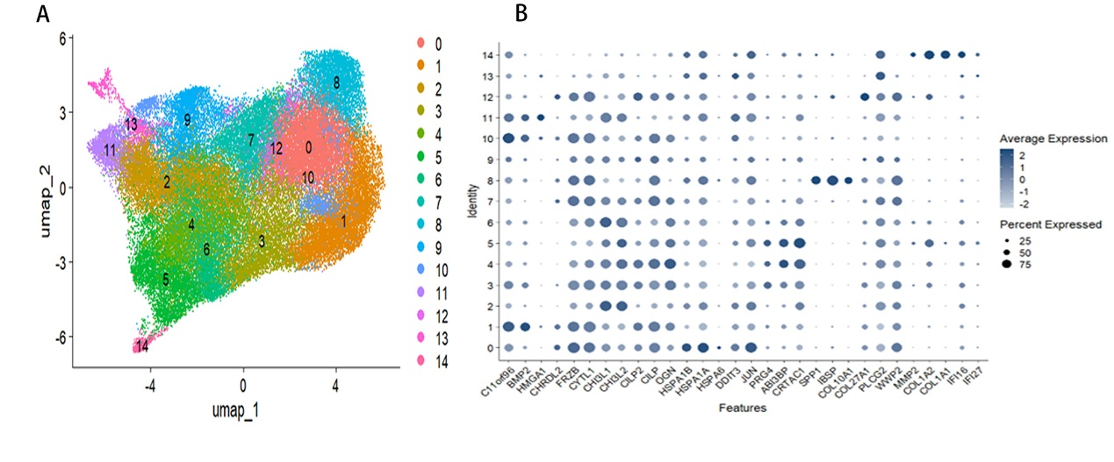
Supplementary Figure 1. Cell clustering and canonical marker gene expression profiling of human cartilage single-cell transcriptomes. (A) UMAP dimensional reduction plot showing 14 distinct cell clusters colored and numbered individually after quality control filtering and integration. (B) Dot plot illustrating the average expression level (color gradient) and cellular expression percentage (dot size) of canonical cartilage marker genes across the 14 cell clusters.
Supplementary Figure 2. Morphological observation and collagen II identification of isolated chondrocytes. Cells isolated from mouse articular cartilage were subjected to morphological observation and collagen II immunofluorescence identification. (A) The cells displayed elongated spindle morphology, which conforms to the typical characteristics of chondrocytes. (B) Intensive positive staining of collagen type II was observed, verifying that the isolated cells were chondrocytes.
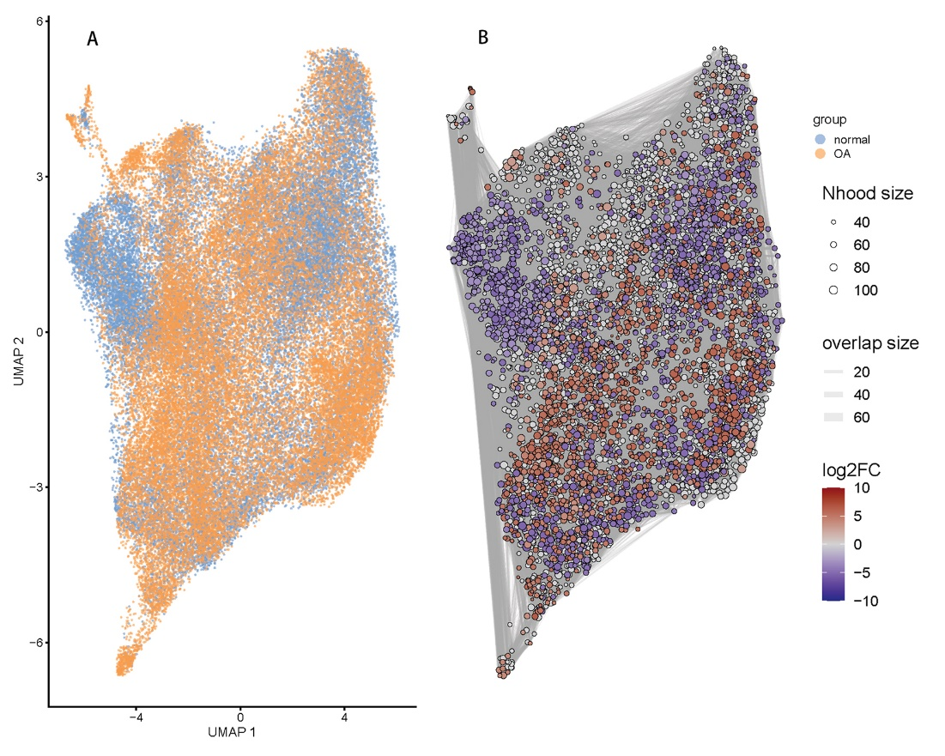
Supplementary Figure 3. Group distribution and MiloR DA analysis of chondrocytes. (A) UMAP plot showing the distribution of chondrocytes from normal (blue) and KOA (orange) groups. (B) MiloR neighbourhood-level DA result; circle size = neighbourhood size, edge width = neighbourhood overlap size, colour gradient indicates log₂FC of cell abundance between KOA and normal cartilage. Differential abundance, DA; KOA, knee osteoarthritis.
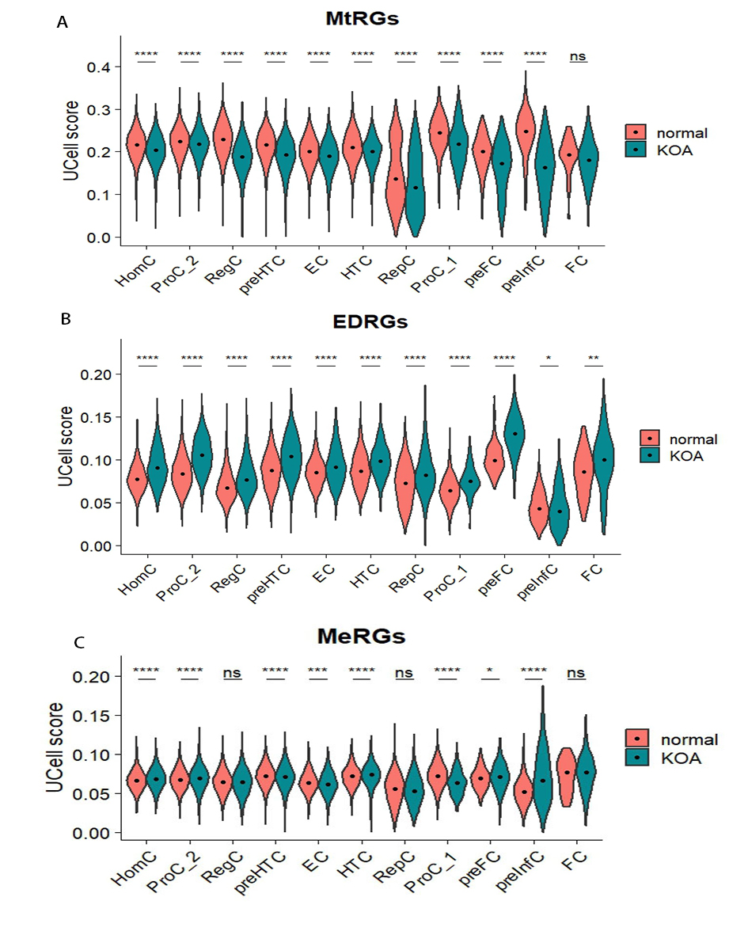
Supplementary Figure 4. UCell score of MtRGs, EDRGs and MeRGs across cell subtypes between normal and KOA groups. (A-C) Violin plots displaying the UCell score of (A) MtRGs, (B) EDRGs and (C) MeRGs in distinct chondrocyte subtypes. normal group: red, KOA group : teal; median values are marked with black dots. Wilcoxon rank-sum test with FDR correction was performed for inter-group comparison. **** P < 0.0001, *** P < 0.001, ** P < 0.01, * P < 0.05, ns P > 0.05. MtRGs, mitophagy-related genes; EDRGs, ECM degradation-related genes; MeRGs, mechanical stimulus response-related genes; KOA, knee osteoarthritis.
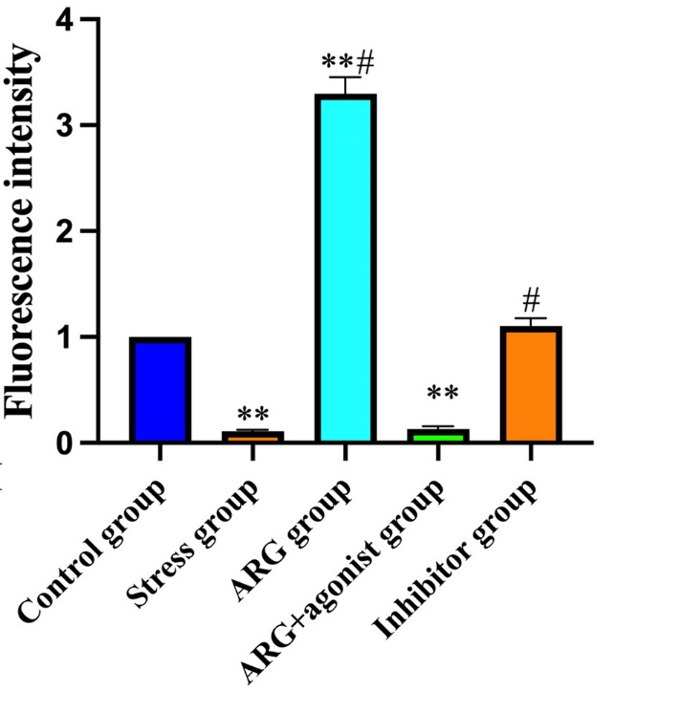
Supplementary Figure 5. COL2A1 fluorescence intensity in chondrocytes from control group, mechanical stress group, ARG group, ARG + TRPV4 agonist group and TRPV4 inhibitor group.** P<0.05 vs control group; # P<0.05 vs stress group. ARG, arctigenin.

