Supplementary Materials:
The Effect of Higher NO_{x} Emission Tax Rates on Carbon Efficiency Progress: A Quasi-Natural Experiment from China's NO_{x} Emission Tax Rate Reform

A1. Calculation and decomposition of carbon efficiency progress index
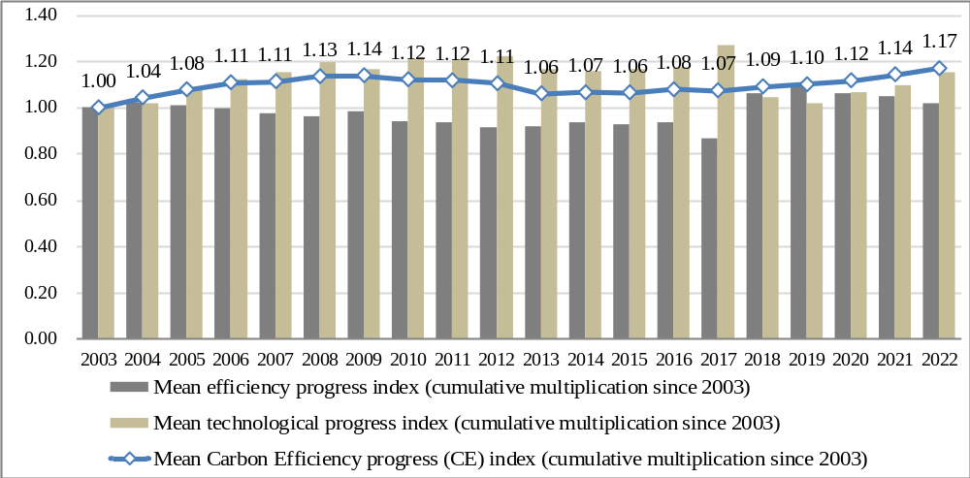
Fig. A.1 Calculation and decomposition results of carbon efficiency progress (CE) index.

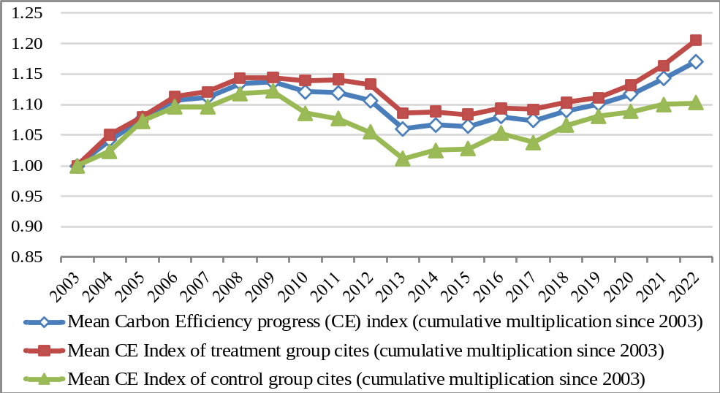
Fig. A.2 Comparison of carbon efficiency progress trends between treatment group and control group cities.

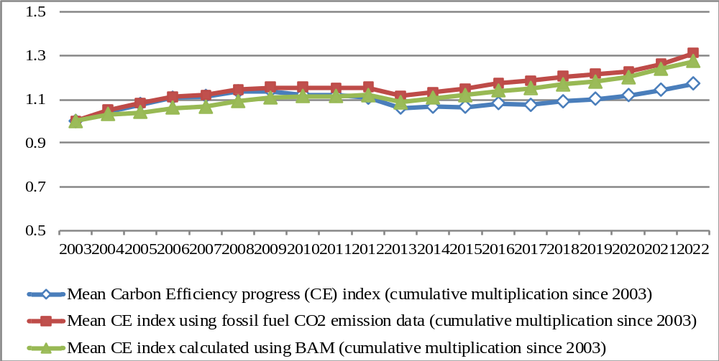
Fig. A.3 Comparison of carbon efficiency indices using different carbon emission data and DEA models.

A2. Complete estimation results of DID models
Table A.1. Estimation results of DID models
 | Model A |  | Model B | Model C | Model D | Model E | Model F | Model G
 | Benchmark Regression (TWFE) |  | Estimatior from Borusyak et al. (2021) | PSM-DID | 2SLS-DID  (IV: PRS & APDIST) | GDID (Considering the differences between tax rates and national standard) | Spatial-DID (SDM using spatial weight matrix) | Spatial-DID (SDM using economic distance spatial weights matrix)
Dep. Var.:  Variables | CE |  | CE | CE | CE | CE | CE | CE
TAXREF | 0.0395*** |  | 0.0614*** | 0.0349*** | 0.277*** | - | 0.026*** | 0.04***
 | (0.0145) |  | (0.0133) | (0.00841) | (0.0665) | - | (0.0088) | (0.0067)
TAXREF×NOTR | - |  | - | - | - | 0.0358*** | - | -
 | - |  | - | - | - | (0.0128) | - | -
YCP | 0.272*** |  | 0.289*** | 0.286*** | 0.264*** | 0.272*** | 0.301*** | 0.271***
 | (0.0307) |  | (0.0331) | (0.0165) | (0.0139) | (0.0310) | (0.0127) | (0.0112)
POPUD | 0.0155 |  | 0.00560 | -0.00747 | 0.0286* | 0.0135 | 0.021* | 0.014
 | (0.0326) |  | (0.0317) | (0.0163) | (0.0152) | (0.0327) | (0.012) | (0.0124)
RDEXP | 0.0568*** |  | 0.0524*** | 0.0467*** | 0.0615*** | 0.0525*** | 0.05*** | 0.052***
 | (0.0186) |  | (0.0197) | (0.0111) | (0.0115) | (0.0188) | (0.0091) | (0.0093)
ROAD | -0.0629*** |  | -0.0362 | -0.0435*** | -0.0620*** | -0.0566** | -0.055*** | -0.059***
 | (0.0241) |  | (0.0268) | (0.0116) | (0.0113) | (0.0236) | (0.008) | (0.0082)
INVMPF | 0.00792* |  | 0.00490 | 0.000404 | 0.00763*** | 0.00729* | 0.008*** | 0.009***
 | (0.00404) |  | (0.00453) | (0.00257) | (0.00264) | (0.00405) | (0.0021) | (0.0022)
W_{s}×TAXREF | - |  | - | - | - | - | 0.0513* | -
 | - |  | - | - | - | - | (0.0308) | -
W_{s}×CE (Dependent Variable) | - |  | - | - | - | - | 0.761*** | -
 | - |  | - | - | - | - | (0.0308) | -
W_{e}×TAXREF | - |  | - | - | - | - | - | 0.3544***
 | - |  | - | - | - | - | - | (0.0907)
W_{e}×CE (Dependent Variable) | - |  | - | - | - | - | - | 0.134*
 | - |  | - | - | - | - | - | (0.0728)
Constant | -2.833*** |  | - | - | - | -2.803*** | - | -
 | (0.468) |  | - | - | - | (0.473) | - | -
Observations | 5,396 |  | 5,396 | 3819 | 5,396 | 5,396 | 5,396 | 5,396
Number of cities | 284 |  | 284 | 201 | 284 | 284 | 284 | 284
R² | 0.173 |  | - | 0.190 | 0.034 | 0.175 | 0.8022 | 0.7913
Individual fixed effect | Yes |  | Yes | Yes | Yes | Yes | Yes | Yes
Time fixed effect | Yes |  | Yes | Yes | Yes | Yes | Yes | Yes
Note: Robust standard errors clustered at the cross-sectional individual unit (city) level are marked in parentheses. *, **, and *** denote significance at 10%, 5%, and 1% levels, respectively.
Table A.2. Heterogeneity analysis results
 | Model A |  | Model H | Model I | Model J | Model K | Model L
 | Benchmark Regression (TWFE) |  | Cities in Eastern China | Proportion of The Secondary Industry In GDP | Proportion of Gas Users in the Population | Key Regions in National Air Pollution Control Plans | Low Carbon Cities
Dep. Var.:  Variables | CE |  | CE | CE | CE | CE | CE
TAXREF | 0.0395*** |  | 0.0206 | 0.0467*** | 0.0133 | 0.0210 | 0.0271*
 | (0.0145) |  | (0.0147) | (0.0139) | (0.0145) | (0.0151) | (0.0143)
YCP | 0.272*** |  | 0.294*** | 0.281*** | 0.303*** | 0.279*** | 0.275***
 | (0.0307) |  | (0.0296) | (0.0313) | (0.0296) | (0.0299) | (0.0303)
POPUD | 0.0155 |  | 0.0197 | 0.0179 | 0.00445 | 0.0156 | 0.0119
 | (0.0326) |  | (0.0321) | (0.0326) | (0.0305) | (0.0324) | (0.0320)
RDEXP | 0.0568*** |  | 0.0486*** | 0.0558*** | 0.0416** | 0.0571*** | 0.0512***
 | (0.0186) |  | (0.0179) | (0.0186) | (0.0172) | (0.0187) | (0.0182)
ROAD | -0.0629*** |  | -0.0503** | -0.0626** | -0.0499** | -0.0551** | -0.0575**
 | (0.0241) |  | (0.0238) | (0.0242) | (0.0221) | (0.0238) | (0.0232)
INVMPF | 0.00792* |  | 0.00700* | 0.00743* | 0.00632 | 0.00678* | 0.00772*
 | (0.00404) |  | (0.00410) | (0.00402) | (0.00397) | (0.00409) | (0.00401)
TAXREF×EAST | - |  | 0.104*** | - | - | - | -
 | - |  | (0.0239) | - | - | - | -
TAXREF×SIND | - |  | - | 0.00279* | - | - | -
 | - |  | - | (0.00151) | - | - | -
TAXREF×GASR | - |  | - | - | 0.112*** | - | -
 | - |  | - | - | (0.0171) | - | -
TAXREF×APCTRL | - |  | - | - | - | 0.0957*** | -
 | - |  | - | - | - | (0.0241) | -
TAXREF×LCC | - |  | - | - | - | - | 0.137***
 | - |  | - | - | - | - | (0.0308)
Constant | -2.833*** |  | -3.049*** | -2.935*** | -2.957*** | -2.927*** | -2.807***
 | (0.468) |  | (0.463) | (0.478) | (0.445) | (0.468) | (0.460)
Observations | 5,396 |  | 5,396 | 5,396 | 5,396 | 5,396 | 5,396
Number of cities | 284 |  | 284 | 284 | 284 | 284 | 284
R² | 0.173 |  | 0.191 | 0.177 | 0.217 | 0.185 | 0.191
Individual fixed effect | Yes |  | Yes | Yes | Yes | Yes | Yes
Time fixed effect | Yes |  | Yes | Yes | Yes | Yes | Yes
Note: Robust standard errors clustered at the cross-sectional individual unit (city) level are marked in parentheses. *, **, and *** denote significance at 10%, 5%, and 1% levels, respectively.

A3. Results of robustness test models

Table A.3. Mean standardized bias of variables before and after PSM (for Model C).
Year  Bias (%) | 2004 | 2005 | 2006 | 2007 | 2008 | 2009 | 2010 | 2011 | 2012 | 2013 | 2014 | 2015 | 2016 | 2017 | 2018 | 2019 | 2020 | 2021 | 2022
Unmatched | 20.006 | 17.756 | 20.277 | 22.364 | 13.837 | 14.709 | 16.119 | 16.861 | 17.205 | 17.814 | 16.183 | 16.321 | 13.735 | 9.461 | 12.194 | 14.789 | 16.520 | 14.088 | 12.926
Matched | 4.115 | 2.426 | 4.209 | 5.310 | 1.402 | 5.415 | 1.817 | 3.174 | 2.303 | 2.741 | 3.809 | 1.485 | 3.397 | 5.453 | 3.019 | 4.741 | 2.963 | 4.174 | 4.479
Note: Limited to space, only the mean standardization bias of all control variables is reported here. The specific matching results (balance test results) of typical years (2004, 2011, and 2018) are reported in Table A.1 of the supplementary materials.

Table A.4. Bias reduction of variables after PSM (for Model C).
 |  |  |  |  | 2004 |  |  |  |  |  |  | 2013 |  |  |  |  |  |  | 2021
 | Unmatched (U) |  | Mean |  |  | %reduct | t-test |  |  | Mean |  |  | %reduct | t-test |  |  | Mean |  |  | %reduct | t-test
 | Matched (M) |  | Treated | Untreated | Bias(%) | |Bias| | t | p>|t| |  | Treated | Untreated | Bias(%) | |Bias| | t | p>|t| |  | Treated | Untreated | Bias(%) | |Bias| | t | p>|t|
YCP | U |  | 9.2533 | 9.0594 | 30.4 |  | 2.33 | 0.02 |  | 10.261 | 10.116 | 25.5 |  | 1.92 | 0.056 |  | 10.604 | 10.462 | 25.5 |  | 1.95 | 0.052
 | M |  | 9.0879 | 9.062 | 4.1 | 86.6 | 0.27 | 0.791 |  | 10.11 | 10.119 | -1.5 | 94.1 | -0.1 | 0.922 |  | 10.511 | 10.478 | 5.7 | 77.5 | 0.38 | 0.702
POPUD | U |  | 9.3239 | 9.2606 | 18.8 |  | 1.39 | 0.166 |  | 8.9011 | 8.8748 | 8.2 |  | 0.61 | 0.541 |  | 8.7777 | 8.7384 | 13.1 |  | 0.98 | 0.327
 | M |  | 9.2682 | 9.3004 | -9.6 | 49 | -0.6 | 0.547 |  | 8.8661 | 8.8805 | -4.5 | 45 | -0.27 | 0.785 |  | 8.7232 | 8.7396 | -5.4 | 58.4 | -0.34 | 0.733
RDEXP | U |  | 6.9892 | 6.8592 | 17 |  | 1.37 | 0.172 |  | 8.5587 | 8.4981 | 9.4 |  | 0.75 | 0.455 |  | 8.7667 | 8.7349 | 4.9 |  | 0.39 | 0.694
 | M |  | 6.9502 | 6.921 | 3.8 | 77.6 | 0.24 | 0.809 |  | 8.5235 | 8.5163 | 1.1 | 88 | 0.07 | 0.944 |  | 8.778 | 8.7462 | 5 | -0.3 | 0.31 | 0.756
ROAD | U |  | 2.2245 | 2.1101 | 24.9 |  | 1.87 | 0.063 |  | 2.8675 | 2.7512 | 24.9 |  | 1.87 | 0.063 |  | 3.2703 | 3.1751 | 22.2 |  | 1.76 | 0.08
 | M |  | 2.1381 | 2.1317 | 1.4 | 94.4 | 0.09 | 0.932 |  | 2.7698 | 2.7557 | 3 | 87.9 | 0.2 | 0.844 |  | 3.2073 | 3.1962 | 2.6 | 88.4 | 0.17 | 0.869
INVMPF | U |  | -3.4873 | -3.5704 | 8.9 |  | 0.68 | 0.494 |  | -4.242 | -4.0132 | -21.2 |  | -1.58 | 0.114 |  | -4.3129 | -4.3664 | 4.7 |  | 0.37 | 0.714
 | M |  | -3.5541 | -3.5698 | 1.7 | 81.1 | 0.1 | 0.917 |  | -4.0691 | -4.0305 | -3.6 | 83.1 | -0.23 | 0.819 |  | -4.3827 | -4.4072 | 2.1 | 54.2 | 0.14 | 0.888

Table A.5. Complete results of 2SLS-DID models (Model D).
 | Model C  Benchmark Regression (TWFE) |  | 2SLS-DID  (IV: PRS & APDIST)  Step1 | 2SLS-DID  (IV: PRS & APDIST)  Step2
Variables | Dep. Var.:  CE |  | Dep. Var.:  TAXREF | Dep. Var.:  CE
TAXREF | 0.0395*** |  | - | 0.277***
 | (0.0145) |  | - | (0.0665)
PRS | - |  | 0.111*** | -
 | - |  | (0.0414) | -
APDIST | - |  | 0.180*** | -
 | - |  | (0.0360) | -
YCP | 0.272*** |  | 0.0248 | 0.264***
 | (0.0307) |  | (0.0260) | (0.0139)
POPUD | 0.0155 |  | -0.0644** | 0.0286*
 | (0.0326) |  | (0.0258) | (0.0152)
RDEXP | 0.0568*** |  | -0.0205 | 0.0615***
 | (0.0186) |  | (0.0214) | (0.0115)
ROAD | -0.0629*** |  | -0.00974 | -0.0620***
 | (0.0241) |  | (0.0170) | (0.0113)
INVMPF | 0.00792* |  | 0.00183 | 0.00763***
 | (0.00404) |  | (0.00495) | (0.00264)
Constant | -2.833*** |  | - | -
 | (0.468) |  | - | -
Observations | 5,396 |  | 5,396 | 5,396
Number of cities | 284 |  | 284 | 284
R² | 0.173 |  | 0.522 | 0.034
Individual fixed effect | Yes |  | Yes | Yes
Time fixed effect | Yes |  | Yes | Yes
F-test statistic for the first stage regression | - |  | 16.35*** | -
Underidentification test  (Kleibergen-Paap rk LM statistic) | - |  | - | 28.497***
Weak identification test (Cragg-Donald Wald F statistic)  (Stock-Yogo weak ID test critical values:  10% maximal IV size) | - |  | - | 24.804  (19.93)
Overidentification test of all instruments:  Hansen J statistic  (P-value of Hansen J statistic) | - |  | - | 0.276  (0.321)
Note: Robust standard errors clustered at the cross-sectional individual unit (city) level are marked in parentheses. *, **, and *** denote significance at 10%, 5%, and 1% levels, respectively. The results in this table are estimated by stata17 and the script provided by Schaffer (2010).
Interpretation of the 2SLS-DID Model Verification Results:
The first-stage F-statistic equals 16.35 and exceeds the threshold of 10 (Staiger & Stock, 1997). The Kleibergen–Paap rk LM statistic rejects the null hypothesis of underidentification at the 1% level. The Cragg–Donald Wald F statistic equals 24.804 and exceeds the Stock-Yogo 10% maximal IV size critical value of 19.93. These tests confirm that the IVs are relevant and not weak. The Hansen J statistic from the overidentification test is 0.276 (p-value = 0.321), which supports the validity of the exclusion restriction.
A3.1 Methods and Results of Spatial Autocorrelation Tests (for Model F)

The implementation of spatial econometric analysis must be based on the existence of spatial autocorrelation of the explained variables, and its judging index is mainly Moran’s I of the global spatial autocorrelation test. The larger the absolute value of Moran’s I, the stronger the spatial autocorrelation. The Moran’s I is calculated as:
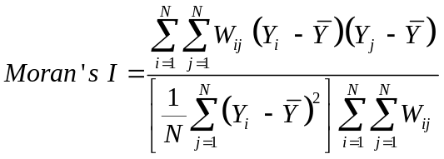 (A.1)
The value range of Moran's I is [-1, 1]. In formula (A.1), Y_{i} is the observed value of the variable in the i-th city, and 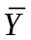 is the mean value of all observed values. W represents the spatial weight matrix.
The local spatial autocorrelation analysis mainly focuses on the local spatial autocorrelation through Local Indicators of Spatial Association (LISA). The commonly used analysis methods of LISA are local Moran's I and Moran scatter plot. The local Moran's I of the i-th sample city can be calculated by the following formula:
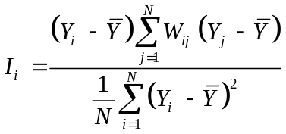 (A.2)

Table A.6. Global Moran's I of carbon efficiency progress (CE) index, 2004–2022
Year | 2004 | 2005 | 2006 | 2007 | 2008 | 2009 | 2010 | 2011 | 2012 | 2013 | 2014 | 2015 | 2016 | 2017 | 2018 | 2019 | 2020 | 2021 | 2022
I | 0.047 | 0.038 | 0.047 | 0.048 | 0.048 | 0.048 | 0.048 | 0.048 | 0.049 | 0.049 | 0.045 | 0.038 | 0.036 | 0.035 | 0.038 | 0.053 | 0.055 | 0.055 | 0.064
Z(I) | 8.051 | 6.611 | 7.979 | 8.174 | 8.056 | 8.123 | 8.139 | 8.174 | 8.275 | 8.246 | 7.545 | 6.520 | 6.217 | 6.016 | 6.438 | 8.799 | 9.106 | 9.187 | 10.619
P-value | 0.000 | 0.000 | 0.000 | 0.000 | 0.000 | 0.000 | 0.000 | 0.000 | 0.000 | 0.000 | 0.000 | 0.000 | 0.000 | 0.000 | 0.000 | 0.000 | 0.000 | 0.000 | 0.000
a. 2005 b. 2013 c. 2021

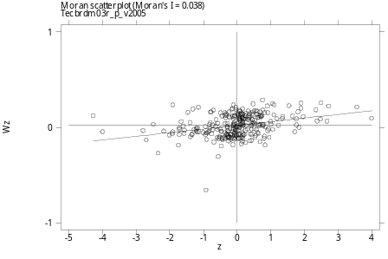 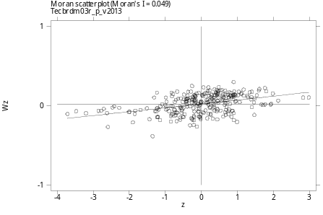 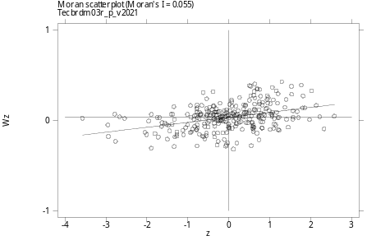
Fig. A.4. Moran scatter plots of CE index in 284 China’s cities (three typical years).
Note: The horizontal axis is the value of the standardized Z statistics, and the vertical axis value is obtained by multiplying the spatial weight matrix W by the vector of Z statistics.

Table A.7. Complete results of Spatial DID model (Model F).
 | Model F |  |  |  | Model F
Variables | Spatial-DID (SDM) | Direct Effects (Impacts on Local) | Indirect Effects (Spatial Spillovers) |  | Spatial-DID (SDM-WE) | Direct Effects (Impacts on Local) | Indirect Effects (Spatial Spillovers)
TAXREF | 0.026*** | 0.031*** | 0.317*** |  | 0.04*** | 0.040*** | 0.427***
 | (2.94) | (3.443) | (2.900) |  | (5.933) | (5.851) | (3.705)
YCP | 0.301*** | 0.294*** | -0.397*** |  | 0.271*** | 0.272*** | -0.030
 | (23.649) | (23.385) | (-2.814) |  | (24.199) | (24.259) | (-0.171)
POPUD | 0.021* | 0.012 | -1.214*** |  | 0.014 | 0.013 | 0.245
 | (1.744) | (0.962) | (-3.219) |  | (1.127) | (1.125) | (1.522)
RDEXP | 0.05*** | 0.053*** | 0.429** |  | 0.052*** | 0.051*** | 0.084
 | (5.523) | (5.086) | (2.209) |  | (5.598) | (5.839) | (0.646)
ROAD | -0.055*** | -0.056*** | -0.639*** |  | -0.059*** | -0.058*** | 0.282***
 | (-6.858) | (-8.837) | (-3.554) |  | (-7.209) | (-7.413) | (2.795)
INVMPF | 0.008*** | 0.008*** | -0.134 |  | 0.009*** | 0.009*** | 0.136***
 | (3.769) | (3.658) | (-1.638) |  | (4.124) | (3.951) | (4.439)
W×TAXREF | 0.0513* | - | - |  | 0.3544*** | - | -
 | (1.664) | - | - |  | (3.909) | - | -
W×YCP | -0.333*** | - | - |  | -0.06 | - | -
 | (-8.9) | - | - |  | (-0.426) | - | -
W×POPUD | -0.309*** | - | - |  | 0.212 | - | -
 | (-3.106) | - | - |  | (1.485) | - | -
W×RDEXP | 0.069 | - | - |  | 0.069 | - | -
 | (1.38) | - | - |  | (0.588) | - | -
W×ROAD | -0.121** | - | - |  | 0.252*** | - | -
 | (-2.063) | - | - |  | (2.97) | - | -
W×INVMPF | -0.039** | - | - |  | 0.115*** | - | -
 | (-2.271) | - | - |  | (4.935) | - | -
W×CE | 0.761*** | - | - |  | 0.134* | - | -
 | (24.711) | - | - |  | (1.841) | - | -
 |  | - | - |  |  | - | -
Observations | 5396 | - | - |  | 5396 | - | -
Number of cities | 284 | - | - |  | 284 | - | -
R² | 0.802 | - | - |  | 0.796 | - | -
Log likelihood | 4029.380 | - | - |  | 3919.229 | - | -
Wald spatial lag test | 100.223*** | - | - |  | 57.851*** | - | -
LR spatial lag test | 101.248*** | - | - |  | 79.440*** | - | -
Wald spatial error test | 30.151*** | - | - |  | 60.740*** | - | -
LR spatial error test | 31.140*** | - | - |  | 61.836*** | - | -
Note: T-statistics in parentheses. Coefficients marked with ∗∗∗, ∗∗, and ∗ are significant at the 1%, 5%, and 10% level, respectively. The estimated results and direct and indirect effect calculations in this table are obtained using the script provided by Elhorst (2012). Readers should note that this table's direct and indirect effects have different meanings from the concepts of the same name in the mediating effect analysis (Wen & Ye, 2014).

A4. Mediating effect analysis
Table A.8. Complete results of mediating effect analysis.
 |  | Innovation Effect (per Capita Green Invention Patent) |  |  | Innovation Effect (per Capita Green Utility Model Patent) |  |  | Industrial Agglomeration Effect |  |  |  | Synergistic Emission Reduction Effect
 | Model C
Variables | Benchmark Regression (TWFE) | Stage 1, Dep. Var.: GPAT | Stage 2, Dep. Var.:  CE |  | Stage 1, Dep. Var.: GUPAT | Stage 2, Dep. Var.:  CE |  | Stage 1, Dep. Var.: INDAGG | Stage 2, Dep. Var.:  CE |  | Stage 1, Dep. Var.:  CO2PY | Stage 2, Dep. Var.:  NOxPY | Stage3, Dep. Var.:  CE
TAXREF | 0.0395*** | - | - |  | - | - |  | - | - |  | - | - | -
(effect c) | (0.0145) | - | - |  | - | - |  | - | - |  | - | - | -
TAXREF | - | 0.229*** | - |  | 0.145*** | - |  | -0.329*** | - |  | -0.0461*** | -0.0330** | -
(effect a/a₁/a₂) | - | (0.0605) | - |  | (0.0435) | - |  | (0.0637) | - |  | (0.00829) | (0.0157) | -
TAXREF | - | - | 0.0329** |  | - | 0.0390*** |  | - | 0.0370** |  | - | - | 0.0219
(effect c') | - | - | (0.0147) |  | - | (0.0145) |  | - | (0.0145) |  | - | - | (0.0136)
YCP | 0.272*** | 0.283** | 0.263*** |  | 0.512*** | 0.270*** |  | 0.162 | 0.273*** |  | -0.775*** | -0.692*** | -0.0409
 | (0.0307) | (0.117) | (0.0305) |  | (0.0942) | (0.0310) |  | (0.129) | (0.0304) |  | (0.0259) | (0.0388) | (0.0504)
POPUD | 0.0155 | -0.181 | 0.0208 |  | -0.0629 | 0.0158 |  | -0.130 | 0.0145 |  | -0.0314 | -0.0714** | -0.00225
 | (0.0326) | (0.116) | (0.0323) |  | (0.0858) | (0.0326) |  | (0.123) | (0.0323) |  | (0.0212) | (0.0359) | (0.0296)
RDEXP | 0.0568*** | 0.178* | 0.0517*** |  | -0.00429 | 0.0568*** |  | 0.0584 | 0.0573*** |  | -0.0793*** | -0.0773** | 0.0241
 | (0.0186) | (0.100) | (0.0178) |  | (0.0706) | (0.0186) |  | (0.0842) | (0.0185) |  | (0.0148) | (0.0329) | (0.0175)
ROAD | -0.0629*** | -0.153** | -0.0585** |  | 0.0403 | -0.0631*** |  | 0.0387 | -0.0626*** |  | 0.0303** | 0.0174 | -0.0519**
 | (0.0241) | (0.0758) | (0.0236) |  | (0.0580) | (0.0241) |  | (0.0873) | (0.0239) |  | (0.0136) | (0.0229) | (0.0236)
INVMPF | 0.00792* | -0.00989 | 0.00821** |  | -0.00217 | 0.00793* |  | 0.00849 | 0.00799** |  | -0.00109 | 0.00165 | 0.00779**
 | (0.00404) | (0.0184) | (0.00396) |  | (0.0142) | (0.00403) |  | (0.0203) | (0.00402) |  | (0.00328) | (0.00496) | (0.00375)
GPAT | - | - | 0.0291*** |  | - | - |  | - | - |  | - | - | -
(effect b) | - | - | (0.00630) |  | - | - |  | - | - |  | - | - | -
GUPAT | - | - | - |  | - | 0.00376 |  | - | - |  | - | - | -
(effect b) | - | - | - |  | - | (0.00717) |  | - | - |  | - | - | -
INDAGG | - | - | - |  | - | - |  | - | -0.00775** |  | - | - | -
(effect b) | - | - | - |  | - | - |  | - | (0.00310) |  | - | - | -
CO2PY | - | - | - |  | - | - |  | - | - |  | - | - | -0.298***
(effect b₁) | - | - | - |  | - | - |  | - | - |  | - | - | (0.0504)
NOxPY | - | - | - |  | - | - |  | - | - |  | - | - | -0.118***
(effect b₂) | - | - | - |  | - | - |  | - | - |  | - | - | (0.0309)
Indirect Effect (a×b, | - | - | 0.00667*** |  | - | 0.000546 |  | - | 0.00255*** |  | - | - | -
GPAT, GUPAT or INDAGG, Bootstrap) | - | - | (0.00125) |  | - | (0.000588) |  | - | (0.000747) |  | - | - | -
Indirect Effect (a₁×b₁, | - | - | - |  | - | - |  | - | - |  | - | - | 0.0137***
CO2PY, Bootstrap) | - | - | - |  | - | - |  | - | - |  | - | - | (0.00167)
Indirect Effect (a₂×b₂, | - | - | - |  | - | - |  | - | - |  | - | - | 0.00390***
NOxPY, Bootstrap) | - | - | - |  | - | - |  | - | - |  | - | - | (0.00102)
Total Indirect Effect | - | - | - |  | - | - |  | - | - |  | - | - | 0.0176***
(a₁×b₁+a₂×b₂, Bootstrap) | - | - | - |  | - | - |  | - | - |  | - | - | (0.00208)
Direct Effect | - | - | 0.0329*** |  | - | 0.0390*** |  | - | 0.0370*** |  | - | - | 0.0219***
(effect c', Bootstrap) | - | - | (0.00761) |  | - | (0.00713) |  | - | (0.00737) |  | - | - | (0.00722)
Constant | -2.833*** | -16.12*** | -2.364*** |  | -17.45*** | -2.768*** |  | -3.109* | -2.857*** |  | 7.809*** | -1.517*** | -0.685
 | (0.468) | (1.809) | (0.472) |  | (1.384) | (0.477) |  | (1.681) | (0.466) |  | (0.347) | (0.478) | (0.580)
Observations | 5,396 | 5,396 | 5,396 |  | 5,396 | 5,396 |  | 5,396 | 5,396 |  | 5,396 | 5,396 | 5,396
Number of cities | 284 | 284 | 284 |  | 284 | 284 |  | 284 | 284 |  | 284 | 284 | 284
R² | 0.173 | 0.726 | 0.189 |  | 0.872 | 0.173 |  | 0.142 | 0.175 |  | 0.911 | 0.921 | 0.239
Individual fixed effect | Yes | Yes | Yes |  | Yes | Yes |  | Yes | Yes |  | Yes | Yes | Yes
Time fixed effect | Yes | Yes | Yes |  | Yes | Yes |  | Yes | Yes |  | Yes | Yes | Yes
Note: Robust standard errors clustered at the cross-sectional individual unit (city) level are marked in parentheses. *, **, and *** denote significance at 10%, 5%, and 1% levels, respectively. Readers should note that this table's direct and indirect effects have different meanings from the concepts of the same name in the spatial econometric analysis (Wen & Ye, 2014).

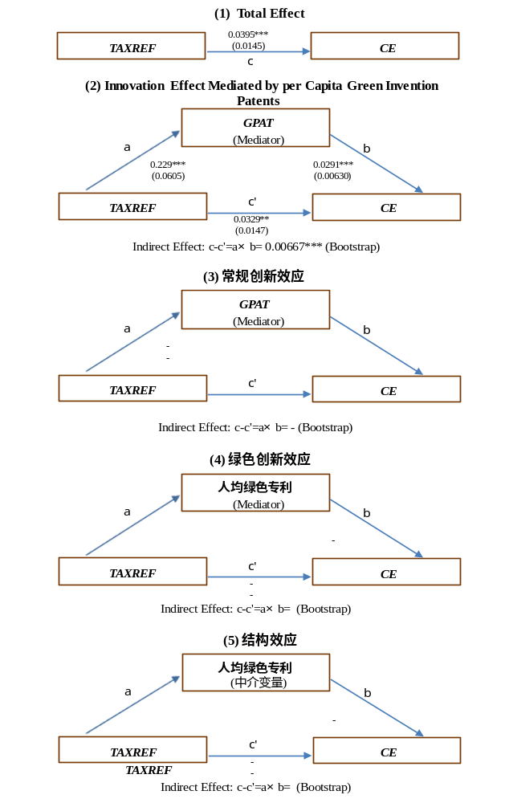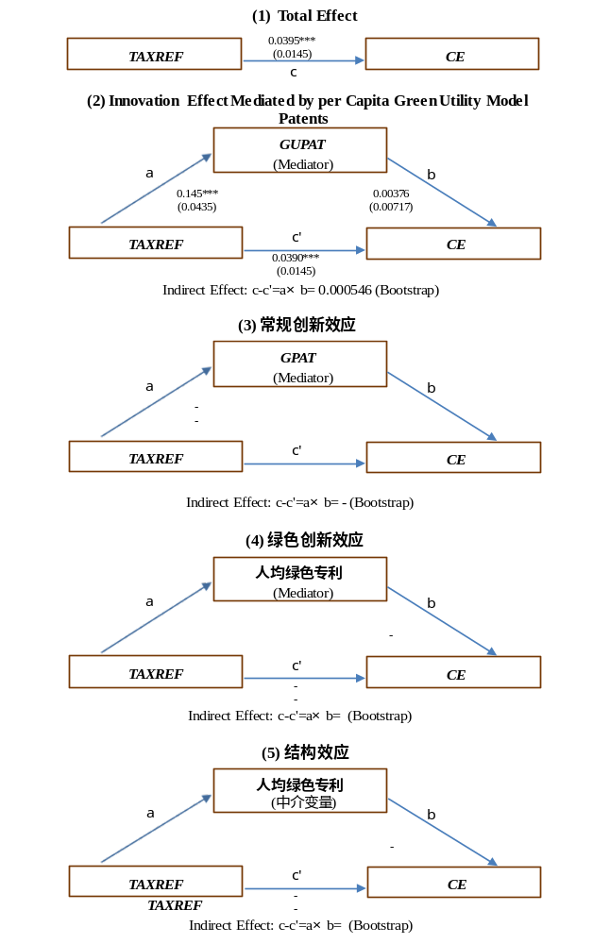
Fig. A.5. Comparison of innovation effects: The effect mediated by green invention patents (left) and the effect mediated by green utility model patents (right).

A5 Setting and Solving of RDM
A5.1 Basic RDM
The RDM developed by Portela et al. (2004) was inspired by the well-known directional distance function (DDF) of Chambers et al. (1998). To construct a distance function based on RDM, firstly, set the factor inputs (with the total number K) used by n cities (regarded as decision-making units, DMUs) be x=(x₁, x₂..., x_{K})∈R+ K, and set the expected output of cities (with the total number M) be y=(y₁, y₂..., y_{M})∈R+ M. Simultaneously, the cities also produce the unexpected outputs b=(b₁, b₂..., b_{I})∈R+ I (bad outputs, with the total number I). The production possibility set in period t is:
(A.7)
The current distance function (Färe & Grosskopf, 2000) is defined as：
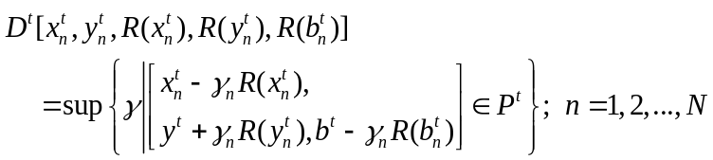 (A.7)
In the above formula, 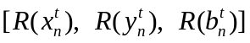 is defined as the possible improvement range of DMUn in period t (Portela & Thanassoulis, 2010), which is specifically defined as:
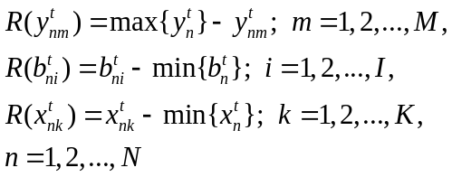 (A.7)
In the DRM, the value of 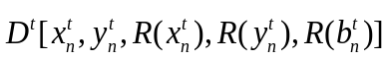 can be obtained by solving the following linear programming problem (Portela et al., 2004):
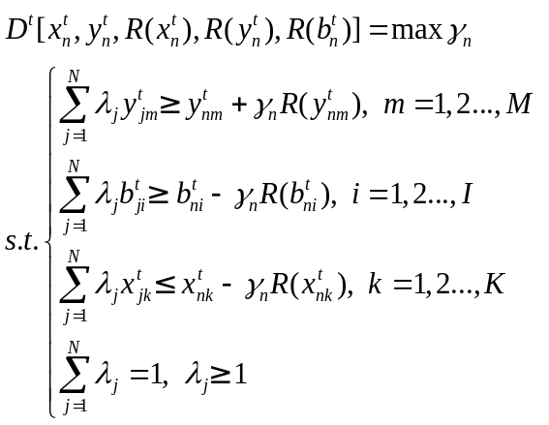 (A.6)
A5.2 Expand RDM to global form
This paper uses a global index, so we first need to take the union of the production possibility sets of all periods to obtain the global frontier first:
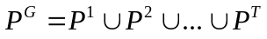.
According to Portela et al. (2004) and Oh (2010), the global direction distance function can be defined as:
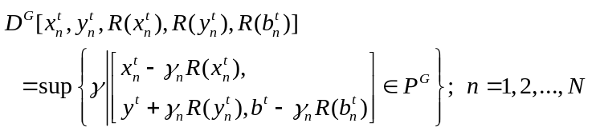 (A.7)
Referring to Portela et al. (2004) and Oh (2010), the value of 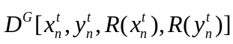 can be obtained by solving the following linear programming problem:
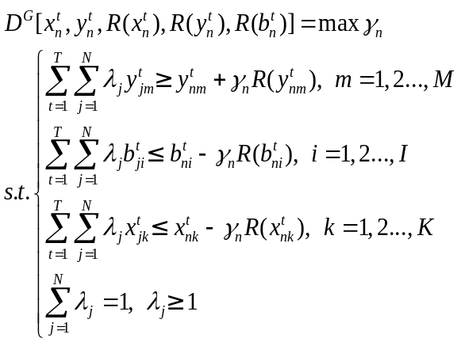 (A.8)

If the linear programming solutions based on formula (A.7) and (A.9) are 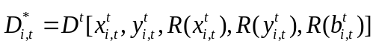 and 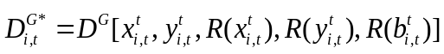, the Global Malmquist-Luenberger (GML) index (Oh, 2010) of carbon efficiency (CE) from period t to period t+1 can be constructed as follows:
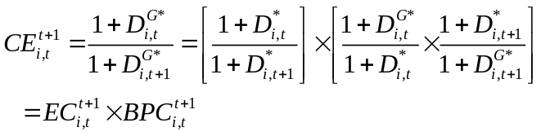 (A.9)

Following the National Bureau of Statistics of China, the eastern region contains provinces (or province-level municipalities) including Beijing, Tianjin, Hebei, Liaoning, Shanghai, Jiangsu, Zhejiang, Fujian, Shandong, Guangdong, and Hainan.
This variable encompasses the key regions identified in China’s successive national air-pollution prevention plans: The Action Plan for Air Pollution Prevention and Control (September 2013) and the Three-Year Action Plan for Winning the Blue-Sky Defense War (July 2018). These regions include the Beijing–Tianjin–Hebei corridor, the Yangtze River Delta, the Fen-Wei Plain, the Pearl River Delta, Shanxi province, Henan province, and others.
The pilot scheme for low-carbon cities (LCC) is implemented by the National Development and Reform Commission of China, and the list of pilot cities was released in batches in 2010, 2012, and 2017.

