Supplementary Material
Association Between Repeated Pringle Clamping Cycles and Postoperative Acute Kidney Injury After Liver Resection

Supplementary Table S1 Propensity-score balance before and after matching
Covariate | Absolute SMD before matching | Absolute SMD after matching
Age | 0.150 | 0.027
Sex | 0.214 | 0.020
Body mass index | 0.187 | 0.039
Chronic kidney disease | 0.127 | 0.076
Diabetes mellitus | 0.187 | 0.069
Arterial hypertension | 0.043 | 0.056
Open approach | 0.063 | 0.065
Major hepatectomy | 0.605 | 0.039
Operative duration | 0.792 | 0.019
Blood transfusion | 0.434 | 0.026
Minimum MAP | 0.337 | 0.048

Matching compared patients with at least two cycles with patients without a Pringle maneuver. One-to-one nearest-neighbour matching without replacement used a caliper of 0.2 standard deviations of the logit of the propensity score and generated 106 pairs. All post-matching absolute standardized mean differences were below 0.10.

Supplementary Table S2 Sensitivity analyses for acute kidney injury
Analysis | Odds ratio | 95% confidence interval | P value
Primary multivariable model | 1.87 | 1.07–3.30 | 0.029
Firth bias-reduced regression | 2.11 | 1.12–3.13 | 0.028
Propensity-score matched analysis | 1.88 | 1.01–3.50 | 0.046
Total ischemia duration, per minute* | 1.01 | 0.99–1.02 | 0.082

*Estimated in a separate adjusted model. The first three rows evaluate at least two cycles versus no Pringle maneuver. The Firth model used the same covariates as the primary model.

Supplementary Table S3 Post-hepatectomy liver failure
Group | Patients with PHLF, n (%) | P value
No AKI (n=322) | 8 (2.5%)
AKI (n=107) | 23 (21.5%) | <0.001
AKI stage 1 (n=61) | 7 (11.5%)
AKI stages 2–3 (n=46) | 16 (34.8%) | <0.001
No Pringle maneuver (n=154) | 11 (7.1%)
One cycle (n=45) | 0 (0.0%)
At least two cycles (n=230) | 20 (8.7%) | 0.120

Supplementary Table S4 Renal replacement therapy during the index hospitalization
AKI stage during postoperative days 0–7 | Patients, n | RRT, n (%)
No AKI | 322 | 3 (0.9%)
Stage 1 | 61 | 4 (6.6%)
Stages 2–3 | 46 | 13 (28.3%)
Total | 429 | 20 (4.7%)

RRT was captured throughout the index hospitalization. The three patients classified as no AKI and four classified as stage 1 initiated RRT after the postoperative day 0–7 AKI ascertainment window.

Supplementary Table S5 Length of hospital stay
AKI stage | Patients, n | Median (IQR), days | Mean ± SD, days
No AKI | 321* | 9.0 (6.0–15.0) | 12.5 ± 10.7
Stage 1 | 61 | 16.0 (9.0–26.0) | 19.7 ± 15.0
Stages 2–3 | 46 | 19.0 (13.0–26.0) | 22.5 ± 14.7

*Length of stay was unavailable for one patient without AKI.

Supplementary Table S6 Exploratory model for post-hepatectomy liver failure
Variable | Odds ratio | 95% confidence interval | P value
Open surgery | 10.96 | 1.46–82.27 | 0.020
Major resection | 4.62 | 1.35–15.77 | 0.015
Any Pringle maneuver | 0.85 | 0.38–1.87 | 0.678

Only 31 PHLF events occurred, and no patient in the one-cycle group developed PHLF. The estimates are exploratory and imprecise.

Supplementary Table S7 In-hospital mortality according to acute kidney injury
Group | In-hospital mortality, n (%) | P value
No AKI (n=322) | 7 (2.2%)
Any AKI (n=107) | 26 (24.3%) | <0.001
Stage 1 AKI (n=61) | 8 (13.1%)
Stages 2–3 AKI (n=46) | 18 (39.1%) | <0.001

Supplementary Table S8 Crude absolute risk of acute kidney injury
Pringle exposure | Patients, n | AKI events, n | Absolute risk | Risk difference vs no maneuver
No Pringle maneuver | 154 | 29 | 18.8% | Reference
One cycle | 45 | 12 | 26.7% | 7.8 percentage points
At least two cycles | 230 | 66 | 28.7% | 9.9 percentage points

Risk differences are unadjusted descriptive measures and should not be interpreted causally.

Supplementary Figure S1 Covariate balance before and after propensity-score matching
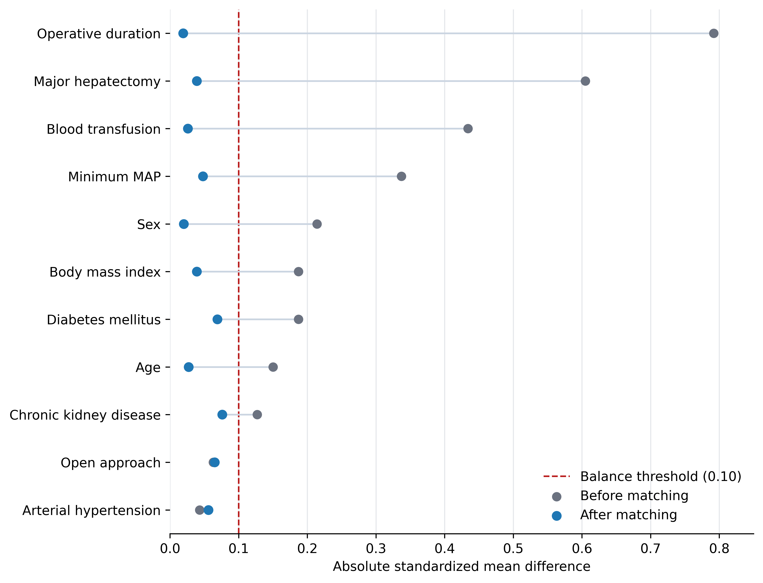
Absolute standardized mean differences before and after 1:1 matching. The dashed line marks the prespecified balance threshold of 0.10.
Supplementary Table S9 Exploratory complete-case model including fluid administration and CVP
Predictor | Odds ratio | 95% confidence interval | P value
One cycle vs no Pringle | 1.19 | 0.42–3.37 | 0.738
At least two cycles vs no Pringle | 1.84 | 1.01–3.35 | 0.046
Age, per year | 1.03 | 1.00–1.05 | 0.041
Arterial hypertension | 2.44 | 1.37–4.34 | 0.002
Chronic kidney disease | 1.90 | 0.87–4.14 | 0.105
Major hepatectomy | 0.94 | 0.51–1.73 | 0.834
Open surgery | 8.72 | 3.47–21.90 | <0.001
Operative duration, per minute | 1.00 | 0.994–1.003 | 0.514
Minimum MAP, per mmHg | 0.98 | 0.95–1.01 | 0.117
Administered fluid volume, per 1000 mL | 1.01 | 0.85–1.20 | 0.899
Red blood cell units | 1.00 | 0.73–1.38 | 1.000
Fresh frozen plasma units | 1.02 | 0.78–1.33 | 0.909
Albumin, recorded units | 0.97 | 0.68–1.39 | 0.877
CVP during resection, per mmHg | 1.02 | 0.93–1.12 | 0.641
CVP at end of surgery, per mmHg | 1.02 | 0.93–1.11 | 0.737
Post hoc logistic regression in 381 of 429 patients: 103 with AKI and 278 without AKI. Forty-eight had at least one missing predictor (four with AKI). Administered volume is not net fluid balance. Red blood cell units replaced the binary transfusion indicator. Duration was not entered alongside cycle number. In-sample AUC: 0.784. Volume OR is per 1000 mL; other estimates are rounded. This model does not replace the primary analysis or propensity matching.

