Table of Contents
- Figures S1-6
- Tables S1-3
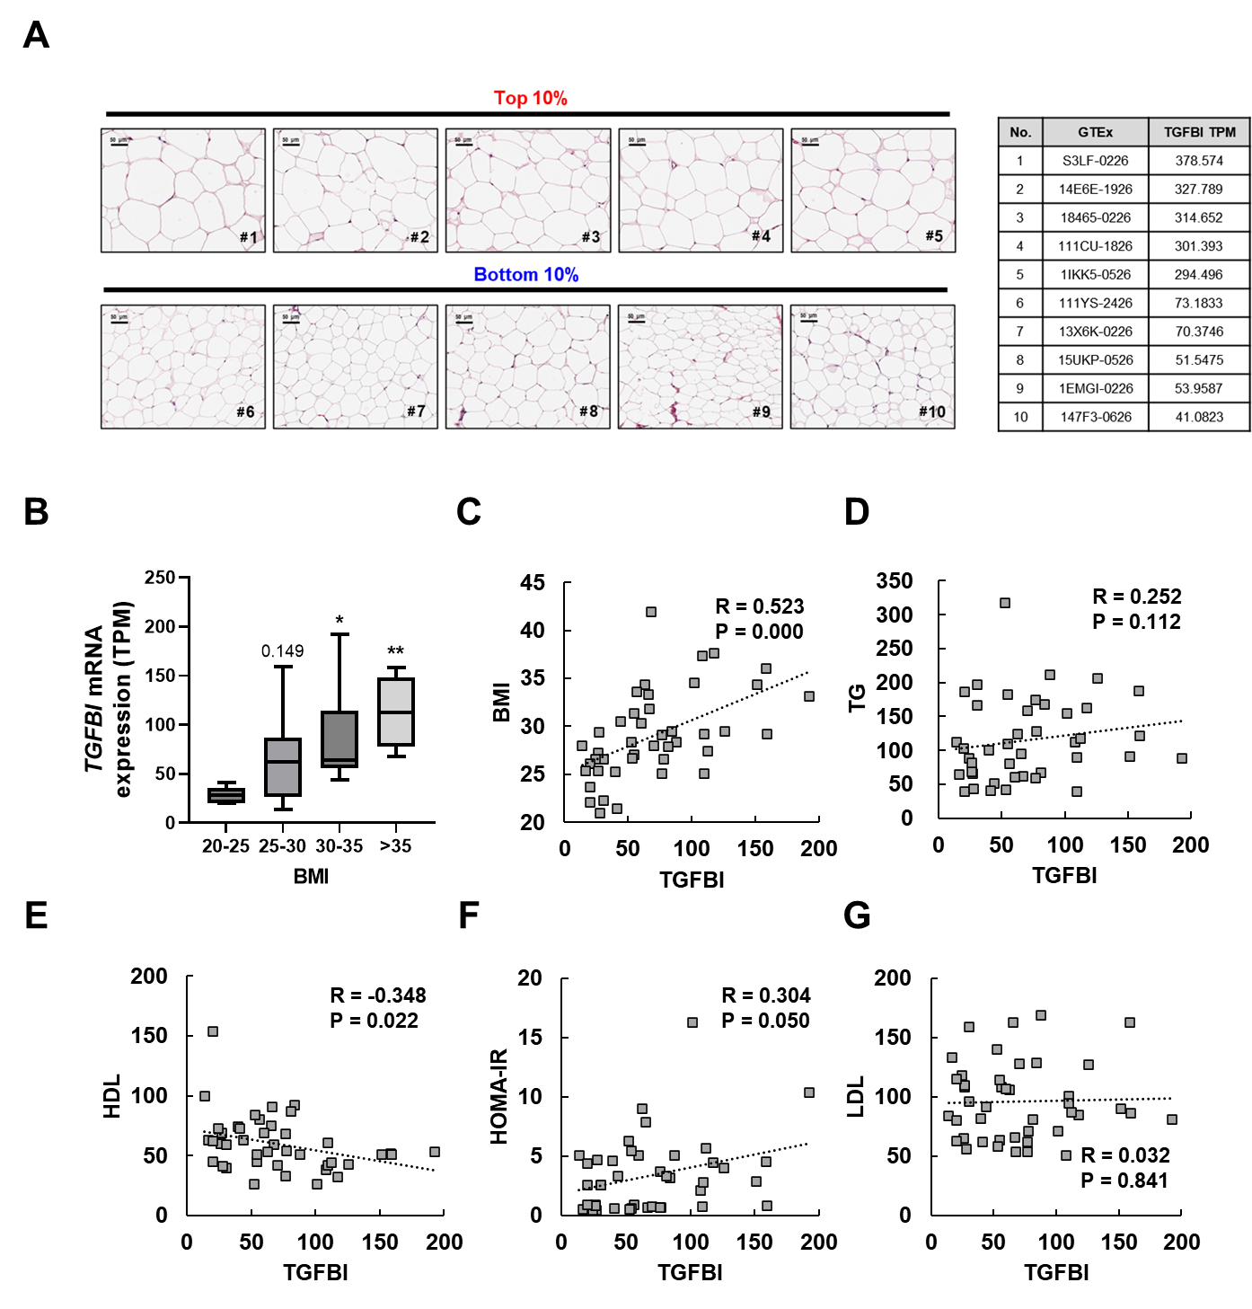
Fig S1. Public dataset analysis supports an association between TGFBI expression and obesity. (A) Representative H&E-stained scWAT images from subjects in the top and bottom TGFBI expression deciles (left, scale bars = 50 μm). GTEx ID and TGFBI TPM values (right). (B) Box plot showing TGFBI mRNA expression (TPM) in scWAT across four BMI categories: 20–25, 25–30, 30–35, and >35. Boxes indicate the interquartile range, with the central horizontal line representing the median, and whiskers denote the minimum and maximum values. Statistical significance is denoted using asterisks: * p < 0.05, and ** p < 0.01. (C–G) Graphs showing the correlations between TGFBI mRNA expression in scWAT and BMI, TG, HDL, HOMA-IR, and LDL. Each point in the graph represents an individual subject.

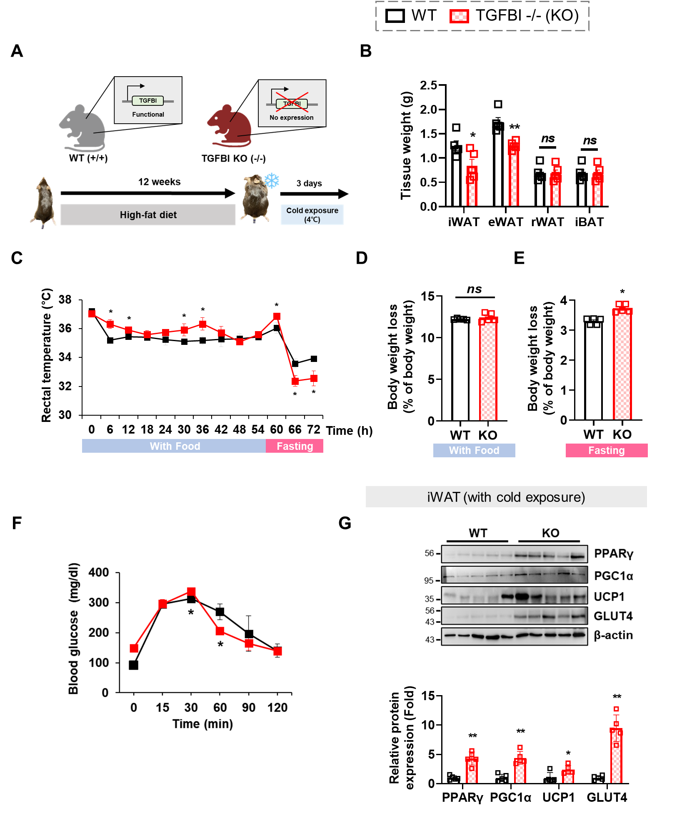
Fig. S2. TGFBI deficiency increases adipose tissue browning during cold exposure. (A) The experimental design: WT and TGFBI KO mice were fed an HFD for 12 weeks and then exposed to cold for 3 days (n = 5). (B) The tissue weights of four adipose tissue types, iWAT, eWAT, rWAT, and BAT, after cold exposure. (C) Rectal temperatures during cold exposure. (D–E) Body weight loss during cold exposure with food available (D) and while fasting (E). (F) Blood glucose levels during the intraperitoneal glucose tolerance test. (G) Western blot bands and quantified band intensities for browning-related proteins (PGC1α, UCP1, PRDM16, and PPARγ) and GLUT4 in iWAT after cold exposure. All data are represented as means ± SEM, and statistical significance is denoted using asterisks: * p < 0.05, and ** p < 0.01.

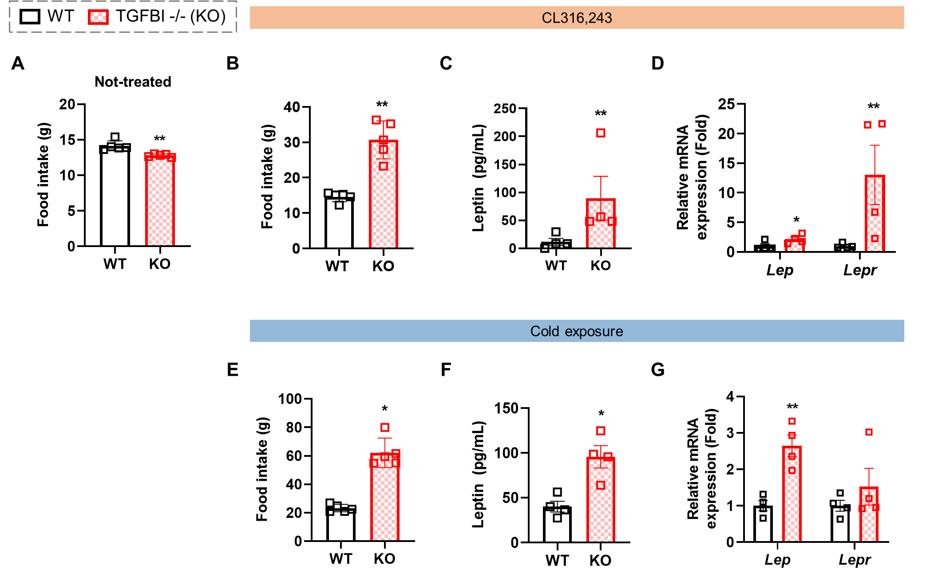
Fig. S3. Under β3-AR activation, TGFBI deficiency regulates food intake and leptin levels in adipose tissue. (A, B) The food intake of obese WT and KO mice at basal levels (A, n = 5) and after CL316,243 treatment (B, n = 5). (C) Serum leptin levels in obese WT and KO mice after CL316,243 treatment (n = 4). (D) Lep and Lepr mRNA expression in the iWAT of obese WT and KO mice after CL316,243 treatment (n = 4). (E, F) The food intake (E; n = 5) and serum leptin levels (F; n = 4) in obese WT and KO mice after cold exposure (n=5). (G) Relative Lep and Lepr mRNA expression in the iWAT of obese WT and KO mice after cold exposure (n = 4). Lep and Lepr mRNA expression was normalized based on β-actin expression. All data are presented as means ± the SEM, and statistical significance is denoted using asterisks: * p < 0.05, and ** p < 0.01.

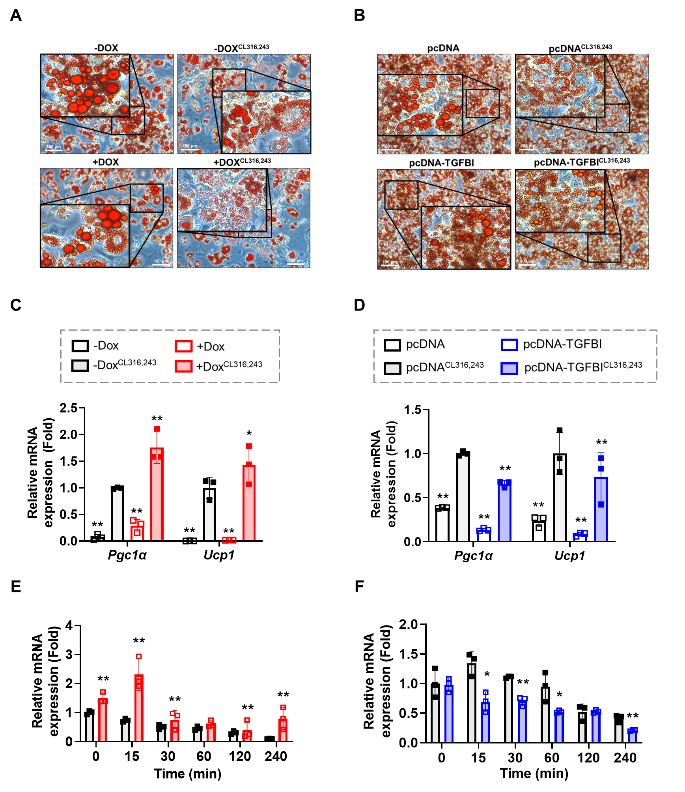
Fig. S4. TGFBI regulation modulates browning-related phenotypic and transcriptional changes. (A, B) Changes in Oil Red O-stained droplets in the Dox-inducible TGFBI KD 3T3-L1 (A) and TGFBI OE 3T3-L1 (B) adipocyte models (scale bars = 100 μm). (C, D) The mRNA expression of adipose browning-related genes Ucp1 and Pgc1α in the Dox-inducible TGFBI KD (C) and transient TGFBI OE (D) models. (E) Time-dependent changes in Adrb3 mRNA expression during CL316,243 treatment in TGFBI KD 3T3-L1 adipocytes. (F) Time-dependent changes in Adrb3 mRNA expression during CL316,243 treatment in TGFBI KD 3T3-L1 adipocytes. All data are represented as means ± SDs, and statistical significance is denoted using asterisks: * p < 0.05, ** p < 0.01.

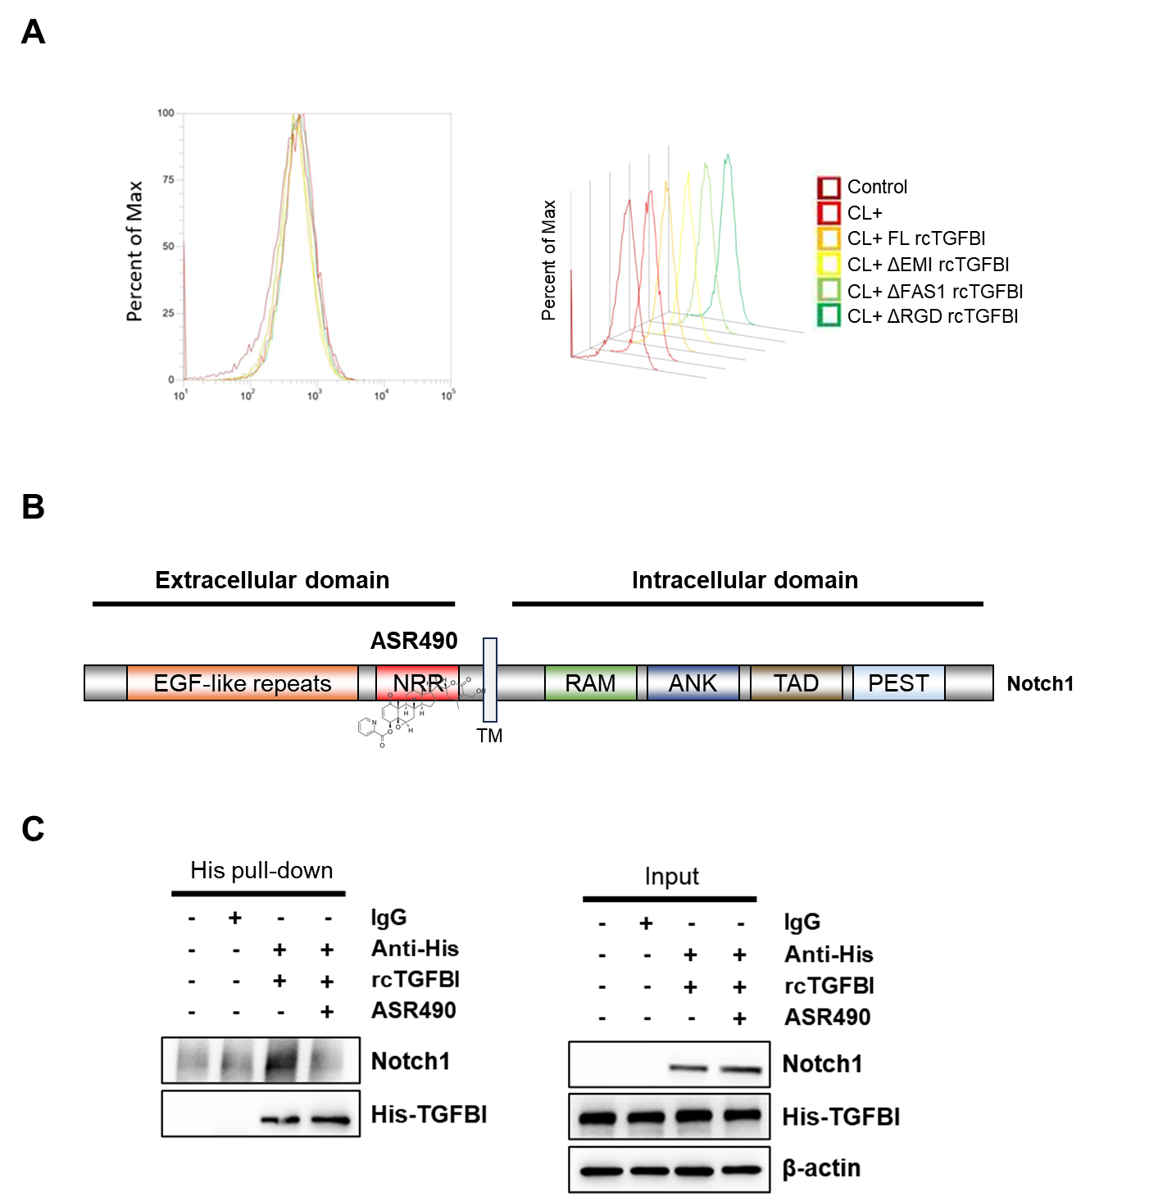

Fig. S5. TGFBI may interact with the NRR region of Notch1. (A) Overlaid flow cytometry histograms showing fluorescence intensities in control cells, CL-treated cells, and CL-treated cells supplemented with FL or domain-deleted recombinant TGFBI proteins lacking EMI, FAS, or RGD. (B) A schematic diagram showing the structural domains of Notch1 and the binding site of ASR490 within the Notch1 extracellular region. (C) His pull-down assay results showing the binding between His-tagged TGFBI and Notch1 with or without the presence of ASR490. IgG was used as a negative control to confirm binding specificity, and input lysates were included to verify the presence of total TGFBI and Notch1 protein.
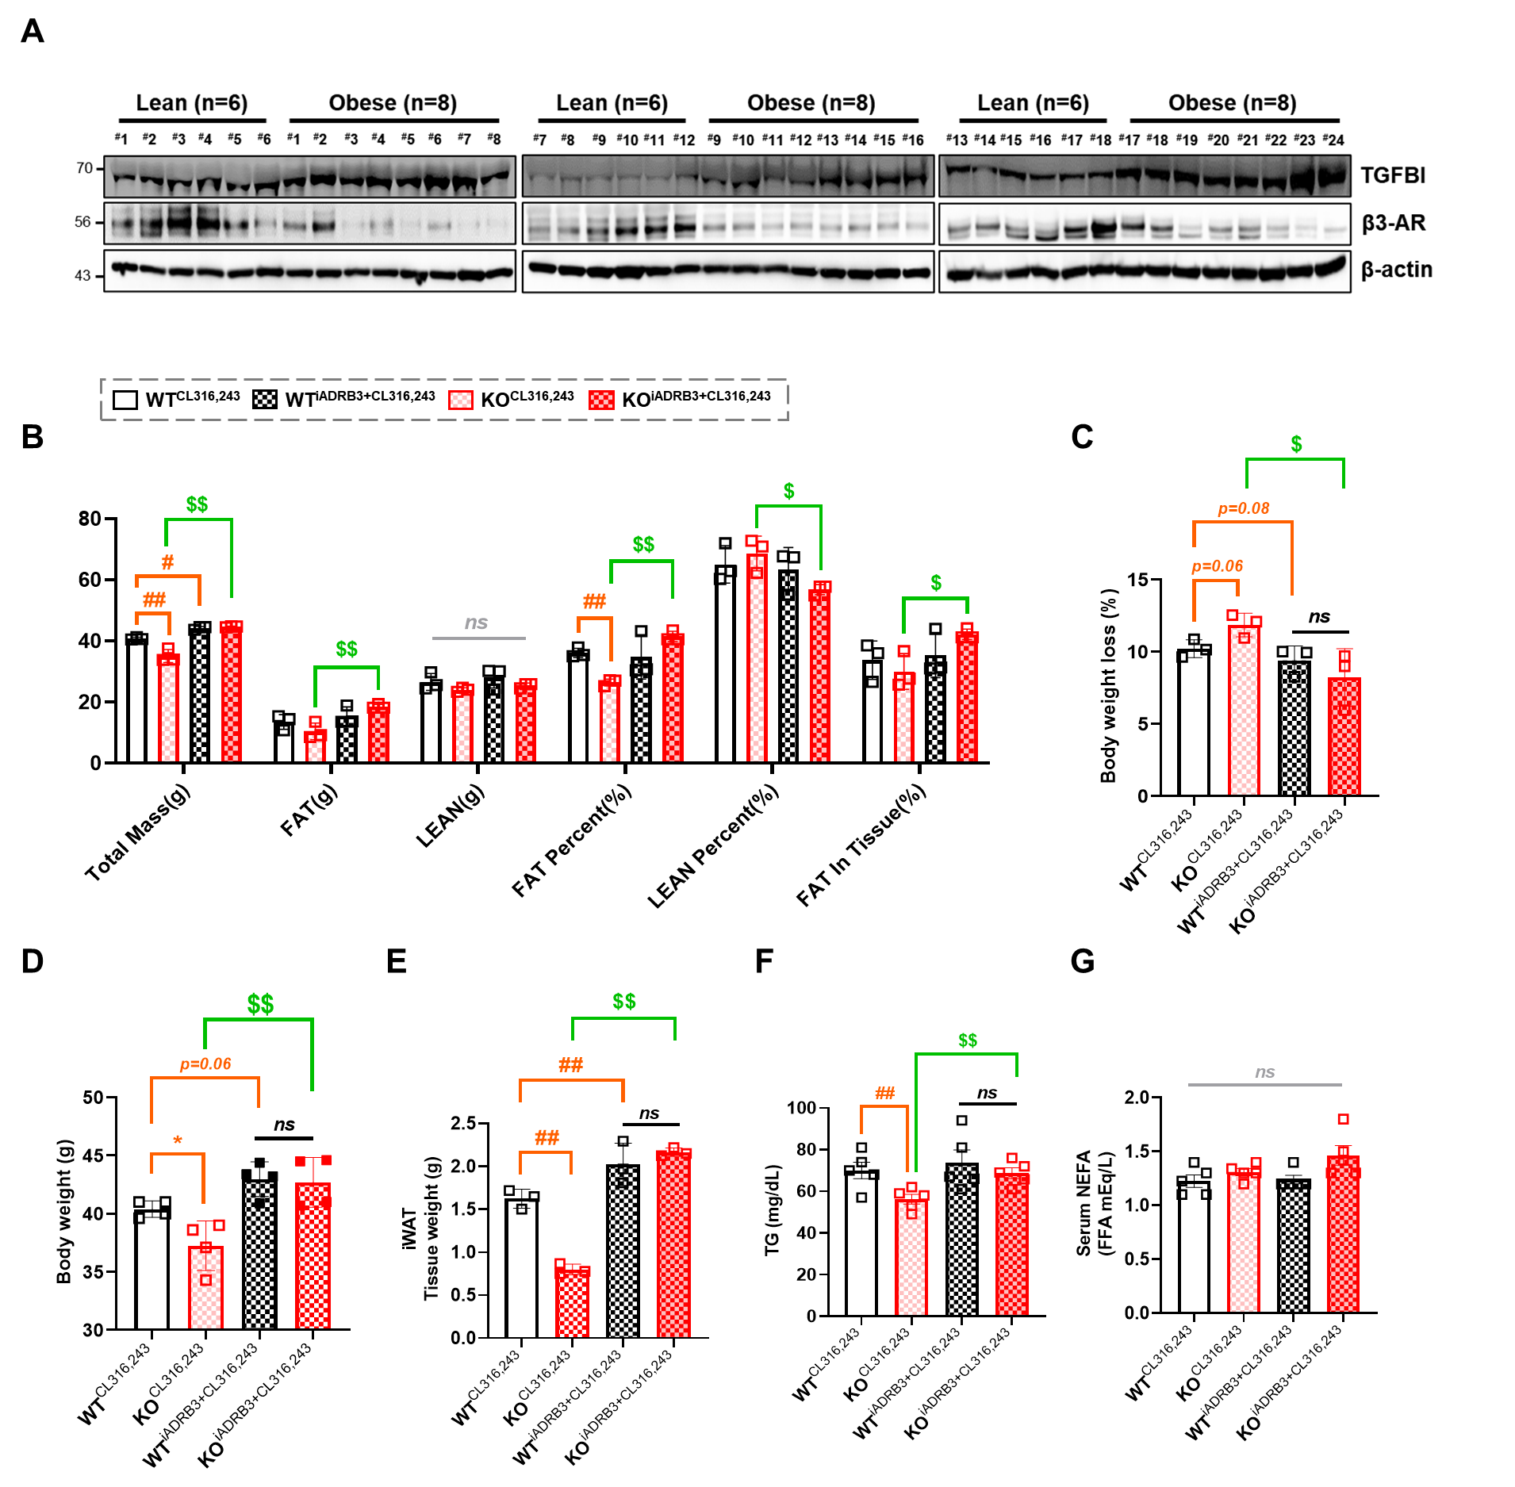
Fig. S6. β3-AR inhibition attenuates CL316,243-induced anti-obesity effects in TGFBI KO mice. (A) Western blot bands for TGFBI and β3-AR in the iWAT of 18 ND-fed mice and 24 HFD-fed obese mice. (B) A graph quantifying the results of mouse dual-energy X-ray scans, including the measured values for total mass, fat mass, lean body weight, expressed in grams and as percentages relative to body weight (fat) and total fat mass (lean and tissue fat). (C–G) Body weight loss (C), body weight (D), iWAT weight (E), serum triglyceride levels (F), and serum NEFA (Non-esterified fatty acids) levels (G), measured just before sacrifice, after CL316,243 treatment or CL316,243–iADRB3 cotreatment in WT and TGFBI KO mice. All data are presented as means ± the SEM. Orange # symbols and lines denote comparisons with WT^{CL316,243} as the control group: # p < 0.05, and ## p < 0.01. Green $ symbols and lines denote comparisons between KO^{CL316,243} and KO^{iADRB3+CL316,243}: $ p < 0.05, and $$ p < 0.01. The black “ns” indicates no significant difference between WT^{iADRB3+CL316,243} and KO^{iADRB3+CL316,243}. The gray “ns” denotes no significant differences among the four groups.

Table S1. Western blot (WB) antibodies used in this study
Genes | Company | Product No. | Dilution
PPARγ | Santa Cruz Biotechnology | SC-7273 | 1:500
C/EBPα | Cell Signaling Technology | 2295S | 1:1000
PGC1α | Abcam | ab72230 | 1:1000
UCP1 | Cell Signaling Technology | 72298S | 1:1000
PRDM16 | Cell Signaling Technology | 16212S | 1:1000
TGFBI | Abcam | ab170874 | 1:1000
NICD | Cell Signaling Technology | 4147T | 1:1000
HES1 | Cell Signaling Technology | 11988S | 1:1000
Notch1 | Cell Signaling Technology | 3608S | 1:1000
Lamin B1 | Abcam | ab16048 | 1:1000
β-tubulin | Abcam | ab179513 | 1:1000
β3-AR | Santa Cruz Biotechnology | SC-515763 | 1:500
p-PKA substrates | Cell Signaling Technology | 9624S | 1:1000
β-actin | Santa Cruz Biotechnology | SC-47778 | 1:500
His-Tag | Santa Cruz Biotechnology | SC-8036 | 1:100 (Co-IP) 1:1000 (WB)

Table S2. Custom-designed RT-qPCR primers used in this study.
Genes | Sequence
Pgc1α | Forward | CCCTGCCATTGTTAAGACC
Pgc1α | Reverse | TGCTGCTGTTCCTGTTTTC
Ucp1 | Forward | CTGCCAGGACAGTACCCAAG
Ucp1 | Reverse | TCAGCTGTTCAAAGCACACA
Pparγ | Forward | TTTTCAAGGGTGCCAGTTTC
Pparγ | Reverse | AATCCTTGGCCCTCTGAGAT
C/ebpα | Forward | TTACAACAGGCCAGGTTTCC
C/ebpα | Reverse | GGCTGGCGACATACAGATCA
Adrb3 | Forward | CCTTCAACCCGGTCATCTACTG
Adrb3 | Reverse | CGCACCTTCATAGCCATCAAA
Tgfbi | Forward | GGAAGTTCACCATCTTTGC
Tgfbi | Reverse | ATGTTGACGTTGCTCACCAG
Prdm16 | Forward | TCCGCCACCAGATGTCTCA
Prdm16 | Reverse | ACACCTTGACACAGTTTTCACATTC
Lep | Forward | GTGGCTTTGGTCCTATCTGTC
Lep | Reverse | CGTGTGTGAAATGTCATTGATCC
Lepr | Forward | ACCTGGCATATCCAATCTCTCC
Lepr | Reverse | TTCAAAGCCGAGGCATTGTTT
Adipoq | Forward | ACCTACGACCAGTATCAGGAAAAG
Adipoq | Reverse | ACTAAGCTGAAAGTGTGTCGACTG
Hes1 | Forward | ACACCGGACAAACCAAAGAC
Hes1 | Reverse | AATGCCGGGAGCTATCTTTC
β-actin | Forward | CGTGCGTGACATCAAAGAGAA
β-actin | Reverse | GCTCGTTGCCAATAGTGATGA

Table S3. Pathway enrichment results for differentially expressed genes in iWAT from WT and TGFBI KO mice.
Source | Term_id | GO Term Name | Gene count | -log₁₀(Padj)
GO:MF | GO:0005215 | transporter activity | 114 | 13.06981535
GO:MF | GO: 0008289 | lipid binding | 58 | 2.179404503
GO:MF | GO:0005102 | signaling receptor binding | 95 | 3.480172006
GO:MF | GO:0005509 | calcium ion binding | 66 | 7.707743929
GO:BP | GO:0055085 | transmembrane transport | 111 | 8.336204878
GO:BP | GO:0010876 | lipid localization | 47 | 6.868381336
GO:BP | GO:0008202 | steroid metabolic process | 39 | 6.776504059
GO:BP | GO:0048518 | positive regulation of biological process | 292 | 4.419075024
GO:BP | GO:0006629 | lipid metabolic process | 83 | 3.60119227
GO:BP | GO:0006631 | fatty acid metabolic process | 33 | 1.797239313
GO:BP | GO:0033559 | unsaturated fatty acid metabolic process | 33 | 3.8467951
GO:CC | GO:0098590 | plasma membrane region | 124 | 20.44177158

