Supplementary Information for: Assessment of isoprene epoxydiol reactive uptake onto acidic sulfate aerosols by real-time isomer characterization

M. Riva^{1,2,†,*}, Y. Chen^{3,†}, M. Shrivastava³, P. Mettke⁴, M. P. Frauenheim⁵, R. L. Rice⁵, B. Gaudet³, J. D. Surratt^{5,6}, M. Claflin⁷, H. Stark⁷, V. Yatsyna¹, S. Graf¹, U. Rohner¹, L. Poulain⁴, H. Herrmann⁴, S. Gerber¹, F. Lopez-Hilfiker¹, A. Gold^{5,*}, M. Z. Kamrath^{1,*}

¹ Tofwerk, 3645 Thun, Switzerland.
² Institute for Atmospheric and Earth System Research (INAR) /Physics, University of Helsinki, Helsinki, Finland.
³ Pacific Northwest National Laboratory, Richland, Washington 99354, United States.
⁴ Atmospheric Chemistry Department (ACD), Leibniz Institute for Tropospheric Research (TROPOS), Leipzig, Germany.
⁵ Department of Environmental Sciences and Engineering, Gillings School of Global Public Health, University of North Carolina at Chapel Hill, Chapel Hill, North Carolina 27599, United States.
⁶ Department of Chemistry, College of Arts and Sciences, University of North Carolina at Chapel Hill, North Carolina 27514, United States.
⁷ Aerodyne Research Inc., Billerica, Massachusetts 01821 United States.
†These authors contributed equally.
*Correspondence: matthieu.n.riva@helsinki.fi; golda@email.unc.edu; Michael.Kamrath@tofwerk.com

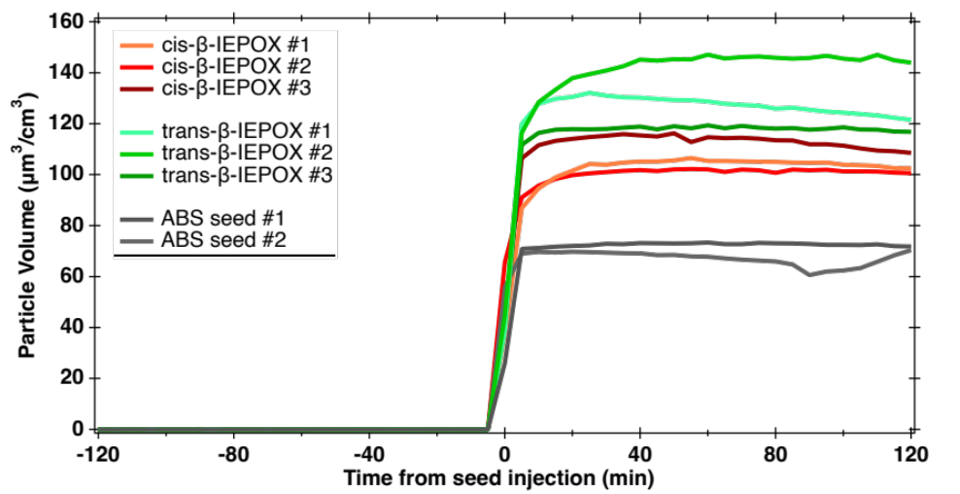

Supplementary Fig. 1. Particle volume concentration measured by the SMPS during the different experiments with and without the addition of either cis- or trans-β-IEPOX.

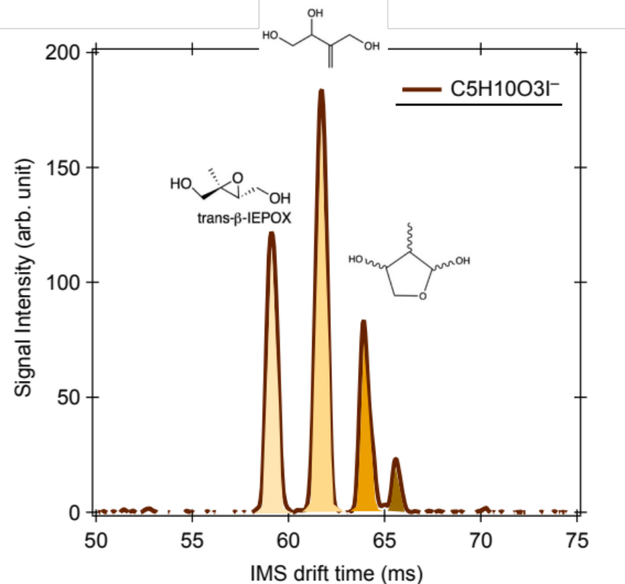

Supplementary Fig. 2. Isomeric separation of C₅H₁₀O₃ compounds during the reactive uptake of trans-β-IEPOX. IMS drift times were identified using authentic standards.

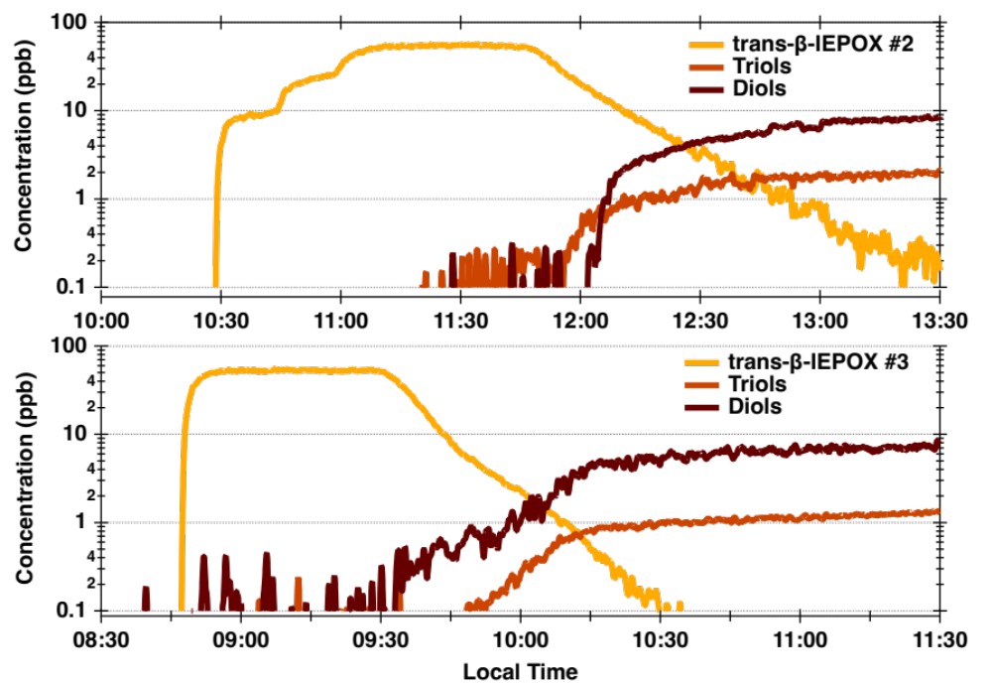
Supplementary Fig. 3. Evolution of the isomeric C₅H₁₀O₃ compounds during the reactive uptake of trans-β-IEPOX for the repeat experiments performed in this study.

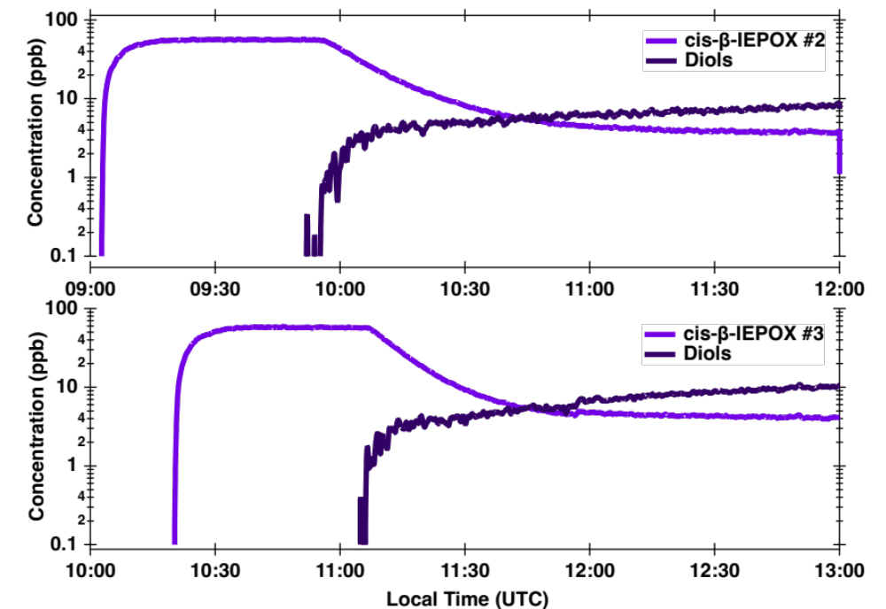
Supplementary Fig. 4. Evolution of the isomeric C₅H₁₀O₃ compounds during the reactive uptake of cis-β-IEPOX for the repeat experiments performed in this study.

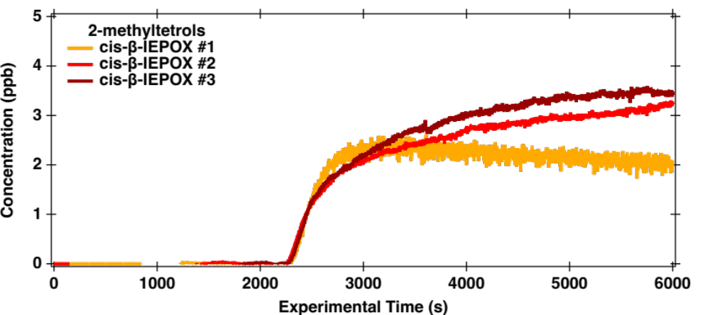
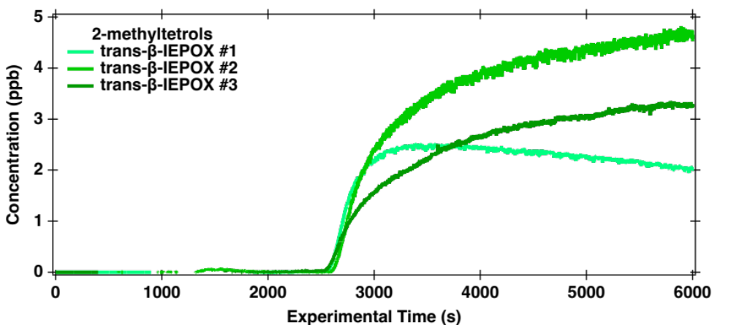
Supplementary Fig. 5. Formation of 2-methyltetrols from the reactive uptake of (a) trans- and (b) cis-β-IEPOX in the presence of acidic seed aerosol for the different experiments performed in this study.

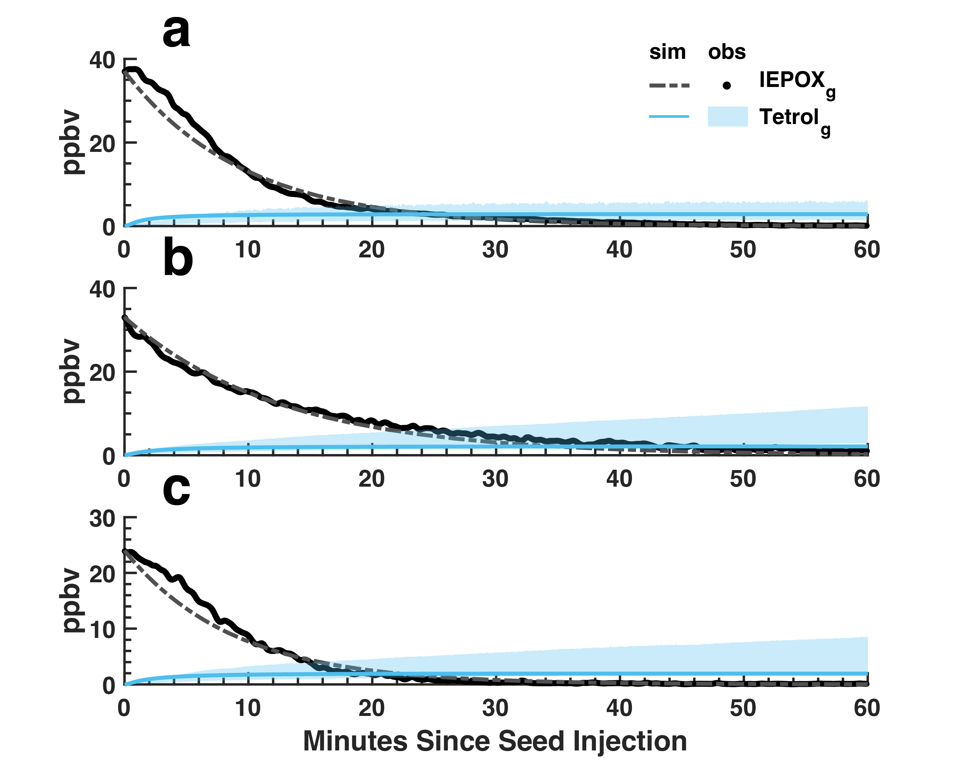Supplementary Fig. 6. Box model simulation showing the model fit of gas-phase IEPOX and 2-methyltetrols for (a) trans-β IEPOX experiment #1 (09/21/2023), (b) trans-β IEPOX experiment #2 (09/29/2023), (c) trans-β IEPOX experiment #3 (10/05/2023). The shaded area reflects an uncertainty factor of 2 from the measured tetrol concentrations).

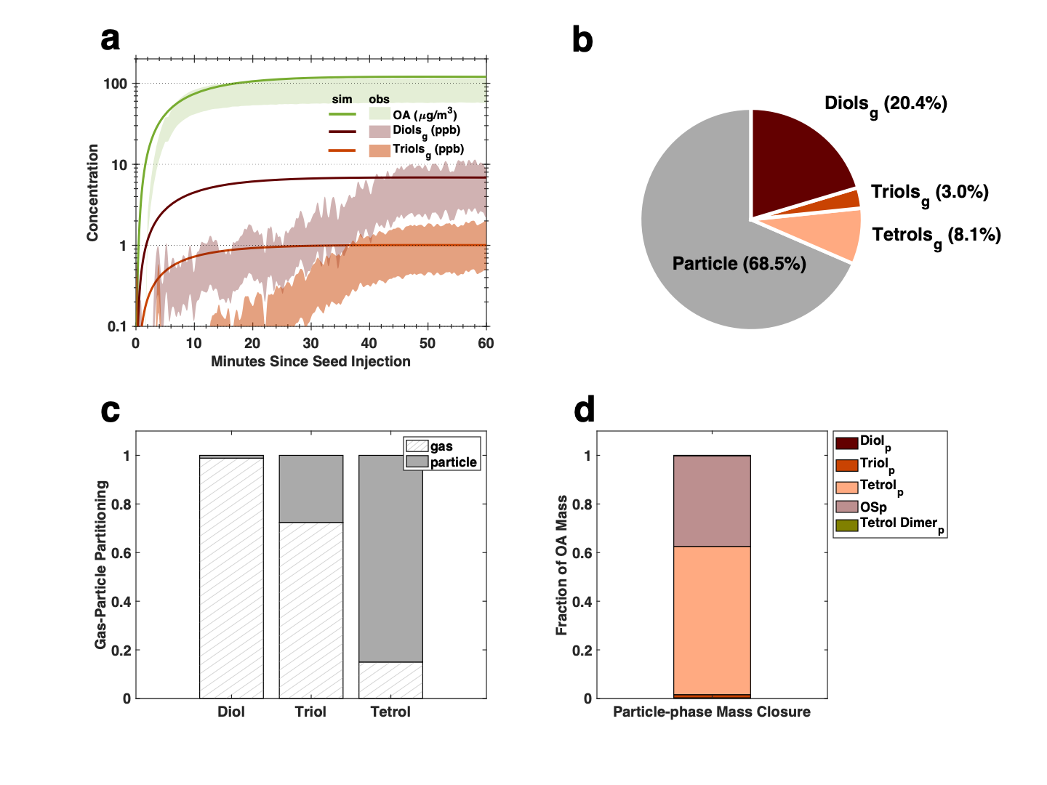
Supplementary Fig. 7. Box model simulation showing a) the fit of OA and gas-phase diols and triols observation (shaded area reflect an uncertainty factor of 2 from the measured values); b) the fate of IEPOX c) the gas- and particle partitioning of semivolatile species including diols, triols, and tetrols; d) the particle-phase product distribution for trans-β IEPOX experiment #1 (9/21/2023).
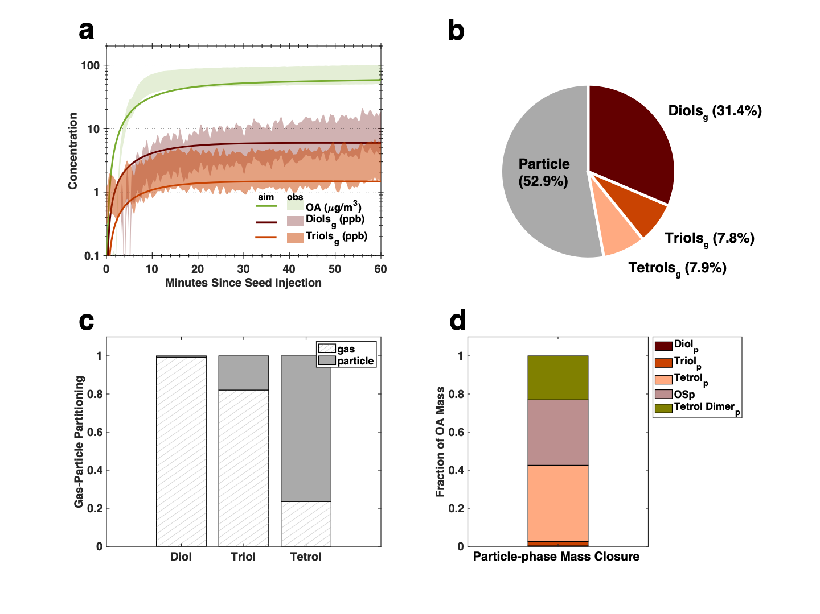Supplementary Fig. 8. Box model simulation showing a) the fit of OA and gas-phase diols and triols observation (shaded area reflect an uncertainty factor of 2 from the measured values); b) the fate of IEPOX c) the gas- and particle partitioning of semivolatile species including diols, triols, and tetrols; d) the particle-phase product distribution for trans-β IEPOX experiment #3 (10/05/2023).

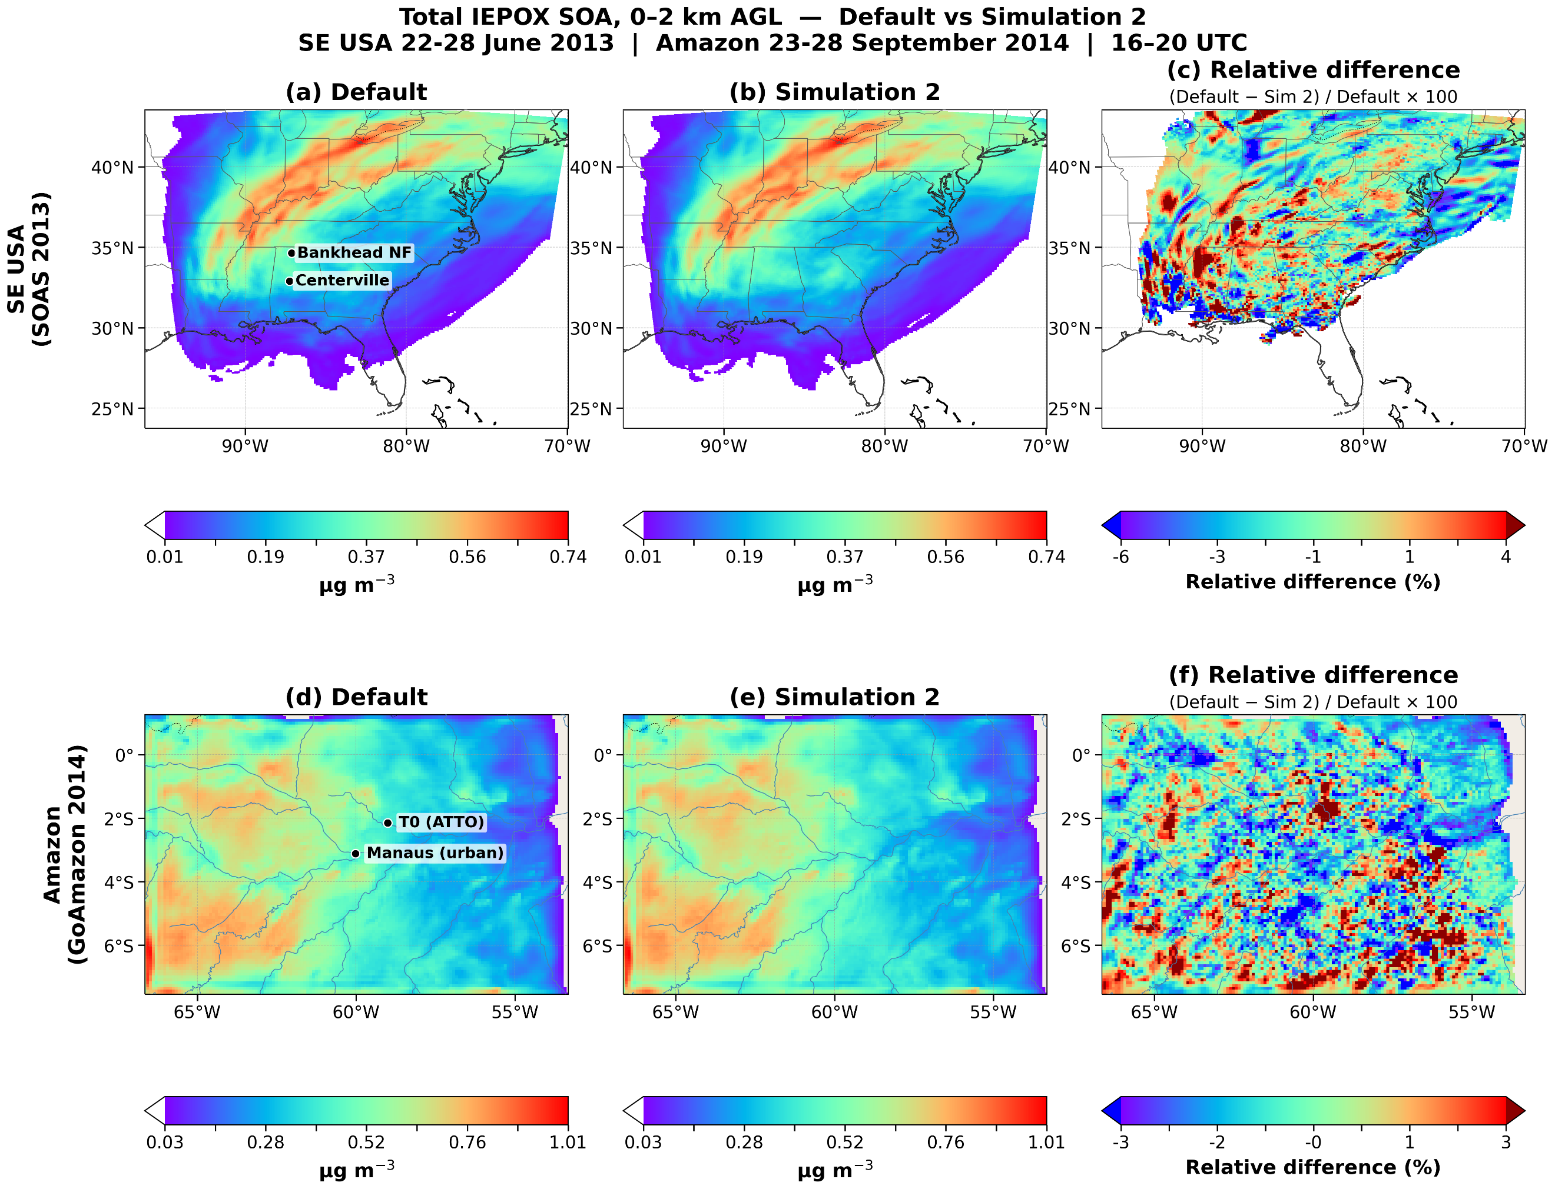

Supplementary Fig. 9. WRF-Chem-simulated spatial distributions of IEPOX-SOA for Simulation 2 (2-methyltetrol C* = 10 μg m⁻³, with THF-diol and triol formation included). Near surface-layer (0–2 km altitude) IEPOX-SOA concentrations (μg m⁻³) are shown for the default parameterization (left panels) and Simulation 2 (middle panels). The relative difference between the two simulations is shown in percent (right panels). Panels a–c correspond to simulations over the southeastern United States (20–28 June 2013), and panels d–f correspond to simulations over the Amazon Basin (21–29 September 2014).
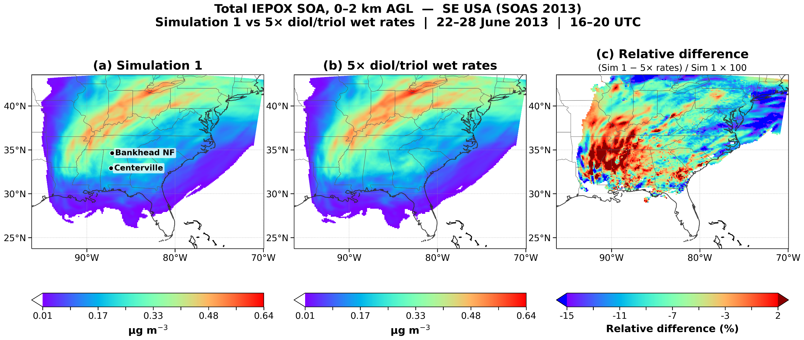
Supplementary Fig. 10. WRF-Chem simulation over the southeastern United States (20–28 June 2013) of IEPOX-SOA. Near surface-layer (0–2 km altitude) IEPOX-SOA concentrations (μg m⁻³) are shown for the updated parameterization Simulation 1 (left panels) and the faster rate constants (5x) derived from the chemical kinetic box model (middle panels). The relative difference between the two simulations is shown in percent (right panels).

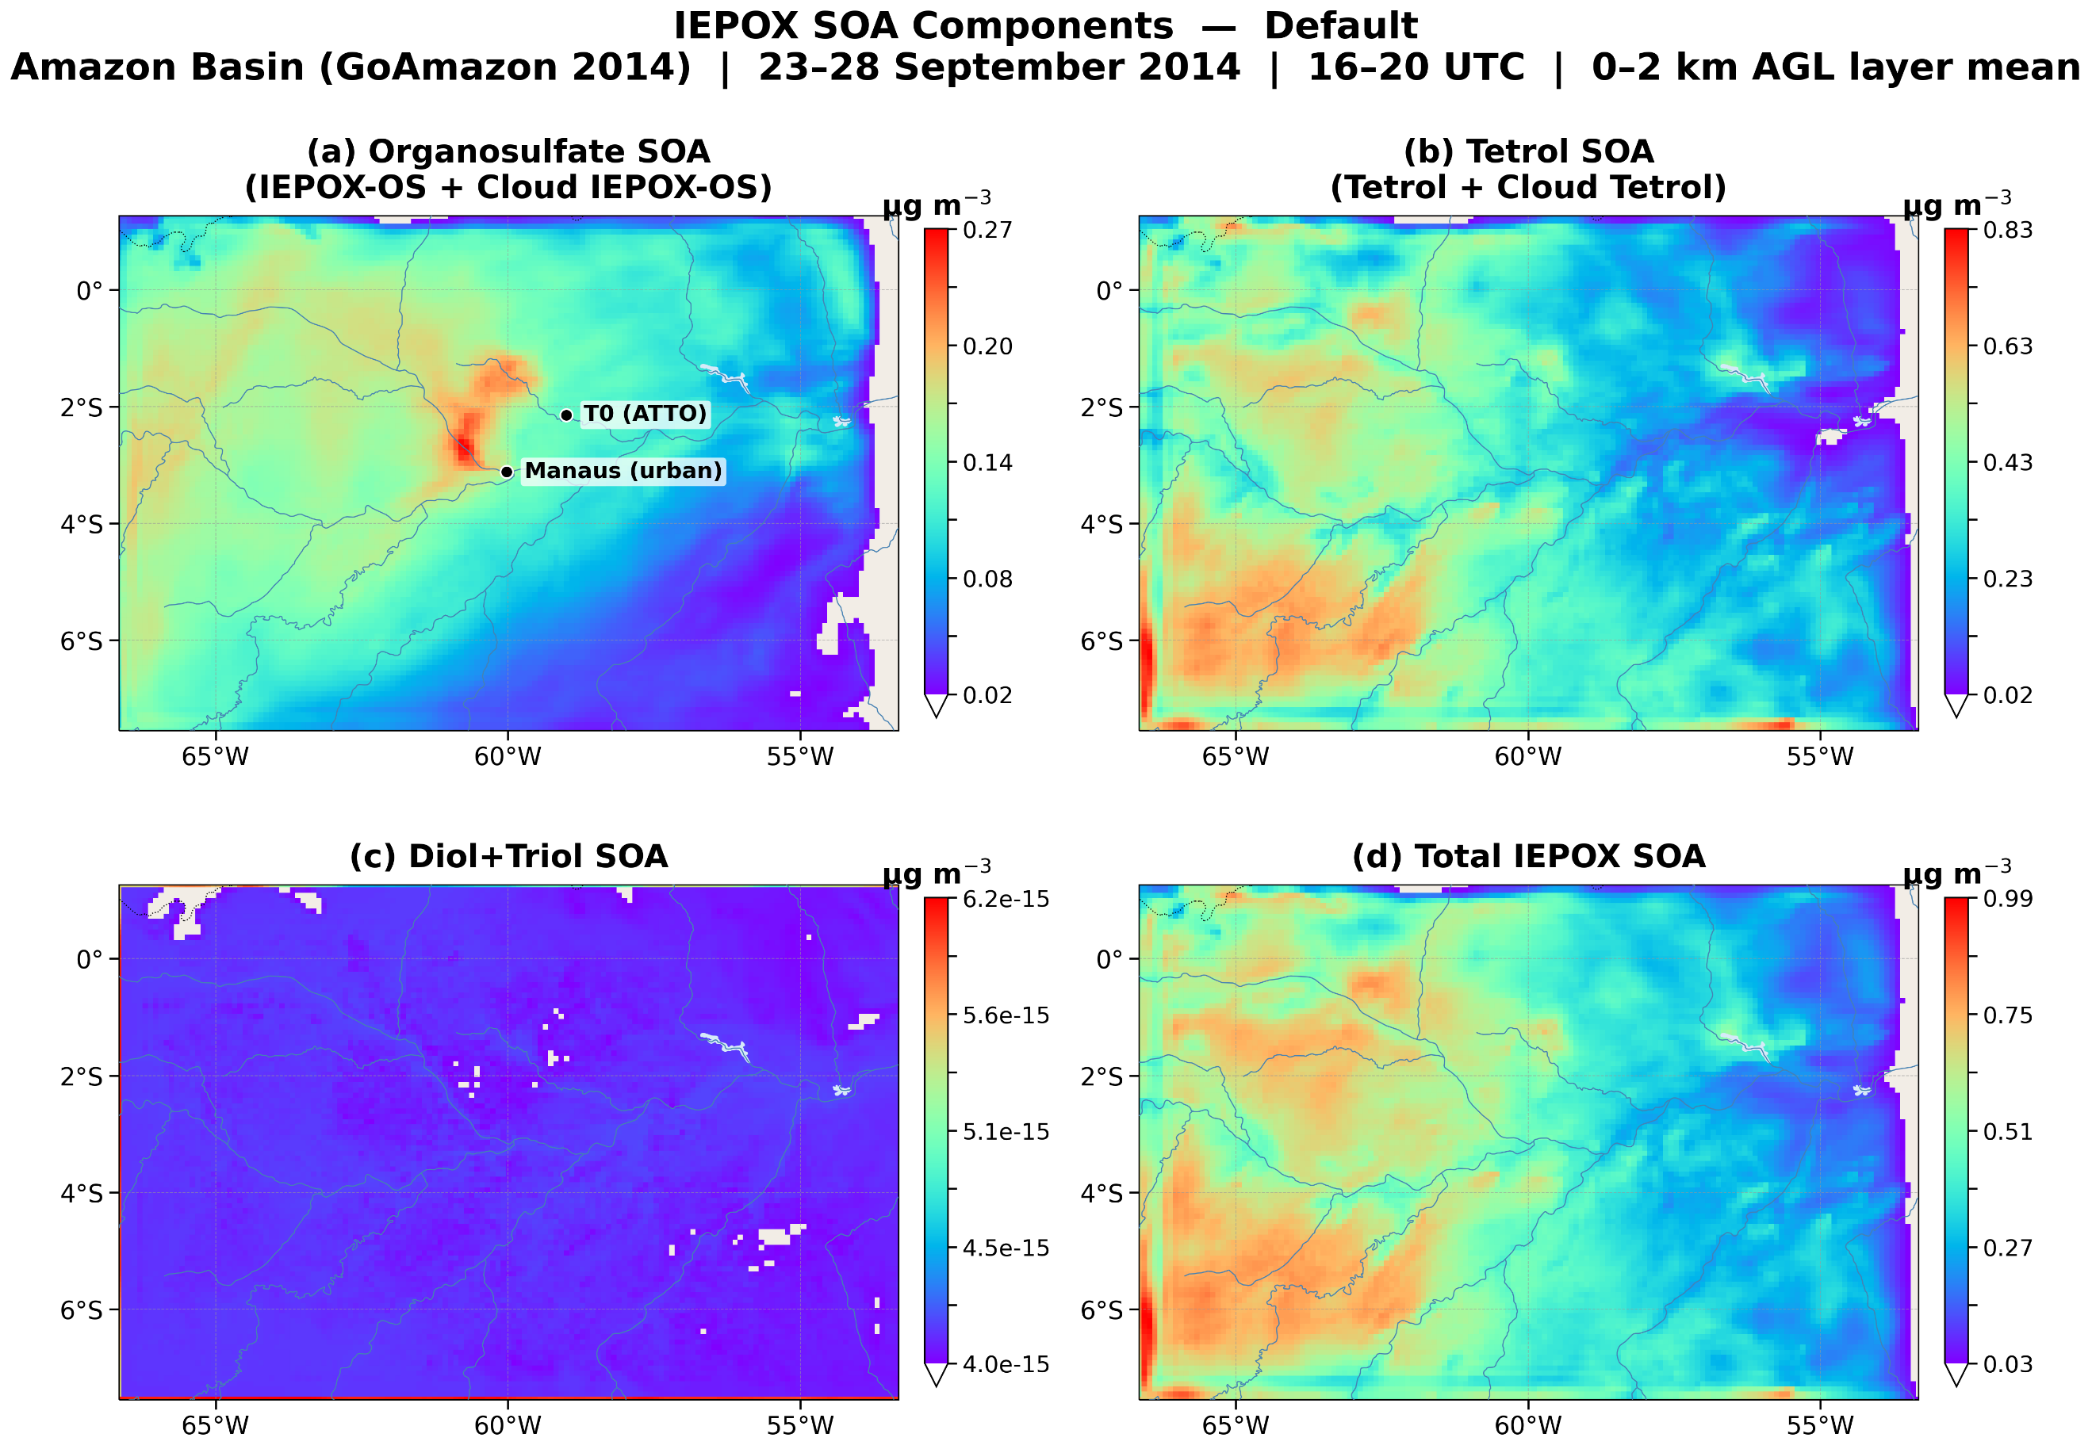
Supplementary Fig. 11. WRF-Chem-simulated IEPOX-SOA component maps over the Amazon Basin for the default parameterization (21–29 September 2014, 16–20 UTC, 0–2 km AGL layer average). (a) Total organosulfate SOA (aerosol- + cloud-phase); (b) total tetrol SOA (aerosol- + cloud-phase); (c) diol+triol SOA; (d) total IEPOX-SOA. Aerosol- and cloud-phase organosulfates and tetrols are tracked separately in WRF-Chem using distinct tracers and summed here; cloud-phase organosulfate formation is negligible under the dilute, low-acidity conditions of cloud droplets, so aerosol-phase organosulfate formation dominates (see Supplementary Fig. 14 for the full per-tracer breakdown).

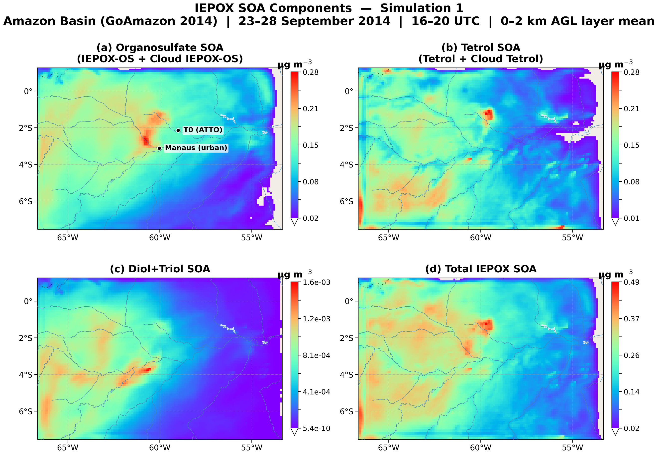
Supplementary Fig. 12. As in Supplementary Fig. 11, but for Simulation 1 (2-methyltetrol C* = 35 μg m⁻³, with THF-diol and triol formation included).

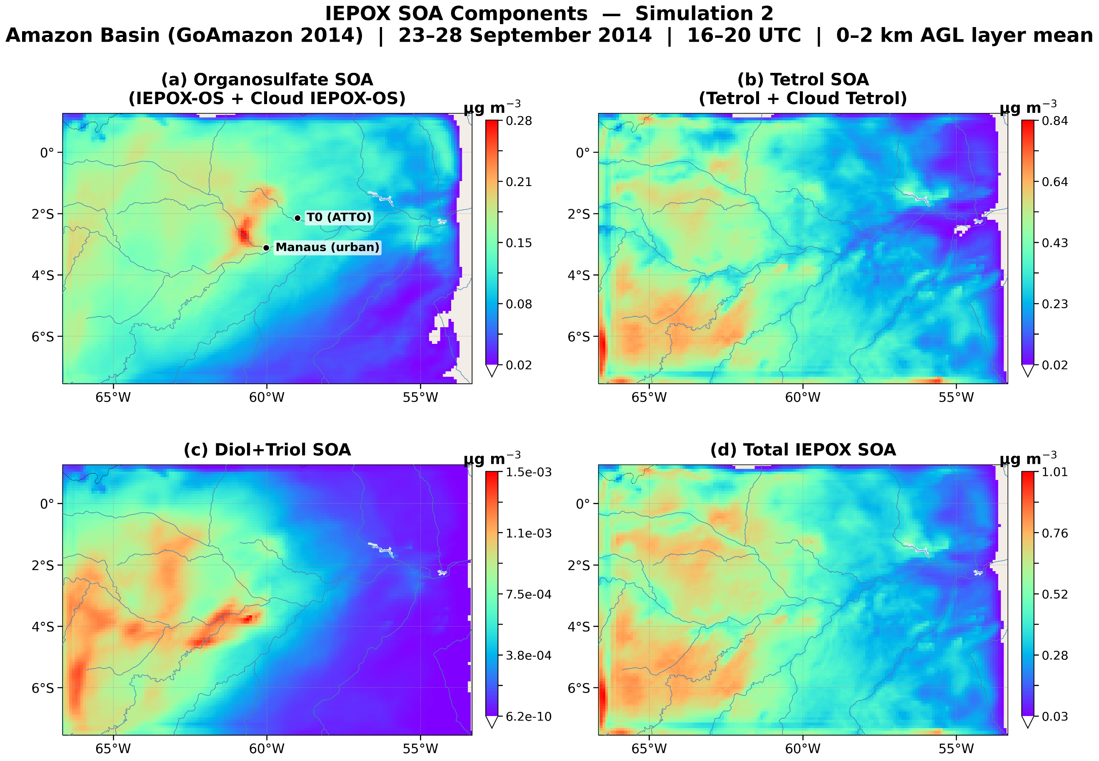
Supplementary Fig. 13. As in Supplementary Fig. 11, but for Simulation 2 (2-methyltetrol C* = 10 μg m⁻³, with THF-diol and triol formation included).

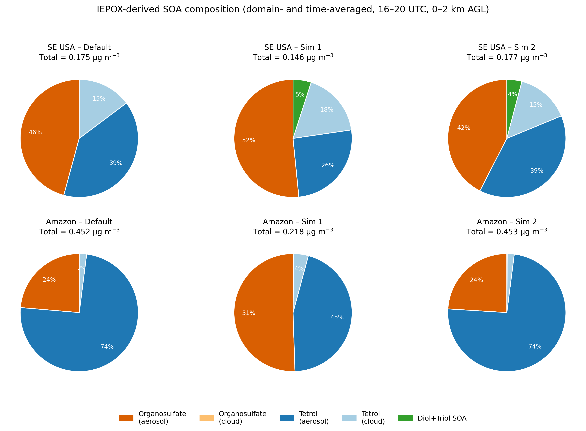
Supplementary Fig. 14. Domain- and time-averaged (16–20 UTC, 0–2 km AGL, averaged over the simulated period) composition of WRF-Chem IEPOX-derived SOA by individual model tracer, for the SE USA and Amazon domains under the Default, Simulation 1, and Simulation 2 parameterizations. Organosulfates (iepoxos) and tetrols (tetrol) are aerosol-phase tracers; cldiepoxos and cldtetrol are the corresponding organosulfate and tetrol formed by in-cloud chemistry; tanv is the sum of diol+triol SOA. Cloud-phase organosulfate formation (cldiepoxos) is negligible (<0.001 μg m−3) across all cases because tetrol formation dominates in the dilute, low-acidity conditions of cloud droplets, consistent with the aerosol-phase dominance of organosulfate formation discussed in the main text.

Supplementary Table 1. Sensitivities (cps pptv⁻¹) normalized by reagent ions for the different isoprene oxidation products characterized by the Vocus CI-IMS-MS

Compounds | Reagent Ion | Sensitivity (cps/ppt)
cis-β-IEPOX | Iodide (–) | 7.0
trans-β-IEPOX | Iodide (–) | 2.1
3-methyltetrahydrofuran-2,4-diol | Iodide (–) | 0.19
3-methyltetrahydrofuran-3,4-diol | Iodide (–) | 0.12
3-methylenebutane-1,2,4-triol | Iodide (–) | 6.3
2-methyltetrol | Iodide (–) | 17

Supplementary Table 2. Second- and third-order reaction rate constants derived from the current work.

Reaction Index | SOA tracer | k |  |  | Mean
Reaction Index | SOA tracer | Expt #1 | Expt #2 | Expt #3 | Mean
2 | Diols | 1.27×10⁻² M⁻¹s⁻¹ | 1.02×10⁻² M⁻¹s⁻¹ | 2.54×10⁻² M⁻¹s⁻¹ | 1.61×10⁻² M⁻¹s⁻¹
3 | Triols | 2.54×10⁻³ M⁻¹s⁻¹ | 3.81×10⁻³ M⁻¹s⁻¹ | 7.62×10⁻³ M⁻¹s⁻¹ | 4.66×10⁻³ M⁻¹s⁻¹
4 | Tetrols | 2.54×10⁻³ M⁻²s⁻¹ | 2.79×10⁻³ M⁻²s⁻¹ | 2.54×10⁻³ M⁻²s⁻¹ | 2.62×10⁻³ M⁻²s⁻¹
5 | Tetrol Sulfates | 1.27×10⁻³ M⁻²s⁻¹ | 1.27×10⁻³ M⁻²s⁻¹ | 1.27×10⁻³ M⁻²s⁻¹ | 1.27×10⁻³ M⁻²s⁻¹
6 | Tetrol Dimers | 9.65×10⁻⁵ M⁻²s⁻¹ | 1.06×10⁻⁴ M⁻²s⁻¹ | 9.65×10⁻⁵ M⁻²s⁻¹ | 9.97×10⁻⁵ M⁻²s⁻¹

Supplementary Table 3. Second- and third-order reaction rate constants reported in the literature.

Reaction Index | SOA tracer | k
Reaction Index | SOA tracer | Cole-Filipiak(1) | Eddingsaas(2) | Piletic(3) | Riedel(4) | Chen(5)
2 | Diols | - | - | - | 2.6×10⁻⁴ M⁻¹s⁻¹ | -
3 | Triols |  | - | - | 8.8×10⁻⁴ M⁻¹s⁻¹ | -
4 | Tetrols | 6.5 × 10⁻⁴ M⁻²s⁻¹ | 9.0×10⁻⁴M⁻²s⁻¹ | 5.3×10⁻² M⁻²s⁻¹ | 3.4×10⁻⁵ M⁻²s⁻¹ | 5.3×10⁻⁴ M⁻²s⁻¹
5 | Tetrol Sulfates | - | 2.0×10⁻⁴ M⁻²s⁻¹ | 5.2×10⁻¹ M⁻²s⁻¹ | 4.8×10⁻⁵ M⁻²s⁻¹ | 5.2×10⁻³ M⁻²s⁻¹
6 | Tetrol Dimers | - | - | - | 1.3×10⁻⁵ M⁻²s⁻¹ | 5.3×10⁻⁴ M⁻²s⁻¹

Supplementary Table 4. Saturation vapor concentration at 298K. The input SMILES strings for diols, triols, and tetrols are based on the up-to-date understanding of their structures

Model Species | Compound Name | Formula | Structure | SMILES | C* (µg m⁻³)
Diols | 3-methyltetrahydrofuran-2,4-diols¹³ | C₅H₁₀O₃ | 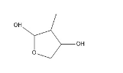 | CC1C(O)OCC1O | 1.69×10⁴
Triols | 3-methylenebutane-1,2,4-triols¹³ | C₅H₁₀O₃ | 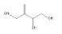 | OCC(C(O)CO)=C | 521
Tetrols | 2-methylbutane-1,2,3,4-tetrols | C₅H₁₂O₄ | 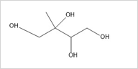 | OCC(O)(C(O)CO)C | 35

Supplementary Table 5. Second- and third-order reaction rate constants used in WRF-Chem Simulations using ammonium sulfate (AS) and ammonium bisulfate (ABS) particles.
Case | Condition | k_{diol}  M⁻¹ s⁻¹ | k_{triol}  M⁻¹ s⁻¹ | k_{tetrol}  M⁻² s⁻¹ | k_{os}  M⁻² s⁻¹ | C_{tetrol}*  ug/m³
Default | RH <50% | - | - | 9.0×10⁻⁴ | 1.27×10⁻³ | 10
 | RH >50% ABS | - | - | 2.25×10⁻⁴ | 1.27×10⁻³ | 10
 | RH >50% AS | - | - | 1.80×10⁻⁴ | 1.91×10⁻⁴ | 10
Simulation 1 | RH <50% | 1.61×10⁻² | 4.66×10⁻³ | 2.62×10⁻³ | 1.27×10⁻³ | 35
 | RH >50% ABS | 1.38×10⁻³ | 3.99×10⁻⁴ | 2.25×10⁻⁴ | 1.27×10⁻³ | 35
 | RH >50% AS | 1.10×10⁻³ | 3.19×10⁻⁴ | 1.80×10⁻⁴ | 1.91×10⁻⁴ | 35
Simulation 2 | RH < 50% | 1.61×10⁻² | 4.66×10⁻³ | 2.62×10⁻³ | 1.27×10⁻³ | 10
 | RH >50% ABS | 1.38×10⁻³ | 3.99×10⁻⁴ | 2.25×10⁻⁴ | 1.27×10⁻³ | 10
 | RH >50% AS | 1.10×10⁻³ | 3.19×10⁻⁴ | 1.80×10⁻⁴ | 1.91×10⁻⁴ | 10

*Differences of Simulation 1 and 2 from the Base case were highlighted in bolded texts.
**New reaction rate constants for diols and triols derived from laboratory experiments were applied as is to dryer conditions (RH<50%) in WRF-Chem.
***For more humid conditions, new reaction rate constants for diols and triols were scaled according to the tetrol rate constants of the Default case, but the new relative rates of diols and triols to tetrols were kept.
For Supplementary Fig. 10b, the Sim 1 5x diol/triol rates is same as Simulation 1 above except the RH>50% ABS and AS kdiol and ktriol are increased by factor of 5 compared to their values listed under Simulation 1.

Supplementary Table 6: WRF-Chem model configuration for the Amazon rainforest from Shrivastava et al. (6)
WRF-Chem version 4.2 domain | 1500 × 1000 km domain around Manaus with horizontal grid spacing of 10 km and 45 vertical levels
Simulation period | September 21-29, 2014
Boundary layer | Yonsei University (YSU) Planetary Boundary Layer scheme
Surface | Community Land Model (CLM v4) with MEGAN 2.1 for biogenic emissions (11)
Cloud microphysics | Morrison (2 moments)
Convective parametrization (sub-grid wet removal and sub-grid convective transport) | Grell 3D Ensemble  Grid-scale in-cloud and below cloud wet removal of trace gases and aerosols is included
Aerosol-cloud interactions | Aerosol activation based on the parameterization of Abdul-Razzak and Ghan (7)
Radiation | RRTMG scheme (both longwave and shortwave) (13)
Gas-phase photochemistry | SAPRC-99
Aerosol chemistry | MOSAIC for inorganic aerosols was coupled to new aqueous- and cloud-phase IEPOX-SOA chemistry formulations. Modified Volatility basis set (VBS) for secondary organic aerosols based on Shrivastava et al.(8) with several updates as described in the supplementary text.
Boundary conditions | National Centers for Environmental Prediction (NCEP) Climate Forecast System Version 2 (CFSv2) reanalysis data for meteorology and quasi-global WRF for aerosols and trace gases (9, 10)

Supplementary Table 7. WRF-Chem model configuration for SE USA

WRF-Chem version 4.2 domain | 2160 × 2160 km domain covering most of the Southern USA with horizontal grid spacing of 12 km and 46 vertical levels
Simulation period | June 20-28, 2013
Boundary layer | Yonsei University (YSU) Planetary Boundary Layer scheme
Surface | Community Land Model (CLM v4) with MEGAN 2.1 for biogenic emissions (11)
Cloud microphysics | Morrison (2 moments)
Convective parametrization (sub-grid wet removal and sub-grid convective transport) | KF-CuP (12)  Grid-scale in-cloud and below cloud wet removal of trace gases and aerosols is included.
Aerosol-cloud interactions | Aerosol activation based on the parameterization of Abdul-Razzak and Ghan (7)
Radiation | RRTMG scheme (both longwave and shortwave) (13)
Gas-phase photochemistry | SAPRC-99
Aerosol chemistry | MOSAIC for inorganic aerosols (14). Volatility basis set (VBS) for secondary organic aerosols, Radical 2D-VBS for monoterpene SOA, and eight different new particle formation schemes with several updates for anthropogenic SOA from VCPs and mobile sources in the USA, as described in Shrivastava et al. (15). New updates including the dynamic gas-particle partitioning approach including diffusion limitations for SOA with online predictions of OA viscosity in WRF-Chem
Boundary conditions | ERA5 analysis data for meteorology (16) and CAM-Chem global model simulations for initial and boundary conditions (17) 9/11/26 7:05:00 PM

Supplementary Table 8. THF-diol and triol SOA parameterization in WRF-Chem model based on SOA yields reported by Frauenheim et al. (18)*

 | k_{OH} (cm³ molecules ⁻¹ s⁻¹)*** | Yield ABS** | Yield AS**
3MTHF24D | 2.0×10⁻¹¹ | 0.267 | 0.17
3MB124T | 1.1×10⁻¹⁰ | 0.93 | 0.48

* Frauenheim et al.(18) reported yields for two acidity regimes. In WRF Chem implementation, yield was calculated as average weighted by fraction of ABS and AS.
** THF-diol and triol SOA was calculated using mass-based yield (SOA mass formed/Precursor mass reacted).
*** The reaction rate constants with OH radical were determined using the structure activity relationships described in Kwok and Atkinson (19) and Ziemann and Atkinson (20)

1. N. C. Cole-Filipiak, A. E. O’Connor, M. J. Elrod, Kinetics of the Hydrolysis of Atmospherically Relevant Isoprene-Derived Hydroxy Epoxides. Environ. Sci. Technol. 44, 6718–6723 (2010).
2. N. C. Eddingsaas, D. G. VanderVelde, P. O. Wennberg, Kinetics and Products of the Acid-Catalyzed Ring-Opening of Atmospherically Relevant Butyl Epoxy Alcohols. J. Phys. Chem. A 114, 8106–8113 (2010).
3. I. R. Piletic, E. O. Edney, L. J. Bartolotti, A computational study of acid catalyzed aerosol reactions of atmospherically relevant epoxides. Phys. Chem. Chem. Phys. 15, 18065 (2013).
4. T. P. Riedel, Y.-H. Lin, Z. Zhang, K. Chu, J. A. Thornton, W. Vizuete, A. Gold, J. D. Surratt, Constraining condensed-phase formation kinetics of secondary organic aerosol components from isoprene epoxydiols. Atmospheric Chemistry and Physics 16, 1245–1254 (2016).
5. Y. Chen, A. E. Ng, J. Green, Y. Zhang, M. Riva, T. P. Riedel, H. O. T. Pye, Z. Lei, N. E. Olson, M. E. Cooke, Z. Zhang, W. Vizuete, A. Gold, B. J. Turpin, A. P. Ault, J. D. Surratt, Applying a Phase-Separation Parameterization in Modeling Secondary Organic Aerosol Formation from Acid-Driven Reactive Uptake of Isoprene Epoxydiols under Humid Conditions. ACS EST Air 1, 511–524 (2024).
6. M. Shrivastava, Q. Z. Rasool, B. Zhao, M. Octaviani, R. A. Zaveri, A. Zelenyuk, B. Gaudet, Y. Liu, J. E. Shilling, J. Schneider, C. Schulz, M. Zöger, S. T. Martin, J. Ye, A. Guenther, R. F. Souza, M. Wendisch, U. Pöschl, Tight Coupling of Surface and In-Plant Biochemistry and Convection Governs Key Fine Particulate Components over the Amazon Rainforest. ACS Earth Space Chem. 6, 380–390 (2022).
7. H. Abdul‐Razzak, S. J. Ghan, A parameterization of aerosol activation 3. Sectional representation. J.‐Geophys.‐Res. 107 (2002).
8. M. Shrivastava, M. O. Andreae, P. Artaxo, H. M. J. Barbosa, L. K. Berg, J. Brito, J. Ching, R. C. Easter, J. Fan, J. D. Fast, Z. Feng, J. D. Fuentes, M. Glasius, A. H. Goldstein, E. G. Alves, H. Gomes, D. Gu, A. Guenther, S. H. Jathar, S. Kim, Y. Liu, S. Lou, S. T. Martin, V. F. McNeill, A. Medeiros, S. S. De Sá, J. E. Shilling, S. R. Springston, R. A. F. Souza, J. A. Thornton, G. Isaacman-VanWertz, L. D. Yee, R. Ynoue, R. A. Zaveri, A. Zelenyuk, C. Zhao, Urban pollution greatly enhances formation of natural aerosols over the Amazon rainforest. Nat Commun 10, 1046 (2019).
9. Z. Hu, C. Zhao, J. Huang, L. R. Leung, Y. Qian, H. Yu, L. Huang, O. V. Kalashnikova, Trans-Pacific transport and evolution of aerosols: evaluation of quasi-global WRF-Chem simulation with multiple observations. Geosci. Model Dev. 9, 1725–1746 (2016).
10. S. Saha, S. Moorthi, H.-L. Pan, X. Wu, J. Wang, S. Nadiga, P. Tripp, R. Kistler, J. Woollen, D. Behringer, H. Liu, D. Stokes, R. Grumbine, G. Gayno, J. Wang, Y.-T. Hou, H. Chuang, H.-M. H. Juang, J. Sela, M. Iredell, R. Treadon, D. Kleist, P. V. Delst, D. Keyser, J. Derber, M. Ek, J. Meng, H. Wei, R. Yang, S. Lord, H. van den Dool, A. Kumar, W. Wang, C. Long, M. Chelliah, Y. Xue, B. Huang, J.-K. Schemm, W. Ebisuzaki, R. Lin, P. Xie, M. Chen, S. Zhou, W. Higgins, C.-Z. Zou, Q. Liu, Y. Chen, Y. Han, L. Cucurull, R. W. Reynolds, G. Rutledge, M. Goldberg, The NCEP Climate Forecast System Reanalysis. Bulletin of the American Meteorological Society 91, 1015–1058 (2010).
11. A. B. Guenther, X. Jiang, C. L. Heald, T. Sakulyanontvittaya, T. Duhl, L. K. Emmons, X. Wang, The Model of Emissions of Gases and Aerosols from Nature version 2.1 (MEGAN2.1): an extended and updated framework for modeling biogenic emissions. Geosci. Model Dev. 5, 1471–1492 (2012).
12. L. K. Berg, M. Shrivastava, R. C. Easter, J. D. Fast, E. G. Chapman, Y. Liu, R. A. Ferrare, A new WRF-Chem treatment for studying regional-scale impacts of cloud processes on aerosol and trace gases in parameterized cumuli. Geosci. Model Dev. 8, 409–429 (2015).
13. M. J. Iacono, J. S. Delamere, E. J. Mlawer, M. W. Shephard, S. A. Clough, W. D. Collins, Radiative forcing by long‐lived greenhouse gases: Calculations with the AER radiative transfer models. J. Geophys. Res. 113, 2008JD009944 (2008).
14. R. A. Zaveri, R. C. Easter, J. D. Fast, L. K. Peters, Model for Simulating Aerosol Interactions and Chemistry (MOSAIC). J. Geophys. Res. 113, 2007JD008782 (2008).
15. M. Shrivastava, J. Zhang, R. A. Zaveri, B. Zhao, J. R. Pierce, S. E. O’Donnell, J. D. Fast, B. Gaudet, J. E. Shilling, A. Zelenyuk, B. N. Murphy, H. O. T. Pye, Q. Zhang, J. Trousdell, Q. Chen, Anthropogenic Extremely Low Volatility Organics (ELVOCs) Govern the Growth of Molecular Clusters Over the Southern Great Plains During the Springtime. JGR Atmospheres 129, e2024JD041212 (2024).
16. H. Hersbach, B. Bell, P. Berrisford, S. Hirahara, A. Horányi, J. Muñoz-Sabater, J. Nicolas, C. Peubey, R. Radu, D. Schepers, A. Simmons, C. Soci, S. Abdalla, X. Abellan, G. Balsamo, P. Bechtold, G. Biavati, J. Bidlot, M. Bonavita, G. De Chiara, P. Dahlgren, D. Dee, M. Diamantakis, R. Dragani, J. Flemming, R. Forbes, M. Fuentes, A. Geer, L. Haimberger, S. Healy, R. J. Hogan, E. Hólm, M. Janisková, S. Keeley, P. Laloyaux, P. Lopez, C. Lupu, G. Radnoti, P. de Rosnay, I. Rozum, F. Vamborg, S. Villaume, J.-N. Thépaut, The ERA5 global reanalysis. Quarterly Journal of the Royal Meteorological Society 146, 1999–2049 (2020).
17. L. K. Emmons, R. H. Schwantes, J. J. Orlando, G. Tyndall, D. Kinnison, J. Lamarque, D. Marsh, M. J. Mills, S. Tilmes, C. Bardeen, R. R. Buchholz, A. Conley, A. Gettelman, R. Garcia, I. Simpson, D. R. Blake, S. Meinardi, G. Pétron, The Chemistry Mechanism in the Community Earth System Model Version 2 (CESM2). J Adv Model Earth Syst 12, e2019MS001882 (2020).
18. M. Frauenheim, J. Offenberg, Z. Zhang, J. D. Surratt, A. Gold, Chemical Composition of Secondary Organic Aerosol Formed from the Oxidation of Semivolatile Isoprene Epoxydiol Isomerization Products. Environ. Sci. Technol. 58, 22571–22582 (2024).
19. E. Kwok, R. Atkinson, Estimation of hydroxyl radical reaction rate constants for gas-phase organic compounds using a structure-reactivity relationship: An update. Atmospheric Environment 29, 1685–1695 (1995).
20. P. J. Ziemann, R. Atkinson, Kinetics, products, and mechanisms of secondary organic aerosol formation. Chem. Soc. Rev. 41, 6582 (2012).

