Supplementary Material

Crystal structure and electrochemical analyses of a multi-component cocrystal of cobalt(II) complexes of pyridine-2,6-dicarboxylic acid: Improving energy storage performance of hybrid device using redox active Electrolyte

Javed Hussain Shahª, Ali Hamzaª, Muhammad Shahbazª, Saeed Ahmad^{b}*, Maham Saeedª Shahzad Sharifª*, Nosheen Kanwal^{c}, Muhammad Rizwanª, Khurram Shahzad Munawar^{d,e}, Onur Şahin^{f}

Table S1 Crystal data and structure refinement parameters for Co(II) cluster (1).
Empirical formula | C₁₁₂H₁₃₀Co₁₃N₁₆O₁₀₂
Formula weight | 4098.40
Crystal system | Triclinic
Space group | P-1
a (Å) | 15.6293 (13)
b (Å) | 15.8130 (13)
c (Å) | 16.4243 (14)
α (º) | 86.053 (3)
β (º) | 68.705 (2)
γ (º) | 76.482 (2)
V (Å³) | 3676.7 (5)
Z | 1
D_{c} (g cm⁻³) | 1.851
μ (mm⁻¹) | 1.55
θ range (º) | 2.2-25.1
Measured refls. | 132037
Independent refls. | 16232
R_{int} | 0.062
S | 1.06
R1/wR2 | 0.063/0.174
Δρ_{max}/Δρ_{min} (eÅ⁻³) | 1.52/-2.04

Table S2 Selected bond distances (Å)and angles (º)
Co1-N1 | 2.020(4) | Co1-O1 | 2.129(4)
Co2-O39 | 2.070(4) | Co3-O13 | 2.168(4)
Co3-N4  Co5-N5  Co5-N6  Co6-N7 | 2.009(4)  2.033(5)  2.026(5)  2.026(4) | Co4-O43  Co5-O23  Co6-O31  Co7-O37 | 2.062(5)  2.119(5)  2.146(3)  2.114(4)
N1-Co1-N2 | 168.25(17) | N2-Co1-O3 | 108.03(16)
O1-Co1-O5 | 93.09(16) | O1-Co1-O7 | 95.14(19)
N4-Co3-N3 | 167.54(17) | O43-Co4-O44 | 88.1(3)
N6-Co5-O21 | 75.52(17) | N7-Co6-O31 | 114.64(14)

Table S3. Hydrogen-bond parameters for complex 1(Å, º)
D-H· · ·A | D-H | H···A | D···A | D-H···A
C2—H2···O42^{ii} | 0.93 | 2.48 | 3.366 (7) | 160
C11—H11···O8^{iii} | 0.93 | 2.51 | 3.372 (6) | 154
C23—H23···O30^{iii} | 0.93 | 2.49 | 3.267 (8) | 141
C30—H30···O18^{iv} | 0.93 | 2.33 | 3.156 (8) | 147
C32—H32···O39^{iv} | 0.93 | 2.41 | 3.308 (7) | 162
C46—H46···O28^{v} | 0.93 | 2.55 | 3.433 (6) | 160
C53—H53···O47^{vi} | 0.93 | 2.55 | 3.463 (7) | 169
O33—H33A···O10^{vii} | 0.83 (2) | 1.89 (2) | 2.710 (5) | 169
O33—H33B···O31 | 0.82 (2) | 2.15 (3) | 2.870 (5) | 147
O34—H34A···O20^{viii} | 0.82 (2) | 1.93 (2) | 2.744 (6) | 176
O34—H34B···O50 | 0.83 (2) | 2.06 (2) | 2.877 (7) | 170
O35—H35A···O5^{ix} | 0.82 (2) | 1.97 (3) | 2.774 (5) | 165
O35—H35B···O26^{x} | 0.83 (2) | 1.91 (2) | 2.730 (5) | 170
O36—H36A···O9^{vii} | 0.82 (2) | 1.92 (2) | 2.725 (5) | 167
O36—H36B···O22^{xi} | 0.82 (2) | 1.89 (2) | 2.709 (5) | 175
O37—H37A···O6^{ix} | 0.82 (2) | 1.95 (2) | 2.770 (5) | 178
O37—H37B···O47^{vi} | 0.84 (2) | 1.97 (2) | 2.808 (6) | 177
O38—H38A···O14 | 0.84 (2) | 1.78 (2) | 2.617 (7) | 172
O38—H38B···O1 | 0.83 (2) | 1.94 (4) | 2.684 (5) | 149
O39—H39A···O46 | 0.83 (2) | 1.88 (2) | 2.675 (9) | 160
O39—H39B···O13 | 0.84 (2) | 1.85 (3) | 2.654 (6) | 160
O40—H40A···O25^{xii} | 0.82 (2) | 1.91 (2) | 2.725 (5) | 171
O40—H40B···O24^{xii} | 0.82 (2) | 1.85 (3) | 2.660 (6) | 168
O41—H41A···O20^{iv} | 0.84 (2) | 2.13 (2) | 2.958 (6) | 169
O41—H41B···O26^{xii} | 0.83 (2) | 2.03 (2) | 2.856 (6) | 169
O42—H42A···O48 | 0.83 (2) | 2.05 (4) | 2.808 (7) | 151
O42—H42B···O23^{xii} | 0.83 (2) | 2.25 (3) | 3.074 (7) | 172
O43—H43A···O22^{viii} | 0.83 (2) | 1.83 (2) | 2.660 (6) | 174
O43—H43B···O6^{iii} | 0.83 (2) | 2.18 (3) | 2.991 (7) | 165
O44—H44A···O3^{viii} | 0.83 (2) | 2.07 (7) | 2.797 (7) | 145
O44—H44B···O43^{i} | 0.83 (2) | 2.39 (9) | 2.908 (9) | 121
O45—H45B···O12 | 0.81 (2) | 1.80 (3) | 2.585 (6) | 162
O46—H46A···O26^{xii} | 0.83 (2) | 2.59 (12) | 3.221 (9) | 133
O46—H46A···O33^{v} | 0.83 (2) | 2.59 (11) | 3.214 (9) | 132
O47—H47B···O37^{v} | 0.84 (2) | 2.32 (2) | 3.154 (7) | 170
O48—H48A···O35^{xiii} | 0.83 (1) | 2.30 (4) | 3.102 (7) | 161
O48—H48B···O19^{xii} | 0.84 (2) | 2.11 (5) | 2.864 (7) | 149
O49—H49A···O4 | 0.84 (2) | 1.88 (4) | 2.639 (7) | 149
O49—H49B···O21 | 0.83 (2) | 2.00 (3) | 2.812 (7) | 165
O50—H50B···O6^{iii} | 0.84 (2) | 2.49 (5) | 3.250 (7) | 150
O51—H51B···O49^{viii} | 0.84 (2) | 1.86 (5) | 2.587 (8) | 145
Symmetry codes: (i) −x, −y+1, −z; (ii) −x+1, −y, −z+1; (iii) −x, −y+1, −z+1; (iv) −x+1, −y+1, −z+1; (v) −x+1, −y+1, −z; (vi) x−1, y+1, z; (vii) x, y+1, z; (viii) x, y, z−1; (ix) x, y+1, z−1; (x) −x+1, −y+2, −z; (xi) −x, −y+2, −z+1; (xii) x, y−1, z; (xiii) x, y−1, z+1.

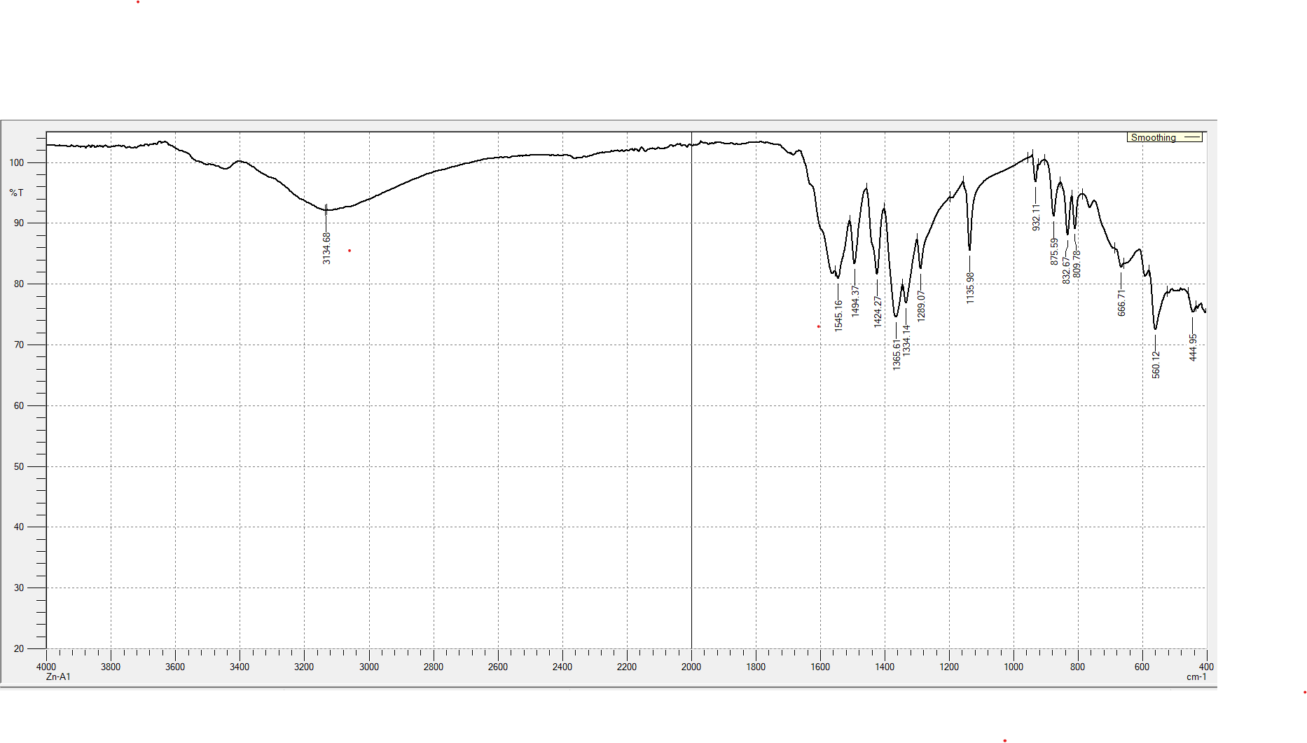

Fig. S1. FT-IR Spectrum of Co(II) compound 1

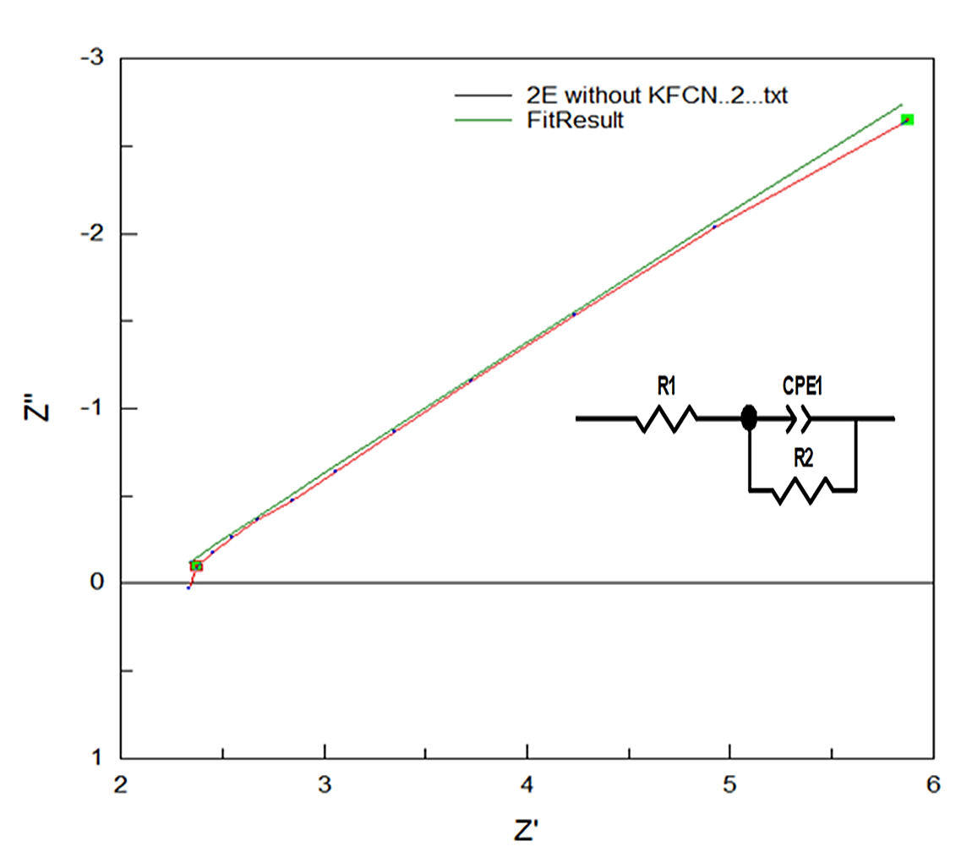
Figure S2. EIS fitting of Co cluster 1//AC without KFCN along with circuit diagram.

Table S4. EIS fitting parameters of cluster 1//AC, without KFCN.

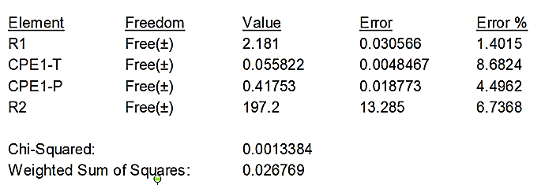

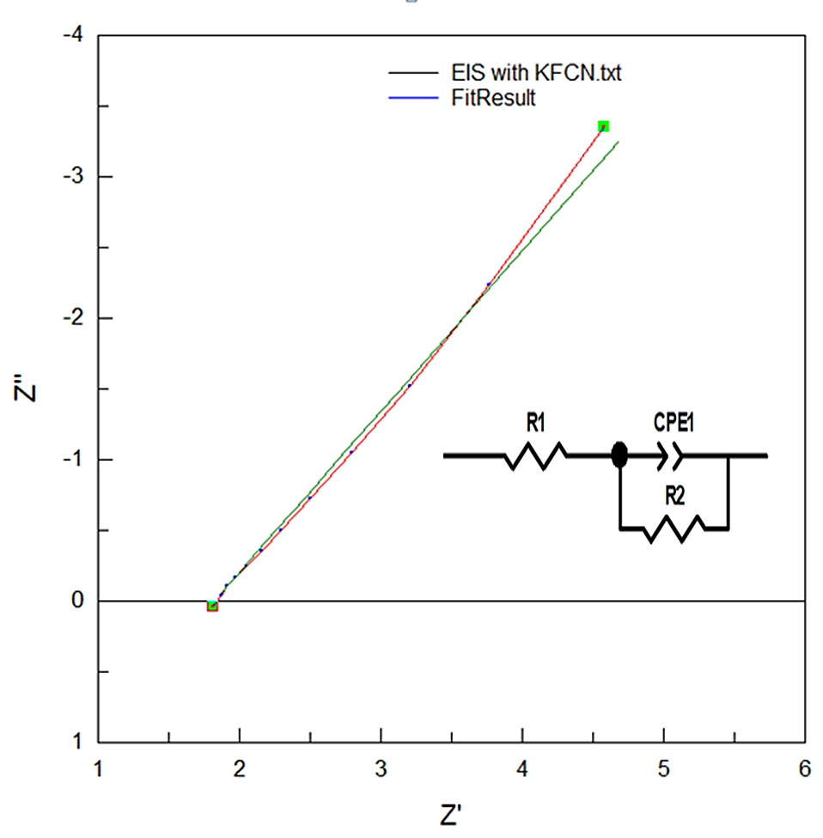
Figure S3. EIS fitting of Co cluster 1//AC with KFCN.

Table S5. EIS fitting parameters of cluster 1//AC KFCN along with circuit.

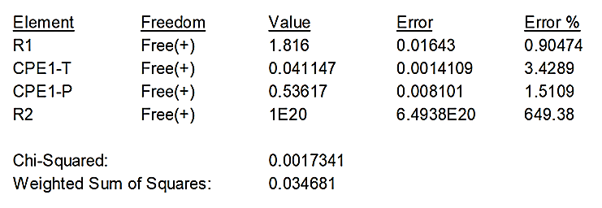

References
[1] Sheldrick, G.M. (2008). ActaCryst.A64, 112.
[2] Sheldrick, G. M. (2015). ActaCryst.C71, 3.
[3] APEX2, Bruker AXS Inc. Madison Wisconsin USA (2013).
[4] Macrae, C. F., Sovago, I., Cottrell, S. J., Galek, P. T. A., McCabe, P., Pidcock, E., Platings, M., Shields, G. P., Stevens, J. S., Towler, M. & Wood, P. A. (2020). J. Appl. Cryst. 53, 226-235.
[5] Farrugia, L. J. (2012). J. Appl. Cryst. 45, 849–854.
[6] G. Gao, X. Wang, Y. Ma, H. Rong, L. Lai, Q. Liu, A three-dimensional Co5-cluster-based MOF as a high-performance electrode material for supercapacitor, Ionics. 26 (2020) 5189–5197.
[7] K. Wang, R. Bi, M. Huang, B. Lv, H. Wang, C. Li, H. Wu, Q. Zhang, Porous Cobalt Metal–Organic Frameworks as Active Elements in Battery–Supercapacitor Hybrid Devices, Inorg. Chem. 59 (2020) 6808–6814.
[8] Y. Zhao, J. Zheng, M. Yuan, Y. Wang, W. Liu, S. Yang, G. Li, J. Lian, Y. Bu, Boosting the energy density of iron-cobalt oxide based hybrid supercapacitors by redox-additive electrolytes, Journal of Alloys and Compounds. 885 (2021) 160886.
[9] Y. Liu, Z. Wang, Y. Zhong, M. Tade, W. Zhou, Z. Shao, Molecular Design of Mesoporous NiCo2O4 and NiCo2S4 with Sub-Micrometer-Polyhedron Architectures for Efficient Pseudocapacitive Energy Storage, Advanced Functional Materials. 27 (2017) 1701229.
[10] Metal-organic framework derived carbon-coated spherical bimetallic nickel-cobalt sulfide nanoparticles for hybrid supercapacitors, ElectrochimicaActa. 385 (2021) 138433.
[11] Ni/Co-based metal organic frameworks rapidly synthesized in ambient environment for high energy and power hybrid supercapacitors, Applied Surface Science. 528 (2020) 146920.
[12] K. Tao, X. Han, Q. Ma, L. Han, A metal–organic framework derived hierarchical nickel–cobalt sulfide nanosheet array on Ni foam with enhanced electrochemical performance for supercapacitors, Dalton Trans. 47 (2018) 3496–3502.
[13] M. Azadfalah, A. Sedghi, H. Hosseini, H. Kashani, Cobalt based Metal Organic Framework/Graphene nanocomposite as high performance battery-type electrode materials for asymmetric Supercapacitors, Journal of Energy Storage. 33 (2021) 101925.
[14] T. Mukhiya, A.P. Tiwari, K. Chhetri, T. Kim, B. Dahal, A. Muthurasu, H.Y. Kim, A metal–organic framework derived cobalt oxide/nitrogen-doped carbon nanotube nanotentacles on electrospun carbon nanofiber for electrochemical energy storage, Chemical Engineering Journal. 420 (2021) 129679.

