Additional file 2: Supplementary analyses
Manuscript: "The great divergence of viral hepatitis in China, 2005–2020: vaccine-driven decline, diagnosis-driven rise, and the hepatitis E exception in a five-type surveillance panel"
Contents: Tables S2–S7; Figure S1. (Additional file 1 is Supplementary Table S1, the NIFDC per-batch vaccine-release records, provided as a separate .xlsx file.)
Table S2. Joinpoint regression detail by hepatitis type: segment-specific annual percent change (APC) and average APC (AAPC), for the 2005–2019 (primary) and 2005–2020 (sensitivity) models.
Model | Type | Joinpoints | Segment APCs | AAPC
2005-2019 | Hepatitis A | 2007, 2012, 2014 | 2005–2007: -0.8%; 2007–2012: -20.4%; 2012–2014: +0.8%; 2014–2019: -7.3% | -10.3%
2005-2019 | Hepatitis B | 2007, 2012, 2014 | 2005–2007: +8.7%; 2007–2012: -2.9%; 2012–2014: -7.4%; 2014–2019: +1.4% | -0.5%
2005-2019 | Hepatitis C | 2007, 2009, 2012 | 2005–2007: +30.7%; 2007–2009: +18.7%; 2009–2012: +14.1%; 2012–2019: +0.9% | +10.0%
2005-2019 | Hepatitis E | 2007, 2008, 2011 | 2005–2007: +14.3%; 2007–2008: -14.4%; 2008–2011: +14.4%; 2011–2019: -0.2% | +3.6%
2005-2020 | Hepatitis A | 2007, 2012, 2014 | 2005–2007: -0.8%; 2007–2012: -20.5%; 2012–2014: +1.4%; 2014–2020: -8.0% | -10.3%
2005-2020 | Hepatitis B | 2007, 2015, 2018 | 2005–2007: +9.9%; 2007–2015: -3.9%; 2015–2018: +2.6%; 2018–2020: -5.7% | -1.1%
2005-2020 | Hepatitis C | 2007, 2012, 2018 | 2005–2007: +32.5%; 2007–2012: +15.6%; 2012–2018: +0.8%; 2018–2020: -4.8% | +8.6%
2005-2020 | Hepatitis E | 2009, 2011, 2018 | 2005–2009: +4.4%; 2009–2011: +14.5%; 2011–2018: +0.3%; 2018–2020: -16.6% | +0.7%
Unspecified-type hepatitis: joinpoints and AAPC as reported in the main text (−11·9% per year, 2005–2019). APC values are per year.
Table S3. Seasonality of reported incidence by type: Edwards test statistics, 2005–2019 (day-adjusted monthly counts).
Type | Peak month | Seasonal amplitude (R) | Edwards χ² | P
Hepatitis A | 6.7 | 5.2% | 11,969 | <0·001
Hepatitis B | 4.2 | 3.7% | 171,157 | <0·001
Hepatitis C | 4.1 | 3.3% | 21,951 | <0·001
Hepatitis E | 3.0 | 14.0% | 58,093 | <0·001
Unspecified | 4.7 | 5.1% | 12,412 | <0·001
Table S4. Kitagawa decomposition of the change in crude reported rate per 100 000 from 2005 to 2019 (primary endpoint) and 2020 (sensitivity endpoint): rate effect versus age-structure effect.
Type | Endpoint year | Δ rate | Rate effect | Age-structure effect | Structure share
HAV | 2019 | -4.329 | -4.303 | -0.026 | 0.6%
HAV | 2020 | -4.653 | -4.62 | -0.033 | 0.7%
HEV | 2019 | 0.801 | 0.633 | 0.168 | 21.0%
HEV | 2020 | 0.142 | 0.006 | 0.136 | 95.8%
The 2005→2020 endpoint for hepatitis E is a COVID-era artefact (reporting collapse in young ages) and should not be interpreted demographically.
Table S5. Warming-attributable reported cases, 2005–2020, by age band (two-stage DLNM attribution; hepatitis E values from the companion study).
Type | Ages 0–19 | Ages 20–59 | Ages ≥60 | Total
HAV | -638 | -808 | 477 | -969
HEV | -49 | 1247 | 1102 | 2300
Table S6. Hepatitis A decline by provincial vaccine type (two-dose inactivated EPI provinces vs one-dose live attenuated provinces), 2005/2008/2019.
Population | Vaccine group | Rate 2005 | Rate 2008 | Rate 2019 | APC 2008–2019 | Decline 2008–2019
全人群 | Inactivated (Beijing, Tianjin, Shanghai, Jiangsu) | 2.73 | 1.99 | 0.89 | -6.04% | -55.5%
全人群 | Live attenuated (27 provinces) | 6.02 | 4.52 | 1.43 | -9.73% | -68.3%
0-19岁 | Inactivated (Beijing, Tianjin, Shanghai, Jiangsu) | 1.06 | 1.06 | 0.1 | -17.61% | -91.0%
0-19岁 | Live attenuated (27 provinces) | 7.82 | 6.94 | 0.47 | -20.07% | -93.3%
Table S7. Reported cases, deaths and case fatality by hepatitis type, 2005–2020.
Type | Cases | Deaths | CFR per 1 000
Hepatitis C | 2,656,625 | 1,897 | 0.7141
Hepatitis B | 16,533,417 | 9,704 | 0.5869
Hepatitis E | 388,867 | 423 | 1.0878
Hepatitis A | 571,552 | 200 | 0.3499
肝炎未分型 | 611,639 | — | —
Figure S1. National batch-release volumes of hepatitis A vaccines, by vaccine type, 2019–2020 (NIFDC per-batch records; Additional file 1).
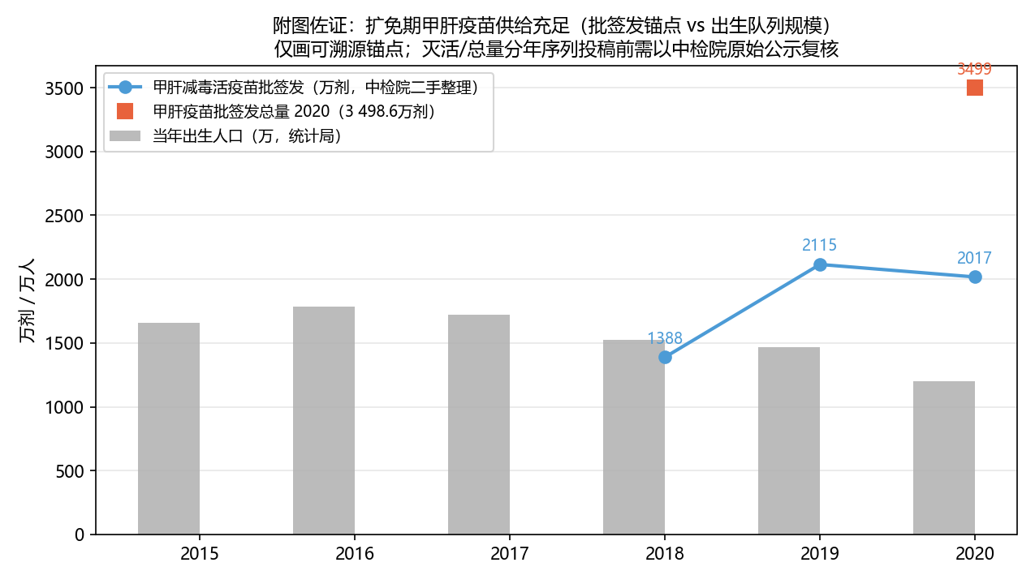
Vertical reference: annual birth cohort (14.65 million in 2019; 12.00 million in 2020, National Bureau of Statistics). Live attenuated releases alone exceeded the birth cohort by 44% (2019) and 68% (2020).

