SUPPLEMENTARY INFORMATON
Metabolic profiling reveals interleukin-17A monoclonal antibody treatment ameliorate lipids metabolism with the potentiality to reduce cardiovascular risk in psoriasis patients

Han Cao^{a,c}, Shengmin Su^{a,c}, Qi Yang^{b}, Yunchen Le^{b}, Lihong Chen^{b}, Mengyan Hu^{b}, Xiaoyu Guoª, Jie Zheng^{b}, Xia Li^{b*}, Yunqiu Yu^{a*}
ªSchool of Pharmacy, Fudan University, Shanghai 201203, PR China
^{b}Department of Dermatology, Ruijin Hospital, School of Medicine, Shanghai Jiaotong University, Shanghai 200025, PR China
^{c}These authors contributed equally

*Corresponding author: Yunqiu Yu, Email: yqyu@shmu.edu.cn; Xia Li, Email: drlixia@126.com

Table S1. Differential metabolites between different groups
Metabolites | RT  (min) | m/z | level | p value  (vs Pso) |  |  | VIP value  (vs Pso) |  | Fold change  (vs Pso)
 |  |  |  | Con | Ixe | Con |  | Ixe | Con | Tread | Ixe | Trend
LPC (16:1) | 11.15 | 494.3250 | 2 | 0.008 | 0.001 | 0.27 |  | 1.83 | 1.38 | ↑ | 0.77 | ↓
LPC (18:0) | 14.63 | 546.3530 | 1 | 5.65E-05 | 1.06E-05 | 1.94 |  | 6.06 | 1.44 | ↑ | 0.62 | ↓
LPC (18:1) | 12.86 | 522.3559 | 1 | 0.001 | 4.16E-07 | 5.34 |  | 10.95 | 1.33 | ↑ | 0.60 | ↓
LPC (18:2) | 11.69 | 520.3403 | 1 | 1.12E-09 | 4.78E-10 | 18.69 |  | 22.92 | 1.56 | ↑ | 0.56 | ↓
LPC (20:2) | 13.45 | 592.3610 | 2 | 1.12E-09 | 0.009 | 2.61 |  | 1.78 | 1.93 | ↑ | 0.83 | ↓
LPC (20:3) | 12.31 | 546.3558 | 2 | 2.09E-08 | 8.72E-08 | 8.8 |  | 8.80 | 3.26 | ↑ | 0.37 | ↓
LPC (20:4) | 11.76 | 544.3400 | 2 | 1.02E-08 | 3.76E-05 | 12.62 |  | 13.35 | 1.96 | ↑ | 0.46 | ↓
LPC (20:5) | 11.69 | 542.3222 | 2 | 1.13E-09 | 2.64E-10 | 7.67 |  | 9.42 | 1.39 | ↑ | 0.64 | ↓
LPC (22:5) | 12.14 | 570.3556 | 2 | 4.64E-12 | 5.51E-08 | 3.67 |  | 3.65 | 3.30 | ↑ | 0.30 | ↓
LPC (22:6) | 11.73 | 568.3402 | 2 | 1.09E-07 | 9.46E-10 | 6.27 |  | 7.73 | 1.88 | ↑ | 0.44 | ↓
LPC (O-16:0) | 12.74 | 482.3609 | 2 | 0.382 | 5.85E-05 | 0.41 |  | 2.23 | 1.08 | ↑ | 0.67 | ↓
LPC (O-18:0) | 15.38 | 510.3919 | 2 | 0.203 | 8.69E-07 | 0.42 |  | 1.41 | 1.12 | ↑ | 0.59 | ↓
LPE (18:0) | 14.53 | 482.3245 | 2 | 0.005 | 0.001 | 1.62 |  | 1.98 | 1.43 | ↑ | 0.72 | ↓
LPI (16:0) | 12.34 | 571.2903 | 1 | 3.49E-13 | 0.001 | 2.87 |  | 2.23 | 3.65 | ↑ | 0.65 | ↓
LPI (18:0) | 15.25 | 599.3199 | 1 | 9.98E-14 | 0.001 | 6.77 |  | 4.46 | 2.85 | ↑ | 0.75 | ↓
LPI (18:2) | 11.66 | 595.2893 | 2 | 2.98E-10 | 0.012 | 3.59 |  | 2.23 | 2.01 | ↑ | 0.83 | ↓
LPI (20:4) | 11.77 | 619.2886 | 1 | 3.39E-14 | 0.001 | 5.97 |  | 4.27 | 2.54 | ↑ | 0.76 | ↓
LPA (20:4) | 13.64 | 457.2363 | 1 | 0.002 | 0.043 | 2.38 |  | 1.16 | 2.54 | ↑ | 0.87 | ↓
S1P | 10.58 | 378.2414 | 1 | 9.64E-08 | 0.005 | 2.15 |  | 1.72 | 1.45 | ↑ | 0.85 | ↓
PC (35:6) | 18.94 | 781.5571 | 2 | 0.019 | 0.026 | 3.51 |  | 3.31 | 0.75 | ↓ | 1.37 | ↑
PC (20:4/18:0) | 18.94 | 810.6010 | 2 | 0.154 | 0.026 | 3.31 |  | 4.59 | 0.62 | ↓ | 1.90 | ↑
L-Carnitine | 1.03 | 162.1123 | 1 | 0.003 | 0.008 | 2.58 |  | 2.29 | 1.17 | ↑ | 0.87 | ↓
L-Acetylcarnitine | 1.04 | 204.1226 | 2 | 1.48E-14 | 1.41E-08 | 4.13 |  | 3.36 | 0.43 | ↓ | 2.01 | ↑
L-Octanoylcarnitine | 6.42 | 288.2172 | 1 | 0.001 | 0.877 | 1.43 |  | 0.97 | 0.60 | ↓ | 0.97 | ↓
9-Decenoylcarnitine | 7.19 | 314.2328 | 2 | 4.82E-05 | 0.731 | 1.68 |  | 0.94 | 0.58 | ↓ | 0.94 | ↓
Decanoylcarnitine | 7.86 | 316.2486 | 2 | 0.002 | 0.944 | 1.88 |  | 1.01 | 0.59 | ↓ | 1.01 | ↑
Glycerophosphocholine | 0.95 | 280.0921 | 1 | 7.14E-23 | 4.05E-12 | 3.55 |  | 1.61 | 6.04 | ↑ | 0.17 | ↓
Palmitic amide | 17.91 | 256.2637 | 1 | 0.005 | 0.008182218 | 2.09 |  | 5.71 | 1.87 | ↑ | 0.56 | ↓
Oleamide | 18.62 | 282.2796 | 1 | 0.002 | 0.008 | 5.56 |  | 2.11 | 1.85 | ↑ | 0.55 | ↓
Palmitic acid | 17.91 | 256.2637 | 1 | 4.83E-06 | 0.524 | 1.34 |  | 0.96 | 1.64 | ↑ | 0.21 | ↓
Oleic acid | 20.29 | 281.2479 | 1 | 2.27E-06 | 0.394 | 2.01 |  | 0.93 | 1.58 | ↑ | 0.64 | ↓
Linoleic acid | 18.97 | 279.2325 | 1 | 2.27E-06 | 0.280 | 2.75 |  | 0.94 | 1.63 | ↑ | 0.47 | ↓
Arachidonic acid | 18.74 | 303.2327 | 1 | 0.001 | 0.752 | 1.35 |  | 0.90 | 1.26 | ↑ | 0.17 | ↓
13-Hydroxyhexadecanoic acid | 17.01 | 271.2277 | 2 | 0.010 | 0.031 | 2.68 |  | 2.28 | 1.70 | ↑ | 0.94 | ↓
3-Hydroxyvaleric acid | 4.06 | 117.0553 | 2 | 0.002 | 0.086 | 1.91 |  | 0.83 | 1.70 | ↑ | 0.91 | ↓
3-Methyl-2-oxovaleric acid | 4.82 | 129.0552 | 2 | 1.75E-05 | 0.151 | 1.67 |  | 0.90 | 1.35 | ↑ | 0.86 | ↓
3-Hydroxydodecanedioic acid | 6.35 | 245.1384 | 2 | 4.05E-06 | 0.009 | 4.48 |  | 8.36 | 1.31 | ↑ | 1.31 | ↑
Suberic acid | 5.24 | 173.0828 | 2 | 0.019 | 0.002 | 1.56 |  | 1.54 | 0.39 | ↓ | 2.48 | ↑
Azelaic acid | 5.83 | 187.0965 | 1 | 0.013 | 0.056 | 8.88 |  | 2.09 | 0.46 | ↓ | 11.4 | ↑
Sebacic acid | 6.41 | 201.1125 | 2 | 0.019 | 0.002 | 2.09 |  | 2.28 | 0.47 | ↓ | 2.35 | ↑
Undecanedioic acid | 7.08 | 215.1284 | 1 | 1.63E-05 | 0.013 | 2.77 |  | 3.94 | 0.43 | ↓ | 2.47 | ↑
9-Oxohexadecanoic acid | 11.31 | 329.2334 | 2 | 0.002 | 0.006 | 0.63 |  | 1.51 | 0.75 | ↓ | 1.96 | ↑
Indoxyl sulfate | 4.65 | 212.0021 | 2 | 0.001 | 0.624 | 2.12 |  | 0.65 | 2.48 | ↑ | 0.85 | ↓

Fig S1. a, b. PCA score plots of CON, PSO and IXE group in positive ion and negative ion modes in study cohort 1. c, d. OPLS-DA score plots of CON group versus PSO group in positive and negative ion modes. e, f. Score plots of OPLS-DA model for IXE group versus PSO group in positive and negative ion modes. CON group is labelled by green cycles, PSO group by red cycles and IXE group by blue cycles.
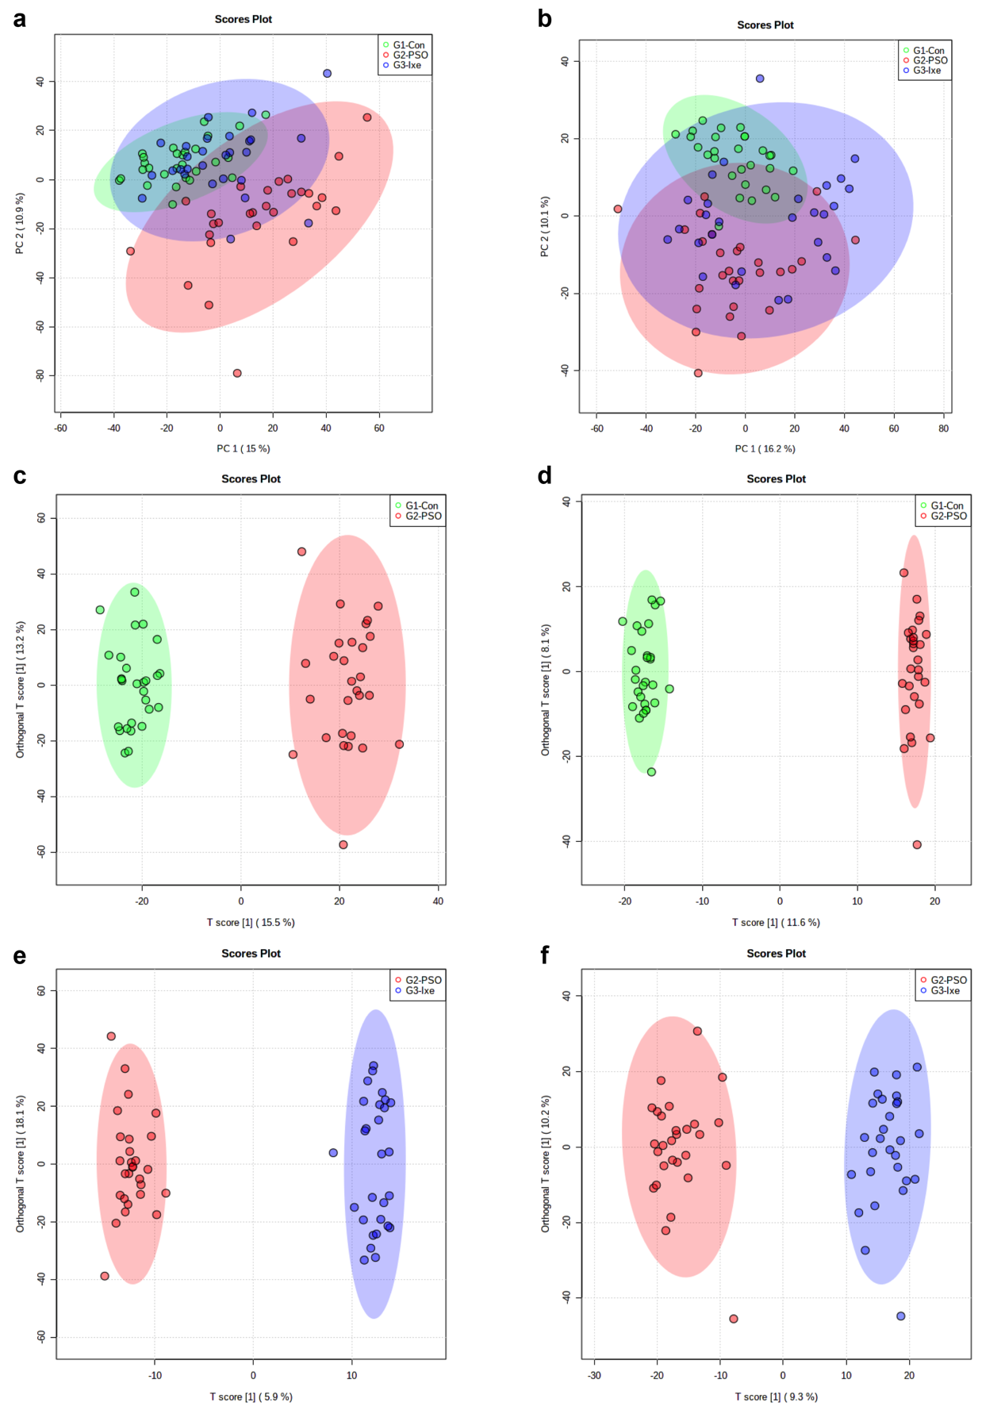

Fig S2. Screen criteria for identified differential metabolites in the IXE/PSO comparison in the study cohort 1. a. Volcano plot represents the variation of metabolites in the comparison of IXE/PSO group according to the -log(p-value). b. Score plots for covariance and reliability correlation from OPLS-DA in the IXE/PSO comparison. c. 31 identified differential metabolites in the IXE/PSO comparison. Bar plots represent, from left to right, −log(p-value) of t-test, fold change and VIP values obtained from OPLS-DA.
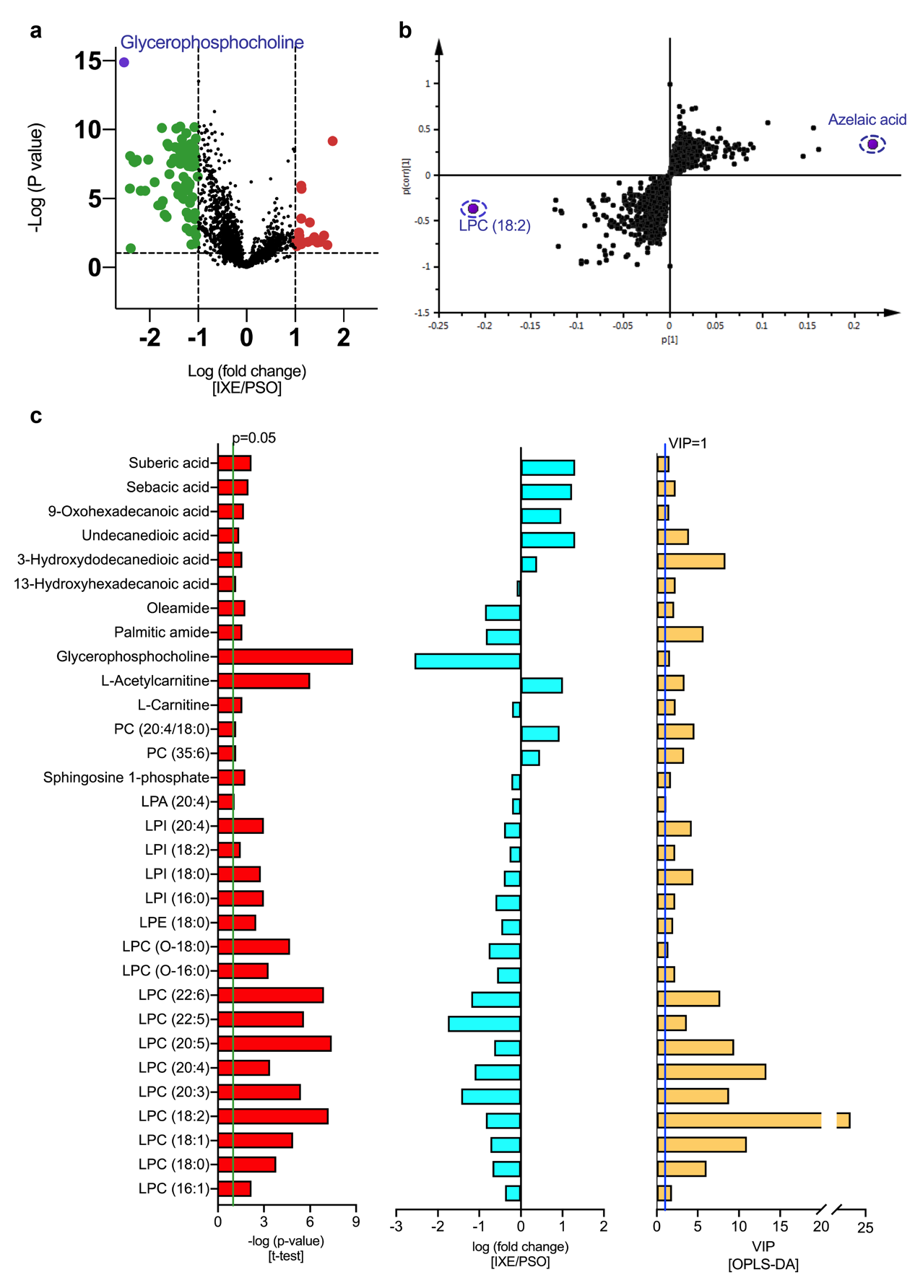

Fig S3. All the identified metabolites are conducted on ROC curve analysis, which is generally considered to be the gold standard for the assessment of biomarkers performance. a. The ROC curve of 38 differential metabolites and heatmap of area under the curve in the PSO/CON comparison. (b) The ROC curve of 31 differential metabolites and heatmap of area under the curve in the IXE/PSO comparison.
