Additional file 1
Predicting recurrence of biliary colic after conservative management in the emergency department: a prospective cohort study with a parametric Weibull survival model
David Alejandro Benalcázar Villavicencio, Diana Gabriela Ibadango Ávila
Supplementary tables and figures
Table S1 Univariable Cox regression of all candidate predictors, unstratified and stratified by Murphy's sign
Variable | Events/exposed | HR (95% CI) | p | HR (95% CI), stratified by Murphy's sign | p, stratified | Schoenfeld p
Age, years | — | 1.00 (0.99–1.01) | 0.613 | 1.00 (1.00–1.01) | 0.380 | 0.81
Age ≥30 years | 142/348 | 0.72 (0.55–0.95) | 0.021 | 0.92 (0.70–1.21) | 0.551 | 0.34
Female sex | 175/388 | 1.06 (0.77–1.47) | 0.700 | 1.07 (0.78–1.48) | 0.658 | 0.90
Height, cm | — | 1.00 (0.99–1.02) | 0.727 | 1.00 (0.99–1.01) | 0.974 | 0.64
Weight, kg | — | 1.00 (0.99–1.01) | 0.443 | 1.00 (0.99–1.01) | 0.722 | 0.94
Body mass index, kg/m² | — | 1.01 (0.98–1.04) | 0.461 | 1.01 (0.98–1.04) | 0.607 | 0.67
Obesity (BMI ≥30) | 82/176 | 1.09 (0.83–1.44) | 0.521 | 1.03 (0.79–1.36) | 0.811 | 0.74
Obesity class II (BMI ≥35) | 26/64 | 0.92 (0.61–1.39) | 0.697 | 0.93 (0.62–1.40) | 0.737 | 0.34
Heart rate, beats/min | — | 0.99 (0.98–1.00) | 0.093 | 0.99 (0.98–1.00) | 0.066 | 0.88
Tachycardia (≥100 beats/min) | 16/44 | 0.83 (0.50–1.39) | 0.481 | 0.84 (0.50–1.39) | 0.491 | 0.81
Systolic blood pressure, mmHg | — | 1.00 (0.99–1.00) | 0.333 | 1.00 (0.99–1.01) | 0.633 | 0.89
Diastolic blood pressure, mmHg | — | 0.99 (0.98–1.00) | 0.100 | 0.99 (0.98–1.01) | 0.413 | 0.80
Mean arterial pressure, mmHg | — | 0.99 (0.98–1.00) | 0.133 | 1.00 (0.98–1.01) | 0.456 | 0.82
Hypertension at presentation (SBP ≥140 or DBP ≥90) | 49/117 | 0.90 (0.66–1.24) | 0.529 | 0.96 (0.70–1.32) | 0.820 | 0.77
Hypotension (MAP ≤65 mmHg) | 3/6 | 1.59 (0.51–4.98) | 0.425 | 1.21 (0.39–3.79) | 0.740 | 0.69
History of diabetes mellitus | 17/25 | 1.98 (1.20–3.25) | 0.007 | 2.00 (1.22–3.29) | 0.006 | 0.31
History of hypertension | 29/51 | 1.43 (0.97–2.11) | 0.072 | 1.44 (0.98–2.13) | 0.067 | 0.41
Symptom duration, hours | — | 1.00 (1.00–1.00) | 0.336 | 1.00 (1.00–1.00) | 0.577 | 0.74
Symptom duration >48 h | 36/82 | 1.00 (0.70–1.43) | 0.996 | 1.04 (0.73–1.49) | 0.828 | 0.63
First-ever episode | 106/264 | 0.81 (0.62–1.05) | 0.111 | 0.90 (0.69–1.17) | 0.410 | 0.69
Fever (≥37.5 °C) | 15/35 | 1.06 (0.63–1.80) | 0.815 | 0.78 (0.46–1.32) | 0.360 | 0.28
Nausea | 168/378 | 1.07 (0.79–1.45) | 0.657 | 0.99 (0.73–1.34) | 0.924 | 0.82
Positive Murphy's sign | 196/320 | 6.41 (4.28–9.61) | <0.001 | Stratification variable | — | 0.01
Pharmacological treatment at first contact | 99/221 | 1.03 (0.79–1.34) | 0.830 | 0.96 (0.74–1.25) | 0.769 | 0.91
Leukocytes, ×10³/µL | — | 1.00 (0.96–1.04) | 0.912 | 1.00 (0.96–1.04) | 0.972 | 0.66
Leukocytes, categorical (≤12; 12.1–18; ≥18.1 ×10³/µL) | — | 0.88 (0.62–1.24) | 0.452 | 0.93 (0.66–1.30) | 0.663 | 0.91
Leukocytosis ≥18 ×10³/µL | 5/5 | 3.41 (1.40–8.31) | 0.007 | 2.12 (0.87–5.17) | 0.099 | 0.67
Neutrophils, % | — | 1.00 (0.99–1.01) | 0.690 | 1.00 (0.99–1.01) | 0.378 | 0.97
Neutrophils ≥75% | 68/156 | 1.00 (0.75–1.33) | 0.983 | 1.05 (0.79–1.40) | 0.718 | 0.34
GGT, U/L | — | 1.00 (1.00–1.00) | 0.784 | 1.00 (1.00–1.00) | 0.828 | 0.33
GGT ≥ULN (32 U/L) | 129/301 | 0.94 (0.72–1.23) | 0.674 | 0.96 (0.73–1.25) | 0.758 | 0.23
Alkaline phosphatase, U/L | — | 1.00 (1.00–1.00) | 0.646 | 1.00 (1.00–1.00) | 0.879 | 0.62
Alkaline phosphatase ≥ULN (129 U/L) | 46/111 | 0.95 (0.69–1.32) | 0.772 | 0.95 (0.69–1.31) | 0.748 | 0.53
AST, U/L | — | 1.00 (1.00–1.00) | 0.155 | 1.00 (1.00–1.00) | 0.259 | 0.20
AST ≥ULN (32 U/L) | 80/200 | 0.84 (0.64–1.10) | 0.206 | 0.88 (0.67–1.15) | 0.340 | 0.09
ALT, U/L | — | 1.00 (1.00–1.00) | 0.664 | 1.00 (1.00–1.00) | 0.588 | 0.15
ALT ≥ULN (35 U/L) | 80/207 | 0.80 (0.61–1.05) | 0.105 | 0.80 (0.61–1.06) | 0.119 | 0.02
Total bilirubin, mg/dL | — | 1.17 (0.99–1.38) | 0.067 | 1.11 (0.94–1.30) | 0.212 | 0.92
Total bilirubin ≥1.1 mg/dL | 35/69 | 1.33 (0.92–1.90) | 0.125 | 1.19 (0.83–1.70) | 0.357 | 0.99
Total bilirubin >1.5 mg/dL | 22/42 | 1.33 (0.86–2.07) | 0.204 | 1.15 (0.74–1.79) | 0.538 | 0.66
Direct bilirubin, mg/dL | — | 1.40 (1.08–1.81) | 0.011 | 1.22 (0.95–1.58) | 0.120 | 0.59
Direct bilirubin ≥0.3 mg/dL | 93/227 | 0.94 (0.72–1.23) | 0.648 | 1.01 (0.77–1.32) | 0.943 | 0.49
Indirect bilirubin, mg/dL | — | 1.16 (0.82–1.64) | 0.404 | 1.12 (0.80–1.57) | 0.514 | 0.66
Indirect bilirubin ≥0.8 mg/dL | 22/46 | 1.16 (0.75–1.81) | 0.500 | 1.13 (0.73–1.76) | 0.580 | 0.60
Sclero-atrophic gallbladder | 0/2 | NE | — | NE | — | —
Gallbladder hydrops | 2/5 | 1.88 (0.47–7.61) | 0.374 | 1.23 (0.30–4.95) | 0.775 | 0.95
Wall thickening (≥4 mm) | 24/53 | 1.13 (0.74–1.73) | 0.571 | 0.83 (0.54–1.27) | 0.397 | 0.62
Single stone | 58/128 | 1.08 (0.80–1.46) | 0.632 | 0.95 (0.70–1.29) | 0.760 | 0.30
Multiple stones | 150/358 | 0.93 (0.69–1.26) | 0.632 | 1.05 (0.77–1.42) | 0.760 | 0.30
Stone diameter, mm | — | 0.99 (0.97–1.01) | 0.235 | 0.99 (0.97–1.01) | 0.165 | 0.39
Stone diameter ≤2 mm | 4/15 | 0.58 (0.21–1.55) | 0.275 | 0.52 (0.19–1.41) | 0.199 | 0.57
Stone diameter ≥10 mm | 96/232 | 0.86 (0.65–1.12) | 0.263 | 0.82 (0.63–1.08) | 0.159 | 0.33
Biliary sludge | 31/64 | 1.32 (0.90–1.93) | 0.155 | 1.37 (0.94–2.00) | 0.106 | 0.32
Wall–echo–shadow sign | 12/31 | 0.92 (0.52–1.65) | 0.790 | 1.35 (0.75–2.42) | 0.315 | 0.93
Impacted stone in gallbladder neck | 15/23 | 1.72 (1.02–2.91) | 0.043 | 1.47 (0.87–2.48) | 0.154 | 0.57
HR hazard ratio, CI confidence interval, NE not estimable, ULN upper limit of normal, BMI body mass index, SBP/DBP systolic/diastolic blood pressure, MAP mean arterial pressure, GGT gamma-glutamyl transferase, AST aspartate aminotransferase, ALT alanine aminotransferase. Events/exposed = recurrences/patients with the characteristic. The Schoenfeld column gives the p value of the proportional hazards test for the unstratified model (p < 0.05 indicates violation). The stratified analysis estimates the effect of each variable within strata defined by Murphy's sign, which therefore has no HR in that column.
Table S2 Comparison of discrimination and fit across the four multivariable specifications
Metric | Cox, stratified by Murphy's sign | Cox, Murphy's sign as covariate | Weibull, "stratified" by Murphy's sign | Weibull, Murphy's sign as covariate (final)
Harrell's C-index | 0.518 | 0.690 | 0.692 | 0.692
Somers' D | 0.036 | 0.380 | 0.384 | 0.384
AIC | 2308.6 | 2471.8 | 1463.3 | 1461.6
Proportional hazards assumption satisfied | Yes (global p = 0.249) | No (Murphy's sign p = 0.006; global p = 0.012) | Not applicable | Not applicable
AIC Akaike information criterion. Harrell's C and Somers' D for the Weibull models were computed on the model linear predictor with correction for censoring. AIC is comparable only within the same likelihood family. The parametric "stratified" specification retains Murphy's sign as a covariate and additionally lets it modify the shape parameter.
Table S3 Weibull model with Murphy's sign modifying the shape parameter ("stratified" specification)
Parameter | Estimate | 95% CI | p
Diabetes mellitus, HR | 2.18 | 1.33–3.57 | 0.002
Shape parameter γ (reference stratum) | 0.46 (ln γ = −0.775) | — | <0.001
Interaction ln γ × Murphy's sign, χ² (1 df) | 0.30 | — | 0.582
AIC | 1463.3 | — | —
HR hazard ratio, CI confidence interval, df degrees of freedom, AIC Akaike information criterion. N = 507; events = 223. The effect of Murphy's sign in this specification varies over time and is not summarized by a single HR; its HR under the final model is given in Table 4.
Table S4 Histopathological findings in resected gallbladders (n = 157)
Finding | n (%)
Chronic cholecystitis | 103 (65.6)
Acute-on-chronic cholecystitis | 24 (15.3)
Acute cholecystitis | 18 (11.5)
Chronic follicular cholecystitis | 2 (1.3)
Chronic hyalinising cholecystitis | 1 (0.6)
Chronic granulomatous cholecystitis | 1 (0.6)
Adenocarcinoma | 2 (1.3)
At least one pathological finding | 149 (94.9)
No pathological finding | 8 (5.1)
Percentages are calculated over the 157 patients who underwent cholecystectomy (before or after the index event) and had a pathology report. The two adenocarcinomas coexisted with acute-on-chronic cholecystitis, so the sum of diagnoses (151) exceeds the number of specimens with at least one finding (149).
Table S5 Biliary complications during follow-up (N = 507)
Complication | n (%)
Any biliary complication | 54 (10.7)
Acute-on-chronic cholecystitis | 24 (4.7)
Acute cholecystitis | 18 (3.6)
Biliary pancreatitis | 9 (1.8)
Choledocholithiasis | 5 (1.0)
Mirizzi syndrome | 2 (0.4)
Cholangitis | 2 (0.4)
Gallstone ileus | 1 (0.2)
Percentages over the whole cohort. Categories are not mutually exclusive: 61 complications occurred in 54 patients (seven patients had two concurrent complications). Acute and acute-on-chronic cholecystitis were defined clinically by decompensation with clinical and laboratory criteria.

Figure S1 Model-based survival and hazard functions of the final Weibull model.
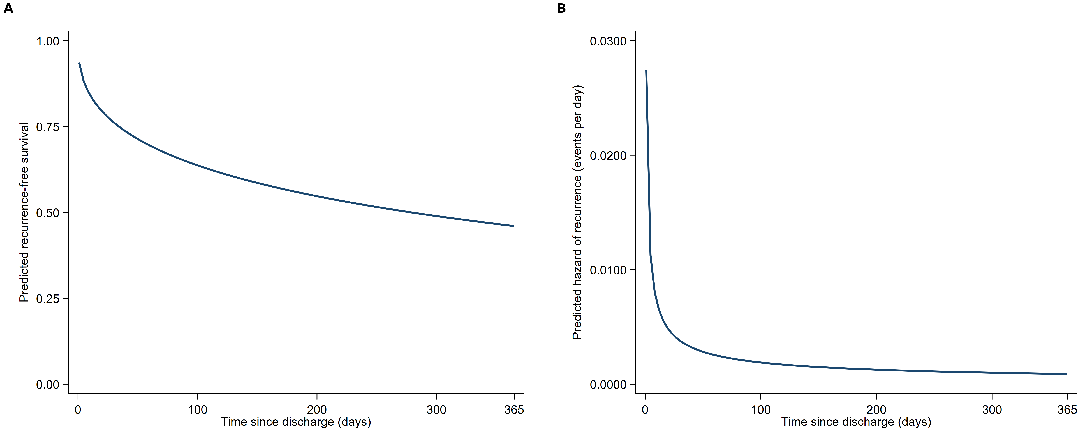
A Survival function estimated by the Weibull model, showing a steep early decline followed by a progressively flatter slope. B Estimated hazard function, high immediately after discharge and declining monotonically toward low values, as expected for a shape parameter γ < 1.

Figure S2 Diagnostics of the final Weibull model.
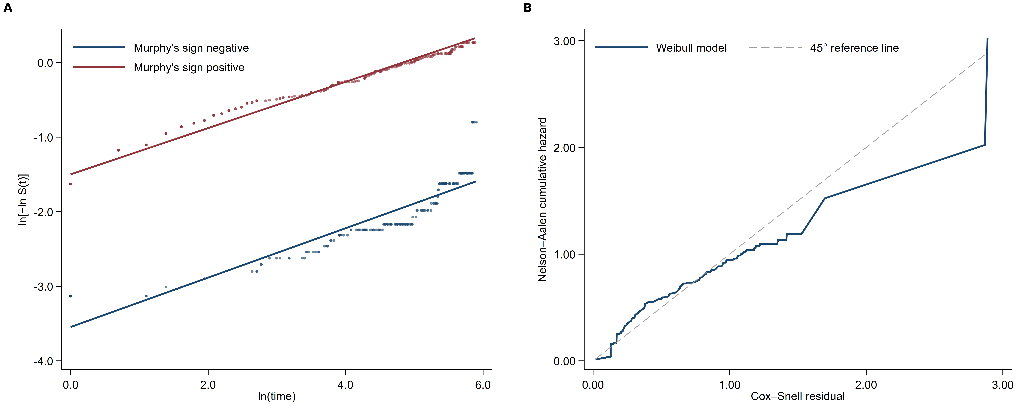
A Complementary log–log plot, ln[−ln S(t)] versus ln(t), by Murphy's sign strata (positive, red; negative, blue): approximately linear and parallel trajectories support the Weibull functional form and comparable shape parameters. B Cox–Snell residuals: the estimated cumulative hazard follows the 45° reference line, with divergence only in the sparsely populated right tail.

Figure S3 Distribution of time to recurrence and hazard curves by risk profile.
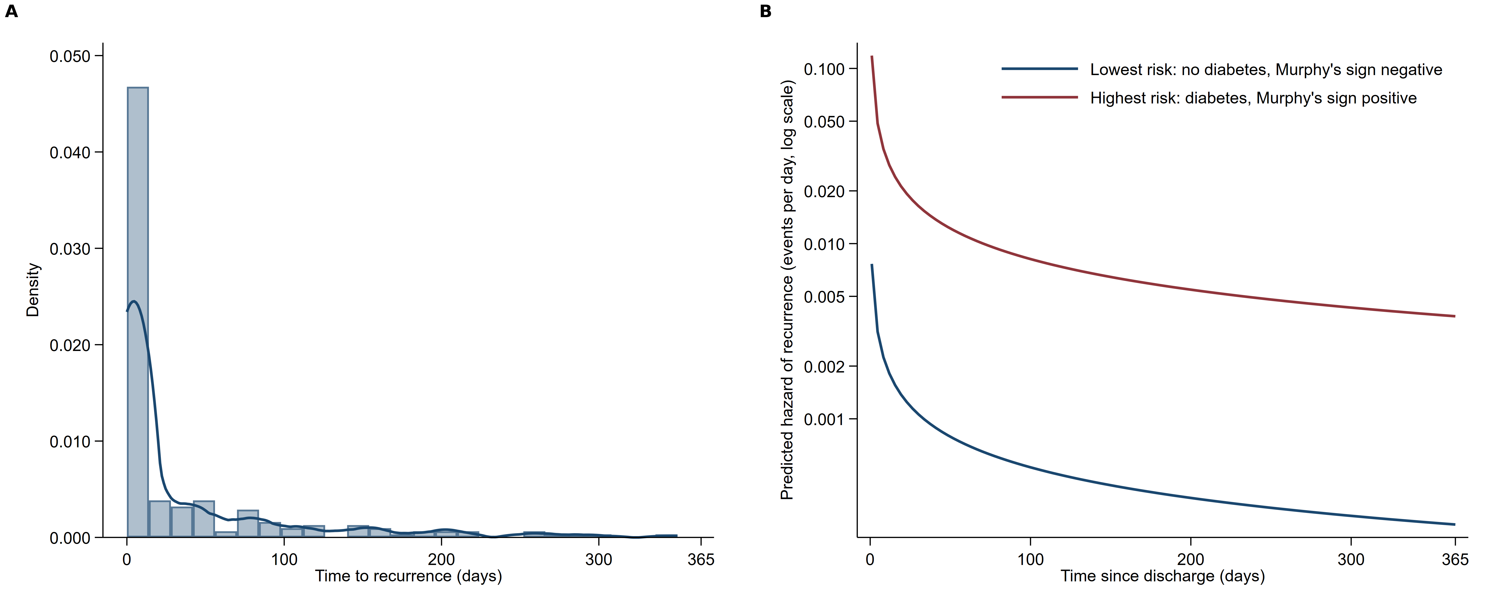
A Kernel density of time to recurrence, markedly right-skewed with a peak in the first days after discharge. B Model-based hazard curves for the lowest-risk (no predictor; blue) and highest-risk (positive Murphy's sign and diabetes; red) profiles on a logarithmic scale, illustrating the constant multiplicative separation implied by the proportional hazards metric.

