Table S1. Database Search Strategies

Ovid MEDLINE(R) ALL 1946 to January 22, 2025

# | Searches | Results
1 | Biomarkers/ | 376799
2 | (biomarker* or "bio-marker*" or "tumor marker* or tumour marker*").ti,ab. | 467751
3 | ((biologic* or clinical or surrogate or endpoint* or immun* or laboratory or serum or viral or biochemical or "bio-chemical") adj marker*).ti,ab. | 77106
4 | or/1-3 [Biomarkers] | 756754
5 | Radiomics/ | 1625
6 | Magnetic Resonance Imaging/ | 502670
7 | Positron Emission Tomography Computed Tomography/ | 22871
8 | "Tomography, X-Ray Computed"/ | 433648
9 | "Image Interpretation, Computer-Assisted"/ | 49311
10 | "Image Processing, Computer-Assisted"/ | 147184
11 | ("magnetic resonance imag*" or MRI or "NMR imag*" or "spin echo imag*" or "chemical shift imag*" or zeugmatography or "NMR tomography" or "MR tomography" or "proton spin tomography" or "PET-CT" or "CT-PET" or "positron emission tomography-computed tomography" or "computer-assisted image interpret*" or "computer-assisted image process*" or "computer-assisted image analys*" or "digital image process*" or "medical image process*" or "image reconstruction*" or "biomedical image process*" or "bio-medical image process*" or radiomic*).ti,ab. | 577739
12 | or/5-11 [Imaging] | 1239136
13 | 4 and 12 [Biomarkers + Imaging] | 40187
14 | exp Radiation Injuries/ | 78265
15 | Radiotherapy/ae [Adverse Effects] | 19382
16 | ("radiation-induced" or radiosensitivit* or "radio-sensitivit*" or "radiation injur*" or "radiation syndrome*" or "radiation sick*" or "radiation pneumoni*" or "normal tissue complication probability" or "adverse effect*" or toxicit*).ti,ab. | 780988
17 | (effect* adj2 radiation).ti,ab. | 17611
18 | or/14-17 [Radiation Toxicities] | 856081
19 | 13 and 18 [Biomarkers + Imaging + Radiation Toxicities] | 843

Embase Classic+Embase 1947 to 2025 January 22

# | Searches | Results
1 | Biological Marker/ | 522229
2 | (biomarker* or "bio-marker*" or "tumor marker* or tumour marker*").ti,ab. | 685563
3 | ((biologic* or clinical or surrogate or endpoint* or immun* or laboratory or serum or viral or biochemical or "bio-chemical") adj marker*).ti,ab. | 118352
4 | or/1-3 [Biomarkers] | 930101
5 | Radiomics/ | 13296
6 | Nuclear Magnetic Resonance Imaging/ | 1088801
7 | Positron Emission Tomography-Computed Tomography/ | 79065
8 | X-Ray Computed Tomography/ | 110891
9 | Computer Assisted Diagnosis/ | 43275
10 | Image Processing/ | 109820
11 | ("magnetic resonance imag*" or MRI or "NMR imag*" or "spin echo imag*" or "chemical shift imag*" or zeugmatography or "NMR tomography" or "MR tomography" or "proton spin tomography" or "PET-CT" or "CT-PET" or "positron emission tomography-computed tomography" or "computer-assisted image interpret*" or "computer-assisted image process*" or "computer-assisted image analys*" or "digital image process*" or "medical image process*" or "image reconstruction*" or "biomedical image process*" or "bio-medical image process*" or radiomic*).ti,ab. | 894584
12 | or/5-11 [Imaging] | 1576527
13 | 4 and 12 [Biomarkers + Imaging] | 65283
14 | exp Radiation Injury/ | 98131
15 | exp Radiotherapy/ae, co [Adverse Drug Reaction, Complication] | 6784
16 | ("radiation-induced" or radiosensitivit* or "radio-sensitivit*" or "radiation injur*" or "radiation syndrome*" or "radiation sick*" or "radiation pneumoni*" or "normal tissue complication probability" or "adverse effect*" or toxicit*).ti,ab. | 1105604
17 | (effect* adj2 radiation).ti,ab. | 26035
18 | or/14-17 [Radiation Toxicities] | 1186771
19 | 13 and 18 [Biomarkers + Imaging + Radiation Toxicities] | 2185

Cochrane

ID | Search | Hits
#1 | MeSH descriptor: [Biomarkers] this term only | 21704
#2 | (biomarker* or (bio NEXT marker*) or (tumor NEXT marker*) or (tumour NEXT marker*)):ti,ab | 45283
#3 | ((biologic* or clinical or surrogate or endpoint* or immun* or laboratory or serum or viral or biochemical or "bio-chemical") NEAR/1 marker*):ti,ab | 9386
#4 | {or #1-#3} | 66857
#5 | MeSH descriptor: [Radiomics] this term only | 59
#6 | MeSH descriptor: [Magnetic Resonance Imaging] this term only | 11819
#7 | MeSH descriptor: [Positron Emission Tomography Computed Tomography] this term only | 473
#8 | MeSH descriptor: [Tomography, X-Ray Computed] this term only | 6583
#9 | MeSH descriptor: [Image Interpretation, Computer-Assisted] this term only | 1082
#10 | MeSH descriptor: [Image Processing, Computer-Assisted] this term only | 2378
#11 | (("magnetic resonance" NEXT imag*) or MRI or (NMR NEXT imag*) or ("spin echo" NEXT imag*) or ("chemical shift" NEXT imag*) or zeugmatography or "NMR tomography" or "MR tomography" or "proton spin tomography" or "PET-CT" or "CT-PET" or "positron emission tomography-computed tomography" or ("computer-assisted image" NEXT interpret*) or ("computer-assisted image" NEXT process*) or ("computer-assisted image" NEXT analys*) or ("digital image" NEXT process*) or ("medical image" NEXT process*) or (image NEXT reconstruction*) or ("biomedical image" NEXT process*) or ("bio-medical image" NEXT process*) or radiomic*):ti,ab | 47658
#12 | {or #5-#11} | 57668
#13 | #4 and #12 | 4466
#14 | MeSH descriptor: [Radiation Injuries] explode all trees | 2132
#15 | MeSH descriptor: [Radiotherapy] this term only and with qualifier(s): [adverse effects - AE] | 1034
#16 | ("radiation-induced" or radiosensitivit* or (radio NEXT sensitivit*) or (radiation NEXT injur*) or (radiation NEXT syndrome*) or (radiation NEXT sick*) or (radiation NEXT pneumoni*) or "normal tissue complication probability" or (adverse NEXT effect*) or toxicit*):ti,ab | 96263
#17 | (effect* NEAR/2 radiation):ti,ab | 885
#18 | {or #14-#17} | 98370
#19 | #13 and #18 | 475

Table S2. Eligibility criteria

Domain | Include | Exclude
Population | - Any gender / sex  - Any age (children and adults) | -
Intervention / Exposure | - Radiotherapy  - Chemoradiotherapy  - Brachytherapy  - Proton therapy  - Ion therapy | - Studies not involving ionizing radiation  - Studies not involving imaging
Comparator / Context | - Dose-response relationships  - Radiation vs. non-radiation comparisons  - Different radiation fractionation schemes  - Combined therapy comparisons  - Treatment decisions guided by imaging biomarkers  - Studies without control groups | - Intervention comparisons not involving radiation  - Studies not involving imaging
Outcome | - Any radiation-related side effects  - Clinical or patient-reported toxicity outcomes  - Cross-sectional or longitudinal toxicity reporting  - Studies reporting on both toxicity and disease (tumour control) outcomes | - Studies reporting exclusively on tumor control outcomes
Study characteristics | - Longitudinal or cross-sectional design  - Any publication date  - Clinical trials and real-world datasets  - Preprints  - Published conference proceedings and abstracts  - Standard peer-reviewed publications  - Reviews | - Non-English language  - Grey literature  - Editorials  - Letters to the editor  - Case reports  - Corrections  - Animal/pre-clinical studies

Table S3. Data extraction template details
Domain | Data Item | Description / Response Options | Purpose in Review
General information | Study ID | DOI or other study identifier | Descriptive synthesis
General information | Title | Title of paper | Descriptive synthesis
General information | First author | Lead author name | Descriptive synthesis
General information | Manuscript type | Full article; Review paper; Preprint; Conference proceedings; Abstract; Other | Descriptive synthesis
General information | Year of publication | Publication year | Descriptive synthesis; temporal trends
Study characteristics | Single- or multi-institutional study | Single institution; Multi-institutional; Other | Descriptive synthesis; implementation mapping
Study characteristics | Region in which study was conducted | United States; Europe; Canada; China; Australia; Other | Descriptive synthesis; implementation mapping
Study characteristics | Aim of study | Study objective(s) as reported by authors | Descriptive synthesis
Study characteristics | Type of study | Clinical trial; Clinical (real-world data); Pre-clinical; In silico; Other | Descriptive synthesis; clinical translation assessment
Study characteristics | Study timing | Prospective; Retrospective; Other | Descriptive synthesis
Study characteristics | Study design | Randomised controlled trial; Cohort study; Case-control study; Non-randomised experimental study; Case report; Other | Descriptive synthesis; evidence level
Population | Study population size | Total population prior to exclusions | Descriptive synthesis; implementation mapping
Population | Inclusion/exclusion workflow | Yes; No; Other | Guideline adherence assessment
Population | Population age | Mean/median and range, where reported | Descriptive synthesis
Population | Gender distribution | Percentage or number of male and female participants | Descriptive synthesis
Temporal framework | Study temporal framework | Longitudinal; Cross-sectional (single timepoint); Other | Implementation readiness assessment
Temporal framework | Timing of imaging | Timing of imaging relative to radiotherapy | Biomarker development and implementation assessment
Temporal framework | Follow-up time | Median and/or range of follow-up duration | Evidence maturity assessment
Disease and endpoints | Cancer type(s) | Cancer diagnosis | Descriptive synthesis
Disease and endpoints | Cancer stage | Disease stage | Descriptive synthesis
Disease and endpoints | Staging system | e.g., AJCC edition used | Guideline adherence assessment
Disease and endpoints | Clinical endpoint | Endpoint evaluated | Clinical translation assessment
Disease and endpoints | Endpoint stage/grade | Grade or severity of endpoint | Clinical translation assessment
Disease and endpoints | Endpoint assessment method | Toxicity grading system, QoL instrument, imaging criteria, etc. | Guideline adherence assessment
Treatment characteristics | Treatment modalities | RT unspecified; 3D-CRT; IMRT; IMPT; VMAT; MRgRT; Brachytherapy; Chemoradiotherapy; Proton therapy; Ion therapy; Other systemic therapies; Other | Descriptive synthesis
Treatment characteristics | Specific treatment details | Dose, fractionation, treatment regimen, etc. | Clinical translation assessment
Treatment characteristics | Treatment intent | Palliative; Radical; Re-irradiation; Adjuvant; Other | Descriptive synthesis
Imaging characteristics | Imaging modalities used | MRI; PET; PET-CT; CT; SPECT; CBCT; Functional; Metabolic; Molecular; Other | Biomarker landscape mapping
Imaging characteristics | Imaging modality details | Sequence/acquisition details | Technical quality and standardisation assessment
Biomarkers | Biomarkers explored | Imaging and non-imaging biomarkers evaluated | Biomarker landscape mapping
Biomarkers | Quantitative or qualitative assessment | Quantitative; Qualitative; Other | Biomarker landscape mapping
Biomarkers | BEST biomarker category | Diagnostic; Monitoring; Predictive; Prognostic; Pharmacodynamic/Response; Safety; Susceptibility/Risk; Unsure; Other | Clinical utility classification
Technical methodology | Technical validation of biomarkers | Yes; No; Other | Guideline adherence; implementation assessment
Technical methodology | Details of technical validation/standardisation | Description of harmonisation, validation, standardisation, QA procedures | Guideline adherence; implementation assessment
Technical methodology | Segmentation software/method | Segmentation approach and software used | Reproducibility and implementation assessment
Outcome associations | Correlation with clinical outcomes | Yes; No; Other | Clinical validity assessment
Outcome associations | Correlation with radiation dose | Yes; No; Other | Biological and clinical validity assessment
Clinical translation | Clinical implementation | Yes; No; Other | Primary outcome: clinical adoption assessment
Clinical translation | Regulatory approval | Yes; No; Other | Primary outcome: implementation assessment
Validation | Study validation | Internal validation; External validation; Prospective validation; Other | Evidence maturity and implementation readiness
Data integration | Other data types included | Clinical, demographic, genomic, dosimetric, laboratory, or other data | Multimodal integration assessment
Analytical methods | Machine/deep-learning methods | Multivariable logistic regression; Other machine-learning; Deep-learning; None; Other | Methodological landscape mapping
Analytical methods | Model performance assessment | Discrimination metrics; Calibration metrics; Other; None | Methodological quality assessment
Findings | Key results and/or conclusions | Summary of principal findings | Evidence synthesis
Findings | Key limitations | Limitations reported by authors | Gap analysis
Reporting quality | EQUATOR checklist(s) | Yes (specify checklist); No; Other | Guideline adherence assessment
Additional information | Additional references | Relevant references and DOIs cited by study | Snowballing and contextualisation
Additional information | Reviewer notes | Free-text reviewer comments and observations | Study interpretation

Table S4.

Study ID | Single vs. Multi-institution | Study Design | N | Gender (%M/%F) | Clear Inclusion / Exclusion Workflow | ML/DL Models | EQUATOR Checklist | Tx. Modality | Tx. Intent | Quant. Vs. Qual. | Clin. Endpoint Assessment
Bishay 2024 | Single | Cohort | 68 | 74/26 | Yes | None | None | 3D Conformal RT; Chemoradiotherapy; IMRT | Radical | Quant. | PET parameters
Choi 2023 | Multi | Cohort | 209 | N/A | No | TPOT | No | RT - modality not specified | Not specified | Qual. | Clinical assessment; PET-based features
Delasos 2024 | Multi | Cohort | 226 | 53/47 | Yes | MV LR | None | RT - modality not specified | Adjuvant; Radical | Qual. | CT-based features; CTCAE; Laboratory assessment
Heyn 2025 | Single | Cohort | 114 | 30/70 | Yes | None | No | SRS; SBRT | Radical | Qual. | DSC parameters; MRI-based features; MRI parameters; RANO
Khalaj 2024 | Single | Cohort | 21 | 57/43 | No | None | None | Chemoradiotherapy; Neoadjuvant therapies | Adjuvant | Quant. | ADC values
Klaar 2024 | Single | Cohort | 23 | 39/61 | Yes | None | None | MRgRT | Radical | Both | CTCAE; MRI parameters
Li 2024 | Single | Cohort | 127 | 83/17 | Yes | None | No | RT - modality not specified | Radical | Quant. | DTI parameters; MoCA
Lorimer 2024 | Single | Cohort | 128 | 67/33 | Yes | None | None | RT - modality not specified | Adjuvant; Radical | Quant. | CTCAE; EORTC QLQ-BN20; EORTC QLQ-ELD14; MoCA; MRI-based features
Mao 2024 | Single | Cohort | 25 | 81/19 | Yes | None | None | RT - modality not specified | Radical | Quant. | CTCAE; DIGEST; MRI-based features
Piffer 2024 | Single | Cohort | 48 | 60/40 | Yes | HC; RF; XGB | No | Tomotherapy | Adjuvant | Quant. | Clinical assessment; Laboratory Assessment; MRI-based features; Neurological Assessment
Sadique 2024 | Multi | Cohort | 158 | 58/42 | Yes | DL | No | Proton therapy | Not specified | Quant. | MRI-based features
Schack 2024 | Single | Cohort | 113 | 50/50 | Yes | None | No | SRS; WBRT | Adjuvant | Quant. | DSC parameters; MRI-based features; Pathology
Yang 2024 | Single | Cohort | 214 | 70/30 | Yes | LASSO | No | Chemoradiotherapy; IMRT | Adjuvant; Neoadjuvant | Quant | CT-based features; CTCAE
Zheng 2023 | Single | Cohort | 109 | 79/21 | Yes | None | No | 2D-CRT; IMRT | Radical | Both | DTI parameters
Alirezaei 2023 | Single | Cohort | 15 | 33/67 | No | MV LR | None | RT - modality not specified | Radical | Quant. | DTI parameters; Laboratory assessment; MRI-based features
Bergamaschi 2023 | Single | Cohort | 116 | 70/30 | Yes | None | No | Chemoradiotherapy; MRgRT; VMAT | Radical | Quant. | CT-based features; CTCAE; Laboratory assessment
Lin 2023 | Single | Cohort | 185 | 68/32 | Yes | MV LR; RF; SVM | None | IMRT | Radical | Quant. | Clinical assessment; MRI-based features
Liu 2023 | Multi | Cohort | 761 | 74/26 | Yes | RF | No | IMRT; Tomotherapy | Radical; Re-irradiation | Quant. | GSEA; MRI-based features
McSweeney 2023 | Single | Cohort | 135 | 61/39 | Yes | DL | No | Chemoradiotherapy; IMRT | Radical | Quant. | CT-based features; CTCAE; ECOG; In-House Dysphagia Score; Laboratory assessment
Trada 2023 | Multi | Cohort | 56 | 90/10 | Yes | None | None | Chemoradiotherapy; IMRT | Radical | Quant. | CTCAE; PET-based features; PET parameters
Bao 2022 | Single | Case control | 216 | 67/33 | Yes | MV LR | No | Chemoradiotherapy; IMRT; Neoadjuvant therapies | Radical | Quant. | MRI-based features
Fanizzi 2022 | Multi | Cohort | 61 | 77/23 | Yes | DL | No | IMRT; VMAT | Adjuvant; Radical | Quant. | Clinical assessment; CT-based features
Lin 2022 | Single | Case-control | 74 | 62/38 | Yes | KNN; MV LR; RF; SVM | None | IMRT; Tomotherapy | Radical | Qual. | MRI-based features
Pruijssen 2022 | Single | Cohort | 26 | 46/54 | Yes | None | No | 3D Conformal RT; IMRT | Not specified | Quant. | MRI-based features; Ultrasound parameters
Qin 2022 | Single | Case control | 66 | 70/30 | Yes | None | No | Chemoradiotherapy; IMRT | Radical | Quant. | AVLT; DST; DSST; MoCA-B; MRI parameters; RS-fMRI parameters; TMT
Speers 2022 | Multi | Cohort | 51 | 0/100 | Yes | None | None | 3D Conformal RT; IMRT | Adjuvant | Qual. | DCE-MRI parameters; Laboratory assessment; Perfusion parameters; MRI parameters
SvanstromRojvall 2022 | Multi | Cohort | 404 | 0/100 | Yes | None | None | Chemoradiotherapy; RT - modality not specified | Adjuvant | Both | Blood counts; MRI-based features
Thomas 2022 | Single | Cohort | 39 | 46/54 | Yes | MV LR | None | Chemoradiotherapy; IMRT; Proton therapy; VMAT | Adjuvant; Radical | Quant. | CTCAE; SPECT perfusion features
Alirezaei 2021 | Single | Cohort | 10 | 50/50 | Yes | None | None | 3D Conformal RT | Neoadjuvant | Both | ACE; MMSE; MoCA; MRS-based features
Beukema 2022 | Single | Cohort | 40 | N/A | No | None | No | 3D Conformal RT; Chemoradiotherapy | Adjuvant; Neoadjuvant; Radical | Both | 6-minute walking test; Echocardiography-based features; EORTC-QLQ; Laboratory assessment; MRI-based features
Bontempi 2021 | Single | Cohort | 16 | 56/44 | Yes | None | None | Proton therapy | Radical | Quant. | DTI-based features
Bousabarah 2021 | Multi | Cohort | 181 | 58/42 | Yes | GB | None | SBRT | Radical | Qual. | CT-based features
Elhalawani 2021 | Single | Cohort | 150 | 89/11 | Yes | None | None | Chemoradiotherapy; IMRT | Radical | Both | CTCAE; PET-based features; PET parameters
Go 2021 | Single | Cohort | 267 | 100/0 | Yes | None | None | RT - modality not specified | Radical | Quant. | CTCAE; CXI; Laboratory assessment
Gommlich 2022 | Single | Cohort | 102 | 62/38 | No | None | None | 3D Conformal RT; IMRT; Proton therapy | Radical | Quant. | MRI-based features
Hu 2022 | Single | Cohort | 106 | 61/39 | Yes | None | None | SBRT | Radical | Both | MRI-based features
Jahangiri 2021 | Multi | Cohort | 71 | 62/38 | Yes | None | None | 3D Conformal RT; Chemoradiotherapy; IMRT | Radical | Quant. | PET parameters
Lin 2021 | Single | Case-control | 155 | 63/37 | Yes | None | None | IMRT; Tomotherapy | Radical | Qual. | MoCA; MRI-based features
Marzi 2021 | Single | Cohort | 89 | 79/21 | Yes | DT | None | Chemoradiotherapy; IMRT | Radical | Both | DCE-MRI parameters; RTOG; XQ
Matsuo 2021 | Multi | Cohort | 169 | 71/29 | Yes | None | None | 3D Conformal RT; SBRT | Radical | Quant. | CT-based features
Otman 2021 | Multi | Cohort | 15 | 40/60 | Yes | None | No | SBRT | Neoadjuvant | Quant. | Clinical assessment; MRI parameters; PET parameters
Smyczynska 2021 | Multi | Cohort | 108 | 77/23 | Yes | AdaBoost Classifier; DT; GNBC; GPC; KNN; MLP; MV LR; QDA; RF; SVC | None | IMRT | Radical | Quant. | CT-based features
Burke 2020 | Single | Cohort | 11 | 82/18 | Yes | None | None | IMPT; IMRT | Radical | Both | Laboratory assessment; MRI-based features
Hirose 2020 | Single | Cohort | 275 | 63/37 | Yes | MV LR | No | 3D Conformal RT | Radical | Quant. | CT-based features; CTCAE
Huynh-Le 2021 | Single | Cohort | 59 | 57/43 | Yes | None | None | IMRT; Proton therapy; VMAT | Radical | Quant. | D-KEFS-TM; D-KEFS-TM-LS; D-KEFS-TM-NS; D-KEFS-TM-VS; MRI-based features; WAIS-IV DF
Qin 2020 | Single | Cohort | 34 | 76/24 | Yes | MV LR | None | RT - modality not specified | Not specified | Quant. | CTCAE; CBCT-based features; CT-based features
Tibbs 2020 | Single | Cohort | 59 | 57/43 | Yes | MV LR | None | Chemoradiotherapy; IMRT; Proton therapy; VMAT | Adjuvant; Radical | Quant. | BNT; DKEFS-CF; DTI parameters; MRI-based features
Wilkie 2020 | Single | Cohort | 47 | 89/11 | Yes | MV LR | No | IMRT | Radical | Quant. | Sialometry; XQ
Abdollahi 2019 | Single | Cohort | 30 | 100/0 | No | None | None | RT - modality not specified | Radical | Quant. | ADC values; MRI-based features
Abdollahi 2019 | Single | Cohort | 33 | 100/0 | Yes | MV LR | None | IMRT | Radical | Quant. | CTCAE; MRI-based features
Bian 2019 | Single | Cohort | 18 | 56/44 | Yes | None | None | Chemoradiotherapy; IMRT | Radical | Quant. | ERP-P300; DTI parameters; MMSE; MoCA; PWI parameters
Chen 2019 | Single | Cohort | 73 | N/A | Yes | DL | None | RT - modality not specified | Radical | Qual. | MRI-based features
Leng 2019 | Single | Cohort | 67 | 70/30 | Yes | SVM | None | 3D Conformal RT; IMRT | Radical | Both | DTI parameters
Richter 2019 | Single | Cohort | 11 | 63/37 | No | None | None | 3D Conformal RT; Proton therapy | Radical | Both | Laboratory assessment; MRI parameters
Saednia 2020 | Single | Cohort | 90 | 0/100 | Yes | RF | None | RT - modality not specified | Adjuvant | Quant. | CTCAE; Thermal imaging parameters
Sun 2019 | Single | Cohort | 47 | 64/36 | Yes | None | None | Brachytherapy; IMRT; SBRT | Radical | Quant. | CTCAE; MRI parameters
Tringale 2019 | Single | Cohort | 56 | 50/50 | Yes | None | None | Chemoradiotherapy; IMRT; Proton therapy | Adjuvant; Radical | Quant. | BVMT-R; DWI-based features; HVLT; MRI-based features
Beshr 2017 | Single | Cohort | 12 | 33/67 | Yes | None | None | RT - modality not specified | Radical | Quant. | PET parameters
Ding 2018 | Single | Cohort | 90 | 74/26 | Yes | None | No | 2D-CRT; IMRT | Radical | Quant. | DTI-based features; fMRI-based features
ElNaqa 2018 | Single | Cohort | 192 | 78/22 | No | None | None | IMRT; SBRT | Not specified | Quant. | Clinical assessment; CTCAE; DCE parameters; Laboratory assessment
Fahlstrom 2018 | Single | Cohort | 17 | N/A | Yes | None | None | Chemoradiotherapy; IMRT; VMAT | Adjuvant | Quant. | DCE parameters
Lv 2019 | Single | Case-control | 78 | 67/33 | Yes | None | None | Chemoradiotherapy; IMRT; Tomotherapy | Adjuvant | Quant. | MoCA; MRI-based features
Meheissen 2019 | Single | RCT | 46 | 91/9 | Yes | None | None | Chemoradiotherapy; IMPT; IMRT | Adjuvant; Radical | Quant. | DIGEST; MRI parameters
vanDijk 2018 | Multi | Cohort | 68 | 66/34 | Yes | MV LR | No | IMRT | Radical | Quant. | EORTC QLQ-H&N35; MRI-based features
Veiga 2018 | Single | Cohort | 27 | 74/26 | Yes | None | None | 3D Conformal RT; Chemoradiotherapy; IMRT | Radical | Quant. | CT-based features; CTCAE; EORTC/RTOG
Winter 2018 | Single | Cohort | 18 | 39/61 | Yes | None | None | SRS | Radical | Quant. | DCE parameters; DWI parameters
Zhang 2018 | Single | Cohort | 168 | 77/23 | Yes | None | No | 2D-CRT; Chemoradiotherapy; IMRT | Radical | Quant. | MRI-based features
Kundu 2017 | Single | Cohort | 21 | 57/43 | No | None | None | Chemoradiotherapy; RT - modality not specified | Adjuvant; Radical | Quant. | MRI-based features
Ma 2017 | Multi | Case control | 59 | 73/27 | Yes | None | No | RT - modality not specified | Radical | Quant. | MoCA; MRI-based features; RS-fMRI parameters
Molad 2017 | Multi | Cohort | 110 | 61/39 | Yes | None | None | 3D Conformal RT; SRS; WBRT | Radical | Qual. | DWI-based features
Niedzielski 2017 | Single | RCT | 134 | 56/44 | No | None | None | IMRT; Proton therapy | Radical | Quant. | CT-based features; CTCAE
Niedzielski 2017 | Single | Cohort | 134 | 50/50 | Yes | MV LR | None | Chemoradiotherapy; IMRT; Proton therapy | Adjuvant | Quant. | CT-based features; CTCAE
vanDijk 2017 | Single | Cohort | 249 | 76/24 | Yes | MV LR | None | 3D Conformal RT; Chemoradiotherapy; IMRT;VMAT | Radical | Quant. | CT-based features; EORTC QLQ-H&N35
Xie 2018 | Single | Cohort | 40 | 60/40 | Yes | None | No | RT - modality not specified | Radical | Quant. | MRS parameters; PWI parameters
Yoon 2017 | Single | Cohort | 154 | 59/41 | Yes | None | No | Chemoradiotherapy | Adjuvant | Quant. | MRI-based features; Pathology
Ahmad 2016 | Single | Cohort | 26 | 69/31 | No | None | None | Chemoradiotherapy; IMRT; Neoadjuvant therapies; SBRT | Adjuvant; Radical | Both | MRI-based features; Pathology; PET-based features
Farjam 2015 | Single | Cohort | 27 | 63/37 | Yes | None | None | 3D Conformal RT; IMRT | Radical | Quant. | COWA; DCE parameters; HVLT-R; TMT
Meheissen 2016 | Single | Cohort | 32 | 97/3 | Yes | None | None | Chemoradiotherapy; IMPT; IMRT | Radical | Quant. | DCE parameters
Ma 2016 | Single | Cohort | 59 | 73/27 | Yes | MVPA; SVM | No | Chemoradiotherapy; IMRT | Radical | Quant. | MoCA; RS-fMRI parameters
Seibert 2017 | Single | Cohort | 58 | 67/33 | Yes | None | None | Chemoradiotherapy; IMRT; VMAT | Adjuvant; Radical | Quant. | MRI-based features
Wong 2016 | Single | Cohort | 14 | 60/40 | Yes | None | None | WBRT | Not specified | Quant. | COWA; DCE-MRI parameters; FACT-Br; FACT-G; HVLT; Laboratory assessment; MMSE
Castillo 2015 | Single | Cohort | 228 | 87/13 | Yes | None | No | 3D Conformal RT; Chemoradiotherapy; IMRT; Proton therapy | Radical | Both | CTCAE; PET parameters
Li 2015 | Single | Cohort | 34 | 85/15 | Yes | None | No | 3D Conformal RT | Radical | Qual. | Clinical assessment; MRI-based features
Castillo 2014 | Single | Cohort | 100 | 60/40 | Yes | None | None | 3D Conformal RT; Chemoradiotherapy; IMRT; Proton therapy | Radical | Quant. | Clinical assessment; CTCAE; PET parameters
Hsieh 2014 | Single | Cohort | 22 | 94/6 | Yes | None | None | Chemoradiotherapy; IMRT | Adjuvant | Quant. | CTCAE; MRI-based features
Nazem-Zadeh 2014 | Single | Cohort | 34 | 50/50 | Yes | None | None | IMRT | Radical | Both | Clinical assessment; DTI parameters
Yang 2014 | Single | Cohort | 47 | 83/17 | Yes | None | None | IMRT | Not specified | Both | EORTC/RTOG; Ultrasound-based features
Abdulla 2014 | Single | Cohort | 20 | 45/55 | No | None | None | Chemoradiotherapy; RT - modality not specified | Radical | Quant. | PET parameter;, PET-based features
Chung 2013 | Single | Cohort | 57 | 53/47 | Yes | None | None | Chemoradiotherapy; Neoadjuvant therapies | Adjuvant | Quant. | DCE-based features; Pathology
Hope 2015 | Single | Case-control | 25 | 83/17 | No | None | None | Chemoradiotherapy | Adjuvant; Radical | Quant. | DTI parameters
Lam 2013 | Single | Cohort | 25 | 40/60 | Yes | None | No | 90Y radioembolization | Not specified | Quant. | CTCAE; Laboratory assessment; Liver enzymes; SPECT parameters
Martens 2014 | Single | Cohort | 35 | 85/15 | Yes | None | No | Chemoradiotherapy | Neoadjuvant | Both | MRI-based features; Pathology
Ravn 2013 | Single | Cohort | 19 | 47/53 | No | None | No | RT - modality not specified | Not specified | Quant. | ADC values
Chapman 2012 | Single | Cohort | 10 | 90/10 | Yes | None | None | 3D Conformal RT | Not specified | Quant. | DTI-based features; MMSE; KPS; RTOG Neurologic Function Class
Sanuki 2012 | Single | Cohort | 106 | 82/18 | Yes | None | None | 3D Conformal RT; Chemoradiotherapy | Palliative; Radical | Quant. | Clinical assessment; CT-based features; CTCAE
Cannon 2012 | Single | Cohort | 112 | 83/17 | No | None | None | IMRT | Radical | Quant. | EORTC/RTOG; PET parameters; Sialometry; XQL
D'Errico 2012 | Single | Non-rand. exp. | 60 | N/A | Yes | None | None | Chemoradiotherapy; RT - modality not specified | Radical | Quant. | Echocardiography-based features; Laboratory assessment
Narang 2011 | Single | Case control | 37 | 50/50 | Yes | None | No | Chemoradiotherapy; Neoadjuvant therapies; RT - modality not specified | Adjuvant; Radical | Quant. | DCE-MRI parameters
Yamashita 2010 | Single | Cohort | 117 | 84/16 | Yes | None | None | 3D Conformal RT | Palliative; Radical | Both | CT-based features; CTCAE
Cao 2009 | Single | Cohort | 10 | 90/10 | Yes | None | None | 3D Conformal RT | Radical | Quant. | COWA; DCE parameters; HVLT
Sundgren 2009 | Single | Cohort | 11 | 91/9 | No | None | None | 3D Conformal RT | Not specified | Quant. | MRS parameters
Nagesh 2008 | Single | Cohort | 25 | 68/32 | Yes | None | None | 3D Conformal RT | Not specified | Quant. | DTI parameters
Non-rand. exp.=Non-randomized experimental study; RCT=Randomized controlled trial
ML=Machine learning; DL=Deep learning; DT=Decision Tree; GB=Gradient Boost; GNBC=Gaussian Naive Bayes Classifier; GPC=Gaussian Process Classification; HC=Hierarchical Clustering; KNN=K-Nearest Neighbor; LASSO=Least Absolute Shrinkage and Selection Operator; MLP=Multilayer Perceptron; MV LR=Multivariate logistic regression; MVPA=Multi-Voxel Pattern Analysis; QDA=Quadratic Discriminant Analysis; RF=Random Forest; SVC=Support Vector Classifier; SVM=Support Vector Machine; TPOT=Tree-Based Pipeline Optimization Tool; XGB=Extreme Gradient Boosting
Cal.=Calibration; Discr.=Discrimination
Qual.=Qualitative; Quant.=Quantitative
ACE = Addenbrooke Cognitive Examination; ADC = apparent diffusion coefficient; AVLT = auditory verbal learning test; BNT = Boston Naming Test; BVMT-R = Brief Visuospatial Memory Test-Revised; COWA = Controlled Oral Word Association Test; CTCAE = Common Terminology Criteria for Adverse Events; CXI = cachexia index; DCE = dynamic contrast-enhanced; DIGEST = Dynamic Imaging Grade for Swallowing Toxicity; D-KEFS-CF = Delis-Kaplan Executive Function System Category Fluency; D-KEFS TM= Delis-Kaplan Executive Function System Trail Making; D-KEFS TM-LS = Delis-Kaplan Executive Function System Letter Sequencing; D-KEFS TM-NS = Delis-Kaplan Executive Function System Number Sequencing; D-KEFS TM-VS = Delis-Kaplan Executive Function System Visual Scanning; DST = digital span test; DSST = digit symbol substitution test; DTI = diffusion tensor imaging; EORTC = European Organisation for Research and Treatment of Cancer; EORTC QLQ-H&N34 = European Organisation for Research and Treatment of Cancer Quality of Life Questionnaire Head and Neck Module; ERP-P300 = event-related potential P300; FACT-Br = Functional Assessment of Cancer Therapy-Brain; FACT-G = Function Assessment of Cancer Therapy-General; GSEA = gene set enrichment analysis; HVLT = Hopkins Verbal Learning Test; HVLT-R = revised Hopkins Verbal Learning Test; KPS = Karnofsky Performance Scale Status; MMSE = Folstein Mini Mental State Exam; MoCA = Montreal Cognitive Assessment; MoCA-B = Montreal Cognitive Assessment-Basic; MRS = magnetic resonance spectroscopy; PWI = perfusion-weighted imaging; RANO = Response Assessment in Neuro-Oncology; rs-fMRI = resting state functional magnetic resonance imaging; RTOG = Radiation Therapy Oncology Group; SUVR = standardized uptake value ratio; TMT = trail making test; WAIS-IV DF = Weschler Adult Intelligence Scale Digits Span Digits Forward test; XQ = University of Michigan Xerostomia Questionnaire; XQL = self-reported late xerostomia-specific questionnaire
Table S5. Preferred Reporting Items for Systematic reviews and Meta-Analyses extension for Scoping Reviews (PRISMA-ScR) Checklist
SECTION | ITEM | PRISMA-ScR CHECKLIST ITEM | REPORTED ON PAGE #
TITLE
Title | 1 | Identify the report as a scoping review. | 1
ABSTRACT
Structured summary | 2 | Provide a structured summary that includes (as applicable): background, objectives, eligibility criteria, sources of evidence, charting methods, results, and conclusions that relate to the review questions and objectives. | 2-3
INTRODUCTION
Rationale | 3 | Describe the rationale for the review in the context of what is already known. Explain why the review questions/objectives lend themselves to a scoping review approach. | 4
Objectives | 4 | Provide an explicit statement of the questions and objectives being addressed with reference to their key elements (e.g., population or participants, concepts, and context) or other relevant key elements used to conceptualize the review questions and/or objectives. | 4-5
METHODS
Protocol and registration | 5 | Indicate whether a review protocol exists; state if and where it can be accessed (e.g., a Web address); and if available, provide registration information, including the registration number. | 5
Eligibility criteria | 6 | Specify characteristics of the sources of evidence used as eligibility criteria (e.g., years considered, language, and publication status), and provide a rationale. | Supplementary Table S2
Information sources* | 7 | Describe all information sources in the search (e.g., databases with dates of coverage and contact with authors to identify additional sources), as well as the date the most recent search was executed. | 5
Search | 8 | Present the full electronic search strategy for at least 1 database, including any limits used, such that it could be repeated. | Supplementary Table S1
Selection of sources of evidence† | 9 | State the process for selecting sources of evidence (i.e., screening and eligibility) included in the scoping review. | 5
Data charting process‡ | 10 | Describe the methods of charting data from the included sources of evidence (e.g., calibrated forms or forms that have been tested by the team before their use, and whether data charting was done independently or in duplicate) and any processes for obtaining and confirming data from investigators. | 5
Data items | 11 | List and define all variables for which data were sought and any assumptions and simplifications made. | Supplementary Table S3
Critical appraisal of individual sources of evidence§ | 12 | If done, provide a rationale for conducting a critical appraisal of included sources of evidence; describe the methods used and how this information was used in any data synthesis (if appropriate). | N/A
Synthesis of results | 13 | Describe the methods of handling and summarizing the data that were charted. | 5-6
RESULTS
Selection of sources of evidence | 14 | Give numbers of sources of evidence screened, assessed for eligibility, and included in the review, with reasons for exclusions at each stage, ideally using a flow diagram. | 7
Characteristics of sources of evidence | 15 | For each source of evidence, present characteristics for which data were charted and provide the citations. | 26-38
Critical appraisal within sources of evidence | 16 | If done, present data on critical appraisal of included sources of evidence (see item 12). | N/A
Results of individual sources of evidence | 17 | For each included source of evidence, present the relevant data that were charted that relate to the review questions and objectives. | 9-16
Synthesis of results | 18 | Summarize and/or present the charting results as they relate to the review questions and objectives. | 7-19
DISCUSSION
Summary of evidence | 19 | Summarize the main results (including an overview of concepts, themes, and types of evidence available), link to the review questions and objectives, and consider the relevance to key groups. | 22
Limitations | 20 | Discuss the limitations of the scoping review process. | 26
Conclusions | 21 | Provide a general interpretation of the results with respect to the review questions and objectives, as well as potential implications and/or next steps. | 22-23
FUNDING
Funding | 22 | Describe sources of funding for the included sources of evidence, as well as sources of funding for the scoping review. Describe the role of the funders of the scoping review. | 1-2
JBI = Joanna Briggs Institute; PRISMA-ScR = Preferred Reporting Items for Systematic reviews and Meta-Analyses extension for Scoping Reviews.
* Where sources of evidence (see second footnote) are compiled from, such as bibliographic databases, social media platforms, and Web sites.
† A more inclusive/heterogeneous term used to account for the different types of evidence or data sources (e.g., quantitative and/or qualitative research, expert opinion, and policy documents) that may be eligible in a scoping review as opposed to only studies. This is not to be confused with information sources (see first footnote).
‡ The frameworks by Arksey and O’Malley (6) and Levac and colleagues (7) and the JBI guidance (4, 5) refer to the process of data extraction in a scoping review as data charting.
§ The process of systematically examining research evidence to assess its validity, results, and relevance before using it to inform a decision. This term is used for items 12 and 19 instead of "risk of bias" (which is more applicable to systematic reviews of interventions) to include and acknowledge the various sources of evidence that may be used in a scoping review (e.g., quantitative and/or qualitative research, expert opinion, and policy document).
From: Tricco AC, Lillie E, Zarin W, O'Brien KK, Colquhoun H, Levac D, et al. PRISMA Extension for Scoping Reviews (PRISMAScR): Checklist and Explanation. Ann Intern Med. 2018;169:467–473. doi: 10.7326/M18-0850.

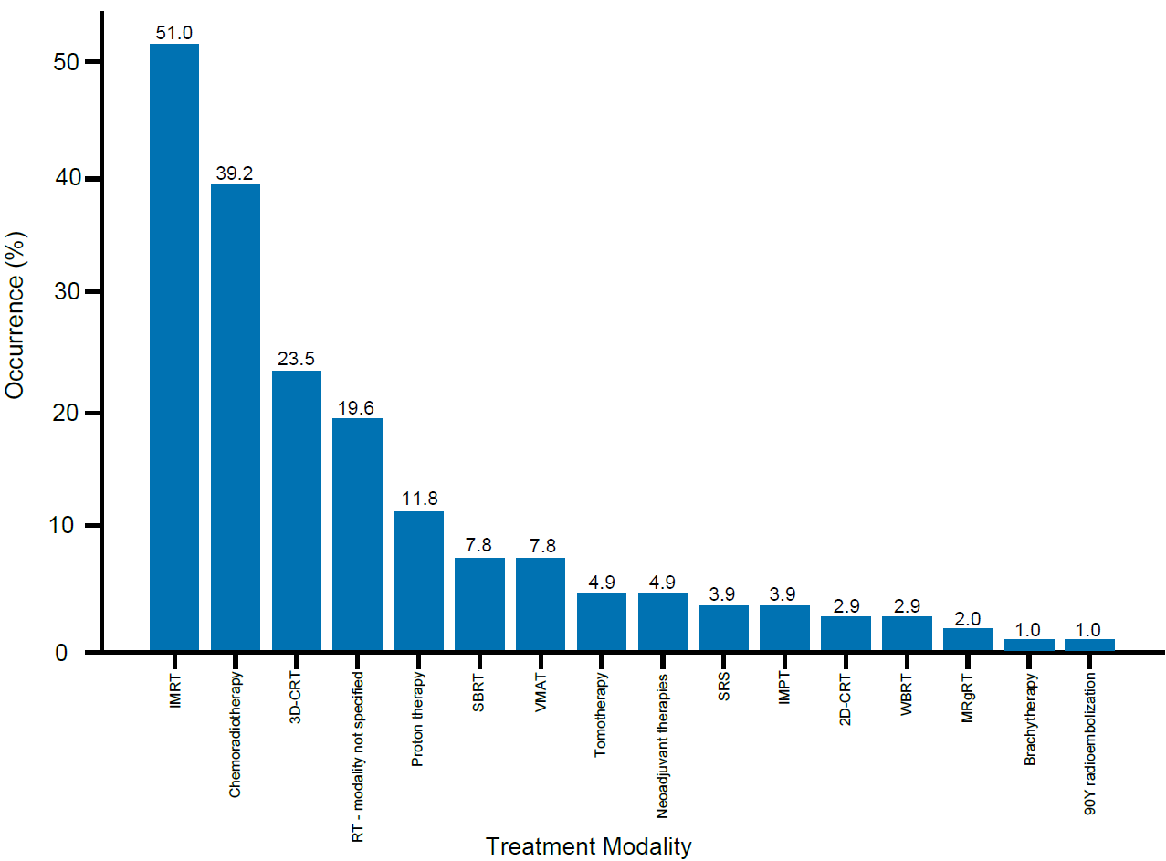
Figure S1. Distribution of treatment modalities used. Percentage of counts observed for the recorded treatment modalities: intensity-modulated RT (IMRT), chemoradiotherapy, three-dimensional conformal RT (3D-CRT), RT - modality not specified, proton therapy, stereotactic body RT (SBRT), volumetric modulated arc therapy (VMAT), tomotherapy, neoadjuvant therapies, stereotactic radiosurgery (SRS), intensity-modulated proton therapy (IMPT), two-dimensional conformal RT (2D-CRT), whole-brain RT (WBRT), MR-guided RT (MRgRT), brachytherapy, and 90Y radioembolization. The sum of distributions exceeds 100% as studies used multiple treatment modalities.

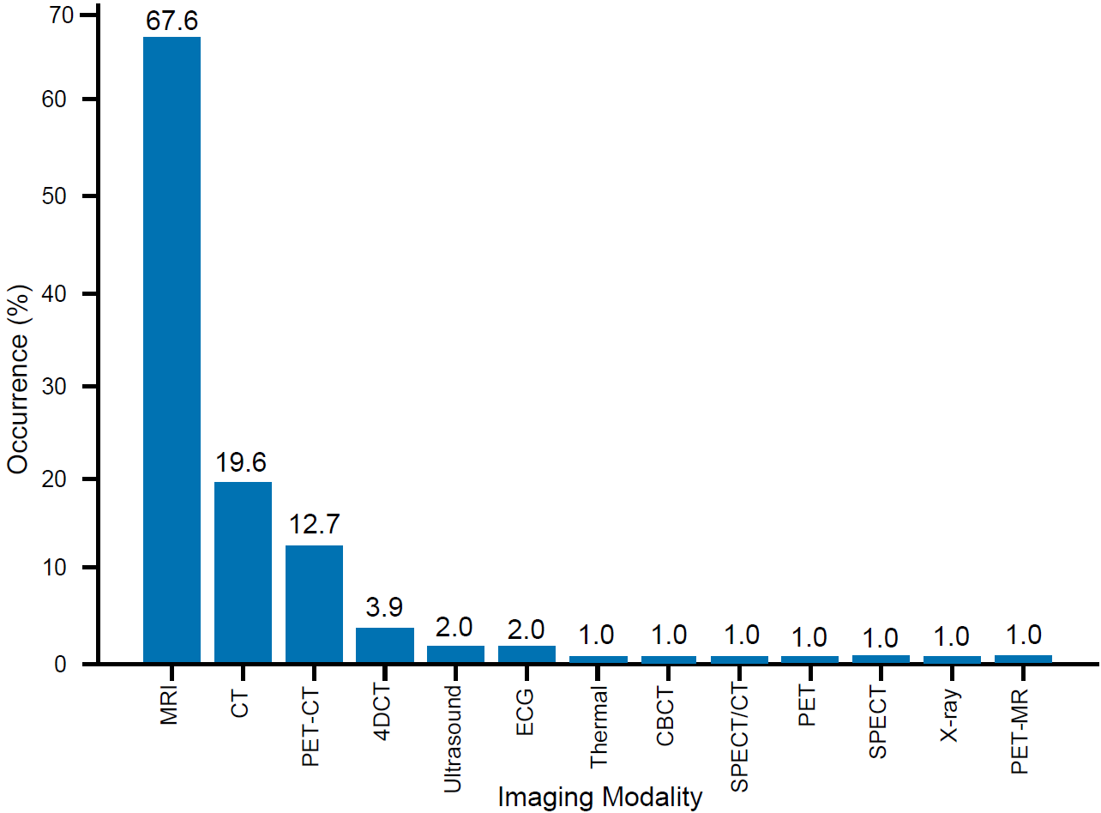
Figure S2. Distribution of imaging modalities used. Percentage of counts observed for the recorded imaging modalities: magnetic resonance imaging (MRI), computed tomography (CT), positron emission tomography (PET)-CT, four-dimensional CT (4DCT), ultrasound, echocardiography (ECG), thermal imaging, cone beam CT (CBCT), single-photon emission CT (SPECT)/CT, PET, SPECT, x-ray, and PET-MR. The sum of distributions exceeds 100% as studies used multiple imaging modalities.

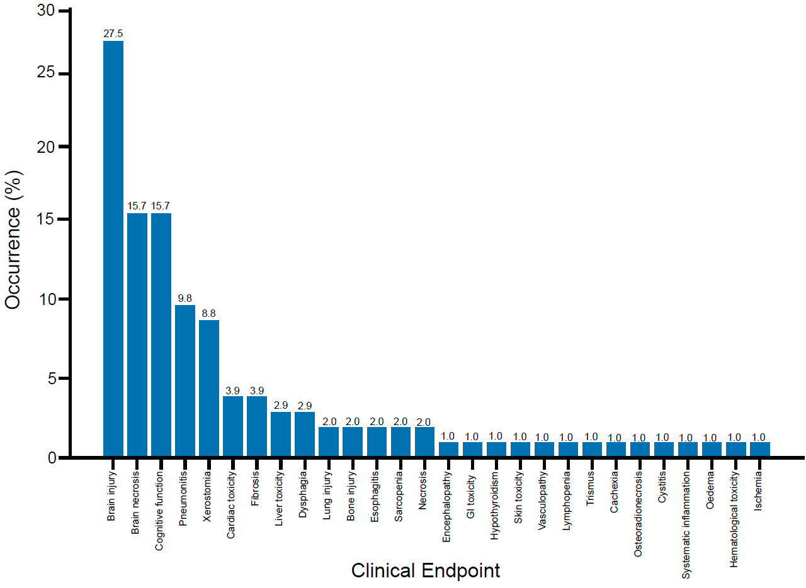
Figure S3. Distribution of clinical endpoints assessed. Percentage of counts observed for the recorded clinical endpoints: brain injury, brain necrosis, cognitive function, pneumonitis, xerostomia, cardiac toxicity, fibrosis, dysphagia, lung injury, bone injury, esophagitis, sarcopenia, necrosis, encephalopathy, gastrointestinal (GI) toxicity, hypothyroidism, skin toxicity, vasculopathy, lymphopenia, trismus, cachexia, osteoradionecrosis, cystitis, systematic inflammation, oedema, hematological toxicity, and ischemia. The sum of distributions exceeds 100% as studies assessed multiple clinical endpoints.
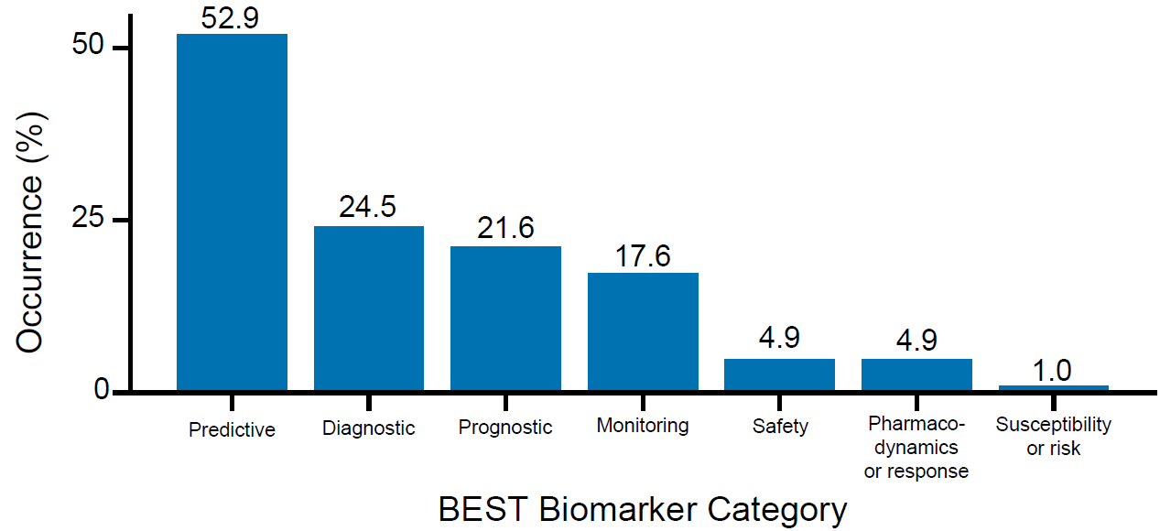

Figure S4. Distribution of BEST Biomarker Category. Percentage of counts observed for each of the BEST Biomarker Categories¹⁷: Predictive, Diagnostic, Prognostic, Monitoring, Safety, Pharmacodynamics or response, and Susceptibility or risk. The sum of distributions exceeds 100% as studies assessed multiple biomarkers.

