Supporting Information

Dynamic Ferroelectricity in Antiferroelectric Hafnia-Zirconia Thin Films at Cryogenic Temperatures

Radha Rathod†,*, Balreen Saini^{†,1}, Cristian E. Ruano Arens†, Vivek Thampy#, Wilman Tsai†, John D. Baniecki#, and Paul C. McIntyre†,#,*

†Department of Materials Science and Engineering, Stanford University, CA 94305, USA
#SLAC National Accelerator Laboratory, Menlo Park, CA 94025, USA
*Corresponding Author; email: pcm1@stanford.edu

Methods

Device fabrication

Metal–ferroelectric–metal (MFM) capacitor structures were fabricated to investigate the temperature-dependent structural and polarization-switching characteristics of HZO thin films. A 10-nm-thick TiN bottom electrode was deposited on Si substrates by radio-frequency (RF) reactive sputtering of a Ti target in an N₂ ambient. The HZO thin films (10 nm thick) are grown using plasma enhanced atomic layer deposition (ALD) at temperatures of 200°C or 250°C with intermittent pulses of TDMA-Hf ([(CH₃)₂N]₄Hf) and TDMA-Zr ([(CH₃)₂N]₄Zr) as the Hf and Zr precursors respectively, with oxygen plasma as the co-reactant. A 10-nm-thick TiN top electrode was subsequently deposited by RF reactive sputtering. Capacitor structures with an area of 50 × 50 μm² were defined by photolithography. A 40-nm-thick Pt layer was deposited by electron-beam evaporation and patterned by photolithography and lift-off to form the electrical contact pads. The TiN top electrode was then selectively removed using an SC-1 solution consisting of H₂O/H₂O₂/NH₄OH = 5:1:1 volume ratio, with the Pt pads serving as an etch mask. with Pt pads as masks. The HZO films were crystallized by rapid thermal annealing at 500 °C for 30 s in an N₂ ambient. Film thicknesses were determined by spectroscopic ellipsometry.

Electrical Characterization

Room-temperature electrical measurements were performed using a Cascade Microtech Summit 12000 probe station. Polarization-voltage (P-V) hysteresis, capacitance–voltage (C-V), and electrical cycling measurements were performed using a Keithley 4200-SCS semiconductor parameter analyzer and an HP 4156C parameter analyzer. Unless otherwise specified, P-V measurements and voltage cycling were performed using triangular waveforms with a maximum voltage of 3 V (voltage sweep : 0 V to +3 V to -3 V) and a frequency of 100 kHz. The field cycling endurance measurements showed in Fig. 6(c) up to 10¹⁰ cycles are performed at 200 kHz frequency to limit the measurement time. All measurements were performed on multiple capacitors (3-5 individual capacitors) fabricated on the same film, with a characteristic device-to-device reproducibility yield of approximately 90–95% for each film. Positive-up–negative-down (PUND) measurements were used to determine the switchable polarization by separating the switching contribution from non-switching currents. PUND measurements were performed using trapezoidal voltage pulses with a maximum amplitude of 3 V, 100 ns rise and fall times, a 500 ns pulse width, and a 100 ns delay between pulses. C-V measurements were performed by sweeping the DC bias from −3 V to +3 V and back, at an average rate of ~0.20 V s⁻¹ (0.06 V voltage step), while applying a 30 mV-amplitude sinusoidal signal at 50 kHz. Temperature-dependent electrical measurements were performed using a Lakeshore Model CPX cryogenic probe station integrated with a Keithley 4200-SCS parameter analyzer. Measurements were conducted between 12.5 and 296 K under a base pressure of approximately 1 × 10⁻⁶ Torr. The system was initially cooled to 12.5 K and allowed to stabilize before electrical measurements were performed. Measurements at higher temperatures were subsequently acquired while warming the samples from 12.5 to 296 K, with a stabilization period of 1 hour at each temperature. P-V hysteresis and electrical cycling measurements at different temperatures were performed using the measurement parameters described above, unless otherwise specified. The same capacitor devices were monitored during the temperature-dependent measurements to minimize variations associated with device-to-device differences.

Synchrotron X-ray diffraction measurements

Synchrotron X-ray diffraction measurements were performed at beamline 17-2 of the Stanford Synchrotron Radiation Lightsource (SSRL). Measurements were conducted in grazing-incidence geometry using an incident X-ray energy of 7.6 keV (λ = 1.630 Å) and an incidence angle of 1.75°. High-resolution diffraction patterns were collected using a a Pilatus 100k detector (195 × 487 pixels, 172 µm pitch) on the 2θ detector arm over a scattering-vector (Q) range of approximately 1.8-3.6 Å⁻¹.

The detector geometry was calibrated from a direct-beam scan: the attenuated beam was stepped across the detector by incrementing 2θ, a Gaussian was fitted to the beam profile in each frame, and a linear fit of fitted peak position against detector angle gave the angular size of one pixel. This yielded a sample-to-detector distance of 995.4 mm (5787.5 pixels), with the beam centre at pixel (243, 97). No powder standard was used, so the 2θ scale rests on the accuracy of the detector-arm motor. For each diffraction scan, every frame was normalized to the monitor counts and assigned its own geometry from the recorded 2θ. Frames were then merged into a single I(q) pattern using pyFAI's multi-geometry integrator with bounding-box pixel splitting, in 3000 uniform bins over q = 1.5–4.3 Å⁻¹. Uncertainties were estimated as √I.

For in-situ cryogenic temperature-dependent measurements, the samples were mounted in a sample holder enclosed by a beryllium vacuum dome and cooled using liquid helium. The sample temperature was controlled using a temperature controller and allowed to stabilize at each measurement temperature before diffraction data were acquired. The minimum temperature accessible with this diffraction setup was approximately 50 K. The diffraction measurements were performed while varying the sample temperature to monitor changes in the HZO crystal structure. The resulting diffraction patterns were analyzed as a function of (Q) to track temperature-dependent changes in the positions and intensities of the HZO diffraction features.

Temperature dependence of the switching peak positions
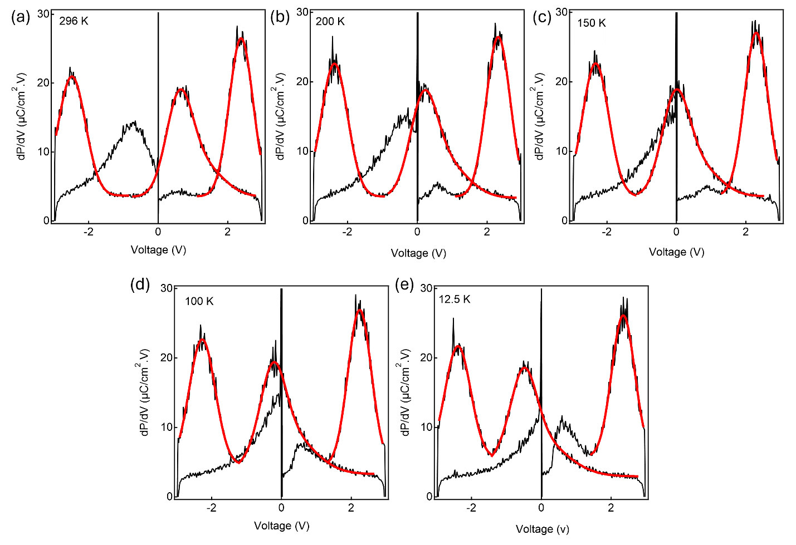
Fig. S1 | Multi-Gaussian analysis of differential polarization response. Differential polarization response (dP/dV) as a function of applied voltage at (a) 296 K, (b) 200 K, (c) 150 K, (d) 100 K and (e) 12.5 K. The switching features are fitted with single- or multi-Gaussian functions to determine the peak positions and quantify their temperature-dependent shifts.

To quantify the temperature dependent shifts of the switching peaks, the differential polarization response dP/dV was analyzed for the HZO capacitors at temperatures ranging from 296 and 12.5 K. The switching features in the dP/dV vs. V plots were analyzed using Gaussian fitting to determine the corresponding peak positions as shown in Fig. S1. Peaks 1 and 3 were fitted using a single Gaussian function, whereas the broad and asymmetric Peak 2 was fitted using a double-Gaussian function. Peak 4 is excluded from the peak-shift analysis because its discontinuous peak shape results from the voltage sweep beginning at 0 V. The multi-Gaussian fitting function used for Peak 2 is given by,
$$Y=A \exp^{-{\left(\frac{x-x0}{w0}\right)}^{2}}+B \exp^{-{\left(\frac{x-x1}{w1}\right)}^{2}}$$
where A and B are the amplitudes of the two Gaussian components, x0 and x1 are the corresponding peak positions, and w0 and w1 are the width parameters of the respective Gaussian components. For Peaks 1 and 3, a single Gaussian component was used. The extracted values of x0 and x1 were used to determine the voltage positions of the individual switching features.

Frequency dependence of the switching peak positions
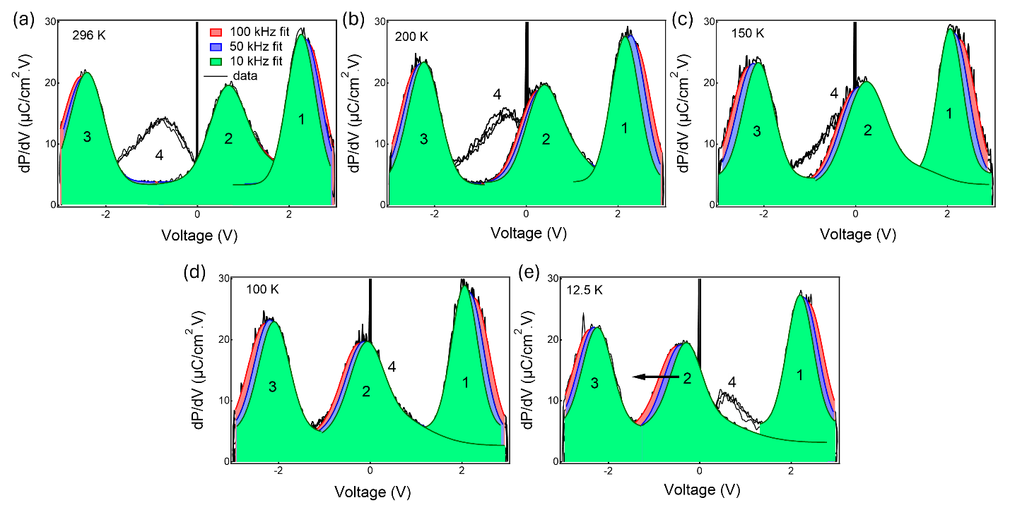Fig S2. Temperature- and frequency-dependence of the differential polarization response. Differential polarization response, (dP/dV), as a function of applied voltage at (a) 296 K, (b) 200 K, (c) 150 K, (d) 100 K and (e) 12.5 K, measured at cycling frequencies of 10, 50 and 100 kHz. The cycling frequency varied by adjusting the rise time of the triangular voltage waveform while maintaining the same voltage amplitude.
To quantify the frequency dependence of the switching processes, the differential polarization response dP/dV was analyzed for the HZO capacitors at 296 and 12.5 K as shown in Fig. S2. The switching features were identified by fitting the dP/dV vs. V curves with Gaussian functions. Peaks 1 and 3 were fitted using individual Gaussian functions, whereas the broader Peak 2 feature was fitted using the multi-Gaussian components as discussed above. The center position of each fitted peak was taken as the characteristic switching voltage V_{peak}. The difference between switching current peak positions are considered for calculation of ∆V plotted in Fig 6(b).

Timescale-dependent persistence of the field-induced polar state.
The contrasting responses observed in P-V and C-V measurements at 12.5 K provide an indication that enhanced polarization is governed by the finite timescale of the field-induced o-to-t back-switching. The P-V measurements employ a bipolar triangular voltage waveform with a rise time of 2.5 μs at 100 kHz, corresponding to a voltage ramp rate of approximately $1.2 ×{10}^{6} V/s$. At 10 kHz, the corresponding rise time is 25 μs and the voltage ramp rate is $1.2 ×{10}^{5} V/s$ In contrast, the C-V measurements use a much slower DC voltage sweep from -3 to +3 V and back to -3 V over approximately 60 s, corresponding to an average DC sweep rate of only $0.2 V/s$ with approximately 0.30 s between successive 0.06 V bias points. The 50-kHz signal used during the C-V measurement is a small-signal AC excitation and does not define the DC voltage-sweep timescale. Thus, the P-V measurements probe the polarization response on a microsecond-to-tens-of-microseconds timescale, whereas the C-V measurement interrogates the device over sub-second to second timescales. At 12.5 K, the substantial switchable polarization observed in the fast P-V measurement, together with the predominantly AFE-like C-V response obtained under the much slower bias sweep, is consistent with a field-induced polar o-phase that persists long enough to contribute to the P-V response but relaxes toward the tetragonal state on the longer timescale of the C-V measurement. These measurements therefore provide a broad experimental constraint on the relevant zero-bias relaxation timescale, placing it between the microsecond-to-tens-of-microseconds regime probed by P-V and the approximately 0.3 s timescale associated with individual C-V bias points.

Authors contributed equally.

