Supplemental Material C: Supporting Figures

Mesoscale Model Forecast Skill for Hourly Rainfall During Postfire Flood and Debris-Flow Events in California

Submitted to Natural Hazards

Nina S. Oakley^{1*}, Luke A. McGuire², Deanna Nash³

¹California Geological Survey, Burned Watershed Geohazards Program, Santa Rosa, CA, USA
²Department of Geosciences, University of Arizona, Tucson, AZ, USA
³Center for Western Weather and Water Extremes, Scripps Institution of Oceanography,
University of California, San Diego, La Jolla ,CA, USA

*Corresponding author, nina.oakley@conservation.ca.gov
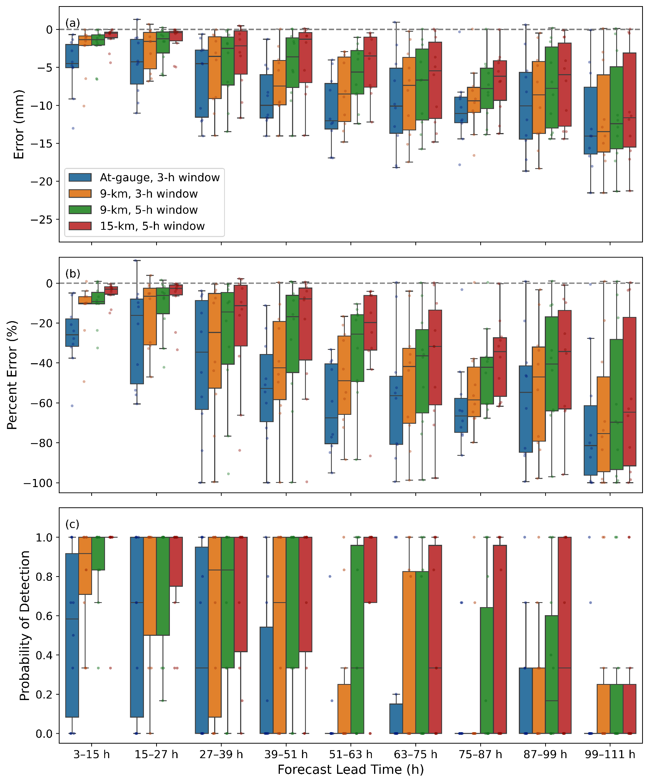
Fig. S1 Box plots representing error (a) and percent error (b) and probability of detection (c) among stations in all 10 events for the WestWRF analysis. Blue box plots represent verification based on the grid cell in which the gauge is located and a 3 h time window. Orange box plots represent a 9 km neighborhood and 3 h time window. Green box plots represent a 9 km neighborhood and 5 h time window. Red box plots represent a 15 km neighborhood and 5 h time window. Whisker extent is 1.5 times the interquartile range. Both plots use the “best” fit value in the space/time window. The blue and orange dots represent the mean of error, percent error, and POD in their respective plots among gauges for each of the 10 events, with color corresponding to the spatial/temporal window used.
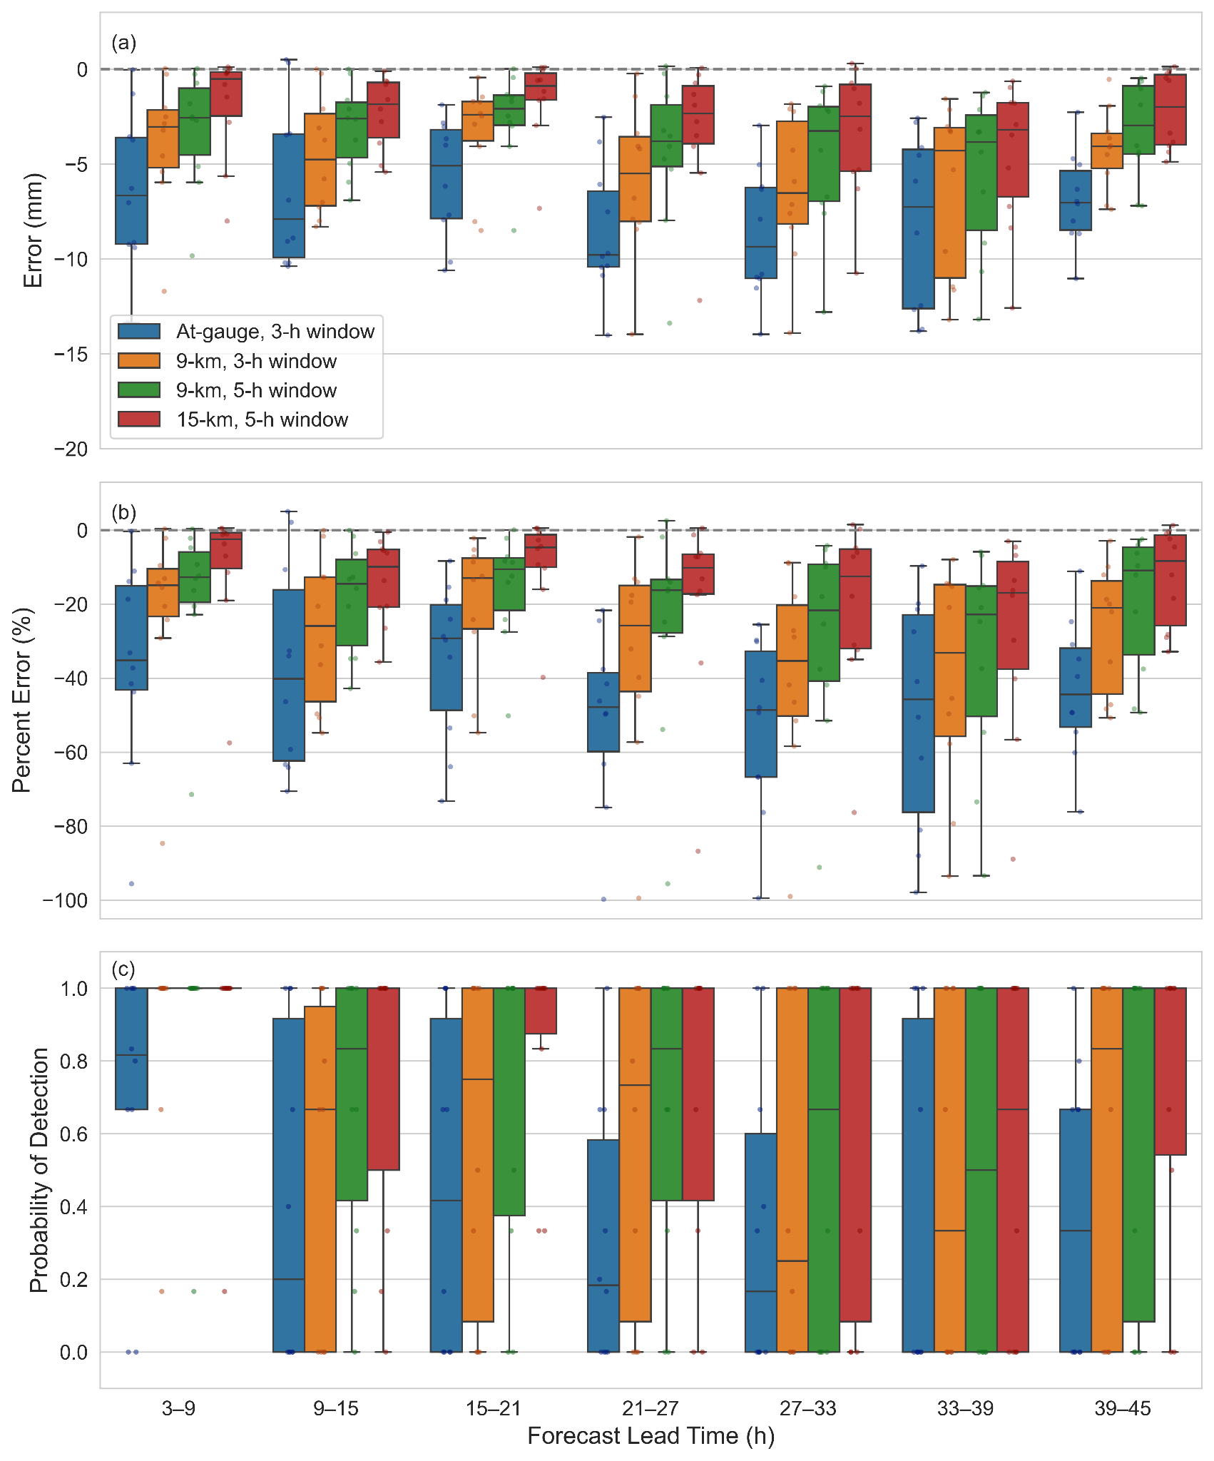
Fig. S2 As in Fig. S1 for HRRR analysis.

WestWRF Event-Specific Figures
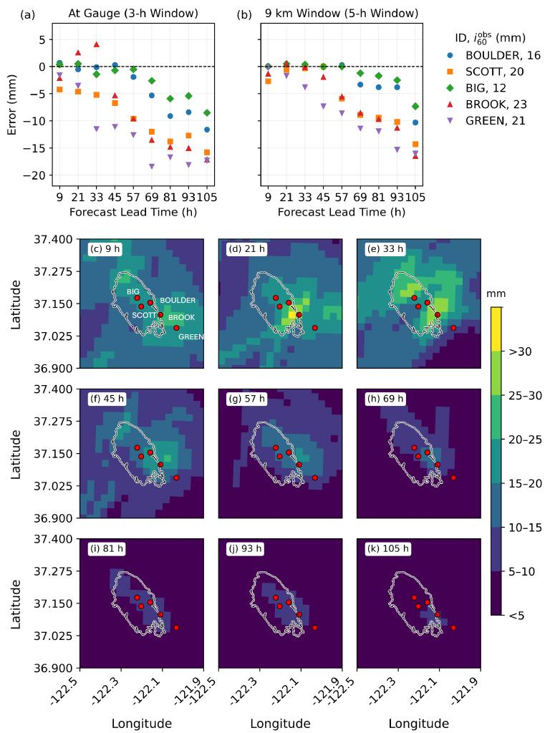
Fig. S3 Analysis of WestWRF for the CZU Fire event, 27 January 2021. Forecast error (mm) for a) model grid cell associated with gauge location and 3h temporal window, and b) a 9 km neighborhood of model grid cells and 5h temporal window. The forecast is compared to three rain gauge stations in the vicinity of the burn area. Station IDs and associated peak 1 h rainfall are given in the upper right of the figure.Panels c-k provide a spatial depiction of peak 1h rainfall for the 3h event window (Table 1) at each forecast lead time. Colorbar indicates the 1h rainfall accumulation, in mm. Fire perimeter is indicated by a grey outline, red dots indicate location of each of the stations evaluated.
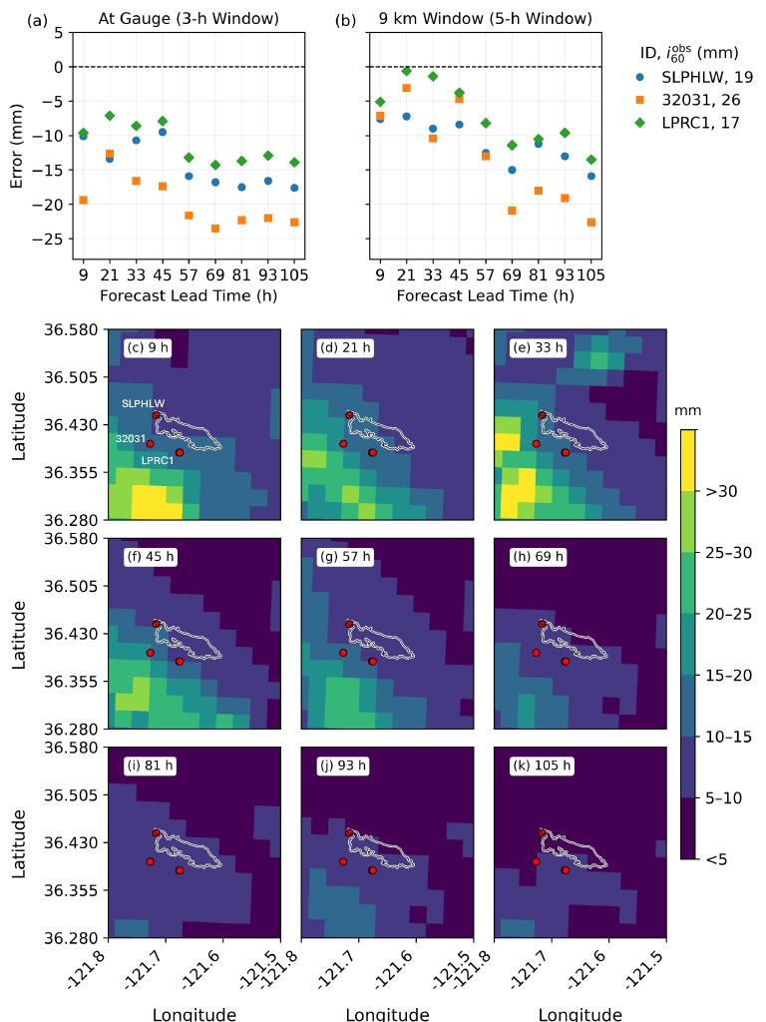

Fig. S4 As in Fig. S1 for the 27 January 2021 Carmel Fire event.

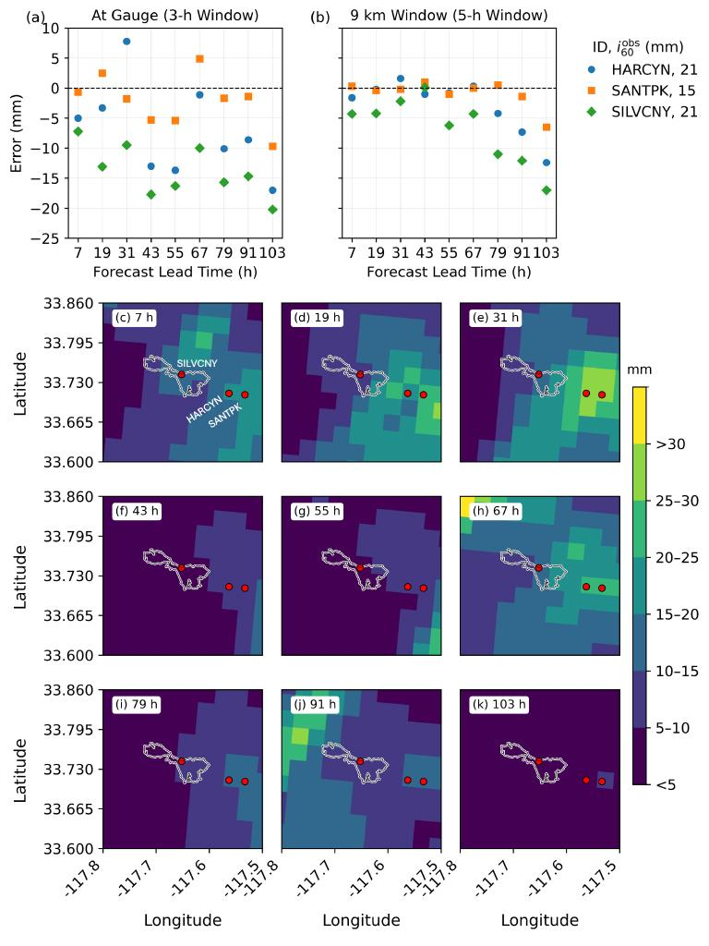
Fig. S5 As in Fig. S1 for the 14 December 2021 Bond Fire event.
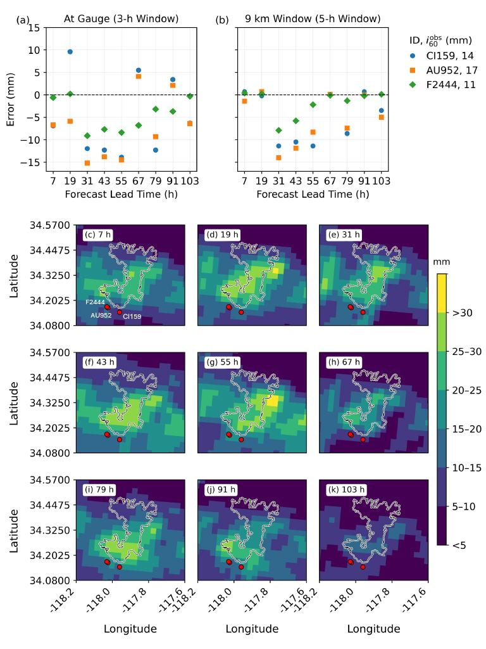
Fig. S6 As in Fig. S1 for the 14 December 2021 Bobcat Fire event.
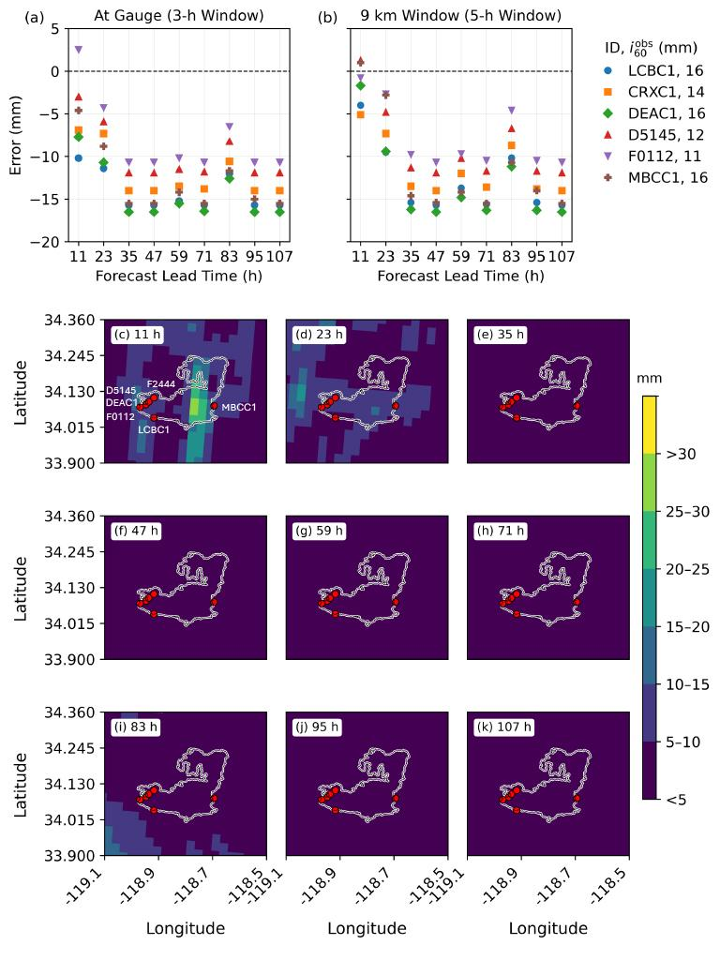
Fig. S7 As in Fig. S1 for the 30 December 2021 Woolsey Fire event.
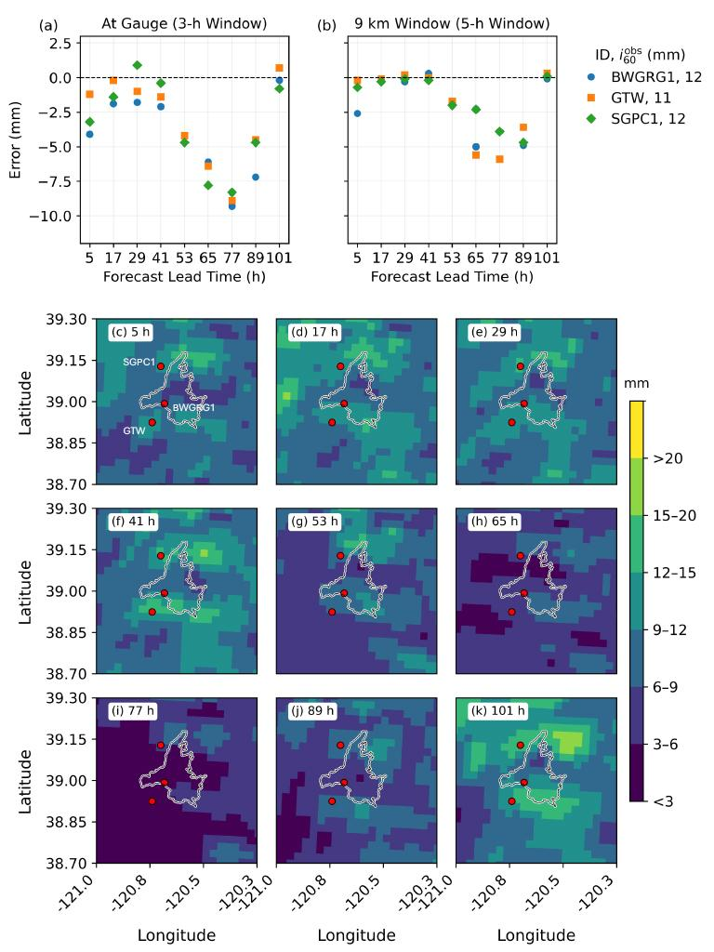
Fig. S8 As in Fig. S1 for the 9 January 2023 Mosquito Fire event.
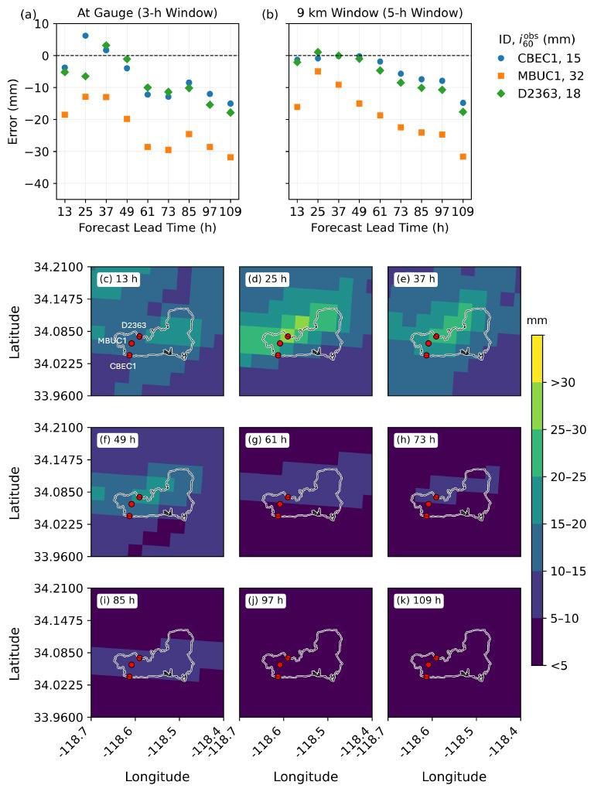
Fig. S9 As in Fig. S1 for the 13-14 February 2025 Palisades Fire event.

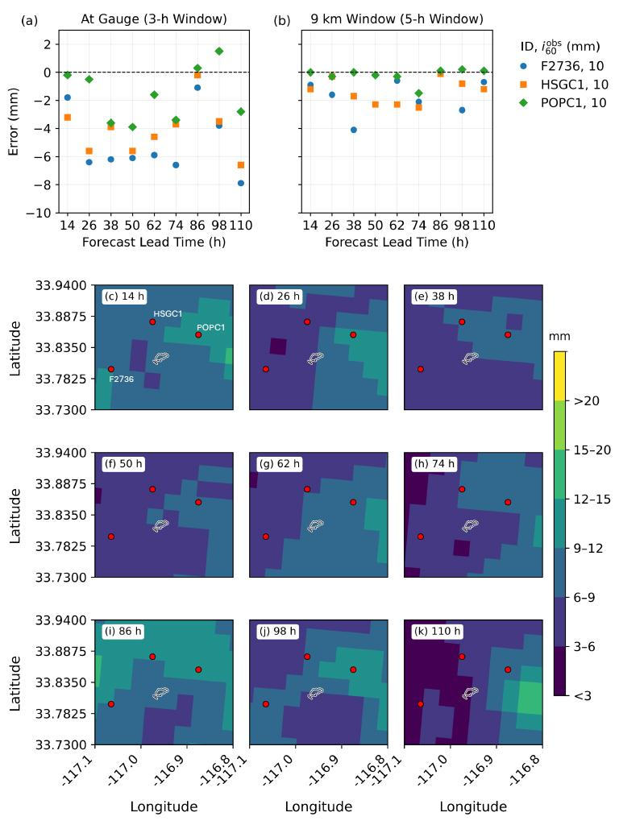
Fig. S10 As in Fig. S1 for the 13 March 2025 Record Fire event.

HRRR Event-Specific Figures
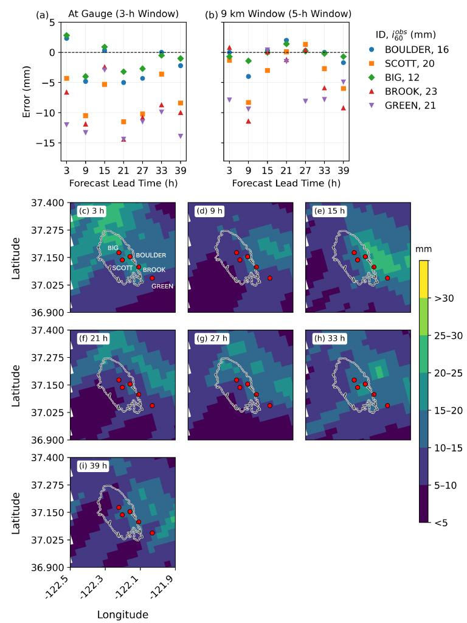
Fig. S11 Analysis of HRRR for the CZU Fire event, 27 January 2021. Forecast error (mm) for a) model grid cell associated with gauge location and 3 h temporal window, and b) a 9 km neighborhood of model grid cells and 5 h temporal window. The forecast is compared to three rain gauge stations in the vicinity of the burn area. Station IDs and associated peak 1 h rainfall are given in the upper right of the figure. Panels c-i provide a spatial depiction of peak 1 h rainfall for the 3 h event window (Table 1) at each forecast lead time. Colorbar indicates the 1 h rainfall accumulation, in mm. Fire perimeter is indicated by a grey outline, red dots indicate location of each of the stations evaluated.

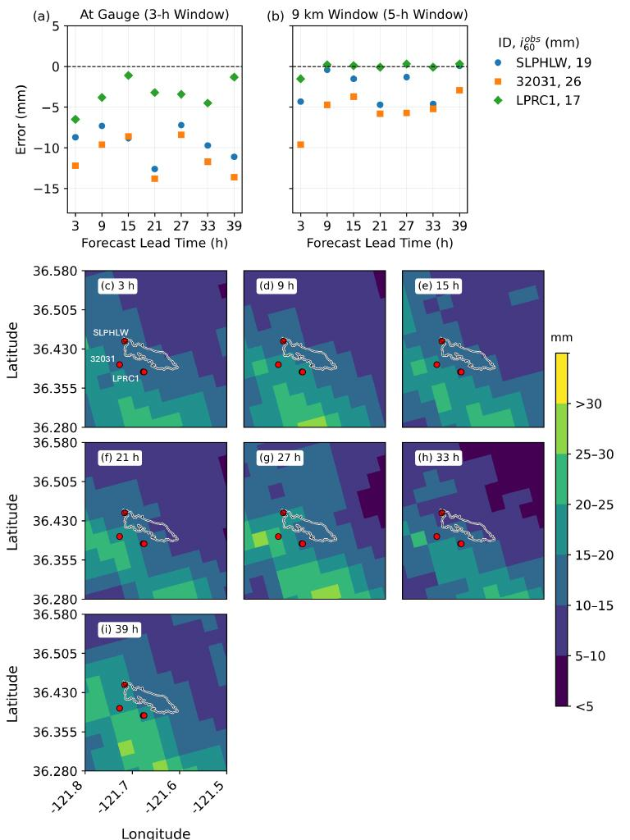
Fig. S12 As in Fig. S9 for the 27 January 2021 Carmel Fire event.
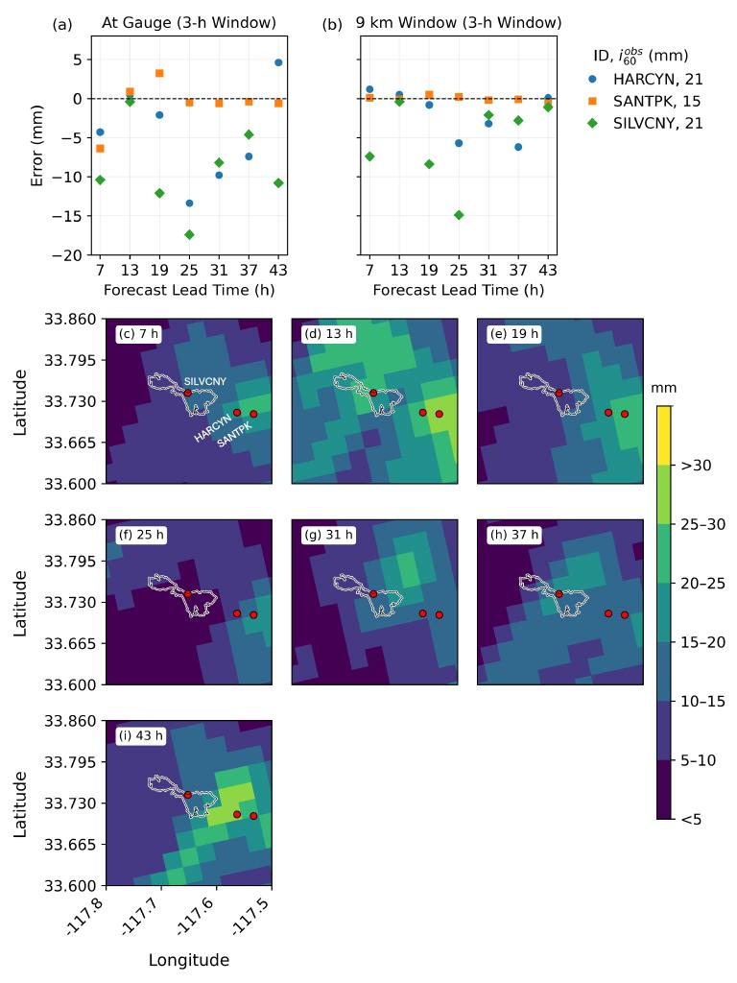
Fig. S13 As in Fig. S9 for the 14 December 2021 Bond Fire event.
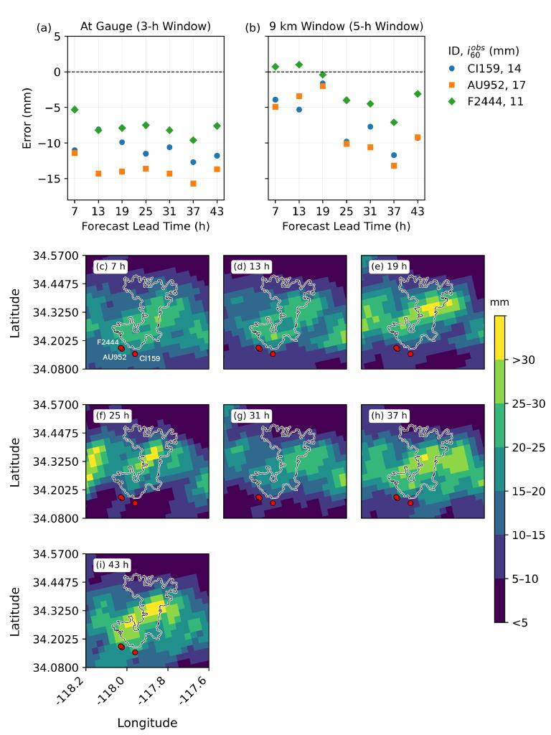
Fig. S14 As in Fig. S9 for the 14 December 2021 Bobcat Fire event.
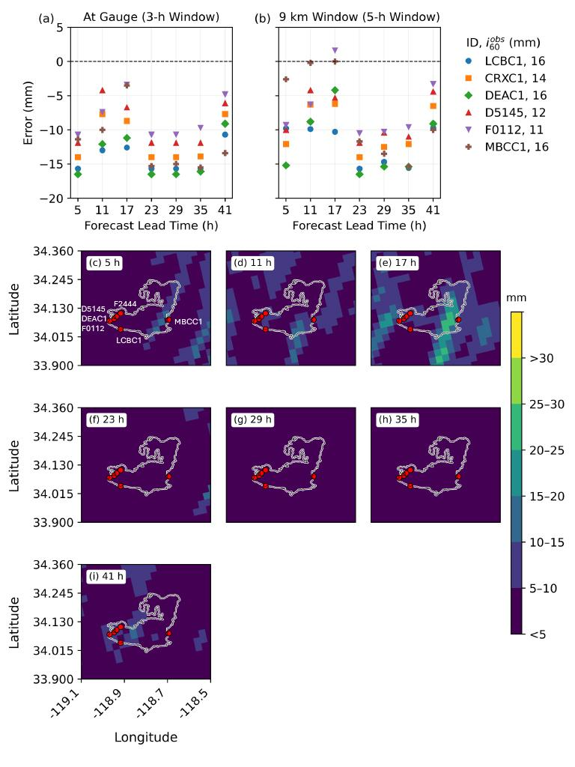
Fig. S15 As in Fig. S9 for the 30 December 2021 Woolsey Fire event.
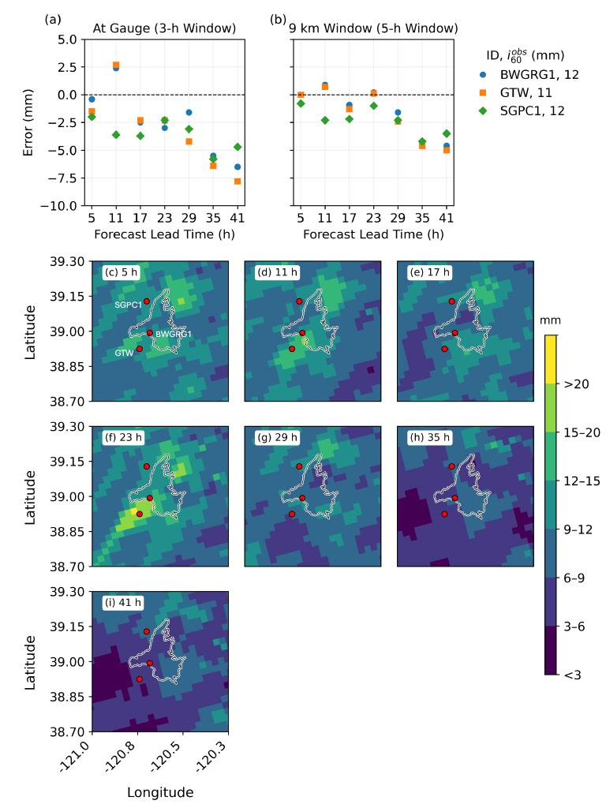
Fig. S16 As in Fig. S9 for the 9 January 2023 Mosquito Fire event.
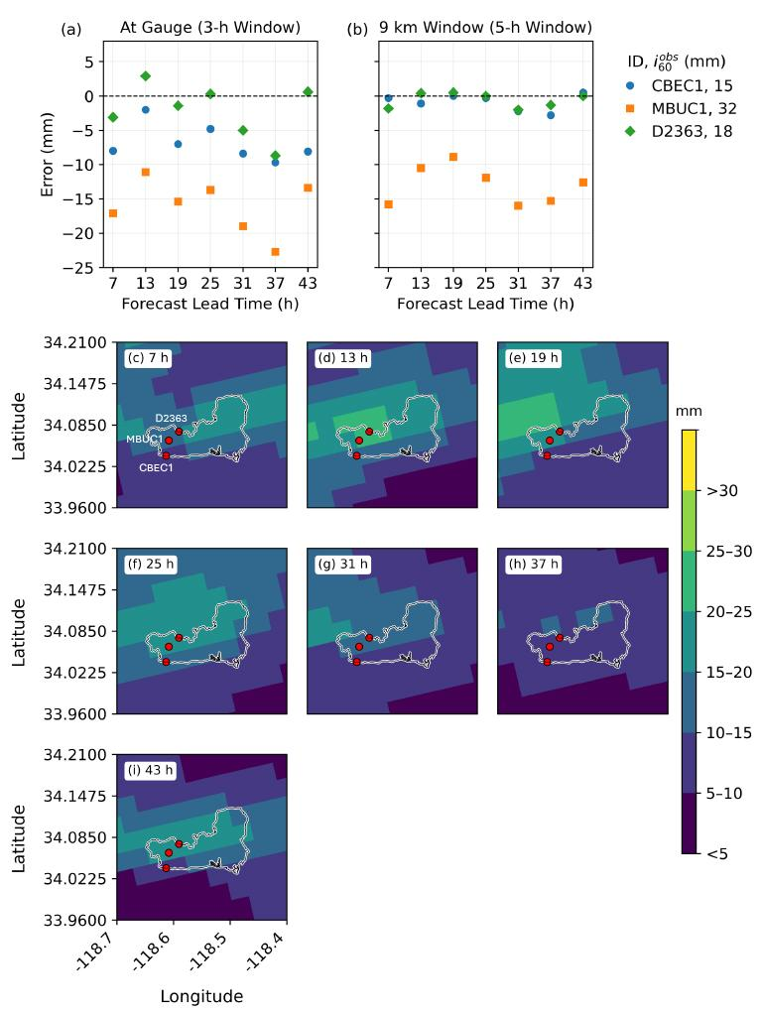
Fig. S17 As in Fig. S9 for the 13-14 February 2025 Palisades Fire event.
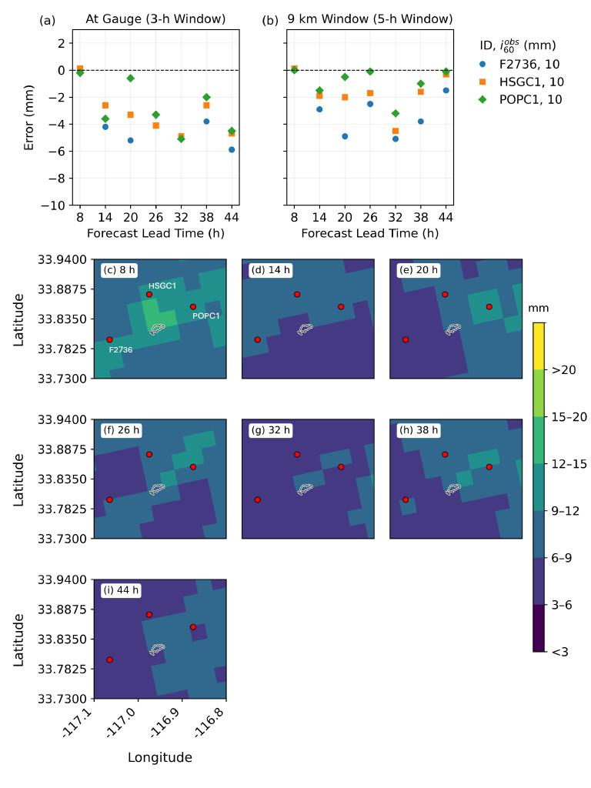
Fig. S18 As in Fig. S9 for the 13 March 2025 Record Fire event.

