Table of Contents
1. Setting
Fig. S1. Ghana administrative regions and districts
Fig S2. Ghana ecological zones

2. Yellow fever case data
Table S1. Case definitions
Occurrences

3. Spatial statistics: Moran’s I
Fig. S3. Local Moran’s I map of yellow fever probable/confirmed cases by district 2005-2024
Fig. S4. Local Moran’s I map of yellow fever suspected cases by district 2005-2024

4. Spatial statistics: Cluster analysis
Fig. S5. L function of yellow fever cases 2005-2024
Fig. S6. Kernel density estimate of yellow fever cases 2005-2024

5. Spatial data
Fig. S7. Conceptual framework for yellow fever risk in Ghana
Table S2. Covariates for Ecological Niche Model
Fig. S8. Map of covariates included in Ecological Niche Model

6. Vaccination coverage estimation
Fig. S9. Map of annual vaccination coverage in Ghana, 2005-2025

7. Ecological Niche Models/Risk Map
Table S3. Ecological niche model checklist
Table S4. Summary of Model Results
Table S5. Covariate importance
Fig. S10. Comparison of local vs global YF risk maps
Fig. S11. Yellow fever ecological niche model uncertainty, 2005-2024
Fig. S12. Response curves

8. Sensitivity Analysis, yellow fever, 1969-2024
Table S6. Summary of Model Result, 1969-2024
Table S7. Covariate importance, 1969-2024
Fig. S13. Ecological niche model environmental suitability of yellow fever, 1969-2024
Fig. S14. Yellow fever ecological niche model uncertainty, 1969-2024
Fig. S15. Response curves, 1969-2024

9. Risk map survey instrument

10. Risk map survey results

1. Setting

Fig S1. Ghana administrative regions and districts
The 261 districts and 16 regions in Ghana are shown. The shapefile of the administrative boundaries was obtained via the Ghana Statistical Service (https://statsbank.statsghana.gov.gh/assets/geofiles.zip) and is publicly available.

Fig S2. Ghana ecological zones
The primary ecological zones and districts in Ghana are shown. There is not a universally accepted standard for Ghana’s ecological zones. Therefore, we used the agro-ecological zone boundaries developed by the University of Ghana Remote Sensing and GIS laboratory (publicly available at: https://www.arcgis.com/home/item.html?id=0776dae5c5314102bd03fdaab8df0356). This classification includes seven ecological zones: Coastal savanna, Wet evergreen, Most evergreen, Deciduous forest, Transitional zone, Guinea Savanna, and Sudan savanna. Ecological zones were assigned to regions and districts based on the highest proportion of geographic area at the regional level. Using this approach, districts were found to predominantly fit in five of the seven defined ecological zones.
2. Yellow fever case data
Individual line-level data of all patients tested for YF from 2005-2024 were obtained in partnership with the GHS. For the line-level data, we categorized cases according to the IDSR case definitions, which are the operational definitions for YF in Ghana. The RT-PCR results and PRNT confirmatory results were only available from 2023 and 2024. For cases that were YF IgM positive during an outbreak but did not have additional confirmatory results, these were treated as probable cases per the WHO Vaccine Preventable Disease Surveillance Standards case definitions.
Table S1. Case Definitions
 | IDSR 2019 (Ghana Operational Definition) | WHO Vaccine Preventable Disease Surveillance Standards 2020
Suspected | Any person with acute onset of fever, with jaundice appearing within 14 days of onset of the first symptoms. | Any person with acute onset of fever, with jaundice appearing within 14 days of onset of the first symptoms.
Probable | A suspected case AND one of the following: (a) Epidemiological link to a confirmed case or an outbreak (b) Positive post-mortem liver histopathology | A suspected case AND at least one of the  following: (a) Presence of YF IgM antibody in the absence of YF immunization within 30 days of illness onset  (b) Epidemiological link to a confirmed case or an outbreak (e.g. household members or persons in close proximity to case through work, residence in  past month)
Confirmed | A probable case AND One of the following: (a) Detection of YF-specific* IgM (b) Detection of four-fold increase in YF IgM and/or IgG antibody titres between acute and convalescent serum samples (c) Detection of YFV-specific* neutralizing antibodies  *YF-specific means that antibody tests (such as IgM or neutralizing antibody) for other prevalent flavivirus are negative. This testing should include at least IgM for Dengue and West Nile and may include other flavivirus depending on local epidemiology.  OR One of the following: (a) Detection of YF virus genome in blood or other organs by PCR (b) Detection of yellow fever antigen in blood, liver or other organs by immunoassays (c) Isolation of the yellow fever virus | A probable case AND at least one of  the following:  (a) Negative results of differential neutralization testing with flaviviruses endemic in the area of exposure  (b) Seroconversion in appropriately paired samples tested by YF neutralization testing  AND Absence of YF immunization within 30 days before onset of illness  OR A suspected case AND at least one of the following:  (a) Detection of YF virus genome in blood or  other organs by real-time reverse transcriptase  polymerase chain reaction (RT-PCR)  (b) Detection of YF antigen in liver, or other organs  by immunohistochemistry  (c) Isolation of YF virus  AND  Absence of YF immunization within 14 days  before onset of illness

The YF case data were cleaned to fit the naming conventions of the current 261 district administrative boundaries provided by the Ghana Statistical Service. Because there have been multiple changes to the district boundaries (notably in 2008, 2012, and 2018), we encountered multiple situations where we had to clean the data to reflect the most recent district boundaries. If an original district was upgraded to a municipal district (i.e. Bolgatanga to Bolgatanga municipal in 2008), we attributed the cases to the most recent municipal district boundaries. Of the 14534 individual cases, 77 suspected cases were missing location information.

Occurrences
Yellow fever probable/confirmed cases were further georeferenced to obtain coordinates for the cluster analysis and ecological niche models (ENMs). We recorded the coordinates of the town of residence for each case. If the town of residence was unavailable, we used the healthcare facility where the patient was seen.
Coordinates for town names were identified using Google Earth (https://earth.google.com/), Fallingrain Global Gazeteer version 2.3 (https://www.fallingrain.com/world/GH/), OpenStreetMap (https://www.openstreetmap.org/), and geographic.org (https://geographic.org/geographic_names/index.html). Coordinates for healthcare facilities were sourced from the Ghana Health Service. All coordinates were reported to at least two decimal places. In addition to the 185 probable/confirmed cases from the GHS surveillance data, for the ENM we included nine unique occurrence locations from our prior literature review (Judson et al. 2024).
Processing YF Occurrence and Background Data
Occurrence records were further processed prior to modelling. First, we mapped the coordinates to ensure that all occurrences were within Ghana’s administrative boundaries and visually inspected the locations in Google Earth to confirm the presence of a settlement. We then removed any duplicate locations, resulting in a final dataset of 130 unique occurrences. The temporal range of occurrences was 2005-2024.
To account for sampling bias, we created a kernel-density bias raster using the spatial distribution of occurrence data. The kernel-density was used to weight background point selection, ensuring the background points reflected the spatial structure of sampling effort. Using Ripley’s L function, we calculated the maximal distance of case clustering at 30.1 km and used at bandwidth of 25 km in the kernel density estimation. We chose to use a kernel-density bias raster rather than a spatial thinning approach to retain all valid occurrence points.

3. Spatial statistics: Moran’s I

Fig. S3. Local Moran’s I map of yellow fever probable/confirmed cases by district 2005-2024

The Local Indicators of Spatial Association (LISA) were mapped at the district level, calculated via local Moran’s I of yellow fever incidence rates of confirmed or probable cases in each respective time period (2005-2009, 2010-2014, 2015-2019, and 2020-2024). The median-based quadrant classification is shown, indicating whether the district incidence rate is above or below the overall median and the high or low status of its neighbors.

Fig. S4. Local Moran’s I map of yellow fever suspected cases by district 2005-2024
The Local Indicators of Spatial Association (LISA) were mapped at the district level, calculated via local Moran’s I of yellow fever incidence rates of suspected cases in each respective time period (2005-2009, 2010-2014, 2015-2019, and 2020-2024). The median-based quadrant classification is shown, indicating whether the district incidence rate is above or below the overall median and the high or low status of its neighbors.

4. Spatial statistics: Cluster analysis

Fig. S5. L function of yellow fever cases 2005-2024

Ripley’s L-r function with a 95% Monte Carlo envelope calculated using 999 simulations and an isotropic correction for georeferenced yellow fever cases used in the ecological niche model (n = 130). L_{obs} represents the observed L(r) – r function at distance r while L_{theo} represents the theoretical L(r) – r function under complete spatial randomness. L_{hi} and L_{lo} represent the upper and lower confidence envelopes around complete spatial randomness, respectively. Positive deviations of L_{obs} above L_{theo} indicates spatial clustering at distance, r with higher values of L-r indicating stronger clustering. Clustering was strongest at a distance of approximately 30.2 km.

Fig. S6. Kernel density estimate of yellow fever cases 2005-2024

The L function was used to calculate the maximal distance of case clustering (30.1km). We chose a bandwidth of 25 km to estimate the intensity of case clustering and balance over- and undersmoothing. Coordinates of yellow fever cases are displayed as orange points.

5. Spatial data

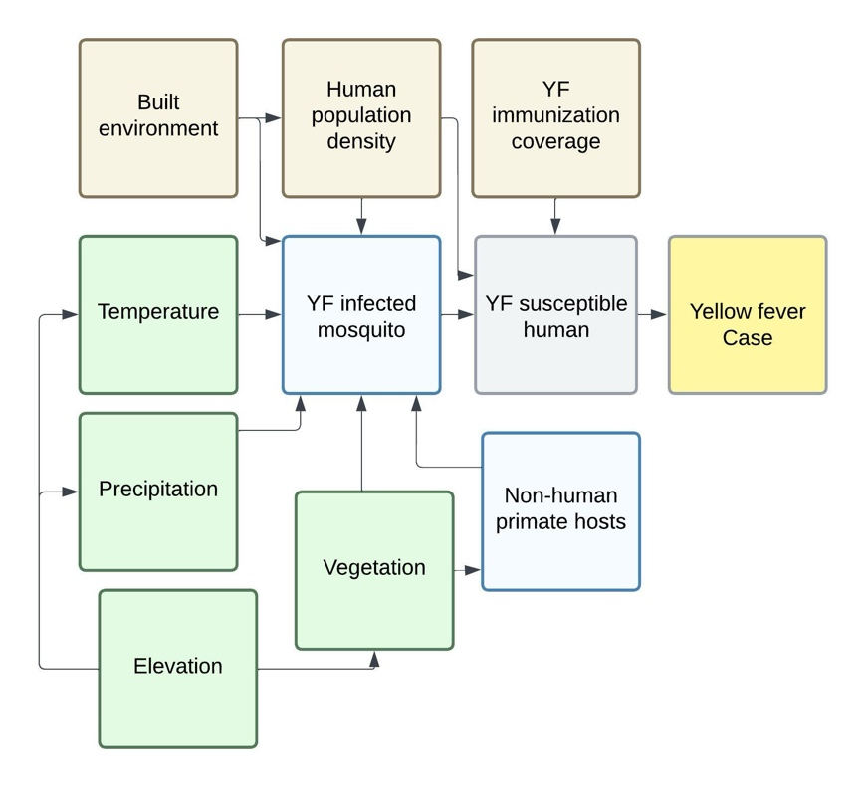
Fig. S7. Conceptual framework for yellow fever risk in Ghana
The conceptual framework used to identify spatial covariates for modelling is shown above. Human yellow fever cases were the outcome of interest. Unobserved mediators that were not included in the models were the presence of suitable mosquito vectors (Aedes spp.), non-human primate reservoir hosts, and susceptible humans. Ecological drivers (green) included precipitation, temperature, elevation, and vegetation. Sociodemographic drivers (brown) included human population density, built environment, and immunization coverage.

Table S2. Covariates for Ecological Niche Model
Covariate | Download date | Data source version | Spatial resolution | Temporal resolution | Extraction Method | Citation
Bioclimatic variables | 8/28/2026 | WorldClim version 2.1 climate data. We excluded bioclimatic variables 8, 9, 18, and 19 due to discontinuities in the tropics | 30 arc | 1970-2000 | A raster file of Ghana’s bioclimatic variables was imported into R using the geodata package. One bioclimatic layer was used to create a spatial template for all covariates. Using the terra package, the layer’s extent was increased by two cells in all directions, and it was masked using the Ghana shapefile from the Ghana Statistical Service. The template was used to ensure that all raster covariates shared the same extent, resolution, and alignment. | Fick, S.E. and R.J. Hijmans, 2017. WorldClim 2: new 1km spatial resolution climate surfaces for global land areas. International Journal of Climatology 37 (12): 4302-4315.  Booth, T.H. (2022), Checking bioclimatic variables that combine temperature and precipitation data before their use in species distribution models. Austral Ecology, 47: 1506-1514. https://doi.org/10.1111/aec.13234
Elevation | 1/27/2026 | WorldClim Shuttle Radar Topography (SRTM) | 30 arc |  | An elevation GeoTIFF file was exported from WorldClim. The raster file was imported into R and projected, masked, and cropped using the spatial template. | Fick, S.E. and R.J. Hijmans, 2017. WorldClim 2: new 1km spatial resolution climate surfaces for global land areas. International Journal of Climatology 37 (12): 4302-4315
NDVI | 1/27/2026 | MOD13A3 V6.1 | 1 km | 2000-2024 (averaged) | A GEOTIFF file of Ghana’s mean annual NDVI from 2000-2024 was exported from Google Earth Engine. The raster file was imported into R and projected, masked, and cropped using the spatial template. | Didan, K. (2021). MODIS/Terra Vegetation Indices Monthly L3 Global 1km SIN Grid V061 [Data set]. NASA Land Processes Distributed Active Archive Center. https://doi.org/10.5067/MODIS/MOD13A3.061
Edge density [Derived from Copernicus Global Land Service in landscapemetrics] | 4/14/2026 | CGLS-LC100-PROBA-V 100m v3.0.1 | 100 m | 2019 | A binary raster file of Ghana’s forested and non-forested area in 2019 was obtained from the Copernicus Global Land Service in Google Earth Engine. Land cover classes 111-126 were assigned as forested areas and all other classes were assigned as non-forested areas. The data was exported as a GEOTIFF file. The raster file was imported into R and projected to EPSG 32630. The window_lsm function in the landscapemetrics package was used to create a raster file of landscape edge density in a 1 km moving window. | Buchhorn, M. ; Lesiv, M. ; Tsendbazar, N. - E. ; Herold, M. ; Bertels, L. ; Smets, B. Copernicus Global Land Cover Layers-Collection 2. Remote Sensing 2020, 12Volume 108, 1044. doi:10.3390/rs12061044
Population density | 6/15/2026 | FAO catalog - Human Population Density (Global - Annual - 1 km) - WorldPop | 1 km | 2005-2020 (averaged) | GEOTIFF files of WorldPop global population density from 2005-2024 were downloaded from the FAO google cloud. The files were imported into R, stacked, and projected, masked, and cropped using the spatial template. The average population density during the study period was calculated using the mean function in the terra package. | WorldPop (www.worldpop.org - School of Geography and Environmental Science, University of Southampton (2018). Global High Resolution Population Denominators Project https://dx.doi.org/10.5258/SOTON/WP00675  Linard, C., Gilbert, M., Snow, R.W., Noor, A.M. and Tatem, A.J., 2012, Population distribution, settlement patterns and accessibility across Africa in 2010, PLoS ONE, 7(2): e31743.  Data download: https://console.cloud.google.com/storage/browser/fao-gismgr-wpop-data/DATA/WPOP/MAPSET/WPOP-D;tab=objects?prefix=&forceOnObjectsSortingFiltering=false
Built-up surface area | 6/5/2026 | GHSL: Global built-up surface 1975-2030 (P2023A) | 1 km | 2005-2025 (averaged) | A GEOTIFF file was exported from Google Earth Engine by averaging the built-up surface images from 2005, 2010, 2015, 2020, and 2025 and cropping the image to the GHS shapefile boundaries. | Dataset : Pesaresi, Martino; Politis, Panagiotis (2023): GHS-BUILT-S R2023A - GHS built-up surface grid, derived from Sentinel2 composite and Landsat, multitemporal (1975-2030). European Commission, Joint Research Centre (JRC). PID: http://data.europa.eu/89h/9f06f36f-4b11-47ec-abb0-4f8b7b1d72ea doi:10.2905/9F06F36F-4B11-47EC-ABB0-4F8B7B1D72EA  Methodology : Pesaresi, Martino, Marcello Schiavina, Panagiotis Politis, Sergio Freire, Katarzyna Krasnodebska, Johannes H. Uhl, Alessandra Carioli, et al. (2024). Advances on the Global Human Settlement Layer by Joint Assessment of Earth Observation and Population Survey Data. International Journal of Digital Earth 17(1). doi:10.1080/17538947.2024.2390454.

Fig. S8 Map of covariates included in Ecological Niche Model
All potential covariates were scaled and assessed for collinearity. Covariates with a correlation coefficient >0.7 were removed from the final list of included covariates using the findCorrelation function from the caret package in R. The final list of covariates used for modelling included mean temperature of the coldest quarter, precipitation of the wettest quarter, NDVI, built-up surface area, and edge density.

6. Vaccination coverage estimation
Vaccination Coverage
We developed a district-level, age-structured cohort vaccination model estimating yellow fever vaccination coverage in Ghana from 2000 to 2025. This model combines routine immunization of infants and supplementary campaigns, along with age-structured population estimates, for tracking the yearly transition of infants and non-infants from unvaccinated to vaccinated states. Annual age-structured population proportions per district were extracted from UN’s World Population Prospects and applied to WorldPop estimates of population distributions (using a 1km x 1km spatial resolution) based on current district boundaries. Baseline vaccination coverage per district in 2000 was extracted from Shearer et al. 2017. Routine infant YF immunization data were shared via the GHS from 2000-2025. Supplementary immunization activities (preventative and reactive campaigns) were obtained via the GHS and from literature review. We searched across several electronic databases, including PubMed/MEDLINE, using the University of California Library using search terms “yellow fever” AND “Ghana”. Additional searches were done on the WHO IRIS database using search terms “yellow fever” AND “Ghana”. The search was conducted between February 5th, 2026 through March 3rd, 2026.
The vaccination model consisted of two cohorts: infant (<1 year old) and non-infant (>1 year old). For every year, proportions of each cohort were transferred into either a vaccinated or unvaccinated state, with transition probabilities based on vaccination rates from annual routine immunization (for infants only) or supplementary campaigns (infants and non-infants). For supplementary campaigns, dose counts were split proportionally between remaining unvaccinated infants (following routine vaccination) and unvaccinated non-infants. As yellow fever immunization is presumed to infer lifelong immunity, the annual coverage per district was then calculated by aggregating the number of vaccinated infants and non-infants together with the previous year’s vaccinated cohort population. We assumed that only unvaccinated individuals were targeted. The R scripts and data for the model are publicly available at: https://github.com/Judson-Lab/YF_Ghana_RiskMap/tree/main/Vaccination%20coverage%20model

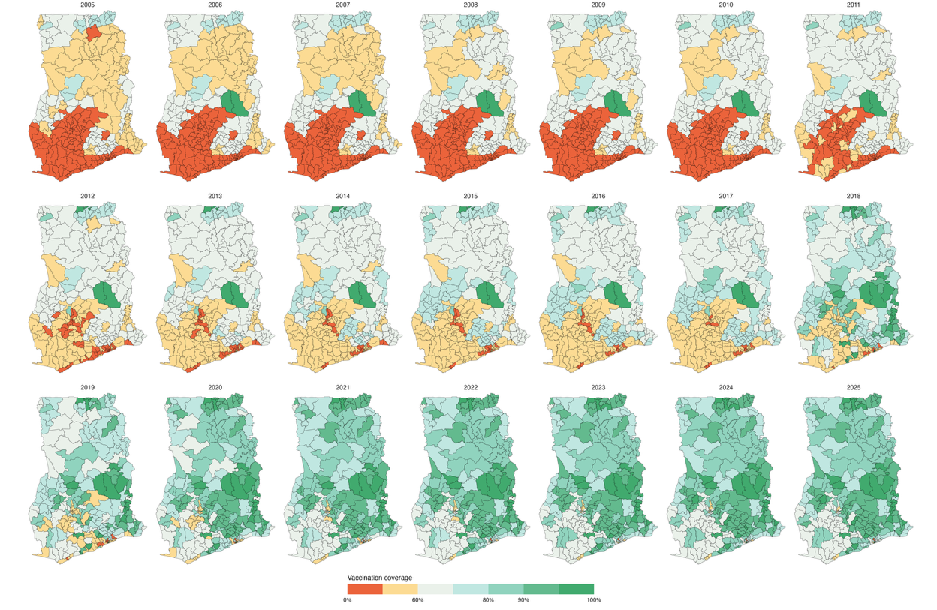

Figure S9. Annual vaccination coverage by district in Ghana, 2005-2025
The maps show the estimated annual vaccination coverage in Ghana, based on an age-structured cohort vaccination model. The model includes routine annual childhood vaccination rates and supplementary campaigns from 2005-2025.

7. Ecological Niche Models

Table S3. Ecological niche model checklist

The table below is based on the checklist from:
Feng, X., Park, D.S., Walker, C. et al. A checklist for maximizing reproducibility of ecological niche models. Nat Ecol Evol 3, 1382–1395 (2019). https://doi.org/10.1038/s41559-019-0972-5

Workflow | Category | What to report | Your method | Your rationale
(A) Obtaining and processing occurrence data | metadata | (A1) source of occurrence data | Town coordinates: Google Earth, Fallingrain, geographic.org, OSM;  Healthcare facility coordinates: GHS | Coordinates of town of residence were prioritized to align with locations of exposure. If the coordinates of towns of residence were not available, the coordinates of the healthcare facility where the patient was evaluated were used instead.
(A) Obtaining and processing occurrence data | metadata | (A2) download date; version of data source | Yellow fever data from 2005-2024 was received from GHS in June 2025. Nine occurrence locations included in the analysis were found from a prior literature review (Judson et al. 2024).
(A) Obtaining and processing occurrence data | metadata | (A3) basis of records | Individual line-level data of all patients tested for YF from 2005-2024 were obtained in partnership with the GHS and a prior literature review (Judson et al. 2024). | For the line-level data, we categorized cases according to the IDSR case definitions, which are the operational definitions for YF in Ghana. The RT-PCR results and PRNT confirmatory results were only available from 2023 and 2024. For cases that were YF IgM positive during an outbreak but did not have additional confirmatory results, these were treated as probable cases per the WHO Vaccine Preventable Disease Surveillance Standards case definitions.
 |  | (A4) spatial extent | Ghana
 |  | (A5) temporal range | 2005-2024
 | processing | (A6-1) duplicate coordinates | Duplicate coordinates were removed from the final list of occurrences, reducing the number of cases from 185 to 130.
 |  | (A6-2) spatial/environmental outlier; error | Coordinates were checked to ensure they were within Ghana’s boundaries and visually inspected via satellite imagery in Google Earth to confirm the presence of a settlement
 |  | (A6-3) spatial/coordinate uncertainty | Coordinates were reported to 2 decimal places.
 |  | (A7-1) sampling bias | We addressed sampling bias by creating a kernel-density bias raster using the spatial distribution of the occurrence data. The kernel-density was used to weight background point selection, so the background points would reflect the spatial structure of sampling effort. We chose to use a kernel-density bias raster rather than a spatial thinning approach to retain all valid occurrence points. | Balej, P., Moudrý, V., Prajzlerová, D., Gábor, L., Sillero, N., Rocchini, D. and Šímová, P. (2025), Species-observer link and kernel density estimation of background points allow for sampling bias correction in bird species distribution models. Ecography, 2025: e08202. https://doi.org/10.1002/ecog.08202  Inman, R., J. Franklin, T. Esque, and K. Nussear. 2021. Comparing sample bias correction methods for species distribution modelling using virtual species. Ecosphere 12(3):e03422. 10.1002/ecs2.3422  Tong R, Yesson C, Yu J, Luo Y and Zhang L (2023) Key factors for species distribution modelling in benthic marine environments. Front. Mar. Sci. 10:1222382. doi: 10.3389/fmars.2023.1222382  Phillips et al. 2009. Ecological Applications 19(1):181-197 for details).  Balej, P., Moudrý, V., Prajzlerová, D., Gábor, L., Sillero, N., Rocchini, D. and Šímová, P. (2025), Species-observer link and kernel density estimation of background points allow for sampling bias correction in bird species distribution models. Ecography, 2025: e08202. https://doi.org/10.1002/ecog.08202
 |  | (A7-2) spatial autocorrelation | To account for spatial autocorrelation, spatial blocks were used to partition the occurrence and background data into four geographically independent folds. | Kass, J. M., Muscarella, R., Galante, P. J., Bohl, C. L., Pinilla‐Buitrago, G. E., Boria, R. A., ... & Anderson, R. P. (2021). ENMeval 2.0: Redesigned for customizable and reproducible modelling of species’ niches and distributions. Methods in Ecology and Evolution, 12(9), 1602-1608.
(B) Obtaining and processing environmental data | metadata & processing | (B1) source | See table S2 above
(B) Obtaining and processing environmental data | metadata & processing | (B2) download date; version of data source | See table S2 above
(B) Obtaining and processing environmental data | metadata & processing | (B3) spatial resolution | See table S2 above
(B) Obtaining and processing environmental data | metadata & processing | (B4) temporal range | See table S2 above
(C) Model calibration | data input | (C1) modelling domain | Ghana
 |  | (C2) number of background data | 10,000 | 10,000 background points have been shown to produce the most accurate predictive models using the Maxent algorithm.  Barbet-Massin, M., Jiguet, F., Albert, C.H. and Thuiller, W. (2012), Selecting pseudo-absences for species distribution models: how, where and how many?. Methods in Ecology and Evolution, 3: 327-338. https://doi.org/10.1111/j.2041-210X.2011.00172.x  Hysen, L., Nayeri, D., Cushman, S., & Wan, H. Y. (2022). Background sampling for multi-scale ensemble habitat selection modelling: Does the number of points matter?. Ecological Informatics, 72, 101914.  Phillips SJ, Dudík M, Elith J, Graham CH, Lehmann A, Leathwick J, Ferrier S. Sample selection bias and presence-only distribution models: implications for background and pseudo-absence data. Ecol Appl. 2009 Jan;19(1):181-97. doi: 10.1890/07-2153.1. PMID: 19323182.
 |  | (C3) sampling method for background data | We selected 10,000 background points weighted by the kernel-density estimate of occurrence data. We used Ripley’s L function to estimate the maximal distance of case clustering and identify reasonable bandwidth values between 25-30.1 km. We chose a bandwidth of 25 km to produce the kernel density estimate.
 |  | (C4) variable selection | We assessed collinearity and removed variables with a correlation coefficient of >0.7 using the caret package in R. Bioclimatic variables 8, 9, 18, and 19 from WorldClim were excluded due to issues with discontinuities in tropical regions (Booth, 2022). Bioclimatic variable 6 was manually removed from the environmental stack because its response curves were implausible based on a priori hypotheses and low variable importance. Population density was manually removed from the environmental stack due to missing values at borders and information overlap (see conceptual framework) with built environment. | Booth TH. Checking bioclimatic variables that combine temperature and precipitation data before their use in species distribution models. Austral Ecology. 2022;47: 1506–1514.
 | algorithm | (C5) name | Maxent
 | algorithm | (C6) version of algorithm and software | ENMeval version 2.0.5 in R version 4.5.2
 | algorithm | (C7) parameterization | spatial block partitioning using hierarchical checkerboards and an aggregation factor of (8,8). Regularization multipliers ranged from 0.5 – 5 in 0.5 increments. Feature classes included linear, quadratic, linear-quadratic.  The optimal parameters were chosen using the ENMevaluate function. | Model tuning tested varying complexity settings (i.e., feature class options and regularization multipliers) and cross-validation techniques to identify the best performing model. We chose to exclude the more complex feature classes (i.e., hinge, product, and threshold) to avoid overfitting the model.  Kass, J. M., Muscarella, R., Galante, P. J., Bohl, C. L., Pinilla‐Buitrago, G. E., Boria, R. A., ... & Anderson, R. P. (2021). ENMeval 2.0: Redesigned for customizable and reproducible modelling of species’ niches and distributions. Methods in Ecology and Evolution, 12(9), 1602-1608.  Merow, C., Smith, M.J. and Silander, J.A., Jr (2013), A practical guide to MaxEnt for modelling species' distributions: what it does, and why inputs and settings matter. Ecography, 36: 1058-1069. https://doi.org/10.1111/j.1600-0587.2013.07872.x
(D) Model transfer and evaluation | evaluation | (D1) evaluation index | Continuous Boyce Index (CBI), omission rate 10 (OR10) threshold | CBI is a metric that does not require true absence data and is less impacted by background point selection.  OR10 thresholds can assess model overfitting using by comparing omission rates across validation folds and between testing and training data.  Hirzel AH, Le Lay G, Helfer V, Randin C, Guisan A, 2006. Evaluating the ability of habitat suitability models to predict species presences. Ecol Model 199: 142–152.  Whitford, A. M., Shipley, B. R., & McGuire, J. L. (2024). The influence of the number and distribution of background points in presence-background species distribution models. Ecological Modelling, 488, 110604.  Wang, J. G., Wu, J. W., & Li, W. J. (2025). Ecological Niche Changes and Risk Regionalization of the Invasive Plant Praxelis clematidea. Ecology and evolution, 15(6), e71546. https://doi.org/10.1002/ece3.71546
 | evaluation | (D2) threshold for evaluation index | In addition to evaluating the model using the CBI and OR10, we assessed the sensitivity of the minimum training presence (MTP), OR10, and maximum sensitivity and specificity (maxSSS) on the test occurrence data.
 |  | (D3) dataset used to evaluate models | All occurrence data from 2024 was excluded from training the model and used for testing and evaluation (n=33).
 | output | (D4) format/transformation | Complimentary log-log (cloglog)
 | output | (D5) threshold | We produced a cloglog, continuous suitability map (range: 0-1) and a categorical suitability map using MTP and OR10 values. Suitability values less than the MTP threshold were categorized as low suitability, values between the MTP and OR10 thresholds were categorized as moderate suitability, and values greater than the OR10 threshold were categorized as high suitability. | Acharya, B. K., Cao, C., Xu, M., Khanal, L., Naeem, S., & Pandit, S. (2018). Present and Future of Dengue Fever in Nepal: Mapping Climatic Suitability by Ecological Niche Model. International Journal of Environmental Research and Public Health, 15(2), 187. https://doi.org/10.3390/ijerph15020187
 | extrapolation | (D6) novelty of projected environments compared with training environments | NA | Testing data was assessed using the same training environment.
 | extrapolation | (D7) collinearity shift between training and projected environments | NA
 | extrapolation | (D8) extrapolation strategy | NA
 | metadata | (D9) source | See B1
 | metadata | (D10) download date; version of data source | See B2
 | metadata | (D11) spatial resolution | See B3
 | metadata | (D12) temporal range | See B4

Table S4. Summary of Model Results

Hyperparameter Tuning:
Optimal Model: Feature class L, regularization multiplier 0.5
Metric | Value
Training CBI | 0.87
Test CBI | 0.94
OR10 | 0.10
Test OR10 | 0.21

CBI and OR10 values in the training dataset (n = 97, years: 2005-2023) and testing dataset (n = 33, years: 2024) from the optimal model.

Table S5. Covariate importance

Covariate | Permutation importance (%) | Standard deviation (%)
Built surface area | 50.23 | 2.55
Mean temperature of coldest quarter | 15.90 | 2.92
Elevation | 12.65 | 2.38
Edge density | 11.50 | 1.22
NDVI | 5.90 | 1.81
Precipitation of wettest quarter | 3.77 | 2.04

Variable permutation importance and standard deviation for the optimal model calculated using the VarImp function in the SDMtune package.

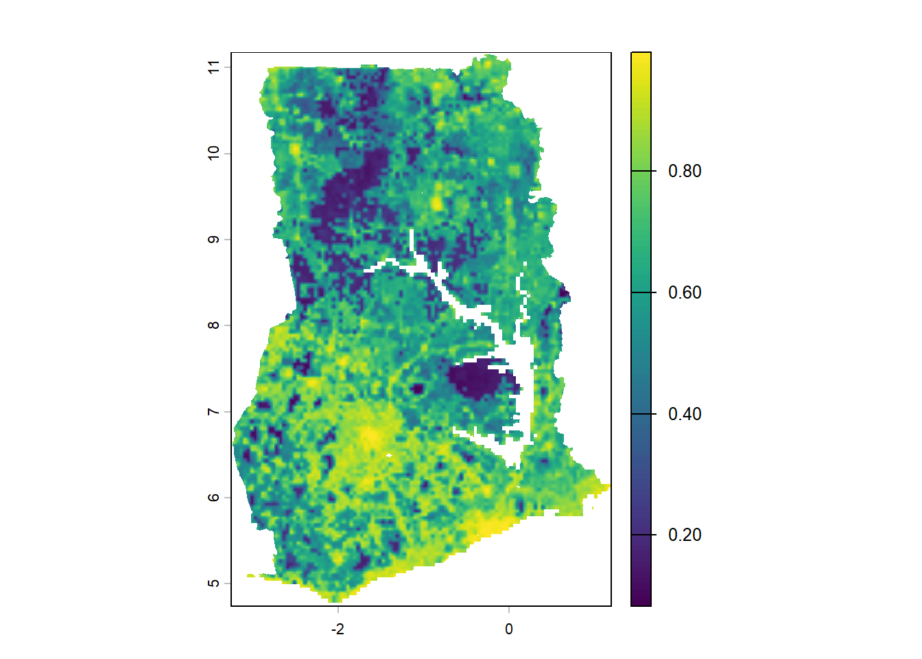
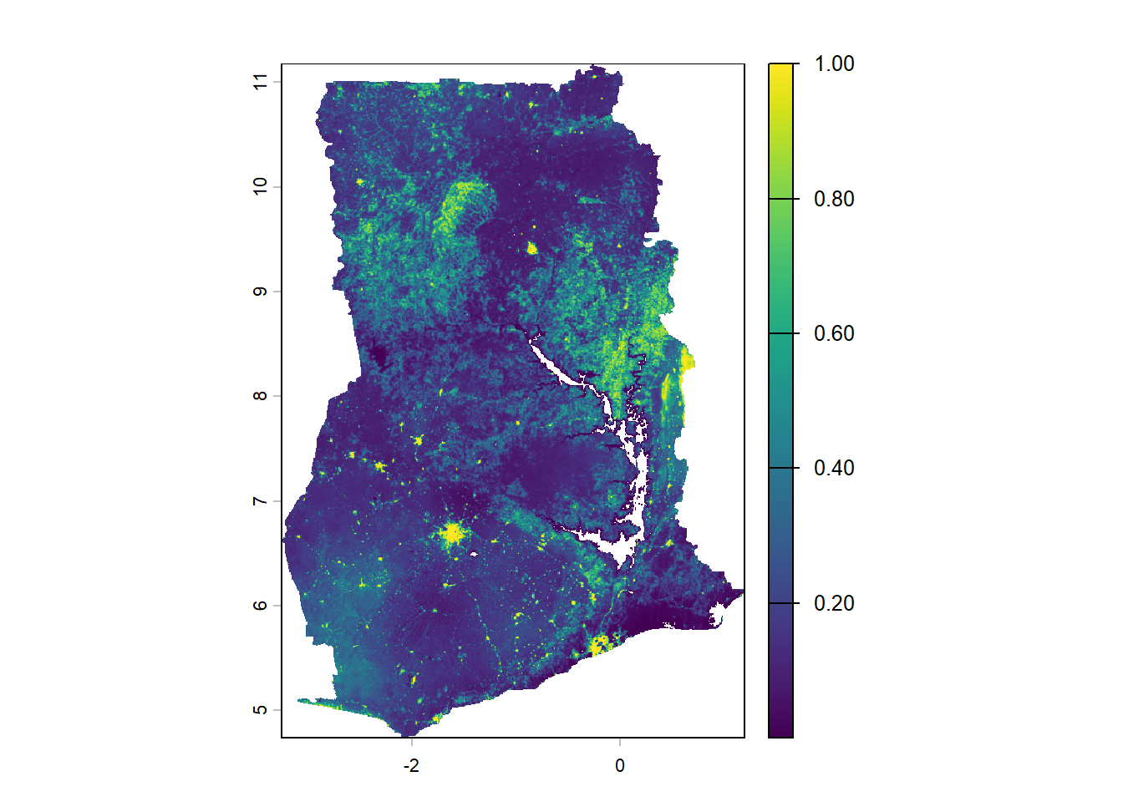
a
b
c

Fig. S10. Comparison of local vs global YF risk maps

The continuous predicted environmental suitability maps for yellow fever (range: 0-1) predicted by the study’s optimal model (a) and global model by Lim et. al 2025 (b). The binary threshold model by Lim et al. 2025 (c) is shown with yellow indicating predicted areas at risk; Mole National Park is outlined in green. The global raster provided by Lim et. al was downloaded from https://github.com/ahyoung-lim/Arbo_riskmaps_public/blob/main/outputs/Rasters/YF_riskmap_wmean_masked.tif and was cropped, resampled, and masked to Ghana.

Fig. S11. Yellow fever ecological niche model uncertainty, 2005-2024
The map depicts the standard deviation of environmental suitability of yellow fever produced by the ecological niche model.

Fig. S12. Response curves

Complementary log-log (cloglog) response curves showing the relationship between modeled covariates and probability of yellow fever occurrence under the optimal model.

8. Sensitivity Analysis

We assessed the sensitivity of the ecological niche model by expanding the temporal range of case data to 1969-2024. Training data included cases from 1969-2023 (n =113) and testing data included cases from 2024 (n = 33). Covariates and model tuning procedures remained the same as those listed above.
Table S6. Summary of Model Results, 1969-2024

Hyperparameter Tuning:
Optimal Model: Feature class L, regularization multiplier 0.5
Metric | Value
Training CBI | 0.88
Test CBI | 0.94
OR10 | 0.10
Test OR10 | 0.27

CBI and OR10 values in the training dataset (n = 113, years: 1969-2023) and testing dataset (n = 33, years: 2024) from the sensitivity analysis model.

Table S7. Covariate importance, 1969-2024

Covariate | Permutation importance (%) | Standard deviation (%)
Built surface area | 50.83 | 2.27
Mean temperature of coldest quarter | 16.07 | 2.44
Elevation | 11.80 | 1.52
Edge density | 10.68 | 1.32
NDVI | 7.60 | 0.77
Precipitation of wettest quarter | 2.98 | 1.67

Variable permutation importance and standard deviation in the sensitivity analysis model calculated using the VarImp function in the SDMTune package.

Fig. S13 Ecological niche model environmental suitability of yellow fever, 1969-2024

Complementary log-log (cloglog) outputs of continuous mean suitability of environmental suitability from a sensitivity analysis of an ecological niche model using data from 1969-2024.

Fig. S14 Yellow fever ecological niche model uncertainty, 1969-2024

Complementary log-log (cloglog) outputs of standard deviation of environmental suitability from a sensitivity analysis of an ecological niche model using data from 1969-2024.

Fig. S15. Response curves, 1969-2024
Complementary log-log (cloglog) response curves showing the relationship between modeled covariates and probability of yellow fever occurrence under the sensitivity analysis of an ecological niche model using data from 1969-2024.

9. Risk map survey instrument

Background
Primary Professional Role:
Years of Public Health Experience:
Disease focus (if applicable):
Question: "Have you ever used spatial risk maps in your professional practice?"
- [1] Yes [2] No
Statement: "I have direct public health experience with yellow fever (e.g., case investigation, immunization campaigns, diagnostics)."
- [1] Strongly Disagree [2] Disagree [3] Neutral [4] Agree [5] Strongly Agree

Section 1:

1. Alignment with Expectations
Statement: "The spatial distribution of risk shown on this map is consistent with my expectations of disease risk in Ghana."
- [1] Strongly Disagree [2] Disagree [3] Neutral [4] Agree [5] Strongly Agree

2. Influence of Development Source
Statement: "I am confident in using a risk map if it is developed internally (e.g., by our local health service or agency)."
- [1] Strongly Disagree [2] Disagree [3] Neutral [4] Agree [5] Strongly Agree
Statement: "I am confident in using a risk map if it is developed externally (e.g., by international research academic groups or external partners)."
- [1] Strongly Disagree [2] Disagree [3] Neutral [4] Agree [5] Strongly Agree
Statement: "I am confident in using a risk map if it is co-developed (e.g., with international research academic groups or external partners)."
- [1] Strongly Disagree [2] Disagree [3] Neutral [4] Agree [5] Strongly Agree

Section 2:

1. Target Audience & Utility
Open text: "Who do you think could benefit from using this risk map, and in what specific decision-making scenarios could it be used?"

2. Operational Relevance
Statement: "This risk map provides actionable information for targeting preventative vaccination strategies."
- [1] Strongly Disagree [2] Disagree [3] Neutral [4] Agree [5] Strongly Agree
Statement: "This risk map provides actionable information for prioritizing diagnostic testing and surveillance."
- [1] Strongly Disagree [2] Disagree [3] Neutral [4] Agree [5] Strongly Agree

3. Missing Features
Open text: "What changes to the map or additional information would make this map more useful?"

Section 3:

1. Likelihood of Adoption
Statement: "My colleagues and I would use this type of risk map to inform our work.
- [1] Strongly Disagree [2] Disagree [3] Neutral [4] Agree [5] Strongly Agree

2. Level of Adoption
Question: At which administrative level would this type of risk map most likely be used?
- [1] subdistrict [2] district [3] regional [4] national

3. Barriers to Use
Open text: "What challenges might prevent you or your colleagues from using this risk map?"

10. Risk Map Survey Results
