Additional File 2

Expanded Methods for Random Survival Forest Modelling
To establish a clinical prognostic model, strict quality-control filters were first applied to collated data as detailed in results. Censoring time was defined as the age at last contact, and survival time as time from presentation to death or censoring. A mixture of continuous and categorical candidate prognostic variables were selected based on clinical plausibility, data completeness, and robustness of the reported phenotype or measure. These included the sum of CADD scores for the two variants per individual, and also the experimentally unified variant function score. Many categorical phenotypic findings were not documented in clinical reports, especially those focused primarily on functional studies of INSR variants. To prevent selection bias and to avoid removing these records, we implemented a dual-stage categorical imputation. First, for ten phenotypic features, we applied probabilistic recoding based on expert clinical judgment (Supplementary Table 1). Within each training subset, a specific proportion of "unknown" values was recoded to "No", reflecting expert-adjudicated priors that unreported findings indicate true absence of a feature. For example, if no cardiac abnormalities were documented, we estimated an 80% probability that cardiac abnormalities were truly absent, mapping 80% of those unknown records to "No". This process reflected clinical judgement and preserved the study population. Second, any remaining unknown categorical values were stochastically imputed. This was done by sampling "Yes" or "No" based on the observed distribution of present/absent symptoms in the training subset. Continuous variables with missing values were imputed using the median values calculated within the training partition. For model execution, categorical predictors were transformed via one-hot encoding, while rare classification levels were handled using infrequent-category encoding. To ensure the model remained clinical, any predictor with more than 50% overall missingness within a training set was excluded from that specific partition.
Prognostic risk parsing was conducted using a Random Survival Forest (RSF) machine learning model. To estimate model generalisability and prevent overfitting, the dataset was first split into five distinct validation groups, with each group maintaining the same proportion of survival events (deaths). Each group was iteratively withheld to serve as an independent test set, while the remaining four groups were pooled to form the model training set. Comparing the model's performance across these different training and testing configurations provided an unbiased estimate of stability. The RSF architecture was constructed with a forest size of 500 individual survival trees. Split options at each internal node were restricted to the square root of the total candidate feature count. To control tree growth, we required a minimum of 10 observations to perform an internal node split, and a minimum of 5 observations in any terminal leaf node. All stochastic procedures were governed by a fixed random seed of 42 to ensure exact reproducibility of results.
For each independent test set, the RSF model generated a continuous prognostic risk score and an individualised survival curve. Discrimination, or the model's capacity to correctly rank patient risk was evaluated using Harrell’s concordance index (C-index) and Uno’s C-index. Short-term prognostic accuracy at 2 years post-presentation was assessed using the time-dependent cumulative/dynamic Area Under the Curve (AUC) and the 2-year Brier score. The Integrated Brier Score (IBS) was also used when estimable across a continuous time window from 0.1 to 2.0 years to track long-term calibration consistency. Meaning and interpretation of model performance indices is summarised in Supplementary Table 2. To evaluate model calibration, patients were partitioned into five subgroups based on their predicted 2-year survival probabilities. It is important to note that these predictions were generated out-of-fold, meaning each patient's prognosis was predicted by a model that had not seen their clinical data during training. The mean predicted survival within each of the five cohorts was then directly compared against the observed survival calculated using Kaplan-Meier estimates. For optimistic bias prevention, all calibration and risk-stratification analyses were based on these pooled out-of-fold test set predictions.
Clinical risk categories were defined by dividing the pooled risk scores into tertiles, classifying patients into Low-risk, Medium-risk, and High-risk cohorts. Key drivers of mortality risk were defined by calculated Permutation Feature Importance. Within each independent test fold, the values of each predictor were shuffled across 30 repeated runs, and the resulting drop in model concordance was measured and averaged across folds. All statistical evaluations and calculations were performed in Python using pandas (version 2.2), NumPy (version 1.26), scikit-survival (version 0.22), scikit-learn (version 1.4), lifelines (version 0.28), matplotlib (version 3.8), and seaborn (version 0.13).

Supplementary Tables

Phenotypic Feature | Probability assigned that absence comment mean absence of phenotype
Cardiac abnormalities | 0.8
Diabetes | 0.8
Coagulopathy | 0.7
Hypoglycaemia | 0.7
Liver abnormalities | 0.6
Nephromegaly | 0.5
Nephrocalcinosis | 0.6
Hypothyroidism | 0.6

Supplementary Table 1. Phenotype-specific interpretation of absent categorical data

Methodological Term | Definition | Utility and Interpretation
Random Survival Forest (RSF) | A non-parametric machine learning method that constructs an ensemble of decision trees to analyse survival data. Each tree splits patients into branches based on combinations of variables that yield the greatest differences in survival. | Captures complex, non-linear relationships and multi-variable interactions (such as specific mutation types behaving differently when diabetes is present) without requiring manual interaction terms.
Right-Censored Data | A scenario where the target event (death) has not occurred for a patient within the study's observation window. | Ensures patients who are alive at their last follow-up are not ignored or counted as treatment failures, allowing the model to make full use of all available patient tracking data.
Five-Fold Stratified Cross-Validation | A validation technique where the dataset is split into five equal parts. The model is trained on four parts and tested on the remaining part. This is repeated five times so every patient is evaluated as an unseen case. | Prevents optimistic bias and overfitting, simulating how the model would perform when used for new patients.
Out-of-Fold (OOF) Prediction | A patient's predicted risk score or survival curve generated when the model predicting their outcome never saw their data during training. | Provides an honest assessment of the model's accuracy on new patients, preventing the artificial performance inflation that occurs when validation is performed on the training data.
Harrell's and Uno's Concordance Indices (C-index) | Validation metrics that assess a model's ability to rank patients by survival time. A C-index of 0.5 indicates random guessing, while 1.00 represents perfect clinical ranking. Uno's C-index adjusts for censoring patterns over time. | Unlike accuracy measurements for stable conditions, the C-index evaluates if the model correctly and consistently assigns higher risk scores to patients who experience complications or death earlier.
Brier Score and Integrated Brier Score (IBS) | The Brier score measures the average squared difference between a model's predicted survival probability and a patient's actual status (0 = alive, 1 = deceased) at a specific time. The IBS integrates this score continuously across a time window. | While the C-index measures risk ranking, the Brier score measures calibration accuracy. A score closer to 0 confirms that the predicted survival percentages match clinical reality.
Permutation Feature Importance | An evaluation technique that identifies key risk drivers by randomly shuffling the values of a single variable across patients and measuring the resulting drop in model accuracy. | Shuffling a highly important variable causes a drop in model concordance, whereas shuffling an unimportant variable has little impact. This allows ranking of risk factors.
One-Hot Encoding and Infrequent-Category Encoding | A process used to translate qualitative categories (e.g. sex, reporting era, or mutation groups) into binary numbers (1 = present; 0 = absent) that the algorithm can compute. Categories that appear only a few times across the cohort are grouped together into a single "infrequent" category before this process. | Machine learning models cannot directly process text-based clinical categories. One-hot encoding solves this by creating separate "yes/no" indicators for each category. Automatically grouping very rare or unique variations under an "infrequent" banner ensures the model does not over-interpret unique outliers, keeping its risk predictions focused on broad, reliable patient trends.
Supplementary Table 2: Random Survival Forest Model Bibliography and Explanation of Terms

 | All |  | non-KO |  | KO
 | N | Median  [25th,75th centile] | N | Median  [25th,75th centile] | N | Median  [25th,75th centile]
Age at presentation (years) | 219 | 0.08 [0,5] | 199 | 0.25 [0,6] | 20 | 0
Age at last reporting (years) | 244 | 7.5 [0.75,16] | 224 | 9.5 [1.2,17] | 20 | 0.30 [0.17,0.33]
Age at death (years) | 72 | 0.36 [0.25,1.36] | 56 | 0.54 [0.25,1.56] | 16 | 0.33 [0.19,0.33]
Birthweight SDS | 135 | -2.8 [-3.3,-1.8] | 123 | -2.7 [-3.3,-1.7] | 12 | -3.6 [-4.2,-2.9]
HbA1c (mmol/mol) | 122 | 78 [47,107] | 120 | 77 [44,108] | 2 | 83 [80,86]
Fasting insulin (pmol/L) | 133 | 1778 [727,3583] | 128 | 1663 [708,3491] | 5 | 8454 [3300,27239]
Fasting glucose (mmol/L) | 132 | 4.7 [2.9,9.3] | 124 | 4.8 [3.3,9.3] | 8 | 1.5 [0.9,10.8]
Post challenge insulin (pmol/L) | 91 | 3965 [1800,6300] | 119 | 6000 [2500,12000] | 7 | 5560 [1800,6144]
Post challenge glucose (mmol/L) | 117 | 13.7 [8.6,19.4] | 105 | 13.4 [8.2,19.8] | 12 | 14.1 [10.2,18.7]
Leptin (ug/L) | 33 | 2.7 [0.5,5.0] | 32 | 2.8 [0.5,5.1] | 1 | 0.1
Adiponectin (mg/L) | 16 | 17.9 [10.1,30.8] | 15 | 20.2 [10.9,32.8] | 1 | 9.4
Triglycerides (mmol/L) | 34 | 0.8 [0.7,1.1] | 34 | 0.8 [0.7,1.2] | 0 | n/a
HDL-C (mmol/L) | 31 | 1.6 [1.3,1.9] | 30 | 1.7 [1.3,1.9] | 1 | 1
Supplementary Table 3: Continuous Clinical and Biochemical Features of Biallelic Insulin Receptoropathy. KO = Knockout, as defined in methods; Non-KO = other genotypes not meeting KO criteria; SDS = Standard Deviation Score

Supplementary Figure

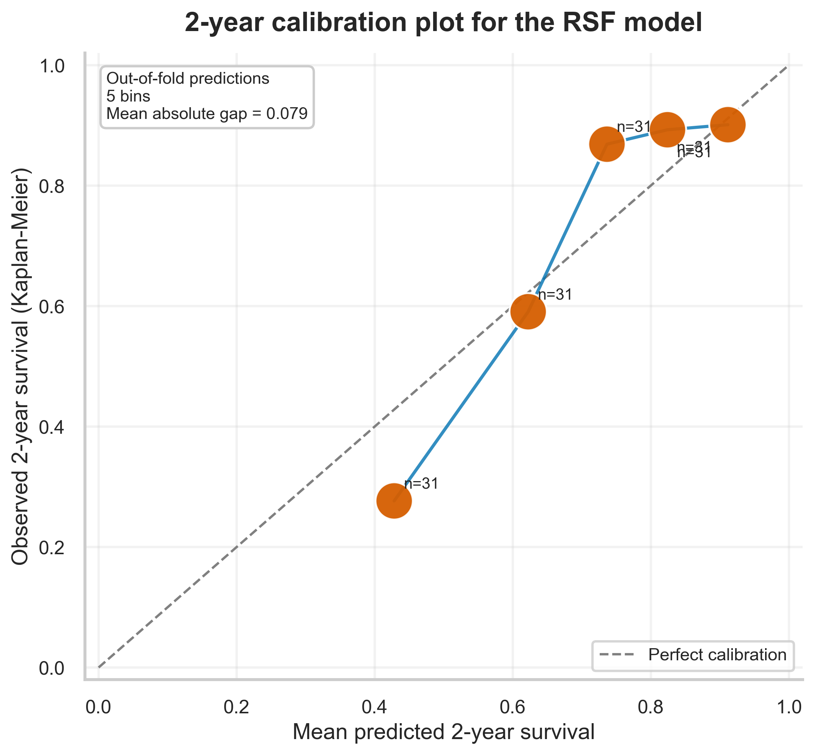
Supplementary Figure 1: Calibration of Random Survival Forest Model. Observed Kaplan-Meier survival plotted against mean predicted 2-year survival across five equal-sized patient quintiles (n=31 per bin). The dashed diagonal line representing perfect calibration indicates that the RSF model possesses excellent predictive accuracy, particularly within moderate-to-high survival brackets.

