Supplementary materials
- Figures

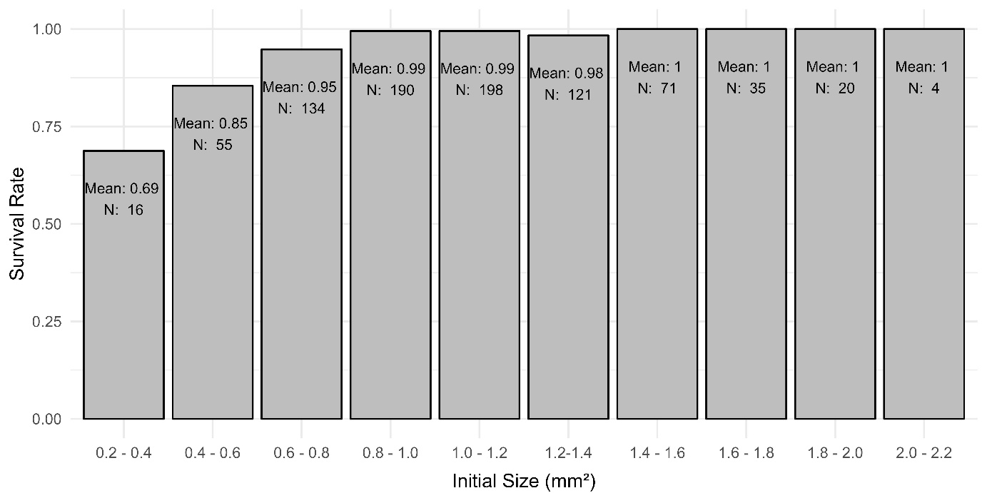
Supplementary Fig. 1: Bar plots of mean survival by bins of initial size (in mm²). Initial size bins were computed in 0.3 mm² breaks between the smallest and largest initial size as part of the descriptive statistics. The plot includes mean survivals by bin and number of observations per bin (N).

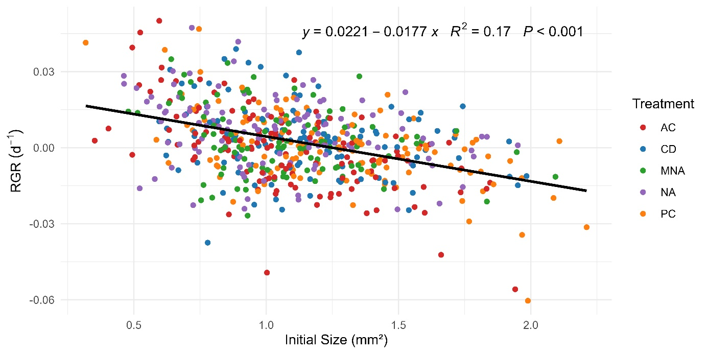
Supplementary Fig. 2: Scatter plot of individual observations showing the relationship between Initial Size and Relative Growth Rate (RGR) (d⁻¹) by treatment. The black line represents the fitted linear regression line with a 95% confidence interval. Treatment groups: AC – Absolute Control, CD – Commercial Diet, MNA – 1-Day Meta-Nauplii, NA – Freshly Hatched Nauplii, PC – Procedural Control.
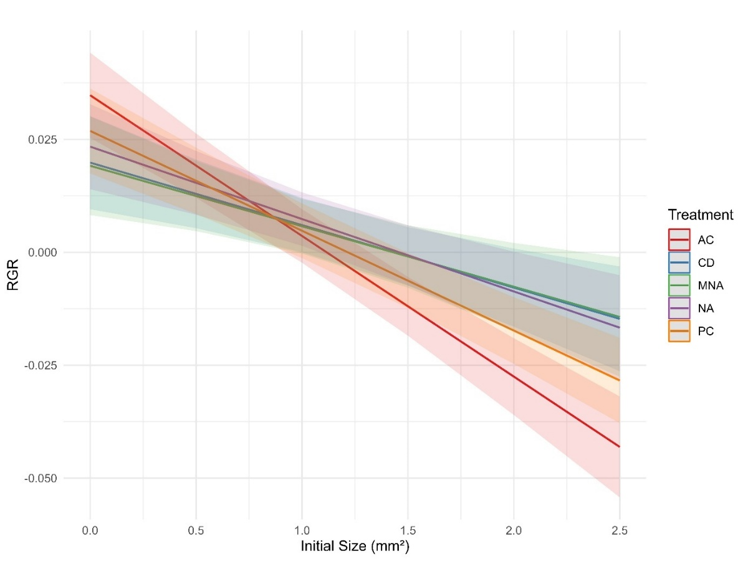
Supplementary Fig. 3: Partial effects plot for the growth model’s fixed effect initial size. The plot shows the effect of initial size on RGR (day⁻¹) for each treatment group. Shaded ribbons indicate 95 % confidence intervals around the predicted lines. Treatment groups: AC – Absolute Control, CD – Commercial Diet, MNA – 1-Day Meta-Nauplii, NA – Freshly Hatched Nauplii, PC – Procedural Control.

- Tables
Supplementary Table 1: Type III Analysis of Variance Table with Satterthwaite's method.
 | SSQ | Mean Sq | DF | DenDF | F-value | P-value
Distance | 0.001555615 | 0.001555614 | 1 | 592.7461 | 10.092110 | 0.0015 | **
Initial Size | 0.021132103 | 0.021132102 | 1 | 593.3233 | 137.095311 | <0.001 | ***
Treatment | 0.001513753 | 0.000378438 | 4 | 592.3171 | 2.455133 | 0.0447 | *
Initial Size:Treatment | 0.002775656 | 0.000693914 | 4 | 592.3029 | 4.501793 | 0.0013 | **
Signif. codes: 0 ‘***’ 0.001 ‘**’ 0.01 ‘*’ 0.05 ‘.’ 0.1

Supplementary Table 2: Results of the mixed model ANOVA for growth. Treatment groups: CD – Commercial Diet, MNA – 1-Day Meta- Nauplii, NA – Freshly Hatched Nauplii, PC – Procedural Control.
 | Growth
Predictors | Estimates |  | CI | P-value
(Intercept) | 0.0333724 |  | 0.0248661 – 0.0418788 | <0.001 | ***
Distance | 0.0003745 |  | 0.0001430 – 0.0006060 | 0.002 | **
Initial Size | -0.0310681 |  | -0.0377404 – -0.0243957 | <0.001 | ***
Treatment [CD] | -0.0148838 |  | -0.0262755 – -0.0034920 | 0.011 | *
Treatment [MNA] | -0.0155999 |  | -0.0275409 – -0.0036590 | 0.011 | *
Treatment [NA] | -0.0114229 |  | -0.0219611 – -0.0008848 | 0.034 | *
Treatment [PC] | -0.0077842 |  | -0.0184993 – 0.0029309 | 0.154
Initial Size:Treatment [CD] | 0.0172978 |  | 0.0074694 – 0.0271262 | 0.001 | ***
Initial Size:Treatment [MNA] | 0.0177177 |  | 0.0071014 – 0.0283341 | 0.001 | **
Initial Size:Treatment [NA] | 0.0151973 |  | 0.0057388 – 0.0246558 | 0.002 | **
Initial Size:Treatment [PC] | 0.0090205 |  | 0.0002001 – 0.0178409 | 0.045 | *
Random Effects
σ² | 1.541e-04
τ₀₀ _{Side} | 7.185e-06
ICC | 0.045
N _{Side} | 2
Observations | 594
Marginal R² / Conditional R² | 0.259 / 0.292
Signif. codes: 0 ‘***’ 0.001 ‘**’ 0.01 ‘*’ 0.05 ‘.’ 0.1
Supplementary Table 3: Pairwise comparisons of estimated marginal mean differences in daily RGR among treatments at mean initial spat size and mean distance to the nearest neighboring spat. Estimates represent model-predicted treatment differences, with standard errors (SE), adjusted P-values, and Cohen’s d. Negative Cohen’s d values indicate that the estimated marginal mean difference was negative in the direction of the specified contrast. Significant contrasts (P < 0.05) are printed in bold. Treatment groups: AC – Absolute Control, CD – Commercial Diet, MNA – 1-Day Meta- Nauplii, NA – Freshly Hatched Nauplii, PC – Procedural Control.
Contrast | Estimate | SE | P-value | Cohen's d
AC - CD | -0.00454 | 0.00162 | 0.0414 | -0.366
AC - MNA | -0.00430 | 0.00166 | 0.0733 | -0.346
AC - NA | -0.00565 | 0.00164 | 0.0056 | -0.455
AC - PC | -0.00235 | 0.00169 | 0.6326 | -0.189
CD - MNA | 0.00024 | 0.00170 | 0.9999 | 0.020
CD - NA | -0.00110 | 0.00167 | 0.9644 | -0.089
CD - PC | 0.00220 | 0.00170 | 0.6968 | 0.177
MNA - NA | -0.00135 | 0.00173 | 0.9374 | -0.108
MNA - PC | 0.00195 | 0.00179 | 0.8122 | 0.157
NA - PC | 0.00330 | 0.00168 | 0.2836 | 0.266
Supplementary Table 4: Pairwise comparisons of treatment-specific trends in daily RGR as a function of initial spat size. Estimates represent differences in the slope of RGR against initial spat size between treatments. P-values were adjusted using the Tukey method. Significant contrasts (P < 0.05) are printed in bold. Treatment groups: AC – Absolute Control, CD – Commercial Diet, MNA – 1-Day Meta- Nauplii, NA – Freshly Hatched Nauplii, PC – Procedural Control.
Contrast | Estimate | SE | df | t-ratio | P-value
AC - CD | -0.01730 | 0.00505 | 602.1 | -3.43 | 0.0059
AC - MNA | -0.01772 | 0.00545 | 602.2 | -3.25 | 0.0107
AC - NA | -0.01520 | 0.00486 | 602.7 | -3.13 | 0.0159
AC - PC | -0.00902 | 0.00453 | 602.1 | -1.99 | 0.2713
CD - MNA | -0.00042 | 0.00567 | 602.2 | -0.07 | 1.0000
CD - NA | 0.00210 | 0.00508 | 602.8 | 0.41 | 0.9939
CD - PC | 0.00828 | 0.00478 | 602.1 | 1.73 | 0.4150
MNA - NA | 0.00252 | 0.00551 | 603.1 | 0.46 | 0.9910
MNA - PC | 0.00870 | 0.00520 | 602.1 | 1.67 | 0.4511
NA - PC | 0.00618 | 0.00459 | 603.2 | 1.35 | 0.6625
Supplementary Table 5: Results of the GLMM for survival. Estimates are expressed as odds ratios. Treatment groups: CD – Commercial Diet, MNA – 1-Day Meta- Nauplii, NA – Freshly Hatched Nauplii, PC – Procedural Control.
 | Survival
Predictors | Odds Ratios | CI | P-value
(Intercept) | 0.5382 | 0.1033 – 2.8036 | 0.462
Initial Size | 229.7347 | 56.9640 – 926.5152 | <0.001 | ***
Treatment [CD] | 0.3988 | 0.1378 – 1.1543 | 0.090 | .
Treatment [MNA] | 0.4762 | 0.1627 – 1.3938 | 0.176
Treatment [NA] | 1.7847 | 0.5155 – 6.1786 | 0.361
Treatment [PC] | 0.8820 | 0.2546 – 3.0555 | 0.843
Random Effects
σ² | 3.29
τ₀₀ _{side} | 0.63
ICC | 0.16
N _{side} | 2
Observations | 1688
Marginal R² / Conditional R² | 0.491 / 0.573
Signif. codes: 0 ‘***’ 0.001 ‘**’ 0.01 ‘*’ 0.05 ‘.’ 0.1

Supplementary Table 6: Analysis of Deviance Table (Type III Wald chi-square tests) of the GLMM.
 | ChiSq | DF | P-Value
(Intercept) | 0.541 | 1 | 0.462
Initial Size | 58.393 | 1 | <0.001 | ***
Treatment | 9.380 | 4 | 0.052 | .
Signif. codes: 0 ‘***’ 0.001 ‘**’ 0.01 ‘*’ 0.05 ‘.’ 0.1

Supplementary Table 7: Estimated marginal means of survival probability by treatment. Values represent model-estimated survival probabilities for each treatment group, with standard errors (SE) and confidence intervals (CI) calculated on the response scale. Treatment groups: AC – Absolute Control, CD – Commercial Diet, MNA – 1-Day Meta- Nauplii, NA – Freshly Hatched Nauplii, PC – Procedural Control.
Treatment | Estimated survival probability | SE | df | Lower CI | Upper CI
AC | 0.9938 | 0.0047 | Inf | 0.9726 | 0.9986
CD | 0.9846 | 0.0104 | Inf | 0.9432 | 0.9960
MNA | 0.9871 | 0.0093 | Inf | 0.9482 | 0.9969
NA | 0.9965 | 0.0028 | Inf | 0.9836 | 0.9993
PC | 0.9930 | 0.0053 | Inf | 0.9698 | 0.9984

Supplementary Table 8: Pairwise comparisons of survival among treatments. Values represent model-based contrasts between treatment groups expressed as odds ratios, with standard errors (SE), confidence intervals (CI), Z-ratio and P-values. Marginally significant contrasts (P < 0.1) are printed in bold. Treatment groups: AC – Absolute Control, CD – Commercial Diet, MNA – 1-Day Meta- Nauplii, NA – Freshly Hatched Nauplii, PC – Procedural Control.
Contrast | Odds ratio | SE | df | Lower CI | Upper CI | Z-ratio | P-value
AC - CD | 2.5076 | 1.3597 | Inf | 0.6608 | 9.5158 | 1.6954 | 0.4367
AC - MNA | 2.0999 | 1.1507 | Inf | 0.5457 | 8.0817 | 1.3540 | 0.6572
AC - NA | 0.5603 | 0.3550 | Inf | 0.1179 | 2.6620 | -0.9143 | 0.8915
AC - PC | 1.1338 | 0.7187 | Inf | 0.2384 | 5.3909 | 0.1980 | 0.9997
CD - MNA | 0.8374 | 0.4056 | Inf | 0.2545 | 2.7558 | -0.3663 | 0.9962
CD - NA | 0.2234 | 0.1247 | Inf | 0.0567 | 0.8812 | -2.6861 | 0.0560
CD - PC | 0.4521 | 0.2463 | Inf | 0.1184 | 1.7262 | -1.4573 | 0.5904
MNA - NA | 0.2668 | 0.1563 | Inf | 0.0632 | 1.1267 | -2.2558 | 0.1595
MNA - PC | 0.5399 | 0.3164 | Inf | 0.1278 | 2.2814 | -1.0519 | 0.8310
NA - PC | 2.0235 | 1.2712 | Inf | 0.4316 | 9.4875 | 1.1219 | 0.7950

