Supporting Information for:
Movement and sociodemographic predictors of zoonotic and human hookworm infection in rural Madagascar

Contents
1. Metabarcoding Thresholding 2
2. Correlation among Networks 3
3. Averaged Models of Infection 4
4. Conditional coefficients for infection models 6
5. Hookworm prevalence across recruitment chains and seeds 7
6. PERMANOVA Results 8
7. Binary k-test 9

Metabarcoding Thresholding

Given the large number of multiplexed samples, which increases the chances of tag jumping, index misassignment, and sequencing errors, we included many negative controls across the entire sequencing run, which included additional samples (288 total negative controls). All samples, including negative controls, were normalized during the pooling stage of library preparation. This meant that we often pooled larger volumes from negative control wells, as well as from biological samples with no infection, allowing us to directly compare controls to samples and improving our ability to distinguish between true infection and likely noise. Read distributions in negative control wells showed a clear threshold at 500 reads, with 99% falling below this threshold (Figure S1). Only 3 of 288 (1%) negative controls showed amplification >1000 reads; further investigation indicated that these were rare cases of localized contamination.
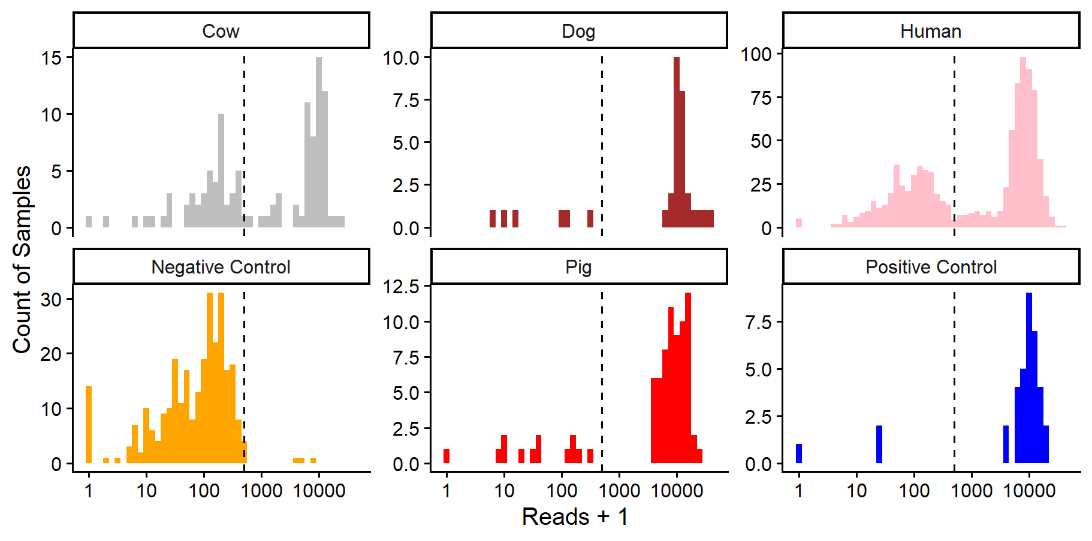
Figure S1. Distribution of total sequencing reads in all samples, negative controls, and positive controls. Note that the x-axis is displayed on the log10 scale. Vertical lines illustrate the 500 read threshold used to identify infections in this study.

Correlation among Networks

To assess the degree to which different networks were related to each other, we performed QAP using the sna package for all pairwise combinations of networks for each of the three villages. All but one network pair produced a significant p-value, due in part to considerable power from relatively large networks. However, the extent of the correlation varied widely, with utilization distribution networks from outside the village often being closely related [g_{cor} 0.52 – 0.97], with very low correlations with house coordinates [0.04 – 0.33] and the friendship network [0.01 – 0.09]. Space use within the village had a moderate correlation with other land use networks [g_{cor} 0.37 – 0.63].
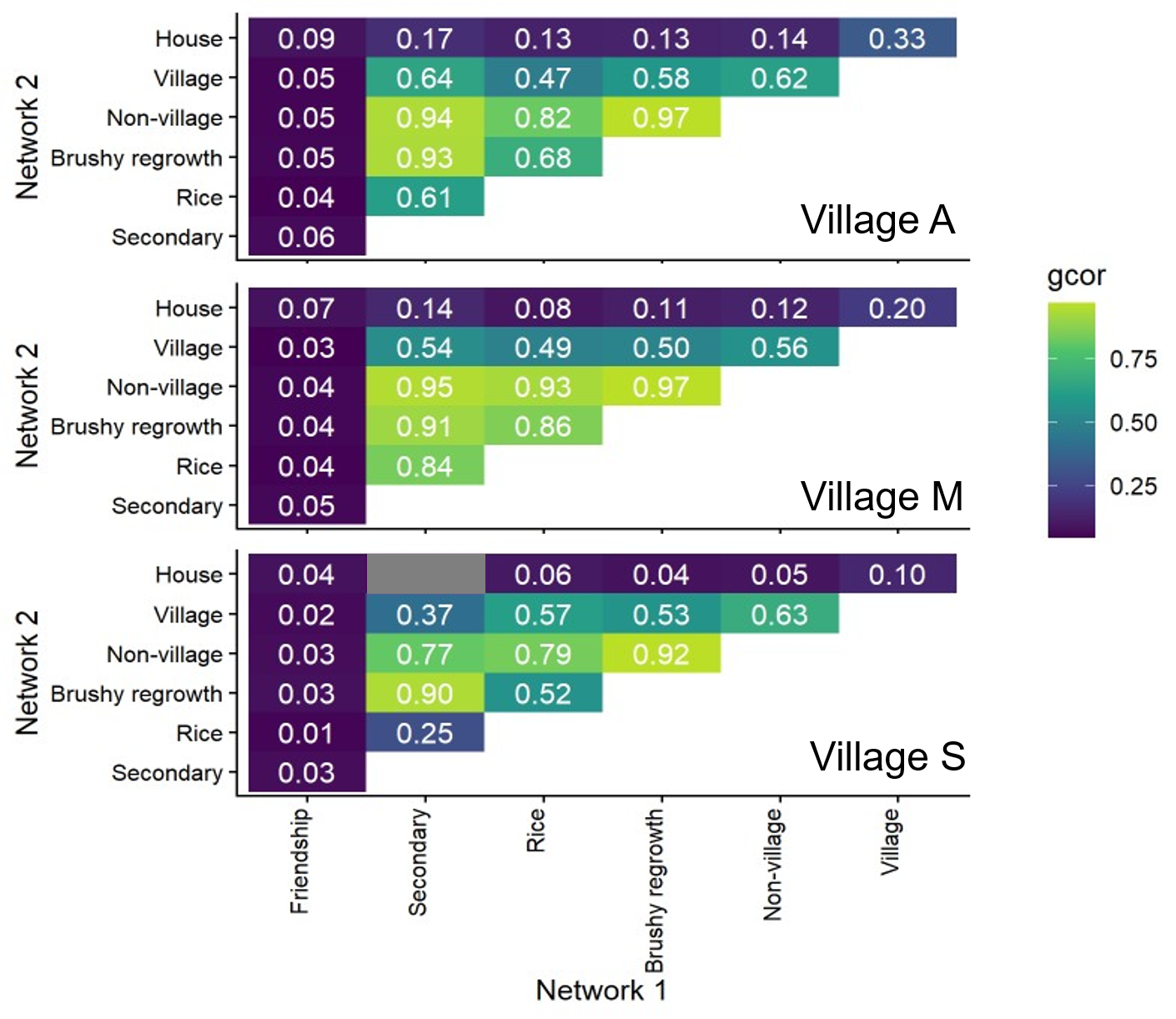
Figure S2.

Averaged Models of Infection

Table S1: Component models for averaged model of Necator americanus infection.
Necator americanus  Component models: |  |  |  |  | Model Composition
df | logLik | AICc | delta AICc | weight | Age | Gender | House Wealth PC1 | Material Wealth PC1 | School Level | Dog Contact | Season | Village
9 | -551.53 | 1121.28 | 0.00 | 0.29 | X | X |  | X | X |  | X | x
8 | -552.89 | 1121.96 | 0.68 | 0.20 |  | X |  | X | X |  | X | X
8 | -553.02 | 1122.22 | 0.93 | 0.18 | X | X |  | X |  |  | X | x
10 | -551.44 | 1123.14 | 1.86 | 0.11 | X | X | X | X | X |  | X | X
7 | -554.54 | 1123.21 | 1.93 | 0.11 | X | X |  | X | X |  |  | x
10 | -551.49 | 1123.25 | 1.97 | 0.11 | X | X |  | X | X | x | X | x
 |  | Proportion of models: |  |  | 0.83 | 1 | 0.17 | 1 | 0.83 | 0.17 | 0.83 | 1

Table S2: Component models for averaged model of Ancylostoma ceylanicum infection.
Ancylostoma ceylanicum  Component models: |  |  |  |  | Model Composition
df | logLik | AICc | delta  AICc | weight | Age | Gender | House Wealth PC1 | Material Wealth PC1 | School Level | Dog Contact | Season | Village
9 | -403.06 | 824.34 | 0 | 0.27 | X | X |  |  | X | X | X | X
8 | -404.25 | 824.67 | 0.34 | 0.23 |  | X |  |  | X | X | X | x
10 | -402.32 | 824.9 | 0.56 | 0.21 | x | X |  | X | X | X | X | x
9 | -403.44 | 825.09 | 0.75 | 0.19 |  | X |  | X | X | X | X | x
10 | -403.02 | 826.29 | 1.96 | 0.1 | x | x | x |  | X | X | X | X
 |  | Proportion of models: |  |  | 0.5 | 1 | 0.17 | 0.33 | 1 | 1 | 1 | 1

Table S3: Component models for averaged model of Necator americanus and Ancylostoma ceylanicum co-infection.
Coinfections  Component models: |  |  |  |  | Model Composition
df | logLik | AICc | delta | weight | Age | Gender | House Wealth PC1 | Material Wealth PC1 | School Level | Dog ownership | Season | Village
6 | -317.49 | 647.08 | 0 | 0.2 |  | X |  | X | X |  |  | x
5 | -318.68 | 647.42 | 0.34 | 0.17 |  | X |  | X |  |  |  | x
7 | -316.76 | 647.65 | 0.57 | 0.15 |  | X | X | X | X |  |  | x
6 | -318.04 | 648.18 | 1.1 | 0.12 |  | X | X | X |  |  |  | x
8 | -316.12 | 648.41 | 1.33 | 0.1 |  | X |  | X | X |  | X | x
7 | -317.2 | 648.53 | 1.44 | 0.1 |  | X |  | X |  |  | X | x
7 | -317.36 | 648.85 | 1.77 | 0.08 |  | X |  | X | X | x |  | x
7 | -317.38 | 648.9 | 1.82 | 0.08 | x | x |  | x | x |  |  | x
 |  | Proportion of models: |  |  | 0.13 | 1 | 0.25 | 1 | 0.63 | 0.13 | 0.25 | 1

Conditional coefficients for infection models

Table S4: Model-averaged coefficients for the conditional model of Necator americanus infections
Term | Estimate | Std. Error | Adjusted SE | z value | Pr(>|z|)
(Intercept) | 0.02 | 0.41 | 0.41 | 0.04 | 0.970
Village: M | -0.81 | 0.20 | 0.20 | 4.04 | <0.001 | ***
Village: S | -0.60 | 0.17 | 0.17 | 3.48 | 0.001 | ***
Season: Dry | 0.41 | 0.20 | 0.20 | 2.07 | 0.039 | *
Season: Wet | 0.03 | 0.19 | 0.19 | 0.16 | 0.876
Gender: Male | 0.69 | 0.15 | 0.15 | 4.64 | 0.000 | ***
Age (decade) | 0.09 | 0.05 | 0.05 | 1.80 | 0.073 | .
School level | -0.20 | 0.11 | 0.11 | 1.84 | 0.066 | .
Material wealth PC 1 | -1.87 | 0.45 | 0.45 | 4.19 | <0.001 | ***
House wealth PC 1 | -0.16 | 0.37 | 0.37 | 0.43 | 0.667
Dog contact | 0.04 | 0.15 | 0.15 | 0.28 | 0.776

Table S5: Model-averaged coefficients for the conditional model of Ancylostoma ceylanicum infections
Term | Estimate | Std. Error | Adjusted SE | z value | Pr(>|z|)
(Intercept) | -1.33 | 0.46 | 0.46 | 2.88 | 0.004 | **
Village: M | 0.89 | 0.25 | 0.25 | 3.57 | <0.001 | ***
Village: S | 1.03 | 0.21 | 0.21 | 4.95 | <0.001 | ***
Season: Dry | -0.50 | 0.25 | 0.25 | 2.01 | 0.044 | *
Season: Wet | -0.68 | 0.23 | 0.23 | 3.01 | 0.003 | **
Gender: Male | 0.41 | 0.18 | 0.18 | 2.24 | 0.025 | *
Age (decade) | -0.10 | 0.06 | 0.06 | 1.51 | 0.131
School level | -0.31 | 0.13 | 0.13 | 2.29 | 0.022 | *
Material wealth PC 1 | -0.67 | 0.54 | 0.54 | 1.24 | 0.215
House wealth PC 1 | 0.13 | 0.43 | 0.43 | 0.30 | 0.762
Dog contact | 0.48 | 0.18 | 0.18 | 2.61 | 0.009 | **

Table S6: Model-averaged coefficients for the conditional model of coinfections
Term | Estimate | Std. Error | Adjusted SE | z value | Pr(>|z|)
(Intercept) | -2.43 | 0.36 | 0.36 | 6.78 | < 0.001 | ***
Village: M | 0.92 | 0.27 | 0.27 | 3.38 | 0.001 | ***
Village: S | 0.80 | 0.25 | 0.25 | 3.20 | 0.001 | **
Season: Dry | -0.18 | 0.29 | 0.29 | 0.61 | 0.540
Season: Wet | -0.44 | 0.27 | 0.27 | 1.61 | 0.107
Gender: Male | 0.49 | 0.21 | 0.22 | 2.28 | 0.023 | *
Age (decade) | -0.03 | 0.07 | 0.07 | 0.46 | 0.642
School level | -0.23 | 0.15 | 0.15 | 1.53 | 0.125
Material wealth PC 1 | -1.46 | 0.66 | 0.66 | 2.22 | 0.026 | *
House wealth PC 1 | 0.61 | 0.52 | 0.52 | 1.18 | 0.240
Dog contact | 0.11 | 0.21 | 0.21 | 0.51 | 0.610

- Hookworm prevalence across recruitment chains and seeds

Prevalence by recruitment chain
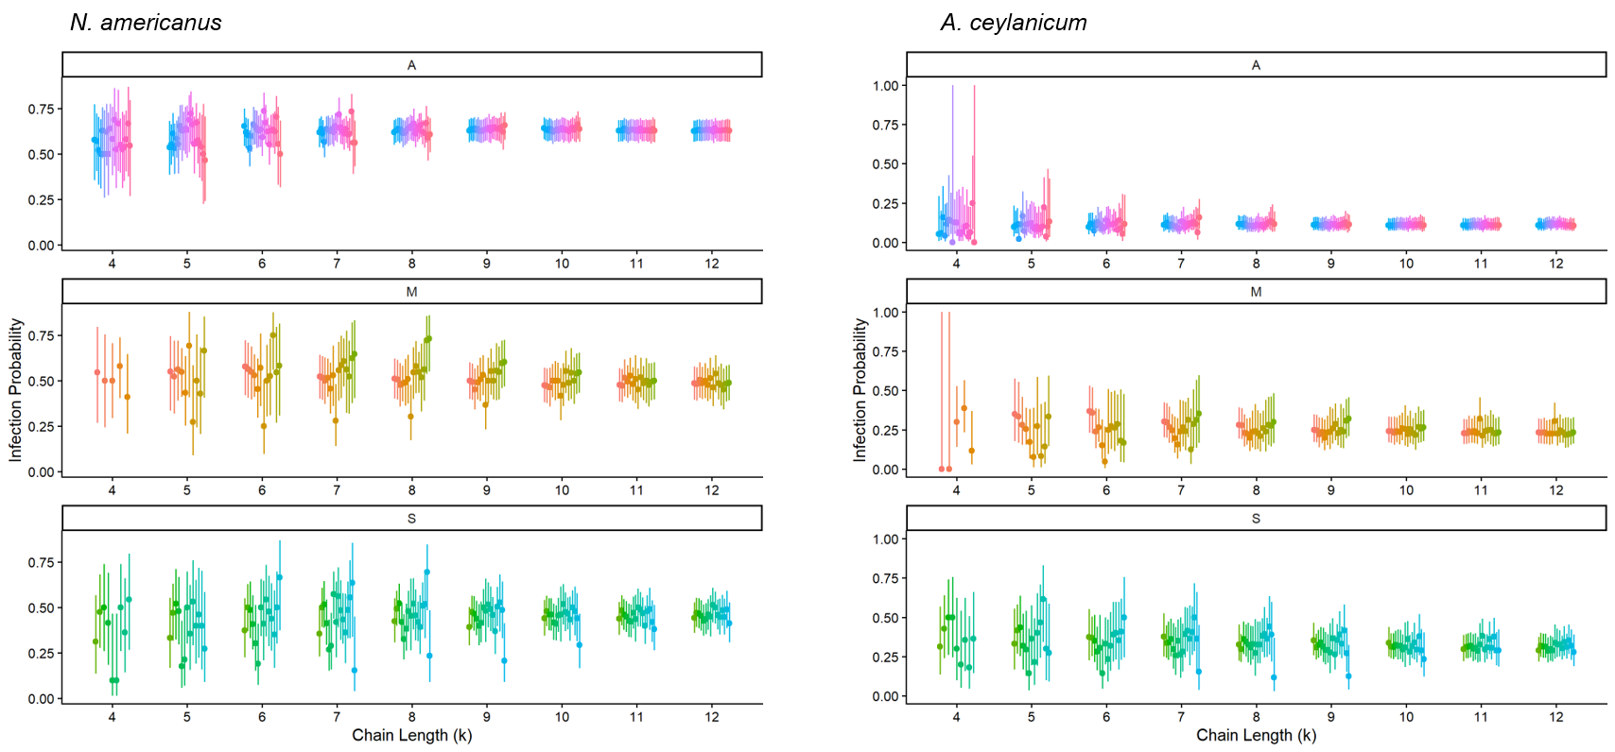
To check whether recruitment chains may have influenced prevalence estimates across villages, we tested whether individual-level hookworm infection probability varied by recruitment ‘chain’ at varying path lengths (k) from a given seed. Infection probability was not significantly different across the 18 different chains for any path length >4. Path lengths <4 were not tested because they gave fewer than 10 individuals in every group because not all named individuals provided fecal samples for testing. Infection probability for both parasites converged as path length increased.

Figure S3. Estimated marginal means of infection probability by recruitment chain (different colors) for varying chain lengths (k) for Necator americanus infections and Ancylostoma ceylanicum infections. Separate panels show infection probability in each village (A, M, S).

Prevalence by nearest seed
Because increasing path lengths increase the probability that a single individual falls within multiple seed groups, we also assigned each individual to their nearest seed based on path lengths. In the event of a tie, we randomly assigned individuals to one of the nearest seeds. We then fit a binomial GLM to test whether infection probability varied by seed group, repeating this procedure 1000 times and generating a distribution of p-values. For all three villages, significant p-values (alpha = 0.05) were rare (3-10%), suggesting that prevalence estimates are largely robust to the sampling technique, and increasing our confidence in the raw prevalence comparisons across villages.

PERMANOVA Results

To assess how infection related to human and zoonotic hookworm infection risk, we used a permutational MANOVA to test whether utilization distributions across land use classifications varied by parasite infection using the adonis2 function in the vegan package (Oksanen et al., 2026). We fit two models for each parasite: the first examined the effect of infection alone, and the second explored the marginal effect of infection after accounting for gender and village.
The PERMANOVA of land use revealed that sociodemographic characteristics and infection status explained variation in land use for N. americanus but not A. ceylanicum. Specifically, the model containing only Necator americanus infection status as a predictor showed a very small but significant difference in compositional land use for infected versus uninfected individuals (F_{1,676} = 6.296, R² = 0.009, p = 0.003). The model including effects of village and gender as well as infection status revealed that village explained the highest marginal proportion of variation (F_{2,673} = 26.79, R² = 0.072, p = 0.001), followed by gender (F_{1,673} = 10.45, R² = 0.014, p = 0.001) and infection status (F_{1,673} = 3.57, R² = 0.005, p = 0.031). For A. ceylanicum, infection status was only a marginally significant variable in explaining differences in land use (F_{1,676} = 2.38, R² = 0.004, p = 0.079), and this effect was negligible when accounting for gender (F_{1,673} = 12.63, R² = 0.017, p = 0.001) and village (F_{2,673} = 26.31, R² = 0.071, p = 0.001).

Oksanen J, Simpson G, Blanchet F, Kindt R, Legendre P, Minchin P, O'Hara R, Solymos P, Stevens M, Szoecs E, Wagner H, Bedward M, Bolker B, Borcard D, Carvalho G, De Caceres M, Durand S, Evangelista H, Hannigan G, Hill M, Lahti L, Martino C, Ouellette M, Ribeiro Cunha E, Smith T, Stier A, Ter Braak C, Weedon J (2026). vegan: Community Ecology Package. R package version 2.8-0, https://vegandevs.github.io/vegan/.
Binary k-test

Methods
As reported in the main manuscript, we investigated whether there were non-random patterns in the distribution of strength centrality such that strongly connected individuals on shared land use networks would have a higher probability of infection. To verify our results, we also ran the standard k-test, which tests whether infected individuals overlapped in land use with a greater number of other infected individuals than would be expected by chance. The standard k-test is calculated based on network degree centrality and requires binarized edge weights; therefore, because many networks were dense (i.e., nearly all individuals on the village network were connected to each other because most people spent time in the same area at least once), we created three sub-networks using different “cutpoints” to define edges, with edges representing the top 10, 20, and 30th percentile of edge weights for each network. We also used the binary k-test to determine if there were non-random patterns of infection in the friendship network.

Results
Friendship network

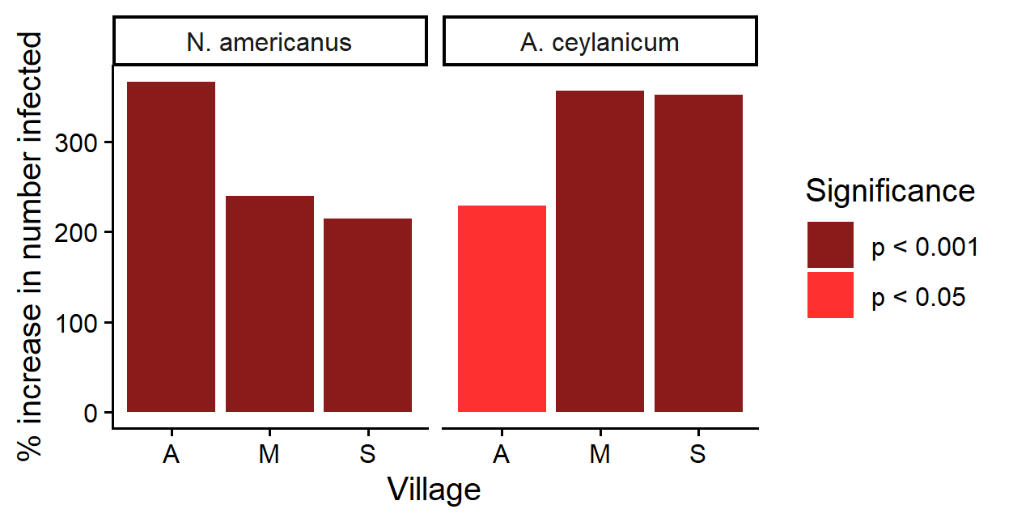
Figure S4: We found significant p-values for binary k-tests of parasite infection on the friendship networks for both parasites across the three villages. Infected individuals were connected to 2-3 times as many infected others than expected by chance.

Land use networks
K-tests of associations between networks of landscape use were defined as either the sum of total gridcells used for any period of time (“overlapping area”) or the sum-product of time spent in the same areas (“overlapping time”). Below, we compare the strength k-test results for the overlapping area and overlapping time networks (Figure S5). We also report the k-test results for binarized networks at each of the different cutpoints for both the overlapping area and the overlapping time networks. For ease of comparison, we note where these results differ from those based on the analyses presented in the main manuscript.

Strength k-test: Overlapping area vs. overlapping time
As noted in the main manuscript, strength k-test results from networks based on overlapping area and overlapping time were correlated in terms of effect size and direction (strength: Spearman’s ρ=0.69, p<0.001) but not p-value (ρ=0.08, p=0.72).
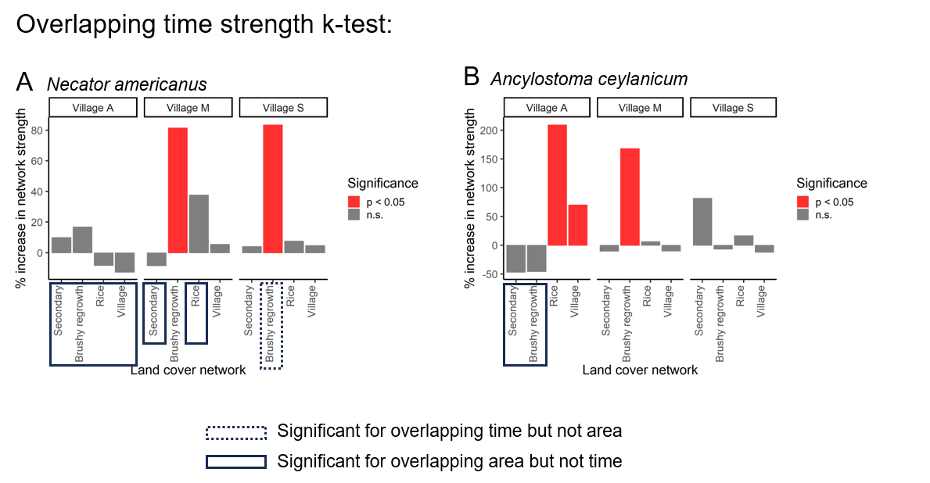
Figure S5. Strength test results for networks with edges weighted by the sum-product of shared time (“overlapping time”) in gridcells for each habitat type. Networks with any result that differed in terms of p-value significance are outlined in boxes in the x-axis.

Binary k-test vs. strength k-test for overlapping area and time:
For the overlapping area networks, the strength k-test results were very similar to the binary k-test results. Across both parasite species, there were two instances where the strength k-test results returned a significant p-value when the binary k-tests did not (Figure S6, left panel). For the overlapping time networks, the strength k-test results largely agreed with the binary k-test results, with the exception that brushy regrowth networks without cutpoints (Network cutpoint = 0) were significant for the binary k-test but not the strength k-test (Figure S6, right panel).
Results from binary networks based on overlapping area and overlapping time were marginally correlated to each other in terms of effect size and direction (r = 0.18, p = 0.07), but not p-value (r = 0.04, p = 0.68). Networks based on overlapping area were less sensitive to cutpoints than networks based on overlapping time.
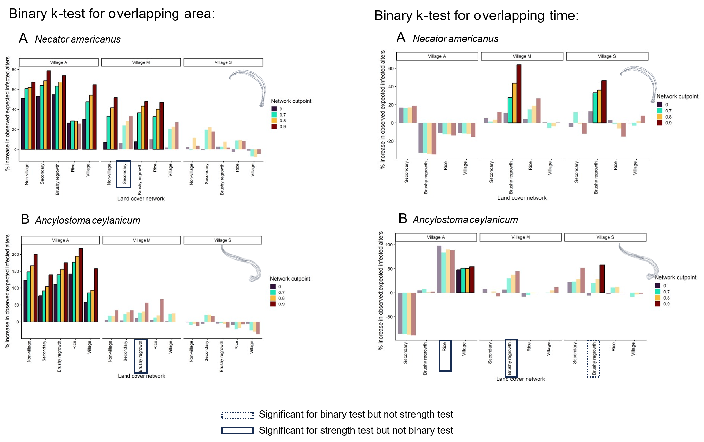
Figure S6. Binary k-test results compared to strength k-test results. Network cutpoints refer to the percentile of edges that were kept based on edge weights. A network cutpoint of 0 indicates that any overlap between individuals in a gridcell constitutes an edge. Network cutpoints of 0.7, 0.8, and 0.9 indicate that only the top 30%, 20%, and 10% of edge weights between two individuals are kept in a network, thus creating binary networks of more tightly-connected individuals. Networks with any result that differed in terms of p-value significance compared to the strength test results are outlined in boxes in the x-axis.

