Supplementary Figures

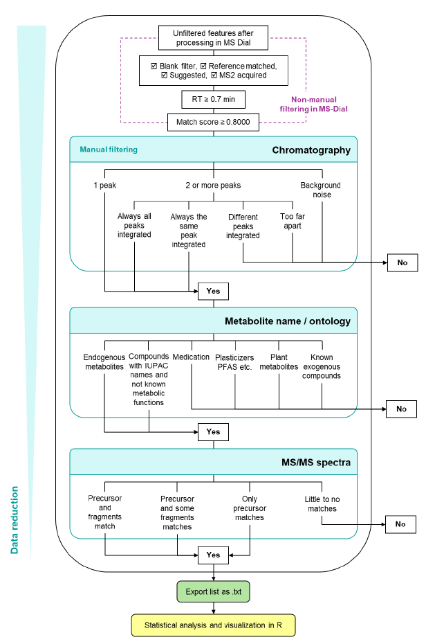
Supplementary Figure 1: Decision tree for manual peak filtering in MSDial.

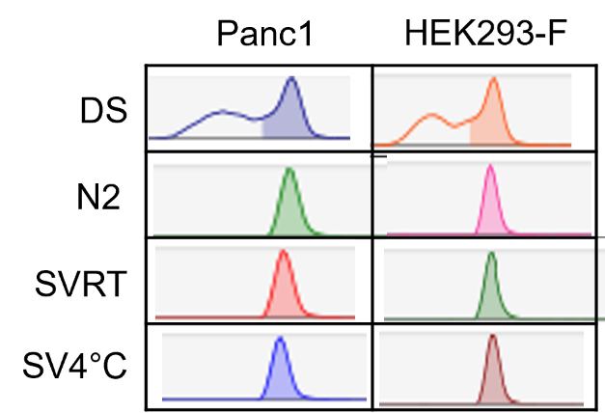
Supplementary Figure 2: Representative chromatograms of panthenol illustrating the mentioned peak broadening issue when applying dilute and shoot (DS). (N2: N₂ evaporation; SVRT: evaporation using SpeedVac at room temperature; SV4°C: evaporation using SpeedVac at 4°C.

