Table S1: Frequencies of Indels in An. gambiae s.l mosquitoes from Ghana
Chromosome | Amplicon | Position | Transcript | Indel | N | Ref | Alt | Alternate allele freq.
2L | vgsc-I | 2390909 | AGAP004707-RD | Insertion | 230 | G | GA | 0.91
2L | vgsc-I | 2391043 | AGAP004707-RD | Deletion | 180 | GA | G | 0.09
2L | vgsc-I | 2391085 | AGAP004707-RD | Deletion | 174 | AT | A | 0.86
2L | vgsc-I | 2390958 | AGAP004707-RD | Insertion | 46 | TAAATAATAATATTAC | TCAAATAATAATATTAC | 0.22
2L | vgsc-III | 2429538 | AGAP004707-RD | Insertion | 194 | CTATA | TCTATA | 0.19
2L | vgsc-III | 2429530 | AGAP004707-RD | Insertion | 59 | A | AT | 0.18
2L | rdl | 25428905 | AGAP006028-RA | Deletion | 56 | CATCATGCACCT | T | 0.19
2L | rdl | 25428921 | AGAP006028-RA | Deletion | 192 | TGCAC | T | 0.04
2L | rdl | 25429015 | AGAP006028-RA | Deletion | 247 | GAATCA | AATCA | 0.26
2L | rdl | 25429015 | AGAP006028-RA | Duplication | 193 | GAATCA | GAATTCA | 0.004
2L | rdl | 25428971 | AGAP006028-RA | Duplication | 247 | GAAAAAAAACAAA | GAAAAAAAAAACAAA | 0.043
2L | rdl | 25428971 | AGAP006028-RA | Duplication | 247 | GAAAAAAAACAAA | GAAAAAAAAACAAA | 0.12
2L | rdl | 25428971 | AGAP006028-RA | Deletion | 247 | GAAAAAAAACAAA | GAAAAAAACAAA | 0.56
2L | rdl | 25429077 | AGAP006028-RA | Deletion | 233 | GT | G | 0.70
2L | rdl | 25429077 | AGAP006028-RA | Duplication | 248 | GT | GTT | 0.13
2L | rdl | 25429077 | AGAP006028-RA | Duplication | 248 | GT | GTTT | 0.05
2L | rdl | 25429077 | AGAP006028-RA | Duplication | 248 | GT | GTTTT | 0.05
3R | gste2 | 28598138 | AGAP009194-RA | Deletion | 285 | GGAAAAACAG | GGAAAACAG | 0.55
3R | gste2 | 28598083 | AGAP009194-RA | Insertion | 321 | G | GT | 0.03
Nucleotides highlighted in Red are indels

Table S2: Linkage disequilibrium R2 values for pairwise combinations of insecticide resistance SNPs across the vgsc resistance gene amplicon
Amplicons | R² value | vgsc-I | vgsc-II |  | vgsc-III |  |  | vgsc-IV
Amplicons | R² value | V402L | L995F | L995S | I1527T | F1529C | N1570Y | A1746S
vgsc-I | V402L | 1 | 0.495 | 0.007 | 0.9 | 0.083 | 0.006 | 0.084
vgsc-II | L995F | 0.495 | 1 | 0.172 | 0.508 | 0.061 | 0 | 0.068
vgsc-II | L995S | 0.007 | 0.17 | 1 | 0.011 | 0.006 | 0.001 | 0.018
vgsc-III | I1527T | 0.9 | 0.51 | 0.011 | 1 | 0.129 | 0.004 | 0.085
vgsc-III | F1529C | 0.083 | 0.06 | 0.006 | 0.129 | 1 | 0.001 | 0.009
vgsc-III | N1570Y | 0.006 | 0 | 0.001 | 0.004 | 0.001 | 1 | 0.004
vgsc-IV | A1746S | 0.084 | 0.07 | 0.018 | 0.085 | 0.009 | 0.004 | 1

Table S3: Linkage disequilibrium R2 values for pairwise combinations of insecticide resistance SNPs across the gste2 resistance gene amplicon
Amplicons | R² value |  |  |  | gste2
Amplicons | R² value | I114T | F120L | L119V | A185T | P174L | T154S | N148E | I126F | G171N
gste2 | I114T | 1 | 0.025 | 0.082 | 0.004 | 0.004 | 0.110 | 0.002 | 0.007 | 0.004
gste2 | F120L | 0.025 | 1 | 0.117 | 0.007 | 0.007 | 0.254 | 0.000 | 0.013 | 0.007
gste2 | L119V | 0.082 | 0.117 | 1 | 0.001 | 0.001 | 0.502 | 0.001 | 0.002 | 0.001
gste2 | A185T | 0.004 | 0.007 | 0.001 | 1 | 0.000 | 0.020 | 0.000 | 0.000 | 0.000
gste2 | P174L | 0.004 | 0.007 | 0.001 | 0.000 | 1 | 0.003 | 0.000 | 0.000 | 1.000
gste2 | T154S | 0.110 | 0.254 | 0.502 | 0.020 | 0.003 | 1 | 0.003 | 0.039 | 0.003
gste2 | N148E | 0.002 | 0.000 | 0.001 | 0.000 | 0.000 | 0.003 | 1 | 0.000 | 0.000
gste2 | I126F | 0.007 | 0.013 | 0.002 | 0.000 | 0.000 | 0.039 | 0.000 | 1 | 0.000
gste2 | G171N | 0.004 | 0.007 | 0.001 | 0.000 | 1.000 | 0.003 | 0.000 | 0.000 | 1

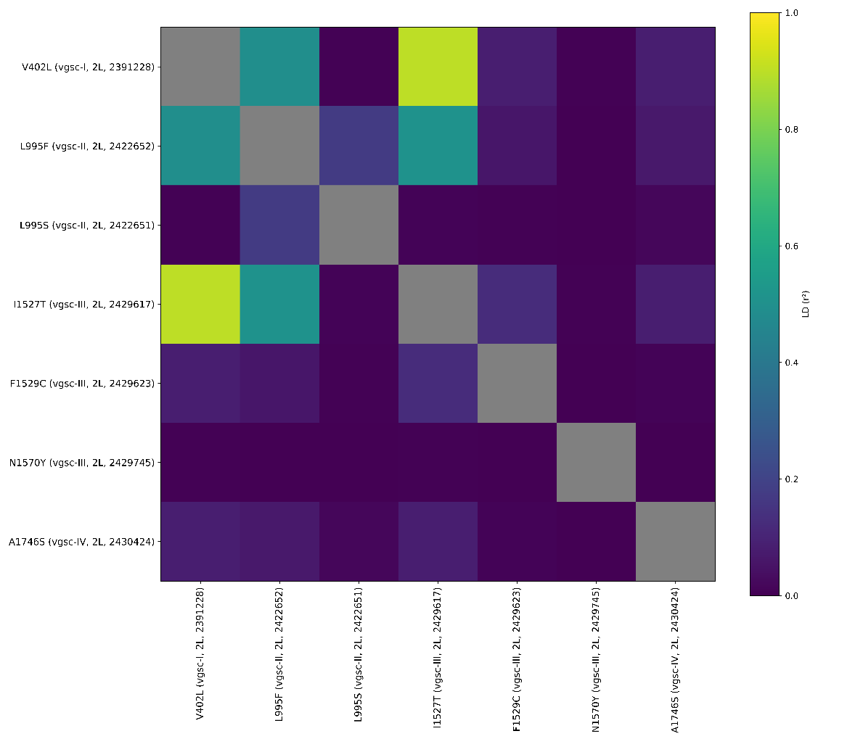
Fig 1: Linkage disequilibrium (r²) between known vgsc insecticide resistance non-synonymous mutations. Mutations are labelled with the amino-acid substitution, gene region (amplicons), chromosome arm, and physical genome position. A value of 1 indicates that two mutations are in perfect linkage, meaning that one of the mutations only ever found in combination with the other. Similarly, a value of 0 indicates that two alleles are never found in combination with each other.
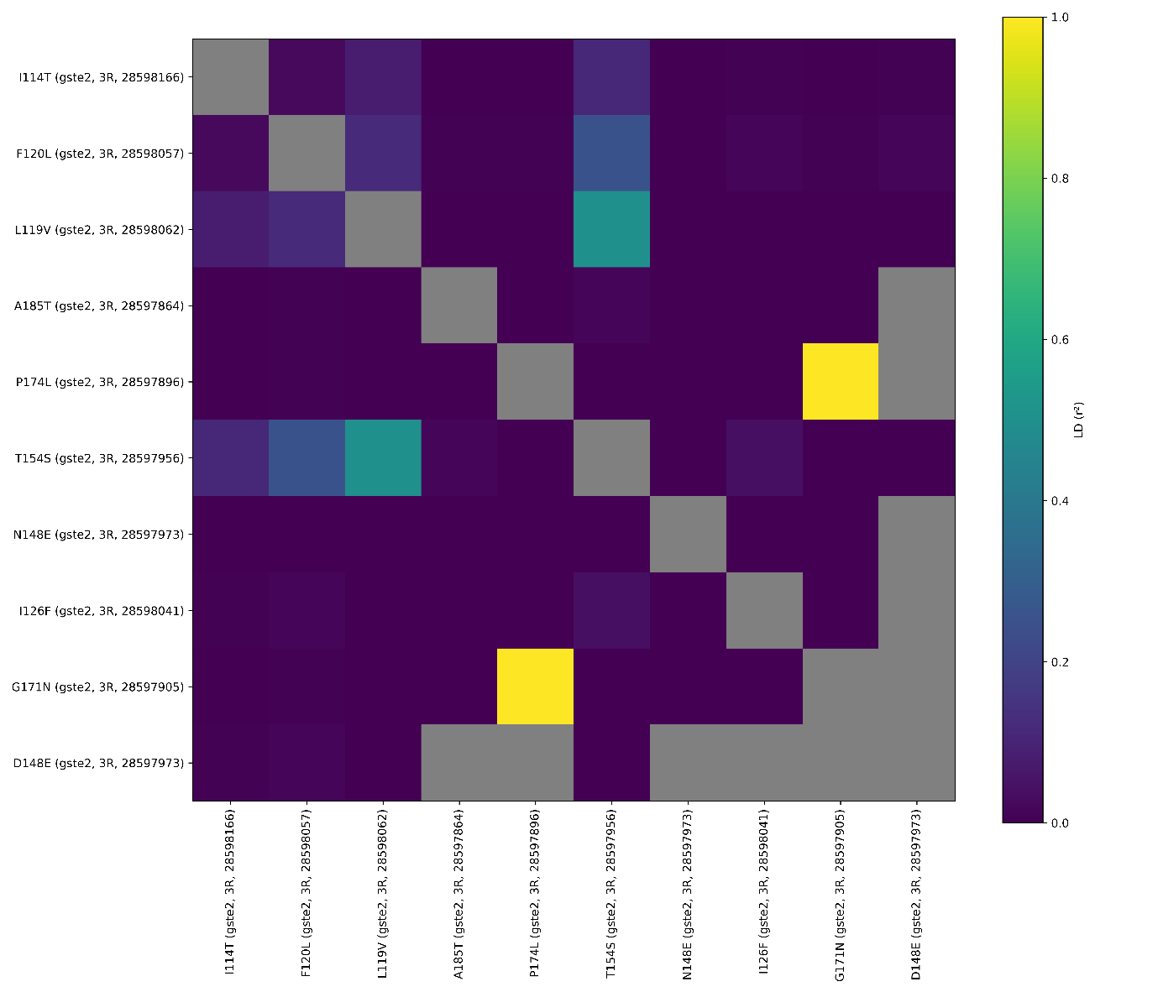
Fig 2: Linkage disequilibrium (r²) between known gste2 insecticide resistance non-synonymous mutations. Mutations are labelled with the amino-acid substitution, gene region (amplicons), chromosome arm, and physical genome position. A value of 1 indicates that two mutations are in perfect linkage, meaning that one of the mutations only ever found in combination with the other. Similarly, a value of 0 indicates that two alleles are never found in combination with each other.

