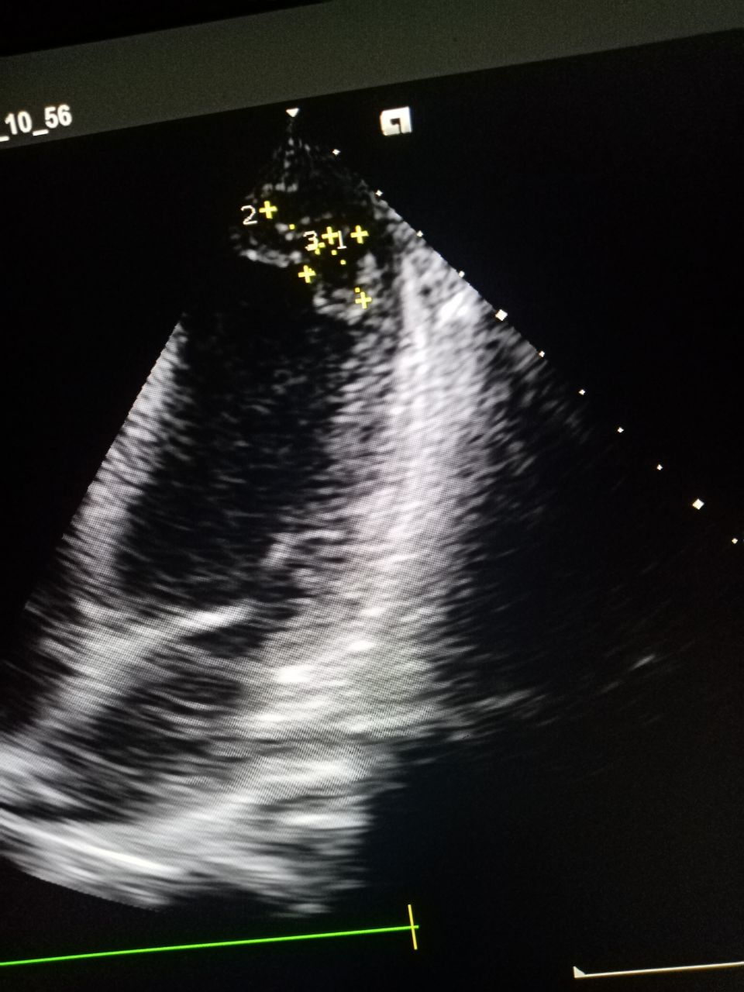
Figure 1: Echocardiography showed anterior, septal, apical and anterolateral wall hypokinesia

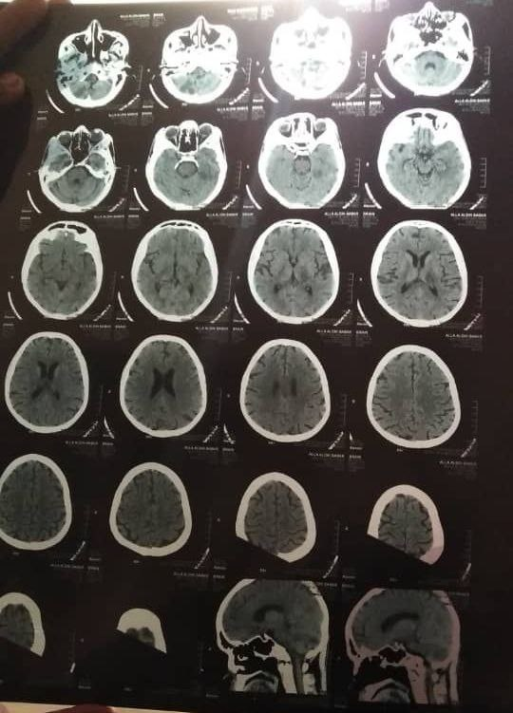
Figure 2: Brain CT scan which showed left parietal area infarction

