Supplementary Information
Supplementary information contains Supplementary Tables 1-2, and Supplementary Figures 1-9 and their corresponding captions.
Supplementary Table 1
REAGENT or RESOURCE | SOURCE | IDENTIFIER
Antibodies
Mouse Anti-Human IgG Fc-PE (JDC-10) | SouthernBiotech | 9040-09
Mouse Anti-Human IgG1 Hinge-PE (4E3) | SouthernBiotech | 9052-09
Mouse Anti-Human IgG2 Fc-PE (31-7-4) | SouthernBiotech | 9060-09
Mouse Anti-Human IgG3 Hinge-PE (HP6050) | SouthernBiotech | 9210-09
Mouse Anti-Human IgG4 Fc-PE (HP6025) | SouthernBiotech | 9200-09
Mouse Anti-Human IgA1-PE (B3506B4) | SouthernBiotech | 9130-09
Mouse Anti-Human IgA2-PE (A9604D2) | SouthernBiotech | 9140-09
Mouse Anti-Human IgM-PE (SA-DA4) | SouthernBiotech | 9020-09
PE-Cy™5 Mouse Anti-Human CD107a | BD Biosciences | 555802
PE-Cy™7 Mouse Anti-Human CD56 (NCAM-1) | BD Biosciences | 557747
APC-Cy™7 Mouse Anti-Human CD16 | BD Biosciences | 557758
Pacific Blue™ Mouse Anti-Human CD3 | BD Biosciences | 558117
PE Mouse Anti-Human MIP-1β | BD Biosciences | 550078
FastImmune™ FITC Mouse Anti-Human IFN-γ | BD Biosciences | 340449
Chemicals, Peptides, and Recombinant Proteins
Influenza A H1N1 (A/Wisconsin/588/2019) Hemagglutinin / HA Protein (His Tag) | Sino Biological | 40787-V08H1
Influenza B (B/Austria/1359417/2021) Hemagglutinin / HA Protein (ECD, His Tag) | Sino Biological | 40862-V08B
Influenza B (B/PHUKET/3073/2013) Hemagglutinin / HA trimer Protein (His Tag) (MALS-verified) | Sino Biological | 40498-V08B
Influenza A H3N2 (A/Darwin/6/2021) Hemagglutinin / HA Protein (ECD, His Tag) | Sino Biological | 40868-V08B
Influenza A H1N1 (A/Wisconsin/67/2022) Hemagglutinin / HA Protein (ECD, His Tag) | Sino Biological | 40940-V08H
Influenza A H1N1 (A/Brisbane/02/2018) Hemagglutinin / HA Protein (ECD, His Tag) | Sino Biological | 40719-V08H
Influenza A H3N2 (A/Darwin/9/2021) Hemagglutinin / HA Protein (ECD, His Tag) | Sino Biological | 40859-V08B
Influenza A H3N2 (A/Hong Kong/4801/2014) Hemagglutinin / HA Protein (His Tag) | Sino Biological | 40555-V08B
Influenza A H1N1 (A/Michigan/45/2015) Hemagglutinin / HA Protein (His Tag) | Sino Biological | 40567-V08H1
Influenza A H3N2 (A/Cambodia/e0826360/2020) Hemagglutinin / HA Protein (His Tag) | Sino Biological | 40789-V08H
Influenza A H3N2 (A/Switzerland/9715293/2013) Hemagglutinin / HA Protein (His Tag) | Sino Biological | 40497-V08B
Influenza A H3N2 (A/Kansas/14/2017) Hemagglutinin / HA Protein (His Tag) | Sino Biological | 40720-V08H
Influenza A H3N2 (A/Massachusetts/18/2022; A/Thailand/8/2022) Hemagglutinin / HA Protein (His Tag) | Sino Biological | 40992-V08B
Influenza A H3N2 (A/Hong Kong/45/2019) Hemagglutinin / HA trimer Protein (His Tag) | Sino Biological | 40765-V08H
Influenza A H1N1 (A/California/07/2009) Hemagglutinin / HA Protein (His Tag) | Sino Biological | 11085-V08B
Influenza A H3N2 (A/Hong Kong/CUHK31987/2011) Hemagglutinin / HA Protein (His Tag) | Sino Biological | 40146-V08B
Influenza B (B/Brisbane/60/2008) Hemagglutinin / HA Protein (His Tag) | Sino Biological | 40016-V08B
Influenza B (B/Colorado/06/2017) Hemagglutinin / HA Protein (His Tag) | Sino Biological | 40581-V08H
Influenza A H3N2 (A/Singapore/INFIMH-16-0019/2016) Hemagglutinin / HA Protein (His Tag) | Sino Biological | 40580-V08H
Influenza A H1N1 (A/Hawaii/70/2019;A/Guangdong-Maonan/SWL1536/2019) Hemagglutinin / HA Protein (ECD, His Tag) | Sino Biological | 40717-V08B
Influenza B (B/Washington/02/2019) Hemagglutinin / HA Protein (His Tag) | Sino Biological | 40722-V08H
Influenza A H3N2 (A/District of Columbia/27/2023) Hemagglutinin / HA Protein (His Tag) | Sino Biological | 41056-V08H
Influenza A H1N1 (A/Missouri/11/2025) Hemagglutinin / HA Trimer Protein (His Tag) (MALS-verified) | Sino Biological | 41105-V08H
Influenza B (B/Pennsylvania/14/2025) Hemagglutinin / HA Trimer Protein (His Tag) (MALS-verified) | Sino Biological | 41128-V08H
Influenza A H3N2 (A/New York/GKISBBBG87773/2025; A/Darwin/1415/2025) Hemagglutinin / HA trimer Protein (His Tag) (MALS-verified) | Sino Biological | 41128-V08B
Ebola Virus (subtype Zaire) Glycoprotein | Sino Biological | 40459-V08H
Human cytomegalovirus (HCMV) Glycoprotein B / gB Protein (His Tag) | Sino Biological | 10202-V08H1
Human coronavirus (HCoV-OC43) Spike Protein (S1+S2 ECD, His Tag) | Sino Biological | 40607-V08B
Human Serum Albumin / HSA / ALB Protein | Sino Biological | 10968-HNAY
SARS-CoV-2 WT Spike Trimer | Abwiz Bio | 2720-200
SARS-CoV-2 XBB.1.5 Spike Trimer | Abwiz Bio | 2712-200
6`SLN-C3-PAA-biot | Sigma-Aldrich | 0997-BP
Human soluble FcγRIIA | Duke University | Custom Order
Human soluble FcγRIIB | Duke University | Custom Order
Human soluble FcyRIIIA | Duke University | Custom Order
Human soluble FcyRIIIB | Duke University | Custom Order
Pierce EDC | Thermo Fisher | A35391
BirA500: BirA biotin-protein ligase standard reaction kit | Avidity LLC | BirA500
Streptavidin-R-Phycoerythrin | Agilent | PJ31S
Brefeldin A | Sigma Aldrich | B7651
Human IL-15 Recombinant Protein | Stemcell Technologies | 78031
Paraformaldehyde solution 4% in PBS | Santa Cruz Biotechnology | sc-281692
GolgiStop™ Protein Transport Inhibitor | BD Biosciences | 554724
UltraPureTM 0.5M EDTA, pH 8.0 | Thermo Fisher | 15575020
Dimethyl Sulfoxide, Fisher BioReagents™ | Fisher Scientific | BP231
RPMI-1640 Medium | Sigma Aldrich | R0883
HEPES Buffer | Fisher Scientific | MT25060CI
Trypan Blue Solution, 0.4% (w/v) in PBS | Fisher Scientific | MT25900CI
L-glutamine Solution | Fisher Scientific | MT25005CI
Penicillin-Streptomycin Solution | Fisher Scientific | MT30001CI
Fetal Bovine Serum | Sigma Aldrich | F4135
Bovine Serum Albumin | Sigma Aldrich | A4737
Polysorbate 20 | Fisher Scientific | BP337
Dulbecco's Phosphate-Buffered Salt Solution 1X | Fisher Scientific | MT21031CV
MES hydrate | Sigma Aldrich | M8250
Sodium Hydroxide Solution | Sigma Aldrich | S8263
Anhydrous sodium phosphate monobasic | Sigma Aldrich | S3139
Sodium Azide | Sigma Aldrich | S2002
Experimental Models: Primary Cell
Human Peripheral Blood Leukopak (Tenth), Fresh | Stemcell Technologies | 200-0092
Critical Commercial Assays
Sulfo-NHS (N-hydroxysulfosuccinimide) | Thermo Fisher | A39269
Fix & Perm Cell Permeabilization Kit (Medium A) | Thermo Fisher | GAS001S100
Fix & Perm Cell Permeabilization Kit (Medium B) | Thermo Fisher | GAS002S100
EasySepTM Human NK Cell Isolation Kit | Stemcell Technologies | 17955
EasySepTM Buffer | Stemcell Technologies | 20144
Zebra-Spin Desalting and Chromatography Columns | Thermo Fisher | 89882
Software and Algorithms
iQue Forecyt 9.1 | Sartorius | 60028
R Studio V 6.0 Build 421 | R Project for Statistical Computing | RRID:SCR_000432
SPIDR V.1.0.1 | Zenodo | DOI: 10.5281/zenodo.20721203
Other
iQue Screener Plus | Sartorius | 11811
LuminexTM xMAP INTELLIFLEX System | Thermo Fisher | APX2020
MagPlex Microspheres | DiaSorin | MC12001-01 (Cataloged by region)
384-well HydroSpeed Plate Washer | Tecan | 30190112
Countess™ 3 Automated Cell Counter | Thermo Fisher | AMQAX2000
Intelliflex Calibration Kit | Thermo Fisher | IFXCALK20
Intelliflex Performance Verification Kit | Thermo Fisher | IFXPVERK20
xMAP™ Sheath Concentrate PLUS, RUO | Thermo Fisher | 4050023
iQue® Screener Plus Validation Beads | Sartorius | 91091
iQue® Qsol Buffer Concentrate Solution | Sartorius | 91304

Supplementary Table 2
Strain | SNAb Target | Feature | Model Status | VIP-Score
H3N2 HA | SNAb H3N2 HA A/NY-K/25 | IgG2 H1N1 HA A/Wisconsin/588/2019 | Success | 0.5240744
H3N2 HA | SNAb H3N2 HA A/NY-K/25 | FcγR3B H1N1 HA A/Missouri/11/2025 | Success | 0.674437569
H3N2 HA | SNAb H3N2 HA A/NY-K/25 | IgG2 H3N2 HA A/District of Columbia/27/2023 | Success | 0.888746354
H3N2 HA | SNAb H3N2 HA A/NY-K/25 | IgA1 H3N2 HA A/District of Columbia/27/2023 | Success | 0.890989717
H3N2 HA | SNAb H3N2 HA A/NY-K/25 | FcγR3A H3N2 HA A/NY-K/25 | Success | 1.143640801
H3N2 HA | SNAb H3N2 HA A/NY-K/25 | FcγR2B H3N2 HA A/NY-K/25 | Success | 1.191986992
H3N2 HA | SNAb H3N2 HA A/NY-K/25 | FcγR2A H3N2 HA A/NY-K/25 | Success | 1.199922885
H3N2 HA | SNAb H3N2 HA A/NY-K/25 | Total IgG H3N2 HA A/NY-K/25 | Success | 1.232146515
H3N2 HA | SNAb H3N2 HA A/District of Columbia/27/2023 | IgG2 H3N2 HA A/District of Columbia/27/2023 | Success | 0.84792922
H3N2 HA | SNAb H3N2 HA A/District of Columbia/27/2023 | Total IgG H3N2 HA A/Massachusetts/18/2022 | Success | 0.969278937
H3N2 HA | SNAb H3N2 HA A/District of Columbia/27/2023 | FcγR2B H3N2 HA A/District of Columbia/27/2023 | Success | 1.044227439
H3N2 HA | SNAb H3N2 HA A/District of Columbia/27/2023 | FcγR3A H3N2 HA A/District of Columbia/27/2023 | Success | 1.048614875
H3N2 HA | SNAb H3N2 HA A/District of Columbia/27/2023 | FcγR2A H3N2 HA A/District of Columbia/27/2023 | Success | 1.07308447
H3N2 HA | SNAb H3N2 HA A/Massachusetts/18/2022 | FcγR2A H3N2 HA A/Cambodia/e0826360/2020 | Success | 0.611034469
H3N2 HA | SNAb H3N2 HA A/Massachusetts/18/2022 | IgG3 H3N2 HA A/District of Columbia/27/2023 | Success | 0.837178496
H3N2 HA | SNAb H3N2 HA A/Massachusetts/18/2022 | IgG2 H3N2 HA A/District of Columbia/27/2023 | Success | 0.950992237
H3N2 HA | SNAb H3N2 HA A/Massachusetts/18/2022 | FcγR2B H3N2 HA A/Darwin/9/2021 | Success | 1.000401243
H3N2 HA | SNAb H3N2 HA A/Massachusetts/18/2022 | FcγR3B H3N2 HA A/Massachusetts/18/2022 | Success | 1.056382525
H3N2 HA | SNAb H3N2 HA A/Massachusetts/18/2022 | FcγR2B H3N2 HA A/Massachusetts/18/2022 | Success | 1.200479156
H3N2 HA | SNAb H3N2 HA A/Massachusetts/18/2022 | Total IgG H3N2 HA A/Massachusetts/18/2022 | Success | 1.20974622
H3N2 HA | SNAb H3N2 HA A/Darwin/6/2021 | IgG2 H3N2 HA A/Switzerland/9715293/2013 | Success | 0.899120247
H3N2 HA | SNAb H3N2 HA A/Darwin/6/2021 | IgG2 H3N2 HA A/Massachusetts/18/2022 | Success | 0.920185784
H3N2 HA | SNAb H3N2 HA A/Darwin/6/2021 | FcγR2B H1N1 HA A/Missouri/11/2025 | Success | 1.159672758
H3N2 HA | SNAb H3N2 HA A/Darwin/9/2021 | Total IgG H3N2 HA A/Darwin/9/2021 | Success | 0.99109746
H3N2 HA | SNAb H3N2 HA A/Darwin/9/2021 | FcγR2B H3N2 HA A/Darwin/9/2021 | Success | 1.008823981
H3N2 HA | SNAb H3N2 HA A/Kansas/14/2017 | FcγR2B H3N2 HA A/Switzerland/9715293/2013 | Success | 0.905309278
H3N2 HA | SNAb H3N2 HA A/Kansas/14/2017 | IgG2 H1N1 HA A/Missouri/11/2025 | Success | 0.968143819
H3N2 HA | SNAb H3N2 HA A/Kansas/14/2017 | IgG2 H3N2 HA A/Switzerland/9715293/2013 | Success | 0.97332719
H3N2 HA | SNAb H3N2 HA A/Kansas/14/2017 | FcγR2B H1N1 HA A/Missouri/11/2025 | Success | 1.138308763
H3N2 HA | SNAb H3N2 HA A/Hong Kong/4801/2014 | FcγR2B IBV HA B/Austria/1359417/2021 | Success | 0.544733428
H3N2 HA | SNAb H3N2 HA A/Hong Kong/4801/2014 | FcγR2B H3N2 HA A/Hong Kong/4801/2014 | Success | 1.090411267
H3N2 HA | SNAb H3N2 HA A/Hong Kong/4801/2014 | FcγR2A H3N2 HA A/Hong Kong/4801/2014 | Success | 1.109693517
H3N2 HA | SNAb H3N2 HA A/Hong Kong/4801/2014 | Total IgG H3N2 HA A/Hong Kong/4801/2014 | Success | 1.132629268
H3N2 HA | SNAb H3N2 HA A/Hong Kong/CUHK31987/2011 | FcγR2B IBV HA B/Brisbane/60/2008 | Success | 0.491799909
H3N2 HA | SNAb H3N2 HA A/Hong Kong/CUHK31987/2011 | IgG2 H3N2 HA A/Hong Kong/CUHK31987/2011 | Success | 0.925203475
H3N2 HA | SNAb H3N2 HA A/Hong Kong/CUHK31987/2011 | FcγR2B H3N2 HA A/Hong Kong/CUHK31987/2011 | Success | 1.196445115
H3N2 HA | SNAb H3N2 HA A/Hong Kong/CUHK31987/2011 | Total IgG H3N2 HA A/Hong Kong/CUHK31987/2011 | Success | 1.212703783
H3N2 HA | SNAb H3N2 HA A/Switzerland/9715293/2013 | FcγR3B H3N2 HA A/Switzerland/9715293/2013 | Success | 0.924297904
H3N2 HA | SNAb H3N2 HA A/Switzerland/9715293/2013 | IgG2 H3N2 HA A/Hong Kong/4801/2014 | Success | 0.926533112
H3N2 HA | SNAb H3N2 HA A/Switzerland/9715293/2013 | FcγR2A H3N2 HA A/Switzerland/9715293/2013 | Success | 1.015432424
H3N2 HA | SNAb H3N2 HA A/Switzerland/9715293/2013 | FcγR2B H3N2 HA A/Hong Kong/4801/2014 | Success | 1.015707085
H3N2 HA | SNAb H3N2 HA A/Switzerland/9715293/2013 | FcγR3A H3N2 HA A/Switzerland/9715293/2013 | Success | 1.024086271
H3N2 HA | SNAb H3N2 HA A/Switzerland/9715293/2013 | Total IgG H3N2 HA A/Hong Kong/4801/2014 | Success | 1.037528512
H3N2 HA | SNAb H3N2 HA A/Switzerland/9715293/2013 | Total IgG H3N2 HA A/Switzerland/9715293/2013 | Success | 1.048440642
H1N1 HA | SNAb H1N1 HA A/Missouri/11/2025 | FcγR2B IBV HA B/Brisbane/60/2008 | Success | 0.231306845
H1N1 HA | SNAb H1N1 HA A/Missouri/11/2025 | IgM H1N1 HA A/California/07/2009 | Success | 0.310943125
H1N1 HA | SNAb H1N1 HA A/Missouri/11/2025 | Total IgG H3N2 HA A/Kansas/14/2017 | Success | 0.500008163
H1N1 HA | SNAb H1N1 HA A/Missouri/11/2025 | IgG1 H3N2 HA A/District of Columbia/27/2023 | Success | 0.891950256
H1N1 HA | SNAb H1N1 HA A/Missouri/11/2025 | IgA2 H1N1 HA A/Wisconsin/67/2022 | Success | 0.896834855
H1N1 HA | SNAb H1N1 HA A/Missouri/11/2025 | FcγR2A H3N2 HA A/NY-K/25 | Success | 1.021191733
H1N1 HA | SNAb H1N1 HA A/Missouri/11/2025 | IgA1 H3N2 HA A/Cambodia/e0826360/2020 | Success | 1.047287291
H1N1 HA | SNAb H1N1 HA A/Missouri/11/2025 | IgA1 H1N1 HA A/Wisconsin/67/2022 | Success | 1.159989118
H1N1 HA | SNAb H1N1 HA A/Missouri/11/2025 | IgA1 H1N1 HA A/Wisconsin/588/2019 | Success | 1.182948071
H1N1 HA | SNAb H1N1 HA A/Missouri/11/2025 | FcγR2A H1N1 HA A/Wisconsin/67/2022 | Success | 1.76503009
H1N1 HA | SNAb H1N1 HA A/Wisconsin/67/2022 | Total IgG H3N2 HA A/Kansas/14/2017 | Success | 0.298542291
H1N1 HA | SNAb H1N1 HA A/Wisconsin/67/2022 | FcγR2B IBV HA B/Phuket/3073/2013/ | Success | 0.301760974
H1N1 HA | SNAb H1N1 HA A/Wisconsin/67/2022 | FcγR2B IBV HA B/Brisbane/60/2008 | Success | 0.324971627
H1N1 HA | SNAb H1N1 HA A/Wisconsin/67/2022 | IgM H1N1 HA A/Missouri/11/2025 | Success | 0.372391468
H1N1 HA | SNAb H1N1 HA A/Wisconsin/67/2022 | IgA2 H3N2 HA A/Kansas/14/2017 | Success | 0.390360087
H1N1 HA | SNAb H1N1 HA A/Wisconsin/67/2022 | IgM H1N1 HA A/California/07/2009 | Success | 0.428501777
H1N1 HA | SNAb H1N1 HA A/Wisconsin/67/2022 | IgA2 IBV HA B/Phuket/3073/2013/ | Success | 0.432247373
H1N1 HA | SNAb H1N1 HA A/Wisconsin/67/2022 | IgM IBV HA B/Colorado/06/2017/ | Success | 0.528299567
H1N1 HA | SNAb H1N1 HA A/Wisconsin/67/2022 | IgA2 H1N1 HA A/Wisconsin/67/2022 | Success | 0.79308152
H1N1 HA | SNAb H1N1 HA A/Wisconsin/67/2022 | FcγR3B H1N1 HA A/Brisbane/02/2018 | Success | 0.905882619
H1N1 HA | SNAb H1N1 HA A/Wisconsin/67/2022 | IgA1 H1N1 HA A/Wisconsin/67/2022 | Success | 1.069942341
H1N1 HA | SNAb H1N1 HA A/Wisconsin/67/2022 | IgA1 H1N1 HA A/Wisconsin/588/2019 | Success | 1.152613838
H1N1 HA | SNAb H1N1 HA A/Wisconsin/67/2022 | IgG2 H1N1 HA A/Wisconsin/67/2022 | Success | 1.376349784
H1N1 HA | SNAb H1N1 HA A/Wisconsin/67/2022 | FcγR2B H1N1 HA A/Wisconsin/67/2022 | Success | 1.445013173
H1N1 HA | SNAb H1N1 HA A/Wisconsin/67/2022 | FcγR3A H1N1 HA A/Wisconsin/67/2022 | Success | 1.455010482
H1N1 HA | SNAb H1N1 HA A/Wisconsin/67/2022 | Total IgG H1N1 HA A/Wisconsin/67/2022 | Success | 1.689797958
H1N1 HA | SNAb H1N1 HA A/Wisconsin/67/2022 | FcγR2A H1N1 HA A/Wisconsin/67/2022 | Success | 1.701712823
H1N1 HA | SNAb H1N1 HA A/Wisconsin/588/2019 | FcγR2B IBV HA B/Brisbane/60/2008 | Success | 0.301706247
H1N1 HA | SNAb H1N1 HA A/Wisconsin/588/2019 | FcγR2B H3N2 HA A/Kansas/14/2017 | Success | 0.427143529
H1N1 HA | SNAb H1N1 HA A/Wisconsin/588/2019 | IgG2 H3N2 HA A/Cambodia/e0826360/2020 | Success | 0.459830192
H1N1 HA | SNAb H1N1 HA A/Wisconsin/588/2019 | FcγR2A H3N2 HA A/Kansas/14/2017 | Success | 0.478998613
H1N1 HA | SNAb H1N1 HA A/Wisconsin/588/2019 | IgA1 H1N1 HA A/Wisconsin/588/2019 | Success | 0.983131568
H1N1 HA | SNAb H1N1 HA A/Wisconsin/588/2019 | FcγR3A H1N1 HA A/Wisconsin/67/2022 | Success | 1.160547427
H1N1 HA | SNAb H1N1 HA A/Wisconsin/588/2019 | IgG2 H1N1 HA A/Michigan/45/2015 | Success | 1.338774047
H1N1 HA | SNAb H1N1 HA A/Wisconsin/588/2019 | Total IgG H1N1 HA A/Wisconsin/588/2019 | Success | 1.415918358
H1N1 HA | SNAb H1N1 HA A/Wisconsin/588/2019 | FcγR2A H1N1 HA A/Wisconsin/588/2019 | Success | 1.474815078
H1N1 HA | SNAb H1N1 HA A/California/07/2009 | IgA1 H3N2 HA A/Switzerland/9715293/2013 | Success | 0.826097342
H1N1 HA | SNAb H1N1 HA A/California/07/2009 | FcγR3B H1N1 HA A/Brisbane/02/2018 | Success | 0.860215629
H1N1 HA | SNAb H1N1 HA A/California/07/2009 | FcγR3A H1N1 HA A/Michigan/45/2015 | Success | 1.034525429
H1N1 HA | SNAb H1N1 HA A/California/07/2009 | IgG2 H1N1 HA A/Michigan/45/2015 | Success | 1.22774158
H1N1 HA | SNAb H1N1 HA A/Hawaii/70/2019 | IgG2 H1N1 HA A/Michigan/45/2015 | Fail | N.A

Supplementary Table 2. List of LASSO-identified features explaining the PLSR Model for the SNAb target. Shown for each SNAb target are the LASSO-identified features, the model validation (see Methods), and the VIP Score for each feature within the LASSO.

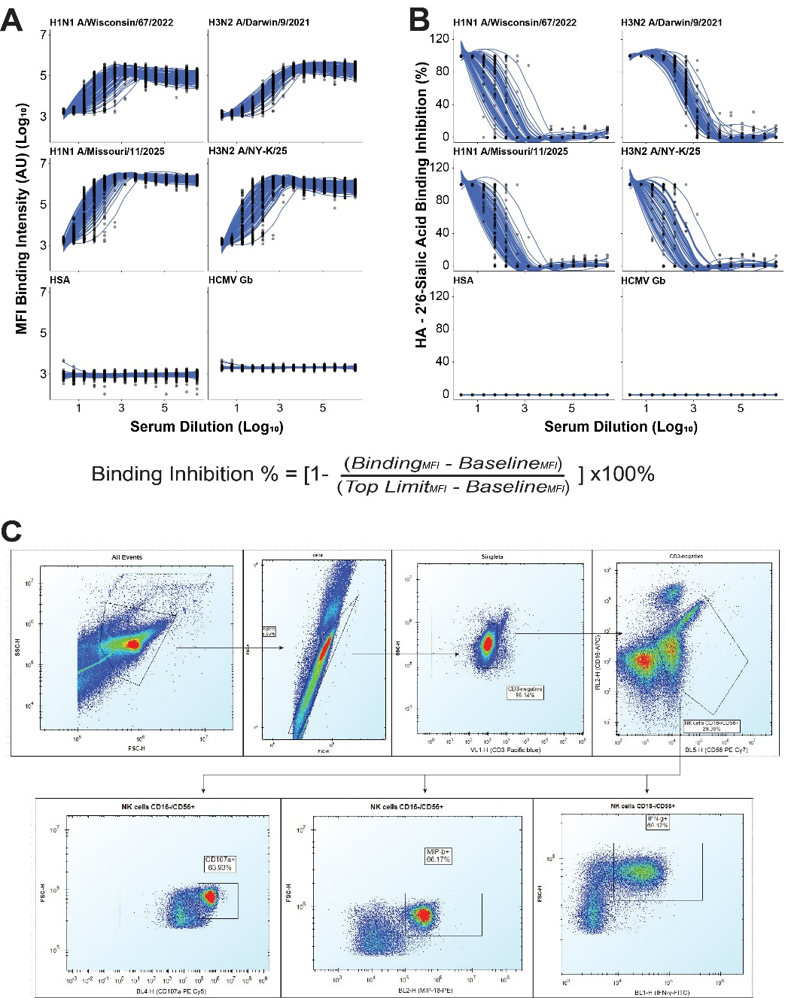
Fig. S1. HA and α-2’6-linked sialic acid binding inhibition and gating strategy for ADNKA. A. Antigen-specific binding curves across serial serum dilutions from the vaccinated participants for representative vaccine-strain hemagglutinins (H1N1 HA A/Wisconsin/67/2022, H1N1 HA A/Missouri/11/2025, H3N2 HA A/Darwin/9/2021, H3N2 HA A/NY-K/25) and for HSA and HCMV as negative control antigens. Each curve is one sample. B. Corresponding inhibition of HA binding to α-2,6-sialic acid across the same dilution series, shown as percentage of maximum binding intensity. Curves are 4-parameter logistic fits from which the SNAb titer is interpolated. No inhibition is detected against the control antigens. C. Representative gating strategy for the ADNKA assay, from all events through cells, singlets, CD3⁻/CD16⁻/CD56⁺ NK cells (activated NK cells) for CD107a, MIP-1β, and IFN-γ positive populations. The CD16- were used to measure responses of the activated NK cells, and not the total population.
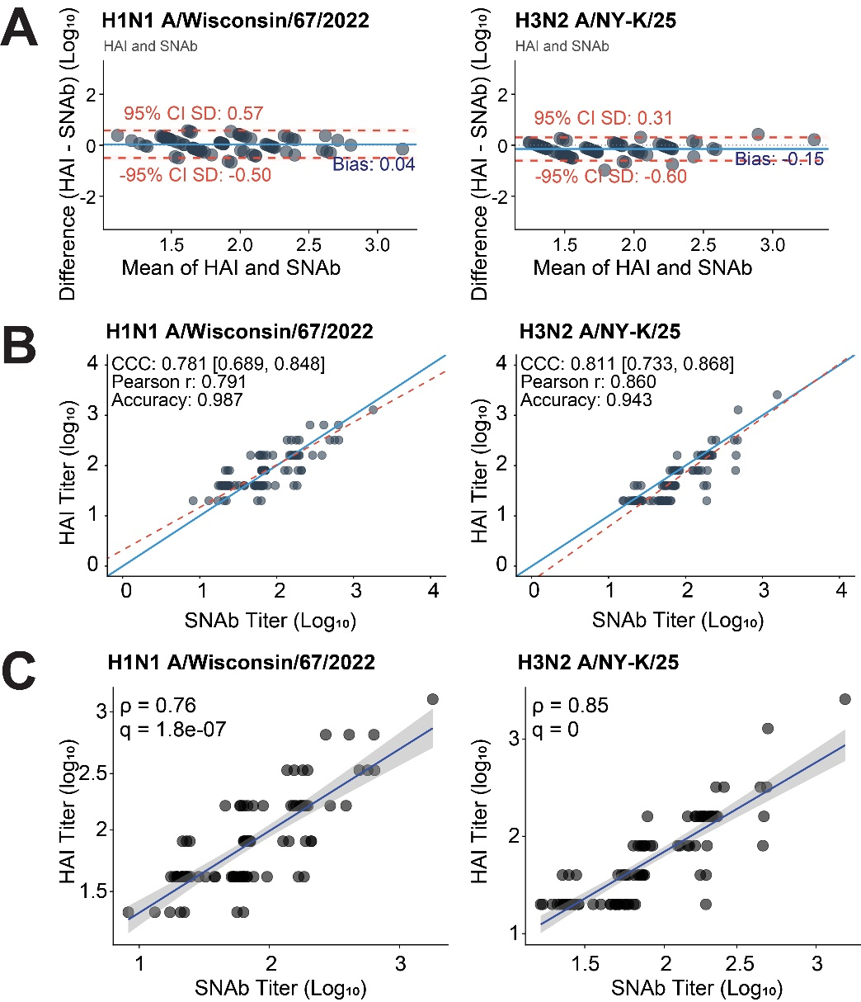
Fig. S2. Method agreement evaluation of SNAb and HAI. A. Bland-Altman analysis of SNAb and HAI titers for H1N1 A/Wisconsin/67/2022 (left) and H3N2 A/NY-K/25 (right). The x-axis gives the mean of the two assays for each sample, and the y-axis their difference. The solid blue line indicates assay mean bias, and the dashed lines indicate the limits of agreement (95% confidence interval, or CI). Log₁₀ transformation was performed before analysis. A positive bias score would indicate an overcount for HAI, and a negative bias score would indicate an overcount for SNAb. B. Lin’s concordance correlation coefficient (CCC) for SNAb and HAI titers for H1N1 A/Wisconsin/67/2022 (left) and H3N2 A/NY-K/25 (right). The dashed line (red) is the fitted curve, and the solid line (blue) is the perfect concordance. The CCC value is shown with its 95% CI, along with precision (Pearson r) and accuracy (Bias correction factor). C. Spearman rank correlation between SNAb and HAI titers for H1N1 A/Wisconsin/67/2022 (left) and H3N2 A/NY-K/25 (right). The Spearman’s rho (ρ) and Bonferroni adjusted significance (q) are shown.

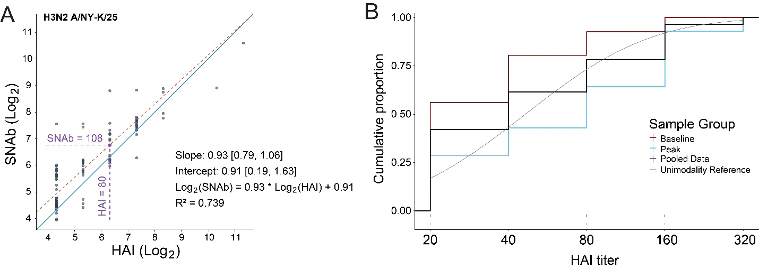
Fig. S3. Conversion of SNAb titers to an inferred HAI scale, and the limits of the HAI readout. A. Deming regression relating to log₂-transformed SNAb and HAI titers against H3N2 A/NY-K/25, accounting for measurement error in both assays. The fitted relationship (red dashed line) is shown with its slope and intercept 95% confidence intervals; the solid line (blue) is the line of identity. The R² and regression equation were also provided in the plot; for example, conversion from HAI titer of 80 equals SNAb titer of 108 (purple). This relationship was inverted to express SNAb titers on an inferred continuous HAI scale. B. Empirical cumulative distribution of measured HAI titers for baseline, peak, and pooled samples, with a unimodal reference distribution. Because HAI is reported as a discrete endpoint titer, the distribution advances in two-fold steps, and the unpopulated interval resolved on the continuous SNAb-inferred scale (Fig. 2B) is not detectable through endpoint calculation.

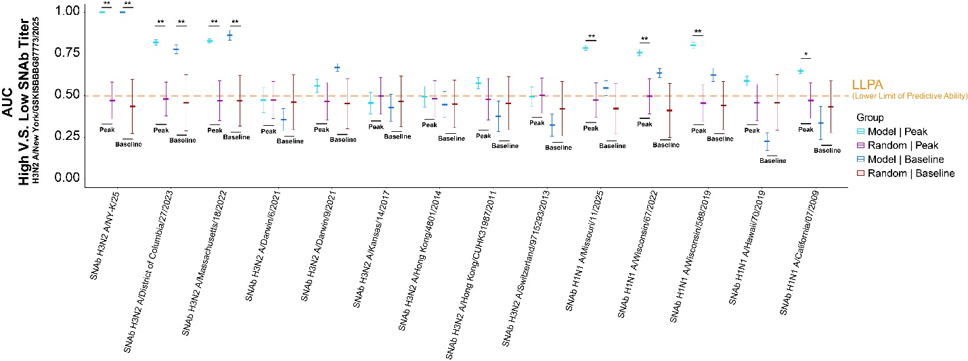
Fig S4. Validation of the SNAb-titer classification across all DIVA-panel targets. AUC for classification of the high vs. low H3N2 A/NY-K/25 SNAb-inferred HAI titer population using the raw SNAb titer against each indicated target as the only predictor. Shown are the models’ performance for pre- and post-vaccination collections, alongside the corresponding Random-label test (see Methods). Crossbars are means, and error bars are standard deviations. The dashed line marks the lower limit of predictive ability (LLPA; AUC = 0.5). Significance was assessed by empirical comparison against the null distributions: *p < 0.05, **p < 0.01.

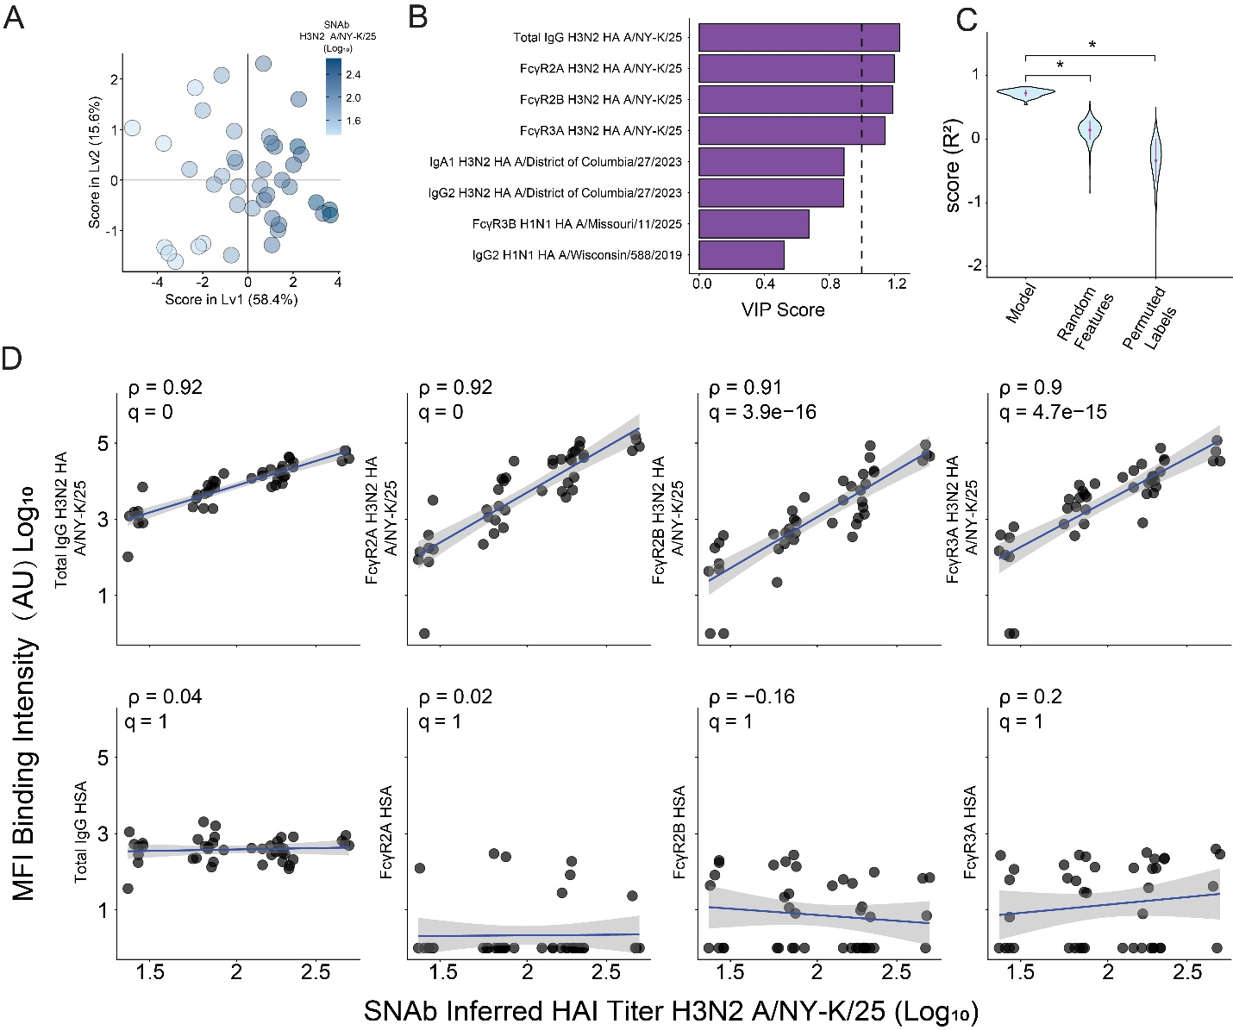
Fig. S5. PLSR modeling of the antibody signature explaining the SNAb titer against H3N2 A/NY-K/25. A. PLSR scores for the model relating LASSO-selected antibody features to the SNAb titer against H3N2 A/NY-K/25 at peak. Each point is one subject, shaded by measured SNAb titer (log₁₀). The axes are the percentage of variance captured by latent variable (Lv1) (58.4%) and Lv2 (15.6%). B. VIP scores for the LASSO-selected features. The dashed line marks VIP = 1, which was used as a cutoff for validation in D. C. Cross-validated R² for the true model compared with two null models (random features, permuted labels). Violin plots show the distribution across cross-validation replicates. Significance was assessed by empirical comparison against the null distributions:* = p < 0.05. D. Univariate correlations between the SNAb titer against H3N2 A/NY-K/25 and the four features with VIP > 1 (top row). Antibody features against human serum albumin (HSA) were used as non-specific binding controls (bottom row). Lines are fitted with 95% CI; ρ= Spearman’s rho; q = Bonferroni-adjusted p-value. A q-value of 0 indicates machine zero.

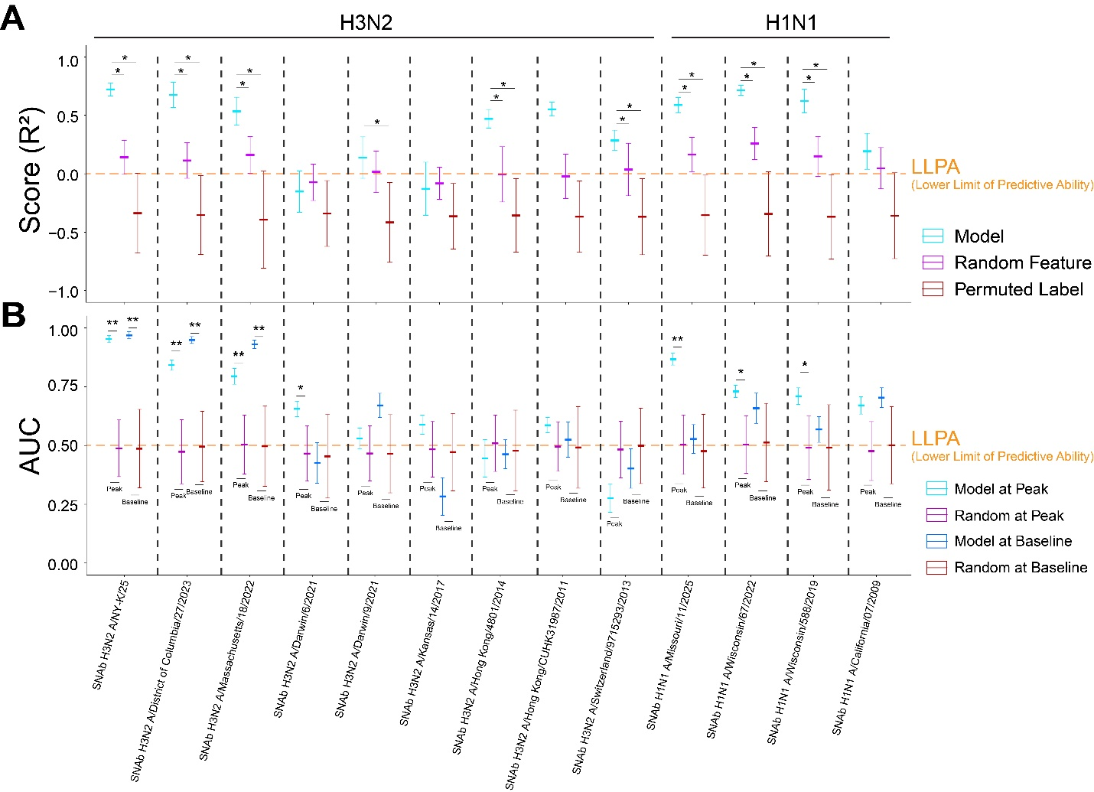
Fig. S6. Model validation across all SNAb targets for PLSR and ROC curve. A. Cross-validated R² for PLSR models relating LASSO-selected antibody features to SNAb titer against each indicated target, compared with random-feature and permuted-label null models. No LASSO-based model could be built for H1N1 A/Hawaii/2019, thus no validation test was done for this strain. B. AUC for classification of the H3N2 A/NY-K/25 population using each target-derived signature, shown separately for pre- and post-vaccination samples alongside the corresponding random nulls. Crossbars are means and error bars are standard deviations. Dashed lines mark the LLPA (R² = 0 for regression; AUC = 0.5 for classification). Significance was assessed by empirical comparison against the null distributions: *p < 0.05, **p < 0.01.
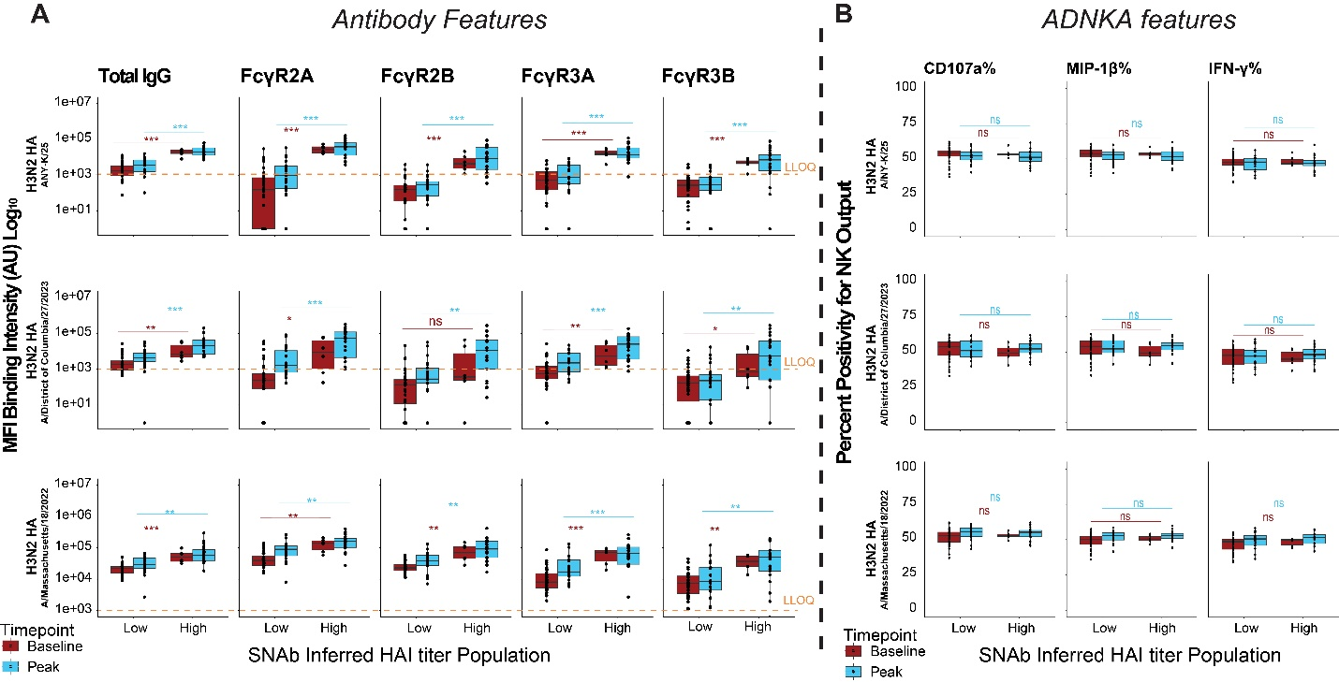
Fig. S7. Subjects reaching high titer classification against H3N2 HA A/NY-K/25 show elevated Fc-receptor binding, but not NK cell activation. A. Antigen-specific total IgG and binding to FcγR2A, FcγR2B, FcγR3A, and FcγR3B in the low- and high-titer H3N2 HA A/NY-K/25 populations. Rows correspond to the three most recent H3N2 vaccine antigens A/NY-K/25, A/District of Columbia/27/2023, A/Massachusetts/18/2022, from the 2026, 2025, and 2024 formulations, respectively. Pre- and post-vaccination samples are shown by color. Orange dashed lines indicate the lower limit of quantification (LLOQ), defined as the upper limit of the negative control. B. Antibody-dependent NK cell activation (ADNKA) against the three most recent H3N2 vaccine antigens. ADNKA was measured by the percentages of CD107a, MIP-1β and IFN-γ positive NK cells. Comparisons by Wilcoxon test with Benjamini–Hochberg correction: *p < 0.05, **p < 0.01, ***p < 0.001; ns, not significant.

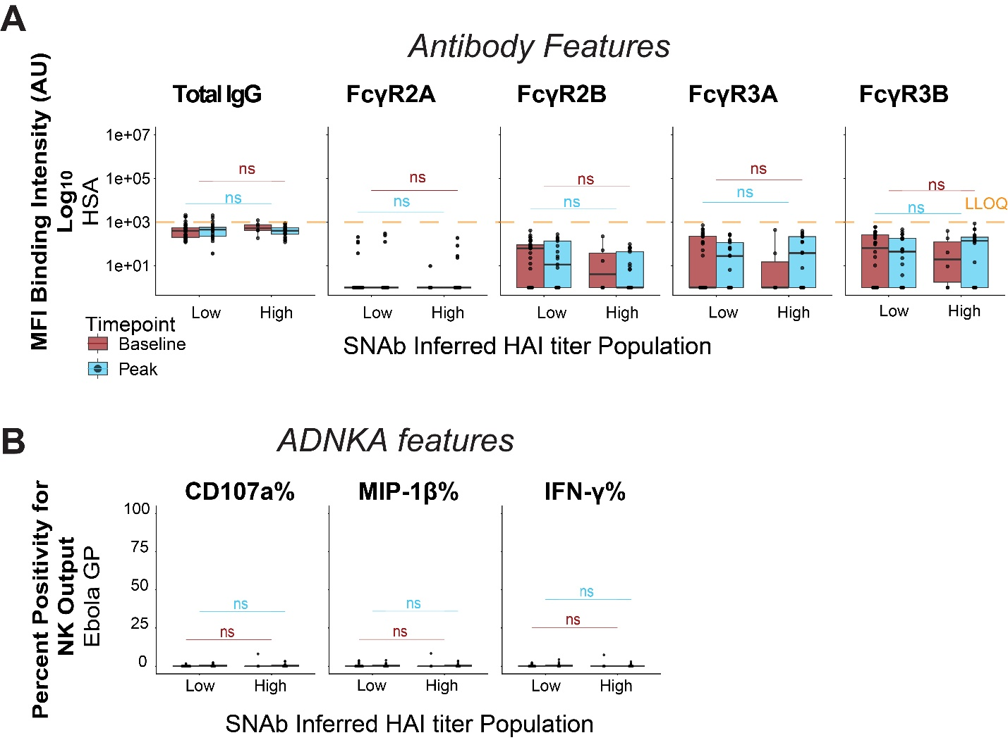
Fig. S8. Negative response control antigens show no association with low vs. high titer status against H3N2A/NY-K/25. A. Total IgG and FcγR-binding against human serum albumin (HSA) in subjects with low and high SNAb titer against H3N2 HA A/NY-K/25. Pre- and post-vaccination samples are shown by color. The orange dashed line indicates the LLOQ, which is a no serum added sample. B. ADNKA against Ebola virus glycoprotein, represented by percentages of CD107a, MIP-1β and IFN-γ positive NK cells. Pre- and post-vaccination samples are shown by color. No comparison reached significance (Wilcoxon test with Benjamini–Hochberg correction).

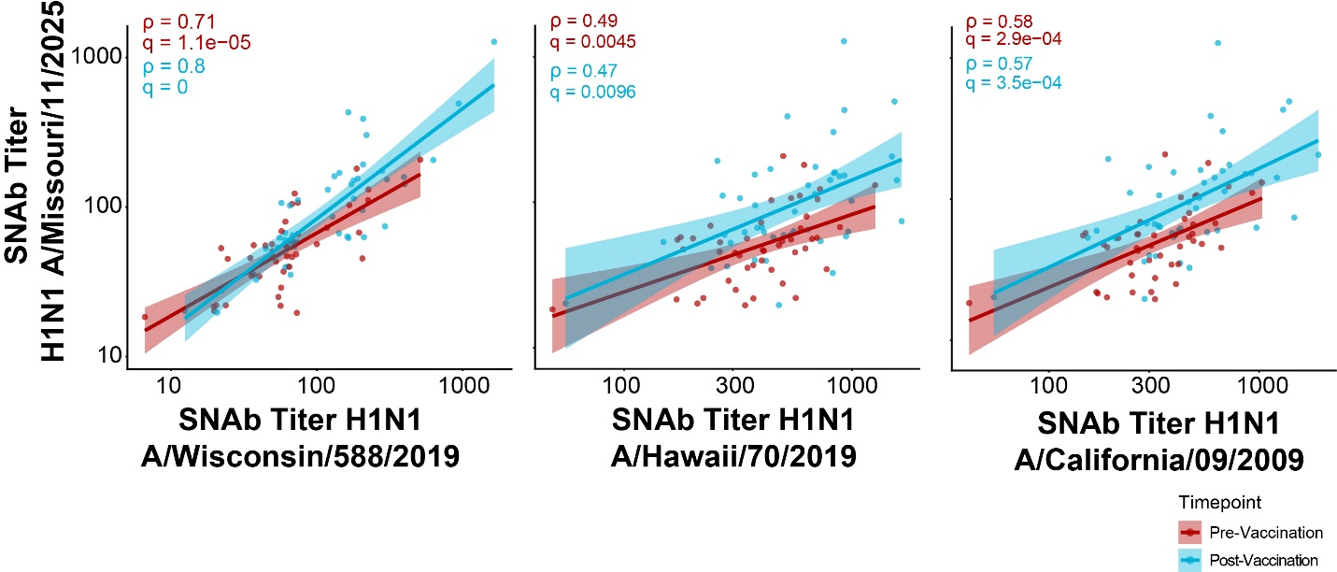
Fig. S9 Correlations between current circulating and previous H1N1 strains. Univariate correlations between the SNAb titer against H1N1 A/Missouri/11/2025 and titers against previous H1N1 vaccine components, arranged in recency. Shown are pre- and post-vaccination 2025 vaccination collections of the cohort. The H1 HA targets were H1N1 HA A/Wisconsin/588/2019 (2021 and 2022 component), H1N1 HA A/Hawaii/70/2019 (2020 component), and H1N1 HA A/California/07/2009 (2015 and 2016 component). Lines are fitted with 95% confidence bands; ρ = Spearman’s rho; q = Bonferroni-adjusted p value.

