Advancing Microplastic Analysis in Complex Matrices Towards Harmonization: Insights from an Interlaboratory Study Supporting the Development of a Standardized Extraction Protocol

AUTHOR NAMES. Dean Velikov¹, Claudia Armbrust², Olga Hermann², Marion Wagner², Lars Meyer², Pascal Hagedorn¹, Isabel Fernández Artime³, Laura Cherta Cucala³, Guillaume Bucher⁴, Otmar Geiss⁴, Federico Benetti⁵, Manuel Vega del Riego⁵, Alessandro Perini⁵, Andrea Vittadello⁶, Paulo A. Da Costa Filho⁷, Lei Lei⁷, Pauline Seidel^{8,9}, Oliver Kretschmar^{8,10,11}, Kathrin Harre^{8,11}, Felix Thier¹², Ievgeniia Lomako¹², Anastasia Ceta¹², Carla Schachner¹², Evelin El Said¹², Sebastian Köppel¹², Kyle Akred¹³, Shaofang Yu¹³, Jeanne Hankett¹³, Korinna Altmann¹⁴, Yosri Wiesner¹⁴, Andreas Künkel², Thilo Hofmann¹, Frank von der Kammer¹, and Patrizia Marie Schmidt²*
1 Department of Environmental Geosciences, Centre for Microbiology and Environmental Systems Science, University of Vienna, Josef-Holaubek-Platz 2, UZA II, 1090 Vienna, Austria
2 BASF SE, Carl-Bosch-Str. 38, 67056 Ludwigshafen, Germany
3 IMDEA Water Institute, University of Alcalá, Av. Punto Com 2 (28805), Madrid, Spain
4 European Commission, Joint Research Centre (JRC), Ispra, Italy
5 ECSIN-ECAMRICERT SRL Laboratory (ECSIN), 35127 Padua, Italy
6 Merieux Nutrisciences Italy, 31023 Resana, Italy
7 Societé des Produits Nestlé S. A. Nestlé Research, Route du Jorat 57, Lausanne, Switzerland
8 Faculty of Agriculture, Environment and Chemistry, University of Applied Sciences Dresden, Friedrich-List-Platz 1, Dresden, 01069, Saxony, Germany
9 Institute for Geography and Geomorphology, Julius-Maximilans-Universität Würzburg, Sanderring 2, 97070 Würzburg, Germany
10 Leibniz Institute of Polymer Research Dresden, Hohe Straße 6, 01069 Dresden, Germany
11Chair of Physical Chemistry of Polymeric Materials, Faculty of Chemistry and Food Chemistry, TU Dresden, 01062 Dresden, Germany
12 Umweltbundesamt GmbH, Spittelauer Lände 5, 1090 Vienna, Austria
13 BASF Corporation, 1609 Biddle Ave. Wyandotte, MI 48192, United States
14 Bundesanstalt für Materialforschung und -prüfung (BAM), Berlin, Germany

Corresponding author:
Patrizia Marie Schmidt, patrizia-marie.schmidt@basf.com

Number of pages 19
Number of figures 9
Number of tables 4

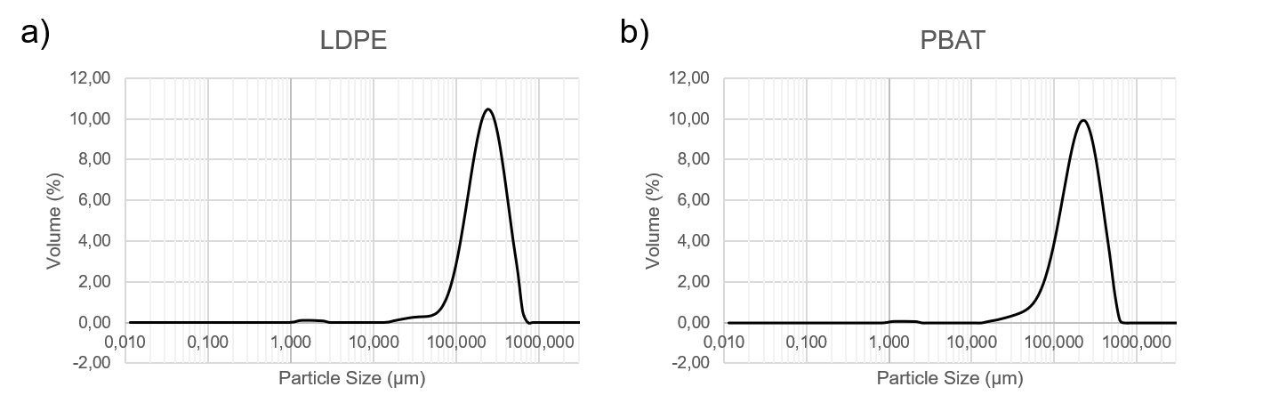
Figure S 1: Particle size distributions of a) the final LDPE powder and b) the final PBAT powder used for spiking.

Table S 1: Particle size distributions of the original polymer powders, determined via Fraunhofer light scattering (Lab 1), µ-Raman (Lab 1) and fluorescence microscopy (Lab 3).
LDPE
Fraunhofer light scattering | Dx10 [µm] |  | Dx50 [µm] |  |  | Dx90 [µm]
Fraunhofer light scattering | 105 |  | 219 |  |  | 397
µ-Raman (Lab 1, 33 mg powder in water) | <50 µm | 50-100 µm |  | 100-200 µm | 200-300 µm |  | > 300 µm
µ-Raman (Lab 1, 33 mg powder in water) | 6800±624 | 4833±909 |  | 4907±674 | 1113±372 |  | 353±330
µ-Raman (Lab 1, 33 mg powder in ethanol) | <50 µm | 50-100 µm |  | 100-200 µm | 200-300 µm |  | > 300 µm
µ-Raman (Lab 1, 33 mg powder in ethanol) | 950 | 7200 |  | 14350 | 5000 |  | 750
Fluorescence microscopy  (Lab 3, 33 mg powder in ethanol) | <50 µm | 50-100 µm |  | 100-200 µm | 200-300 µm |  | > 300 µm
Fluorescence microscopy  (Lab 3, 33 mg powder in ethanol) | 7896±3011 | 8720±3186 |  | 16803±2866 | 6474±2234 |  | 936±833
PBAT
Fraunhofer light scattering | Dx10 [µm] |  | Dx50 [µm] |  |  | Dx90 [µm]
Fraunhofer light scattering | 78 |  | 185 |  |  | 349
µ-Raman (Lab 1, 33 mg powder in water) | <50 µm | 50-100 µm |  | 100-200 µm | 200-300 µm |  | > 300 µm
µ-Raman (Lab 1, 33 mg powder in water) | 14893± 5187 | 14193±4780 |  | 10287±3281 | 2867±1002 |  | 620±251
Fluorescence microscopy  (Lab 3, 33 mg powder in water) | <50 µm | 50-100 µm |  | 100-200 µm | 200-300 µm |  | > 300 µm
Fluorescence microscopy  (Lab 3, 33 mg powder in water) | 20695±4476 | 18263±4468 |  | 9393±2781 | 3031±2438 |  | 561±631

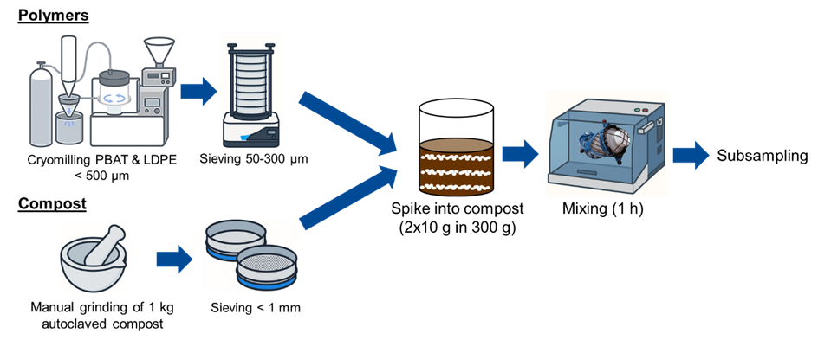
Figure S 2: Procedure for the ILC sample preparation: mixing ground and sieved compost with cryomilled LDPE and PBAT particles followed by subsampling to obtain the 1 g samples that were distributed to the partners of the ILC.

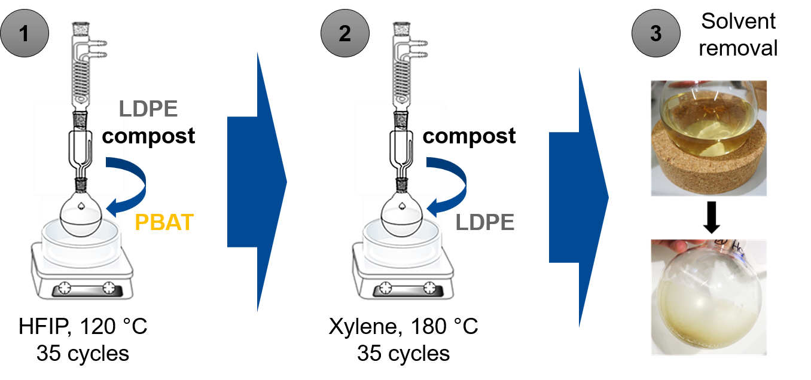
Figure S 3: Schematic representation of the Soxhlet sample preparation protocol to determine the variability between spiked samples sent out for the ILC.

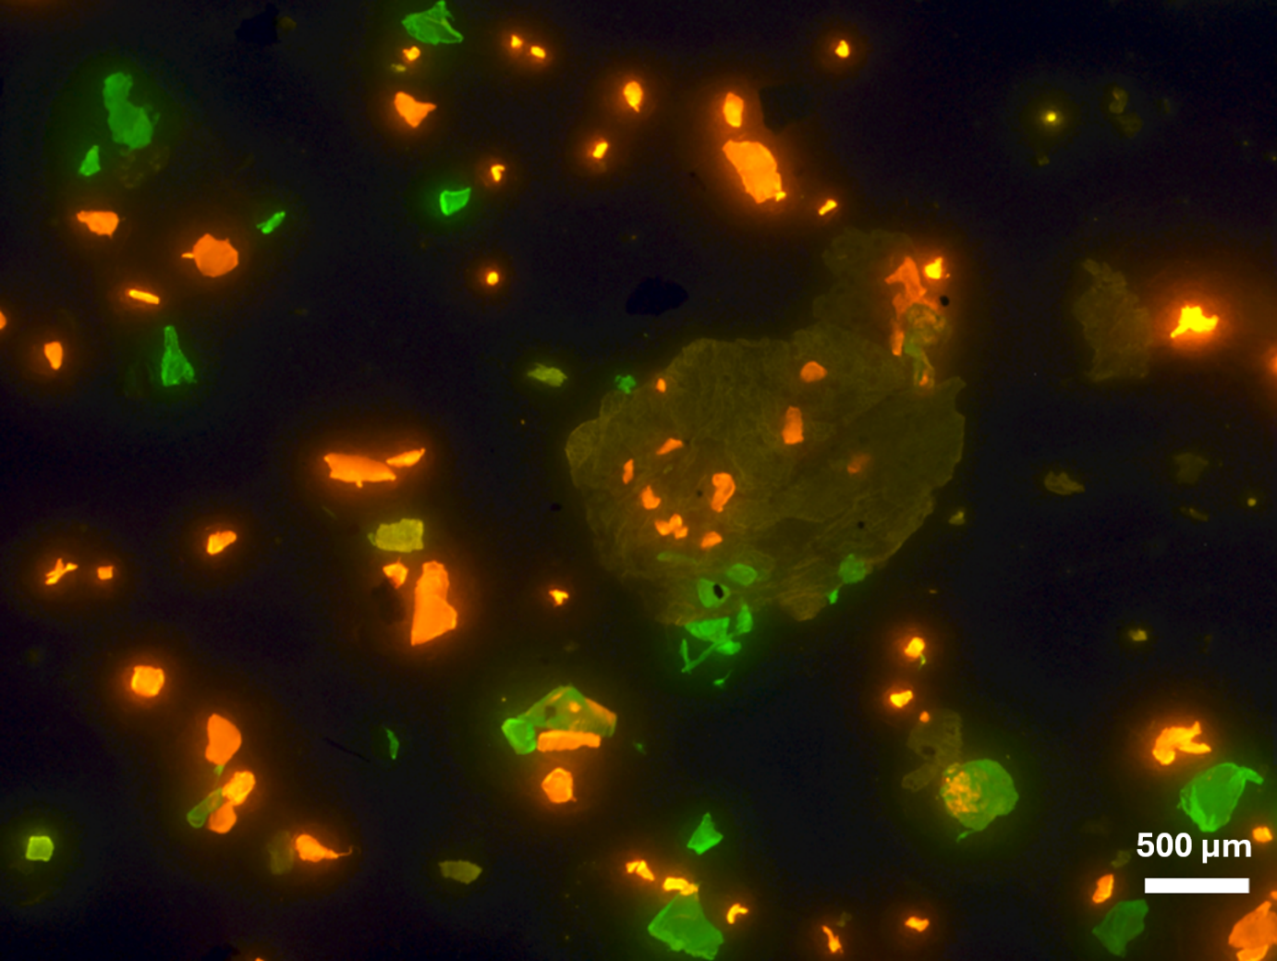
Figure S 4: Fluorescence image from a spiked compost extract sample stained with DANS. Showing in orange the PBAT particles, in green the LDPE particles and some slightly colored particles, which are not counted and can therefore be attributed to background compost contamination.

Analytical procedure followed by each laboratory using number-based methods

Lab 1:
Samples (100 mL) were homogenized by shaking, and an aliquot (typically 2 mL) was withdrawn using a pipette and filtered through a polycarbonate membrane selected to provide optimal optical contrast to the particles (Whatman Cyclopore PC, pore size 0.2 µm, diameter 47 mm, black). The filter was removed from the filtration unit and mounted onto an appropriate sample holder for microscopic analysis. Raman microscopy was performed using a confocal Raman microscope (WITec alpha300 R). A laser excitation wavelength of 785 nm was employed. The use of a 785 nm laser was preferred due to its reduced susceptibility to fluorescence interference compared to shorter excitation wavelengths.
An initial overview image of the entire filter surface was acquired using a low‑magnification objective (e.g., 5x) under brightfield or, if required to enhance particle contrast, darkfield illumination. Automated particle detection was subsequently performed using a threshold optimized to detect the maximum possible number of particles. Detected objects with equivalent circular diameters (ECD) smaller than 25 µm were excluded from further analysis.
To establish suitable measurement conditions, representative particles of different morphologies and material types were measured individually directly on the filter. Based on these preliminary measurements, optimal parameters for laser power, acquisition time, and focus were defined. Subsequently, all remaining particles were analyzed automatically using autofocus and higher‑magnification objectives (20x). Care was taken to exclude filter regions exhibiting intense Raman bands originating from the filter material.
Raman spectra were acquired using laser powers of approximately 30 mW. Raman spectral acquisition, particle recognition, and data processing were performed using WITec Suite FIVE and ParticleScout software.
All acquired spectra were subjected to library searches using reference spectra of relevant polymers (including PBAT and LDPE) measured under identical instrumental conditions. Particles were subsequently classified according to polymer type, and particle size distributions were evaluated based on the equivalent circular diameter.

Lab 2:
Subsamples from the 100 mL sample were obtained by pulling 2 mL from the bottom to the top of the sample container while the sample was actively swirling with a glass pipette and filtered through a black etched polycarbonate filter (Cyclopore PC, 0.2 µm pore size, 47 mm diameter, black). The filter was transferred to a glass slide to maintain flatness for microscopic analysis.
Raman analysis was completed utilizing a HORIBA XploRA PLUS microRaman system. A mosaic image of the entire filter area was collected using the 10x objective, darkfield illumination, and NavSharp autofocus (+/-120 µ) function. The Particle Finder tool was then used to automatically detect particles, gather morphological data, and obtain spectra. Particle sizes were determined by equivalent circular diameter. A particle detection threshold was manually selected and optimized for all samples. Morphological filters were applied to reduce the frequency of individual particles being detected as more than one particle. Spectra were collected using a 785 nm laser at 25% power (<20 mW) for a total of 10 s per particle, 2 s acquisition time with 5 accumulations to reduce background noise. All spectra were baselined using the FLAT correction baseline subtraction method. Multivariate analysis (MVA) based on classical least squares was utilized to automatically identify particles and verified with reference spectra collected from pristine materials and representative samples on the filter.
Lab 3:
For Raman
After dispersing the extract in the standardized 100 mL of ultrapure water a subsample of 2 ml was taken with a 5 mL pipette and vacuum filtered on a white track etched polycarbonate filter (Dorsan). The filters were glued with double sided tape on a custom-made PLA microscope slide, in the shape of the slide holder of the micro-Raman. The filters were transported to the micro-Raman microscope. The analysis of the entirety of the filter was performed using static mode, generating a stitched image of the entire filter. Followed by an automated particle selection based on intensity and contrast differences, with a particle lower size cut-off at 50 µm. Finally, all detected particles were automatically analyzed, acquiring the spectra from 400-3200 cm⁻¹ and comparing it with a library, HQI index was set to be above 50 to consider it a match.
The system used for the experiments was a Horiba Jobin Yvon LabRAM, coupled with a 532 nm laser and a x10 objective. Data was recorded with LCD display and a grating of 300 g/mm. ParticleFinder was used for the particle selection based on different parameters, like size, contrast and brightness. The system detects the particle and automatically focuses on them, spectral autofocus mode was used to find the focal point of each particle. Spectra were acquired with 2 accumulations of 10 s acquisition time for each, acquisition window was from 400 to 3200 cm⁻¹. IDFinder was used to perform the library matching, the library used was custom created for the experiments and included LPDE, PBAT and PC(filter material); other polymers were also included in the library. HQI index for the experiments was verified prior of taking the data and set at 50.
For fluorescence
Samples were generated by subsampling 2 mL from the parent polymer dispersion. The subsamples were vacuum filtered through a 47 mm diameter glass fiber filter with a 1 µm pore size. Subsequent staining was completed directly on the filter through a drop-wise addition of 10 µM 4-Dimethylamino-4′-nitrostilbene (DANS) in ethanol solution, ensuring coverage of the entire filter. Stained filters were dried at 60 °C for 1 hour. Images were taken under a Nikon SMZ1500 stereomicroscope, equipped with a Prior Scientific Lumen 200 fluorescence probe, and a ProgRes® SpeedXT^{Core} 5 camera at a magnification of 20x. A representative 9 images were taken per sample. The quantity of particles per filter was derived using the mean particle density per image (MPD) Total particles=MPD*Filter area.
MP particle size was established via the free image analysis software ImageJ/Fiji. The area (A) of manually selected fluorescent particles was measured in µm², from which the equivalent circular diameter (ECD) was derived using the following formula: $ECD=2\sqrt{A/π}$. Particles were grouped into bins depending on their ECD; <20 µm, 20 – 40 µm, 40 – 50 µm, 50 – 100 µm, 100 – 150 µm, 150 – 200 µm, 200 – 250 µm, 250 – 300 µm, and > 300 µm.

Lab 4:
After dispersing the extract in the 100 mL of ultrapure water a subsample of 2 mL was vacuum filtered on a 47 mm diameter, 0.1 µm cutoff Anodisc filter with an effective filtration diameter of 36 mm. The dry filters were covered and stored in glass Petri-dishes till analysis. Analysis of the samples was performed using a inVia™ Qontor™ confocal Raman microscope (Renishaw, Dublin, Ireland) using a 10x objective, 785 nm laser source at 100% laser power, 3x0.5s illumination time and 300-3400 cm-1 spectral range. Measurement positions – corresponding to the particles - were selected based on a stitched micrograph of the central part of the Anodisc filters (20 mm diameter), which was collected using transmission type illumination and the same (10x) objective, and which represented 31% of the effective filtration area. The binarised optical image was used by the Particle Analysis module of Wire software v5.6 (Renishaw) to determine the area and equivalent circle diameter (ECD) of the individual particles. Only particles with area ≥ 490 µm2 (ECD ≥ 25 µm) were measured and analysed. A home built spectral library containing the spectra of most prominent, environmentally relevant polymer types (Polymer Kit 1.0, Hawai‘i Pacific University Center for Marine Debris Research and reference polymer sheets from Goodfellow) and also spectra of inorganic materials (silica, titanium oxide, etc) was used to compare spectra (first derivatives) to a database and to recognise microplastics particles. The spectrum of PBAT was added to the database before the exercise - after collecting spectra using the positive control samples provided by the ILC organisers. Each hit with HQI below 60% was also double checked also by the experienced operator to confirm spectrum matching.

Lab 5:
The 100 mL sample obtained from the enrichment protocol was homogenized by manual shaking, and a 0.5 mL aliquot was subsequently collected using a pipette. The aliquot was filtered through a silver membrane filter (1.2 µm pore size; STERLITECH, Madrid, Spain) mounted on a vacuum filtration unit. The filter was then placed in an in-house designed and 3D-printed sample holder fabricated from PLA.
µ-FTIR imaging was performed using a Nicolet iN10 microscope (Thermo Fisher Scientific) operated in reflection mode and equipped with a liquid nitrogen-cooled detector. Spectra were acquired in extinction format over a spectral range of 4000-500 cm⁻¹ with an acquisition time of 22 s. Brightness and focus were adjusted manually prior to measurement. Measurements and particle analyses were conducted using Particle Wizard mode (Picta 1.9 software with OMNIC 9.14). The entire filter area was mapped. Following measurement, the particle size range was restricted to the expected size distribution of the recovered plastic particles (50-300 µm ± 50 µm). Subsequently, particles were manually masked until all visible particles on the filter had been assigned. A background spectrum was collected for each filter following each measurement. To enable polymer identification, spectra of the pristine microplastic particles supplied for the interlaboratory comparison were acquired and incorporated into the spectral library. Following analysis, each detected particle was matched against the spectral library, and the resulting data were exported as a .csv file containing the particle coordinates on the filter and the corresponding compound identification. Particle dimensions were determined by matching the IR images with optical images using an in-house Python script and ImageJ software. Feret diameters and equivalent circular diameters (ECDs) were subsequently calculated for all identified particles. The final dataset was exported as an .xlsx file containing all relevant particle parameters.

Lab 6:
Samples (100 mL) were homogenized by shaking, and an aliquot (2 mL) was withdrawn using a pipette and filtered through a polycarbonate membrane selected to provide optimal optical contrast to the particles (Dorsan PCTE, pore size 0.2 µm, diameter 47 mm, black). The filter was removed from the filtration unit and mounted onto an appropriate sample holder using adhesive tape for subsequent microscopic analysis.
Raman spectra were collected using a WITec Apha 300 R Raman microscope (WITec GmbH, Germany) equipped with 785 nm laser operating at powers of 40 mW. Measurements were performed using a 600 lines mm⁻¹ grating and a 20x objective (numerical aperture 0.5, working distance 2.2 mm). The filtered area of the membrane was imaged using dark-field illumination. Autofocus optimization along the z-axis was performed over a range of −500 to 500 µm for particles with Feret Max ≤ 40 µm, and a minimum integration time of 0.10 s was applied. Each spectrum was acquired as the average of 10 accumulations, with an integration time of 0.2 s per accumulation. Raman spectra of each detected particle (approximately 20000 - 25000 particles) across the entire filter were collected over the range of 100–3600 cm⁻¹.
Spectral identification was performed using an in-house polymer database in combination with the TrueMatch module integrated into the ParticleScout software, with an HQI threshold set above 60 to consider a positive match for automated Raman spectral identification.

Lab 7:
A 0.5 mL subsample was withdrawn from the standardized 100 mL solution and vacuum filtered through a silver filter (pore size 3 µm, diameter 25 mm). The filter was subsequently analyzed via FT-IR microscopy using reflection mode imaging. To perform the mapping, the microscope was equipped with a 64x64-pixel Focal Plane Array (FPA) detector. Spectral acquisition was performed using a spectral resolution of 8 cm⁻¹, 60 scans per pixel, and a scan speed of 2.2, with an effective pixel size of 25 µm to define the spatial resolution. Instrumental parameters were optimized to ensure a proper balance between signal-to-noise ratio, spectral sharpness, and acquisition time.
Data processing and analysis of the FT-IR imaging maps were carried out using the open-source software siMPle (Systematic Identification of MicroPLastics in the Environment). The software automatically applied spectral pre-processing algorithms, including normalization and differentiation. Subsequently, acquired spectra were subjected to a library search and mathematically compared against a reference library containing target LDPE and PBAT samples. Pixels were assigned a chemical identity based on the highest spectral similarity using correlation indices. Finally, adjacent pixels (25 µm in size) sharing the same chemical signature were digitally merged to isolate individual particles, and their geometric parameters, including total area and maximum Feret diameter, were automatically calculated.

Lab 8:
Under constant stirring, subsamples with volumes ranging from 2.29 to 3.06 mL were drawn from the final extract with a metal sampling probe for liquids. The subsamples were then vacuum filtered on white Al₂O₃ membrane filters with a pore size of 0.2 µm and a diameter of 47 mm. Filters were dried over night at room temperature, followed by a final drying step for 30 min at 60°C before being mounted into custom-made aluminum filter holders. FTIR images of the total suctioned filter area (20 mm diameter) were acquired in transmission mode using a PerkinElmer Spotlight 400 FTIR-microscope. Spectra were recorded from 4000 to 1250 cm⁻¹ with a pixel size of 25 µm. A subsequent correlation analysis of the obtained FTIR images vs. reference spectra of PE or PBAT displayed the correlation factor in each pixel, allowing for particle visualization. Manual data evaluation and interpretation was then carried out by an expert team.

Analytical procedure followed by each laboratory using mass-based methods
Lab 2:
For Py-GC/MS analysis, aliquots of the extracted sample suspensions were first dried at approximately 80 °C until complete water removal. Depending on sample volume, drying required up to several days. Subsequently, toluene was added to the dried residues, and the mixtures were heated to boiling to dissolve the recovered polymer particles. After cooling to near room temperature, a homogeneous aliquot of each solution was transferred into pyrolysis sample cups. The cups were then gently heated to evaporate the solvent completely prior to analysis. This approach enabled simultaneous analysis of both LDPE and PBAT without the need for polymer-specific sample preparation procedures.
Pyrolysis-gas chromatography/mass spectrometry (Py-GC/MS) was performed using a Frontier Lab EGA/PY-3030D multi-shot pyrolyzer coupled to an Agilent 7890B gas chromatograph and an Agilent 5977B mass selective detector. Samples were pyrolyzed at 700 °C under a constant helium carrier gas flow of 1.0 mL min⁻¹. Separation was achieved using an HP-5MS capillary column. The GC oven temperature program started at 50 °C, followed by heating at 10 °C min⁻¹ to 300 °C and a final hold of 15 min at 300 °C.
The pyrolysis temperature was selected based on preliminary experiments conducted between 450 and 700 °C. Lower temperatures resulted in incomplete volatilization of LDPE pyrolysis products and increased risk of carry-over between analyses. A pyrolysis temperature of 700 °C provided efficient decomposition of both LDPE and PBAT and was therefore used for all measurements.
External calibration was performed using polymer standards prepared over a range of concentrations. Quantification of PBAT was based on the characteristic pyrolysis product benzophenone, whereas LDPE was quantified using the summed peak area of the characteristic pyrolysis product distribution eluting between 6.0 and 30.5 min. Calibration curves showed good linearity across the investigated concentration ranges (R² = 0.998 for PBAT and R² = 1.000 for LDPE). Procedural blank samples were analyzed alongside extracted samples to assess potential background contamination. No PBAT was detected in blank samples, while only minor LDPE-related signals were observed at levels substantially below those of the spiked samples. Special attention was given to contamination control during sample handling; containers and caps containing polyethylene or polypropylene were avoided to minimize background contributions.

Lab 4:
Preparation for Py-GC/MS: After dispersing the extract in the 100 mL of ultrapure water, a 1 mL subsample was taken with a 1 mL pipette and vacuum-filtered directly onto a 15 mm glass-fibre filter (Whatman GF/F, Cat. No. 1825-015). The residue on the filter was washed five times with 1 mL of ultrapure water, then dried at 40 °C for 4 h in a drying oven; the filters were covered with beakers during drying to prevent contamination. Once dry, each filter was folded and transferred whole into a pyrolysis cup (Frontier Lab Eco-Cup LF, P/N PY1-EC80F). Pyrolysis was performed with a Frontier EGA/PY3030D multi-shot pyrolyser, setting the furnace temperature to 600 °C and the interface temperature to 280 °C. The resulting vapours were separated and detected on an Agilent 8890 gas chromatograph coupled to a 5977B single-quadrupole mass spectrometer. Injection was carried out in split mode (1:100) with the injector temperature set at 280 °C; the carrier gas flow was constant at 1 mL min⁻¹. The GC oven programme was: 50 °C for 1 min, ramp 30 °C min⁻¹ to 150 °C (hold 4 min), then ramp 30 °C min⁻¹ to 300 °C (hold 18 min). The chromatographic column was an HP-5 (30 m × 0.25 mm ID, 0.25 µm film, Part No. 19091S-433). Target compounds for identification and quantification were for PBAT: bis(Butenyl)adipate (m/z 183) and terephthalic acid, di(but-3-eny l)-ester (m/z 203) and for PE: 1,20-Heneicosadeiene (C21) (m/z 82) and 1,12 Tridecadiene (first peak of triplet) (C13) (m/z 82) and 1-Tridecene (second peak of triplet) (C13) (m/z 82). Calibration was performed using neat powders supplied by BASF, the same material employed for spiking the compost.

Lab 9:
TED-GC/MS sample preparation occurred by a vacuum filtration of 1 mL of the extract dispersed in 100 mL of Milli-Q water through a stainless-steel filtering cup with a mesh size of 5-6 µm (diameter: 9 mm, heigh: 13 mm; GKD group, www.gkd-group.com). The filter residue was dried overnight in a desiccator. The filter cup including the residue particles was directly measured in the TED-GC/MS system.
The TED-GC/MS is a multi-step instrumental setup, which connects the extraction by thermogravimetric analysis (TGA) with the trace analysis of a GC/MS (GC: 6890+ gas chromatograph (Agilent Technologies, Palo Alto, CA, United State system; MS: Agilent MSD 5973N). The sample (filter cup with loaded particles) is placed in the autosampler of the TGA (TGA/SDTA 851 single arm thermobalance, Mettler-Toledo GmbH, Gießen, Germany) and heated from 25 to 600 °C (10K/min) under nitrogen atmosphere (30 mL/min). The decomposition gases are collected on an adsorber (SorbStar© Polydimethylsiloxane, length: 20 mm and diameter: 2 mm, Innovative MessTechnik GmbH, Vohenstrauß, Germany), which is placed in a thermodesorption unit (TDU). After final collection, the adsorber is fully automated transferred to another TDU at the GC/MS system, where the decomposition gases are slightly heated for removal (270 °C with 12 K/s) and collected in a cold injection system (CIS4, Gerstel) at -100 °C. The gases are then given to the GC column (HP-5MS), separated according to their interaction with the column and determined in the mass spectrometer by fragments. The initial oven temperature of 40 °C was increased to 300 °C at a rate of 5 K/min. The mass spectrometer works in electron ionization mode at 70 eV. The measurements were performed in full scan mode with a mass range of m/z 35 to m/z 350. Analysis was done with Chemstation.
Polymer identification was done by screening the total ion chromatogram for PE and PBAT for specific marker molecules. The markers for PE have been: 1,10-undecadiene, 1,11-dodecadiene, 1,12-tridecadiene, 1,13-tetradecadiene, 1,14-pentadecadiene, 1,15-hexadecadiene. Quantification of PE occurred by calculating the average of all 6 PE marker peak areas with the m/z 81. The markers for PBAT have been: ethylbenzoate (m/z 105), terephthalic acid dibut-3-enyl ester (m/z 203), adipic acid dibut-3-enyl ester (m/z 55) and 1.6-dioxacyclododecane-7.12-dione (m/z 55), where again the average of the peak areas was determined for quantification. An additional TED-GC/MS measurement was done with pristine PE or PBAT and known mass (m₁). The mass (m_{S}) of PE or PBAT in the original sample was determined by dividing the average of all six PE or 4 PBAT marker peak areas of the sample (A_{S}) through the average of all six PE or 4 PBAT marker peak areas of the pristine measurement (A₁) multiplied by the known mass of the pristine polymer measurements:
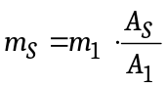

Lab 10:
The extract dispersed in 100 mL of Milli-Q water was filtered through a wire mesh of 25 µm pore size. The filter with the retained particles was transferred to a beaker, and 10 mL of dichloromethane was added and stirred for 5 minutes, in order to dissolve PBAT particles. An aliquot was transferred to a specific tube for Py-GC/MS analysis.
Then the solvent in the beaker was allowed to evaporate, and the remaining solid particles (LDPE among them) were resuspended in about 20 mL of Milli-Q water. Ultrasonic bath during 30 minutes was applied. Then it was filtered using a 200 nm Al₂O₃ filter and subsequently subjected to cryogenic grinding in a ball mill. An aliquot of the solid mixture obtained was transferred to a specific tube for Py-GC/MS analysis.
Extracted samples were analyzed by Py-GC/MS using a CDS Analytical Pyrolyzer 6200 coupled to an Agilent 7890B gas chromatograph and a 5977B mass selective detector. Pyrolysis was performed by heating the sample from 150 to 600 °C at a rate of 20 °C ms⁻¹, followed by a hold time of 1 min at 600 °C. The pyrolyzer interface and transfer line were maintained at 300 °C throughout the analysis. Chromatographic separation was carried out using an HP-5 capillary column (30 m × 0.32 mm i.d., 0.25 μm film thickness; Agilent Technologies). Helium was used as carrier gas at a constant flow rate of 1.5 mL min⁻¹. Samples were introduced in split mode (10:1) with an injector temperature of 300 °C. The GC oven was initially held at 40 °C for 2 min, then programmed at 10 °C min⁻¹ to 325 °C with a final hold of 2 min. The GC-MS interface was maintained at 280 °C. Mass spectrometric detection was performed in electron ionization (EI) mode with a source temperature of 230 °C and data acquisition in full-scan mode. Quantification of PBAT was based on the characteristic pyrolysis product terephthalic acid, di(but-3-enyl) ester (DBT), monitored using the characteristic ions m/z 203, 149, and 121. LDPE was quantified using the pyrolysis product 1-undecene with the characteristic ions m/z 70, 111, and 97. Polymer concentrations were determined using calibration standards analyzed under identical conditions.

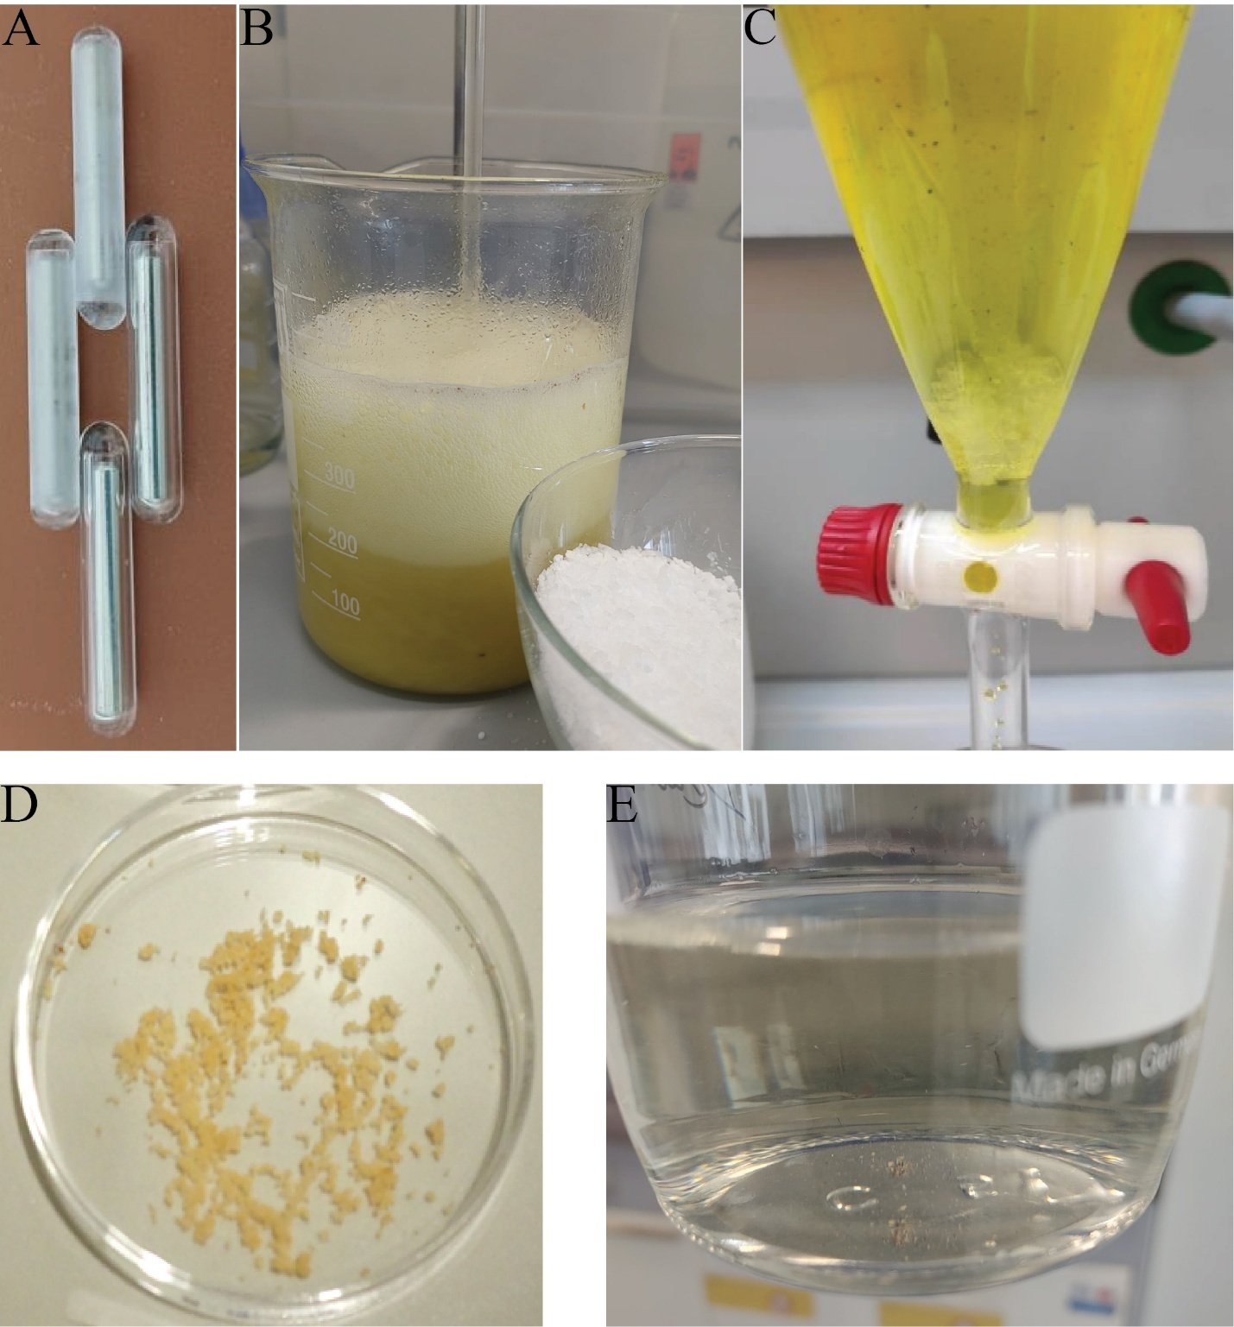
Figure S 5: Representative images illustrating feedback provided by ILC participants. (A) Abrasion of glass‑encapsulated stirring bars observed during oxidation in presence of compost. (B) Foam formation following the direct addition of CaCl₂ to the dispersion after completion of organic matter removal by Fenton treatment. (C) Crystallization of CaCl₂ observed in the density separation funnel. (D) Discoloration of microplastics attributed to iron oxide formation during the Fenton reaction and subsequent mineral deposition on the polymer surface. (E) Contamination of the CaCl₂ solution during preparation of the procedural blank, indicating the presence of extraneous particles in the salt.

Table S 2: Compilation of reported values in the requested size bins for all participating laboratories using microscopy techniques (spiked samples). Variability expressed as the sample standard deviation.
LDPE | size range
Laboratory | <50 µm | 50-100 µm | 100-200 µm | 200-300 µm | > 300 µm | Total
Lab 1 (Raman, ECD) | 6333±3529 | 6883±2930 | 7383±1533 | 2133±202 | 317±126 | 23050±7530
Lab 2 (Raman, ECD) | 750±606 | 1800±885 | 3667±1049 | 1417±535 | 467±351 | 8100±1600
Lab 3 (Raman, ECD) | 0 | 2147±1139 | 2957±1555 | 1155±479 | 228±150 | 6487±2987
Lab 4 (Raman, ECD) | 1458±742 | 2133±1266 | 2079±866 | 1350±655 | 297±284 | 7317±3775
Lab 5 (FTIR, ECD) | 1000±1217 | 2333±2023 | 3467±3408 | 1400±1058 | 533±611 | 12400±6223*
Lab 5 (FTIR, Feret Max) | 133±231 | 1533±1528 | 3800±3704 | 2000±1709 | 1267±833 | 12400±6223*
Lab 6 (Raman, Feret Max) | 117±126 | 600±265 | 1583±611 | 4817±2386 | 1683±275 | 8800±3632
Lab 7 (FTIR, Feret Max) | 1800±872 | 16867±8353 | 31000±10615 | 11867±5608 | 7667±4291 | 69200±27025
Lab 8 (FTIR, Feret Max) | - | - | - | - | - | 9015±1936
* Replicate 3 reported by Lab 5 was excluded from this evaluation due to markedly lower counts detected.
PBAT | size range
Laboratory | <50 µm | 50-100 µm | 100-200 µm | 200-300 µm | > 300 µm | Total
Lab 1 (Raman, ECD) | 18833±10054 | 22450±11761 | 12083±5084 | 1983±831 | 317±176 | 55667±26859
Lab 2 (Raman, ECD) | 2383±3525 | 8567±2849 | 14233±3365 | 6550±3245 | 3050±2685 | 34783±5146
Lab 3 (Raman, ECD) | 0±0 | 6112±5767 | 7117±5576 | 1938±1426 | 415±341 | 15582±12604
Lab 4 (Raman, ECD) | 1971±1422 | 5589±3138 | 5076±4952 | 1917±2204 | 297±383 | 14850±11662
Lab 5 (FTIR, ECD) | 2067±1858 | 11667±8310 | 14667±9750 | 5467±4460 | 1933±2120 | 49100±13435*
Lab 5 (FTIR, Feret max) | 67±115 | 6533±4509 | 16333±11657 | 7200±5048 | 5667±5077 | 49100±13435*
Lab 6 (Raman, Feret Max) | 83±76 | 1583±382 | 5383±1654 | 6967±1030 | 1650±522 | 15667±2093
Lab 7 (FTIR, Feret Max) | 133±115 | 14867±11385 | 40667±15171 | 21067±8963 | 21667±6054 | 98400±40600
Lab 8 (FTIR, Feret Max) | - | - | - | - | - | 11602±1648
* Replicate 3 reported by Lab 5 was excluded from this evaluation due to markedly lower counts detected.
Table S 3: Compilation of reported method blank values in the requested size bins for all participating laboratories using microscopy techniques. Variability expressed as the sample standard deviation.
LDPE | size range
Laboratory | <50 µm | 50-100 µm | 100-200 µm | 200-300 µm | > 300 µm | Total
Lab 1 (Raman, ECD) | 16±18 | 13±16 | 2±4 | 0±1 | 0±0 | 32±38
Lab 2 (Raman, ECD) | 1±1 | 1±2 | 0±1 | 0±0 | 0±0 | 2±2
Lab 3 (Raman, ECD) | 0±0 | 0±0 | 0±0 | 0±0 | 0±0 | 0±0
Lab 4 (Raman, ECD) | 0±0 | 0±0 | 0±0 | 0±0 | 0±0 | 0±0
Lab 5 (FTIR, ECD) | 0±0 | 0±0 | 0±0 | 0±0 | 0±0 | 0±0
Lab 5 (FTIR, Feret max) | 0±0 | 0±0 | 0±0 | 0±0 | 0±0 | 0±0
Lab 6 (Raman, Feret Max) | 0±0 | 0±0 | 0±0 | 0±0 | 0±0 | 0±0
Lab 7 (FTIR, Feret Max) | 137±116 | 791±656 | 908±749 | 199±158 | 140±109 | 2176±1783
Lab 8 (FTIR, Feret Max) | - | - | - | - | - | 689±46
PBAT | size range
Laboratory | <50 µm | 50-100 µm | 100-200 µm | 200-300 µm | > 300 µm | Total
Lab 1 (Raman, ECD) | 1±2 | 0±0 | 0±0 | 0±0 | 0±0 | 1±2
Lab 2 (Raman, ECD) | 1±1 | 7±8 | 0±0 | 0±0 | 0±0 | 9±6
Lab 3 (Raman, ECD) | 0±0 | 7±9 | 0±0 | 0±0 | 0±0 | 7±9
Lab 4 (Raman, ECD) | 0±0 | 0±0 | 0±0 | 0±0 | 0±0 | 0±0
Lab 5 (FTIR, ECD) | 9±14 | 0±0 | 0±0 | 0±0 | 0±0 | 9±14
Lab 5 (FTIR, Feret max) | 7±12 | 2±2 | 0±1 | 0±0 | 0±0 | 9±14
Lab 6 (Raman, Feret Max) | 0±0 | 0±0 | 0±0 | 0±0 | 0±0 | 0±0
Lab 7 (FTIR, Feret Max) | 0±0 | 1±2 | 1±2 | 0±1 | 2±1 | 5±5
Lab 8 (FTIR, Feret Max) | - | - | - | - | - | 0±0
Table S 4: Reported unspiked matrix sample values in the requested size bins for all participating laboratories using microscopy techniques. Variability expressed as the sample standard deviation.
LDPE | size range
Laboratory | <50 µm | 50-100 µm | 100-200 µm | 200-300 µm | > 300 µm | Total
Lab 1 (Raman, ECD) | 50±50 | 100±50 | 67±58 | 0±0 | 0±0 | 217±153
Lab 2 (Raman, ECD) | 0±0 | 0±0 | 0±0 | 0±0 | 0±0 | 0±0
Lab 3 (Raman, ECD) | 0±0 | 167±165 | 47±66 | 7±9 | 0±0 | 220±241
Lab 4 (Raman, ECD) | 0±0 | 0±0 | 0±0 | 0±0 | 0±0 | 0±0
Lab 5 (FTIR, ECD) | 0±0 | 0±0 | 0±0 | 0±0 | 0±0 | 0±0
Lab 5 (FTIR, Feret max) | 0±0 | 0±0 | 0±0 | 0±0 | 0±0 | 0±0
Lab 6 (Raman, Feret Max) | 0±0 | 0±0 | 0±0 | 0±0 | 0±0 | 0±0
Lab 7 (FTIR, Feret Max) | 667±1155 | 6600±10048 | 12400±18200 | 6067±9815 | 2133±2003 | 27867±41168
Lab 8 (FTIR, Feret Max) | - | - | - | - | - | 1316±143
PBAT | size range
Laboratory | <50 µm | 50-100 µm | 100-200 µm | 200-300 µm | > 300 µm | Total
Lab 1 (Raman, ECD) | 17±29 | 0±0 | 0±0 | 0±0 | 0±0 | 17±29
Lab 2 (Raman, ECD) | 0±0 | 50±50 | 0±0 | 0±0 | 0±0 | 50±50
Lab 3 (Raman, ECD) | 0±0 | 7±9 | 0±0 | 0±0 | 0±0 | 7±9
Lab 4 (Raman, ECD) | 0±0 | 0±0 | 0±0 | 0±0 | 0±0 | 0±0
Lab 5 (FTIR, ECD) | 733±702 | 1333±2139 | 133±230 | 0±0 | 0±0 | 2200±2498
Lab 5 (FTIR, Feret max) | 533±757 | 1067±1677 | 533±924 | 67±115 | 0±0 | 2200±2498
Lab 6 (Raman, Feret Max) | 0±0 | 0±0 | 0±0 | 0±0 | 0±0 | 0±0
Lab 7 (FTIR, Feret Max) | 400±693* | 5600±9699* | 17867±30946* | 9933±17205* | 8800±15242* | 42600±73785*
Lab 8 (FTIR, Feret Max) | - | - | - | - | - | 0±0
* particles were only detected in 1 out of 3 unspiked matrix samples
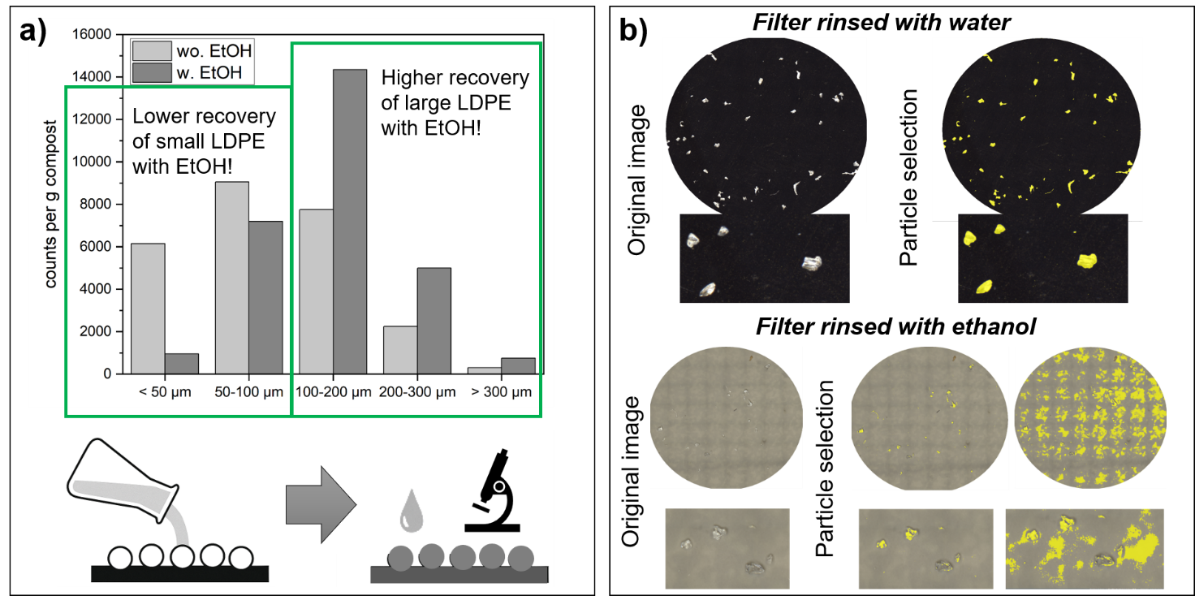
Figure S 6: Results obtained by Raman microscopy (Lab 1) on a spiked compost sample after subsampling from water and for comparison after subsampling from ethanol.

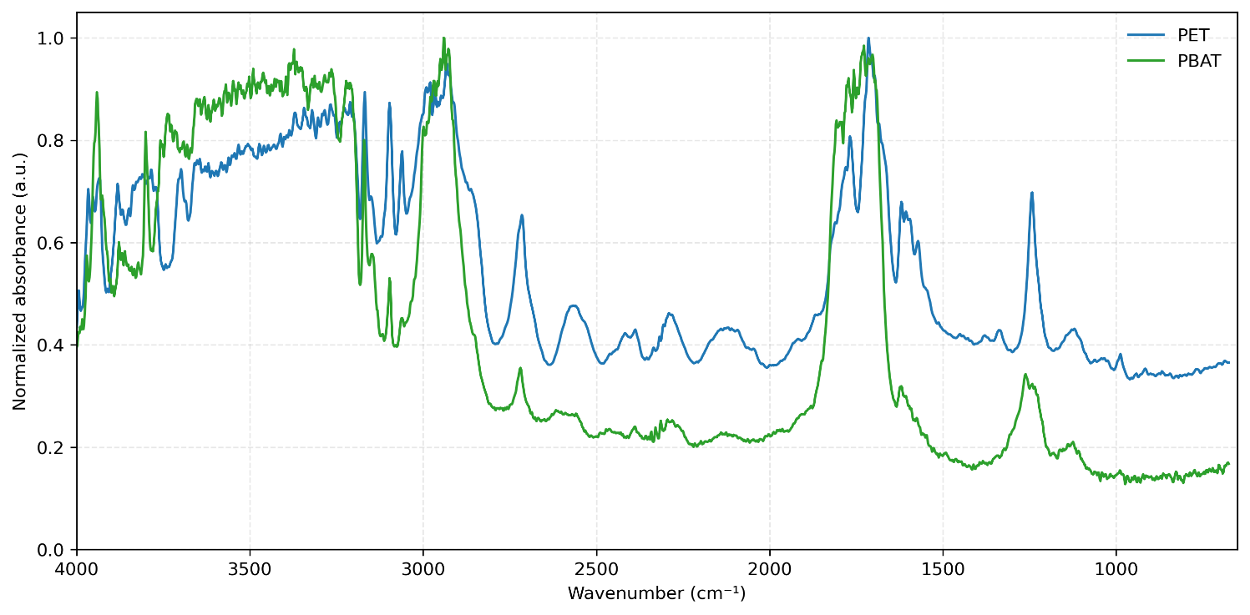
Figure S 7: FTIR spectra provided by Lab 5 of PET and PBAT, acquired with a spectral resolution of 1 cm⁻¹ between a spectral range of 4000 and 400 cm⁻¹, spectra is normalized. As the FTIR spectra of PET and PBAT share several characteristic absorption bands and can be highly similar, a reliable distinction cannot always be guaranteed, particularly for low-quality spectra or automated library matching.
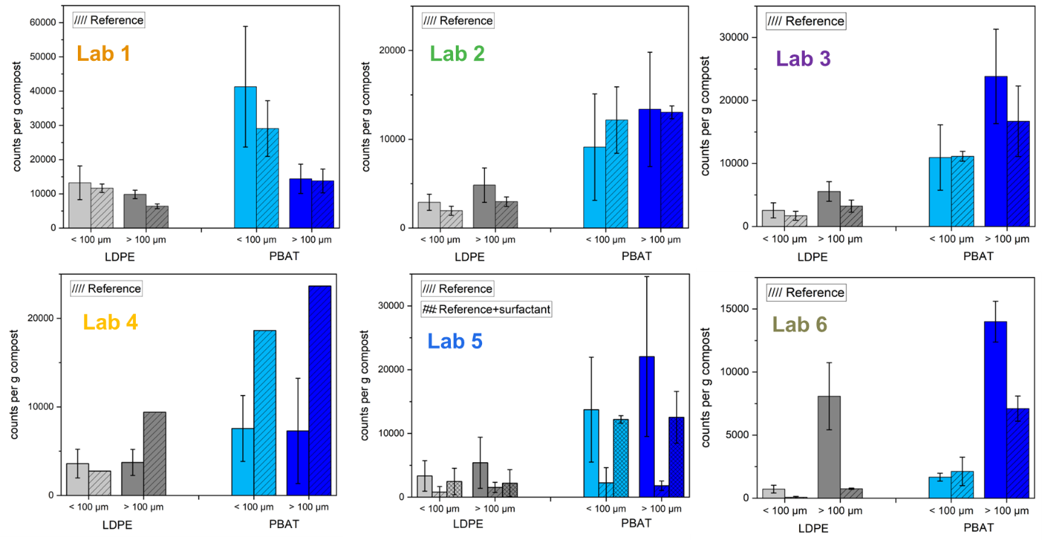
Figure S 8: Results from the water reference sample compared to results obtained from the compost extracts (number-based analysis).

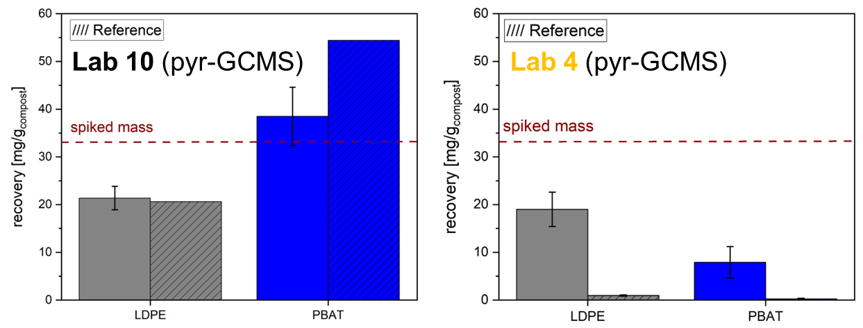
Figure S 9: Results from the water reference sample compared to results obtained from the compost extracts (mass-based analysis).

