Supporting Information for “Social well-being is associated with slower multisystem aging estimated from a single brain MRI scan: prospective evidence from MIDUS”

Minwoo Lee¹, Sara M. Garza-Gonzalez¹, Stacey M. Schaefer², Kyle Bourassa^{1, 3}, & Casey K. Brown¹*
¹Department of Psychology, Georgetown University
²Institute on Aging, University of Wisconsin-Madison
³Center for the Study of Aging and Human Development, Duke University Medical Center
*Corresponding author: Dr. Casey K. Brown;
Contact: Email: casey.brown@georgetown.edu;
Phone: 202-687-9124;
Address: 308 White-Gravenor Hall, 37th & O Streets, NW, Washington, DC 20057.

SI-1. Power analysis and sample size determination

Since no prior work has formally examined the relationship between the multiple dimensions of subjective well-being and DunedinPACNI, we based our expected effect size on prior literature on the psychosocial factors predicting biological aging, prioritizing blood-based pace-of-aging measures derived from the same Dunedin longitudinal cohort used to estimate DunedinPACNI. For instance, Su et al. (2025) reported that a 1-SD increase in cumulative psychosocial stress was associated with a 0.15-SD increase in DunedinPACE¹. Li et al. (2025) similarly found that low social connection was associated with a 0.20 SD higher DunedinPACE among men in a large cohort of middle-aged and older adults². Vyas et al. (2019) reported larger inverse correlations between psychosocial support and accelerated epigenetic aging (r = -.56 )³. Kim et al. (2023) provided more direct evidence, finding that a 1-SD increase in purpose in life was associated with approximately 0.5 years of reduced age acceleration among 1,572 older adults, as measured by DunedinPoAm. These values suggest that the magnitude of psychosocial associations with biological aging plausibly falls within the small-to-medium range. In the absence of a directly comparable estimate for DunedinPACNI, we used Cohen's conventional small-to-medium range for multiple regression (f² = .02–.15, midpoint: f² = .085) as a reference. To provide a more conservative estimate, we specified a reference effect size of f² = .0425 (midpoint of .085). An a priori power analysis for a multiple regression model testing the incremental contribution of one focal well-being predictor, with α = .05, target power of 1-β = .80, and 14 total predictors in G*Power, yielded a required sample size of N = 187. Our final analytic sample of N = 213 exceeded this threshold.

SI-2. Examining selection bias

To assess potential selection bias associated with complete-case analysis, we compared eligible participants from the MIDUS Neuroscience Project who were included in the final analytic sample (n = 213) with those excluded due to missing data (n = 76). We compared groups on chronological age at MRI scan, sex, racial distribution, educational attainment, annual household income, and total number of chronic conditions. Participants included in the analytic sample (age = 56.2 ± 13.6) were significantly younger than those excluded (age = 62.9 ± 12.5), t(287) = −3.77, p < .001. However, the groups did not significantly differ in sex or racial composition, educational attainment, annual household income, or number of chronic health conditions (all Ps > .339). Overall, although the analytic sample showed some selection toward younger participants, we found no evidence of systematic selection in the other demographic, socioeconomic, and health characteristics examined.

SI-3. Descriptive statistics for well-being subscales and example items

Main Instrument | Subscale | Min | Max | M | SD | Example Items
Ryff Psychological Well-being scale | Autonomy | 8.0 | 21.0 | 16.3 | 2.9 | “My decisions are not usually influenced  by what everyone else is doing.”
 | Environmental Mastery | 5.0 | 21.0 | 17.0 | 3.3 | “In general, I feel I am in charge of  the situation in which I live.”
 | Personal Growth | 7.0 | 21.0 | 18.0 | 2.9 | “I have the sense that I have developed  a lot as a person over time.”
 | Positive Relation with Others | 3.0 | 21.0 | 16.8 | 3.7 | “I know that I can trust my friends, and  they know they can trust me.”
 | Purpose in Life | 6.0 | 21.0 | 16.9 | 3.1 | “I have a sense of direction and  purpose in life.”
 | Self-Acceptance | 3.0 | 21.0 | 16.6 | 3.9 | “I like most parts of my personality.”
Keyes Social  Well-being Scale | Social Coherence | 2.0 | 14.0 | 9.8 | 2.9 | “I cannot make sense of  what’s going on in the world.”
 | Social Integration | 3.0 | 21.0 | 14.8 | 3.9 | “I feel close to other people  in my community.”
 | Acceptance of Others | 3.0 | 21.0 | 13.8 | 3.2 | “I believe that people are kind.”
 | Social Contribution | 3.0 | 21.0 | 16.2 | 3.4 | “I have something valuable  to give to the world.”
 | Social Actualization | 3.0 | 20.0 | 12.6 | 3.8 | “The world is becoming  a better place for everyone.”
Positive/negative affect scale | Positive Affect | 1.5 | 5.0 | 3.4 | 0.7 | “During the past 30 days, how much of the time did you feel...[cheerful]?
 | Negative Affect | 1.0 | 4.7 | 1.4 | 0.6 | “During the past 30 days, how much of the time did you feel...[nervous]?
Life Satisfaction Scale |  | 3.4 | 10 | 7.5 | 1.3 | Respondents were asked to rate their life overall, work, health, relationship with spouse/partner, and relationship with children
Note. Total N = 213.

SI-4. Regression analysis modeling the associations between DunedinPACNI and annual income and education level separately (Model 3: Fully adjusted model)

Predictor | B | SE | β | t | p | sr
Constant | -1.89 | .54 | — | -3.52 | <.001 | —
Race | .23 | .13 | .14 | 1.73 | .086 | .10
Age at MRI scan** | .02 | .01 | .39 | 4.29 | <.001 | .25
Sex | -.03 | .09 | -.02 | -.33 | .741 | -.02
MIDUS cohort** | .53 | .09 | .54 | 5.81 | <.001 | .34
Education† | -.04 | .02 | -.15 | -1.99 | .048 | -.12
Annual Income | -8.40 × 10⁻⁷ | .00 | -.07 | -.97 | .332 | -.06
Social Well-being* | -.14 | .05 | -.19 | -2.69 | .008 | -.16
BMI† | .02 | .01 | .14 | 2.14 | .034 | .12
Chronic conditions* | .05 | .02 | .17 | 2.48 | .014 | .14
Drinking history | .00 | .00 | .01 | .16 | .873 | .01
Smoking history | -.01 | .00 | -.10 | -1.50 | .134 | -.09
Exercise frequency | -.00 | .01 | -.01 | -.18 | .856 | -.01
Cognitive activity | .01 | .01 | .04 | .58 | .561 | .03
Marital/co-residency status | .07 | .10 | .05 | .71 | .481 | .04
Social Network Size | -.01 | .04 | -.01 | -.23 | .822 | -.01
Note. N = 213. Dependent variable = DunedinPACNI. R² = .400. For regression analyses, the reference categories were Male for sex, White for race, MR for MIDUS cohort, and Married/co-residing for marital/co-residency status. Significance thresholds for the regression coefficients were Bonferroni-corrected for three comparisons (See Results for the rationale for multiple comparison correction). †p < .05 (nominally significant before Bonferroni-correction); *p < .0167; **p < .0033; ***p < .00033.

SI-5. Covariate selection rationale and zero-order correlation with DunedinPACNI
SI-5-1. Covariate selection rationale.

Age, sex, and race. Chronological age is included because it is a strong determinant of the brain-structural features from which DunedinPACNI is derived, and because it covaries with social and psychological functioning across adulthood. Notably, the rate of physiological and functional decline tends to accelerate with age, often yielding a positive correlation between chronological age and pace-of-aging markers^{4,5}. Sex is included because it has been linked to biological⁶, cognitive⁷, or neural variation⁸ in aging. Race was included to account for population-level differences in socioeconomic and environmental exposures that may influence health and longevity across the life course⁹. Because the sample sizes varied significantly across multiple race categories, race is binarized, with White participants as the reference category. Together, these variables help reduce confounding attributable to basic demographic composition. Sex

Education and household. Education and annual household income were included as indicators of socioeconomic status (SES). SES is robustly associated with mortality and aging-related outcomes¹⁰, and it is also related to subjective evaluations of life circumstances and well-being¹¹. Socioeconomic conditions may shape aging through multiple pathways, including cumulative stress exposure, allostatic burden, environmental conditions, and access to healthcare and other resources^{12,13}. Adjusting for SES therefore helps distinguish associations with well-being from broader, potentially cumulative socioeconomic advantages or disadvantages.

Body mass index (BMI) and the total number of chronic conditions. BMI and the total number of chronic health conditions were included as objective indicators of physical health. Poorer physical health may contribute to both lower subjective well-being and a faster pace of aging^{14,15}. These variables were therefore included to test whether associations between well-being and DunedinPACNI persisted after accounting for differences in general health.

History of smoking, drinking, and exercise frequency. Smoking (total years), alcohol consumption (years drinking heavily), and exercise level (weekly frequency of exercise) were included to account for lifestyle factors with established links to health, aging, and mortality^{16,17}. These behaviors may also be patterned by subjective well-being. Their inclusion, therefore, reduces the possibility that the observed associations with DunedinPACNI primarily reflect differences in health-related behavior.

Cognitive activities. Frequency of participation in cognitively stimulating activities was included because sustained cognitive engagement has been associated with brain health¹⁸. Individuals who report greater well-being may also differ in their tendency to pursue intellectually or mentally engaging activities¹⁹. Controlling for cognitive activity, therefore, helps separate the association with well-being from that of a more generally cognitively engaged lifestyle.

Marital/Co-residency status and social network size. Marital or co-residency status and social network size were included to capture structural aspects of participants’ social environments. Social connectedness is a robust predictor of health, morbidity, and longevity²⁰ and may also shape subjective well-being by influencing opportunities for companionship, support, and regular social interaction. Social network size was calculated by summing the number of close social ties available to participants, including children, close friends, and close family members with whom they reported regular contact. Marital/co-residency status captured the presence of a close relationship within the household. These measures characterize the availability and extent of social relationships, rather than individuals’ subjective perceptions of their social functioning. This distinction is particularly relevant for social well-being, which reflects perceptions of social integration, contribution, acceptance, coherence, and actualization rather than simply the number of relationships an individual possesses. Including these structural indicators of social connectedness therefore allowed us to test whether associations between subjective well-being and DunedinPACNI persisted after accounting for differences in participants’ baseline opportunities for relational connection and interpersonal engagement.

SI-5-2. Zero-order correlation among focal covariates and DunedinPACNI scores.
Index | Variables | 1 | 2 | 3 | 4 | 5 | 6 |  | 7 | 8 |  | 9 | 10 | 11 |  | 12 |  | 13 | 14 | 15 | 16 | 17 | 18
1 | DunedinPACNI | 1
2 | Age | .12 | 1
3 | Sex | .00 | .02 | 1
4 | Race | −.13 | .27** | −.04 | 1
5 | Education | −.27** | −.02 | −.04 | .14* | 1
6 | Household income | −.20** | .00 | −.27** | .11 | .45** | 1
7 | SES | −.27** | −.01 | −.19** | .15* | .84** | .86** | 1
8 | Chronic conditions | .28** | .45** | .09 | .09 | −.03 | −.07 | −.06 |  | 1
9 | Body mass index | .25** | .03 | .09 | −.10 | −.12 | −.05 | −.10 |  | .23** | 1
10 | History of smoking (years) | .10 | .23** | −.02 | −.04 | −.21** | −.14* | −.20** |  | .16* | .10 |  | 1
11 | History of drinking (years) | .08 | .28** | −.02 | .09 | −.04 | −.01 | −.03 |  | .17* | −.14* |  | .13 | 1
12 | Cognitive activities | −.13 | −.06 | .12 | .02 | .23** | .08 | .18** |  | −.12 | −.07 |  | −.18** | −.08 | 1
13 | Exercise frequency (weekly) | −.11 | .05 | .18** | .04 | .07 | .03 | .06 |  | −.05 | −.28** |  | −.08 | .16* | .13 |  | 1
14 | Social network size | .01 | .08 | .10 | −.03 | −.15* | −.10 | −.15* |  | −.01 | .01 |  | −.03 | .01 | .13 |  | .05 |  | 1
15 | Marital/co-residency status | .07 | −.08 | .09 | −.29** | .08 | .01 | .05 |  | .08 | −.05 |  | .17* | −.01 | .03 |  | .01 |  | −.05 | 1
16 | Private well-being | −.19** | .23** | .16* | −.04 | .28** | .04 | .19** |  | −.02 | −.13 |  | −.11 | .05 | .28** |  | .20** |  | .19** | −.06 | 1
17 | Social well-being | −.22** | .22** | .13 | −.02 | .31** | .07 | .22** |  | .01 | −.18** |  | −.13 | .02 | .33** |  | .18* |  | .17* | −.02 | .80** | 1
18 | Hedonic well-being | −.16* | .23** | .16* | −.03 | .24** | .06 | .17* |  | −.07 | −.12 |  | −.09 | .06 | .20** |  | .20** |  | .21** | −.11 | .83** | .75** | 1
Note. N = 213. For continuous variables, values are zero-order Pearson correlations. For categorical variables (sex, race, cohort, and marital/co-residency status), values denote point-biserial correlations. Well-being dimensions are calculated from the best-fitting 3-factor model (See SI-6). SES = socioeconomic status. *p < .05, **p < .01 (two-tailed).

SI-6. Hierarchical organization of well-being: CFA procedures and fit comparisons

SI-6-1. Model specification and fit estimation

As described in the main text (See “Methods” and Figure 1), we compared one-, two-, and three-factor confirmatory factor analysis (CFA) models representing increasingly differentiated structures of well-being. Models were fit in R using “lavaan”²¹, with robust maximum likelihood (MLR) estimation from complete cases (N = 213). Absolute model fit was evaluated using the scaled chi-square (χ²), robust comparative fit index (CFI), robust Tucker-Lewis index (TLI), robust root mean square error of approximation (RMSEA) with 90% confidence intervals, and standardized root mean square residual (SRMR). Relative fit among the models was evaluated using Satorra-Bentler scaled χ² difference tests, supplemented by the Akaike information criterion (AIC) and Bayesian information criterion (BIC). Factor scores from the best-fitting model were estimated using the regression method and carried forward to the primary analyses.

SI-6-2. CFA results and factor loading.

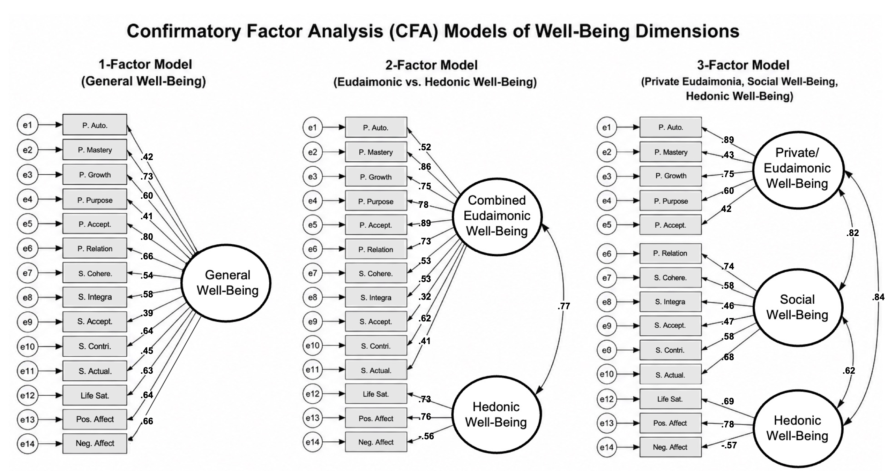

SI-6-3. Comparison of different models of subjective well-being.

Model | Scaled χ² (df) | Robust  CFI | Robust  TLI | Robust RMSEA  [90% CI] | SRMR | AIC | BIC | Δχ² (Δdf) | p
1-factor | 252.5 (77) | .82 | .79 | .11 [.09, .12] | .08 | 13106.45 | 13200.57 | — | —
2-factor | 207.7 (76) | .87 | .84 | .09 [.08, .11] | .07 | 13059.35 | 13156.83 | 34.1 (1) | <.001
3-factor | 169.4 (75) | .90 | .89 | .07 [.06, .08] | .06 | 13021.03 | 13125.23 | 31.1 (1) | <.001
Note. χ² = chi-square; df = degrees of freedom; CFI = comparative fit index; TLI = Tucker–Lewis index; RMSEA = root mean square error of approximation; CI = confidence interval; SRMR = standardized root mean square residual; AIC = Akaike information criterion; BIC = Bayesian information criterion. Lower AIC and BIC values indicate better relative fit. Δχ² values reflect Satorra–Bentler scaled chi-square difference tests comparing each model with the immediately preceding, more constrained model. Boldface indicates the best-fitting model.

Overall, the three-factor model showed an acceptable absolute fit, the highest among the candidates (robust CFI = .90; robust TLI = .89; robust RMSEA = .07, 90% CI: .06, .08, SRMR = .06). Similarly, the three-factor model showed the best relative fit, with the lowest information criteria (AIC = 13021.03; BIC = 13125.23) and improvements on all four fit indices relative to both simpler models. Satorra–Bentler scaled χ² difference tests confirmed that the three-factor model fit better than the two-factor model (Δχ² (1) = 31.12, p < .001), which in turn fit better than the one-factor model (Δχ² (1) = 34.10, p < .001).

Together, these results indicated that the three-factor specification provided the best fit among the prespecified candidate models. It should be noted that the absolute fit indices did not uniformly meet the conventional threshold for a good fit (e.g., CFI and TLI ≥ .95, RMSEA ≤ .06, and SRMR ≤ .08)²². These thresholds, however, are not generally regarded as rigid criteria for model acceptance^{23,24}. Instead, model evaluation is encouraged to incorporate multiple fit indices, alignment with theory, and relative fit ²³. Given the three-factor model's consistent advantage across approximate fit indices, information criteria, and nested-model comparisons, together with its correspondence to the a priori structure proposed by Gallagher et al. (2009)²⁵, the three-factor solution was retained for subsequent analyses.

SI-7. Data-driven variable selection using bootstrapped elastic net regression
To complement the theory-driven hierarchical regression models, we conducted elastic net regression with bootstrap variable selection²⁶. Whereas hierarchical regression evaluates prespecified predictors within an ordered covariate structure, elastic net regression evaluates all candidate predictors simultaneously while shrinking weak or redundant coefficients toward zero. This analysis serves as a robustness check to assess whether each well-being dimension retains predictive information when competing with other predictors in a data-driven framework.
SI-7-1. Procedures
Models were estimated using the “glmnet” package in R²⁷. All three well-being dimensions and covariates from the fully adjusted model (Model 3) were entered simultaneously as predictors of DunedinPACNI. Categorical predictors were dummy-coded, and all continuous variables were standardized before model fitting. The elastic net mixing parameter α was selected using 5-fold cross-validation across values from .10 to 1.00, with mean squared error as the optimization criterion. The optimal value was α = 1.00, corresponding to a lasso-penalized model²⁶. The regularization parameter (λ) was selected using the one-standard-error criterion (λ_{1SE}) favoring a more parsimonious solution. Selection stability was assessed across 10,000 bootstrap iterations. In each iteration, participants were sampled with replacement, and the model was refitted using the selected α. Five-fold cross-validation was performed within each bootstrap sample to re-estimate λ_{1SE}. A predictor was considered selected when its penalized coefficient was nonzero. Selection probability was defined as the proportion of bootstrap iterations in which each predictor was retained, with probabilities of .75 or greater indicating stable selection²⁸. The result of variable selection is visualized below and described in the main text.
SI-7-2. Variable selection results
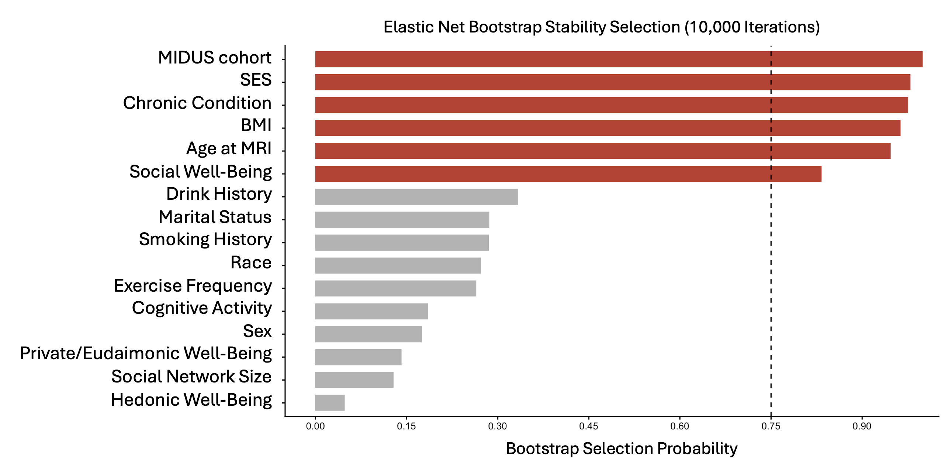
Note. Selection probability represents the proportion of bootstrap samples in which a predictor received a nonzero coefficient. The dashed vertical line indicates the prespecified 75% stability-selection threshold. Predictors meeting or exceeding this threshold are shown in red. Socioeconomic status (SES), chronic conditions, body mass index (BMI), MIDUS cohort, age at MRI, and social well-being exceeded the 75% threshold. Among the three well-being dimensions, social well-being was the only predictor to meet the stability-selection criterion.

SI-8. Results of the regression diagnostics
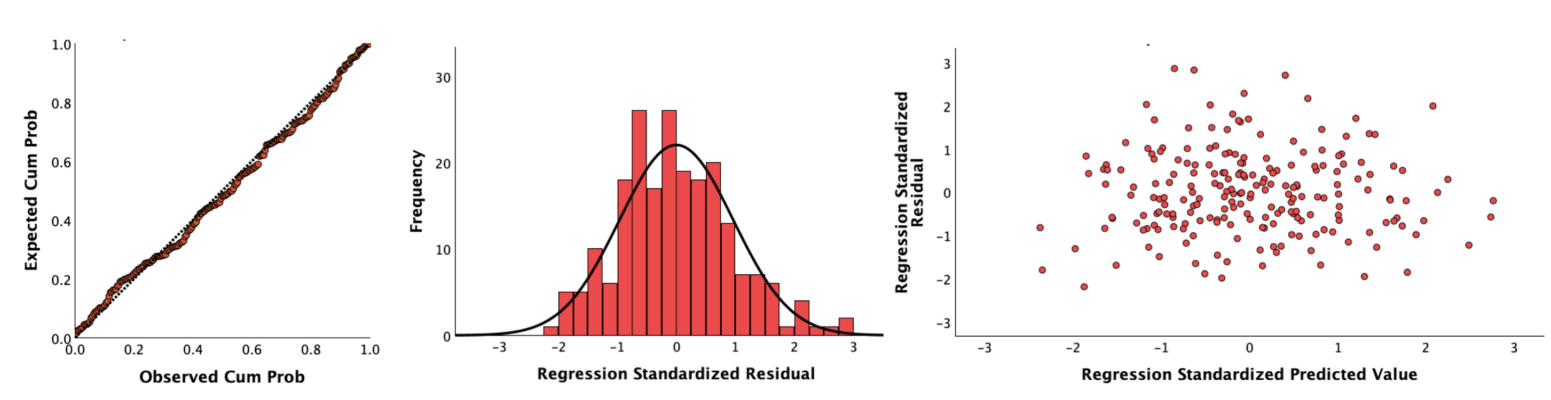
Assumptions underlying the hierarchical linear regression analysis were evaluated across all models. Diagnostic plots for the fully adjusted model are shown above. The normal P–P plot showed close correspondence between observed and expected cumulative probabilities (left), standardized residuals were approximately normally distributed (middle), and residuals plotted against predicted values showed no systematic pattern (right), providing no evidence of meaningful violations of normality, linearity, or homoscedasticity.

We also found no evidence of problematic collinearity (VIF = 1.10-2.57 and tolerance = .389-.913) and influential cases (Cook’s D: mean = .005, max = .049). In a sensitivity analysis that excluded 14 observations exceeding a more conservative threshold (4/[N-k-1] = 0.02), the main findings were unchanged (See “Results”), with social well-being remaining a significant negative predictor of DunedinPACNI across all hierarchical regression models (all Ps < .014).

SI-9. Hierarchical regression model summary and ANOVA table per well-being dimension
Well-being dimension | Model | R² | Adjusted R² | F | df | p | ΔR² | ΔF | Δp
Social well-being | 1 | .322 | .303 | 16.337 | 6, 206 | <.001 | .322 | 16.337 | <.001
 | 2 | .392 | .356 | 10.763 | 12, 200 | <.001 | .070 | 3.838 | .001
 | 3 | .397 | .354 | 9.293 | 14, 198 | <.001 | .004 | .678 | .509
Private/Eudaimonic well-being | 1 | .311 | .291 | 15.473 | 6, 206 | <.001 | .311 | 15.473 | <.001
 | 2 | .383 | .346 | 10.327 | 12, 200 | <.001 | .072 | 3.882 | .001
 | 3 | .387 | .343 | 8.912 | 14, 198 | <.001 | .004 | .643 | .527
Hedonic well-being | 1 | .300 | .280 | 14.747 | 6, 206 | <.001 | .300 | 14.747 | <.001
 | 2 | .373 | .335 | 9.904 | 12, 200 | <.001 | .072 | 3.841 | .001
 | 3 | .378 | .334 | 8.578 | 14, 198 | <.001 | .005 | .760 | .469
Note. N = 213. DV = DunedinPACNI. Model 1 included one of the three well-being dimensions with race, sex, socioeconomic status, age at MRI, and MIDUS cohort. Model 2 additionally included body mass index, chronic conditions, smoking, drinking, exercise frequency, and cognitive activities. Model 3 additionally included social network size and marital/co-residency status. ΔR² and ΔF indicate the incremental variance explained by each block relative to the preceding model.

SI-10. Full outputs from the hierarchical regression analyses testing the associations between well-being dimensions and DunedinPACNI
SI-10-1. Social Well-Being

Model | Variable | B | SE | β | t | sr | p
Model 1 | Constant | −2.161 | .403 | — | −5.368 | — | <.001
 | Race | −.091 | .105 | −.054 | −.859 | −.049 | .391
 | MIDUS cohort | .803 | .110 | .576 | 7.318 | .420 | <.001
 | Age at MRI | .028 | .004 | .554 | 7.114 | .408 | <.001
 | Sex | .043 | .083 | .030 | .510 | .029 | .611
 | SES | −.071 | .025 | −.173 | −2.805 | −.161 | .006
 | Social well-being | −.161 | .047 | −.213 | −3.436 | −.197 | <.001
Model 2 | Constant | −2.717 | .479 | — | −5.676 | — | <.001
 | Race | −.062 | .102 | −.037 | −.608 | −.034 | .544
 | MIDUS cohort | .817 | .108 | .586 | 7.566 | .417 | <.001
 | Age at MRI | .025 | .005 | .488 | 5.553 | .306 | <.001
 | Sex | −.008 | .083 | −.006 | −.100 | −.005 | .921
 | SES | −.078 | .025 | −.190 | −3.156 | −.174 | .002
 | Social well-being | −.140 | .049 | −.185 | −2.864 | −.158 | .005
 | Body mass index | .020 | .008 | .160 | 2.612 | .144 | .010
 | Chronic conditions | .048 | .018 | .175 | 2.711 | .149 | .007
 | History of drinking | .002 | .004 | .026 | .442 | .024 | .659
 | History of smoking | −.006 | .003 | −.108 | −1.808 | −.100 | .072
 | Exercise frequency | −.005 | .009 | −.032 | −.542 | −.030 | .588
 | Cognitive activities | .007 | .009 | .046 | .767 | .042 | .444
Model 3 | Constant | −2.886 | .504 | — | −5.722 | — | <.001
 | Race | −.028 | .107 | −.017 | −.264 | −.015 | .792
 | MIDUS cohort | .821 | .108 | .590 | 7.579 | .418 | <.001
 | Age at MRI | .026 | .005 | .497 | 5.614 | .310 | <.001
 | Sex | −.018 | .084 | −.013 | −.213 | −.012 | .832
 | SES | −.084 | .025 | −.205 | −3.307 | −.183 | .001
 | Social well-being | −.133 | .050 | −.176 | −2.688 | −.148 | .008
 | Body mass index | .021 | .008 | .170 | 2.745 | .152 | .007
 | Chronic conditions | .045 | .018 | .164 | 2.513 | .139 | .013
 | History of drinking | .002 | .004 | .027 | .457 | .025 | .648
 | History of smoking | −.007 | .003 | −.123 | −2.006 | −.111 | .046
 | Exercise frequency | −.005 | .009 | −.031 | −.519 | −.029 | .604
 | Cognitive activities | .007 | .009 | .045 | .742 | .041 | .459
 | Marital/co-residency status | .099 | .092 | .065 | 1.072 | .059 | .285
 | Social network size | −.001 | .003 | −.025 | −.429 | −.024 | .668
N = 213. DV = DunedinPACNI. SES = Socio-economic status; sr = semi-partial correlations.

SI-10-2. Private/Eudaimonic Well-Being

Model | Variable | B | SE | β | t | sr | p
Model 1 | Constant | −2.119 | .406 | — | −5.225 | — | <.001
 | Race | −.092 | .107 | −.054 | −.857 | −.050 | .392
 | MIDUS cohort | .797 | .111 | .572 | 7.199 | .416 | <.001
 | Age at MRI | .028 | .004 | .545 | 6.941 | .402 | <.001
 | Sex | .038 | .084 | .027 | .455 | .026 | .650
 | SES | −.077 | .025 | −.187 | −3.030 | −.175 | .003
 | Private/Eudaimonic well-being | −.132 | .047 | −.178 | −2.845 | −.165 | .005
Model 2 | Constant | −2.680 | .483 | — | −5.547 | — | <.001
 | Race | −.057 | .104 | −.034 | −.553 | −.031 | .581
 | MIDUS cohort | .808 | .109 | .580 | 7.428 | .413 | <.001
 | Age at MRI | .024 | .005 | .473 | 5.343 | .297 | <.001
 | Sex | −.013 | .084 | −.009 | −.150 | −.008 | .881
 | SES | −.082 | .025 | −.200 | −3.304 | −.184 | .001
 | Private/Eudaimonic well-being | −.105 | .047 | −.141 | −2.211 | −.123 | .028
 | Body mass index | .022 | .007 | .177 | 2.905 | .161 | .004
 | Chronic conditions | .046 | .018 | .167 | 2.563 | .142 | .011
 | Years of drinking | .002 | .004 | .034 | .570 | .032 | .569
 | Years of smoking | −.006 | .003 | −.103 | −1.713 | −.095 | .088
 | Exercise frequency | −.004 | .009 | −.029 | −.485 | −.027 | .628
 | Cognitive activities | .004 | .009 | .027 | .457 | .025 | .648
Model 3 | Constant | −2.838 | .508 | — | −5.585 | — | <.001
 | Race | −.023 | .109 | −.014 | −.214 | −.012 | .830
 | MIDUS cohort | .813 | .109 | .584 | 7.445 | .414 | <.001
 | Age at MRI | .025 | .005 | .481 | 5.399 | .301 | <.001
 | Sex | −.023 | .085 | −.016 | −.266 | −.015 | .790
 | SES | −.089 | .026 | −.216 | −3.454 | −.192 | <.001
 | Private/Eudaimonic well-being | −.096 | .048 | −.129 | −1.973 | −.110 | .055
 | Body mass index | .023 | .008 | .187 | 3.025 | .168 | .003
 | Chronic conditions | .043 | .018 | .158 | 2.389 | .133 | .018
 | Years of drinking | .002 | .004 | .035 | .578 | .032 | .564
 | Years of smoking | −.007 | .003 | −.117 | −1.903 | −.106 | .058
 | Exercise frequency | −.004 | .009 | −.029 | −.473 | −.026 | .637
 | Cognitive activities | .004 | .009 | .027 | .439 | .024 | .661
 | Marital/co-residency status | .095 | .093 | .062 | 1.019 | .057 | .309
 | Social network size | −.002 | .004 | −.028 | −.481 | −.027 | .631
N = 213. DV = DunedinPACNI. SES = Socio-economic status; sr = semi-partial correlations.

SI-10-3. Hedonic Well-Being

Model | Variable | B | SE | β | t | sr | p
Model 1 | Constant | −2.084 | .408 | — | −5.105 | — | <.001
 | Race | −.078 | .107 | −.046 | −.727 | −.042 | .468
 | SES | −.082 | .025 | −.199 | −3.225 | −.188 | .001
 | Age at MRI | .027 | .004 | .535 | 6.773 | .395 | <.001
 | Sex | .027 | .085 | .019 | .321 | .019 | .749
 | MIDUS cohort | .797 | .112 | .573 | 7.146 | .416 | <.001
 | Hedonic well-being | −.108 | .048 | −.140 | −2.230 | −.130 | .027
Model 2 | Constant | −2.600 | .486 | — | −5.353 | — | <.001
 | Race | −.039 | .104 | −.023 | −.372 | −.021 | .711
 | SES | −.086 | .025 | −.210 | −3.451 | −.193 | <.001
 | Age at MRI | .023 | .005 | .454 | 5.078 | .284 | <.001
 | Sex | −.023 | .085 | −.017 | −.276 | −.015 | .782
 | MIDUS cohort | .806 | .110 | .579 | 7.353 | .412 | <.001
 | Hedonic well-being | −.063 | .049 | −.082 | −1.297 | −.073 | .196
 | Body mass index | .023 | .008 | .184 | 2.993 | .168 | .003
 | Chronic conditions | .046 | .018 | .165 | 2.484 | .139 | .014
 | Years of drinking | .002 | .004 | .035 | .576 | .032 | .565
 | Years of smoking | −.005 | .003 | −.097 | −1.607 | −.090 | .110
 | Exercise frequency | −.005 | .009 | −.034 | −.550 | −.031 | .583
 | Cognitive activities | .001 | .009 | .008 | .128 | .007 | .898
Model 3 | Constant | −2.799 | .513 | — | −5.454 | — | <.001
 | Race | −.002 | .110 | −.001 | −.017 | −.001 | .986
 | SES | −.094 | .026 | −.229 | −3.632 | −.204 | <.001
 | Age at MRI | .024 | .005 | .462 | 5.140 | .288 | <.001
 | Sex | −.035 | .086 | −.025 | −.408 | −.023 | .684
 | MIDUS cohort | .813 | .110 | .584 | 7.386 | .414 | <.001
 | Hedonic well-being | −.049 | .050 | −.064 | −.983 | −.055 | .327
 | Body mass index | .024 | .008 | .194 | 3.123 | .175 | .002
 | Chronic conditions | .043 | .018 | .157 | 2.338 | .131 | .020
 | Years of drinking | .002 | .004 | .035 | .583 | .033 | .561
 | Years of smoking | −.006 | .003 | −.113 | −1.816 | −.102 | .071
 | Exercise frequency | −.005 | .009 | −.033 | −.547 | −.031 | .585
 | Cognitive activities | .001 | .009 | .008 | .138 | .008 | .890
 | Marital/co-residency status | .101 | .095 | .066 | 1.070 | .060 | .286
 | Social network size | −.025 | .041 | −.036 | −.607 | −.034 | .545
N = 213. DV = DunedinPACNI. SES = Socio-economic status; sr = semi-partial correlations.

SI-11. Bootstrap confidence intervals (CIs) calculated for social, private/eudaimonic, and hedonic well-being (Model 3).

SI-11-1. Social Well-Being

Predictor | B | BCa 99% CI Lower | BCa 99% CI Upper
Constant | −.676 | −1.458 | .168
Race | −.028 | −.358 | .282
Sex | −.018 | −.220 | .172
MIDUS cohort | .821 | .537 | 1.104
Age at MRI | .346 | .184 | .516
SES | −.143 | −.249 | −.032
Social well-being | −.133 | −.259 | −.028
Chronic conditions | .114 | −.023 | .246
BMI | .119 | .014 | .222
History of smoking | −.086 | −.200 | .030
History of drinking | .019 | −.104 | .122
Cognitive activities | .032 | −.076 | .142
Exercise frequency | −.022 | −.123 | .079
Marital/co-residency status | .099 | −.146 | .347
Social network size | −.017 | −.110 | .096
N = 213. DV = DunedinPACNI. SES = Socio-economic status; BMI = Body mass index. BCa = Bias-corrected and accelerated

SI-11-2. Private/Eudaimonic Well-Being
Predictor | B | BCa 99% CI Lower | BCa 99% CI Upper
Constant | −.656 | −1.486 | .196
Race | −.023 | −.366 | .294
Sex | −.023 | −.243 | .186
MIDUS cohort | .813 | .508 | 1.124
Age at MRI | .335 | .163 | .520
SES | −.151 | −.257 | −.043
Private/Eudaimonic well-being | −.096 | −.214 | .017
Chronic conditions | .110 | −.024 | .238
BMI | .130 | .028 | .237
History of smoking | −.082 | −.196 | .039
History of drinking | .024 | −.102 | .130
Cognitive activities | .019 | −.091 | .129
Exercise frequency | −.020 | −.122 | .079
Marital/co-residency status | .095 | −.144 | .342
Social network size | −.020 | −.120 | .097

SI-11-3. Hedonic Well-Being

Predictor | B | BCa 99% CI Lower | BCa 99% CI Upper
Constant | −.662 | −1.479 | .156
Race | −.002 | −.334 | .307
Sex | −.035 | −.255 | .171
MIDUS cohort | .813 | .503 | 1.122
Age at MRI | .322 | .154 | .504
SES | −.160 | −.262 | −.052
Hedonic well-being | −.049 | −.167 | .070
Chronic conditions | .109 | −.027 | .241
BMI | .135 | .037 | .237
History of smoking | −.079 | −.191 | .045
History of drinking | .025 | −.110 | .132
Cognitive activities | .006 | −.110 | .114
Exercise frequency | −.023 | −.127 | .081
Marital/co-residency status | .101 | −.140 | .347
Social network size | −.025 | −.122 | .081

SI-12. Indirect association between community volunteering and DunedinPACNI through social well-being.

In an exploratory mediation model, greater monthly hours of community volunteering were indirectly associated with lower DunedinPACNI scores via higher social well-being. The indirect effect is reported with its 99% bootstrap confidence interval (10,000 resamples) and standardized path coefficients. *p < .05; ***p < .001.

SI-13. Exploratory mediation analysis of volunteering participation (binarized volunteering hours), social well-being, and DunedinPACNI

We repeated the mediation model using a binary indicator of volunteering participation (0 = no volunteering, 1 = any volunteering) to account for the large proportion of participants reporting zero monthly volunteering hours (SI-13-1). 125 (58.7%) of 213 participants reported spending non-zero hours for community volunteering. The mediation model retained the same specification and covariates as the original mediation analysis. We found that the indirect association between volunteering participation and lower DunedinPACNI through social well-being remained significant (SI-13-2).

SI-13-1. Distribution of raw and log-transformed volunteering hours

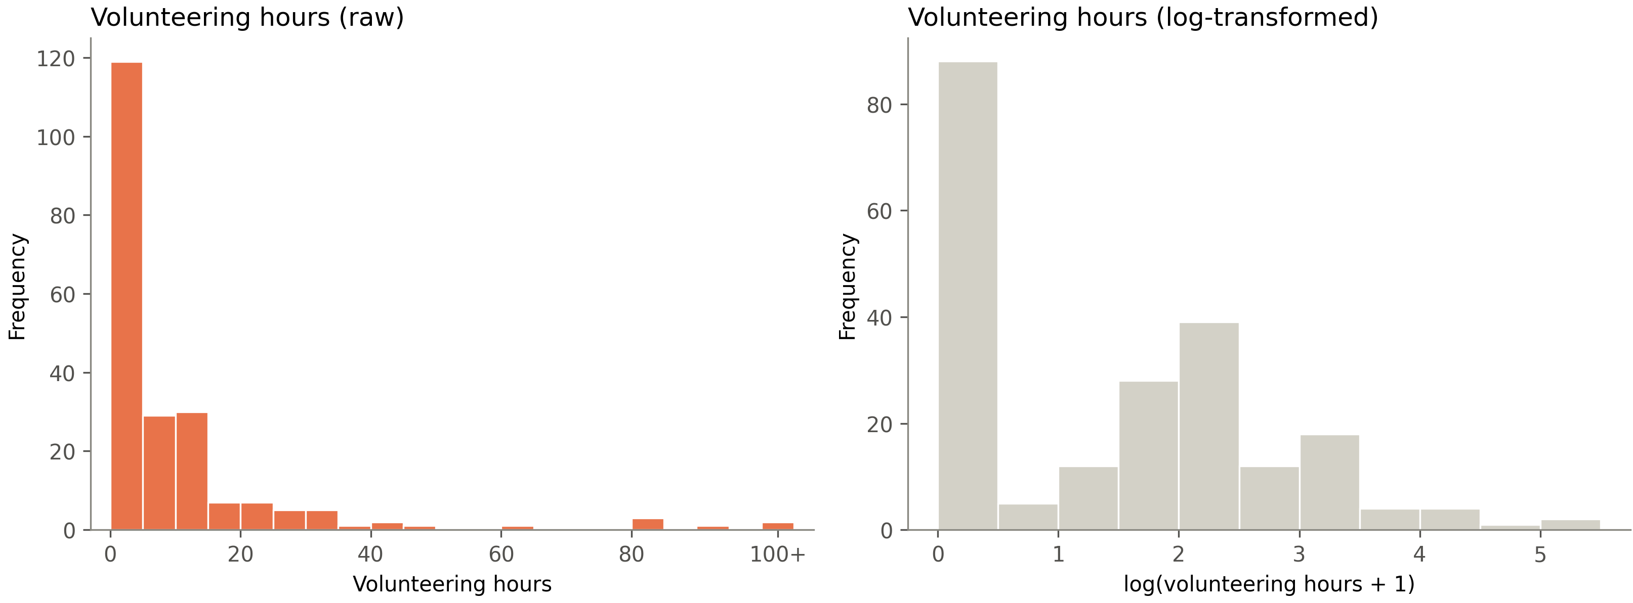

SI-13-2. Indirect effect linking community volunteering participation, social well-being, and DunedinPACNI.

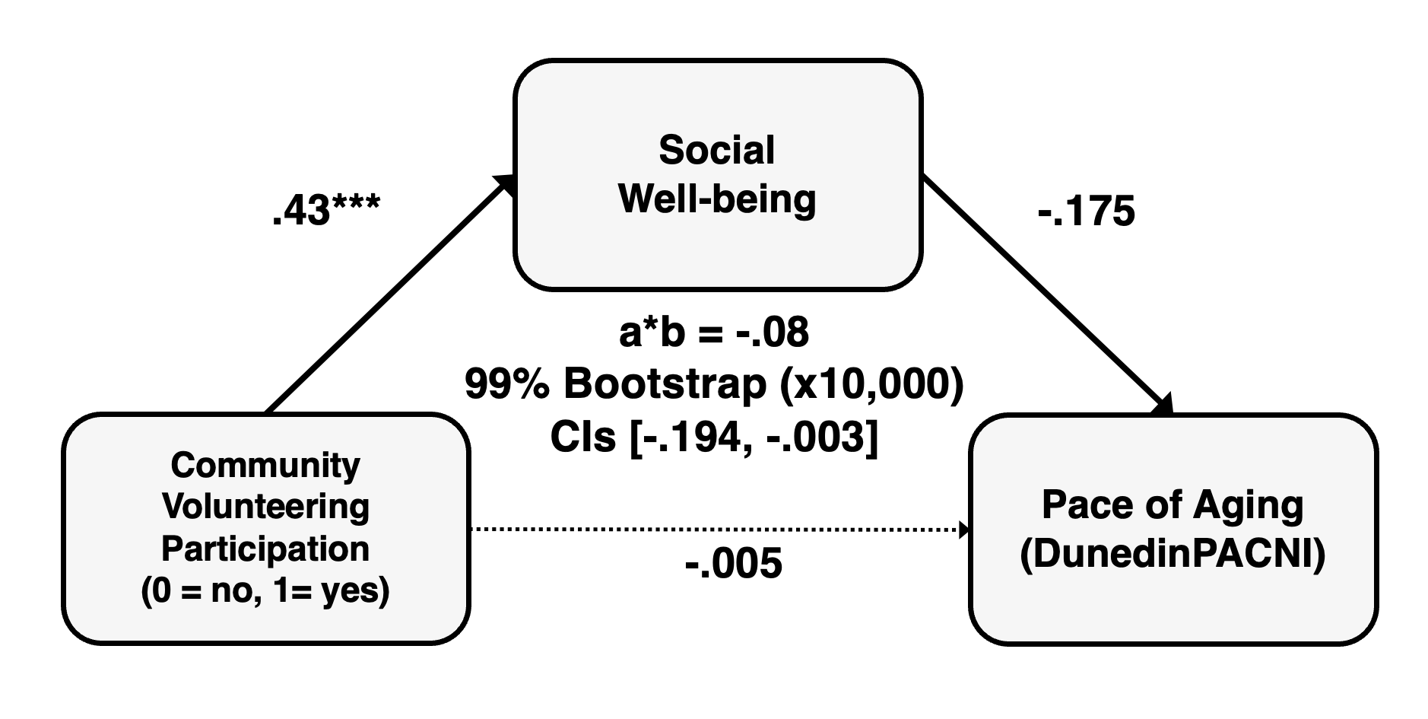

SI-14. Alternative path models linking community volunteering, well-being dimensions, and DunedinPACNI (based on the best-fitting 3-factor model of well-being)

We estimated three alternative path models using factor scores derived from the best-fitting three-factor model. All models included the same covariates as the primary mediation analysis. The alternative models tested private/eudaimonic and hedonic well-being as mediators and reversed the ordering of volunteering and social well-being. The indirect associations from these analyses were not significant, with all the CIs crossing zero.

SI-14-1. Private/Eudaimonic well-being as a mediator

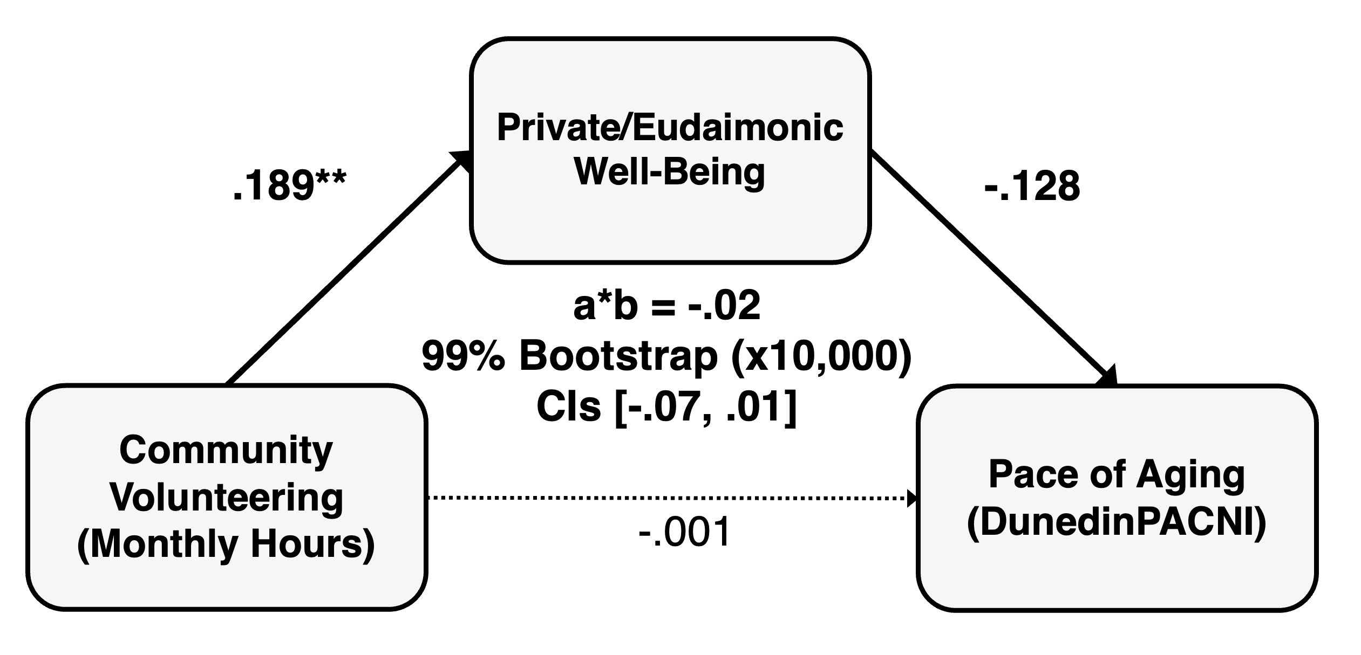
SI-14-2. Hedonic well-being as a mediator

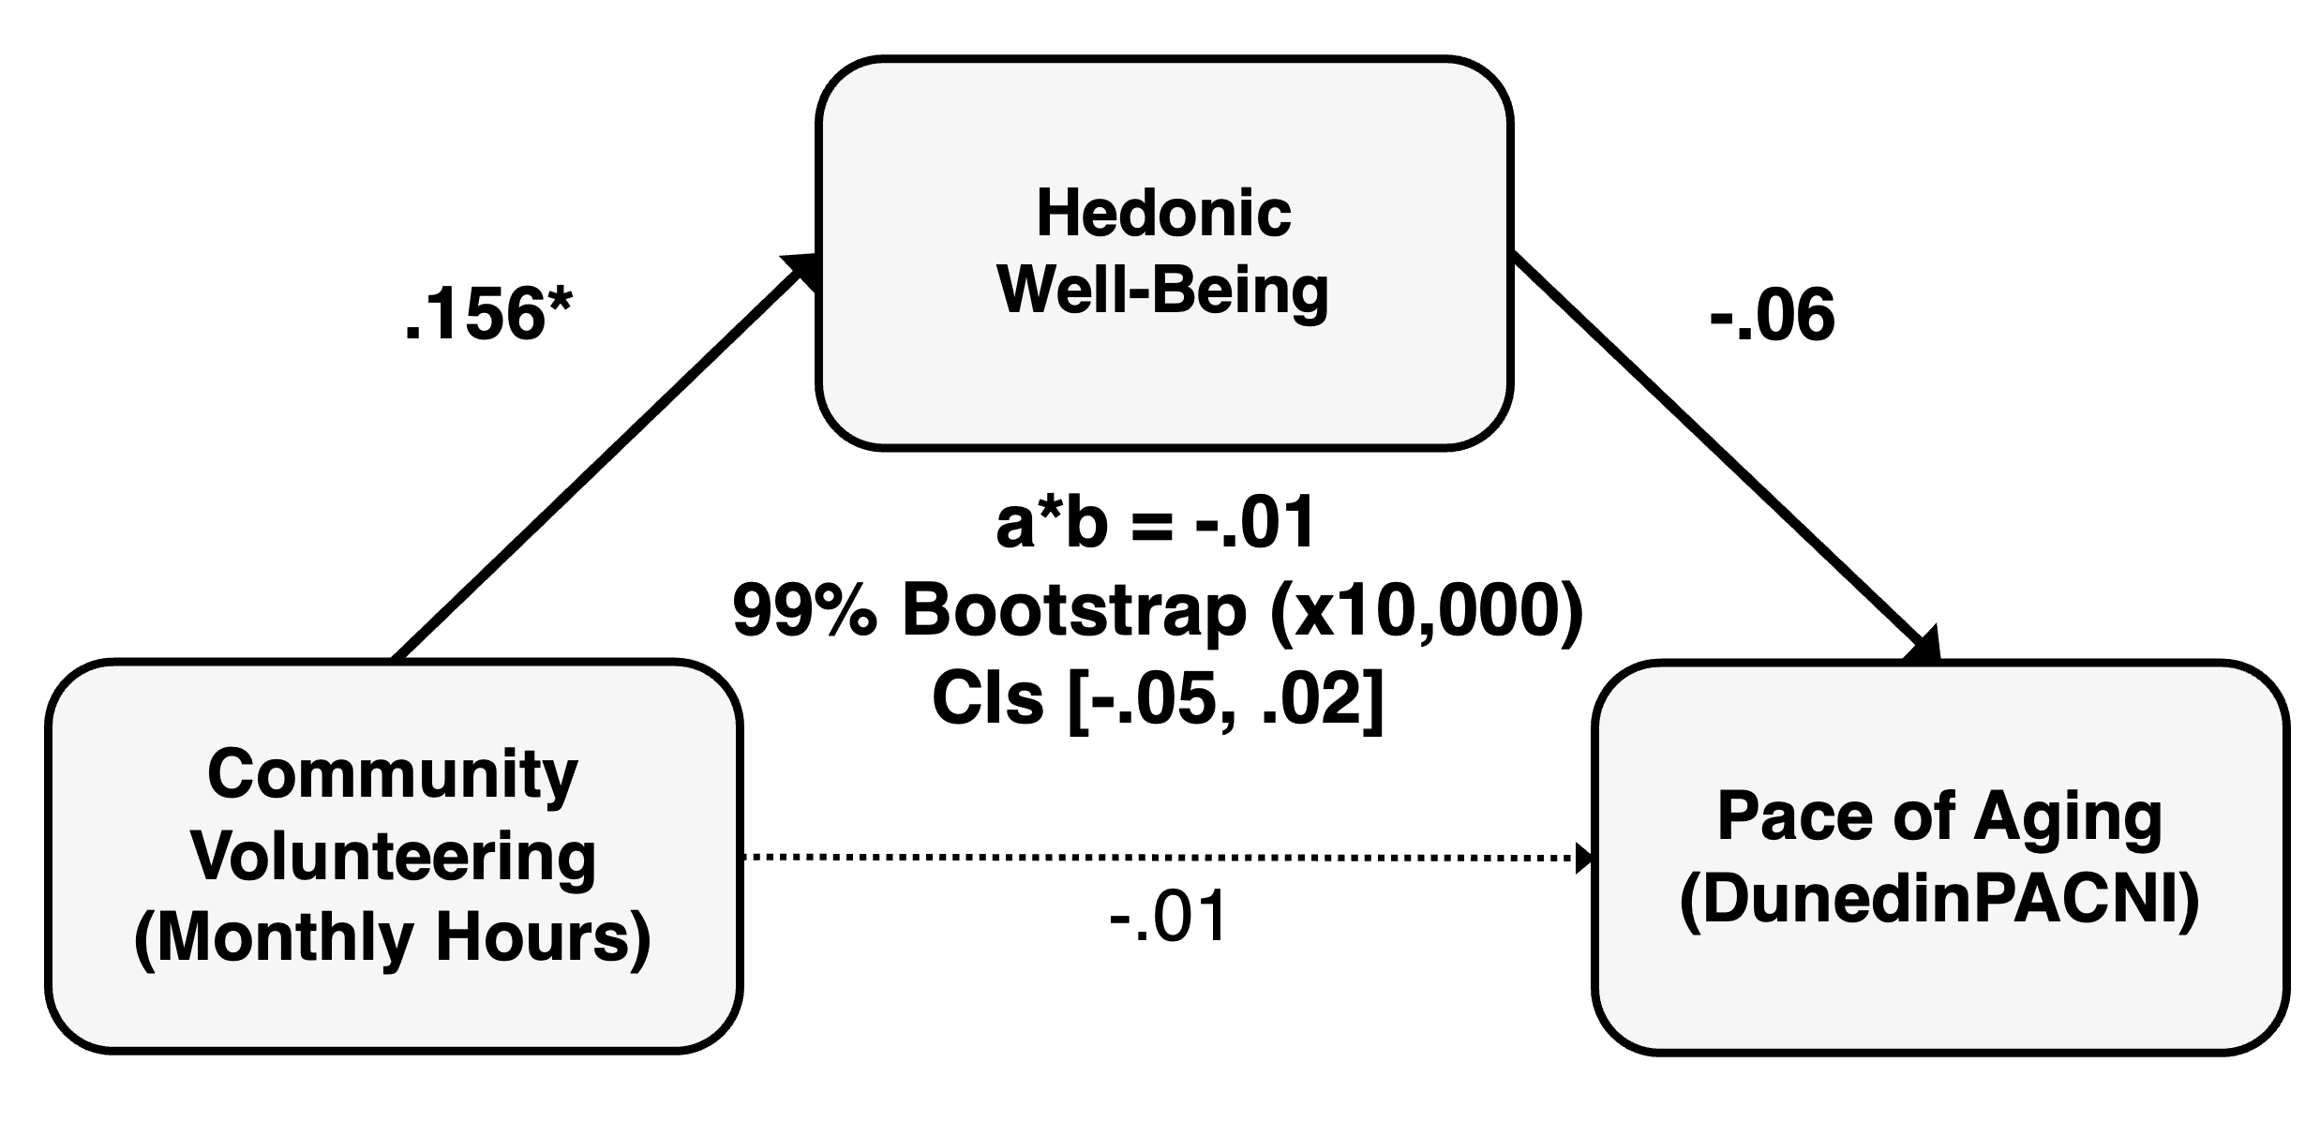

SI-14-3. Social well-being as a predictor

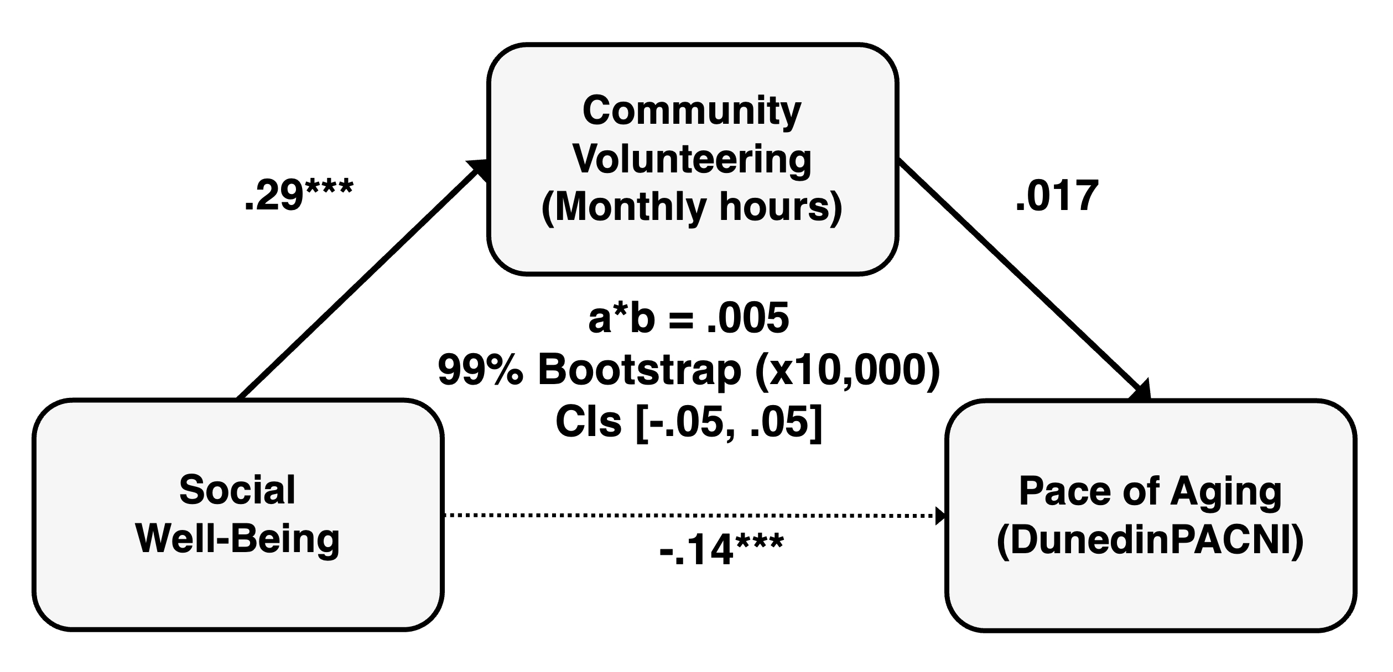

SI-15. Mediation analyses based on the 1-factor and 2-factor solutions of subjective well-being.

To examine whether the indirect association between community volunteering and DunedinPACNI depended on the level of differentiation used to characterize subjective well-being, we repeated the exploratory mediation analyses using factor scores derived from the alternative one- and two-factor CFA solutions. In the one-factor model, we tested general well-being as the mediator. In the two-factor model, we examined broader eudaimonic well-being and hedonic well-being separately as mediators. All models followed the same specification as the primary mediation analysis, with log-transformed monthly volunteering hours as the predictor, DunedinPACNI as the outcome, and the same covariates included in the primary analyses.

No significant indirect association between volunteering and DunedinPACNI emerged through general well-being in the one-factor model (SI-15-1) or via well-being dimensions in the two-factor model (SI-15-2, SI-15-3). In sum, the indirect association observed in the primary analysis was detected only under the three-factor representation, in which social well-being was distinguished from private/eudaimonic and hedonic well-being. These analyses provide additional evidence that the observed behavioral pathway was evident only with the more finely differentiated social dimension of well-being, rather than in broader representations of subjective well-being.

SI-15-1. General well-being as a mediator (1-factor model)

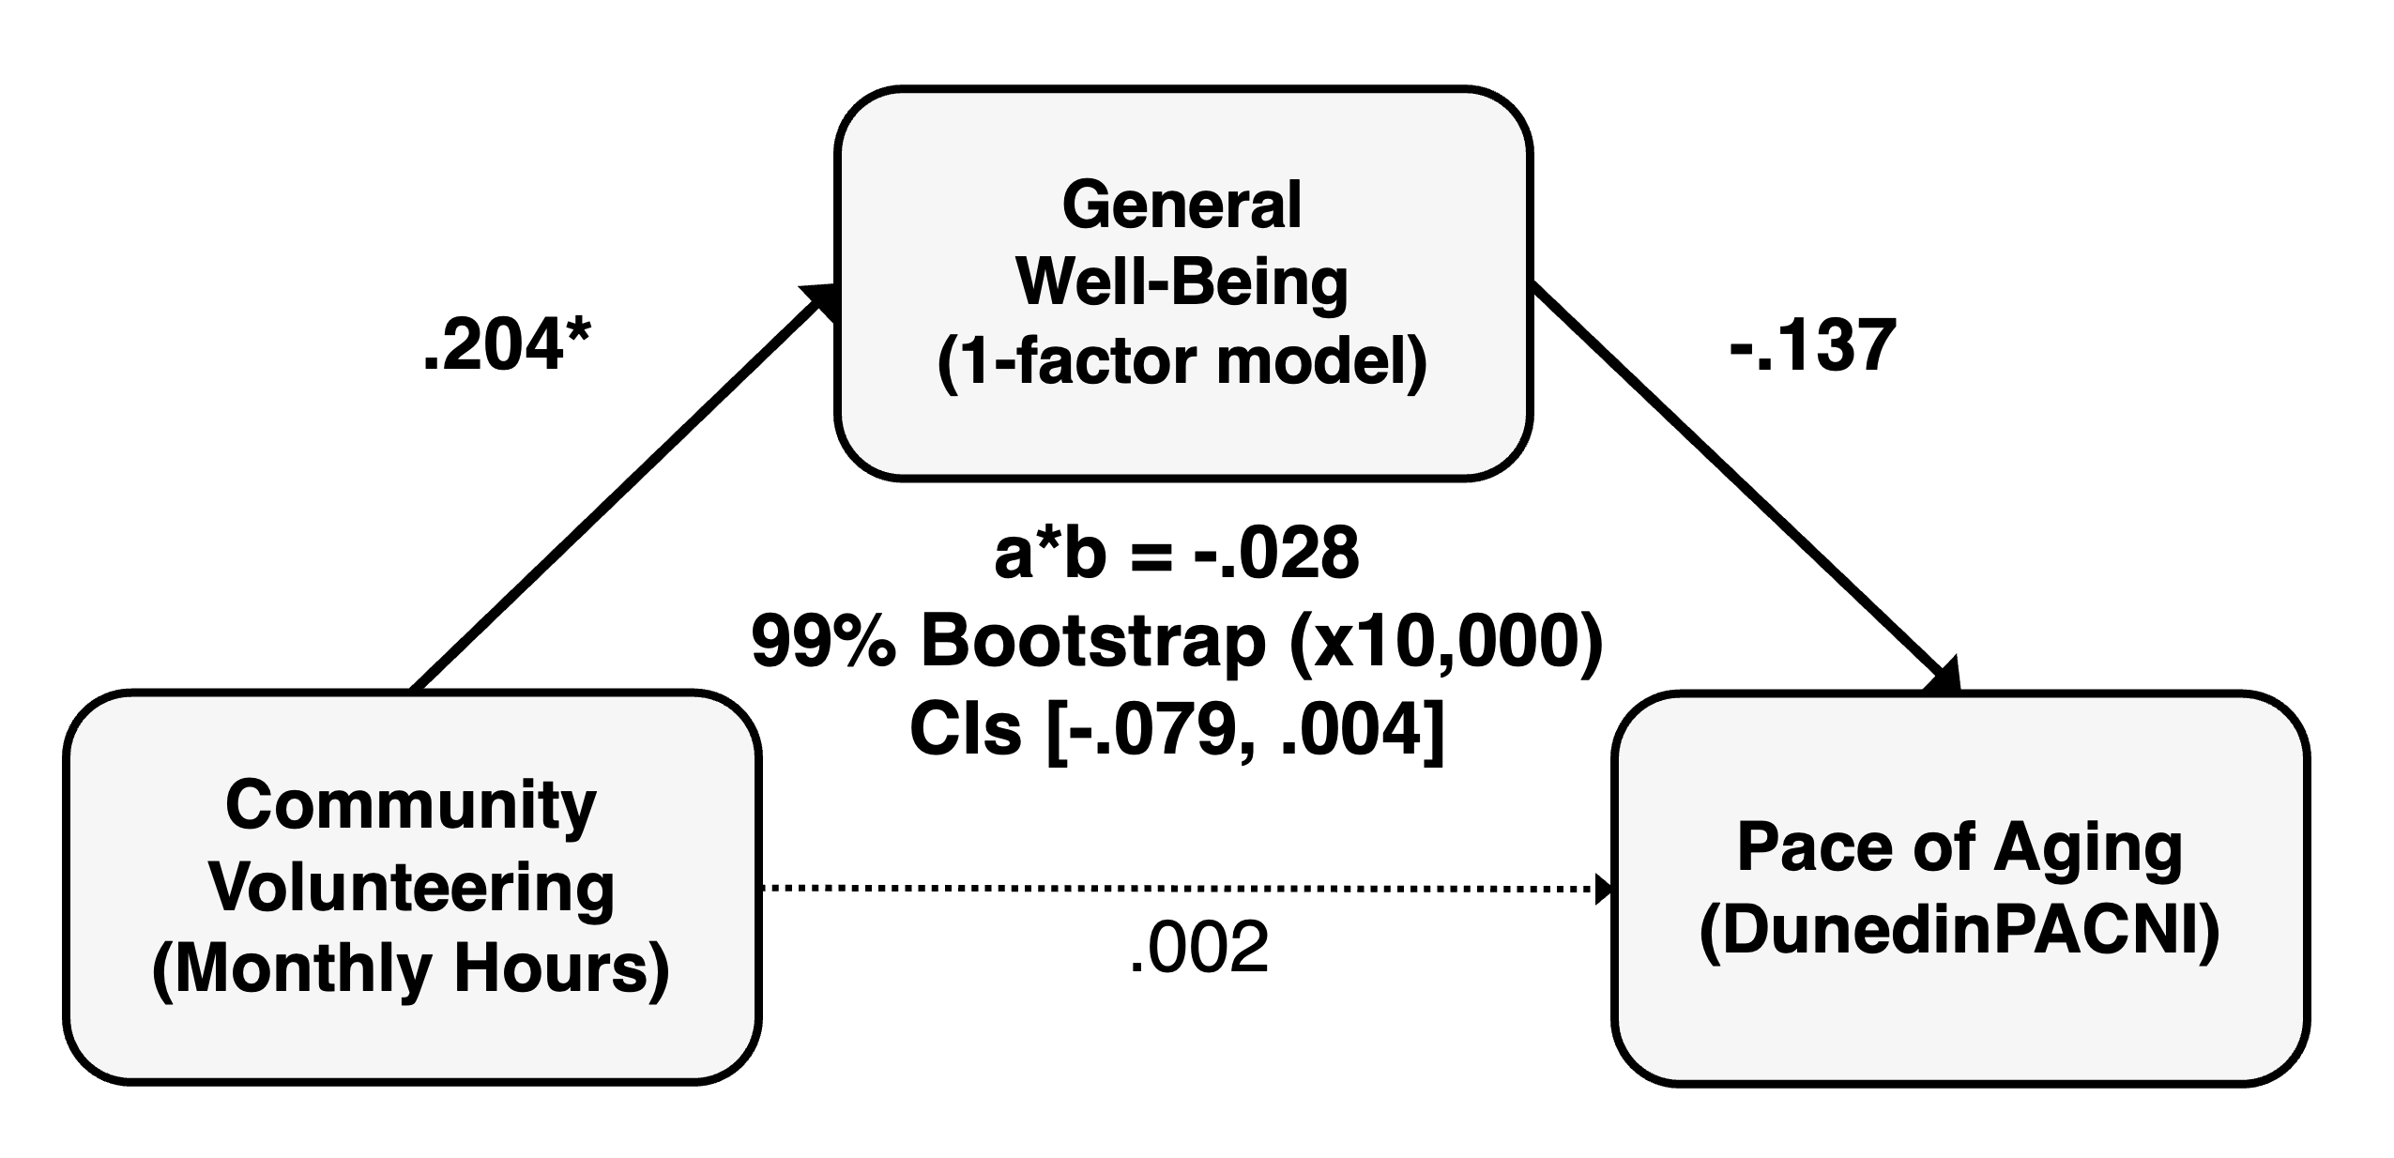

SI-15-2. Combined eudaimonic well-being as a mediator (2-factor model)

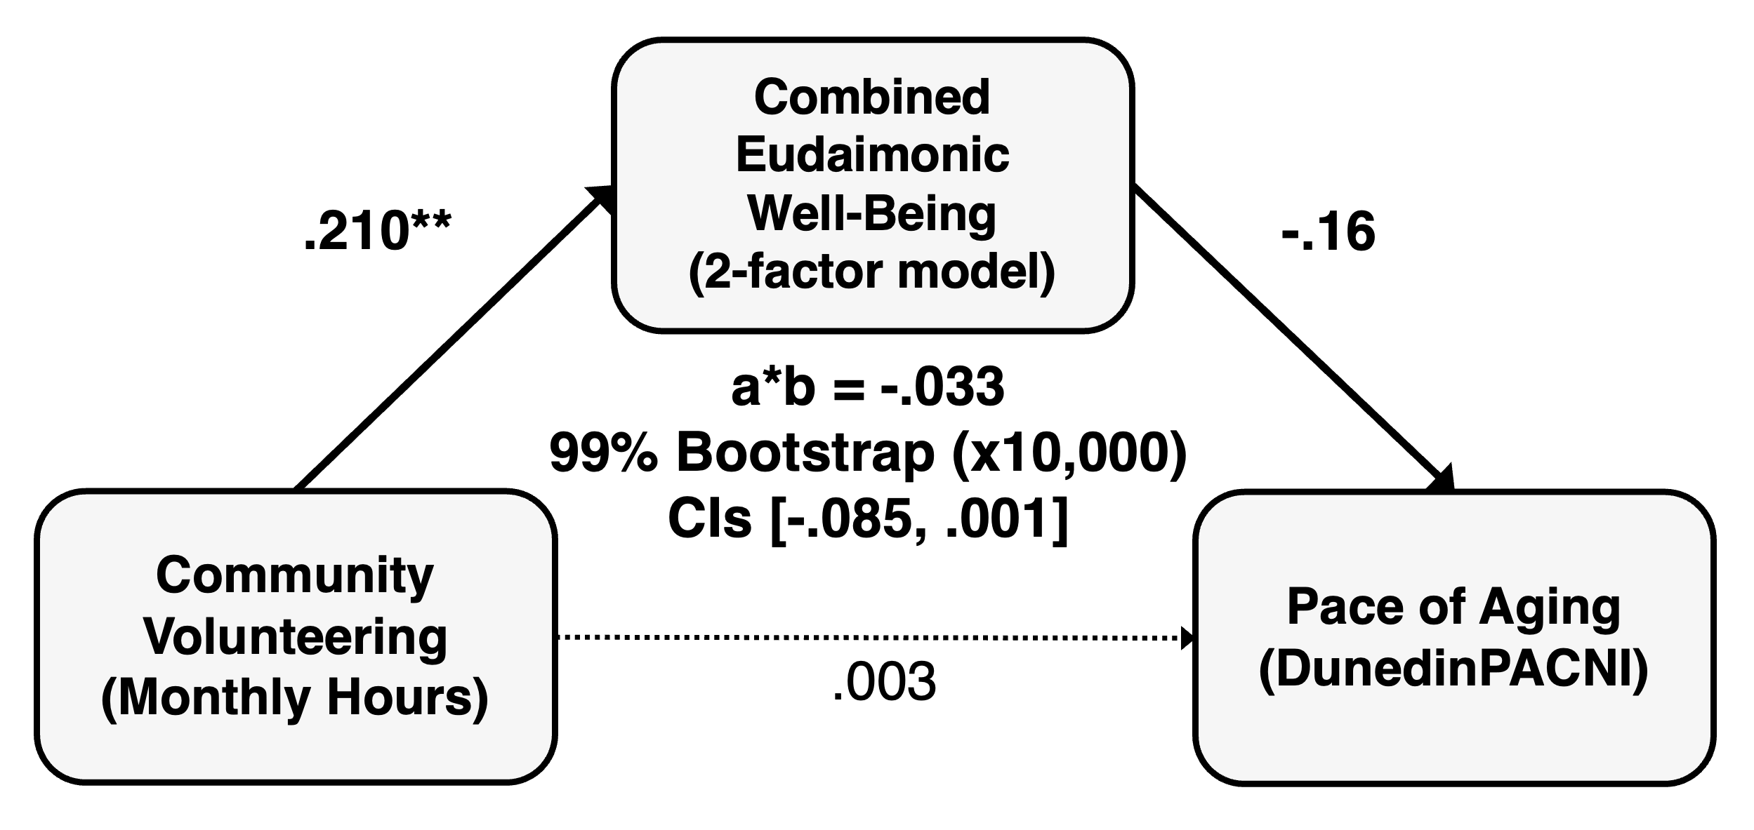

SI-15-3. Hedonic well-being as a mediator (2-factor model)

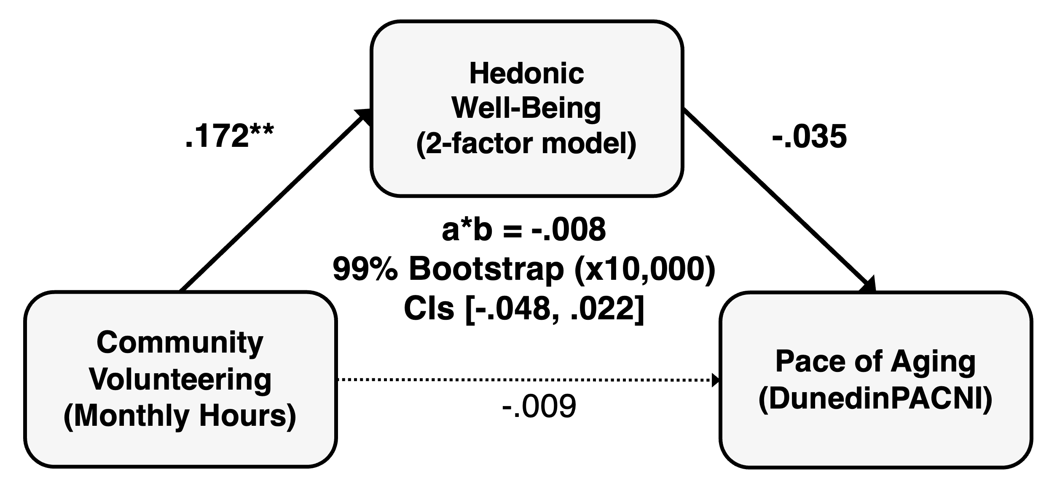

References

1. Su S, Lewis TT, Belsky DW, et al. Impact of psychosocial stress in early life on pace of aging in young adulthood. Clin Epigenetics. 2025;17(1):186. doi:10.1186/s13148-025-02002-y
2. Social relationships and epigenetic markers of aging in middle-aged and older adults: cross-sectional and prospective analyses | The Journals of Gerontology: Series B | Oxford Academic. Accessed August 31, 2026. https://academic.oup.com/psychsocgerontology/article/80/12/gbaf194/8283545
3. Vyas CM, Hazra A, Chang SC, et al. Pilot study of DNA methylation, molecular aging markers and measures of health and well-being in aging. Transl Psychiatry. 2019;9(1):118. doi:10.1038/s41398-019-0446-1
4. Whitman ET, Elliott ML, Knodt AR, et al. DunedinPACNI estimates the longitudinal Pace of Aging from a single brain image to track health and disease. Nat Aging. 2025;5(8):1619-1636. doi:10.1038/s43587-025-00897-z
5. Belsky DW, Caspi A, Corcoran DL, et al. DunedinPACE, a DNA methylation biomarker of the pace of aging. Deelen J, Tyler JK, Suderman M, Deelen J, eds. eLife. 2022;11:e73420. doi:10.7554/eLife.73420
6. Garcia-Segura LM, Azcoitia I, DonCarlos LL. Neuroprotection by estradiol. Prog Neurobiol. 2001;63(1):29-60. doi:10.1016/S0301-0082(00)00025-3
7. Levine DA, Gross AL, Briceño EM, et al. Sex Differences in Cognitive Decline Among US Adults. JAMA Netw Open. 2021;4(2):e210169. doi:10.1001/jamanetworkopen.2021.0169
8. Coffey CE, Lucke JF, Saxton JA, et al. Sex Differences in Brain Aging: A Quantitative Magnetic Resonance Imaging Study. Arch Neurol. 1998;55(2):169-179. doi:10.1001/archneur.55.2.169
9. Brandt EJ. Social determinants of racial health inequities. Lancet Public Health. 2023;8(6):e396-e397. doi:10.1016/S2468-2667(23)00100-7
10. Braveman PA, Cubbin C, Egerter S, Williams DR, Pamuk E. Socioeconomic Disparities in Health in the United States: What the Patterns Tell Us. Am J Public Health. 2010;100(S1):S186-S196. doi:10.2105/AJPH.2009.166082
11. Tan JJX, Kraus MW, Carpenter NC, Adler NE. The association between objective and subjective socioeconomic status and subjective well-being: A meta-analytic review. Psychol Bull. 2020;146(11):970-1020. doi:10.1037/bul0000258
12. Smith JP. Unraveling the SES: Health Connection. Popul Dev Rev. 2004;30:108-132.
13. McMaughan DJ, Oloruntoba O, Smith ML. Socioeconomic Status and Access to Healthcare: Interrelated Drivers for Healthy Aging. Front Public Health. 2020;8. doi:10.3389/fpubh.2020.00231
14. Li J, Wang W, Yang Z, et al. Causal association of obesity with epigenetic aging and telomere length: a bidirectional mendelian randomization study. Lipids Health Dis. 2024;23(1):78. doi:10.1186/s12944-024-02042-y
15. Böckerman P, Johansson E, Saarni SI, Saarni SE. The Negative Association of Obesity with Subjective Well-Being: Is it All About Health? J Happiness Stud. 2014;15(4):857-867. doi:10.1007/s10902-013-9453-8
16. Bosnes I, Nordahl HM, Stordal E, Bosnes O, Myklebust TÅ, Almkvist O. Lifestyle predictors of successful aging: A 20-year prospective HUNT study. PLOS ONE. 2019;14(7):e0219200. doi:10.1371/journal.pone.0219200
17. Loef M, Walach H. The combined effects of healthy lifestyle behaviors on all cause mortality: A systematic review and meta-analysis. Prev Med. 2012;55(3):163-170. doi:10.1016/j.ypmed.2012.06.017
18. Lifestyle Modulators of Neuroplasticity: How Physical Activity, Mental Engagement, and Diet Promote Cognitive Health during Aging - Phillips - 2017 - Neural Plasticity - Wiley Online Library. Accessed August 31, 2026. https://onlinelibrary.wiley.com/doi/full/10.1155/2017/3589271
19. Hogan M. Physical and Cognitive Activity and Exercise for Older Adults: A Review. Int J Aging Hum Dev. 2005;60(2):95-126. doi:10.2190/PTG9-XDVM-YETA-MKXA
20. Holt-Lunstad J, Smith TB, Layton JB. Social Relationships and Mortality Risk: A Meta-analytic Review. PLOS Med. 2010;7(7):e1000316. doi:10.1371/journal.pmed.1000316
21. Rosseel Y. lavaan: An R Package for Structural Equation Modeling. J Stat Softw. 2012;48:1-36. doi:10.18637/jss.v048.i02
22. Hu L, Bentler PM. Cutoff criteria for fit indexes in covariance structure analysis: Conventional criteria versus new alternatives. Struct Equ Model Multidiscip J. 1999;6(1):1-55. doi:10.1080/10705519909540118
23. Marsh HW, Hau KT, Wen Z. In Search of Golden Rules: Comment on Hypothesis-Testing Approaches to Setting Cutoff Values for Fit Indexes and Dangers in Overgeneralizing Hu and Bentler’s (1999) Findings. Struct Equ Model Multidiscip J. 2004;11(3):320-341. doi:10.1207/s15328007sem1103_2
24. Niemand T, Mai R. Flexible cutoff values for fit indices in the evaluation of structural equation models. J Acad Mark Sci. 2018;46(6):1148-1172. doi:10.1007/s11747-018-0602-9
25. The Hierarchical Structure of Well‐Being - Gallagher - 2009 - Journal of Personality - Wiley Online Library. Accessed August 31, 2026. https://onlinelibrary.wiley.com/doi/full/10.1111/j.1467-6494.2009.00573.x
26. Regularization and Variable Selection Via the Elastic Net | Journal of the Royal Statistical Society Series B: Statistical Methodology | Oxford Academic. Accessed August 31, 2026. https://academic.oup.com/jrsssb/article/67/2/301/7109482
27. Hastie T, Qian J, Tay K. An Introduction to glmnet.
28. Stability selection - Meinshausen - 2010 - Journal of the Royal Statistical Society: Series B (Statistical Methodology) - Wiley Online Library. Accessed August 31, 2026. https://rss.onlinelibrary.wiley.com/doi/full/10.1111/j.1467-9868.2010.00740.x

