Table (1): Major oxides (wt.%) and CIPW norms for granitic rocks at G. Nugrus area, SED, Egypt.
Rock type | Syenogranite |  |  |  |  |  |  |  |  | Monzogarnite
Sample No. | N 25 | N 26 | E10 | 6 | 8 | 9 | 10 | N 30 | Aver. | 1 | 3 | 4 | 5 | 7 | 12 | N 27 | N 20 | E16 | Aver.
Major oxides (wt.%)
SiO₂ | 70.7 | 71.8 | 67.89 | 69.64 | 67.58 | 70.34 | 69.20 | 65.69 | 69.11 | 72.43 | 74.77 | 73.27 | 73.63 | 72.65 | 73.33 | 73.85 | 72.83 | 76.2 | 73.81
TiO₂ | 0.26 | 0.15 | 0.11 | 0.26 | 0.48 | 0.3 | 0.26 | 0.49 | 0.29 | 0.41 | 0.32 | 0.22 | 0.18 | 0.27 | 0.27 | 0.24 | 0.24 | 0.11 | 0.23
Al₂O₃ | 14.2 | 13.38 | 14.54 | 13.50 | 14.12 | 14.62 | 14.03 | 14.65 | 14.13 | 13.49 | 13.77 | 13.47 | 13.21 | 13.72 | 13.36 | 13.14 | 13.03 | 12.68 | 13.3
Fe₂O₃ | 2.38 | 2.10 | 3.67 | 2.86 | 4.07 | 2.48 | 3.40 | 5.2 | 3.27 | 2.76 | 1.87 | 1.88 | 1.87 | 2.87 | 1.97 | 2.45 | 2.26 | 1.4 | 2.07
MnO | 0.04 | 0.02 | 0.07 | 0.05 | 0.07 | 0.15 | 0.06 | 0.09 | 0.07 | 0.07 | 0.04 | 0.03 | 0.03 | 0.03 | 0.07 | 0.06 | 0.07 | 0.03 | 0.04
MgO | 0.27 | 0.33 | 0.55 | 0.24 | 0.63 | 1.2 | 0.23 | 0.33 | 0.47 | 0.96 | 0.19 | 0.31 | 0.34 | 0.19 | 0.65 | 0.64 | 0.72 | 0.22 | 0.4
CaO | 0.64 | 0.78 | 1.09 | 2.03 | 2.26 | 1.73 | 2.01 | 2.84 | 1.67 | 1.51 | 0.6 | 0.85 | 0.63 | 0.63 | 1.8 | 1.06 | 1.29 | 0.73 | 0.94
Na₂O | 4.21 | 4.06 | 5.04 | 3.37 | 3.39 | 3.83 | 3.17 | 3.72 | 3.85 | 2.76 | 3.03 | 4.13 | 4.01 | 3.73 | 4.13 | 3.76 | 4.02 | 3.02 | 3.72
K₂O | 6.01 | 6.11 | 5.74 | 6.76 | 6.41 | 4.69 | 6.96 | 6.44 | 6.14 | 5.32 | 4.85 | 5.07 | 5.09 | 4.95 | 3.64 | 3.89 | 3.99 | 4.91 | 4.54
P₂O₅ | 0.09 | 0.04 | 0.06 | 0.08 | 0.17 | 0.07 | 0.07 | 0.15 | 0.09 | 0.06 | 0.11 | 0.11 | 0.16 | 0.11 | 0.12 | 0.02 | 0.01 | 0.2 | 0.1
LOI | 1.35 | 1.24 | 1.23 | 1.2 | 0.84 | 0.58 | 0.60 | 0.46 | 0.94 | 0.3 | 0.55 | 0.68 | 0.87 | 0.75 | 0.68 | 0.91 | 1.55 | 0.55 | 0.81
Total | 100.15 | 100.01 | 99.99 | 99.99 | 100.02 | 99.99 | 99.99 | 100.06 | 100.03 | 100.07 | 100.1 | 100.02 | 100.02 | 99.9 | 100.02 | 100.02 | 100.01 | 100.05 | 100
CIPW Norm - normative values
Qz | 21.07 | 22.79 | 20.96 | 20.45 | 18.04 | 23.98 | 19.84 | 8.3 | 19.43 | 30.73 | 36.83 | 27.36 | 28.83 | 29.79 | 30.51 | 33.13 | 29.77 | 38.05 | 31.78
Or | 35.52 | 36.11 | 10.28 | 39.95 | 37.88 | 27.71 | 41.13 | 49.88 | 34.81 | 31.44 | 28.66 | 29.96 | 30.08 | 29.25 | 21.51 | 22.99 | 23.58 | 29.02 | 26.88
Ab | 35.62 | 34.35 | 42.65 | 28.52 | 28.68 | 32.41 | 26.82 | 18.08 | 30.89 | 23.35 | 25.64 | 34.95 | 33.93 | 31.56 | 34.95 | 31.82 | 34.02 | 25.55 | 31.55
An | 2.1 | 0.24 | 11.91 | 1.74 | 4.38 | 8.13 | 3.5 | 0 | 4 | 7.1 | 2.26 | 3.24 | 2.08 | 2.41 | 0.3 | 5.13 | 5.73 | 2.32 | 2.93
C | 0 | 0 | 0 | 0 | 0 | 0.27 | 0 | 0 | 0.03 | 0.59 | 2.71 | 0 | 0.34 | 1.34 | 0 | 0.86 | 0 | 1.55 | 0.85
Di | 0.42 | 2.85 | 2.45 | 5.09 | 4.82 | 0 | 5.21 | 2.85 | 2.96 | 0 | 0 | 0.22 | 0 | 0 | 0.81 | 0 | 0.5 | 0 | 0.19
Hy | 2.07 | 0.9 | 8.14 | 0 | 1.83 | 4.82 | 0.36 | 1.82 | 2.49 | 4.12 | 1.56 | 1.91 | 2.15 | 2.45 | 2.53 | 3.33 | 3.14 | 1.58 | 2.33
Mt | 3.45 | 3.04 | 5.32 | 4.15 | 5.9 | 3.6 | 4.93 | 1.62 | 4 | 4 | 2.71 | 2.73 | 2.71 | 4.16 | 2.86 | 3.55 | 3.28 | 2.03 | 3
Ap | 0.21 | 0.09 | 0.14 | 0.19 | 0.4 | 0.17 | 0.17 | 0.36 | 0.22 | 0.14 | 0.26 | 0.26 | 0.38 | 0.26 | 0.28 | 0.05 | 0.02 | 0.47 | 0.2475
Ilm | 0.49 | 0.28 | 0.21 | 0.49 | 0.91 | 0.57 | 0.49 | 0.93 | 0.55 | 0.78 | 0.61 | 0.42 | 0.34 | 0.51 | 0.51 | 0.46 | 0.46 | 0.21 | 0.44

Table (2): Trace elements data for the selected samples of granitic rocks at G. Nugrus area, SED, Egypt.
Rock type | Syenogranite |  |  |  |  |  |  |  |  | Monzogarnite
Sample No. | N 25 | N 26 | E 10 | 6 | 8 | 9 | 10 | N 30 | Aver. | 1 | 3 | 4 | 5 | 7 | 12 | N 27 | N 20 | E16 | Aver.
Trace elements (ppm)
Cr | 157 | 467 | 360 | 225 | 87 | 62 | 132 | 916 | 300.7 | 98 | 139 | 79 | 71 | 77 | 148 | 207 | 315 | 45 | 131
Cu | 9 | 103 | 68 | 9 | 48 | 10 | 9 | 62 | 39.75 | 10 | 9 | 9 | 9 | 9 | 10 | 29 | 10 | 9 | 11.55
Ni | 52 | 127 | 180 | 21 | 22 | 22 | 17 | 367 | 101 | 23 | 44 | 25 | 20 | 25 | 43 | 66 | 111 | 36 | 43.6
Zn | 61 | 28 | 104 | 66 | 66 | 68 | 137 | 131 | 82.63 | 80 | 64 | 67 | 83 | 106 | 55 | 82 | 35 | 152 | 80.4
Zr | 281 | 189 | 419 | 286 | 410 | 281 | 315 | 549 | 341.2 | 305 | 305 | 217 | 310 | 378 | 384 | 264 | 271 | 273 | 300.7
Ga | N.D | 49 | 72 | 38 | 48 | 17 | 52 | 71 | 49.57 | N.D | 14 | 20 | 23 | N.D | 41 | 29 | 28 | 19 | 21.75
Sr | 9 | 181 | 451 | 9 | 27 | 9 | 10 | 11 | 88.38 | 10 | 10 | 7 | 10 | 10 | 13 | 89 | 10 | 98 | 28.5
Y | 73 | 71 | 338 | 93 | 101 | 80 | 83 | 50 | 111.1 | 87 | 96 | 71 | 83 | 86 | 50 | 70 | 61 | 16 | 68.8
Rb | 188 | 181 | 163 | 250 | 336 | 190 | 261 | 465 | 254.2 | 235 | 246 | 233 | 257 | 246 | 223 | 198 | 176 | 155 | 218.7
V | 4 | 3 | 9 | 4 | 7 | 4 | 4 | 6 | 5.12 | 4 | 4 | 4 | 4 | 5 | 7 | 4 | 4 | 6 | 4.6
Nb | 49 | 54 | 10 | 49 | 72 | 49 | 55 | 56 | 49.25 | 53 | 53 | 38 | 54 | 54 | 67 | 46 | 49 | 11 | 47.2
Pb | 16 | 7 | 70 | 18 | 73 | 12 | 19 | 17 | 29 | 24 | 18 | 341 | 22 | 22 | 22 | 7 | 10 | 13 | 53.2
Ba | 239 | 888 | 715 | 277 | 735 | 254 | 245 | 371 | 465.5 | 282 | 279 | 249 | 273 | 297 | 475 | 262 | 244 | 258 | 291
S | 69 | 57 | 376 | 55 | 48 | 54 | 51 | 282 | 124 | 77 | 97 | 43 | 59 | 61 | 53 | 66 | 72 | 233 | 84.5
Sc | 511 | 567 | N.D | 493 | 685 | 469 | 916 | 1570 | 744.4 | 652 | 557 | 621 | 432 | 632 | 453 | 633 | 487 | N.D | 496.3
Ru | 486 | 470 | 777 | 543 | 607 | 604 | 683 | 912 | 635.2 | 483 | 433 | 532 | 512 | 489 | 643 | 129 | 532 | 621 | 486
Ag | 7 | 5 | 8 | 8 | 8 | 9 | 9 | 1 | 6.88 | 7 | 8 | 6 | 7 | 8 | 6 | 5 | 8 | 1 | 6.2
Te | 371 | 306 | N.D | 323 | 335 | 322 | 352 | N.D | 334.8 | 307 | 289 | 328 | 307 | 355 | 316 | 309 | 302 | N.D | 279.2
Er | N.D | N.D | N.D | 62 | N.D | 61 | N.D | N.D | 61.5 | 13 | 36 | N.D | 32 | 51 | N.D | 45 | 53 | N.D | 25.5
N.D = Not Detected.

Table (3): Microprobe analyses and calculated chemical formula of pyrite and arsenopyrite at Hangaliya gold mine, SED, Egypt.
Wt.% | Py1 |  |  |  |  | Py2 |  | Arsenopyrite
Cu | 0.013 | 0.022 | 0 | 0.019 | 0.014 | 0.013 | 0 | 0 | 0.017 | 0.004 | 0 | 0
Ni | 0 | 0.005 | 0 | 0.002 | 0 | 0.023 | 0.021 | 0 | 0.013 | 0.015 | 0.008 | 0
Co | 0 | 0 | 0 | 0 | 0 | 0 | 0 | 0 | 0 | 0 | 0 | 0
Fe | 46.82 | 46.84 | 46.39 | 46.78 | 46.84 | 59.27 | 59.40 | 36.48 | 35.95 | 36.06 | 35.62 | 35.98
Zn | 0 | 0 | 0.006 | 0 | 0 | 0.001 | 0.002 | 0 | 0 | 0.013 | 0.005 | 0.014
Se | 0 | 0.055 | 0.04 | 0 | 0.035 | 0 | 0.08 | 0 | 0 | 0 | 0 | 0
As | 1.307 | 0.076 | 1.49 | 0.097 | 0.242 | 0.054 | 0.026 | 38.61 | 39.01 | 38.66 | 41.31 | 39.32
Ag | 0.017 | 0.024 | 0.027 | 0 | 0.024 | 0.008 | 0.034 | 0 | 0.037 | 0 | 0.02 | 0
S | 52.04 | 53.15 | 51.78 | 52.98 | 52.74 | 38.89 | 38.82 | 24.51 | 23.72 | 23.72 | 22.11 | 23.39
Total | 100 | 100 | 99.74 | 99.88 | 99.90 | 98.26 | 98.38 | 99.61 | 98.75 | 98.48 | 99.09 | 98.723
Atomic%
Cu | 0.009 | 0.014 | 0 | 0.012 | 0.009 | 0.009 | 0 | 0 | 0.014 | 0.003 | 0 | 0
Ni | 0 | 0.003 | 0 | 0.001 | 0 | 0.017 | 0.016 | 0 | 0.012 | 0.014 | 0.008 | 0
Co | 0 | 0 | 0 | 0 | 0 | 0 | 0 | 0 | 0 | 0 | 0 | 0
Fe | 33.81 | 33.56 | 33.67 | 33.61 | 33.70 | 46.63 | 46.71 | 33.78 | 33.78 | 33.94 | 33.93 | 33.92
Zn | 0 | 0 | 0.004 | 0 | 0 | 0.001 | 0.001 | 0 | 0 | 0.011 | 0.004 | 0.011
Se | 0 | 0.028 | 0.02 | 0 | 0.018 | 0 | 0.044 | 0 | 0 | 0 | 0 | 0
As | 0.703 | 0.041 | 0.806 | 0.052 | 0.13 | 0.032 | 0.015 | 26.658 | 27.33 | 27.12 | 29.33 | 27.63
Ag | 0.006 | 0.009 | 0.01 | 0 | 0.009 | 0.003 | 0.014 | 0 | 0.018 | 0 | 0.01 | 0
S | 65.46 | 66.34 | 65.48 | 66.31 | 66.12 | 53.29 | 53.18 | 39.55 | 38.83 | 38.89 | 36.7 | 38.42
Formula Atom Prop. | Fe_{1.01}S_{1.96-1.99} |  |  |  |  | Fe_{1.4}S_{1.6} |  | Fe_{1.013-1.018} As_{0.799-0.88} S_{1.101-1.186}
S | 1.96 | 1.99 | 1.96 | 1.99 | 1.98 | 1.6 | 1.59 | 1.186 | 1.165 | 1.167 | 1.101 | 1.152
Fe | 1.014 | 1.007 | 1.01 | 1.008 | 1.01 | 1.39 | 1.4 | 1.013 | 1.014 | 1.018 | 1.018 | 1.018
AS | – | – | – | – | – | – | – | 0.799 | 0.82 | 0.814 | 0.880 | 0.829

Table (4): Paragenetic sequence for the mineral deposition at Hangaliya gold mine, SED, Egypt.

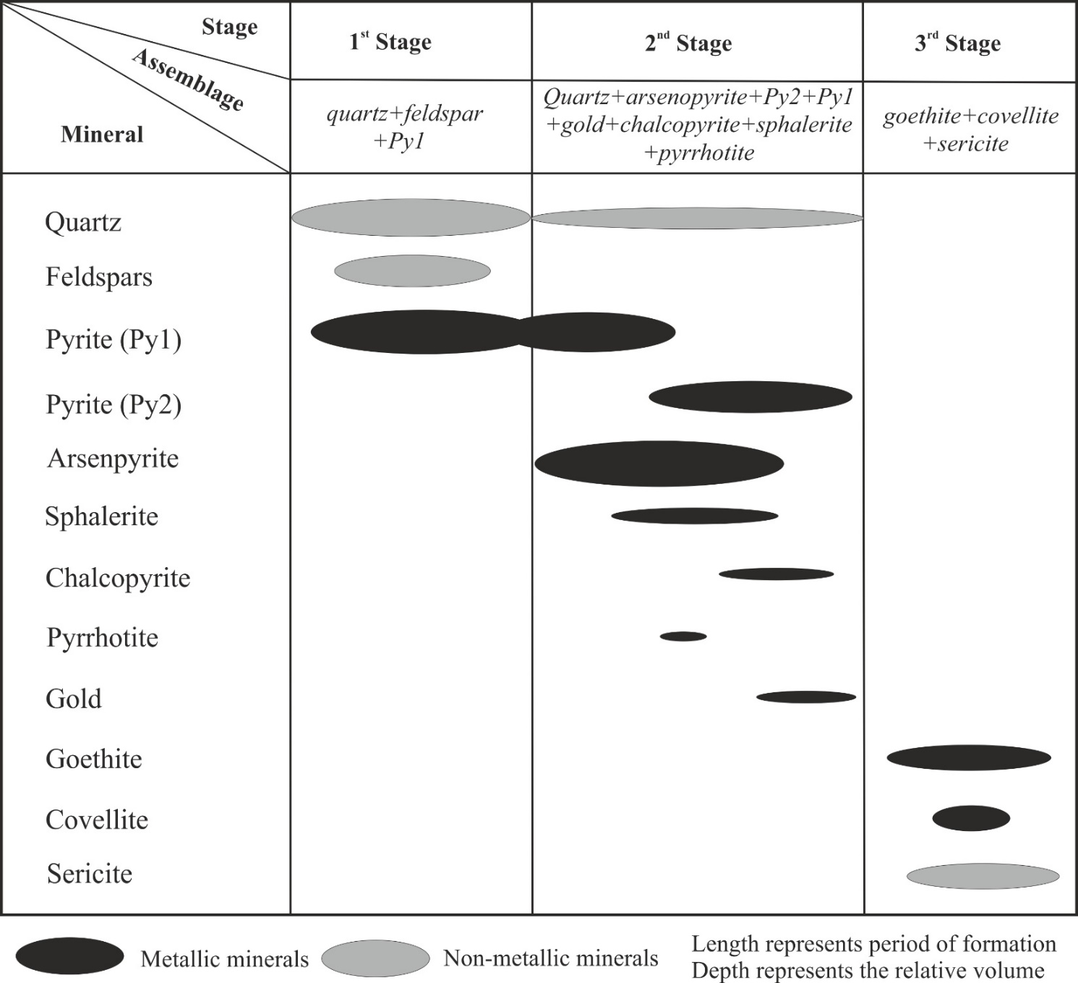

Table (5): Summarized microthermometric data and fluid properties of the quartz-hosted FIs from Hangaliya gold deposit.
Inclusions  Type |  |  | phases | Compositions | Ratio (*) | T_{m} (°C) | T_{h} (°C) | Salinity  (wt.% NaCl equi) | Bulk density  (g/cm³)
Aqueous | Primary |  | Two phases  (L_{H2O}+V) | H₂O–NaCl | 40% | Tm ice: -3.1 to -1.5 | Th total: 215–266  (liquid state) | 2.45–4.93 | 0.86–0.89
Aqueous | Secondary |  | Two phases  (L_{H2O}+V) | H₂O–NaCl | 40% | Tm ice: -2.7 to -1.2 | Th total: 114–155  (liquid state) | 2.07–4.49 | 0.94–0.97
Mixed aqueous-carbonic | (i) |  | Two phases  (L_{H2O} + V_{CO2})  Water rich-FIs | H₂O–CO₂–NaCl | 20% | Tm CO2: -57 to -56.6  Tm ice: -5.3 to -3.7  Tm clath: 5.8 to 7.2 | Th total: 306–345  (liquid state) | 6.08–8.39 | 0.66–0.77
Mixed aqueous-carbonic | (ii) |  | Three phases  (L_{H2O} +L_{CO2}+ V_{CO2})  Carbon rich-FIs | H₂O–CO₂–NaCl | 35% | Tm CO2: -57.1 to -56.6  Tm ice: -5.4 to -3.3  Tm clath: 5.6 °C to 9.6 | Th CO2: 28–30.1  (liquid/critical state)  Th total: 253–395  (liquid state) | 5.47–8.53 | 0.67–0.78
(*) the rest of about 5% from all detected FIs at room temperature is represented by monophases FIs.

