Additional Materials for

Pathological features and mutational landscapes of multiple renal cell carcinoma regions in patient with tuberous sclerosis complex: a case report

Additional Figure 1

Additional Figure 2

Additional Figure 3

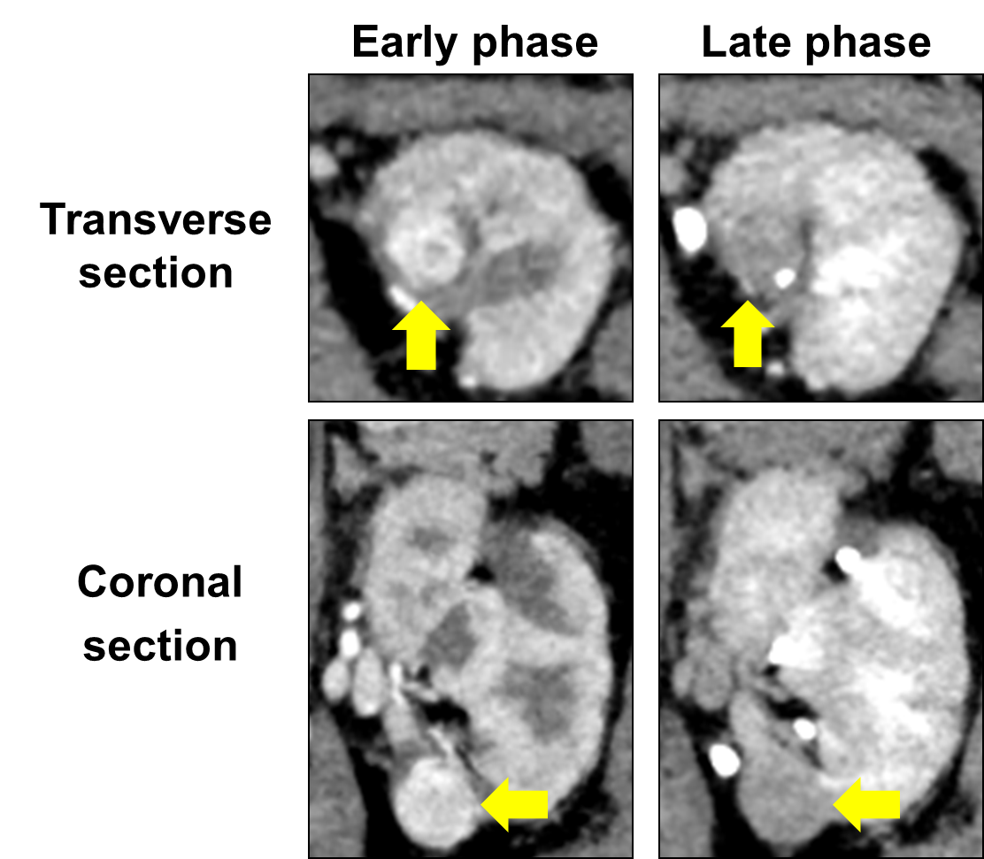

Additional Figure 1. The second recurrent tumor in the left kidney
CT examination shows typical findings of clear cell RCC in the left kidney.

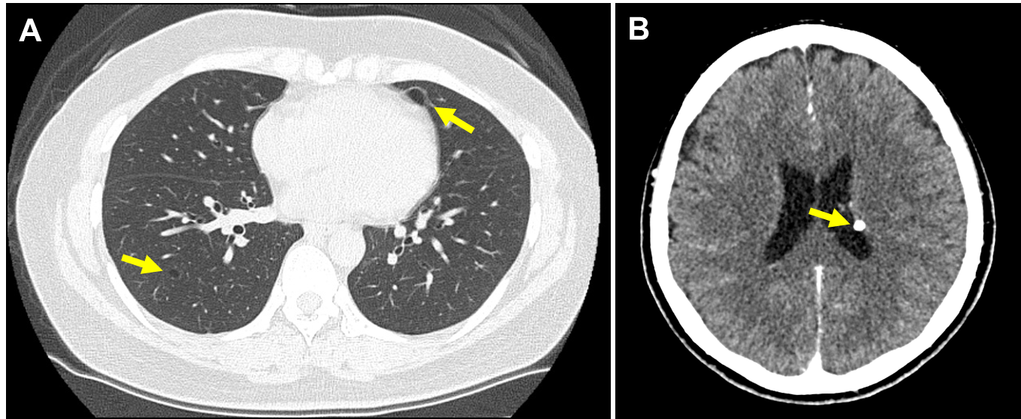

Additional Figure 2. Radiographic TSC features of the patient
A: lung lymphangioleiomyomatosis
B: subependymal nodule at left lateral ventricular wall

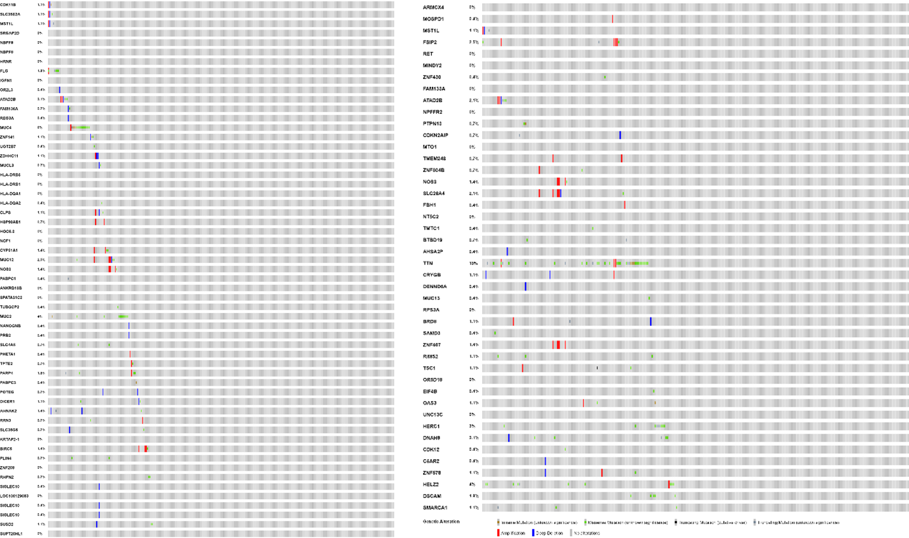
Additional Figure 3. Mutational information in the papillary RCC
Among 128 mutations in the papillary RCC in this patient, 45 mutations (35.2 %) were not found in TCGA database, which correspond to genes of 0% population in figure.

