Physical activity and sedentary behavior; mechanistic insights and role in disease prevention
Wang et al., (a preliminary author list is provided in a separate document)

SUPPLEMENTARY INFORMATION

Table of Contents
SUPPLEMENTARY FIGURES 2
BOX 1 - BRIEF DESCRIPTION OF CANDIDATE GENES PRIORITIZED BY AT LEAST TWO APPROACHES USING INFORMATION FROM GENECARDS, NCBI AND UNIPROT. 15
STUDY SPECIFIC ACKNOWLEDGEMENT AND FUNDING 21
INDIVIDUAL ACKNOWLEDGEMENTS 34
DISCLOSURES 36
REFERENCES 37

Back to top

SUPPLEMENTARY FIGURES
Supplementary Figure 1 – Quantile-quantile plots for the primary GWAS of self-reported physical activity and sedentary traits (page 3)
Supplementary Figure 2 – Significant genetic correlations for accelerometer-assessed physical activity with 108 other traits and diseases in 91,105 UK Biobank participants (page 4)
Supplementary Figure 3 – Manhattan plot of PheWAS for polygenic score of MVPA shows association with morbid obesity in European ancestry individuals in the BioMe Biobank (page 5)
Supplementary Figure 4 – LST-associated loci are enriched for genes with altered expression in skeletal muscle following resistance training (page 6)
Supplementary Figure 5 – A sensitivity analysis shows the analysis of altered gene expression following resistance training is robust to FDR threshold (page 7)
Supplementary Figure 6 – DEPICT-derived tissue enrichment of MVPA and LST (page 8)
Supplementary Figure 7 – Cell type prioritization using CELLECT for MVPA and LST (page 9)
Supplementary Figure 8 – RNA-seq data from GTEx displaying expression levels in the region chr12: 116,087,265 - 116,097,521 across several human tissues (page 10)
Supplementary Figure 9 – QQ plots of 28,390 variants shows enrichment for association with MVPA and LST in 56 previously reported physical activity- or exercise-related genes (page 11)
Supplementary Figure 10 – Molecular Dynamics of ACTN3 E635 and 635A variants from a homology structure shows a divergence in behavior under compressive force (page 12)
Supplementary Figure 11 – Single muscle fiber experiments show a higher maximal stable force and fiber power in E635 compared with 635A (page 13).

MVPA LDSC intercept=1.01 LST LDSC intercept=1.02 SDC LDSC intercept=1.00 SDW LDSC intercept=1.00
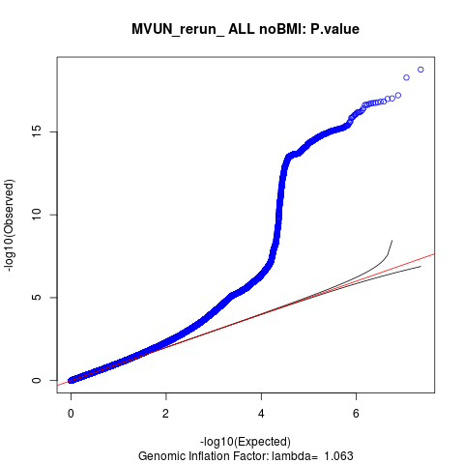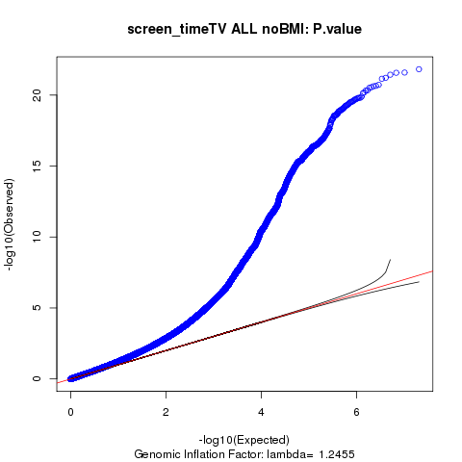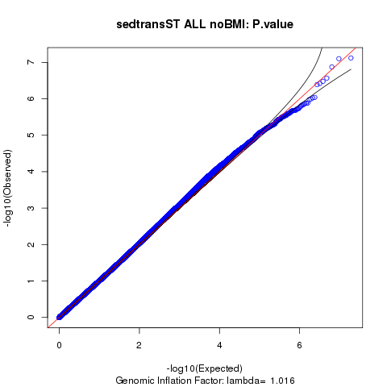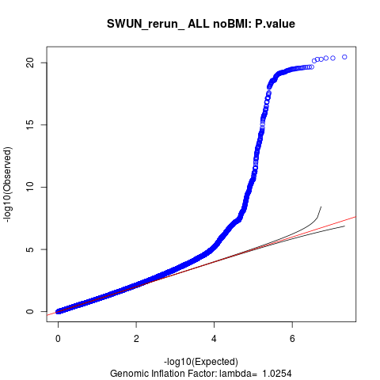
Trans-ethnic MVPA Trans-ethnic LST Trans-ethnic SDC Trans-ethnic SDW
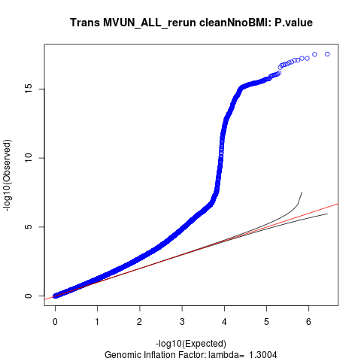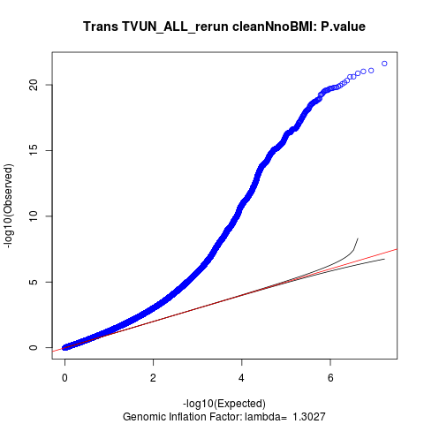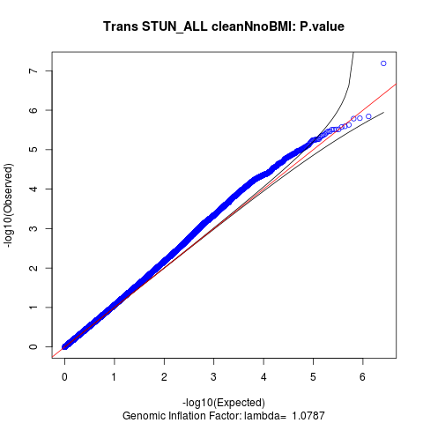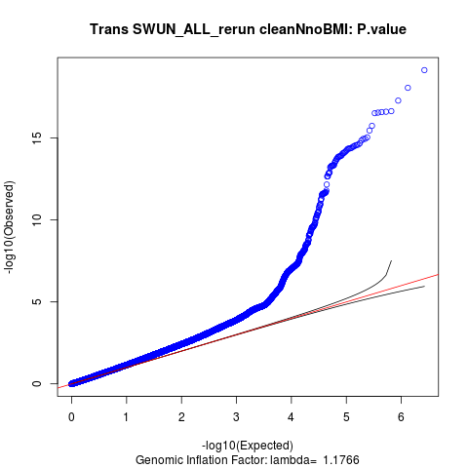

Supplementary Figure 1: Quantile-quantile plots for the primary GWAS of self-reported physical activity and sedentary traits. Moderate-to-vigorous intensity physical activity during leisure time (MVPA); leisure screen time (LST); sedentary behavior at work (SDW); and sedentary commuting behavior (SDC) in individuals of European ancestry only (top) as well as from the trans-ethnic meta-analysis (bottom). The estimated LD Score intercept for the primary GWAS is indicated for the former.

Back to Supplementary Figure overview
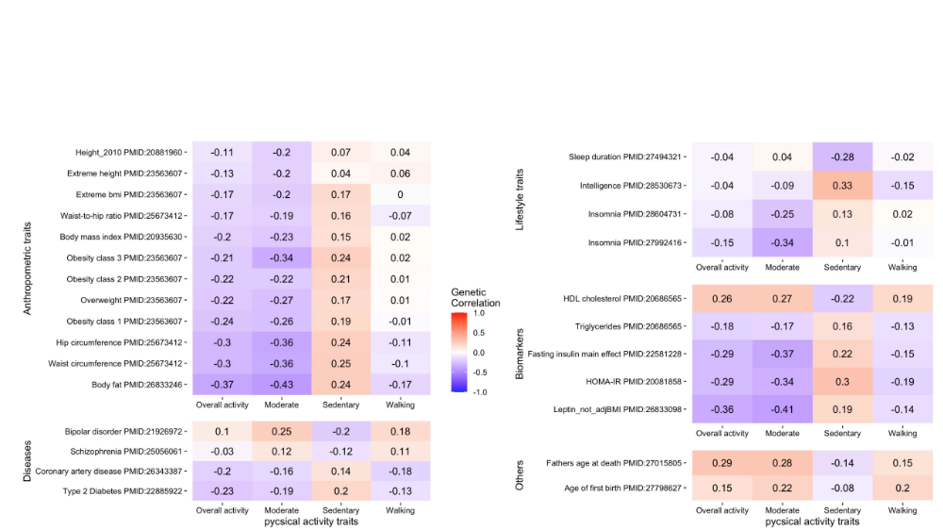

Supplementary Figure 2: Genetic correlations of accelerometer-assessed physical activity with other traits and diseases in 91,105 UK Biobank participants. We computed genetic correlations of four objectively assessed physical activity traits with 108 other traits and diseases using LD score regression, and show results for traits and diseases with at least one genetic correlation of P< 4.6×10⁻⁴ with an objectively assessed physical activity trait.

Back to Supplementary Figure overview
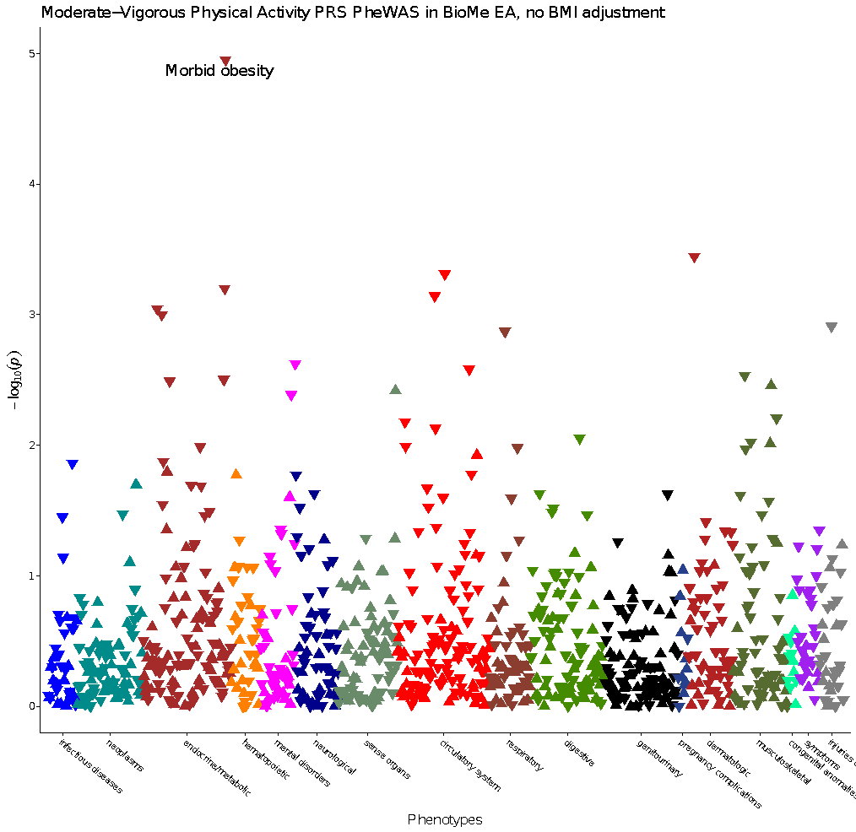

Supplementary Figure 3: Manhattan plot of PheWAS for polygenic score of MVPA shows association with morbid obesity in European ancestry individuals (N=8,959) in the BioMe Biobank. MVPA: moderate-to-vigorous intensity physical activity during leisure time, PheWAS: phenome-wide association study.

Back to Supplementary Figure overview

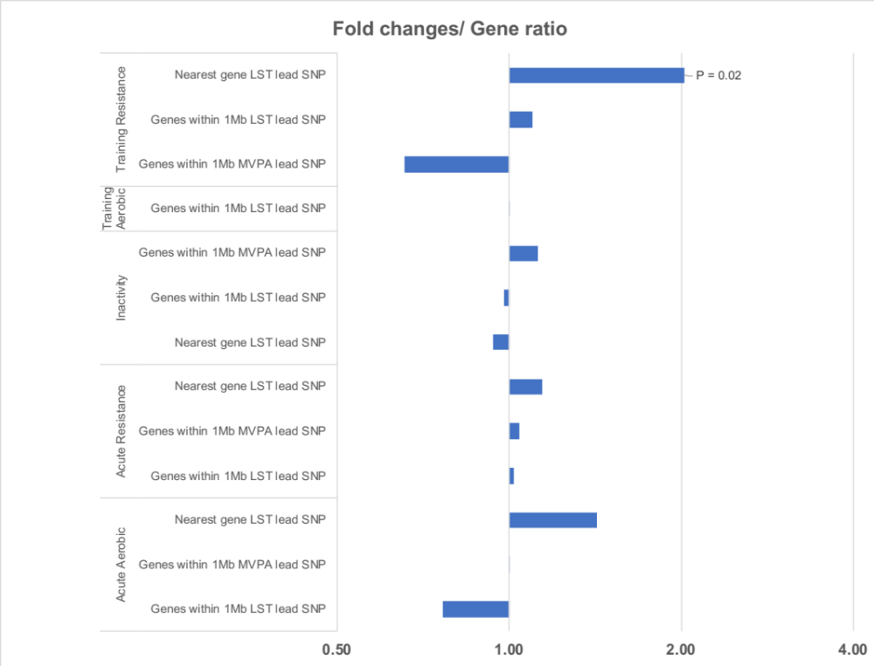

Supplementary Figure 4: LST-associated loci are enriched for genes with altered expression in skeletal muscle following resistance training. Fold-change plot in log scale for the ratio between: 1) the proportion of genes in physical activity (PA)-associated loci that showed an altered expression in skeletal muscle (FDR<0.01) across five categories: inactivity, acute bout of resistance exercise, acute bout of aerobic exercise, resistance training, or aerobic training; and 2) the proportion of all genes that showed an altered expression following such (in)activity in the MetaMex database (PMID: 31980607). Tested loci were: moderate-to-vigorous intensity physical activity during leisure time (MVPA)-associated loci; leisure screen time (LST)-associated loci. In a given set of loci, we either considered only the genes nearest to the lead SNP, or all genes within 1Mb of the lead SNP. Only loci harboring at least five genes with altered gene expression levels after intervention were included in this figure.

Back to Supplementary Figure overview

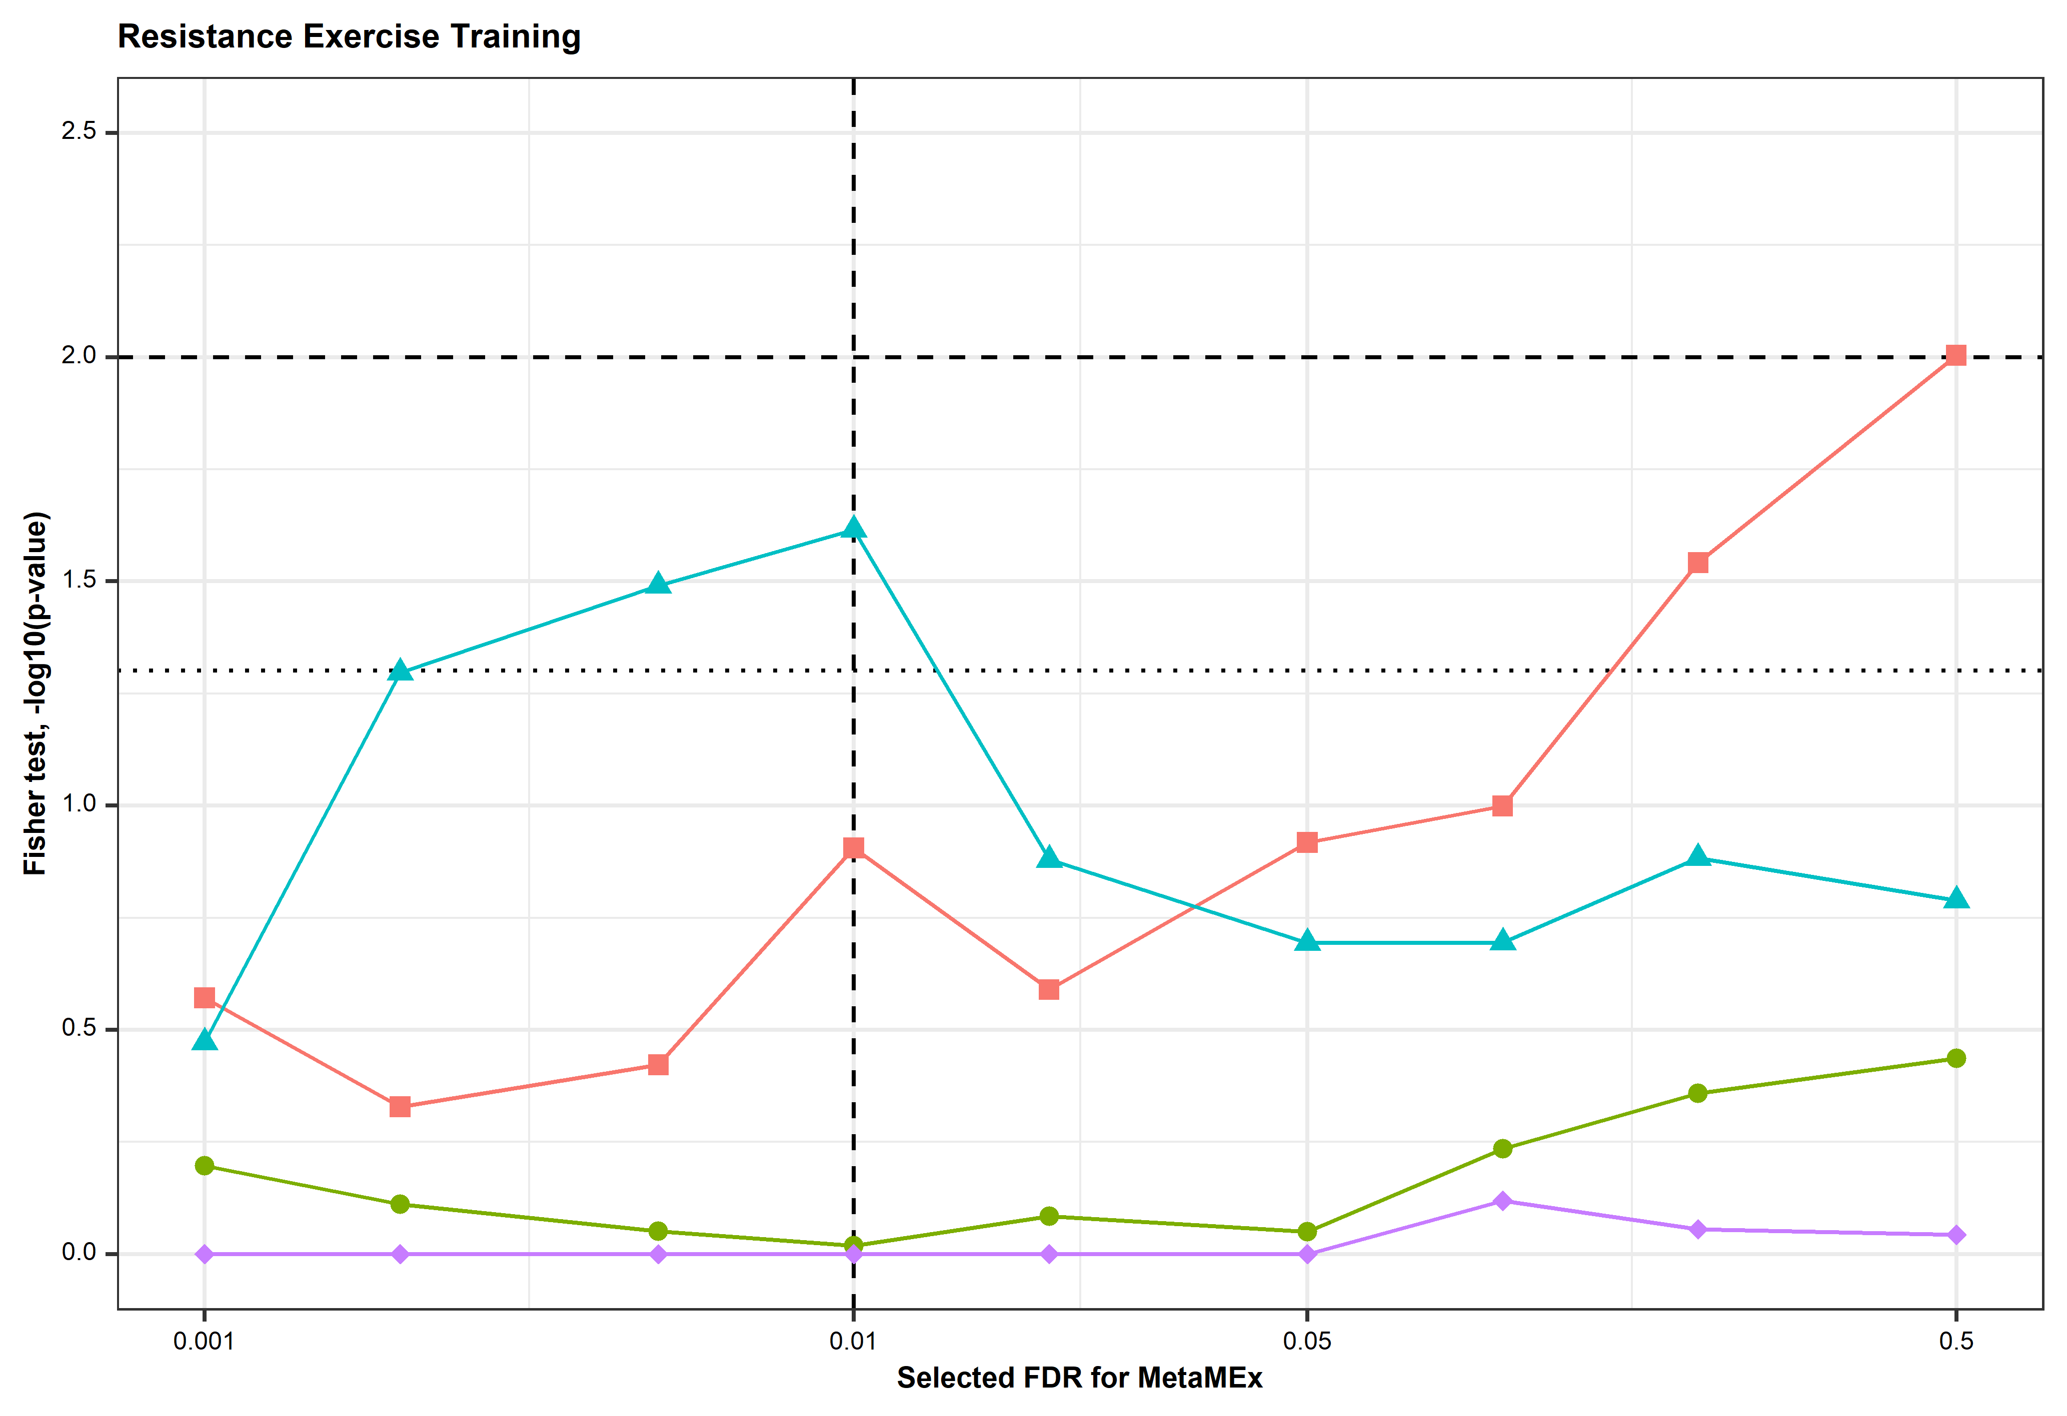

Supplementary Figure 5: A sensitivity analysis shows the analysis of altered gene expression following resistance training is robust to FDR threshold. We examined the effect of different FDR thresholds on Fisher’s exact test results for the enrichment analysis of alteration in gene expression in skeletal muscle following resistance training. Red square: genes within 1mb of the LST lead SNP, Green circle: genes within 1mb of the MVPA lead SNP, Blue triangle: nearest gene LST lead SNP, Purple diamond: nearest gene MVPA lead SNP. The horizonal dotted line indicates nominal significance level P<0.05, the vertical dashed line indicates the FDR threshold that was used. FDR thresholds explored range from 0.001 to 0.5.

Back to Supplementary Figure overview

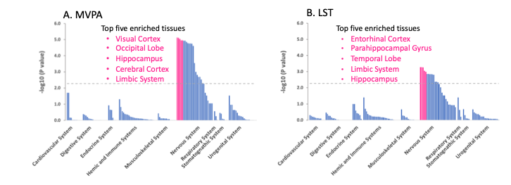

Supplementary Figure 6: DEPICT-derived tissue enrichment of MVPA and LST. MVPA: moderate-to-vigorous intensity physical activity during leisure time (MVPA, A); LST: leisure screen time (LST, B). SNPs with P<1x10⁻⁵ for association were used as input. The dashed line indicates the FDR corrected significance threshold (FDR < 0.05).

Back to Supplementary Figure overview

A Tabula Muris cell types
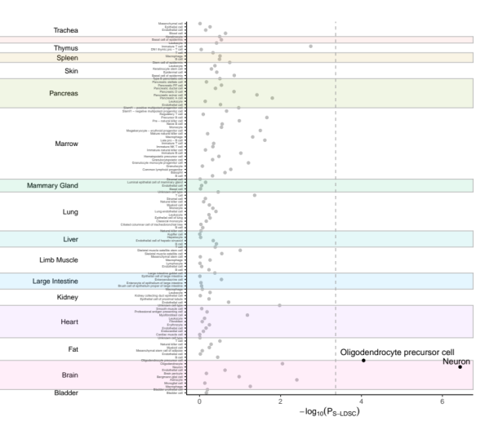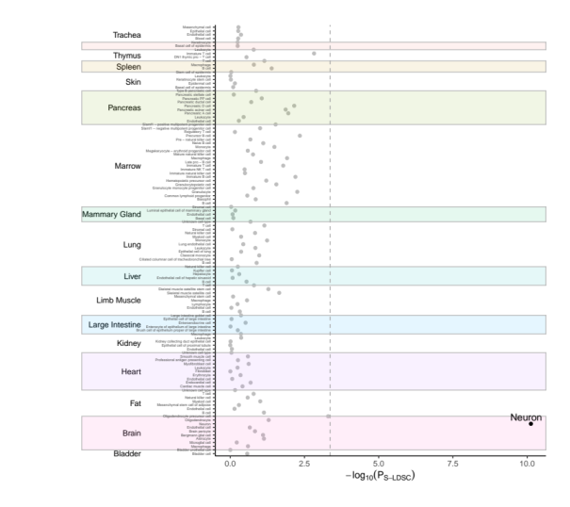
B mouse nervous system cell types
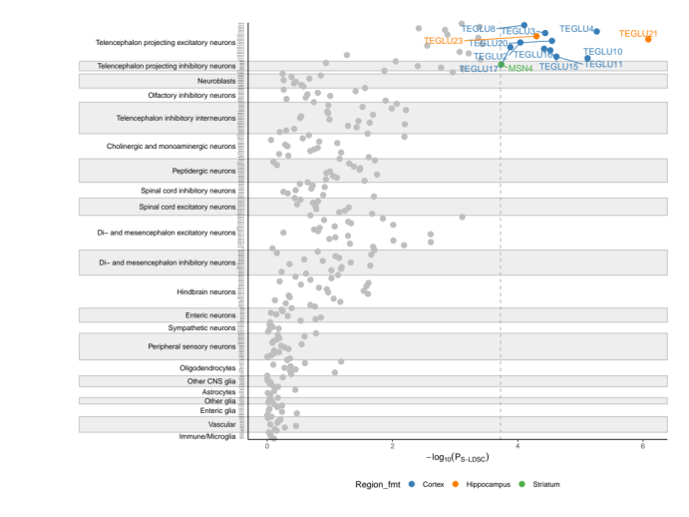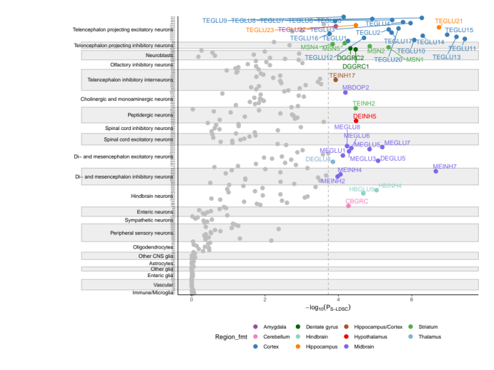

Supplementary Figure 7: Cell type prioritization using CELLECT for MVPA and LST. Panel A. Prioritization of 115 Tabula Muris cell types across 19 tissues identified two cell types from the brain as significantly associated with MVPA (left) and LST (right), namely oligodendrocyte precursor cells and neurons (shown in black; Bonferroni-corrected significance threshold, P<0.05/115). Panel B. Prioritization of 265 mouse nervous system cell types identified 13 and 45 cell types from 12 distinct brain regions as significantly associated with MVPA and LST, respectively (highlighted; Bonferroni-corrected significance threshold, P<0.05/265.

Back to Supplementary Figure overview

Supplementary Figure 8: RNA-seq data from GTEx displaying expression levels in the region chr12: 116,087,265 - 116,097,521 across several human tissues. Top: the region surrounding and including a poly-A signal is conserved across the mouse lncRNA 4930413E15Rik-encoding sequence and a locus on the human Chr 12 that is associated with leisure screen time; Middle: the human region on Chr 12 corresponding with an exonic sequence from the mouse 4930413E15Rik contains regulatory elements; Bottom: the human transcript is most highly expressed across the five highlighted tissues. In other tissues in the GTEx data collection, including whole blood (bottom), the region shows little or no evidence of expression. Chromosomal coordinates shown are from human genome built GRCh38.

Back to Supplementary Figure overview

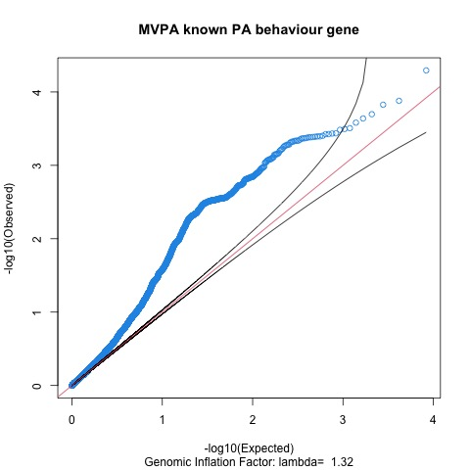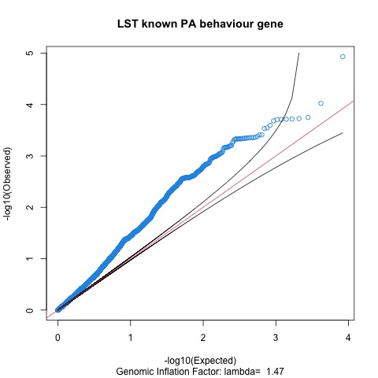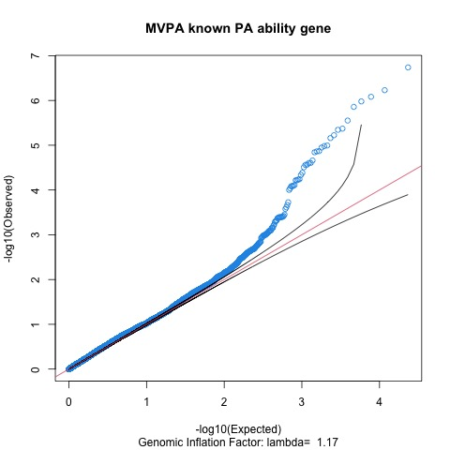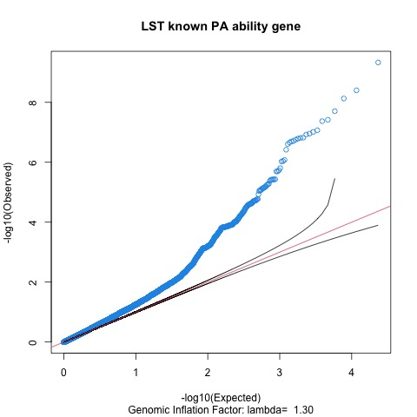

Supplementary Figure 9: QQ plots of 31,673 variants show enrichment for association with MVPA and LST in 58 previously reported exercise (i.e. physical activity (PA)behavior) and fitness (i.e. PA ability) genes. 8,345 variants within 13 PA behavior genes, 23,328 variants within 45 PA ability genes. MVPA: moderate-to-vigorous intensity PA during leisure time; LST: leisure screen time.

Back to Supplementary Figure overview

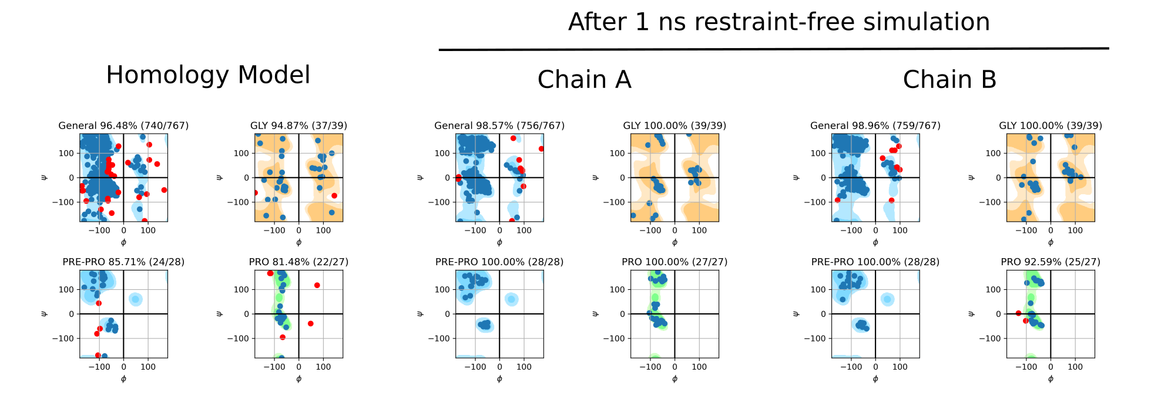
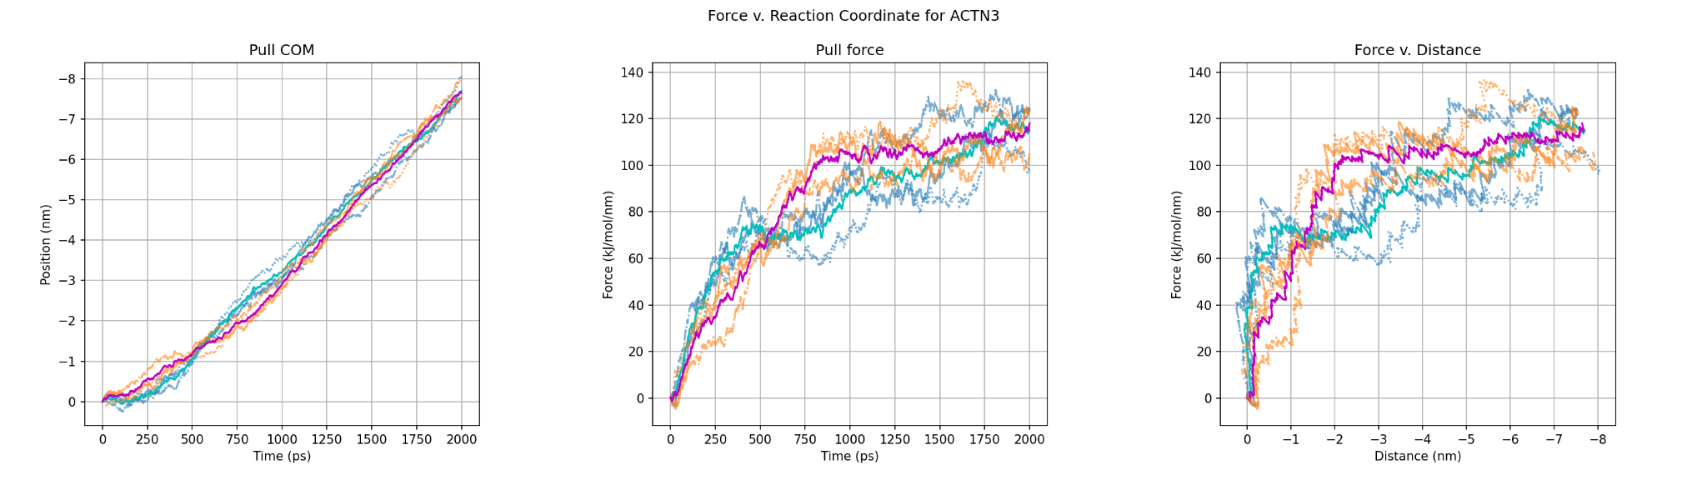

Supplementary Figure 10. Molecular Dynamics of ACTN3 E635 and 635A variants from a homology structure shows a divergence in behavior under compressive force. Top: Ramachandran plot of ACTN3 comparing the monomer (E635 shown here) produced by homology modeling with the dimer after 1 ns restraint-free molecular dynamics (MD) simulation. Bottom: Steered MD (three replicates) of ACTN3 E635 (replicates orange, mean of replicates magenta) and ACTN3 635A (replicates blue, mean of replicates cyan) showing, left to right: the pulling center-of-mass (COM) distance between actin binding domains versus time; the pull force versus time; and the pull force versus pulling COM.

Back to Supplementary Figure overview

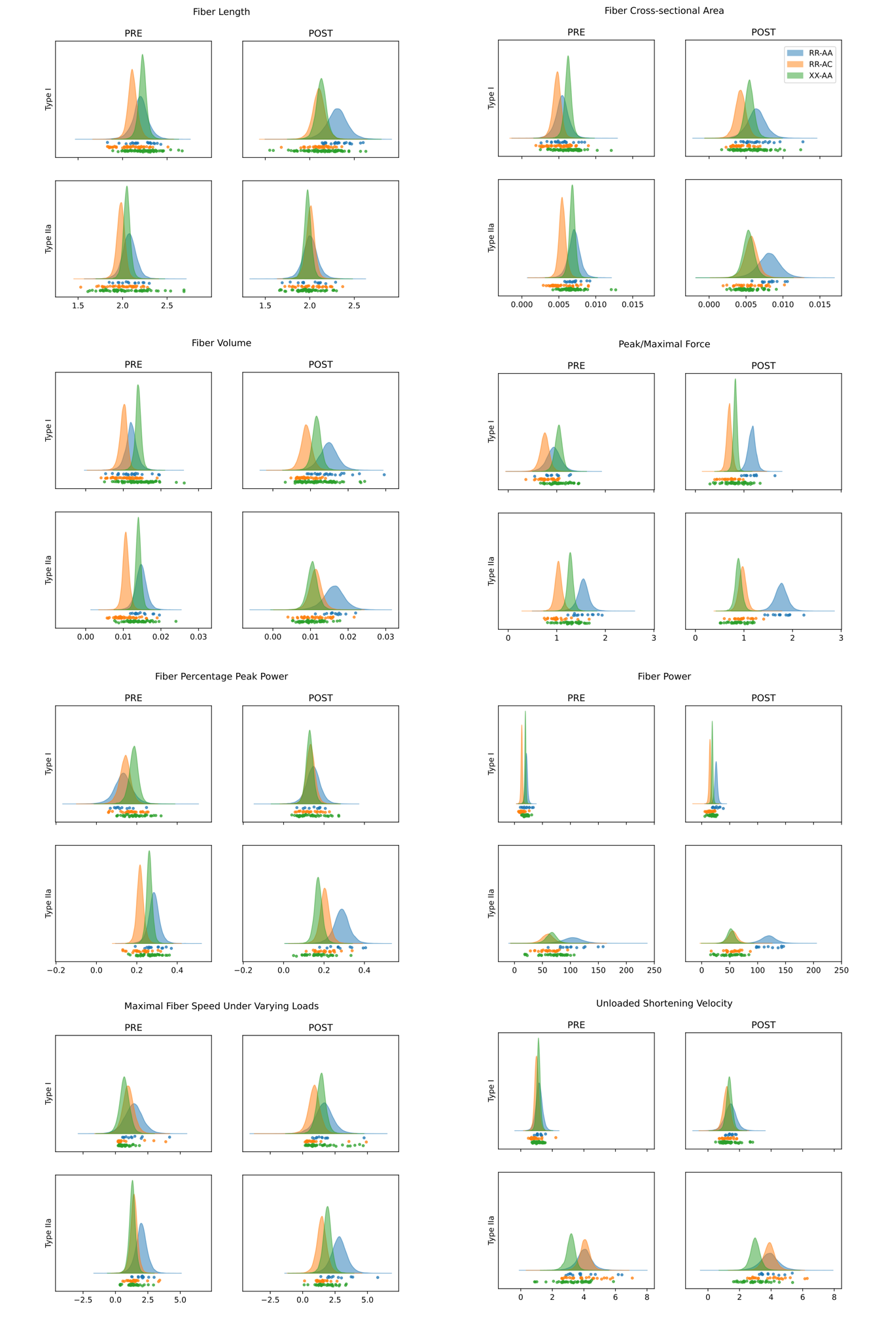

Supplementary Figure 11. Single muscle fiber experiments show a higher maximal stable force and fiber power in E635 compared with E635A. Muscle biopsies from eight healthy young men (four R/R and four X/X at R577X) obtained before (pre) and after (post) an eccentric exercise bout were used to isolate single fibers, which were then functionally characterized. Of the four R/R carriers, one was heterozygous at E635A (46 fibers) and three were homozygous for the E635-encoding allele (32±5 fibers). All four X/X carriers were homozygous for the E635-encoding allele (39±6 fibers). Posterior distributions from 15,000 iteration Markov chain Monte Carlo models are shown separately for type I and type II_{A} fibers pre and post eccentric intervention.

Back to Supplementary Figure overview

Back to top

BOX 1 - BRIEF DESCRIPTION OF CANDIDATE GENES PRIORITIZED BY AT LEAST TWO APPROACHES USING INFORMATION FROM GENECARDS, NCBI AND UNIPROT.
AK5 (chr 1, flagged by the intronic AK5 variant rs71658797; group 3 LST locus)
Prioritized by: DEPICT tissue and gene prioritization; SMR brain
Adenylate Kinase 5 is a cytosolic protein that is exclusively expressed in the brain. It plays a role in regulating the adenine nucleotide composition in a cell by catalyzing the reversible transfer of the terminal phosphate group between nucleoside triphosphates and monophosphates¹.

LRPPRC (chr 2, flagged by the lead LST SNP rs145255225; LST locus)
Prioritized by: SMR brain (lenient); altered expression in skeletal muscle following resistance training (lenient).
This gene encodes a Leucine-rich pentatricopeptide repeat containing protein. Mutations in LRPPRC cause a monogenic mitochondrial disease (Leigh syndrome French Canadian Type) that involves severe muscle and movement problems². In addition to the altered expression in skeletal muscle following resistance training we observed, LRPPRC is also up-regulated by exposure to environmental enrichment that is a complex combination of physical, cognitive, and social stimuli in striatum, which may improve locomotor performance³.

SCN2A (chr 2, flagged by the SCN2A missense variant rs114590429; group 5 LST locus)
Prioritized by: DEPICT gene prioritization; running speed, distance and time run in mice (lenient)
SCN2A (Sodium Voltage-Gated Channel Alpha Subunit 2) mediates the voltage-dependent sodium ion permeability of excitable membranes. Mutations in this gene have been associated with seizure disorders, autism spectrum disorder and general cognitive ability⁴. Scn2a haploinsufficient mice display a spectrum of phenotypes affecting anxiety, sociability, memory flexibility that commonly observed in models of schizophrenia and autism spectrum disorder⁵.

MST1R (chr 3, flagged by the intronic MST1R variant rs7615206; group 2 LST locus)
Prioritized by: SMR skeletal muscle; altered expression in skeletal muscle following resistance training
Also: in a locus under selection in the past 50,000 years⁶
Macrophage Stimulating 1 Receptor is a cell surface receptor for macrophage-stimulating protein (MSP) that has tyrosine kinase activity. It is expressed at the protein level on the ciliated epithelia of the mucociliary transport apparatus of the lung⁷, and together with MSP plays a role in host defense. MST1R regulates physiological processes that include cell survival, migration and differentiation. Ligand binding at the cell surface induces autophosphorylation of RON⁸, which activates the wound healing response by promoting epithelial cell migration, proliferation and survival at the wound site^{9,10}. Following activation, MST1R interacts with PIK3R1, PLCG1 or the adapter GAB1. Recruitment of these downstream effectors by RON leads to the activation of several signaling cascades including the RAS-ERK, PI3 kinase-AKT, or PLCgamma-PKC. MST1R also plays a role in the innate immune response by regulating the migration and phagocytic activity of macrophages.

RNF123 (chr 3, flagged by the intronic MST1R variant rs7615206; group 2 LST locus)
Prioritized by: SMR brain; DEPICT gene prioritization (lenient)
The RNF123 gene encodes E3 ubiquitin-protein ligase, a motif present in a variety of functionally distinct proteins and known to be involved in protein-protein and protein-DNA interactions. It promotes the ubiquitination and proteasome-mediated degradation of CDKN1B, which is the cyclin-dependent kinase inhibitor at the G0-G1 transition of the cell cycle by the ubiquitin-proteasome pathway ^{11,12}. It also functions as a novel inhibitor of innate antiviral signaling, independently of its E3 ligase activity¹³. This gene is more highly expressed in skeletal muscle than in other tissues. Recent studies involving UK Biobank samples also associated the locus with musculoskeletal pain^{14,15}.

REEP5 (chr 5, flagged by the intronic APC variant rs396321; group 5 LST locus)
Prioritized by: DEPICT gene prioritization; SMR skeletal muscle (lenient)
Receptor Accessory Protein 5 (REEP5) expression is muscle-specific, with the highest protein expression in the mouse ventricles and skeletal muscle. In vitro and in vivo experiments have demonstrated that REEP5 plays a critical role in sarco/endoplasmic reticulum organization and function, as well as in normal heart function and development¹⁶.

SIL1 (chr 5, flagged by the intronic SIL1 indel variant rs752485316; LST locus)
Prioritized by: SMR brain; altered expression in skeletal muscle following resistance training (lenient)
SIL1 (SIL1 Nucleotide Exchange Factor) encodes a resident endoplasmic reticulum (ER), N-linked glycoprotein with an N-terminal ER targeting sequence, 2 putative N-glycosylation sites, and a C-terminal ER retention signal. Mutations in this gene have been associated with Marinesco-Sjogren syndrome, which is clinically characterized by progressive myopathy and other tissue pathologies. Experimental characterization in mice reveals a disruption in ER homeostasis upon SIL1 loss, leading to loss of skeletal muscle mass, strength and function¹⁷.

REPS1 (chr 6, flagged by the LST lead intronic deletion variant rs200307517; LST locus)
Prioritized by: SMR brain (lenient); altered expression in skeletal muscle following resistance training (lenient)
REPS1 (RALBP1 Associated Eps Domain Containing 1) encodes a signaling adaptor protein with two EH domains that interacts with proteins that participate in signaling, endocytosis and cytoskeletal changes.

PDE10A (chr 6; flagged by the intronic lead SNP rs58541850 in PDE10A; group 5 LST locus)
Prioritized by: altered expression in skeletal muscle following resistance training; DEPICT gene prioritization
Phosphodiesterase 10A plays a role in signal transduction by regulating the intracellular concentration of cyclic nucleotides. The protein can hydrolyze cAMP and cGMP, and may play a critical role in regulating cAMP and cGMP levels in the striatum¹⁸, a region of the brain contributing to the control of movement and cognition. cAMP and cGMP both mediate the effects of dopamine D1 and D2 receptors on the activity of medium-sized spiny neurons¹⁹. Pharmacological inhibition of PDE10A increases cAMP and cGMP levels; and increases striatal output²⁰.

EXOC4 (chr 7; flagged by the intronic lead SNP rs13235840 in EXOC4 and LOC101928861; group 5 LST locus); DEPICT tissue enrichment using group 3 and 5 loci
Prioritized by: altered expression in skeletal muscle following resistance training; DEPICT gene prioritization;
Exocyst Complex Component 4 is part of the highly conserved exocyst complex that is essential for targeting exocytic vesicles to specific docking sites on the plasma membrane. Exocyst Complex Component 4 participates in GLUT4 translocation and docking to the plasma membrane²¹, and is essential for insulin-stimulated glucose uptake in skeletal muscle²¹.

IMMP2L (chr 7; flagged by the intronic lead SNP rs2529484 in IMMPL2; group 5 LST locus)
Prioritized by: altered expression in skeletal muscle following resistance training; SMR skeletal muscle (lenient)
Inner Mitochondrial Membrane Peptidase Subunit 2 resides in the mitochondria and is required for the catalytic activity of the mitochondrial inner membrane peptidase (IMP) complex. It catalyzes the removal of transit peptides required to transport proteins from the mitochondrial matrix, across the inner membrane, to the intermembrane space²².

BLK (chr 8, flagged by the intronic XKR6 variant rs7821826; group 1 LST locus)
Prioritized by: DEPICT tissue enrichment; SMR blood (lenient)
BLK (BLK Proto-Oncogene, Src Family Tyrosine Kinase) encodes a nonreceptor tyrosine-kinase of the Src family of proto-oncogenes that are typically involved in cell proliferation and differentiation. Mutations at the BLK locus have been linked to Maturity-onset diabetes of the young (MODY) and β-cell dysfunction²³. In pancreatic islets, it acts as a modulator of beta-cells function through the up-regulation of PDX1 and NKX6-1 and consequent stimulation of insulin secretion in response to glucose ²³.

PACS1 (chr 11, flagged by the intronic PACS1 variant rs4483592; group 5 LST locus)
Prioritized by: SMR brain; DEPICT gene prioritization
PACS1 (Phosphofurin Acidic Cluster Sorting Protein 1) encodes a protein that is involved in the trans-Golgi-membrane traffic²⁴. A de novo mutation in PACS1 was recently shown to cause defective migration of cranial-neural-crest cells and resulted in an intellectual disability syndrome and global developmental delay²⁵.

KLC2 (chr 11, flagged by the intronic PACS1 variant rs4483592; group 5 LST locus)
Prioritized by: SMR blood and skeletal muscle; DEPICT gene prioritization
KLC2 (Kinesin Light Chain 2) encodes a light chain of kinesin, a molecular motor responsible for moving vesicles and organelles along microtubules. Defects in this gene cause the rare, autosomal recessive mendelian disorder Spastic Paraplegia, Optic Atropy, and Neuropathy (SPOAN) Syndrome²⁶. This syndrome is characterized by an early-onset, progressive weakness and spasticity of the legs. Zebrafish embryos with morpholino-mediated downregulation of klc2 had a dose-dependent, shortened, twisted tail and were unable to swim. A similar motor phenotype was observed in zebrafish embryos upon upregulation of klc2²⁷.

CCDC92 (chr12, flagged by the deletion variant rs541140319 (aka rs59131741), 866kb from CCDC92; LST locus)
Prioritized by: SMR brain (lenient); SMR skeletal muscle (lenient); spontaneous running speed in mice (lenient)
CCDC92 is a coiled coil domain protein which interacts with proteins in the centriole/ciliary interface²⁸. The CCDC92 locus has been associated with higher insulin, higher triglyceride, and lower HDL-cholesterol levels. Further experimental studies showed that knockout of CCDC92 resulted in less lipid accumulation in a mouse model. These results suggested a role for CCDC92 in adipocyte differentiation²⁹.

MMAB (chr 12, flagged by the intronic MYO1H variant rs7969719; group 5 LST locus)
Prioritized by: DEPICT tissue prioritization; SMR skeletal muscle (lenient)
MMAB (Metabolism Of Cobalamin Associated B) encodes a protein that catalyzes the final step in the conversion of vitamin B(12) into adenosylcobalamin (AdoCbl), a vitamin B12-containing coenzyme for methylmalonyl-CoA mutase. GWAS has reported variants in this gene to be associated with Apolipoprotein A1, HDL, and BMI, amongst others³⁰⁻³².

TESC (chr 12; flagged by the intronic TESC lead SNP rs2173650; group 5 LST locus)
Prioritized by: SMR brain; association with daily running distance and average voluntary running speed in mice; DEPICT tissue enrichment using group 3 and 5 loci
Tescalcin, also known as Calcineurin B Homologous Protein 3 is highly expressed in the striatum³³, which harbours the central reward system and which represents a major site of physical activity regulation³⁴⁻³⁶. TESC encodes a Ca²⁺- and Mg²⁺ -binding protein that is essential for extracellular signal-regulated kinase (ERK) cascade activation, which in turn is critical for normal cell differentiation³⁷, as well as for the motivating effects of reward-associated stimuli along with other important roles related to learning, reinforcing and addiction in the striatum³⁸.

FBXO21 (chr 12, flagged by the intronic TESC lead SNP rs2173650; group 5 LST locus)
Prioritized by: SMR brain (lenient); spontaneous running speed and distance in mice
FBXO21 (F-Box Protein 21) encodes a member of the F-box protein family, fbxs containing either different protein-protein interaction modules or no recognizable motifs.

OGFOD2 (chr 12, flagged by the intronic PITPNM2 indel variant rs541140319 (aka rs59131741); LST locus)
Prioritized by: DEPICT gene prioritization; SMR brain
Gene Ontology annotations related to OGFOD2 (2-Oxoglutarate And Iron Dependent Oxygenase Domain Containing 2) include iron ion binding and oxidoreductase activity, acting on paired donors, with incorporation or reduction of molecular oxygen, using 2-oxoglutarate as a donor, and incorporation of one atom each of oxygen into both donors.

ARL6IP4 (chr 12, flagged by the intronic PITPNM2 variant rs541140319 (aka rs59131741); LST locus)
Prioritized by: SMR blood; running speed in mice (lenient)
ARL6IP4 (ADP Ribosylation Factor Like GTPase 6 Interacting Protein 4) is involved in modulating alternative pre-mRNA splicing with either 5' distal site activation or preferential use of 3' proximal site.

CADM2 (chr 13; flagged by the intronic lead SNP rs1691471; MVPA locus)
Prioritized by: SMR skeletal muscle; DEPICT tissue enrichment, DEPICT gene prioritization (nominal)
CADM2 (also known as SynCAM2, Igsf4d, and Nectin-like molecule 3) encodes the synaptic cell adhesion molecule 2. SNPs in the locus have been associated with a series of psychological traits, such as educational attainment³⁹; self-reported physical activity⁴⁰; risk-taking behaviour⁴¹; alcohol consumption⁴²; substance use and risk-taking⁴³; and obesity⁴⁴. In addition to lower adiposity, lower systemic glucose levels, and better insulin sensitivity, Cadm2-knockout mice exhibited more locomotor activity, higher energy expenditure, and higher core body temperature, suggesting cadm2 is a potent regulator of systemic energy homeostasis⁴⁵. While CADM2 is predominantly expressed in the brain, the top SMR SNP for MVPA in skeletal muscle (rs382210) is in LD with the lead MVPA GWAS SNP rs1691471 (r2=0.29, D’=0.95), it is independent of the previously identified BMI-associated SNP rs13078960 (r2=0.03, D’=0.48)⁴⁴). This suggests that while CADM2 likely influences other complex traits through the brain, it possibly influences PA locally through skeletal muscle.

FARP1 (chr 13; flagged by the intronic lead SNP rs9513416 in FARP1; group 5 LST locus)
Prioritized by: altered expression in skeletal muscle following resistance training; DEPICT gene prioritization; DEPICT tissue enrichment using group 3 and 5 loci
FARP1 encodes FERM, ARH/RhoGEF And Pleckstrin Domain Protein 1, which promotes dendritic growth in neurons

HERC1 (chr 15, flagged by the intronic HERC1 variant rs12324720; group 5 LST locus)
Prioritized by: DEPICT gene prioritization; altered expression in skeletal muscle following resistance training (lenient)
HERC1 (HECT And RLD Domain Containing E3 Ubiquitin Protein Ligase Family Member 1) encodes a protein that stimulates guanine nucleotide exchange on ARF1 and Rab proteins and may be involved in membrane transport processes via some guanine nucleotide exchange factor (GEF) activity and its ability to bind clathrin. HERC1 is involved in the ubiquitin-proteasome system, for which the role in cachexia and sarcopenia is well-described⁴⁶. An Intronic HERC1 variant was associated with heel bone mineral density in UK BioBank data⁴⁷.

AKAP10 (chr 17, flagged by rs385301 downstream of AKAP10; MVPA locus)
Prioritized by: SMR skeletal muscle (lenient); DEPICT gene prioritization (lenient).
In a locus previously identified for physical activity⁴⁰, AKAP10 (alpha‐kinase anchoring protein 10) is known to confine regulatory subunits of protein kinase A to discrete regions of mitochondria⁴⁸. Animal studies have shown evidence for a role of AKAP10 in heart rhythm regulation⁴⁹, but skeletal muscle phenotypes were not reported previously in knockout models. However, A-kinase anchoring proteins (AKAPs) partially restrict cAMP-PKA signaling, especially in highly structured cell types like skeletal myofibers⁵⁰. cAMP signaling participates in muscle development and regeneration mediated by muscle precursor cells⁵¹.

DNM2 (chr 19, flagged by the synonymous ILF3 SNP rs2229383; group 5 LST locus)
Prioritized by: DEPICT tissue enrichment analysis; SMR blood (lenient)
Dynamins represent a subfamily of GTP-binding proteins, which are associated with microtubules and bind actin and other cytoskeletal proteins. DNM2 plays an important role in vesicular trafficking processes, in particular endocytosis. It is also expressed in pancreatic 𝛃-cells, where it regulates biphasic insulin secretion and plasma glucose homeostasis⁵². Associated diseases include myopathy.

ZBTB46 (chr 20, flagged by the intronic ZBTB46 variant rs6010651; group 5 LST locus)
Prioritized by: altered expression in skeletal muscle following resistance training; SMR blood (lenient)
Gene Ontology (GO) annotations for ZBTB46 (Zinc Finger And BTB Domain Containing 46) include nucleic acid binding. ZBTB46 functions as a transcriptional repressor for PRDM1 that mediates a transcriptional program in various immune tissue-resident lymphocyte T cell types.

YWHAB (chr 20, flagged by the intronic YWHAB indel variant rs139900206 (aka rs3838037); LST locus)
Prioritized by: Finemapp & CADD score; SMR brain (lenient); altered expression in skeletal muscle following resistance training (lenient)
YWHAB (Tyrosine 3-Monooxygenase/Tryptophan 5-Monooxygenase Activation Protein Beta, also known as 14-3-3 protein) encodes an adapter protein that is implicated in the regulation of a large spectrum of both general and specialized signaling pathways and plays a role in the cell cycle⁵³. Previous proteomic analyses showed expression of YWHAB is upregulated in rat dorsal hippocampus following consumption of a diet high in fat and refined sugar⁵⁴, as well as in plasma after exercise⁵⁵.

Back to top

STUDY SPECIFIC ACKNOWLEDGEMENT AND FUNDING

AGES

Age, Gene/Environment Susceptibility-Reykjavik Study (AGES) was funded by NIH contract N01-AG-1-2100 and HHSN271201200022C, the NIA Intramural Research Program, Hjartavernd (the Icelandic Heart Association), and the Althingi (the Icelandic Parliament)

ALSPAC
The UK Medical Research Council and Wellcome (Grant ref: 217065/Z/19/Z) and the University of Bristol provide core support for ALSPAC. This publication is the work of the authors and Marcel den Hoed and Zhe Wang will serve as guarantors for the contents of this paper.
We are extremely grateful to all the families who took part in this study, the midwives for their help in recruiting them, and the whole ALSPAC team, which includes interviewers, computer and laboratory technicians, clerical workers, research scientists, volunteers, managers, receptionists and nurses.

ARIC
The Atherosclerosis Risk in Communities study has been funded in whole or in part with Federal funds from the National Heart, Lung, and Blood Institute, National Institutes of Health, Department of Health and Human Services (contract numbers HHSN268201700001I, HHSN268201700002I, HHSN268201700003I, HHSN268201700004I and HHSN268201700005I), R01HL087641, R01HL059367 and R01HL086694; National Human Genome Research Institute contract U01HG004402; and National Institutes of Health contract HHSN268200625226C. The authors thank the staff and participants of the ARIC study for their important contributions. Infrastructure was partly supported by Grant Number UL1RR025005, a component of the National Institutes of Health and NIH Roadmap for Medical Research.

B58C
The management of the 1958 Birth Cohort is funded by the Economic and Social Research Council (grant number ES/M001660/1). Access to these resources was enabled via the 58READIE Project funded by Wellcome Trust and Medical Research Council (grant numbers WT095219MA and G1001799). DNA collection was funded by MRC grant G0000934 and cell-line creation by Wellcome Trust grant 068545/Z/02. This study makes use of data generated by the Wellcome Trust Case-Control Consortium. A full list of investigators who contributed to generation of the data is available from the Wellcome Trust Case-Control Consortium website. Funding for the project was provided by the Wellcome Trust under the award 076113. This research used resources provided by the Type 1 Diabetes Genetics Consortium, a collaborative clinical study sponsored by the National Institute of Diabetes and Digestive and Kidney Diseases (NIDDK), National Institute of Allergy and Infectious Diseases, National Human Genome Research Institute, National Institute of Child Health and Human Development, and Juvenile Diabetes Research Foundation International (JDRF) and supported by U01 DK062418.

BioMe
The Mount Sinai BioMe Biobank is supported by The Andrea and Charles Bronfman Philanthropies. We thank all participants and all our recruiters who have assisted and continue to assist in data collection and management. We are grateful for the computational resources and staff expertise provided by Scientific Computing at the Icahn School of Medicine at Mount Sinai.

BPROOF
We thank the participants of the B-PROOF study for their enthusiasm and cooperation. Furthermore, we thank the dedicated research team that conducted the study. This study is supported and funded by The Netherlands Organization for Health Research and Development (ZonMw, Grant 6130.0031), the Hague; unrestricted grant from NZO (Dutch Dairy Association), Zoetermeer; Orthica, Almere; NCHA (Netherlands Consortium Healthy Ageing) Leiden/Rotterdam; Ministry of Economic Affairs, Agriculture and Innovation (project KB-15-004-003), the Hague; Wageningen University, Wageningen; VUmc, Amsterdam; Erasmus Medical Center, Rotterdam; Unilever, Colworth, UK. All organisations, except Unilever, are based in the Netherlands. The sponsors have no role in the design or implementation of the study, data collection, data management, data analysis, data interpretation, or in the preparation, review, or approval of the manuscript.

Busselton
The Busselton Health Study acknowledges the generous support for the 1994/5 follow-up study from Healthway, Western Australia and the numerous Busselton community volunteers who assisted with data collection and the study participants from the Shire of Busselton. The Busselton Health Study is supported by The Great Wine Estates of the Margaret River region of Western Australia.

CARDIA
The Coronary Artery Risk Development in Young Adults Study (CARDIA) is conducted and supported by the National Heart, Lung, and Blood Institute (NHLBI) in collaboration with the University of Alabama at Birmingham (HHSN268201800005I & HHSN268201800007I), Northwestern University (HHSN268201800003I), University of Minnesota (HHSN268201800006I), and Kaiser Foundation Research Institute (HHSN268201800004I). CARDIA was also partially supported by the Intramural Research Program of the National Institute on Aging (NIA) and an intra‐agency agreement between NIA and NHLBI (AG0005). Genotyping was funded as part of the NHLBI Candidate-gene Association Resource (N01-HC-65226) and the NHGRI Gene Environment Association Studies (GENEVA) (U01-HG004729, U01-HG04424, and U01-HG004446). This manuscript has been reviewed and approved by CARDIA for scientific content.

CHS
Cardiovascular Health Study: This CHS research was supported by NHLBI contracts HHSN268201200036C, HHSN268200800007C, HHSN268201800001C, N01HC55222, N01HC85079, N01HC85080, N01HC85081, N01HC85082, N01HC85083, N01HC85086, 75N92021D00006; and NHLBI grants U01HL080295, R01HL085251, R01HL087652, R01HL105756, R01HL103612, R01HL120393, and U01HL130114 with additional contribution from the National Institute of Neurological Disorders and Stroke (NINDS). Additional support was provided through R01AG023629 from the National Institute on Aging (NIA). A full list of principal CHS investigators and institutions can be found at CHS-NHLBI.org.
The content is solely the responsibility of the authors and does not necessarily represent the official views of the National Institutes of Health.
The provision of genotyping data was supported in part by the National Center for Advancing Translational Sciences, CTSI grant UL1TR001881, and the National Institute of Diabetes and Digestive and Kidney Disease Diabetes Research Center (DRC) grant DK063491 to the Southern California Diabetes Endocrinology Research Center.

CoLaus
The CoLaus study was and is supported by research grants from GlaxoSmithKline, the Faculty of Biology and Medicine of Lausanne, and the Swiss National Science Foundation (grants 33CSCO-122661, 33CS30-139468, 33CS30-148401 and 33CS30_177535/1).

DNBC
The Danish National Birth Cohort (DNBC) is a result of major grants from the Danish National Research Foundation, the Danish Pharmacists’ Fund, the Egmont Foundation, the March of Dimes Birth Defects Foundation, the Augustinus Foundation, and the Health Fund of the Danish Health Insurance Societies. The DNBC biobank is a part of the Danish National Biobank resource, which is supported by the Novo Nordisk Foundation. The generation of GWAS genotype data for the DNBC samples was carried out within the Gene Environment Association Studies (GENEVA) consortium with funding provided through the National Institutes of Health’s Genes, Environment, and Health Initiative (U01HG004423; U01HG004446; U01HG004438). We are very grateful to all DNBC families who took part in the study. We would also like to thank everyone involved in data collection and biological material handling.

EGCUT

This research was supported by the European Union through the European Regional Development Fund (Project No. 2014-2020.4.01.15-0012), by the Estonian Research Council grant PUT (PRG687), by the Estonian Research Council grant PUT (PRG1291). We acknowledge the Estonian Biobank research team. Data analyses were carried out in part in the High-Performance Computing Center of University of Tartu.

EPIC-Norfolk
We are grateful to all the participants who have been part of the EPIC-Norfolk project and to the many members of the study teams at the University of Cambridge who have enabled this research. The study is funded by Medical Research Council (MR/N003284/1, MC-UU_12015/1, MC_PC_13048) Cancer Research UK (C864/A14136).

FamHS
The FamHS is funded by R01HL118305 and R01HL117078 NHLBI grants, and 5R01DK07568102 and 5R01DK089256 NIDDK grant.

FAMILY
We would like to thank all the participants of the FAMILY study. We acknowledge the internal support from the Population Health Research Institute for centralizing the data collect. The FAMILY genetic study has been funded by the Heart and Stroke Foundation of Ontario (grant # NA 7293 “Early genetic origins of cardiovascular risk factors”). The FAMILY study was funded by the Hamilton Health Science Foundation, the Canadian Institutes of Health Research and by Heart & Stroke Foundation of Ontario as well as additional grants from the Population Health Research Institute internal funds.

Fenland
The Fenland Study (10.22025/2017.10.101.00001) is funded by the Medical Research Council (MC_UU_12015/1). We are grateful to all the volunteers and to the General Practitioners and practice staff for assistance with recruitment. We thank the Fenland Study Investigators, Fenland Study Co-ordination team and the Epidemiology Field, Data and Laboratory teams. We further acknowledge support for genomics from the Medical Research Council (MC_PC_13046).

FHS
The Framingham Heart Study is funded by 75N92019D00031

FUSION
Support for FUSION was provided by NIH grants R01-DK062370 (to M.B.) and intramural project number 1Z01-HG000024 (to F.S.C.). Genome-wide genotyping was conducted by the Johns Hopkins University Genetic Resources Core Facility SNP Center at the Center for Inherited Disease Research (CIDR), with support from CIDR NIH contract no. N01-HG-65403.

GENOA
Genetic Epidemiology Network of Arteriosclerosis (GENOA) was supported by the National Institutes of Health grant numbers HL054457, HL054464, HL054481, HL087660, and HL119443 from the National Heart, Lung, and Blood Institute. Genotyping was performed at the Mayo Clinic by Stephan T. Turner, MD, Mariza de Andrade PhD, Julie Cunningham, PhD. We thank Eric Boerwinkle, PhD and Megan L. Grove from the Human Genetics Center and Institute of Molecular Medicine and Division of Epidemiology, University of Texas Health Science Center, Houston, Texas, USA for their help with genotyping. We would also like to thank the families that participated in the GENOA study.

GEOS/BWYSS
GEOS/BWYSS was supported by the Department of Veterans Affairs Biomedical Laboratory Research and Development Service, the Centers for Disease Control and Prevention, and the National Institutes of Health (Grants: R01 NS45012 and R01 NS105150).

GOOD
The GOOD study was funded by the Swedish Research Council, the Swedish state under the agreement between the Swedish government and the county councils, the ALF-agreement, the Lundberg Foundation, the Torsten Söderberg Foundation, the Novo Nordisk Foundation and the Knut and Alice Wallenberg Foundation.

GOYA
The GOYA study was conducted as part of the activities of the Danish Obesity Research Center(DanORC,www.danorc.dk) and the MRC centerfor Causal Analyses in Translational Epidemiology (MRC CAiTE).

GRAPHIC
The GRAPHIC Study was funded by the British Heart Foundation (RG/200004).

HANDLS
The Healthy Aging in Neighborhoods of Diversity across the Life Span study is supported by the National Institute on Aging Intramural Research Program, NIH Project number AG000513. We thank the HANDLS participants for agreeing to donate samples for the study. We also recognize the HANDLS medical staff for their careful evaluation of study participants.

HCHS/SOL
The authors thank the staff and participants of HCHS/SOL for their important contributions. Investigators website - http://www.cscc.unc.edu/hchs/ The Hispanic Community Health Study/Study of Latinos is a collaborative study supported by contracts from the National Heart, Lung, and Blood Institute (NHLBI) to the University of North Carolina (HHSN268201300001I / N01-HC-65233), University of Miami (HHSN268201300004I / N01-HC-65234), Albert Einstein College of Medicine (HHSN268201300002I / N01-HC-65235), University of Illinois at Chicago – HHSN268201300003I / N01-HC-65236 Northwestern Univ), and San Diego State University (HHSN268201300005I / N01-HC-65237).
The following Institutes/Centers/Offices have contributed to the HCHS/SOL through a transfer of funds to the NHLBI: National Institute on Minority Health and Health Disparities, National Institute on Deafness and Other Communication Disorders, National Institute of Dental and Craniofacial Research, National Institute of Diabetes and Digestive and Kidney Diseases, National Institute of Neurological Disorders and Stroke, NIH Institution-Office of Dietary Supplements. The Genetic Analysis Center at the University of Washington was supported by NHLBI and NIDCR contracts (HHSN268201300005C AM03 and MOD03)

Health 06
The Health2006 study was financially supported by grants from the Velux Foundation; the Danish Medical Research Council, Danish Agency for Science, Technology and Innovation; the Aase and Ejner Danielsens Foundation; ALK-Abello´ A/S (Hørsholm, Denmark), Timber Merchant Vilhelm Bangs Foundation, MEKOS Laboratories (Denmark) and Research Centre for Prevention and Health, the Capital Region of Denmark. This project was also supported by the Lundbeck Foundation and produced by The Lundbeck Foundation Centre for Applied Medical Genomics in Personalized Disease Prediction, Prevention and Care (LuCamp, www.lucamp.org). The Novo Nordisk Foundation Center for Basic Metabolic Research is an independent Research Center at the University of Copenhagen partially funded by an unrestricted donation from the Novo Nordisk Foundation (NNF18CC0034900). Further funding came from the Danish Council for Independent Research (Medical Sciences).

HPFS (Health Professional Follow-up Study)
The HPFS and NHS are funded by the National Institute of Deafness and Other Communication Disorders (R03 DC013373 to M.C.C). The NHS (UM1 CA186107) and HPFS (U01 CA167552) are additionally supported by the National Cancer Institute. We thank all participants of the NHS and HPFS for their continued contributions to research.

HRS (Health and retirement study)
HRS is supported by the National Institute on Aging (NIA U01AG009740). The
genotyping was funded separately by the National Institute on Aging (RC2 AG036495,
RC4 AG039029). Our genotyping was conducted by the NIH Center for Inherited
Disease Research (CIDR) at Johns Hopkins University. Genotyping quality control and
final preparation of the data was performed by the Genetics Coordinating Center at the
University of Washington.

HUFS
The views expressed in this manuscript are those of the authors and do not necessarily represent the views of the National Human Genome Research Institute; the National Institutes of Health; or the U.S. Department of Health and Human Services. This project was supported in part by the Intramural Research Program of the National Human Genome Research Institute of the National Institutes of Health through the Center for Research on Genomics and Global Health (CRGGH). The CRGGH is supported by the National Human Genome Research Institute, the National Institute of Diabetes and Digestive and Kidney Diseases, the Center for Information Technology, and the Office of the Director at the National Institutes of Health (Z01HG200362).

Inchianti / BLSA
The InCHIANTI study baseline (1998-2000) was supported as a "targeted project" (ICS110.1/RF97.71) by the Italian Ministry of Health and in part by the U.S. National Institute on Aging (Contracts: 263 MD 9164 and 263 MD 821336).
The study protocol for both studies were reviewed and approved by the Internal Review Board of the National Institute for Environmental Health Sciences (NIEHS) and all participants provided written informed consent.

Inter99
This project was funded by the Lundbeck Foundation and produced by The Lundbeck Foundation Centre for Applied Medical Genomics in Personalised Disease Prediction, Prevention and Care (LuCamp, www.lucamp.org). The Novo Nordisk Foundation Center for Basic Metabolic Research is an independent Research Center at the University of Copenhagen partially funded by an unrestricted donation from the Novo Nordisk Foundation (NNF18CC0034900). Further funding came from the Danish Council for Independent Research (Medical Sciences). The Inter99 study was initiated by Torben Jørgensen (PI), Knut Borch-Johnsen (co-PI), Hans Ibsen, and Troels F. Thomsen. The steering committee comprises the former two and Charlotta Pisinger. The study was financially supported by research grants from the Danish Research Council, the Danish Centre for Health Technology Assessment, Novo Nordisk Inc., Research Foundation of Copenhagen County, Ministry of Internal Affairs and Health, the Danish Heart Foundation, the Danish Pharmaceutical Association, the Augustinus Foundation, the Ib Henriksen Foundation, the Becket Foundation, and the Danish Diabetes Association. We are indebted to the staff and participants of the Inter99, cohort for their important contributions. The authors wish to thank the staff at Novo Nordisk Foundation Center for Basic Metabolic Research, University of Copenhagen, Denmark: A. Forman, T. Lorentzen, B. Andreasen and G. J. Klavsen for technical assistance and A. L. Nielsen, P. Sandbeck and G. Lademann for management assistance.

INTERSTROKE
This study was supported by Canadian Stroke Network, Canadian Institutes of Health Research, and Heart & Stroke Foundation

KARE
This work was supported by the Bio-Synergy Research Project (2013M3A9C4078158) of the Ministry of Science, ICT and Future Planning through the National Research Foundation

KORA 3/4
The KORA study was initiated and financed by the Helmholtz Zentrum München – German Research Center for Environmental Health, which is funded by the German Federal Ministry of Education and Research (BMBF) and by the State of Bavaria.

Lifelines Cohort Study
The LifeLines Cohort Study, and generation and management of GWAS genotype data for the LifeLines Cohort Study is supported by the Netherlands Organization of Scientific Research NWO (grant 175.010.2007.006), the Economic Structure Enhancing Fund (FES) of the Dutch government, the Ministry of Economic Affairs, the Ministry of Education, Culture and Science, the Ministry for Health, Welfare and Sports, the Northern Netherlands Collaboration of Provinces (SNN), the Province of Groningen, University Medical Center Groningen, the University of Groningen, Dutch Kidney Foundation and Dutch Diabetes Research Foundation. The authors wish to acknowledge the services of the Lifelines Cohort Study, the contributing research centers delivering data to Lifelines, and all the study participants.

LifeLines Cohort Study authors at the University of Groningen, University Medical Center Groningen, The Netherlands are:
Behrooz Z Alizadeh, H Marike Boezen and Harold Snieder (Department of Epidemiology); Lude Franke, Morris Swertz and Cisca Wijmenga (Department of Genetics); Pim van der Harst (Department of Cardiology); Gerjan Navis (Department of Internal Medicine, Division of Nephrology); Marianne Rots (Department of Medical Biology); and Bruce HR Wolffenbuttel (Department of Endocrinology)

Malmö DC (MDC)
This study was supported by the European Research Council (Consolidator grant nr 649021, Orho-Melander), the Swedish Research Council, the Swedish Heart and Lung Foundation, the Novo Nordic Foundation, the Swedish Diabetes Foundation, and the Påhlsson Foundation, and by equipment grants from the Knut and Alice Wallenberg Foundation, the Region Skåne, Skåne University Hospital, the Linneus Foundation for the Lund University Diabetes Center and Swedish Foundation for Strategic Research for IRC15-0067.

MEC
The Multiethnic Cohort Study was supported by the National Cancer Institute (U01CA164973)

MESA
MESA and the MESA SHARe project are conducted and supported by the National Heart, Lung, and Blood Institute (NHLBI) in collaboration with MESA investigators. Support for MESA is provided by contracts 75N92020D00001, HHSN268201500003I, N01-HC-95159, 75N92020D00005, N01-HC-95160, 75N92020D00002, N01-HC-95161, 75N92020D00003, N01-HC-95162, 75N92020D00006, N01-HC-95163, 75N92020D00004, N01-HC-95164, 75N92020D00007, N01-HC-95165, N01-HC-95166, N01-HC-95167, N01-HC-95168, N01-HC-95169, UL1-TR-000040, UL1-TR-001079, UL1-TR-001420, UL1-TR-001881, and DK063491. This publication was developed under Science to Achieve Results (STAR) research assistance agreements, No. RD831697 (MESA Air), and RD-83830001 (MESA Air Next Stage), awarded by the U.S Environmental protection Agency. It has not been formally reviewed by the EPA. The views expressed in this document are solely those of the authors and the EPA does not endorse any products or commercial services mentioned in this publication.

METSIM
The METSIM study was funded by the Academy of Finland (grants no. 77299 and 124243).

NBS1
The Nijmegen Biomedical Study was funded by the Radboud university medical center

NESDA
The infrastructure for the NESDA study (www.nesda.nl) is funded through the Geestkracht program of the Netherlands Organisation for Health Research and Development (ZonMw, grant number 10-000-1002) and financial contributions by participating universities and mental health care organizations (VU University Medical Center, GGZ inGeest, Leiden University Medical Center, Leiden University, GGZ Rivierduinen, University Medical Center Groningen, University of Groningen, Lentis, GGZ Friesland, GGZ Drenthe, Rob Giel Onderzoekscentrum).

NFBC66
We thank all cohort members and researchers who participated in the 31 yrs study. We also wish acknowledge the work of the NFBC project center. NFBC1966 received financial support from University of Oulu Grant no. 65354, Oulu University Hospital Grant no. 2/97, 8/97, Ministry of Health and Social Affairs Grant no. 23/251/97, 160/97, 190/97, National Institute for Health and Welfare, Helsinki Grant no. 54121, Regional Institute of Occupational Health, Oulu, Finland Grant no. 50621, 54231.

NHS (Nurse Health Study)
The HPFS and NHS are funded by the National Institute of Deafness and Other Communication Disorders (R03 DC013373 to M.C.C). The NHS (UM1 CA186107) and HPFS (U01 CA167552) are additionally supported by the National Cancer Institute. We thank all participants of the NHS and HPFS for their continued contributions to research.

NSPHS
We acknowledge all the participants and staff involved in NSPHS for their valuable contribution. The NSPHS was funded by the Foundation for Strategic Research and the European Commission FP6. The computations and data handling were enabled by resources provided by the Swedish National Infrastructure for Computing (SNIC) at Uppsala Multidisciplinary Center for Advanced Computational Science (UPPMAX). This work was also funded by the Swedish Research Council 2019-01497, and the Swedish Heart Lung Foundation nr. 20200687.

NTR
Netherland Twin Register: Funding was obtained from the Netherlands Organization for Scientific Research (NWO) and The Netherlands Organisation for Health Research and Development (ZonMW) grants 904-61-090, 985-10-002, 912-10-020, 904-61-193,480-04-004, 463-06-001, 451-04-034, 400-05-717, Addiction-31160008, 016-115-035, 481-08-011, 400-07-080, 056-32-010, Middelgroot-911-09-032, OCW_NWO Gravity program –024.001.003, NWO-Groot 480-15-001/674, Center for Medical Systems Biology (CSMB, NWO Genomics), NBIC/BioAssist/RK(2008.024), Biobanking and Biomolecular Resources Research Infrastructure (BBMRI –NL, 184.021.007 and 184.033.111), X-Omics 184-034-019; Spinozapremie (NWO- 56-464-14192) and KNAW Academy Professor Award (PAH/6635); Amsterdam Public Health research institute (former EMGO+) , Neuroscience Amsterdam research institute (former NCA) ; the European Community's Fifth and Seventh Framework Program (FP5- LIFE QUALITY-CT-2002-2006, FP7- HEALTH-F4-2007-2013, grant 01254: GenomEUtwin, grant 01413: ENGAGE and grant 602768: ACTION); the European Research Council (ERC Starting 284167, ERC Consolidator 771057, ERC Advanced 230374), Rutgers University Cell and DNA Repository (NIMH U24 MH068457-06), the National Institutes of Health (NIH, R01D0042157-01A1, R01MH58799-03, MH081802, DA018673, R01 DK092127-04, Grand Opportunity grants 1RC2 MH089951, and 1RC2 MH089995); the Avera Institute for Human Genetics, Sioux Falls, South Dakota (USA). Part of the genotyping and analyses were funded by the Genetic Association Information Network (GAIN) of the Foundation for the National Institutes of Health.

ORCADES
The Orkney Complex Disease Study (ORCADES) was supported by the Chief Scientist Office of the Scottish Government (CZB/4/276, CZB/4/710), a Royal Society URF to J.F.W., the MRC Human Genetics Unit quinquennial programme “QTL in Health and Disease”, Arthritis Research UK and the European Union framework program 6 EUROSPAN project (contract no. LSHG-CT-2006-018947). DNA extractions were performed at the Wellcome Trust Clinical Research Facility in Edinburgh. We would like to acknowledge the invaluable contributions of the research nurses in Orkney, the administrative team in Edinburgh and the people of Orkney.

PELOTAS1982
The 1982 Pelotas Birth Cohort Study is conducted by the Postgraduate Program in Epidemiology at Universidade Federal de Pelotas with the collaboration of the Brazilian Public Health Association (ABRASCO). From 2004 to 2013, the Wellcome Trust supported the study. The International Development Research Center, World Health Organization, Overseas Development Administration, European Union, National Support Program for Centers of Excellence (PRONEX), the Brazilian National Research Council (CNPq), and the Brazilian Ministry of Health supported previous phases of the study.
Genotyping of 1982 Pelotas Birth Cohort Study participants was supported by the Department of Science and Technology (DECIT, Ministry of Health) and National Fund for Scientific and Technological Development (FNDCT, Ministry of Science and Technology), Funding of Studies and Projects (FINEP, Ministry of Science and Technology, Brazil), Coordination of Improvement of Higher Education Personnel (CAPES, Ministry of Education, Brazil).

QFS
The Quebec Family Study (QFS) was funded by multiple grants from the Medical Research Council of Canada and the Canadian Institutes for Health Research. This work was supported by a team grant from the Canadian Institutes for Health Research (FRCN-CCT-83028)

QIMR
The QIMR cohort consists of twins recruited to two studies conducted at QIMR Berghofer Medical Research Institute: the Over 50’s (Aged) and Alcohol Cohort 1 (AL1) Studies. Twins from the Aged Study were drawn from the Australian National Health and Medical Research Council (NHMRC) Twin Registry. This work was partly supported by a donation from Mr George Landers, and benefited from funding from NHMRC to Ian B. Hickie (931215-Project Grant, and 953208-Program Grant) and Nicholas G. Martin (941177). We thank Fran Boyle and Len Roberts for their work in constructing the questionnaire, Olivia Zheng for administering the mail-out, John Pearson for data management and Nirmala Pandeya for data cleaning. The AL1 study was carried out in co-operation with the Australian Twin Registry, and was supported in part by grants from NIAA (USA) AA07535, AA013320, AA013326, and NHMRC 941177, 951023, 950998, 981339, 241916 and 941944. We are extremely grateful to all the twins who took part in these studies.

SHIP & SHIP-TREND
SHIP is part of the Community Medicine Research net of the University of Greifswald, Germany, which is funded by the Federal Ministry of Education and Research (grants no. 01ZZ9603, 01ZZ0103, and 01ZZ0403), the Ministry of Cultural Affairs as well as the Social Ministry of the Federal State of Mecklenburg-West Pomerania, and the network ‘Greifswald Approach to Individualized Medicine (GANI_MED)’ funded by the Federal Ministry of Education and Research (grant 03IS2061A). Genome-wide data have been supported by the Federal Ministry of Education and Research (grant no. 03ZIK012) and a joint grant from Siemens Healthineers, Erlangen, Germany and the Federal State of Mecklenburg- West Pomerania. The University of Greifswald is a member of the Caché Campus program of the InterSystems GmbH.

Singapore Chinese Health Study (SCHS)
The Singapore Chinese Health Study is supported by the National Institutes of Health, USA (RO1 CA144034 and UM1 CA182876), the nested case-control study of myocardial infarction by the Singapore National Medical Research Council (NMRC 1270/2010) and genotyping by the HUJ-CREATE Programme of the National Research Foundation, Singapore (Project Number 370062002).

SP2
The Singapore Prospective Study Program (SP2) was funded through grants from the Biomedical Research Council of Singapore (BMRC) and the National Medical Research Council of Singapore (NMRC). Genome Institute of Singapore provided services for genotyping.

STR / Twingene
The Swedish Twin Registry is managed by Karolinska Institutet and receives funding through the Swedish Research Council under the grant no 2017-00641.

TRAILS
TRAILS (TRacking Adolescents’ Individual Lives Survey) is a collaborative project involving various departments of the University Medical Center and University of Groningen, the University of Utrecht, the Radboud Medical Center Nijmegen, and the Parnassia Group, all in the Netherlands. TRAILS has been financially supported by various grants from the Netherlands Organization for Scientific Research NWO (Medical Research Council program grant GB-MW 940-38-011; ZonMW Brainpower grant 100-001-004; ZonMw Risk Behavior and Dependence grants 60-60600-97-118; ZonMw Culture and Health grant 261-98-710; Social Sciences Council medium-sized investment grants GB-MaGW 480-01-006 and GB-MaGW 480-07-001; Social Sciences Council project grants GB-MaGW 452-04-314 and GB-MaGW 452-06-004; NWO large-sized investment grant 175.010.2003.005; NWO Longitudinal Survey and Panel Funding 481-08-013 and 481-11-001; NWO Vici 016.130.002 and 453-16-007/2735; NWO Gravitation 024.001.003), the Dutch Ministry of Justice (WODC), the European Science Foundation (EuroSTRESS project FP-006), the European Research Council (ERC-2017-STG-757364 en ERC-CoG-2015-681466), Biobanking and Biomolecular Resources Research Infrastructure BBMRI-NL (CP 32), the Gratama foundation, the Jan Dekker foundation, the participating universities, and Accare Centre for Child and Adolescent Psychiatry. Statistical analyses were carried out on the Genetic Cluster Computer (http://www.geneticcluster.org), which is financially supported by the Netherlands Scientific Organization (NWO 480-05-003) along with a supplement from the Dutch Brain Foundation. We are grateful to everyone who participated in this research or worked on this project to make it possible.

TwinsUK
TwinsUK is funded by the Wellcome Trust, Medical Research Council, European Union, the National Institute for Health Research (NIHR)-funded BioResource, Clinical Research Facility and Biomedical Research Centre based at Guy’s and St Thomas’ NHS Foundation Trust in partnership with King’s College London.

VIS
We would like to acknowledge the staff of several institutions in Croatia that supported the field work, including but not limited to The University of Split and Zagreb Medical Schools, the Institute for Antroplogical Research in Zagreb and the Croatian Institute for Public Health. We would like to acknowledge the invaluable contributions of the recruitment team in Korcula, the administrative teams in Croatia and Edinburgh and the participants. The SNP genotyping was performed in the core genotyping laboratory of the Wellcome Trust Clinical Research Facility at the Western General Hospital, Edinburgh, Scotland. The study was funded by the Medical Research Council UK, the European Union framework program 6 EUROSPAN project (contract no. LSHG-CT-2006-018947), the Croatian National Centre of Research Excellence in Personalized Healthcare grant (number KK.01.1.1.01.0010), and the Centre of Competence in Molecular Diagnostics (KK.01.2.2.03.0006).

WGHS
The WGHS is funded by grants from the NHLBI (HL043851 and HL080467) and NCI (CA047988 and UM1CA182913), with funding for genotyping provided by Amgen.

WHI
WHI: The WHI program is funded by the National Heart, Lung, and Blood Institute, National Institutes of Health, U.S. Department of Health and Human Services through contracts 75N92021D00001, 75N92021D00002, 75N92021D00003, 75N92021D00004, 75N92021D00005. A listing of WHI investigators can be found at: https://www.whi.org/researchers/Documents%20%20Write%20a%20Paper/WHI%20Investigator%20Long%20List.pdf.

YFS
The Young Finns Study has been financially supported by the Academy of Finland: grants 322098, 286284, 134309 (Eye), 126925, 121584, 124282, 129378 (Salve), 117787 (Gendi), and 41071 (Skidi); the Social Insurance Institution of Finland; Competitive State Research Financing of the Expert Responsibility area of Kuopio, Tampere and Turku University Hospitals (grant X51001); Juho Vainio Foundation; Paavo Nurmi Foundation; Finnish Foundation for Cardiovascular Research ; Finnish Cultural Foundation; The Sigrid Juselius Foundation; Tampere Tuberculosis Foundation; Emil Aaltonen Foundation; Yrjö Jahnsson Foundation; Signe and Ane Gyllenberg Foundation; Diabetes Research Foundation of Finnish Diabetes Association; EU Horizon 2020 (grant 755320 for TAXINOMISIS; grant 848146 for To_Aition); European Research Council (grant 742927 for MULTIEPIGEN project); and Tampere University Hospital Supporting Foundation.
We thank the teams that collected data at all measurement time points; the persons who participated as both children and adults in these longitudinal studies; and biostatisticians Irina Lisinen, Johanna Ikonen, Noora Kartiosuo, Ville Aalto, and Jarno Kankaanranta for data management and statistical advice.

Back to top

INDIVIDUAL ACKNOWLEDGEMENTS
- T.S.A. is supported by the Steno Diabetes Center Copenhagen, Copenhagen, Denmark and the Novo Nordisk Foundation Grant NNF18OC0052457.
- J.W.C was supported by grants from the NIH (R01-NS100178; R01-NS105150), the US Department of Veterans Affairs, the AHA (15GPSPG23770000; 17IBDG33700328).
- B.F. was supported by the Oak Foundation.
- T.O.K. was supported by the Novo Nordisk Foundation (grant numbers NNF17OC0026848 and NNF18CC0034900).
- N.G.M. is funded by an NHMRC Investigator Grant (APP1172990).
- S.E.M. is funded by NHMRC Investigator Grant (APP1172917).
- D.M. is supported by a Canada Research Chair in Genetics of Obesity.
- R.C.R. is a de Pass Vice Chancellor's Research Fellow at the University of Bristol.
- S.R.P was supported by the Heart and Stroke Foundation of Ontario (grant # NA 7293).
- N.J.S. holds an NIHR Senior Investigator award.
- N.J.T. is a Wellcome Trust Investigator (202802/Z/16/Z), is the PI of the Avon Longitudinal Study of Parents and Children (MRC & WT 217065/Z/19/Z), is supported by the University of Bristol NIHR Biomedical Research Centre (BRC-1215-2001), the MRC Integrative Epidemiology Unit (MC_UU_00011) and works within the CRUK Integrative Cancer Epidemiology Programme (C18281/A19169).
- X.Z. is supported by China Scholarship Council 201406220101.
- S.S. is supported by Swedish Research Council (grant numbers 2016-06264, 2018-05946 and 2018-05498)
- J.W.C. was partially supported by an American Heart Association (AHA)-Bayer Discovery Grant (Grant 17IBDG33700328), the AHA Cardiovascular Genome-Phenome Study (Grant-15GPSPG23770000), NIH (Grants: R01-NS114045; R01-NS100178; R01-NS105150), and the US Department of Veterans Affairs.
- H.X. was supported by the AHA (Grant 19CDA34760258) and the NIH (Grants: R01-NS114045; R01-NS100178; R01-NS105150).
- K.E.N. is funded by AHA grants 13GRNT16490017 and 15GRNT25880008 and by NIH, grants R01DK089256, R01DK101855, R01HD057194, R01DK122503, R01HG010297, R01HL142302, R01HL143885, and R01HG009974.
- L.F.R. is supported by an AHA grant: 13PRE16100015.
- C.P.N is funded by the BHF (SP/16/4/32697).
- L.N., C.P.N., and N.J.S. are supported by the National Institute for Health Research (NIHR) Leicester Cardiovascular Biomedical Research Centre (BRC-1215-20010).
- T.G. and D.H. were supported by US NSF grant IOS-2038528.
- R.J.F.L. is supported by the NIH (R01DK110113; R01DK075787; R01DK107786; R01HL142302; R01HG010297; R01DK124097; R01HL151152).
- M.d.H. is a fellow of the Swedish Heart-Lung Foundation (20170872, 20200781) and a Kjell and Märta Beijer Foundation researcher. He is further supported by project grants from the Swedish Heart-Lung Foundation (20140543, 20170678, 20180706, 20200602) and the Swedish Research Council (2015-03657, 2019-01417).

Back to top

DISCLOSURES
- C.F. is Vice President and Head, Genetics and Pharmacogenomics, Merck labs.
- M.A.L. has received lecture or consulting fees from Amgen, Lilly, UCB Pharma, Radius Health, Meda, GE-Lunar and Santax Medico/Hologic.
- P.V. Received an unrestricted grant from GlaxoSmithKline to build the CoLaus study.

Back to top

REFERENCES
1. Van Rompay, A.R., Johansson, M. & Karlsson, A. Identification of a novel human adenylate kinase. cDNA cloning, expression analysis, chromosome localization and characterization of the recombinant protein. Eur J Biochem 261, 509-17 (1999).
2. Debray, F.G. et al. LRPPRC mutations cause a phenotypically distinct form of Leigh syndrome with cytochrome c oxidase deficiency. J Med Genet 48, 183-9 (2011).
3. Song, S.-Y. et al. Environmental Enrichment Upregulates Striatal Synaptic Vesicle-Associated Proteins and Improves Motor Function. Frontiers in neurology 9, 465-465 (2018).
4. Dickinson, D. et al. Differential Effects of Common Variants in SCN2A on General Cognitive Ability, Brain Physiology, and messenger RNA Expression in Schizophrenia Cases and Control Individuals. JAMA Psychiatry 71, 647-656 (2014).
5. Tatsukawa, T. et al. Scn2a haploinsufficient mice display a spectrum of phenotypes affecting anxiety, sociability, memory flexibility and ampakine CX516 rescues their hyperactivity. Molecular Autism 10, 15 (2019).
6. Grossman, S.R. et al. Identifying recent adaptations in large-scale genomic data. Cell 152, 703-13 (2013).
7. Mallakin, A. et al. Gene expression profiles of Mst1r-deficient mice during nickel-induced acute lung injury. Am J Respir Cell Mol Biol 34, 15-27 (2006).
8. Wang, M.H. et al. Identification of the ron gene product as the receptor for the human macrophage stimulating protein. Science 266, 117-9 (1994).
9. Nanney, L.B. et al. Proteolytic cleavage and activation of pro-macrophage-stimulating protein and upregulation of its receptor in tissue injury. J Invest Dermatol 111, 573-81 (1998).
10. Feres, K.J., Ischenko, I. & Hayman, M.J. The RON receptor tyrosine kinase promotes MSP-independent cell spreading and survival in breast epithelial cells. Oncogene 28, 279-88 (2009).
11. Kamura, T. et al. Cytoplasmic ubiquitin ligase KPC regulates proteolysis of p27(Kip1) at G1 phase. Nat Cell Biol 6, 1229-35 (2004).
12. Hara, T. et al. Role of the UBL-UBA protein KPC2 in degradation of p27 at G1 phase of the cell cycle. Mol Cell Biol 25, 9292-303 (2005).
13. Wang, S. et al. RNF123 has an E3 ligase-independent function in RIG-I-like receptor-mediated antiviral signaling. EMBO Rep 17, 1155-68 (2016).
14. Johnston, K.J.A. et al. Genome-wide association study of multisite chronic pain in UK Biobank. PLOS Genetics 15, e1008164 (2019).
15. Rahman, M.S. et al. Genome-wide association study identifies RNF123 locus as associated with chronic widespread musculoskeletal pain. Ann Rheum Dis (2021).
16. Lee, S.-H. et al. REEP5 depletion causes sarco-endoplasmic reticulum vacuolization and cardiac functional defects. Nature Communications 11, 965 (2020).
17. Ichhaporia, V.P. et al. SIL1, the endoplasmic-reticulum-localized BiP co-chaperone, plays a crucial role in maintaining skeletal muscle proteostasis and physiology. Disease Models & Mechanisms 11(2018).
18. Chen, J., Zook, D., Crickard, L. & Tabatabaei, A. Effect of phosphodiesterase (1B, 2A, 9A and 10A) inhibitors on central nervous system cyclic nucleotide levels in rats and mice. Neurochem Int 129, 104471 (2019).
19. Greengard, P. The neurobiology of slow synaptic transmission. Science 294, 1024-30 (2001).
20. Threlfell, S., Sammut, S., Menniti, F.S., Schmidt, C.J. & West, A.R. Inhibition of Phosphodiesterase 10A Increases the Responsiveness of Striatal Projection Neurons to Cortical Stimulation. J Pharmacol Exp Ther 328, 785-95 (2009).
21. Inoue, M., Chang, L., Hwang, J., Chiang, S.H. & Saltiel, A.R. The exocyst complex is required for targeting of Glut4 to the plasma membrane by insulin. Nature 422, 629-33 (2003).
22. Burri, L. et al. Mature DIABLO/Smac is produced by the IMP protease complex on the mitochondrial inner membrane. Mol Biol Cell 16, 2926-33 (2005).
23. Borowiec, M. et al. Mutations at the BLK locus linked to maturity onset diabetes of the young and β-cell dysfunction. Proceedings of the National Academy of Sciences 106, 14460-14465 (2009).
24. Wan, L. et al. PACS-1 defines a novel gene family of cytosolic sorting proteins required for trans-Golgi network localization. Cell 94, 205-216 (1998).
25. Schuurs-Hoeijmakers, J.H.M. et al. Recurrent de novo mutations in PACS1 cause defective cranial-neural-crest migration and define a recognizable intellectual-disability syndrome. American journal of human genetics 91, 1122-1127 (2012).
26. Macedo-Souza, L.I. et al. Spastic paraplegia, optic atrophy, and neuropathy is linked to chromosome 11q13. Ann Neurol 57, 730-7 (2005).
27. Melo, U.S. et al. Overexpression of KLC2 due to a homozygous deletion in the non-coding region causes SPOAN syndrome. Hum Mol Genet 24, 6877-85 (2015).
28. Gupta, G.D. et al. A Dynamic Protein Interaction Landscape of the Human Centrosome-Cilium Interface. Cell 163, 1484-99 (2015).
29. Lotta, L.A. et al. Integrative genomic analysis implicates limited peripheral adipose storage capacity in the pathogenesis of human insulin resistance. Nature genetics 49, 17-26 (2017).
30. Richardson, T.G. et al. Evaluating the relationship between circulating lipoprotein lipids and apolipoproteins with risk of coronary heart disease: A multivariable Mendelian randomisation analysis. PLoS Med 17, e1003062 (2020).
31. Nielsen, J.B. et al. Loss-of-function genomic variants highlight potential therapeutic targets for cardiovascular disease. Nature Communications 11, 6417 (2020).
32. Pulit, S.L. et al. Meta-analysis of genome-wide association studies for body fat distribution in 694 649 individuals of European ancestry. Hum Mol Genet 28, 166-174 (2019).
33. Girard, F., Venail, J., Schwaller, B. & Celio, M.R. The EF-hand Ca2+-binding protein super-family: A genome-wide analysis of gene expression patterns in the adult mouse brain. Neuroscience 294, 116-155 (2015).
34. Lightfoot, J.T. et al. Biological/Genetic Regulation of Physical Activity Level: Consensus from GenBioPAC. Medicine and science in sports and exercise 50, 863-873 (2018).
35. Rhodes, J.S., Gammie, S.C. & Garland, T., Jr. Neurobiology of Mice Selected for High Voluntary Wheel-running Activity1. Integrative and Comparative Biology 45, 438-455 (2005).
36. Roberts, M.D. et al. Nucleus accumbens neuronal maturation differences in young rats bred for low versus high voluntary running behaviour. The Journal of physiology 592, 2119-2135 (2014).
37. Levay, K. & Slepak, V.Z. Tescalcin is an essential factor in megakaryocytic differentiation associated with Ets family gene expression. J Clin Invest 117, 2672-83 (2007).
38. Shiflett, M.W. & Balleine, B.W. Contributions of ERK signaling in the striatum to instrumental learning and performance. Behavioural brain research 218, 240-247 (2011).
39. Okbay, A. et al. Genome-wide association study identifies 74 loci associated with educational attainment. Nature 533, 539-542 (2016).
40. Klimentidis, Y.C. et al. Genome-wide association study of habitual physical activity in over 377,000 UK Biobank participants identifies multiple variants including CADM2 and APOE. International Journal of Obesity 42, 1161-1176 (2018).
41. Strawbridge, R.J. et al. Genome-wide analysis of self-reported risk-taking behaviour and cross-disorder genetic correlations in the UK Biobank cohort. Transl Psychiatry 8, 39 (2018).
42. Clarke, T.K. et al. Genome-wide association study of alcohol consumption and genetic overlap with other health-related traits in UK Biobank (N=112 117). Mol Psychiatry 22, 1376-1384 (2017).
43. Pasman, J.A. et al. GWAS of lifetime cannabis use reveals new risk loci, genetic overlap with psychiatric traits, and a causal influence of schizophrenia. Nat Neurosci 21, 1161-1170 (2018).
44. Locke, A.E. et al. Genetic studies of body mass index yield new insights for obesity biology. Nature 518, 197-206 (2015).
45. Yan, X. et al. Cadm2 regulates body weight and energy homeostasis in mice. Molecular metabolism 8, 180-188 (2018).
46. Bowen, T.S., Schuler, G. & Adams, V. Skeletal muscle wasting in cachexia and sarcopenia: molecular pathophysiology and impact of exercise training. Journal of cachexia, sarcopenia and muscle 6, 197-207 (2015).
47. Kim, S.K. Identification of 613 new loci associated with heel bone mineral density and a polygenic risk score for bone mineral density, osteoporosis and fracture. PLOS ONE 13, e0200785 (2018).
48. Scott, J.D., Dessauer, C.W. & Taskén, K. Creating order from chaos: cellular regulation by kinase anchoring. Annu Rev Pharmacol Toxicol 53, 187-210 (2013).
49. Tingley, W.G. et al. Gene-trapped mouse embryonic stem cell-derived cardiac myocytes and human genetics implicate AKAP10 in heart rhythm regulation. Proc Natl Acad Sci U S A 104, 8461-6 (2007).
50. Dessauer, C.W. Adenylyl cyclase--A-kinase anchoring protein complexes: the next dimension in cAMP signaling. Mol Pharmacol 76, 935-41 (2009).
51. Berdeaux, R. & Stewart, R. cAMP signaling in skeletal muscle adaptation: hypertrophy, metabolism, and regeneration. American journal of physiology. Endocrinology and metabolism 303, E1-E17 (2012).
52. Fan, F. et al. Dynamin 2 regulates biphasic insulin secretion and plasma glucose homeostasis. J Clin Invest 125, 4026-41 (2015).
53. Wilker, E. & Yaffe, M.B. 14-3-3 Proteins--a focus on cancer and human disease. J Mol Cell Cardiol 37, 633-42 (2004).
54. Francis, H.M., Mirzaei, M., Pardey, M.C., Haynes, P.A. & Cornish, J.L. Proteomic analysis of the dorsal and ventral hippocampus of rats maintained on a high fat and refined sugar diet. PROTEOMICS 13, 3076-3091 (2013).
55. Wei, Y. et al. Long-term moderate exercise enhances specific proteins that constitute neurotrophin signaling pathway: A TMT-based quantitative proteomic analysis of rat plasma. Journal of Proteomics 185, 39-50 (2018).

