Supplementary information
Supplemental Table 1 Nucleotide sequences of specific primers for RT-qPCR
Target gene | Gene bank accession no. | Sequence (5’-3')
GAPDH | XM_005016745.1 | F：GGTGCTAAGCGTGTCATCATCTC  R：CCCCCTCAGCTGATGCTCCCATGA
MT1 | XM_027466320.1 | F：AAAGGCTGCTGCTCCTGCT  R：AGCTGCACTTGGCGGAGG
ZIP6 | XM_005010612.2 | F：ACGCAGATCATCAGCAGAACTTGG  R：GACCTAACCGAGCAACCGACTTG
ZIP8 | XM_027456008.1 | F：AACCACCATCATCCAGCAACGG  R：ACGGCATCACTCAGTGTTACCATC
ZIP10 | XM_021273981.2 | F：GCCACAACCACAGCCACCAC  R：AATGCCTCCAAGTGCCACAAGAC
ZIP13 | XM_021278935.2 | F：TGCAGTGCAACAACGGA GAAGG  R：TCTAGCGTCAGGAAGGTCAGGAAG
ZIP14 | XM_027443675.1 | F：TGCTACTGGCTGAAGGAGGTGAG  R：TGGAAGACGGAGACGGTGAAGG
CuZnSOD | XM_005019265.4 | F: CCTGTGGTGTCATCGGAATA  R: TTGAACGAGGAAGAGCAAGTA
GPx | XM_027467953.1 | F: CAGTACATCATCTGGTCGCC  R: CCTGGATCTTGATGGTTTCG
CAT | XM_027458335.1 | F: CTGTTGAGGAAGCAGGAAGG  R: GAAAGACCAGGATGGGTAGTTG
BCL2 | XM_005028719.1 | F: TCCTCTCTCCCTTCCTCTTGCT  R: CTCCCTCTCGGAAATCATGGCTCATCC
Bax | KY788660.1 | F: CATCAAGGCTCTGTTCTCGCA  R: AAGATGGTGAGGGTCTGCC
Bak-1 | XM_005026829.1 | F: TTGCAGCTCACCAAGGAGAA  R: GATTACTTCATCAAGATTGCCTCCAGCC
COX-2 | NM_001167718.1 | F: TCCACCAACAGTGAAGGACA  R: GGACCAAGCCAAACACCTC
Caspase-9 | XM_013095294.1 | F: GCTGCTTCAACTTCCTCCGTAA  R: CATCTCCACGGACAGACAAAGG
MT1= metallothionein 1; ZIP 6, 8, 10, 13, 14 = solute carrier family 39 member 6, 8, 10, 13, 14; CuZnSOD = copper-zinc superoxide dismutase; GPx = glutathione peroxidase; CAT = catalase; BCL2 = B-cell lymphoma-2; Bak-1 = BCL2 antagonist/killer 1; BAX = BCL2-associated X protein; COX2 = cyclooxygenase-2; F = forward; R= reverse.
Supplemental Table 2 Summary of the antibodies used for western blotting
Antibodies | Molecular weight (KD) | Host species | Source | Clonality | Catalogue no. | Dilution
GAPDH | 37 | Rabbit | Abcam | Polyclonal | ab22555 | 1:5000
Akt1 | 56 | Rabbit | GeneTek | Polyclonal | GTX128415 | 1:500
ERK1 | 44 | Rabbit | Santa | monoclonal | sc-271269 | 1:300
GAPDH = glyceraldehyde-3-phosphate dehydrogenase; ERK1 = extracellular regulated protein kinases 1.

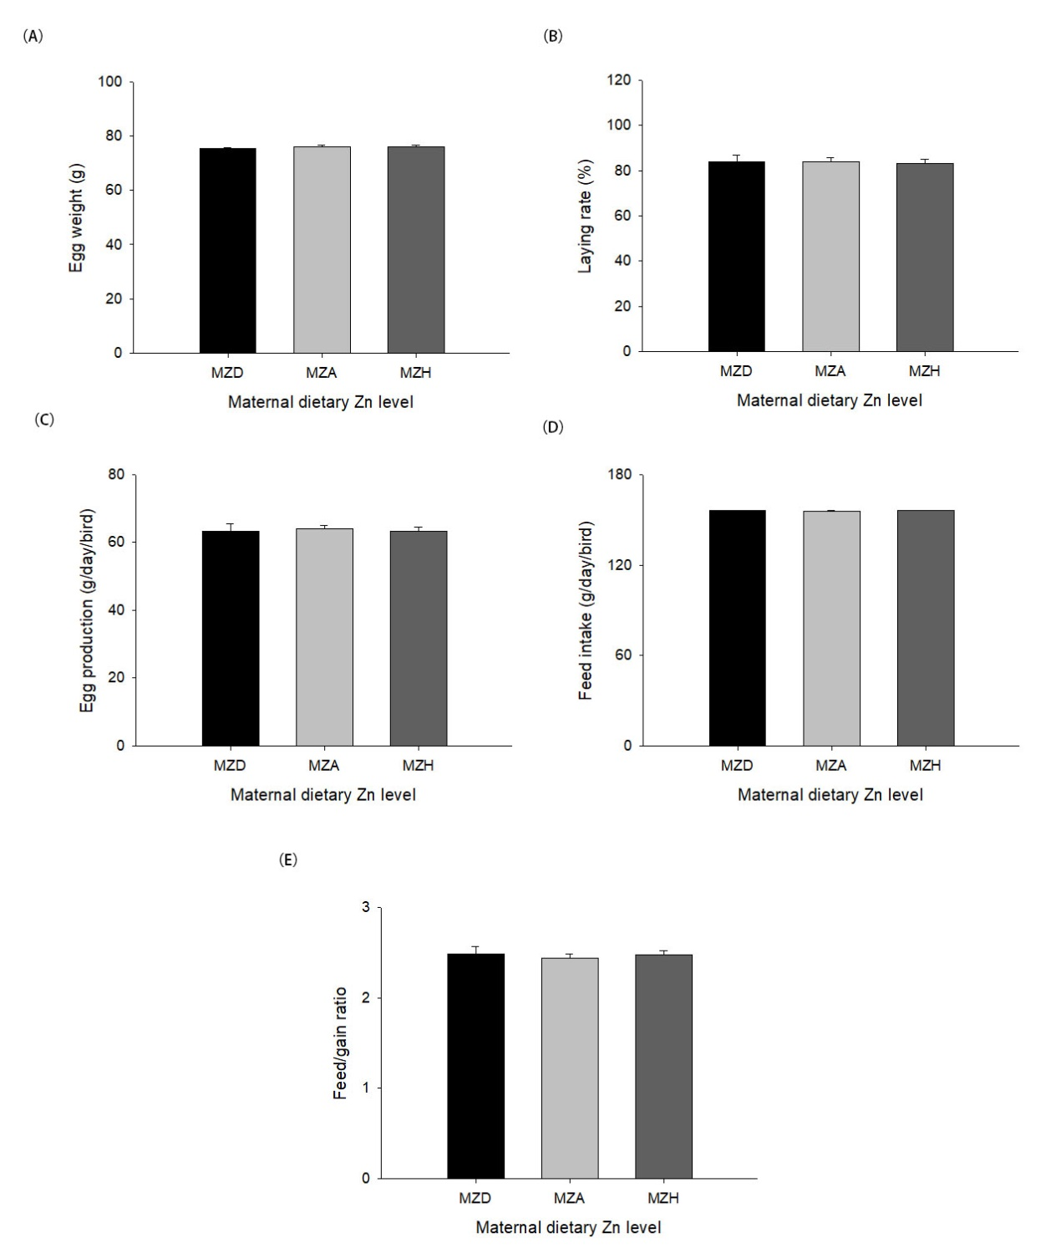
Fig. S1. Effect of maternal dietary Zn levels on egg weight (A), laying rate (B), egg production (C), feed intake (D) and feed/egg ratio (E). All values are expressed as means ± SE. MZD = maternal Zn-deficient group (0 mg Zn/kg diet); MZA = maternal Zn-adequate group (60 mg Zn/kg diet); MZH = maternal Zn-high group (120 mg Zn/kg diet).

