Supplementary Material

Supplementary Methods
These supplementary methods describe the analytical procedures and computational settings underlying the main-text analyses. Empirical findings and observed item-selection decisions are reported in the Results. All analyses were exploratory and used the development sample; independent validation was not performed.

1. Analysis sample and item responses
The development sample comprised 828 respondents: 87 in the other clinical group, 80 in the depression-symptom group, and 661 in the community group. Responses were scored 0–4.
Following exploratory item review, the full form contained 23 items: D1–D15, D17–D19, and SI1–SI5. The selected short form contained 13 items: D1, D4, D7, D8, D9, D10, D12, D14, D15, D17, SI3, SI4, and SI5. NetworkContent13 was its development identifier; after selection, it is referred to as the short form. No responses were missing on the retained items.

2. Full-pool exploratory factor analysis and item comparisons
Factor analyses were conducted in JASP 0.98.1 using polychoric correlations, principal axis factoring, and promax rotation for multifactor solutions. Factor-based parallel analysis, model fit, interpretability, and primary and cross-loadings were considered jointly. An item loading below .30 on every factor was removed during the initial exploratory review. Fixed one- through four-factor solutions were subsequently examined for the retained item set.
For each retained item, frequencies across all five response categories were examined separately within the three study groups. Proportions selecting categories 1–4 and 3–4 summarized nonzero and higher-frequency endorsement, respectively; these item-level thresholds were not diagnostic cut-offs.
Two-sided Mann–Whitney tests compared responses between the depression-symptom and other clinical groups. Rank-biserial correlations quantified differentiation, with positive values indicating higher responses in the depression-symptom group. Item-level comparisons were exploratory and did not independently determine inclusion.

3. Network estimation and bootstrap analyses
The symptom network was first inspected in JASP and subsequently estimated in R 4.5.3 using bootnet 1.9.1 (Epskamp et al., 2018). The R analysis used the extended Bayesian information criterion graphical LASSO model (EBICglasso). The automatic correlation procedure identified the 23 retained items as ordinal and estimated polychoric correlations. Network visualization used qgraph 1.9.8 (Epskamp et al., 2012). Edges were interpreted as regularized conditional associations.
Node strength was the sum of absolute edge weights attached to a node. One-step bridge expected influence, calculated using networktools 1.6.0 (Jones et al., 2021), was the signed sum of weights connecting a node to nodes in other specified communities. Communities followed the working EFA solution; network estimation did not independently validate these communities.
Edge-weight accuracy was examined using 1,000 nonparametric bootstrap replications. Separate case-dropping analyses, each with 1,000 replications, assessed the stability of strength, closeness, betweenness, and bridge expected influence. The correlation stability coefficient summarized the largest tested proportion of cases that could be dropped while retaining a correlation of at least .70 with the original estimates in at least 95% of bootstrap samples (Epskamp et al., 2018). Network indicators were considered alongside stability and clinical content, rather than interpreted as causal effects or used as a numerical selection rule.

4. Evidence review, overlap, and short-form selection
A structured evidence matrix recorded primary four-factor and general-factor loadings; five-category response distributions; between-clinical-group differences in endorsement at levels 1–4 and 3–4; rank-biserial correlations; network strength; and one-step bridge expected influence. These findings were considered alongside clinical content, correspondence to depressive and suicide-related domains, and adolescent cognitive-interview observations (World Health Organization, 2024; Patton et al., 2000; Horowitz et al., 2012). Loadings below .40 prompted review rather than automatic exclusion.
Group-specific two-by-two tables examined potential overlap and distinct coverage at both endorsement thresholds. Comparisons included SI1 versus SI2 in the context of SI3; D3 versus D6/D7; D4 versus D8; D9 versus D10; D2 versus D14; and D12 versus D13. D15 was also compared with endorsement of any other somatic or functional item among D2 and D12–D14. Discordant cells represented coverage at a specified threshold, not an item’s independent contribution to diagnostic accuracy.
An exploratory somatic-predominant profile required endorsement at levels 3–4 of at least two items among D2 and D12–D15, with none of D1, D3, D5, D6, or D7 endorsed at those levels. Frequencies were described within study groups and within the subgroup without frequent endorsement of these mood or anhedonia items. This profile was not a diagnostic rule.
Candidate construction integrated content coverage, factor representation, response patterns, group differentiation, network characteristics, potential redundancy, and clinical utility without combining the evidence domains into a numerical ranking. The complete item-level evidence matrix is provided as a separate electronic supplementary file.

5. Unweighted and provisionally weighted scoring
Unweighted totals were sums of item responses, with theoretical ranges of 0–92 for the full form and 0–52 for the short form. Display scores were transformed using:
$$Score_{100}=100×\frac{\text{Raw total}}{\text{Theoretical maximum}}$$
or
$$Score_{100}=100×\frac{\sum_{i=1}^{k}{x_{i}}}{4×k}$$
where (k) is the number of items. Transformations used theoretical rather than observed maxima. Raw sums were retained for operational interpretation.
Provisional weights were assigned through qualitative synthesis, including observed group differences, rather than by averaging statistics on different scales or numerically optimizing discrimination. Available weights ranged from 1 to 4 in increments of 0.5; assigned full-form weights ranged from 2 to 4. The full-form weighted maximum was 294. Original weights were held constant in exploratory shortened forms, including the selected short form, whose weights summed to 45 and yielded a weighted maximum of 180.
An exploratory staged reduction also examined deletion of D11, then D13, then D6, with the original weights retained. These 22-, 21-, and 20-item scores were intermediate comparisons rather than selected final forms.
Unweighted and weighted scores were compared separately in the depression-symptom versus other clinical contrast and the depression-symptom versus community contrast. AUCs accounted for ties. Each of 2,000 stratified paired bootstrap iterations sampled respondents with replacement within each group, preserving group sizes and applying identical sampled indices to both scoring methods. Percentile intervals were calculated for each AUC and their paired difference. These analyses quantify apparent discrimination conditional on the developed items and weights; they do not correct development optimism (Collins et al., 2024).

6. Ridge regression and nested cross-validation
For the fixed short-form configuration, unweighted and provisionally weighted scores were compared with ridge logistic regression separately within each binary contrast. Models used glmnet 4.1-10 with alpha = 0, standardized predictors, an intercept, and no class-balancing observation weights.
Twenty stratified outer five-fold partitions were generated. Within each outer training set, stratified five-fold inner cross-validation selected lambda.1se using binomial deviance. All scoring methods used identical outer partitions. AUC was calculated within each outer test fold and averaged using the number of positive–negative pairs as weights. Means, standard deviations, and ranges across repetitions describe variation across partitions, not sampling confidence intervals. Random seeds were 20260930 and 20260931 for the other clinical and community contrasts, respectively.
A final community-contrast model was fitted to all 741 eligible respondents using five-fold cross-validation, lambda.1se, and seed 20261001. Its linear score was transformed using theoretical bounds:
$$L=4\sum_{i}{\min\left(b_{i},0\right)}, U=4\sum_{i}{\max\left(b_{i},0\right)}$$
$${\text{Score}}_{0\text{–}100}=100×\frac{\sum_{i}{b_{i}}x_{i}-L}{U-L}$$
This score was not a predicted probability. The same fitted community-model score was used for exploratory uncertain-interval analyses in both contrasts. Those analyses differed from the contrast-specific models evaluated through nested cross-validation.
Cross-validation addressed regression fitting conditional on the selected items. It did not repeat earlier item selection or subsequent threshold selection.

7. Algorithm-estimated uncertain intervals
Uncertain-interval analyses were conducted in jamovi 2.6.44 using the jYS module (Smolyakov, 2025), with reference to Landsheer (2016, 2018). Higher scores were oriented toward the depression-symptom group. Each contrast generated its own distribution intersection and interval boundaries.
Outputs examined jointly included concordance, intersection, lower and upper boundaries, the proportion within the uncertain interval, group-specific interval counts, and classification indices for the more certain intervals. A narrower interval was not automatically considered preferable; allocation and errors outside it were also considered.
Sensitivity and specificity reported for the more certain intervals exclude respondents within the uncertain interval. The reported jYS concordance was retained as software output and was not substituted for empirical full-sample or cross-validated AUCs. An uncertain interval denotes an inconclusive score region, not a confidence interval.

8. Exploratory development and refinement of common raw-score boundaries
Common operational boundaries were examined for use across both comparison groups, separately from the contrast-specific algorithm-estimated intervals. Initial short-form pairs of 18/23 and 18/27 were explored. Lower boundaries were subsequently searched against sensitivity targets: the highest integer boundaries retaining at least 90% sensitivity were 13 for the short form and 21 for the full form; corresponding 95% targets yielded 6 and 13. These targets were adopted during analysis rather than prespecified before data inspection.
At the initial 90% sensitivity boundaries, specificity was limited. Lower boundaries were therefore increased in one-point increments from 13 to 20 for the short form and from 21 to 35 for the full form. For each candidate, analyses recorded depression-symptom respondents below the boundary, sensitivity, specificity against each comparator, and the proportion remaining between that boundary and the retained upper boundary (Tables S13–S14).
Selection considered changes in sensitivity and specificity and the additional respondents placed below the boundary. No loss function, formal optimality criterion, or independent validation procedure was used. The retained provisional lower boundaries were 19 and 32.
Upper candidates were examined separately: 23, 25, and 27 for the short form, and 44 and 45 for the full form. Group classification counts and descriptive gender and care-setting analyses informed this review. The upper boundaries of 23 and 45 were retained (Table S15).
The revised operational bands were:
- Short form: low = 0–18, intermediate = 19–22, high = 23–52.
- Full form: low = 0–31, intermediate = 32–44, high = 45–92.
Band counts and percentages were summarized within each study group and overall (Table S16). At the lower boundary, intermediate and high scores were positive; at the upper boundary, only high scores were positive. Sensitivity and specificity included all respondents in each contrast. Wilson 95% intervals describe binomial sampling precision conditional on the selected boundaries and do not account for selection uncertainty (Table 5).
Lower-boundary sensitivity was also examined descriptively by gender and age within the depression-symptom group. Selected short-form candidates were compared within these subgroups, and individual response profiles below candidate boundaries were inspected. Paired below-boundary classifications were examined to distinguish shared low results from form-specific disagreement (Table S17). These analyses did not establish subgroup-specific decision rules. Threshold stability was not evaluated.

9. Item diagnostics and internal consistency
Item means, standard deviations, corrected item–rest correlations, and omega following item omission were obtained from jamovi for each form (Table S19). Item–rest correlations used the sum of the remaining items in the corresponding form. Shared items therefore had identical means and standard deviations but potentially different item–rest correlations. Omission diagnostics were descriptive and did not reopen selection.
McDonald’s omega was estimated in the pooled sample and separately within each study group (Table S20). Outputs supplied point estimates without confidence intervals. No formal comparison of coefficients was performed. Omega was interpreted as an internal consistency estimate, not evidence of strict unidimensionality, temporal reliability, or equivalence between forms.

10. Short-form exploratory factor analyses
The fixed short form was examined in JASP 0.98.1 using polychoric correlations, principal axis factoring, and factor-based parallel analysis. A one-factor solution and a manually specified two-factor solution were inspected. Promax rotation was used for the two-factor solution.
Evaluation included loadings, uniquenesses, factor correlation, reported variance summaries, chi-square, RMSEA with 90% confidence intervals, SRMR, TLI, CFI, and BIC (Tables S21–S22). Two-factor loadings were interpreted as oblique pattern coefficients. With correlated factors, rotated variance columns were not treated as independent contributions. Pattern coefficients above 1 were noted alongside uniquenesses rather than automatically interpreted as negative-residual-variance cases.
Two parallel-analysis outputs using simulated mean eigenvalues were retained to document borderline retention decisions. The manually specified two-factor solution was not determined by its accompanying parallel-analysis output. Later negative eigenvalues were not interpreted as retained symptom dimensions. No three- or four-factor short-form solution was examined.

11. Paired form comparisons
Unweighted short- and full-form AUCs were compared separately against each comparator. AUC was calculated from average ranks, assigning tied positive–negative pairs half credit. In each of 2,000 stratified paired bootstrap iterations, the same sampled respondents were used for both forms. Intervals were the 2.5th and 97.5th percentiles of the AUC and short-minus-full distributions. Seeds were 20261002 and 20261003 for the other clinical and community contrasts.
All scores were included irrespective of band. No equivalence margin was specified. Fixed-form bootstrap intervals do not correct earlier item-selection optimism.
Three-by-three cross-tabulations placed short-form bands in rows and full-form bands in columns (Table S18). Exact agreement and directional disagreement were calculated within groups and overall (Table 6). Extreme disagreement meant low versus high classification. Neither form was a reference standard. Group-specific results were retained because the community group contributed most observations to overall agreement.

12. Descriptive and subgroup analyses
Descriptive summaries included sample size, mean, standard deviation, median, first and third quartiles, and observed range on raw and 0–100 scales (Table S23). R default quantiles were used.
Gender comparisons used two-sided asymptotic Mann–Whitney tests with continuity correction and tie-adjusted variance within each study group. Rank-biserial correlations were oriented so positive values indicated higher female scores. Holm adjustment covered the three comparisons. Non-binary respondents were described without inferential comparisons (Table S24).
Age-group codes were verified against recorded ages: 13–14, 15–16, and 17–19. Kruskal–Wallis tests were conducted within each study group, with Holm adjustment across three omnibus tests. Pairwise Mann–Whitney comparisons followed the significant adjusted community test, using a separate Holm family of three comparisons (Table S25).
Care-setting comparisons used separate Kruskal–Wallis tests within the two clinical groups, with Holm adjustment across two tests. Five other clinical respondents lacked care-setting information and were excluded, leaving 82 other clinical and 80 depression-symptom respondents. Community respondents’ care codes were structurally inapplicable. No pairwise care comparisons followed (Table S26).
Holm families represented separate exploratory domains rather than a study-wide correction. Analyses were unadjusted for other covariates; measurement invariance and differential item functioning were not assessed.

13. WHO-5 associations and scope of criterion analyses
Pearson correlations with WHO-5 used 766 available paired observations; the inter-form correlation used all 828 respondents (Table S27). Reported 95% confidence intervals accompanied each correlation. WHO-5 scores were unavailable for 62 respondents; no imputation or missingness adjustment was performed. The dependent WHO-5 correlations were not formally compared.
Lifetime suicide-attempt history and the separate death/suicidal-ideation indicator were outside the final criterion-analysis scope. Their lifetime time frame or overlap with screening content limited their suitability as independent current-depression criteria. Suicide prediction was not evaluated. Suicide-related item responses were considered separately from total-score interpretation.

14. Distribution figures
Figures S5–S6 were generated in R 4.5.3 using ggplot2 4.0.2. Violins were scaled to equal maximum width and overlaid with boxplots. Reference lines marked the revised provisional boundaries of 19 and 23 for the short form and 32 and 45 for the full form. Figures were exported as 600-dpi PNG files and vector PDFs.

Supplementary Table S1
Psychometric comparison and operational characteristics of widely used adolescent depression screening and diagnostic instruments Relative to the Proposed Instrument
Instrument (Abbr.) | Items & recall | Framework & focus | Target population & validation setting | Key strengths | Operational limitations
PHQ-A / PHQ-9 (Johnson et al., 2002) | 9 items; Past 2 weeks | Classical Test Theory (CTT); directly maps onto DSM criteria; includes functional item. | Primary care youth (11–18); validated against clinician-rated structured interviews. | Rapid administration; highly familiar in medical triage; direct suicide risk query. | Direct adaptation of adult criteria; limited coverage of adolescent-specific features (irritability, somatic masks).
MFQ / SMFQ (Costello & Angold, 1988; Angold et al., 1995) | 33 items (full), 13 items (short); Past 2 weeks | Clinical & epidemiological screening; developmental symptom focus. | Community cohorts and child/adolescent outpatient clinical settings. | High sensitivity to dynamic affective shifts; validated parallel parent-report version. | Elevated false-positive rates in heterogeneous clinical samples; 33-item form is lengthy for triage.
CDI-2 (Kovacs, 2011) | 28 items (full), 12 items (short); Past 2 weeks | CTT / Multifactorial model; assesses Emotional and Functional/Behavioral domains. | School-based normative cohorts vs. outpatient child/adolescent psychiatric samples. | Robust developmental norms; separates subjective distress from functional/behavioral difficulties. | Proprietary/commercial license; full 28-item form is resource-intensive for rapid intake.
RADS-2 (Reynolds, 2002) | 30 items; Past few days | Developmental psychopathology; evaluates dysphoric mood, anhedonia, negative affect, and somatic complaints. | Broad community normative samples; adolescent psychiatric inpatients and outpatients (12–18). | Comprehensive developmental construct coverage; captures core depressive subscales. | Lengthy administration; lacks direct alignment with ICD-11 severity gradients; proprietary license.
BDI-Y / BYI-II (Beck et al., 2005) | 20 items; Past 2 weeks | CTT / Cognitive behavioral theory; targets cognitive distortions and negative self-schemas. | Community and clinical youth samples (ages 7–18). | Deep operationalization of negative self-evaluation and cognitive schemas. | Proprietary; primarily designed for psychotherapy planning rather than medical triage; adult model adaptation.
CES-DC (Radloff, 1991) | 20 items; Past 1 week | Epidemiological surveillance; assesses general emotional and behavioral distress. | Large-scale school cohorts; population-level youth mental health monitoring (6–17). | Public domain / freely accessible; established international population benchmark. | Lacks clinical specificity; conflates diffuse emotional distress with depressive episode; poor triage utility.
ODSIS (Bentley et al., 2014) | 5 items; Past 1 week | Functional psychometrics; prioritizes symptom severity and functional interference. | Outpatient adults and young adults; emerging adaptations in youth mental health. | Ultra-brief; high sensitivity to functional impairment and treatment monitoring. | Assumes depressive presentation is already established; does not capture symptom topologies or specific risks.
Proposed Tool (Net-DS) (Current Study) | Full & Short forms; Past 2 weeks / current | Integrative: ICD-11 symptom gradients (mild, moderate, severe) + Network psychometrics & factor structure. | Direct multi-group contrast: Depressed clinical vs. Active non-depressed clinical controls vs. Community comparison group. | Grounded in ICD-11 severity gradients and adolescent wording; network-informed selection reduces collinearity; evaluated against active clinical controls with uncertain interval modeling. | Initial cross-sectional evaluation requiring ongoing independent multi-site replication.
Note. CTT = Classical Test Theory; DSM = Diagnostic and Statistical Manual of Mental Disorders; ICD-11 = International Classification of Diseases, 11th Revision.

Table S2
Fit of exploratory factor models for the 23-item pool
Number of factors | χ² | df | RMSEA | 90% CI for RMSEA | SRMR | TLI | CFI | BIC
1 | 4,356.41 | 230 | .147 | [.143, .151] | .060 | .763 | .785 | 2,811.03
2 | 2,040.70 | 208 | .103 | [.099, .107] | .034 | .884 | .905 | 643.15
3 | 1,577.44 | 187 | .095 | [.091, .099] | .028 | .902 | .928 | 320.99
4 | 1,164.48 | 167 | .085 | [.080, .090] | .021 | .921 | .948 | 42.41
Note. N = 828. Models were estimated in JASP (Version 0.98.1) from a polychoric correlation matrix using principal axis factoring. Multifactor solutions used promax rotation. The models contain the same 23 items, after exclusion of D16. CI = confidence interval; RMSEA = root mean square error of approximation; SRMR = standardized root mean square residual; TLI = Tucker–Lewis index; CFI = comparative fit index; BIC = Bayesian information criterion. All model χ² tests had p < .001.

Table S3
Item loadings and uniqueness in the one- and four-factor solutions
Item | One-factor loading | One-factor uniqueness | F1 | F2 | F3 | F4 | Four-factor uniqueness
F1 – Suicidal ideation
SI2 | .852 | .275 | .918 | .026 | −.063 | .100 | .091
SI3 | .869 | .246 | .914 | .017 | .005 | .062 | .062
SI1 | .839 | .297 | .875 | .035 | .036 | .013 | .126
SI5 | .842 | .290 | .870 | .111 | −.049 | .030 | .129
SI4 | .803 | .355 | .693 | −.143 | .415 | −.050 | .189
F2 – Emotional and cognitive symptoms
D3 | .779 | .394 | −.006 | .879 | −.025 | .005 | .263
D7 | .808 | .347 | .067 | .759 | .128 | −.075 | .268
D6 | .747 | .442 | .107 | .641 | −.096 | .183 | .373
D5 | .840 | .295 | −.012 | .577 | .252 | .113 | .249
D1 | .786 | .383 | −.118 | .519 | .236 | .245 | .308
D8 | .882 | .222 | .357 | .482 | .278 | −.152 | .177
D4 | .818 | .331 | .093 | .457 | .292 | .063 | .315
D18 | .777 | .396 | .162 | .418 | .110 | .181 | .388
F3 – Negative self-evaluation and interpersonal distress
D10 | .816 | .335 | .073 | .137 | .741 | −.044 | .233
D9 | .808 | .347 | .166 | .200 | .648 | −.123 | .263
D11 | .735 | .459 | .076 | .014 | .501 | .249 | .414
D19 | .656 | .570 | −.014 | −.064 | .489 | .350 | .495
D17 | .814 | .337 | .194 | .167 | .443 | .108 | .322
F4 – Somatic and activity-related symptoms
D14 | .566 | .679 | .100 | −.113 | −.041 | .756 | .499
D15 | .680 | .538 | .055 | −.102 | .281 | .576 | .433
D12 | .665 | .558 | −.045 | .306 | −.047 | .567 | .426
D2 | .686 | .529 | −.130 | .306 | .073 | .555 | .390
D13 | .629 | .604 | .109 | .354 | −.138 | .403 | .535
Unrotated eigenvalue | 13.771 | -- | 13.870 | 1.243 | .502 | .438 | --
Proportion of variance after rotation, % | 59.9 | -- | 21.1 | 20.8 | 15.3 | 12.6 | --
Cumulative proportion after rotation, % | 59.9 | -- | 21.1 | 41.9 | 57.2 | 69.8 | --
Note. N = 828. EFA = exploratory factor analysis; PAF = principal axis factoring. The four-factor solution was retained based on parallel analysis. EFA was conducted using a polychoric correlation matrix, PAF extraction, and promax rotation. Factor loadings correspond to the pattern matrix, and loadings $≥$ |.40| are presented in boldface. Item uniqueness estimates ($u^{2}$) are reported separately for the unidimensional (one-factor) and four-factor solutions.
Table S4
Item response distributions across the general population, other clinical, and depression-Symptom Groups
Item | Group | Responce category
Item | Group | 0 | 1 | 2 | 3 | 4
D1 | General population | 12.9% | 28.4% | 33.3% | 16.3% | 9.1%
D1 | Other clinical | 16.1% | 21.8% | 37.9% | 17.2% | 6.9%
D1 | Depression | 3.8% | 6.3% | 22.5% | 31.3% | 36.3%
D2 | General population | 8.8% | 24.8% | 25.0% | 25.1% | 16.3%
D2 | Other clinical | 20.7% | 18.4% | 27.6% | 21.8% | 11.5%
D2 | Depression | 5.0% | 6.3% | 21.3% | 27.5% | 40.0%
D3 | General population | 32.7% | 30.7% | 21.5% | 9.5% | 5.6%
D3 | Other clinical | 43.7% | 19.5% | 19.5% | 11.5% | 5.7%
D3 | Depression | 7.5% | 12.5% | 25.0% | 23.8% | 31.3%
D4 | General population | 45.5% | 26.0% | 15.9% | 7.3% | 5.3%
D4 | Other clinical | 43.7% | 21.8% | 19.5% | 10.3% | 4.6%
D4 | Depression | 7.5% | 15.0% | 27.5% | 20.0% | 30.0%
D5 | General population | 31.6% | 33.0% | 20.6% | 11.0% | 3.8%
D5 | Other clinical | 29.9% | 28.7% | 26.4% | 11.5% | 3.4%
D5 | Depression | 7.5% | 11.3% | 23.8% | 26.3% | 31.3%
D6 | General population | 40.2% | 25.7% | 17.9% | 10.3% | 5.9%
D6 | Other clinical | 49.4% | 18.4% | 14.9% | 9.2% | 8.0%
D6 | Depression | 16.3% | 12.5% | 16.3% | 26.3% | 28.8%
D7 | General population | 49.9% | 26.9% | 14.8% | 6.2% | 2.1%
D7 | Other clinical | 54.0% | 14.9% | 18.4% | 6.9% | 5.7%
D7 | Depression | 11.3% | 16.3% | 25.0% | 21.3% | 26.3%
D8 | General population | 53.6% | 21.6% | 13.2% | 6.7% | 5.0%
D8 | Other clinical | 55.2% | 13.8% | 23.0% | 1.1% | 6.9%
D8 | Depression | 6.3% | 15.0% | 27.5% | 16.3% | 35.0%
D9 | General population | 51.7% | 21.9% | 13.6% | 8.3% | 4.4%
D9 | Other clinical | 52.9% | 21.8% | 13.8% | 5.7% | 5.7%
D9 | Depression | 15.0% | 16.3% | 17.5% | 25.0% | 26.3%
D10 | General population | 41.8% | 28.0% | 14.5% | 8.3% | 7.4%
D10 | Other clinical | 39.1% | 27.6% | 19.5% | 11.5% | 2.3%
D10 | Depression | 13.8% | 16.3% | 21.3% | 16.3% | 32.5%
D11 | General population | 40.8% | 26.3% | 18.5% | 8.5% | 5.9%
D11 | Other clinical | 41.4% | 21.8% | 16.1% | 10.3% | 10.3%
D11 | Depression | 18.8% | 10.0% | 31.3% | 22.5% | 17.5%
D12 | General population | 21.8% | 28.7% | 21.6% | 17.7% | 10.1%
D12 | Other clinical | 39.1% | 26.4% | 23.0% | 10.3% | 1.1%
D12 | Depression | 10.0% | 11.3% | 23.8% | 23.8% | 31.3%
D13 | General population | 48.7% | 29.2% | 12.4% | 6.7% | 3.0%
D13 | Other clinical | 69.0% | 12.6% | 12.6% | 3.4% | 2.3%
D13 | Depression | 21.3% | 18.8% | 30.0% | 16.3% | 13.8%
D14 | General population | 25.3% | 26.6% | 21.2% | 13.9% | 13.0%
D14 | Other clinical | 32.2% | 26.4% | 18.4% | 11.5% | 11.5%
D14 | Depression | 10.0% | 12.5% | 25.0% | 16.3% | 36.3%
D15 | General population | 36.3% | 19.5% | 19.2% | 14.4% | 10.6%
D15 | Other clinical | 36.8% | 23.0% | 21.8% | 14.9% | 3.4%
D15 | Depression | 16.3% | 11.3% | 26.3% | 23.8% | 22.5%
D17 | General population | 33.9% | 28.6% | 20.3% | 7.7% | 9.5%
D17 | Other clinical | 43.7% | 21.8% | 21.8% | 9.2% | 3.4%
D17 | Depression | 11.3% | 11.3% | 22.5% | 23.8% | 31.3%
D18 | General population | 47.2% | 25.0% | 15.9% | 7.3% | 4.7%
D18 | Other clinical | 55.2% | 16.1% | 19.5% | 6.9% | 2.3%
D18 | Depression | 15.0% | 18.8% | 26.3% | 21.3% | 18.8%
D19 | General population | 44.8% | 26.2% | 14.2% | 8.3% | 6.5%
D19 | Other clinical | 36.8% | 20.7% | 27.6% | 10.3% | 4.6%
D19 | Depression | 15.0% | 20.0% | 23.8% | 17.5% | 23.8%
SI1 | General population | 68.1% | 15.3% | 7.7% | 4.7% | 4.2%
SI1 | Other clinical | 81.6% | 4.6% | 5.7% | 2.3% | 5.7%
SI1 | Depression | 18.8% | 16.3% | 17.5% | 22.5% | 25.0%
SI2 | General population | 70.7% | 14.8% | 5.9% | 5.6% | 3.0%
SI2 | Other clinical | 82.8% | 6.9% | 4.6% | 2.3% | 3.4%
SI2 | Depression | 25.0% | 20.0% | 10.0% | 20.0% | 25.0%
SI3 | General population | 75.3% | 12.4% | 5.9% | 2.6% | 3.8%
SI3 | Other clinical | 80.5% | 9.2% | 3.4% | 2.3% | 4.6%
SI3 | Depression | 22.5% | 20.0% | 20.0% | 12.5% | 25.0%
SI4 | General population | 69.1% | 16.0% | 7.7% | 3.9% | 3.2%
SI4 | Other clinical | 71.3% | 13.8% | 8.0% | 2.3% | 4.6%
SI4 | Depression | 22.5% | 26.3% | 16.3% | 13.8% | 21.3%
SI5 | General population | 82.6% | 9.1% | 3.5% | 2.0% | 2.9%
SI5 | Other clinical | 87.4% | 4.6% | 4.6% | 2.3% | 1.1%
SI5 | Depression | 31.3% | 25.0% | 13.8% | 10.0% | 20.0%
Note. Values are the number and percentage of participants selecting each response category for each item. Percentages are calculated within groups: general population (n = 661), other clinical group (n = 87), and depression-symptom group (n = 80); N = 828. Response categories were coded as follows: 0 = never or not at all; 1 = one or two days; 2 = some days; 3 = most days; and 4 = every or almost every day.

Table S5
Proportions endorsing each item at two response thresholds across the three groups
Item | General population 1–4 | Other clinical 1–4 | Depression 1–4 | Difference 1–4 (pp) | General population 3–4 | Other clinical 3–4 | Depression 3–4 | Difference 3–4 (pp)
D1 | 87.1% | 83.9% | 96.3% | +12.3 | 25.4% | 24.1% | 67.5% | +43.4
D2 | 91.2% | 79.3% | 95.0% | +15.7 | 41.5% | 33.3% | 67.5% | +34.2
D3 | 67.3% | 56.3% | 92.5% | +36.2 | 15.1% | 17.2% | 55.0% | +37.8
D4 | 54.5% | 56.3% | 92.5% | +36.2 | 12.6% | 14.9% | 50.0% | +35.1
D5 | 68.4% | 70.1% | 92.5% | +22.4 | 14.8% | 14.9% | 57.5% | +42.6
D6 | 59.8% | 50.6% | 83.8% | +33.2 | 16.2% | 17.2% | 55.0% | +37.8
D7 | 50.1% | 46.0% | 88.8% | +42.8 | 8.3% | 12.6% | 47.5% | +34.9
D8 | 46.4% | 44.8% | 93.8% | +48.9 | 11.6% | 8.0% | 51.3% | +43.2
D9 | 48.3% | 47.1% | 85.0% | +37.9 | 12.7% | 11.5% | 51.3% | +39.8
D10 | 58.2% | 60.9% | 86.3% | +25.3 | 15.7% | 13.8% | 48.8% | +35.0
D11 | 59.2% | 58.6% | 81.3% | +22.6 | 14.4% | 20.7% | 40.0% | +19.3
D12 | 78.2% | 60.9% | 90.0% | +29.1 | 27.8% | 11.5% | 55.0% | +43.5
D13 | 51.3% | 31.0% | 78.8% | +47.7 | 9.7% | 5.7% | 30.0% | +24.3
D14 | 74.7% | 67.8% | 90.0% | +22.2 | 26.9% | 23.0% | 52.5% | +29.5
D15 | 63.7% | 63.2% | 83.8% | +20.5 | 25.0% | 18.4% | 46.3% | +27.9
D17 | 66.1% | 56.3% | 88.8% | +32.4 | 17.2% | 12.6% | 55.0% | +42.4
D18 | 52.8% | 44.8% | 85.0% | +40.2 | 12.0% | 9.2% | 40.0% | +30.8
D19 | 55.2% | 63.2% | 85.0% | +21.8 | 14.8% | 14.9% | 41.3% | +26.3
SI1 | 31.9% | 18.4% | 81.3% | +62.9 | 8.9% | 8.0% | 47.5% | +39.5
SI2 | 29.3% | 17.2% | 75.0% | +57.8 | 8.6% | 5.7% | 45.0% | +39.3
SI3 | 24.7% | 19.5% | 77.5% | +58.0 | 6.4% | 6.9% | 37.5% | +30.6
SI4 | 30.9% | 28.7% | 77.5% | +48.8 | 7.1% | 6.9% | 35.0% | +28.1
SI5 | 17.4% | 12.6% | 68.8% | +56.1 | 4.8% | 3.4% | 30.0% | +26.6
Note. Percentages were calculated within each group: general population (n = 661), other clinical group (n = 87), and depression-symptoms group (n = 80). Responses were coded on a five-category scale as follows: 0 = never or not at all; 1 = one or two days; 2 = some days; 3 = most days; and 4 = every or almost every day. “Responses 1–4” denotes any response above 0, whereas “responses 3–4” denotes the two highest response categories. Percentage-point differences were calculated by subtracting the percentage in the other clinical group from the percentage in the depression-symptoms group; positive values indicate a higher percentage in the depression-symptoms group. These thresholds are descriptive summaries of item responses and should not be interpreted as diagnostic cutoffs. There were no missing item responses. D16 was excluded from the retained item pool.

Table S6
Item responses in the two clinical groups and Mann–Whitney comparisons
Item | Other clinical: Mdn [IQR] | Depression symptoms:  Mdn [IQR] | U | r_{rb} | Other clinical: 3–4 (%) | Depression symptoms:  3–4 (%)
Emotional and cognitive symptoms
D3 | 1 [2] | 3 [2] | 1535.5 | .559 | 17.2 | 55.0
D7 | 0 [2] | 2 [3] | 1575.5 | .547 | 12.6 | 47.5
D6 | 1 [2] | 3 [3] | 1802.5 | .482 | 17.2 | 55.0
D5 | 1 [2] | 3 [2] | 1551.5 | .554 | 14.9 | 57.5
D1 | 2 [1] | 3 [2] | 1657.0 | .524 | 24.1 | 67.5
D8 | 0 [2] | 3 [2] | 1253.5 | .640 | 8.0 | 51.2
D4 | 1 [2] | 2.5 [2] | 1539.0 | .558 | 14.9 | 50.0
D18 | 0 [2] | 2 [2] | 1682.5 | .517 | 9.2 | 40.0
Negative self-evaluation and related symptoms
D10 | 1 [2] | 2 [3] | 1768.5 | .492 | 13.8 | 48.8
D9 | 0 [1.5] | 3 [3] | 1604.0 | .539 | 11.5 | 51.2
D11 | 1 [2] | 2 [2] | 2298.0 | .340 | 20.7 | 40.0
D19 | 1 [2] | 2 [2] | 2220.0 | .362 | 14.9 | 41.2
D17 | 1 [2] | 3 [2] | 1507.0 | .567 | 12.6 | 55.0
Somatic and functional symptoms
D14 | 1 [2] | 3 [2] | 1959.0 | .437 | 23.0 | 52.5
D15 | 1 [2] | 2 [2] | 2071.0 | .405 | 18.4 | 46.2
D12 | 1 [2] | 3 [2] | 1430.5 | .589 | 11.5 | 55.0
D2 | 2 [2] | 3 [2] | 1903.0 | .453 | 33.3 | 67.5
D13 | 0 [1] | 2 [2] | 1600.0 | .540 | 5.7 | 30.0
Suicidal ideation
SI2 | 0 [0] | 2 [2.5] | 1362.0 | .609 | 5.7 | 45.0
SI3 | 0 [0] | 2 [2.25] | 1354.0 | .611 | 6.9 | 37.5
SI1 | 0 [0] | 2 [2.25] | 1245.5 | .642 | 8.0 | 47.5
SI5 | 0 [0] | 1 [3] | 1484.0 | .574 | 3.4 | 30.0
SI4 | 0 [1] | 2 [2] | 1619.5 | .535 | 6.9 | 35.0
Note. The other clinical group comprised 87 participants and the depression-symptoms group comprised 80 participants. Mdn = median; IQR = interquartile range; r_{rb} = rank-biserial correlation. All items were scored from 0 to 4. The percentages in the last two columns refer to responses of 3 or 4 within each group. Positive r_{rb} values indicate higher responses in the depression-symptoms group. All two-sided Mann–Whitney tests yielded p < .001 in the JASP output. These are comparisons within the development sample and do not establish diagnostic accuracy in an independent sample.

Table S7
Exploratory somatic or functional symptom profile across the three study groups

A Profile frequency and denominators
Group | Total n | No selected core item ≥3, n | Profile, n | Profile in full group, % | Profile in no-core subgroup, %
Community | 661 | 419 | 83 | 12.6 | 19.8
Other clinical | 87 | 56 | 8 | 9.2 | 14.3
Depression-symptoms | 80 | 22 | 10 | 12.5 | 45.5

B Number of frequent somatic or functional symptoms in the no-core subgroup
Group | Subgroup n | 0 | 1 | 2 | 3 | 4 | 5
Community | 419 | 260 | 76 | 54 | 22 | 7 | 0
Other clinical | 56 | 37 | 11 | 4 | 3 | 1 | 0
Depression-symptoms | 22 | 11 | 1 | 7 | 3 | 0 | 0
Note. The profile required responses 3–4 on at least two of D2 (fatigue or low energy), D12 (concentration difficulty), D13 (slowing of thought, speech, or movement), D14 (sleep problems), and D15 (appetite change), and responses below 3 on all five specified core items: D1 (depressed mood), D3 (indifference or loss of interest or pleasure), D5 (unhappiness), D6 (loss of interest), and D7 (inability to experience pleasure). “No-core subgroup” is shorthand for no response 3–4 on these five items; it does not denote absence of depressive symptoms.
Categories 3–4 indicate higher reported frequency during the preceding two weeks, not independently established diagnostic severity. In panel A, full-group percentages use total group n, whereas subgroup percentages use the number without frequent endorsement of the selected core items. In panel B, counts refer only to that subgroup; the sum of columns 2–5 equals the profile count in panel A. Percentages are rounded to one decimal place. This analysis uses individual item responses; 0–100 total-score transformation is not involved.
Among the ten depression-symptoms participants meeting the profile definition, frequent endorsement occurred for D14 in ten, D2 in six, D12 in three, D13 in one, and D15 in three. These counts overlap because each participant endorsed at least two somatic or functional items. The profile was defined using those items, so their frequency among qualifying participants does not establish causal or incremental diagnostic importance.

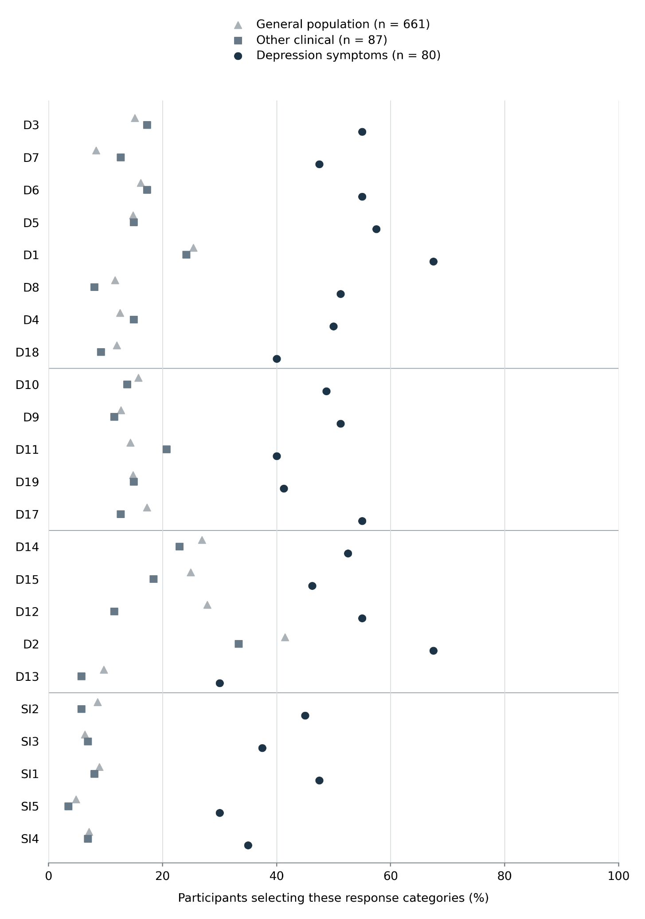

Image S1
Proportions Endorsing Higher-Frequency Symptoms Across the Three Study Groups
Note. Points indicate the percentage of participants selecting response categories 3–4 for each item. These categories represent higher-frequency endorsement during the preceding two weeks, not independently established clinical severity. Horizontal lines separate item groups defined by the working four-factor solution. General population: n = 661; other clinical group: n = 87; depression-symptoms group: n = 80.

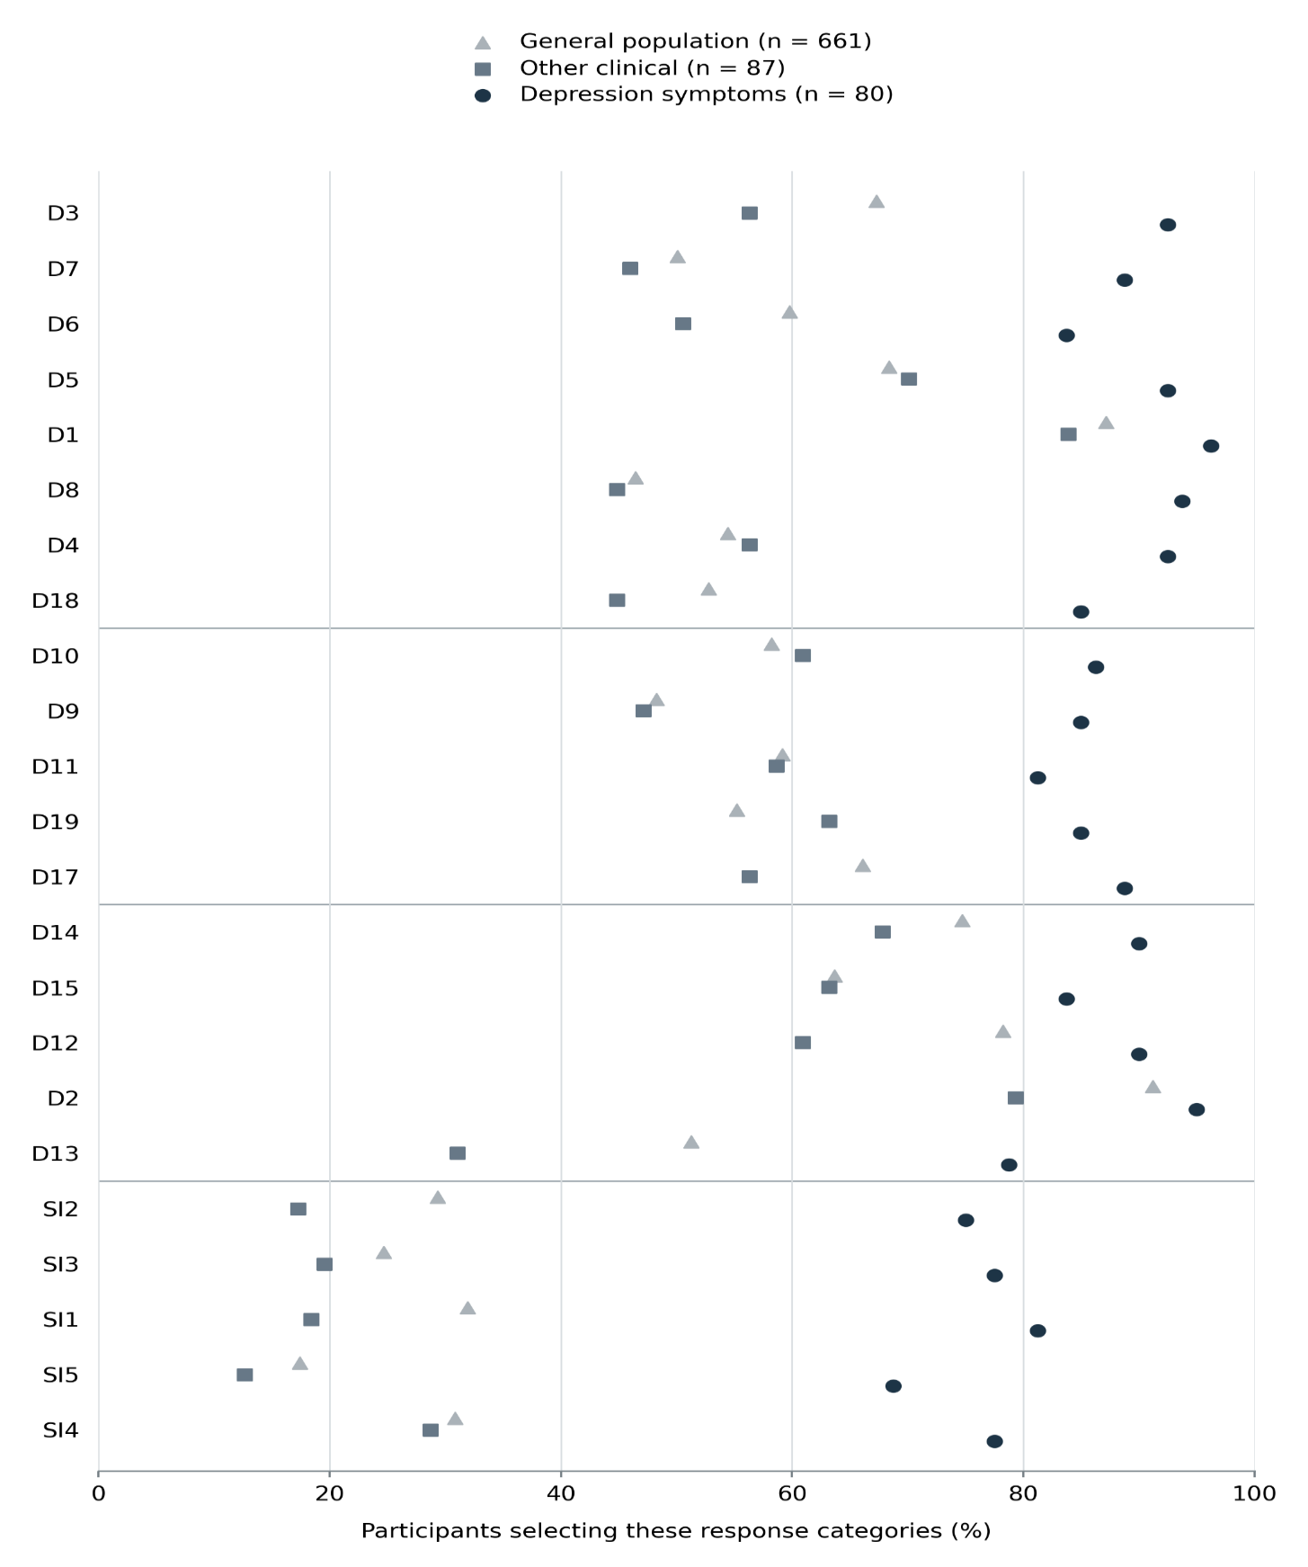
Image S2
Proportions Reporting Any Nonzero Symptom Endorsement Across the Three Study Groups
Note. Points indicate the percentage of participants selecting response categories 1–4 for each item, representing any nonzero endorsement during the preceding two weeks. Nonzero endorsement does not by itself indicate clinically significant symptoms or a depressive disorder. Horizontal lines separate item groups defined by the working four-factor solution. General population: n = 661; other clinical group: n = 87; depression-symptoms group: n = 80.

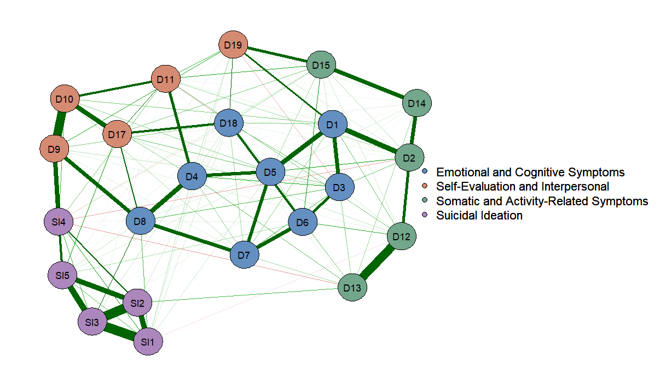
Image S3
Estimated Regularized Partial Correlation Network of the 23 Retained Depression and Suicidal Ideation Items
Note. The network was estimated in R using the bootnet package and visualized using qgraph. Node colors indicate the four item groups defined by the exploratory factor analysis. “Self-Evaluation and Interpersonal” in the legend refers to the Negative Self-Evaluation and Interpersonal Distress factor. Edge thickness represents the magnitude of the estimated association between items.

Image S4
Case-dropping bootstrap stability of one-step bridge expected influence
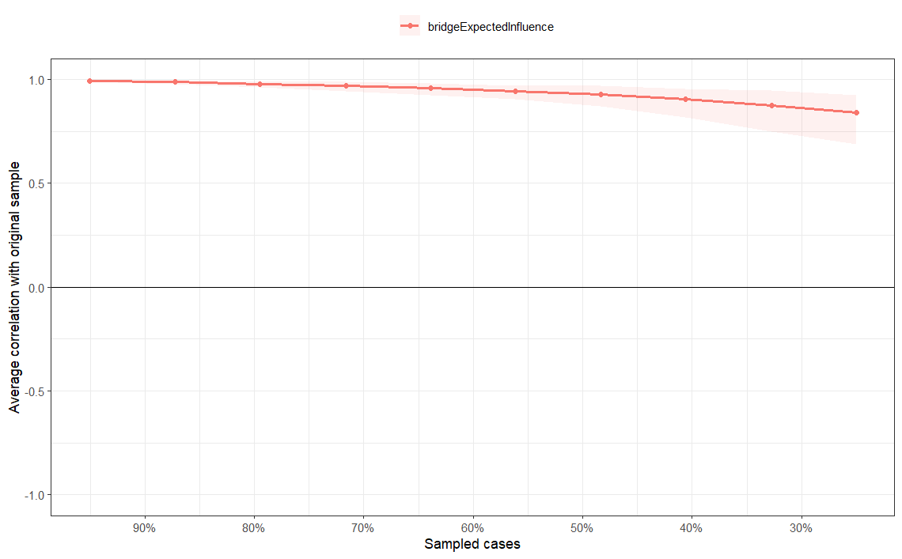
Image S4
Case-dropping bootstrap stability of one-step bridge expected influence
Note. Stability was evaluated using 1,000 case-dropping bootstrap replications for the 23-item symptom network. The horizontal axis shows the percentage of respondents retained; the vertical axis shows the average correlation between bridge expected influence estimates in the reduced samples and those in the original sample. The line represents the mean correlation, and the shaded area represents the 2.5th–97.5th percentile range. The correlation stability coefficient was CS(.70) = .75. Bridge communities were defined from the working exploratory factor solution.

Supplementary Table S8
Node strength and one-step bridge expected influence in the 23-Item symptom network
EFA-derived item group | Item | Strength | Bridge expected influence
Suicidal Ideation | SI1 | 0.999 | 0.168
 | SI2 | 1.089 | 0.110
 | SI3 | 1.251 | 0.190
 | SI4 | 1.032 | 0.290
 | SI5 | 0.999 | 0.211
Emotional and Cognitive Symptoms | D1 | 1.117 | 0.557
 | D3 | 1.020 | 0.127
 | D4 | 0.973 | 0.384
 | D5 | 1.105 | 0.324
 | D6 | 0.932 | 0.294
 | D7 | 0.957 | 0.101
 | D8 | 1.123 | 0.584
 | D18 | 1.005 | 0.493
Negative Self-Evaluation and Interpersonal Distress | D9 | 0.996 | 0.536
 | D10 | 1.019 | 0.304
 | D11 | 0.912 | 0.461
 | D17 | 0.939 | 0.587
 | D19 | 0.813 | 0.500
Somatic and Activity-Related Symptoms | D2 | 0.997 | 0.485
 | D12 | 0.965 | 0.298
 | D13 | 0.793 | 0.305
 | D14 | 0.686 | 0.074
 | D15 | 0.894 | 0.586
Note. N = 828. Item groups were specified from the exploratory four-factor solution and were not identified independently by the network analysis. Strength is the sum of the absolute weights of a node’s connections to all other nodes. One-step bridge expected influence is the signed sum of its connection weights to nodes in the other three specified groups. The network was estimated in R using bootnet; bridge expected influence was calculated using networktools. In case-dropping bootstrap analyses, the correlation stability coefficient was .361 for strength and at least .750 for bridge expected influence; .750 was the largest case-dropping proportion tested. Values are rounded to three decimal places.

Supplementary Table S9a

Community group versus depression-symptoms group: Other clinical group versus depression-symptoms group
Form | AUC | UI limits | UI n/N (%) | Comparison below / UI / above | Depression below / UI / above
Full23 | 0.868 | 34.8–48.9 | 37/167 (22.2) | 62 / 18 / 7 | 12 / 19 / 49
EFA12A Loading | 0.871 | 33.3–50.0 | 41/167 (24.6) | 61 / 21 / 5 | 14 / 20 / 46
EFA12B Content | 0.875 | 29.2–50.0 | 51/167 (30.5) | 54 / 27 / 6 | 10 / 24 / 46
EFA12C SI5 | 0.876 | 27.1–54.2 | 62/167 (37.1) | 51 / 33 / 3 | 10 / 29 / 41
Prior12 | 0.867 | 37.5–47.9 | 28/167 (16.8) | 60 / 14 / 13 | 13 / 14 / 53
Integrative13 | 0.877 | 34.6–53.8 | 42/167 (25.1) | 59 / 22 / 6 | 13 / 20 / 47
Integrative14 D18 | 0.856 | 39.3–44.6 | 15/167 (9.0) | 66 / 6 / 15 | 14 / 9 / 57
NetworkContent13 | 0.876 | 34.6–51.9 | 43/167 (25.7) | 60 / 22 / 5 | 13 / 21 / 46
NetworkContent14 D6 | 0.866 | 35.7–50.0 | 33/167 (19.8) | 64 / 15 / 8 | 14 / 18 / 48
Note. N = total sample size; n = subsample size. The comparison group comprises n = 87 other clinical participants. The depression-symptoms group comprises n = 80. AUC = area under the receiver operating characteristic curve; UI = uncertain interval. Scores were transformed to a 0–100 metric. "Below" and "above" refer to participants scoring outside each form’s empirically estimated UI boundaries; the UI denotes an inconclusive score zone rather than a confidence interval. AUC summarizes overall diagnostic ranking across the entire score range, whereas interval counts describe classification accuracy outside the indeterminate range. Estimates are derived from the development sample and are not optimism-corrected. NetworkContent13 and Full23 represent the short form and full form evaluated in subsequent analyses.

Table S9b

Comparison of principal candidate short forms against the full-length scale: Community group versus depression-symptoms group
Form | AUC | UI limits | UI n/N (%) | Comparison below / UI / above | Depression below / UI / above
Full23 | 0.836 | 35.9–47.8 | 104/741 (14.0) | 472 / 91 / 98 | 14 / 13 / 53
EFA12A Loading | 0.824 | 39.6–41.7 | 37/741 (5.0) | 508 / 33 / 120 | 19 / 4 / 57
EFA12B Content | 0.825 | 39.6–41.7 | 36/741 (4.9) | 508 / 31 / 122 | 19 / 5 / 56
EFA12C SI5 | 0.834 | 31.3–43.8 | 144/741 (19.4) | 428 / 128 / 105 | 12 / 16 / 52
Prior12 | 0.837 | 37.5–43.8 | 75/741 (10.1) | 465 / 66 / 130 | 13 / 9 / 58
Integrative13 | 0.828 | 40.4–42.3 | 35/741 (4.7) | 489 / 33 / 139 | 16 / 2 / 62
Integrative14 D18 | 0.831 | 39.3–44.6 | 69/741 (9.3) | 480 / 60 / 121 | 14 / 9 / 57
NetworkContent13 | 0.838 | 34.6–44.2 | 105/741 (14.2) | 459 / 93 / 109 | 13 / 12 / 55
NetworkContent14 D6 | 0.836 | 33.9–42.9 | 106/741 (14.3) | 450 / 93 / 118 | 12 / 13 / 55
Note. N = total sample size; n = subsample size. The comparison group comprises n = 661 community participants. The depression-symptoms group comprises n = 80. AUC = area under the receiver operating characteristic curve; UI = uncertain interval. Scores were transformed to a 0–100 metric. "Below" and "above" refer to participants scoring outside each form’s empirically estimated UI boundaries; the UI denotes an inconclusive score zone rather than a confidence interval. AUC summarizes overall diagnostic ranking across the entire score range, whereas interval counts describe classification accuracy outside the indeterminate range. Estimates are derived from the development sample and are not optimism-corrected. NetworkContent13 and Full23 represent the short form and full form evaluated in subsequent analyses.

Table S10
Apparent discrimination of unweighted and provisionally weighted scores
Form / contrast | Unweighted AUC  [95% interval] | Weighted AUC  [95% interval] | Weighted − unweighted  [95% interval]
Full23 / Other clinical | .8459 [.7786, .9048] | .8473 [.7812, .9067] | .0014 [−.0029, .0056]
Full23 / Community | .8236 [.7686, .8748] | .8270 [.7722, .8779] | .0035 [.0006, .0066]
Short13 / Other clinical | .84842 [.78387, .90260] | .84713 [.78089, .90209] | −.001293 [−.006539, .003448]
Short13 / Community | .82523 [.77178, .87464] | .82841 [.77579, .87798] | .003187 [.000756, .005900]
Note. Intervals are percentile intervals from 2,000 stratified paired bootstrap resamples. They describe apparent discrimination and sampling variation conditional on fixed items and weights, without optimism correction. Full23 values retain the originally reported precision; subtraction of rounded AUCs can differ slightly from the reported unrounded difference.

Table S11
Repeated nested cross-validation results for Network content13
Contrast | Metric | Mean | SD | Minimum | Maximum
Clinical | Unweighted AUC | 0.848563 | 0.005761 | 0.831537 | 0.856681
Clinical | Weighted AUC | 0.847198 | 0.005070 | 0.832974 | 0.853807
Clinical | Ridge AUC | 0.847989 | 0.006750 | 0.829023 | 0.860632
Clinical | Weighted − unweighted | -0.001365 | 0.002154 | -0.007543 | 0.001437
Clinical | Ridge − unweighted | -0.000575 | 0.002258 | -0.004670 | 0.005029
Clinical | Ridge − weighted | 0.000790 | 0.003419 | -0.005388 | 0.009698
Community | Unweighted AUC | 0.825541 | 0.001370 | 0.823279 | 0.828385
Community | Weighted AUC | 0.828480 | 0.001579 | 0.825643 | 0.831033
Community | Ridge AUC | 0.834049 | 0.002193 | 0.830229 | 0.837509
Community | Weighted − unweighted | 0.002938 | 0.000549 | 0.001986 | 0.003924
Community | Ridge − unweighted | 0.008507 | 0.001794 | 0.004775 | 0.010637
Community | Ridge − weighted | 0.005569 | 0.001629 | 0.001891 | 0.007328
Note. Clinical denotes depression symptoms versus other clinical status; community denotes depression symptoms versus community status. SD and range reflect partition variability across 20 repetitions, not confidence intervals. All methods used identical outer folds; ridge lambda was chosen within inner folds.

Table S12 A Community contrast
Algorithm-estimated uncertain intervals and classification counts
Score | Intersection | Lower / upper | Comparator  Low / UI / high | Depression  Low / UI / high | UI total  n (%)
Ridge13 community model | 35.4 | 31.4 / 39.1 | 484 / 65 / 112 | 13 / 9 / 58 | 74 (10.0)
Originally weighted13 | 37.9 | 31.4 / 44.7 | 445 / 112 / 104 | 11 / 16 / 53 | 128 (17.3)
Unweighted13 | 39.4 | 34.6 / 44.2 | 459 / 93 / 109 | 13 / 12 / 55 | 105 (14.2)
Unweighted23 | 40.7 | 35.9 / 47.8 | 472 / 91 / 98 | 14 / 13 / 53 | 104 (14.0)
Originally weighted23 | 39.3 | 33.5 / 48.1 | 464 / 101 / 96 | 12 / 18 / 50 | 119 (16.1)
Note. Thresholds are on 0–100 scales and are rounded to one decimal as in the jYS output; they should not be used to reconstruct precise software classifications. Group sizes are 80 depression-symptom respondents and 661 community or 87 other clinical respondents. The ridge formula was fitted in the community contrast and held fixed for both UI comparisons.

Table S12 A Community contrast continued
Classification performance outside the algorithm-estimated uncertain interval
Score | jYS concordance | Sensitivity MCI | Specificity MCI | Accuracy MCI
Ridge13 community model | 0.848 | 0.817 | 0.812 | 0.813
Originally weighted13 | 0.844 | 0.828 | 0.811 | 0.812
Unweighted13 | 0.838 | 0.809 | 0.808 | 0.808
Unweighted23 | 0.836 | 0.791 | 0.828 | 0.824
Originally weighted23 | 0.841 | 0.806 | 0.829 | 0.826
Note. MCI excludes UI respondents; the included subset differs by scoring method. These conditional estimates are not whole-sample screening performance. jYS concordance is transcribed as reported and must not be substituted for the AUCs in Tables S2–S3. Exact jYS interval-estimation options and software versions must be documented before submission.

Table S12 B Other clinical contrast
Algorithm-estimated uncertain intervals and classification counts
Score | Intersection | Lower / upper | Comparator  Low / UI / high | Depression  Low / UI / high | UI total  n (%)
Ridge13 community model | 40.6 | 32.2 / 49.7 | 62 / 20 / 5 | 15 / 20 / 45 | 40 (24.0)
Originally weighted13 | 42.5 | 35.3 / 51.9 | 63 / 18 / 6 | 14 / 20 / 46 | 38 (22.8)
Unweighted13 | 43.1 | 34.6 / 51.9 | 60 / 22 / 5 | 13 / 21 / 46 | 43 (25.7)
Unweighted23 | 42.3 | 34.8 / 48.9 | 62 / 18 / 7 | 12 / 19 / 49 | 37 (22.2)
Originally weighted23 | 41.8 | 36.9 / 47.3 | 66 / 11 / 10 | 17 / 11 / 52 | 22 (13.2)
Note. Thresholds are on 0–100 scales and are rounded to one decimal as in the jYS output; they should not be used to reconstruct precise software classifications. Group sizes are 80 depression-symptom respondents and 661 community or 87 other clinical respondents. The ridge formula was fitted in the community contrast and held fixed for both UI comparisons.

Table S12 B Other clinical contrast continued
Classification performance outside the algorithm-estimated uncertain interval
Score | jYS concordance | Sensitivity MCI | Specificity MCI | Accuracy MCI
Ridge13 community model | 0.875 | 0.750 | 0.925 | 0.843
Originally weighted13 | 0.871 | 0.767 | 0.913 | 0.845
Unweighted13 | 0.876 | 0.780 | 0.923 | 0.855
Unweighted23 | 0.868 | 0.803 | 0.899 | 0.854
Originally weighted23 | 0.865 | 0.754 | 0.868 | 0.814
Note. MCI excludes UI respondents; the included subset differs by scoring method. These conditional estimates are not whole-sample screening performance. jYS concordance is transcribed as reported and must not be substituted for the AUCs in Tables S2–S3. Exact jYS interval-estimation options and software versions must be documented before submission.

Table S13
Exploratory comparison of candidate lower boundaries for the short form
Lower boundary | Depression-symptom respondents below boundary, n | Sensitivity, % | Specificity: other clinical, % | Specificity: community, % | Intermediate band: depression symptoms, % | Intermediate band: other clinical, % | Intermediate band: community, %
13 | 8 | 90.00 | 55.17 | 51.74 | 18.75 | 27.59 | 29.65
14 | 10 | 87.50 | 57.47 | 56.13 | 16.25 | 25.29 | 25.26
15 | 10 | 87.50 | 59.77 | 59.46 | 16.25 | 22.99 | 21.94
16 | 10 | 87.50 | 63.22 | 63.24 | 16.25 | 19.54 | 18.15
17 | 12 | 85.00 | 64.37 | 66.87 | 13.75 | 18.39 | 14.52
18 | 13 | 83.75 | 68.97 | 69.44 | 12.50 | 13.79 | 11.95
19 | 13 | 83.75 | 72.41 | 72.47 | 12.50 | 10.34 | 8.93
20 | 16 | 80.00 | 77.01 | 74.89 | 8.75 | 5.75 | 6.51
Note. The short form contains 13 items scored 0–4 (total range 0–52). Sensitivity was calculated against depression-symptom group membership (n = 80); specificity was calculated separately against the other clinical (n = 87) and community (n = 661) groups. A positive result was defined as a score at or above the candidate lower boundary. The intermediate band extended from that boundary to 22; the high band remained ≥23. All respondents contributed to sensitivity and specificity estimates. Bold indicates the retained provisional boundary. Boundaries were examined exploratorily in the development sample.

Table S14
Exploratory comparison of candidate lower boundaries for the full form
Lower boundary | Depression-symptom respondents below boundary, n | Sensitivity, % | Specificity: other clinical, % | Specificity: community, % | Intermediate band: depression symptoms, % | Intermediate band: other clinical, % | Intermediate band: community, %
21 | 8 | 90.00 | 54.02 | 49.47 | 23.75 | 33.33 | 35.70
22 | 9 | 88.75 | 54.02 | 51.29 | 22.50 | 33.33 | 33.89
23 | 11 | 86.25 | 55.17 | 52.65 | 20.00 | 32.18 | 32.53
24 | 11 | 86.25 | 57.47 | 54.61 | 20.00 | 29.89 | 30.56
25 | 11 | 86.25 | 58.62 | 55.82 | 20.00 | 28.74 | 29.35
26 | 11 | 86.25 | 60.92 | 57.94 | 20.00 | 26.44 | 27.23
27 | 11 | 86.25 | 60.92 | 59.46 | 20.00 | 26.44 | 25.72
28 | 12 | 85.00 | 60.92 | 61.72 | 18.75 | 26.44 | 23.45
29 | 12 | 85.00 | 60.92 | 63.84 | 18.75 | 26.44 | 21.33
30 | 12 | 85.00 | 67.82 | 65.36 | 18.75 | 19.54 | 19.82
31 | 12 | 85.00 | 71.26 | 68.08 | 18.75 | 16.09 | 17.10
32 | 12 | 85.00 | 71.26 | 70.05 | 18.75 | 16.09 | 15.13
33 | 14 | 82.50 | 73.56 | 71.41 | 16.25 | 13.79 | 13.77
34 | 16 | 80.00 | 75.86 | 72.47 | 13.75 | 11.49 | 12.71
35 | 18 | 77.50 | 75.86 | 74.89 | 11.25 | 11.49 | 10.29
Note. The full form contains 23 items scored 0–4 (total range 0–92). Group sizes were 80 depression-symptom, 87 other clinical, and 661 community respondents. A positive result was defined as a score at or above the candidate lower boundary. The intermediate band extended from that boundary to 44; the high band remained ≥45. All respondents contributed to sensitivity and specificity estimates. Bold indicates the retained provisional boundary. Boundaries were examined exploratorily in the development sample.

Table S15
Exploratory comparison of candidate upper boundaries
Panel A. High-band classification by form and study group
Form | Upper boundary | Depression symptoms, n (%) | Other clinical, n (%) | Community, n (%)
Short form | 23 | 57 (71.25) | 15 (17.24) | 123 (18.61)
Short form | 25 | 53 (66.25) | 9 (10.34) | 104 (15.73)
Short form | 27 | 47 (58.75) | 6 (6.90) | 88 (13.31)
Full form | 44 | 53 (66.25) | 12 (13.79) | 104 (15.73)
Full form | 45 | 53 (66.25) | 11 (12.64) | 98 (14.83)

Panel B. Change in short-form high-band classification when increasing the upper boundary from 23 to 25, by gender
Group | Gender | N | Score ≥23, n (%) | Score ≥25, n (%) | Moved out of high band, n | Decrease, percentage points
Other clinical | Male | 20 | 3 (15.00) | 2 (10.00) | 1 | 5.00
Other clinical | Female | 67 | 12 (17.91) | 7 (10.45) | 5 | 7.46
Depression symptoms | Male | 15 | 9 (60.00) | 6 (40.00) | 3 | 20.00
Depression symptoms | Female | 65 | 48 (73.85) | 47 (72.31) | 1 | 1.54
Community | Male | 266 | 26 (9.77) | 23 (8.65) | 3 | 1.13
Community | Female | 379 | 87 (22.96) | 72 (19.00) | 15 | 3.96
Community | Non-binary | 16 | 10 (62.50) | 9 (56.25) | 1 | 6.25
Note. High-band classification was defined as a score at or above the candidate upper boundary. Panel A percentages use the complete study-group denominators: depression symptoms, n = 80; other clinical, n = 87; community, n = 661. Panel B percentages use the corresponding gender subgroup denominators. Respondents moving out of the high band had short-form scores of 23–24. Bold indicates the retained provisional upper boundaries. Subgroup comparisons were descriptive and did not establish differential item functioning, threshold fairness, or gender-specific boundaries.

Table S16
Distribution of revised provisional score bands by study group
Group | N | Form | Low, n (%) | Intermediate, n (%) | High, n (%)
Other clinical | 87 | Short form | 63 (72.41) | 9 (10.34) | 15 (17.24)
Other clinical | 87 | Full form | 62 (71.26) | 14 (16.09) | 11 (12.64)
Depression symptoms | 80 | Short form | 13 (16.25) | 10 (12.50) | 57 (71.25)
Depression symptoms | 80 | Full form | 12 (15.00) | 15 (18.75) | 53 (66.25)
Community | 661 | Short form | 479 (72.47) | 59 (8.93) | 123 (18.61)
Community | 661 | Full form | 463 (70.05) | 100 (15.13) | 98 (14.83)
All respondents | 828 | Short form | 555 (67.03) | 78 (9.42) | 195 (23.55)
All respondents | 828 | Full form | 537 (64.86) | 129 (15.58) | 162 (19.57)
Note. Short-form bands were low = 0–18, intermediate = 19–22, and high = 23–52. Full-form bands were low = 0–31, intermediate = 32–44, and high = 45–92. Percentages were calculated within each group and form and may not sum to 100 because of rounding. No total scores were missing. These operational bands are provisional and distinct from the algorithm-estimated uncertain intervals.

Table S17
Exploratory subgroup sensitivity and overlap of below-boundary classifications in the depression-symptom group
Panel A. Sensitivity at the revised lower boundaries by gender and age
Subgroup | N | Short form below 19, n | Short-form sensitivity, % | Full form below 32, n | Full-form sensitivity, %
Male | 15 | 4 | 73.33 | 4 | 73.33
Female | 65 | 9 | 86.15 | 8 | 87.69
13–14 years | 11 | 6 | 45.45 | 6 | 45.45
15–16 years | 34 | 5 | 85.29 | 4 | 88.24
17–19 years | 35 | 2 | 94.29 | 2 | 94.29

Panel B. Paired classification at the revised lower boundaries
Short-form classification | Full form <32 | Full form ≥32 | Total
Score <19 | 12 | 1 | 13
Score ≥19 | 0 | 67 | 67
Total | 12 | 68 | 80

Panel C. Gender and age distribution of respondents below both lower boundaries
Gender | 13–14 years | 15–16 years | 17–19 years | Total
Male | 2 | 1 | 1 | 4
Female | 4 | 3 | 1 | 8
Total | 6 | 4 | 2 | 12
Note. All panels concern the depression-symptom group (n = 80). In Panel A, sensitivity is the proportion scoring ≥19 on the short form or ≥32 on the full form. Gender and age rows represent separate subgroup breakdowns; no non-binary respondents were present in this group. Panel B includes all paired scores, with no missing pairs. The single respondent below only the short-form boundary was a 16-year-old girl with a short-form score of 17 and a full-form score of 33, placing her in the full-form intermediate band. Panel C describes the 12 respondents below both boundaries. Four of these respondents had short-form scores of 0–4 and full-form scores of 3–13. Subgroup estimates are exploratory and based on small samples; they do not establish measurement invariance or subgroup-specific thresholds.

Panel D. Short-form sensitivity across selected candidate lower boundaries by gender and age
Subgroup | N | ≥13: below, n / sensitivity, % | ≥16: below, n / sensitivity, % | ≥17: below, n / sensitivity, % | ≥18: below, n / sensitivity, % | ≥19: below, n / sensitivity, %
Male | 15 | 2 / 86.67 | 4 / 73.33 | 4 / 73.33 | 4 / 73.33 | 4 / 73.33
Female | 65 | 6 / 90.77 | 6 / 90.77 | 8 / 87.69 | 9 / 86.15 | 9 / 86.15
13–14 years | 11 | 5 / 54.55 | 5 / 54.55 | 6 / 45.45 | 6 / 45.45 | 6 / 45.45
15–16 years | 34 | 2 / 94.12 | 3 / 91.18 | 4 / 88.24 | 5 / 85.29 | 5 / 85.29
17–19 years | 35 | 1 / 97.14 | 2 / 94.29 | 2 / 94.29 | 2 / 94.29 | 2 / 94.29
Note. Panel D concerns the depression-symptom group. Each cell reports the number scoring below the candidate boundary, followed by sensitivity, calculated as the percentage scoring at or above that boundary. Gender and age rows represent separate subgroup breakdowns. Boundaries of 14 and 15 are omitted because their subgroup classifications were identical to those at 16: overall sensitivity was unchanged across boundaries of 14–16. These exploratory estimates describe threshold-related changes within the development sample and do not establish age- or gender-specific decision rules.

Table S18
Cross-tabulation of revised provisional score bands for the short and full forms
Sample | Short-form band | Full form: low | Full form: intermediate | Full form: high | Total
Other clinical | Low | 59 | 4 | 0 | 63
 | Intermediate | 3 | 5 | 1 | 9
 | High | 0 | 5 | 10 | 15
 | Total | 62 | 14 | 11 | 87
Depression symptoms | Low | 12 | 1 | 0 | 13
 | Intermediate | 0 | 10 | 0 | 10
 | High | 0 | 4 | 53 | 57
 | Total | 12 | 15 | 53 | 80
Community | Low | 454 | 25 | 0 | 479
 | Intermediate | 9 | 48 | 2 | 59
 | High | 0 | 27 | 96 | 123
 | Total | 463 | 100 | 98 | 661
All respondents | Low | 525 | 30 | 0 | 555
 | Intermediate | 12 | 63 | 3 | 78
 | High | 0 | 36 | 159 | 195
 | Total | 537 | 129 | 162 | 828
Note. Values are respondent counts. Rows represent short-form classifications and columns represent full-form classifications. Short-form bands were low = 0–18, intermediate = 19–22, and high = 23–52; full-form bands were low = 0–31, intermediate = 32–44, and high = 45–92. All 828 respondents had complete paired scores. Diagonal cells indicate agreement; all disagreements involved adjacent bands. Neither form is a reference standard, and the bands were selected exploratorily within the development sample.

Table S19
Item descriptive statistics and internal consistency diagnostics in the full development sample
Item | M | SD | Full form: item–rest r | Full form: ω if omitted | Short form: item–rest r | Short form: ω if omitted
D1 | 1.906 | 1.17 | .731 | .958 | .690 | .930
D2 | 2.196 | 1.24 | .628 | .960 | — | —
D3 | 1.367 | 1.25 | .720 | .959 | — | —
D4 | 1.162 | 1.27 | .756 | .958 | .737 | .928
D5 | 1.367 | 1.20 | .793 | .958 | — | —
D6 | 1.269 | 1.31 | .703 | .959 | — | —
D7 | .995 | 1.17 | .742 | .958 | .718 | .929
D8 | 1.047 | 1.29 | .808 | .957 | .805 | .926
D9 | 1.050 | 1.27 | .739 | .958 | .741 | .928
D10 | 1.237 | 1.31 | .757 | .958 | .765 | .927
D11 | 1.232 | 1.27 | .678 | .959 | — | —
D12 | 1.682 | 1.30 | .621 | .960 | .589 | .933
D13 | .924 | 1.13 | .578 | .960 | — | —
D14 | 1.698 | 1.37 | .525 | .961 | .505 | .936
D15 | 1.494 | 1.38 | .626 | .960 | .602 | .933
D17 | 1.397 | 1.32 | .757 | .958 | .750 | .928
D18 | 1.069 | 1.22 | .712 | .959 | — | —
D19 | 1.182 | 1.28 | .593 | .960 | — | —
SI1 | .752 | 1.22 | .748 | .958 | — | —
SI2 | .675 | 1.17 | .746 | .958 | — | —
SI3 | .610 | 1.14 | .746 | .958 | .734 | .928
SI4 | .684 | 1.13 | .702 | .959 | .714 | .929
SI5 | .450 | 1.01 | .679 | .959 | .677 | .930
Note. N = 828. The full and short forms contain 23 and 13 items, respectively. Item–rest correlations exclude the focal item from the corresponding form’s total. “ω if omitted” denotes McDonald’s omega for the form with that item removed. Dashes denote items absent from the short form. Whole-form omega was .960 for the full form and .935 for the short form.

Table S20
Internal consistency by form and respondent group
Sample | n | Full form: ω | Short form: ω
All respondents | 828 | .960 | .935
Other clinical | 87 | .933 | .885
Depression symptoms | 80 | .965 | .943
Community | 661 | .953 | .923
Note. The full and short forms contain 23 and 13 items, respectively. Values are point estimates of McDonald’s omega obtained in jamovi. Confidence intervals were not provided, and no formal comparison of coefficients was performed.

Table S21
Short-form factor loadings and uniquenesses in the one- and two-factor solutions
Item | One-factor loading | One-factor u² | Two-factor F1 | Two-factor F2 | Two-factor u²
D1 | .839 | .296 | .317 | .574 | .279
D4 | .854 | .270 | .376 | .528 | .262
D7 | .831 | .310 | .447 | .427 | .312
D8 | .941 | .115 | .728 | .254 | .109
D9 | .868 | .247 | .489 | .423 | .249
D10 | .866 | .249 | .446 | .467 | .249
D12 | .737 | .457 | .231 | .553 | .435
D14 | .538 | .710 | −.093 | .681 | .629
D15 | .627 | .606 | −.120 | .808 | .487
D17 | .855 | .269 | .472 | .428 | .270
SI3 | .874 | .236 | 1.031 | −.121 | .123
SI4 | .861 | .258 | .859 | .036 | .210
SI5 | .876 | .232 | 1.033 | −.121 | .118
Note. Principal axis factoring was applied to polychoric correlations. Two-factor loadings are pattern coefficients obtained with promax rotation; the factor correlation was .802. Pattern coefficients exceeded 1 for SI3 and SI5, while their uniquenesses remained positive. u² = uniqueness. F1 and F2 refer only to this short-form solution and do not correspond to the factor numbering of the full form.

Table S22
Model fit and factor-based parallel analysis of the short form
Panel A. Fit of the one- and two-factor solutions
Fit statistic | One factor | Two factors
χ² (df) | 474.735 (65) | 348.995 (53)
p | < .001 | < .001
RMSEA | .194 | .183
RMSEA 90% CI | [.179, .212] | [.165, .202]
SRMR | .051 | .039
TLI | .793 | .816
CFI | .828 | .876
BIC | 142.065 | 77.741
Reported cumulative variance | .673 | .713

Panel B. First five positive observed factor eigenvalues and corresponding simulated means from two parallel-analysis runs
Factor | Observed eigenvalue | Simulated mean: Run A | Simulated mean: Run B
1 | 8.744 | .772 | .640
2 | .400 | .374 | .395
3 | .283 | .292 | .295
4 | .220 | .225 | .214
5 | .054 | .154 | .156
Note. Analyses were conducted in JASP using principal axis factoring of polychoric correlations and factor-based parallel analysis. The two-factor solution was manually specified and used promax rotation. Run A accompanied the one-factor output; Run B accompanied the manually specified two-factor output. Observed eigenvalues in Panel B are those reported for parallel analysis, rather than the variance summaries for the extracted solutions. Later observed eigenvalues were negative from factor 7 onward and are not shown. The second observed eigenvalue only slightly exceeded the simulated means in both runs; the fourth exceeded its simulated mean only in Run B. These results did not provide a stable exact factor-retention decision. Reported cumulative variance does not establish adequate model fit or strict unidimensionality.

Table S23
Descriptive statistics for raw and transformed totals of the short and full forms
Group | Score | n | M (SD) | Median | Q1–Q3 | Observed range
Other clinical | Short form: raw | 87 | 12.79 (9.44) | 11.00 | 5.00–19.00 | 0–44
Other clinical | Short form: 0–100 | 87 | 24.60 (18.14) | 21.15 | 9.62–36.54 | 0.00–84.62
Other clinical | Full form: raw | 87 | 22.95 (16.71) | 19.00 | 8.50–33.00 | 0–78
Other clinical | Full form: 0–100 | 87 | 24.95 (18.16) | 20.65 | 9.24–35.87 | 0.00–84.78
Depression symptoms | Short form: raw | 80 | 30.36 (13.50) | 29.00 | 21.00–41.00 | 0–52
Depression symptoms | Short form: 0–100 | 80 | 58.39 (25.95) | 55.77 | 40.38–78.85 | 0.00–100.00
Depression symptoms | Full form: raw | 80 | 53.24 (23.27) | 52.50 | 40.00–74.25 | 3–92
Depression symptoms | Full form: 0–100 | 80 | 57.87 (25.30) | 57.07 | 43.48–80.71 | 3.26–100.00
Community | Short form: raw | 661 | 13.95 (10.82) | 12.00 | 6.00–20.00 | 0–52
Community | Short form: 0–100 | 661 | 26.82 (20.82) | 23.08 | 11.54–38.46 | 0.00–100.00
Community | Full form: raw | 661 | 24.92 (18.61) | 21.00 | 10.00–35.00 | 0–91
Community | Full form: 0–100 | 661 | 27.08 (20.23) | 22.83 | 10.87–38.04 | 0.00–98.91
Note. Theoretical raw-score ranges are 0–52 for the 13-item short form and 0–92 for the 23-item full form. Transformed totals were calculated as 100 × raw total / theoretical maximum, rather than using observed sample maxima. No total scores were missing. Q1 and Q3 denote the first and third quartiles.

Table S24
Short-form scores and gender comparisons within study groups
Panel A. Descriptive statistics
Group | Gender | n | M (SD) | Median | Q1–Q3 | Observed range
Other clinical | Male | 20 | 11.05 (8.38) | 12.50 | 3.75–15.50 | 0–27
Other clinical | Female | 67 | 13.31 (9.73) | 11.00 | 5.50–19.50 | 0–44
Depression symptoms | Male | 15 | 23.73 (10.05) | 23.00 | 16.50–30.00 | 9–47
Depression symptoms | Female | 65 | 31.89 (13.79) | 34.00 | 22.00–43.00 | 0–52
Community | Male | 266 | 10.14 (9.25) | 8.00 | 3.00–14.00 | 0–46
Community | Female | 379 | 16.04 (10.74) | 15.00 | 8.00–22.00 | 0–52
Community | Non-binary | 16 | 27.75 (12.85) | 28.00 | 18.75–33.25 | 5–51
Panel B. Male–female comparisons
Group | n male / female | U female | Rank-biserial r | p | Holm-adjusted p
Other clinical | 20 / 67 | 766.5 | .144 | .33236 | .33236
Depression symptoms | 15 / 65 | 677.0 | .389 | .019756 | .039511
Community | 266 / 379 | 68613.5 | .361 | 5.2752 × 10⁻¹⁵ | 1.5826 × 10⁻¹⁴
Note. Scores are unweighted short-form totals (theoretical range 0–52); no scores were missing in these subgroups. Panel B reports two-sided asymptotic Mann–Whitney tests with continuity correction and tie-adjusted variance. Positive rank-biserial correlations indicate higher female scores. Holm adjustment covers the three study-group comparisons. Non-binary respondents were described without inferential comparisons. These observed-score comparisons do not establish measurement invariance.

Table S25
Short-form scores and age-group comparisons within study groups
Panel A. Descriptive statistics
Group | Age group, years | n | M (SD) | Median | Q1–Q3 | Observed range
Other clinical | 13–14 | 23 | 12.35 (10.24) | 12 | 3.50–22.00 | 0–29
Other clinical | 15–16 | 28 | 13.71 (11.08) | 10 | 6.75–18.00 | 0–44
Other clinical | 17–19 | 36 | 12.36 (7.56) | 12 | 5.75–19.00 | 0–26
Depression symptoms | 13–14 | 11 | 23.45 (20.28) | 16 | 6.50–46.00 | 0–49
Depression symptoms | 15–16 | 34 | 29.50 (12.30) | 28 | 21.00–39.75 | 1–52
Depression symptoms | 17–19 | 35 | 33.37 (11.40) | 34 | 25.50–41.50 | 6–52
Community | 13–14 | 218 | 12.23 (10.40) | 9 | 5.00–18.00 | 0–51
Community | 15–16 | 236 | 14.87 (11.80) | 12 | 6.00–20.00 | 0–52
Community | 17–19 | 207 | 14.71 (9.89) | 13 | 7.00–20.50 | 0–50
Panel B. Omnibus age-group comparisons
Group | n | H (df = 2) | p | Holm-adjusted p
Other clinical | 87 | .25623 | .879754 | .879754
Depression symptoms | 80 | 3.34527 | .187752 | .375503
Community | 661 | 11.29775 | .003522 | .010564
Panel C. Pairwise age-group comparisons in the community group
Comparison | n older / younger | U older | Rank-biserial r | p | Holm-adjusted p
15–16 vs 13–14 | 236 / 218 | 29220 | .136 | .012275 | .024551
17–19 vs 13–14 | 207 / 218 | 26625 | .180 | .001323 | .003970
17–19 vs 15–16 | 207 / 236 | 25402 | .040 | .467829 | .467829
Note. Scores are unweighted short-form totals (theoretical range 0–52). No age or score values were missing. Panel B reports Kruskal–Wallis tests with Holm adjustment across the three study-group tests. Panel C reports two-sided asymptotic Mann–Whitney follow-ups with continuity correction and tie-adjusted variance after the significant Holm-adjusted community omnibus test. Positive rank-biserial correlations indicate higher older-group scores. A separate Holm adjustment covers these three follow-ups. The youngest depression-symptom subgroup comprised only 11 respondents. These analyses concern observed scores and do not establish measurement invariance across age groups.

Table S26
Short-form scores and care-setting comparisons within the clinical groups
Panel A. Descriptive statistics
Group | Care setting | n | M (SD) | Median | Q1–Q3 | Observed range
Other clinical | Inpatient | 16 | 17.94 (13.73) | 16.5 | 4.75–28.25 | 0–44
Other clinical | Outpatient | 23 | 9.39 (8.16) | 7 | 2.50–14.50 | 0–26
Other clinical | Community-based | 43 | 11.86 (7.32) | 10 | 5.50–18.50 | 2–26
Depression symptoms | Inpatient | 26 | 34.69 (14.46) | 38 | 25.75–45.75 | 1–52
Depression symptoms | Outpatient | 30 | 30.60 (12.15) | 30 | 20.50–40.00 | 6–52
Depression symptoms | Community-based | 24 | 25.38 (12.84) | 26 | 20.00–30.00 | 0–49
Panel B. Omnibus care-setting comparisons
Group | Analysed n | Missing care setting, n | H (df = 2) | p | Holm-adjusted p
Other clinical | 82 | 5 | 4.8498 | .088487 | .088487
Depression symptoms | 80 | 0 | 6.3074 | .042695 | .085389
Note. Scores are unweighted short-form totals (theoretical range 0–52). Community-based care refers to community-based mental health care within the clinical sample, not membership in the community study group. Five other clinical respondents lacked care-setting information and were excluded from these analyses; no scores were missing among included respondents. Panel B reports Kruskal–Wallis tests with Holm adjustment across the two clinical-group tests. Neither comparison remained significant after adjustment; no pairwise follow-up tests were performed.

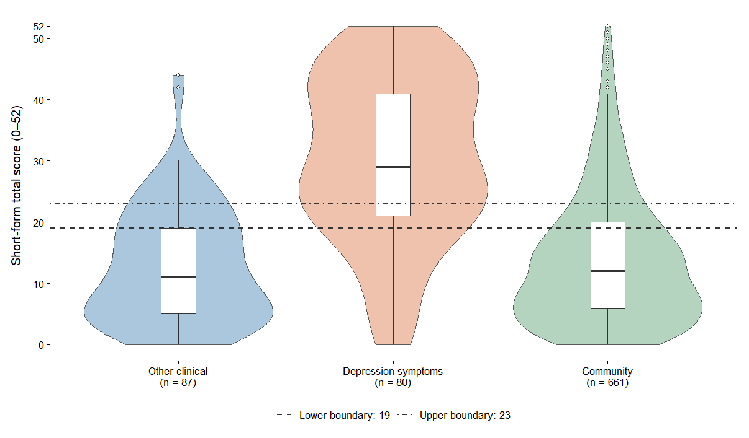

Figure S5. Distributions of short-form total scores across the three study groups.
Note. Violins show estimated score densities, scaled to equal maximum width. Embedded boxplots indicate medians and interquartile ranges; whiskers extend to the most extreme observations within 1.5 interquartile ranges of the box, and points indicate observations beyond the whiskers. Dashed and dot-dashed lines mark the provisional lower (19) and upper (23) boundaries, respectively. These boundaries were selected exploratorily in the development sample.

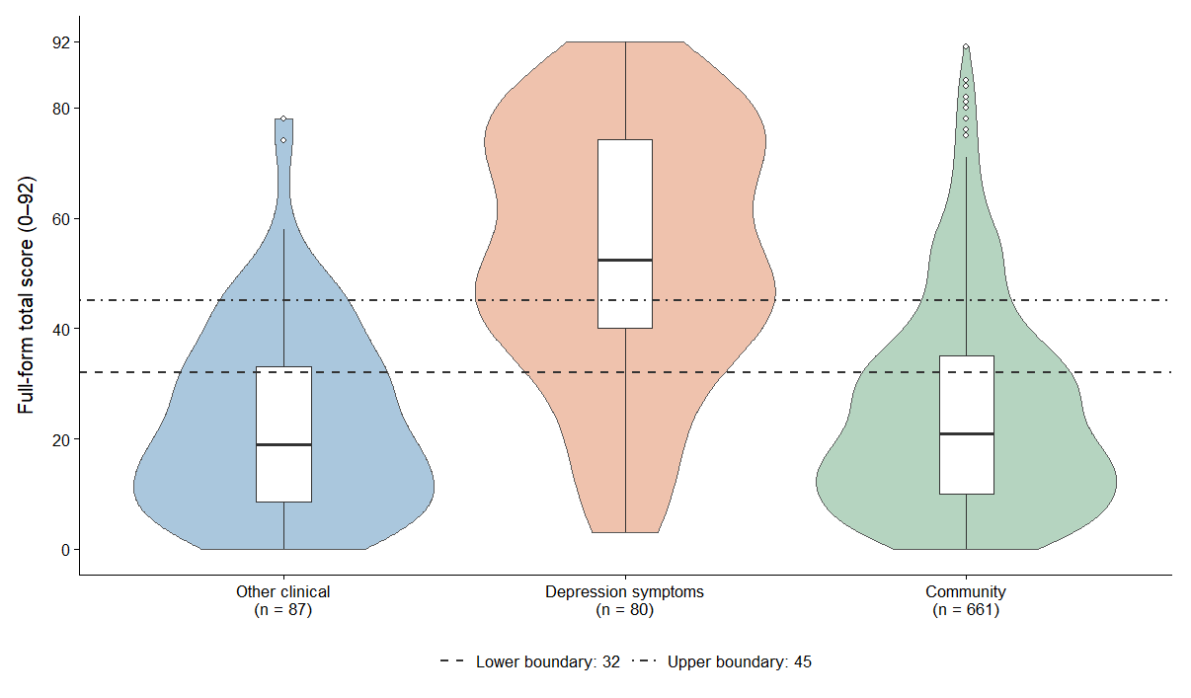
Figure S6. Distributions of full-form total scores across the three study groups.
Note. Violins show estimated score densities, scaled to equal maximum width. Embedded boxplots indicate medians and interquartile ranges; whiskers extend to the most extreme observations within 1.5 interquartile ranges of the box, and points indicate observations beyond the whiskers. Dashed and dot-dashed lines mark the provisional lower (32) and upper (45) boundaries, respectively. These boundaries were selected exploratorily in the development sample.
Table S27
Correlations with WHO-5 and between screening forms
Pair | n | Pearson’s r | 95% CI | p
Short form and WHO-5 | 766 | −.631 | [−.672, −.586] | < .001
Full form and WHO-5 | 766 | −.649 | [−.688, −.606] | < .001
Short form and full form | 828 | .987 | [.985, .989] | < .001
Note. Analyses used available paired observations. WHO-5 scores were unavailable for 62 respondents. Screening-form scores were raw unweighted totals. Higher WHO-5 scores indicate greater well-being. The short form contains 13 items drawn from the 23-item full form; their correlation therefore reflects shared item content. No formal comparison of the dependent correlations with WHO-5 was performed.

