Additional file 1
Development and pilot temporal validation of the PREST score for predicting non-response to intravenous glucocorticoids in active moderate-to-severe thyroid eye disease: a retrospective cohort study
Supplementary figures
Figure S1. Comparison of ROC Curves for PREST Models Developed Inclusive vs Exclusive of TSI.
ROC curves comparing the performance of two PREST model versions: one incorporating TSI and one excluding TSI. The TSI-inclusive model demonstrated an AUC of 0.809, whereas the TSI-exclusive model demonstrated an AUC of 0.796. The diagonal dashed line represents the reference line for random classification performance.
Abbreviations: ROC, receiver operating characteristic; AUC, area under the curve; TSI, thyroid-stimulating immunoglobulin; PREST, Predictive Risk Estimation of Steroid non-response in Thyroid Eye Disease.
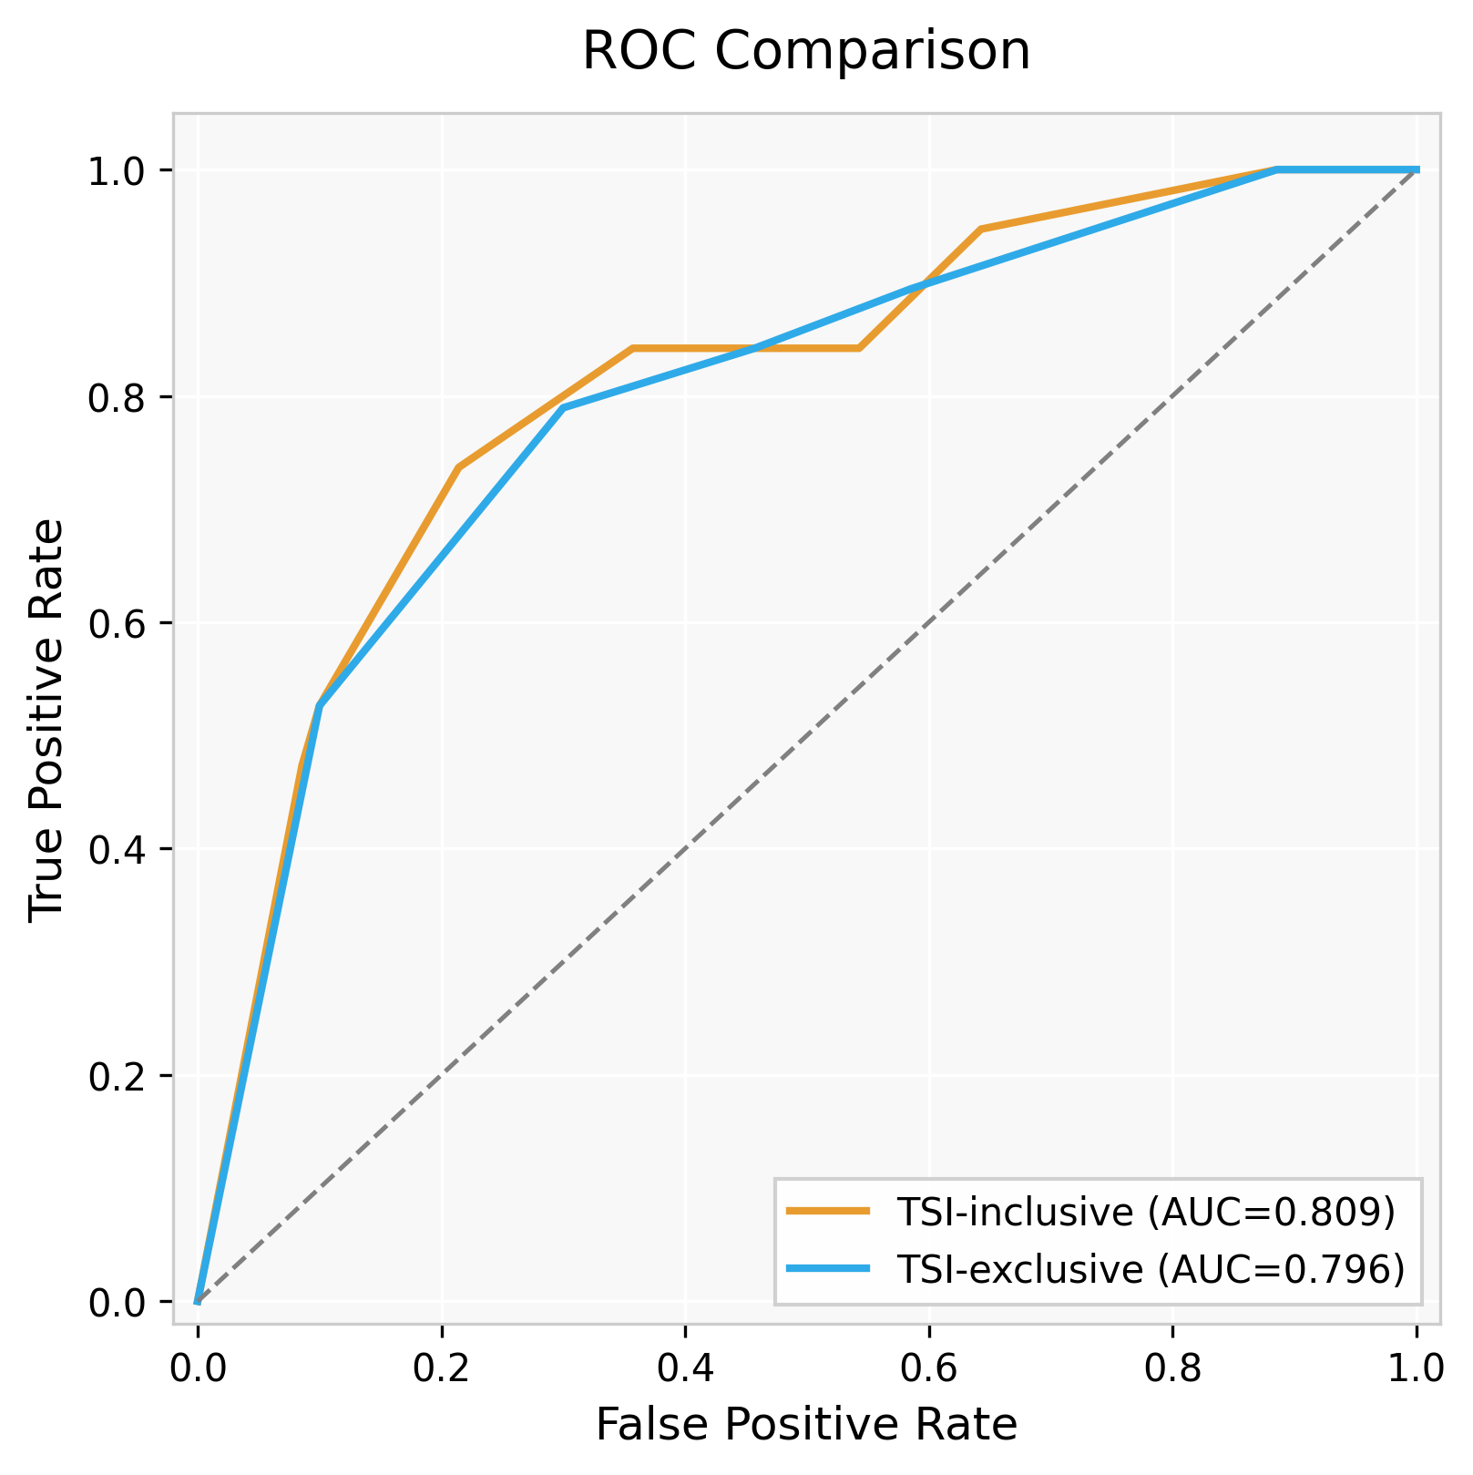

Figure S2. Distribution of PREST Scores and Steroid Response Rates.
(A) Distribution of total patients and steroid responders across individual PREST score values (0–8) in the development cohort (n=89). Bars represent the total number of patients (gray) and steroid responders (green), and the red line indicates the corresponding steroid response rate (%) for each score value. (B) Distribution of patients and response rates across PREST scores in the temporal validation cohort (n=24), using the same visualization scheme. The dual-axis format displays absolute patient counts on the primary y-axis and response rates on the secondary y-axis.
Abbreviations: PREST, Predictive Risk Estimation of Steroid non-response in Thyroid Eye Disease.
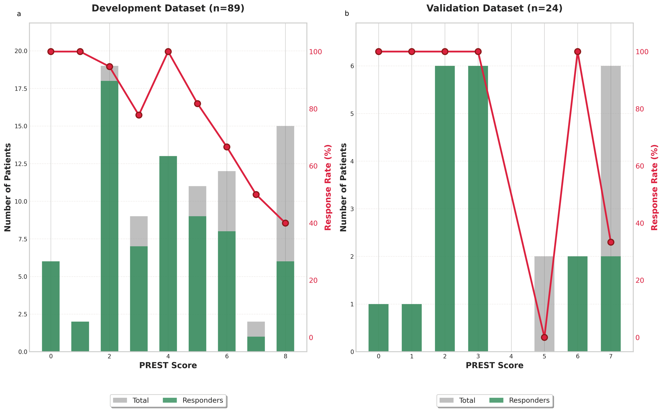

Figure S3. PREST Calculator Interface.
Screenshot of the PREST calculator interface. The tool accepts four clinical inputs (TRAb, TSI, CAS, and exophthalmos measurement) to compute the PREST score and the calibrated probability of steroid non-response. The interface displays automated risk stratification categories (low, intermediate, and high risk), a score–responsiveness plot showing observed response rates across PREST score values, and a table summarizing the number of patients, responders, non-responders, responsiveness percentages, and odds ratios associated with each score category. Available from: https://justgivemeaname-oh.github.io/PREST-Calculator/ [last accessed: January 16 2026].
Abbreviations: PREST, Predictive Risk Estimation of Steroid non-response in Thyroid Eye Disease; TRAb, thyrotropin receptor antibody; TSI, thyroid-stimulating immunoglobulin; CAS, clinical activity score.
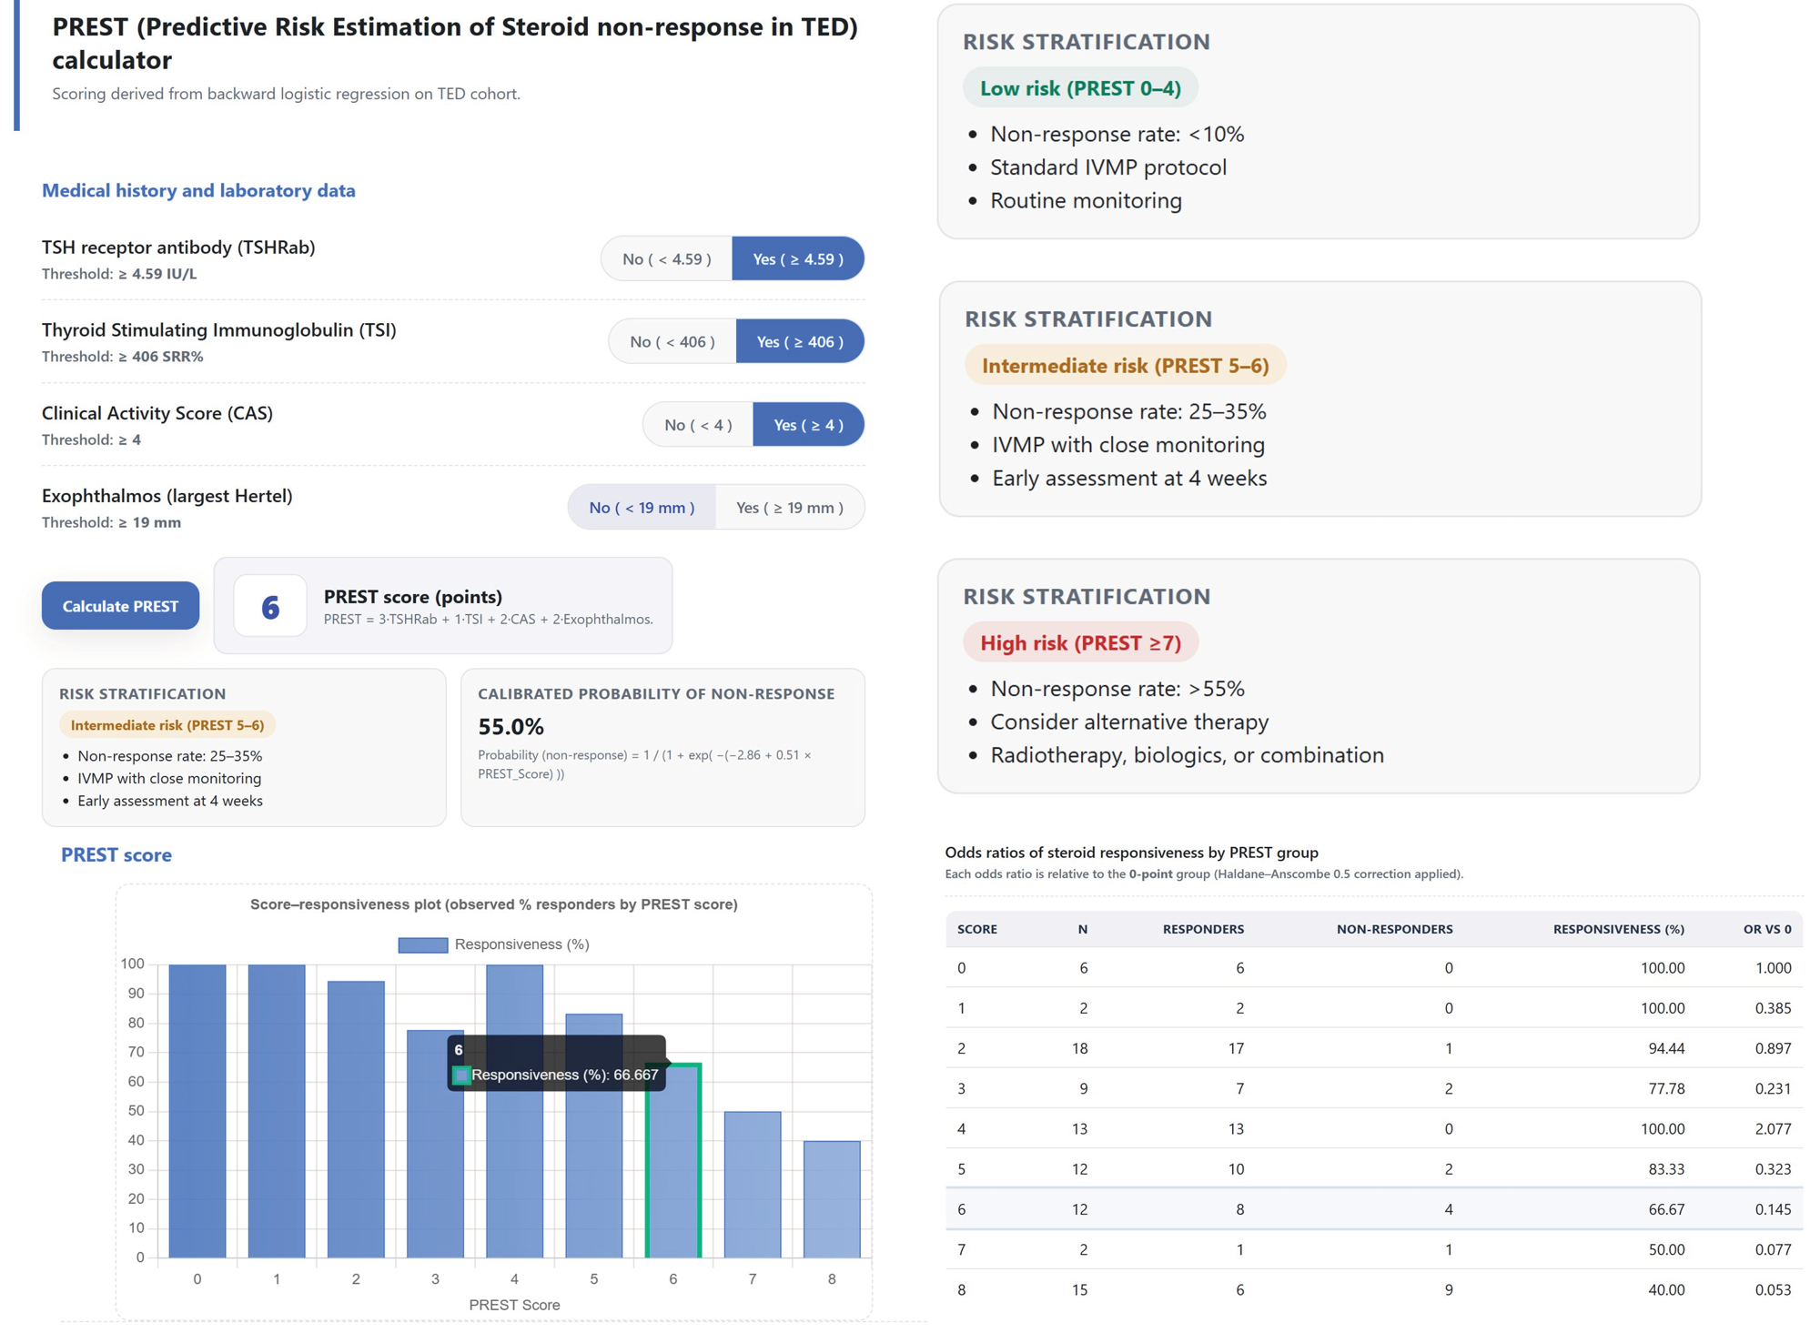

Supplementary tables
Table S1. Cutoffs Used for Dichotomization of Thyroid Function and Lipid Parameters
Parameter | Threshold / Range | Rationale / Source (summary)
Free thyroxine (free T4) | Normal: 0.75–2.0 ng/dL | Reference range derived from euthyroid populations and guideline-endorsed laboratory intervals.
Total triiodothyronine (T3) | Normal: 79–200 ng/dL | Manufacturer-validated reference limits in euthyroid adults; standard thresholds for thyrotoxicosis.
Thyroid-stimulating hormone (TSH) | Normal: 0.3–5.0 μIU/mL | Population-based reference interval consistent with major thyroid society guidelines.
Total cholesterol | Desirable: <200 mg/dL | Adult Treatment Panel criteria for desirable total cholesterol.
Low-density lipoprotein cholesterol (LDL-C) | Elevated: ≥100 mg/dL | Guideline definitions for optimal LDL-C and elevated atherogenic cholesterol.
High-density lipoprotein cholesterol (HDL-C) | High: ≥60 mg/dL | Guideline threshold at which HDL-C is considered a negative cardiovascular risk factor.
Triglycerides | Elevated: ≥150 mg/dL | Threshold used in guideline definitions of hypertriglyceridemia and metabolic syndrome.

Table S2. Prompts Provided to ChatGPT-5.1 to Develop the PREST Calculator
Task | Prompts Used
Load anonymized dataset and generate comparison code between responders vs non-responders | You are assisting with code generation for a retrospective clinical prediction study of steroid non-response in thyroid eye disease. Generate Python code using pandas, numpy, and scipy that reads an anonymized CSV file (ted_data.csv). The binary outcome column is Non-Response (0=responder, 1=non-responder). Generate code that: (1) loads the dataset; (2) splits the sample into responder vs non-responder groups; (3) conducts Shapiro–Wilk tests for continuous variables; (4) performs t-tests or Mann–Whitney U tests as appropriate; and (5) performs chi-square or Fisher’s exact tests for categorical predictors. Do not interpret results; produce only reusable code templates.
Dichotomization code (clinical thresholds + median splits) | Generate Python code that dichotomizes predictor variables in a DataFrame (df). Use predefined clinical thresholds for the following variables: Proptosis ≥19, EOM limitation (0, others), free T4 [0.75,2], T3 [79,200], TSH [0.3,5], Total cholesterol <200, LDL-C ≥100, HDL-C ≥60, Triglycerides ≥150, TRAb ≥4.59, and TSI ≥406. For remaining continuous variables without clinical cutoffs, create binary variables based on the cohort median. Compute medians dynamically in code. Do not assume or infer any dataset-specific values.
Logistic regression (univariable + multivariable) code drafting | Write Python code using statsmodels to perform univariable and multivariable logistic regression for predicting steroid non-response. The outcome is Non-response. Use dichotomized predictors such as CAS_bin, TRAb_bin, TSI_bin, and Proptosis_bin. Produce code that prints odds ratios, 95% CIs, and p-values without interpreting results. Include an example of backward-elimination structure without choosing the final model.
PREST score formula implementation | Create Python code that computes the PREST score using binary variables: TRAb_bin (3 points), TSI_bin (1 point), CAS_bin (2 points), and Proptosis_bin (2 points). Add a new DataFrame column PREST_Score and create optional risk groups (0–2, 3–4, 5–6, ≥7). Do not perform statistical tests.
ROC curve & AUC computation | Generate Python code that computes ROC curves and AUC using scikit-learn. Split the dataset by Cohort into development and validation sets. Use PREST_Score as a continuous predictor of Non-response. Plot ROC curves for both cohorts and print AUC values. Do not interpret results.
PREST calculator HTML generator prompt | Generate a complete self-contained HTML file implementing the PREST calculator. Include four toggle inputs (TRAb ≥4.59 IU/L, TSI ≥406%, CAS ≥4, Exophthalmos ≥19 mm), updating a JavaScript state object. Compute the PREST score using weights {TRAb:3, TSI:1, CAS:2, EXO:2}; display score and formula. Add dynamic risk stratification (0–4 low, 5–6 intermediate, ≥7 high) with descriptive bullet points. Compute calibrated non-response probability using p = 1/(1 + exp(-(−2.86 + 0.51×PREST_Score))). Include a Chart.js bar plot and an OR table using hard-coded constants (RESP_PCT, COUNTS, RESPN, NRESPN, OR_VS0). Highlight the corresponding table row and bar when a score is calculated. Use CSS variables, modern UI styling, and embed all HTML/CSS/JS in a single file without external data sources.
Explanatory text, tooltips, and clinical notes for the calculator | Provide concise, clinically oriented explanatory text for the PREST calculator. Add tooltips describing TRAb, TSI, CAS, and proptosis. Write short paragraphs describing appropriate use: decision-support only, requires clinical context, based on a single-center cohort, external validation recommended. Avoid treatment recommendations or legal statements.

Table S3. Baseline Characteristics of Active, Moderate-to-Severe Thyroid Eye Disease Patients by Response to Intravenous Glucocorticoids
 | Development set |  |  |  | Validation set
Variable | Total (N=89) | Response (N=70) | Non-response (N=19) | p-value (dev) | Total (N=24) | Response (N=18) | Non-response (N=6) | p-value (val)
Female, no. (%) | 49 (55.1) | 38 (54.3) | 11 (57.9) | 0.98 | 17 (70.8) | 13 (72.2) | 4 (66.7) | 1.00
Age, mean (SD), y | 51.89 (13.63) | 51.74 (13.38) | 52.42 (14.90) | 0.86 | 54.17 (11.27) | 50.78 (10.49) | 58.83 (2.86) | 0.08
Smoking habit, ever, no. (%) | 35 (39.3) | 30 (42.9) | 5 (26.3) | 0.30 | 3 (12.5) | 3 (16.7) | 0 (0) | 0.54
Family history, yes, no. (%) | 19 (21.3) | 15 (21.4) | 4 (21.1) | 1.00 | 2 (8.3) | 0 (0) | 2 (33.3) | 0.054
TED duration, median (IQR), mo | 5.00 (3.00–12.00) | 5.00 (3.00–11.75) | 4.00 (2.00–10.50) | 0.18 | 5.0 (2.25–12.0) | 5.0 (3.00–11.25) | 5 (2.00–10.25) | 0.58
GD duration, median (IQR), mo | 9.00 (2.00–26.00) | 11.00 (3.00–36.75) | 5.00 (0.50–13.00) | 0.07 | 8.0 (0–24.0) | 6 (0.00–34.00) | 12 (3.75–21.00) | 0.42
Orbital radiotherapy, no. (%) | 18 (20.2) | 10 (14.3) | 8 (42.1) | 0.02 | 11 (45.8) | 5 (27.8) | 6 (100) | 0.003
CAS, median (IQR), score | 4.00 (3.00–5.00) | 4.00 (3.00–5.00) | 4.00 (4.00–5.00) | 0.02 | 4.0 (4.00–5.25) | 4.0 (3.25–4.75) | 5.0 (4.25–5.75) | 0.14
IIOP, no. (%) | 12 (13.5) | 10 (14.3) | 2 (10.5) | 1.00 | 9 (37.5) | 5 (27.8) | 4 (66.7) | 0.15
Proptosis ≥19 mm, no. (%) | 45 (50.6) | 32 (45.7) | 13 (68.4) | 0.13 | 11 (45.8) | 9 (50.0) | 2 (33.3) | 0.65
Muscle predominant, no. (%) | 65 (73.0) | 50 (71.4) | 15 (78.9) | 0.58 | 18 (75) | 14 (77.8) | 4 (66.7) | 0.62
EOM limitation, no. (%) | 55 (61.8) | 44 (62.9) | 11 (57.9) | 0.90 | 9 (37.5) | 7 (38.9) | 2 (33.3) | 1.00
Diplopia, no. (%) | 24 (27.0) | 20 (28.6) | 4 (21.1) | 0.72 | 3 (12.5) | 1 (5.6) | 2 (33.3) | 0.14
Visual Field Index, median (IQR) | 97.00 (93.00–99.00) | 96.50 (93.25–99.00) | 97.00 (92.84–99.00) | 0.63 | 100.00 (100.00–100.00) | 100.00 (100.00–100.00) | 100.00 (100.00–100.00) | 0.58
free T4, median (IQR), ng/dL | 1.28 (1.07–1.68) | 1.24 (1.06–1.69) | 1.42 (1.17–1.63) | 0.51 | 1.39 (1.02–1.45) | 1.26 (1.00–1.43) | 1.42 (1.12–1.51) | 0.42
T3, median (IQR), ng/dL | 130.90 (103.00–162.00) | 125.80 (102.00–155.80) | 145.17 (122.35–184.50) | 0.24 | 117.00 (101.75–124.50) | 116.00 (102.5–124.00) | 122.0 (73.25–125.00) | 1.00
TSH, median (IQR), mIU/L | 0.09 (0.00–2.53) | 0.26 (0.00–2.53) | 0.00 (0.00–0.64) | 0.04 | 1.33 (0.18–4.12) | 1.46 (0.26–3.50) | 1.20 (0.35–6.71) | 0.92
TRAb, median (IQR), IU/L | 4.71 (1.51–13.54) | 3.76 (1.27–11.68) | 9.55 (5.48–34.21) | 0.004 | 6.77 (3.71–9.69) | 5.54 (1.91–7.42) | 9.95 (8.05–12.08) | 0.02
TSI, mean (SD), SRR% | 399.37 (162.77) | 384.04 (170.78) | 455.83 (116.00) | 0.04 | 282.13 (85.92) | 281.17 (96.84) | 285.00 (45.33) | 0.97
Total cholesterol, mean (SD), mg/dL | 185.76 (35.31) | 185.62 (37.23) | 186.26 (27.98) | 0.94 | 213.43 (59.48) | 215.85 (63.41) | 206.67 (51.24) | 0.54
LDL cholesterol, mean (SD), mg/dL | 113.50 (31.52) | 114.43 (33.89) | 110.07 (20.91) | 0.49 | 122.35 (40.43) | 125.88 (43.10) | 112.33 (32.89) | 0.49
HDL cholesterol, median (IQR), mg/dL | 56.00 (48.00–65.00) | 57.00 (48.50–65.00) | 54.00 (47.00–64.50) | 0.44 | 61.0 (53.5–69.0) | 64.00 (58.00–69.00) | 58.00 (43.00–80.50) | 0.56
Triglycerides, median (IQR), mg/dL | 134.00 (95.00–173.11) | 140.50 (92.75–174.53) | 132.00 (113.50–153.50) | 0.59 | 94.0 (66.0–124.00) | 94.00 (66.00–124.00) | 66.0 (42.00–182.30) | 0.87
Continuous variables are presented as mean (SD) for normally distributed data (Welch’s t-test) or as median (IQR) for non-normally distributed data (Mann–Whitney U test). Categorical variables were compared using chi-square or Fisher’s exact test, as appropriate. Normality was assessed using the Shapiro–Wilk test. CAS is treated as a continuous variable. IIOP defined as IOP ≥21 mmHg in the more affected eye; proptosis defined as ≥19 mm in the more affected eye; muscle involvement assessed by radiological findings; EOM limitation measured by HESS or Lancaster test; diplopia includes only constant diplopia; visual field index taken as the lower value of both eyes.
Abbreviations: CAS, clinical activity score; EOM, extraocular muscle; GD, Graves’ disease; HDL, high-density lipoprotein; IIOP, increased intraocular pressure; IQR, interquartile range; LDL, low-density lipoprotein; SD, standard deviation; SRR, specimen-to-reference ratio; TED, thyroid eye disease; TRAb, thyrotropin receptor antibody; TSH, thyroid-stimulating hormone; TSI, thyroid-stimulating immunoglobulin; RT, radiotherapy.

Table S4. Comparison of Predictive Performance Between TSI-Inclusive and TSI-Exclusive PREST Score Models
Analysis | TSI-inclusive (Cutoff ≥6) | TSI-exclusive (Cutoff ≥5) | Difference | p-value
AUC (Development) | 0.809 | 0.796 | +0.013 | 0.234
Specificity (Development) | 74.3% | 68.6% | +5.7% | NA
AUC (Validation) | 0.870 | 0.880 | −0.010 | 1.000
Sensitivity (Validation) | 66.7% | 100.0% | −33.3% | NA

Table S5. Comparative Predictive Performance of the PREST Score and Machine Learning Models
Model | Dataset | AUC (95% CI) | Sensitivity (95% CI) | Specificity (95% CI) | PPV | NPV | Accuracy (95% CI)
PREST Score (cutoff=6) | Development | 0.809 (0.696–0.909) | 73.7% (50.0–93.3) | 74.3% (64.0–84.7) | 43.75% | 91.23% | 74.2% (65.2–83.1)
PREST Score (cutoff=6) | Validation | 0.870 (0.721–0.974) | 66.7% (25.0–100.0) | 77.8% (57.1–94.1) | 50.00% | 87.50% | 75.0% (58.3–87.5)
Logistic Regression | Development | 0.883 (0.800–0.947) | 78.9% (57.9–95.2) | 82.9% (73.1–91.4) | 55.56% | 93.55% | 82.0% (74.2–89.9)
Logistic Regression | Validation | 0.722 (0.500–0.916) | 66.7% (25.0–100.0) | 61.1% (38.9–84.2) | 36.36% | 84.62% | 62.5% (41.7–83.3)
SVM | Development | 0.994 (0.979–1.000) | 94.7% (81.8–100.0) | 97.1% (92.8–100.0) | 90.00% | 98.55% | 96.6% (92.1–100.0)
SVM | Validation | 0.648 (0.400–0.882) | 0.0% (0.0–0.0) | 77.8% (57.1–94.4) | 0.00% | 70.00% | 58.3% (37.5–79.2)
Random Forest | Development | 0.964 (0.923–0.995) | 100.0% (100.0–100.0) | 55.7% (44.9–67.5) | 38.00% | 100.00% | 65.2% (56.2–75.3)
Random Forest | Validation | 0.815 (0.600–0.945) | 100.0% (100.0–100.0) | 77.8% (57.1–94.1) | 60.00% | 100.00% | 83.3% (66.7–95.8)
XGBoost | Development | 1.000 (1.000–1.000) | 100.0% (100.0–100.0) | 77.1% (67.5–86.8) | 54.29% | 100.00% | 82.0% (74.2–89.9)
XGBoost | Validation | 0.704 (0.552–0.936) | 66.7% (25.0–100.0) | 66.7% (44.4–87.5) | 40.00% | 85.71% | 66.7% (45.8–83.3)
LightGBM | Development | 1.000 (1.000–1.000) | 100.0% (100.0–100.0) | 84.3% (75.4–91.9) | 63.33% | 100.00% | 87.6% (80.9–94.4)
LightGBM | Validation | 0.685 (0.455–0.866) | 33.3% (0.0–75.0) | 77.8% (57.1–94.1) | 33.33% | 77.78% | 66.7% (45.8–83.3)
Abbreviations: AUC, area under the curve; CI, confidence interval; LightGBM, Light Gradient Boosting Machine; NPV, negative predictive value; PPV, positive predictive value; PREST, Predictive Risk Estimation of Steroid non-response in Thyroid Eye Disease; SVM, support vector machine; XGBoost, Extreme Gradient Boosting.

Table S6. PREST Score Bands and Steroid Response Rates
Dataset | Score Range | N (%) | Responders n (%) | Non-responders n (%) | p-value
Development (n=89) | 0–2 | 27 (30.3) | 26 (96.3) | 1 (3.7)
 | 3–4 | 22 (24.7) | 20 (90.9) | 2 (9.1)
 | 5–6 | 23 (25.8) | 17 (73.9) | 6 (26.1)
 | ≥7 | 17 (19.1) | 7 (41.2) | 10 (58.8) | <0.001
Validation (n=24) | 0–2 | 8 (33.3) | 8 (100.0) | 0 (0.0)
 | 3–4 | 6 (25.0) | 6 (100.0) | 0 (0.0)
 | 5–6 | 4 (16.7) | 2 (50.0) | 2 (50.0)
 | ≥7 | 6 (25.0) | 2 (33.3) | 4 (66.7) | 0.001

Table S7. HTML Code for the PREST Calculator
<!DOCTYPE html>
<html lang="en">
<head>
<meta charset="utf-8" />
<meta name="viewport" content="width=device-width, initial-scale=1" />
<title>PREST (Predictive Risk Estimation of Steroid non-response in TED) calculator</title>
<link rel="stylesheet" href="https://cdnjs.cloudflare.com/ajax/libs/Chart.js/3.7.1/chart.min.css">
<style>
:root{
--bg:#f7f8fb;
--card:#ffffff;
--ink:#1b1f24;
--muted:#606a78;
--accent:#2f6fed;
--accent-2:#12b886;
--border:#e5e8ef;
--shadow: 0 8px 24px rgba(10, 22, 70, 0.08);
--radius:16px;
}
*{box-sizing:border-box;font-family:ui-sans-serif,system-ui,-apple-system,Segoe UI,Roboto,Helvetica,Arial,"Apple Color Emoji","Segoe UI Emoji";}
body{margin:0;background:var(--bg);color:var(--ink);}

.wrap{ max-width: 980px; margin: 48px auto; padding: 0 16px; }
.frame{ background:var(--card); border:1px solid var(--border); border-radius: var(--radius); box-shadow: var(--shadow); }
.title-frame{ padding: 24px 28px; margin-bottom:18px; border-left:5px solid var(--accent);}
.title-frame h1{ margin:0; font-size: 22px; font-weight: 700; letter-spacing:.2px; }
.subtitle{margin-top:6px; color:var(--muted); font-size:14px;}

.panel{ padding: 22px 24px; }
.panel h2{ margin-top:0; margin-bottom:14px; font-size:16px; font-weight:700; color:var(--accent); }

.row{
display:flex;
flex-wrap:wrap;
align-items:center;
justify-content:space-between;
gap:12px;
padding:14px 0;
border-top:1px dashed var(--border);
}
.row:first-of-type{border-top:0;}
.label{ flex:1 1 360px; font-weight:600; line-height:1.35; }
.hint{ color:var(--muted); font-weight:500; font-size:13px; margin-top:4px; }

.toggle{ display:inline-flex; border:1px solid var(--border); border-radius: 999px; overflow:hidden; background:#f9fafc; }
.toggle button{ appearance:none; border:0; padding:10px 18px; cursor:pointer; font-weight:600; color:var(--muted); background:transparent; }
.toggle button.active.yes{background:var(--accent); color:#fff;}
.toggle button.active.no{background:#e9eefc; color:#2948c2;}
.toggle button:focus-visible{outline:2px solid var(--accent); outline-offset:2px; border-radius: 999px;}

.score-box{ display:flex; align-items:center; gap:14px; padding:14px 16px; background:#f5f8ff; border:1px solid #dfe7ff; border-radius:12px; }
.score-num{ font-size:28px; font-weight:800; color:#2948c2; min-width:64px; text-align:center; border-radius:12px; background:#fff; border:1px solid var(--border); padding:8px 12px; }
.btn-primary{ appearance:none; border:0; border-radius: 12px; background:var(--accent); color:#fff; padding:12px 18px; font-weight:700; cursor:pointer; box-shadow: var(--shadow); }
.btn-primary:hover{filter:brightness(1.02);}
.btn-primary:active{transform:translateY(1px);}

/* Risk + probability */
.risk-prob-grid{
display:flex;
flex-wrap:wrap;
gap:12px;
margin-top:12px;
}
.risk-card, .prob-card{
flex:1 1 260px;
border-radius:12px;
border:1px solid var(--border);
background:#f9fafc;
padding:12px 14px;
}
.card-title{
font-size:13px;
font-weight:700;
text-transform:uppercase;
letter-spacing:.04em;
color:var(--muted);
margin-bottom:6px;
}
.risk-pill{
display:inline-flex;
align-items:center;
padding:4px 10px;
border-radius:999px;
font-size:12px;
font-weight:700;
margin-bottom:6px;
}
.risk-pill.low{
background:rgba(18,184,134,0.08);
color:#087f5b;
}
.risk-pill.intermediate{
background:rgba(255,176,0,0.12);
color:#ad6800;
}
.risk-pill.high{
background:rgba(230,82,82,0.12);
color:#c92a2a;
}
.risk-points{
font-size:13px;
color:var(--ink);
margin:0;
padding-left:16px;
}
.risk-points li{ margin-bottom:2px; }

.prob-value{
font-size:20px;
font-weight:700;
color:#1b1f24;
margin-bottom:4px;
}
.prob-caption{
font-size:11px;
color:var(--muted);
line-height:1.5;
}

table{width:100%; border-collapse:collapse; border:1px solid var(--border); border-radius:12px; overflow:hidden;}
thead th{background:#f1f4fb; color:#24324a; font-size:13px; letter-spacing:.2px; text-transform:uppercase;}
th, td{padding:10px 12px; border-bottom:1px solid var(--border); text-align:right;}
th:first-child, td:first-child{text-align:left;}
tbody tr:hover{background:#fafbff;}

.chart-wrap{
padding:0;
border:1px dashed var(--border);
border-radius:12px;
background:#fff;
margin:0;
}
canvas{width:100%; height:360px; display:block;}

.note{color:var(--muted); font-size:12px; line-height:1.5;}

#output .row.chart-row{
padding-top:0;
padding-bottom:0;
border-top:0;
}
</style>
</head>
<body>
<div class="wrap frame">

<!-- Title frame -->
<div class="title-frame">
<h1>PREST (Predictive Risk Estimation of Steroid non-response in TED) calculator</h1>
<div class="subtitle">Scoring derived from backward logistic regression on TED cohort.</div>
</div>

<!-- Input frame -->
<div class="panel">
<h2>Medical history and laboratory data</h2>

<!-- Row: TSHRab -->
<div class="row">
<div class="label">
TSH receptor antibody (TSHRab)
<div class="hint">Threshold: <strong>≥ 4.59 IU/L</strong></div>
</div>
<div class="toggle" data-field="TSHRab">
<button class="no" type="button">No ( &lt; 4.59 )</button>
<button class="yes" type="button">Yes ( ≥ 4.59 )</button>
</div>
</div>

<!-- Row: TSI -->
<div class="row">
<div class="label">
Thyroid Stimulating Immunoglobulin (TSI)
<div class="hint">Threshold: <strong>≥ 406 SRR%</strong></div>
</div>
<div class="toggle" data-field="TSI">
<button class="no" type="button">No ( &lt; 406 )</button>
<button class="yes" type="button">Yes ( ≥ 406 )</button>
</div>
</div>

<!-- Row: CAS -->
<div class="row">
<div class="label">
Clinical Activity Score (CAS)
<div class="hint">Threshold: <strong>≥ 4</strong></div>
</div>
<div class="toggle" data-field="CAS">
<button class="no" type="button">No ( &lt; 4 )</button>
<button class="yes" type="button">Yes ( ≥ 4 )</button>
</div>
</div>

<!-- Row: Exophthalmos -->
<div class="row">
<div class="label">
Exophthalmos (largest Hertel)
<div class="hint">Threshold: <strong>≥ 19 mm</strong></div>
</div>
<div class="toggle" data-field="EXO">
<button class="no" type="button">No ( &lt; 19 mm )</button>
<button class="yes" type="button">Yes ( ≥ 19 mm )</button>
</div>
</div>

<div style="display:flex; gap:12px; align-items:center; margin-top:8px;">
<button id="calcBtn" class="btn-primary" type="button">Calculate PREST</button>
<div class="score-box" aria-live="polite" aria-atomic="true">
<div class="score-num" id="prestScore">0</div>
<div>
<div style="font-weight:700;">PREST score (points)</div>
<div class="note">PREST = 3·TSHRab + 1·TSI + 2·CAS + 2·Exophthalmos.</div>
</div>
</div>
</div>

<!-- Risk + probability -->
<div class="risk-prob-grid">
<div class="risk-card">
<div class="card-title">Risk stratification</div>
<div id="riskPill" class="risk-pill low">Low risk (PREST 0–4)</div>
<ul id="riskDetails" class="risk-points">
<li>Non-response rate: &lt;10%</li>
<li>Standard IVMP protocol</li>
<li>Routine monitoring</li>
</ul>
</div>

<div class="prob-card">
<div class="card-title">Calibrated probability of non-response</div>
<div id="nonRespProb" class="prob-value">0.0%</div>
<div class="prob-caption">
Probability (non-response) = 1 / (1 + exp( −(−2.86 + 0.51 × PREST_Score) ))
</div>
</div>
</div>
</div>

<!-- Output frame -->
<div class="panel" id="output">
<h2>PREST score</h2>

<!-- 1) Chart -->
<div class="row chart-row" style="flex-direction:column;">
<div class="chart-wrap">
<canvas id="chart" width="900" height="360" aria-label="Score-responsiveness chart"></canvas>
</div>
</div>

<!-- 2) OR description -->
<div class="row" style="align-items:flex-start;">
<div class="label">
Odds ratios of steroid responsiveness by PREST group<br/>
<span class="hint">Each odds ratio is relative to the <strong>0-point</strong> group (Haldane–Anscombe 0.5 correction applied).</span>
</div>
</div>

<!-- 3) OR table -->
<div class="row">
<div style="width:100%; overflow-x:auto;">
<table id="orTable">
<thead>
<tr>
<th>Score</th>
<th>n</th>
<th>Responders</th>
<th>Non-responders</th>
<th>Responsiveness (%)</th>
<th>OR vs 0</th>
</tr>
</thead>
<tbody></tbody>
</table>
<div class="note" style="margin-top:8px;">
Cohort-derived values (n=89). External validation recommended.
</div>
</div>
</div>
</div>

</div>

<script src="https://cdn.jsdelivr.net/npm/chart.js"></script>
<script>
// === Model constants ===
const WEIGHTS = { TSHRab: 3, TSI: 1, CAS: 2, EXO: 2 };

const RESP_PCT = { 0:100.0, 1:100.0, 2:94.444444, 3:77.777778, 4:100.0, 5:83.333333, 6:66.666667, 7:50.0, 8:40.0 };
const COUNTS = { 0:6, 1:2, 2:18, 3:9, 4:13, 5:12, 6:12, 7:2, 8:15 };
const RESPN = { 0:6, 1:2, 2:17, 3:7, 4:13, 5:10, 6:8, 7:1, 8:6 };
const NRESPN = { 0:0, 1:0, 2:1, 3:2, 4:0, 5:2, 6:4, 7:1, 8:9 };
const OR_VS0 = { 0:1.0, 1:0.3846153846, 2:0.8974358974, 3:0.2307692308, 4:2.0769230769, 5:0.3230769231, 6:0.1452991453, 7:0.0769230769, 8:0.0526315789 };

const state = { TSHRab: 0, TSI: 0, CAS: 0, EXO: 0 };

// === Toggle logic ===
document.querySelectorAll(".toggle").forEach(group => {
const field = group.getAttribute("data-field");
const [btnNo, btnYes] = group.querySelectorAll("button");

function setActive(v){
state[field] = v;
btnNo.classList.toggle("active", v===0);
btnYes.classList.toggle("active", v===1);
}
setActive(0);

btnNo.onclick = () => setActive(0);
btnYes.onclick = () => setActive(1);
});

// === Risk & probability ===
function updateRisk(score){
const pill = document.getElementById("riskPill");
const details = document.getElementById("riskDetails");

if(score <= 4){
pill.textContent = "Low risk (PREST 0–4)";
pill.className = "risk-pill low";
details.innerHTML = `
<li>Non-response rate: &lt;10%</li>
<li>Standard IVMP protocol</li>
<li>Routine monitoring</li>`;
}
else if(score <= 6){
pill.textContent = "Intermediate risk (PREST 5–6)";
pill.className = "risk-pill intermediate";
details.innerHTML = `
<li>Non-response rate: 25–35%</li>
<li>IVMP with close monitoring</li>
<li>Early assessment at 4 weeks</li>`;
}
else{
pill.textContent = "High risk (PREST ≥7)";
pill.className = "risk-pill high";
details.innerHTML = `
<li>Non-response rate: &gt;55%</li>
<li>Consider alternative therapy</li>
<li>Radiotherapy, biologics, or combination</li>`;
}
}

function updateProbability(score){
const logit = -2.86 + 0.51 * score;
const p = 1 / (1 + Math.exp(-logit));
document.getElementById("nonRespProb").textContent = (p*100).toFixed(1) + "%";
}

// === PREST Calculation ===
function calcPrest(){
const score =
state.TSHRab * 3 +
state.TSI * 1 +
state.CAS * 2 +
state.EXO * 2;

document.getElementById("prestScore").textContent = score;

updateRisk(score);
updateProbability(score);
highlightRow(score);
highlightBar(score);
}

document.getElementById("calcBtn").onclick = calcPrest;

// === OR Table ===
function buildTable(){
const tbody = document.querySelector("#orTable tbody");
tbody.innerHTML = "";
Object.keys(COUNTS).sort((a,b)=>a-b).forEach(s=>{
const tr = document.createElement("tr");
tr.setAttribute("data-score-row", s);
tr.innerHTML = `
<td>${s}</td>
<td>${COUNTS[s]}</td>
<td>${RESPN[s]}</td>
<td>${NRESPN[s]}</td>
<td>${RESP_PCT[s].toFixed(2)}</td>
<td>${OR_VS0[s].toFixed(3)}</td>`;
tbody.appendChild(tr);
});
}
buildTable();

function highlightRow(score){
document.querySelectorAll("#orTable tbody tr").forEach(tr=>{
tr.style.background = "transparent";
tr.style.outline = "none";
});

const row = document.querySelector(`#orTable tbody tr[data-score-row='${score}']`);
if(row){
row.style.background="#f7fbff";
row.style.outline="2px solid #d0e6ff";
}
}

// === Chart ===
let chart;

function buildChart(){
const ctx = document.getElementById("chart").getContext("2d");
const labels = Object.keys(RESP_PCT).map(Number).sort((a,b)=>a-b);

const gradient = ctx.createLinearGradient(0,0,900,0);
gradient.addColorStop(0,'rgba(47,111,237,0.85)');
gradient.addColorStop(1,'rgba(165,196,255,0.85)');

chart = new Chart(ctx, {
type:"bar",
data:{
labels:labels,
datasets:[{
label:"Responsiveness (%)",
data:labels.map(x=>RESP_PCT[x]),
backgroundColor:labels.map(()=>gradient),
borderColor:labels.map(()=>'rgba(47,111,237,1)'),
borderWidth:labels.map(()=>1)
}]
},
options:{
maintainAspectRatio:false,
scales:{
y:{beginAtZero:true, max:100},
x:{title:{display:true,text:"PREST Score"}}
},
plugins:{
title:{
display:true,
text:"Score–responsiveness plot (observed % responders by PREST score)"
}
}
}
});
}

function highlightBar(score){
if(!chart) return;
const index = chart.data.labels.indexOf(score);
const ds = chart.data.datasets[0];

ds.borderWidth = ds.borderWidth.map(()=>1);
ds.borderColor = ds.borderColor.map(()=> 'rgba(47,111,237,1)');

if(index >= 0){
ds.borderWidth[index] = 4;
ds.borderColor[index] = 'rgba(18,184,134,1)';
}
chart.update();
}

buildChart();
calcPrest();

</script>
</body>
</html>

Table S8. Components That Defined Non-response in Each Non-responder
Pt# | Cohort | CAS  (Pre) | CAS  (Post) | ΔCAS | CAS component | Treatment escalation or other components not met
1 | Development | 4 | 4 | 0 | Not met (insufficient decrease) | None
2 | Development | 3 | 4 | 1 | Not met (increase) | None
3 | Development | 3 | 4 | 1 | Not met (increase) | None
4 | Development | 4 | 4 | 0 | Not met (insufficient decrease) | Tocilizumab (recurrent/refractory)
5 | Development | 4 | 4 | 0 | Not met (insufficient decrease) | Orbital decompression (for DON)  Adjunctive orbital radiotherapy
6 | Development | 4 | 3 | −1 | Not met (insufficient decrease) | Tocilizumab (recurrent/refractory)  Orbital decompression
7 | Development | 4 | 4 | 0 | Not met (insufficient decrease) | Adjunctive orbital radiotherapy  Imaging-confirmed neuropathy (GCL abnormality)
8 | Development | 4 | 3 | −1 | Not met (insufficient decrease) | Orbital decompression (for DON)
9 | Development | 4 | 5 | 1 | Not met (increase) | None
10 | Development | 5 | 4 | −1 | Not met (insufficient decrease) | None
11 | Development | 5 | 4 | −1 | Not met (insufficient decrease) | Orbital decompression (for DON)
12 | Development | 5 | 4 | −1 | Not met (insufficient decrease) | Additional methylprednisolone course
13 | Development | 5 | 5 | 0 | Not met (insufficient decrease) | Additional methylprednisolone course
14 | Development | 6 | 5 | −1 | Not met (insufficient decrease) | Tocilizumab (recurrent/refractory)
15 | Development | 7 | 5 | −2 | Met (decrease of 2) | Triamcinolone injection (sustained activity)
16 | Development | 6 | 6 | 0 | Not met (insufficient decrease) | Orbital decompression (for DON)
17 | Development | 5 | 4 | −1 | Not met (insufficient decrease) | None
18 | Development | 5 | 4 | −1 | Not met (insufficient decrease) | None
19 | Development | 3 | 4 | 1 | Not met (increase) | None
V1 | Validation | 4 | 3 | −1 | Not met (insufficient decrease) | Orbital decompression (for DON)  Adjunctive radiotherapy
V2 | Validation | 6 | 3 | −3 | Met (decrease of 3) | Adjunctive radiotherapy  no proptosis improvement; no EOM-limitation improvement; no diplopia improvement
V3 | Validation | 5 | 4 | −1 | Not met (insufficient decrease) | Orbital decompression (for DON)  Adjunctive radiotherapy
V4 | Validation | 4 | 3 | −1 | Not met (insufficient decrease) | Adjunctive radiotherapy
V5 | Validation | 6 | 3 | −3 | Met (decrease of 3) | DON  Adjunctive radiotherapy  no EOM-limitation improvement; no diplopia improvement
V6 | Validation | 4 | 3 | −1 | Not met (insufficient decrease) | None
CAS, clinical activity score; DON, dysthyroid optic neuropathy; EOM, extraocular muscle; GCL, ganglion cell layer. The CAS component was not met when CAS decreased by fewer than 2 points and the final CAS was 3 or more. ΔCAS = post-treatment CAS minus baseline CAS (negative values indicate improvement). Patient identifiers were removed; sequence numbers (1–19 and V1–V6) do not correspond to medical record numbers.
Components that defined non-response in each non-responder in the development (n = 19) and validation (n = 6) cohorts. The CAS component was not met in 22 of 25 non-responders (88%). Three non-responders (one in the development cohort and two in the validation cohort) met the CAS component but received additional treatment for persistent activity or did not improve in proptosis, ocular motility, or diplopia. Treatment escalation consisted of orbital decompression (n = 7), tocilizumab (n = 3), adjunctive orbital radiotherapy (n = 7), an additional course of methylprednisolone (n = 2), and triamcinolone injection (n = 1). In the validation cohort, the sequence between the decision for adjunctive radiotherapy and the classification of non-response could not always be determined from the records.

