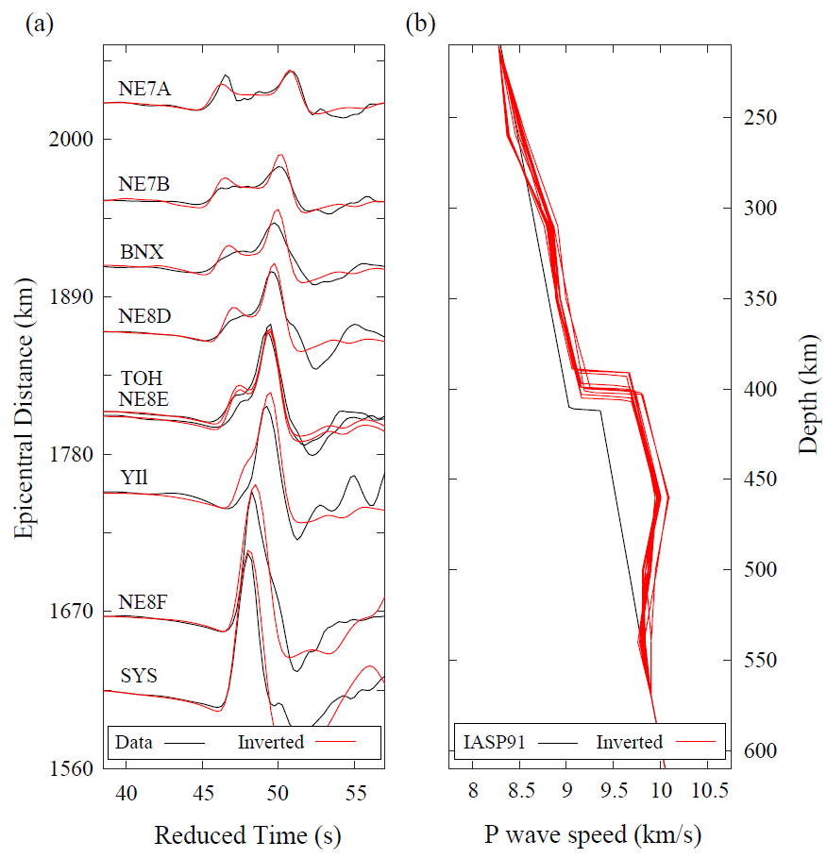
Extended Data Fig. 1 | 1-D Inversion results for the reference region RR’. (a) Waveform comparison between data (black) and 1-D synthetics (red). (b) Acceptable 1-D models (red).

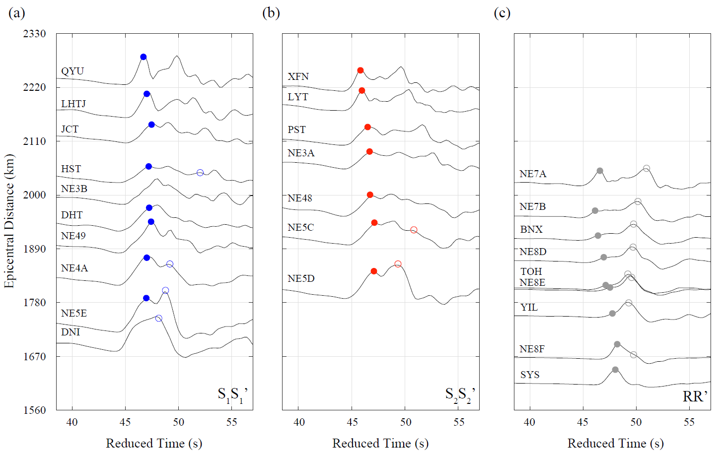
Extended Data Fig. 2 | Waveforms and picked arrival time. Solid and open circles mark the arrivals picked with confidence, for the refracted and direct waves, along S₁S₁’ (a), S₂S₂’ (b), and reference region RR’ (c), respectively.
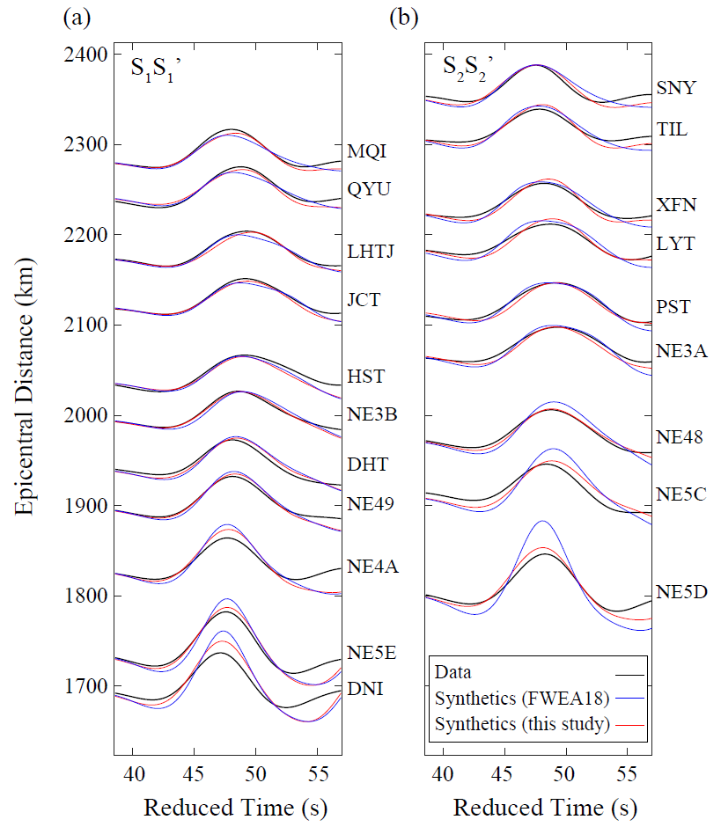
Extended Data Fig. 3 | Waveforms comparison at long periods. Data and synthetics are filtered from 8 to 30 seconds along S₁S₁’ (a) and S₂S₂’ (b). The layer out is the same as Fig. 3.

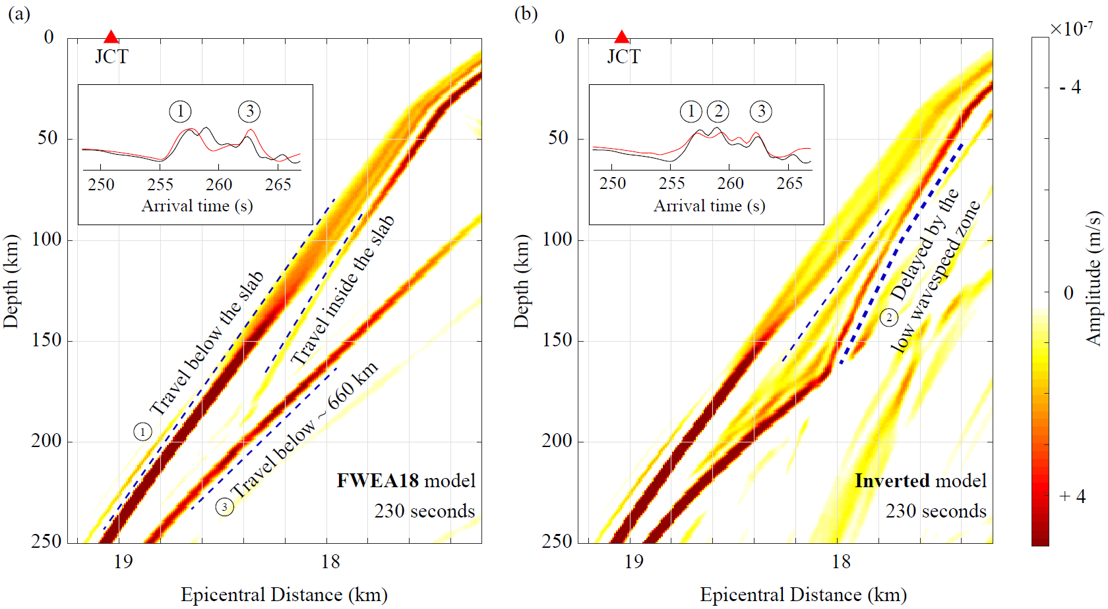
Extended Data Fig. 4 | Snapshot of the velocity wavefield near station JCT along S₁S₁’. (a) For the original model FWEA18. (b) For the inverted model “FWEA18-LVZ” in this study.

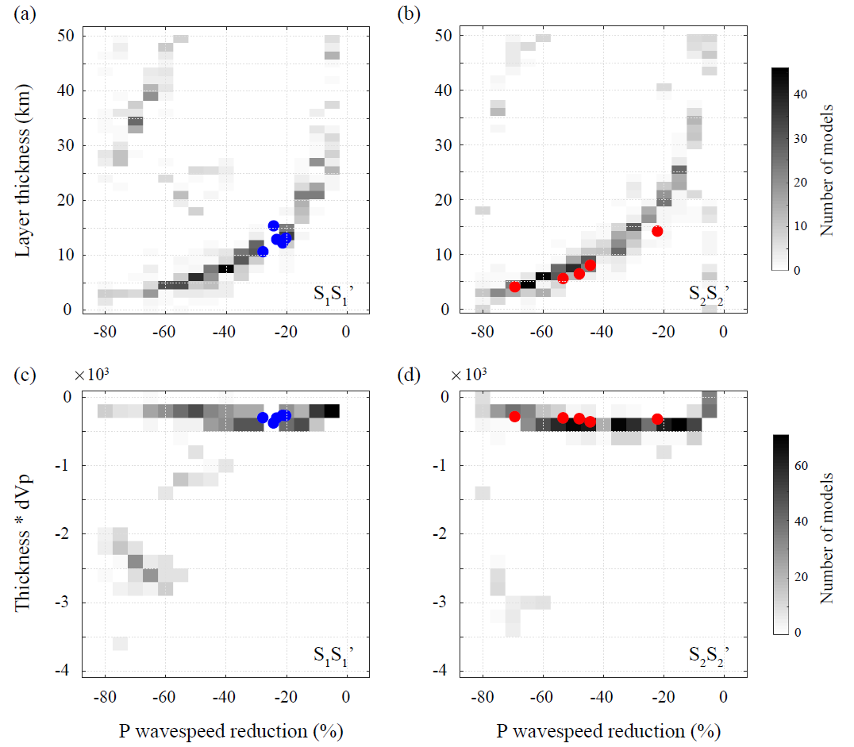
Extended Data Fig. 5 | Models in the last iteration. (a) P wave speed reduction and layer thickness of models in the last iteration of the inversion along S₁S₁’. The red dots mark the models with the best performance (shown in Fig. 4). (c) The y-axis is the product of wave speed reduction and layer thickness along S₁S₁’. (b) and (d) are along S₂S₂’.
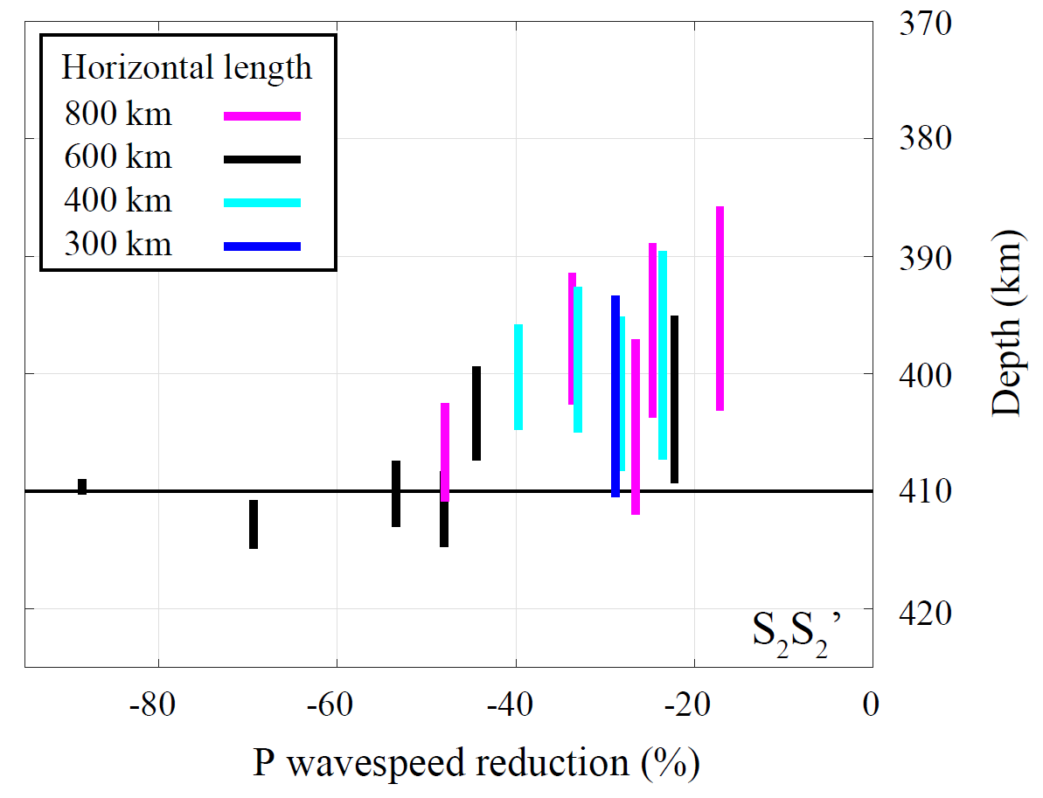
Extended Data Fig. 6 | Influence of the horizontal length of the inversion box. The black bars mark the acceptable models along S₂S₂’ with a horizontal width of 600 km (used in this study). The magenta, cyan, and blue bars indicate the models for other widths of 800 km, 400 km, and 300 km, respectively. Note that when the width is smaller than 200 km, no model can fit the data.
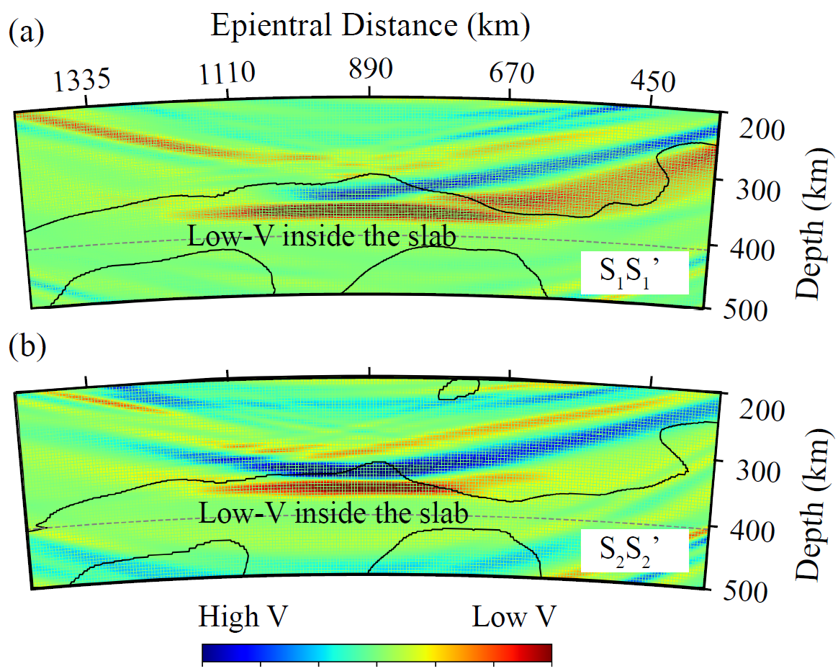
Extended Data Fig. 7 | Sensitivity kernels. (a) Along S₁S₁’. (b) Along S₂S₂’.
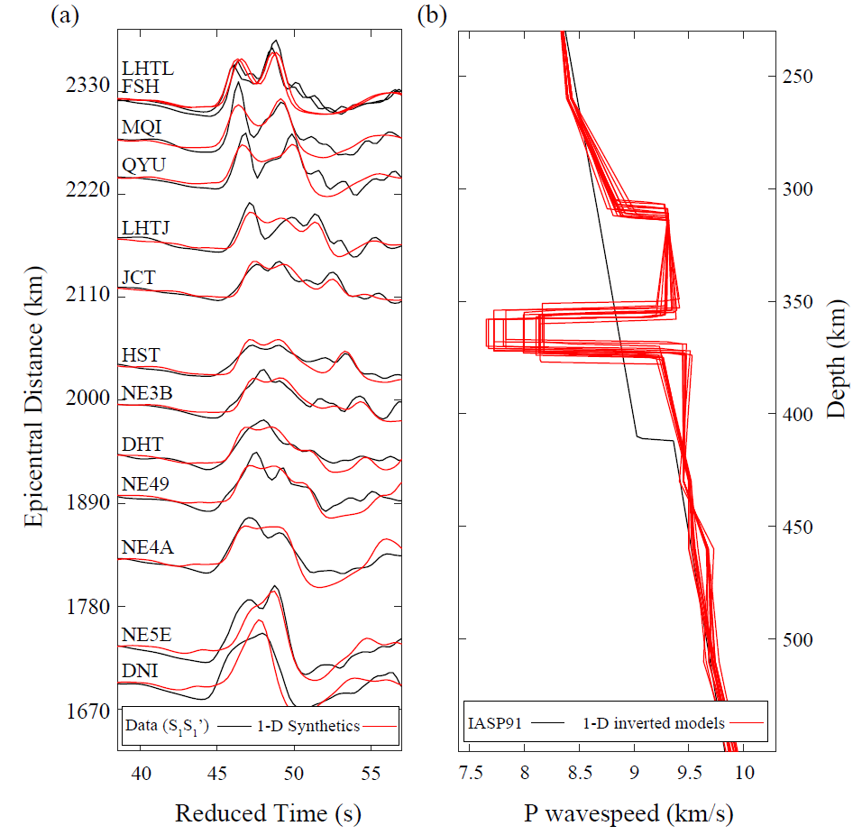
Extended Data Fig. 8 | Inversion results for the 1-D model along S₁S₁’. (a) Waveform comparison between data (black) and 1-D synthetics (red). (b) Acceptable 1-D models (red).

