Supplementary Information for “Aerodynamic characteristics of effective early flight postures for ski jumping: Exploratory CFD analysis” in Sports Engineering

Tomoya Ueno¹*, Shimpei Hatano², Tokimasa Shimada², Rahul Bale^{2, 3}, Keizo Yamamoto¹, Makoto Tsubokura^{2, 3}

¹Graduate School of Lifelong Sport, Hokusho University, Ebetsu, Japan
²Graduate School of System Informatics, Kobe University, Kobe, Japan
³Complex Phenomena Unified Simulation Research Team, RIKEN Advanced Institute for Computational Science, Kobe, Japan

* Corresponding Author (email: tomo.quick1997@gmail.com)
S1. Governing equations
The governing equations consist of the incompressible Navier–Stokes equations and the continuity equation in an inertial reference frame, as expressed in Equations (S1.1) and (S1.2). Here, ρ denotes the fluid density, u represents the fluid velocity vector, p stands for the pressure, μ expresses the dynamic viscosity, and t denotes time.
$$\begin{aligned}ρ\left(\frac{∂u}{∂t}+\left(u⋅∇\right)u\right)=-∇p+μ∇^{2}u \#\left(S1.1\right)\end{aligned}$$
$$\begin{aligned}∇⋅u=0 \#\left(S1.2\right)\end{aligned}$$
For this study, the early flight phase was defined as the 0.2 s interval immediately following take-off, consistent with the definition adopted by Ueno et al. [1]. The posture changes which the jumper adopted during this period were reproduced. During this short time period, the velocity vector of the jumper was assumed to be equal to the in-run velocity vector. However, even within 0.2 s, a jumper traveling at approximately 20 m/s moves about 4 m. As a result, the region within the computational domain which requires high spatial resolution becomes markedly larger, leading to increased computational cost. To avoid this issue, a non-inertial reference frame fixed to the jumper was adopted to reproduce the early flight motion. When the jumper undergoes translational and rotational motion, the coordinate transformation between the inertial frame and the non-inertial reference frame is expressed by Equations (S1.3) and (S1.4).
$$\begin{aligned}x=x_{T}+R⋅x^{*} \#\left(S1.3\right)\end{aligned}$$
$$\begin{aligned}u=\dot{x_{T}}+\dot{R}⋅x^{*}+R⋅u^{*} \#\left(S1.4\right)\end{aligned}$$
Hereinafter, variables with an asterisk (*) denote quantities defined in the non-inertial reference frame. The symbol $x$ is the position vector; $x_{T}$ and $R$ respectively denote the translational vector and the rotation matrix. Time derivatives are denoted by an overdot (˙). By applying Equations (S1.3) and (S1.4), the governing equations in the non-inertial reference frame can be written as Equations (S1.5) and (S1.6).
$$\begin{aligned}ρ\left(\frac{∂u^{*}}{∂t}+\left(u^{*}⋅∇^{*}\right)u^{*}\right)=-∇^{*}p+μ{∇^{*}}^{2}u^{*}-R^{-1}⋅\left(\ddot{x_{T}}+\ddot{R}⋅x^{*}+2\dot{R}⋅u^{*}\right) \#\left(S1.5\right)\end{aligned}$$
$$\begin{aligned}∇^{*}⋅u^{*}=0 \#\left(S1.6\right)\end{aligned}$$
Here, $∇^{*}$ denotes the gradient operator with respect to $x^{*}$ in the non-inertial reference frame. The velocity of the jumper, $U_{b}$, is decomposable into two components: the rigid-body translational velocity of the jumper, $U_{b}^{rigid}$, and the deformation velocity associated with changes in the jumper’s posture, $U_{b}^{def}$. Accordingly, $U_{b}$ is expressed as shown below.
$$\begin{aligned}U_{b}=U_{b}^{rigid}+U_{b}^{def} \#\left(S1.7\right)\end{aligned}$$
The rigid-body velocity of the jumper, $U_{b}^{rigid}$, can be decomposed further into the linear translational velocity, $U_{bl}^{rigid}$, and the rotational component, $Ω_{b}^{rigid}×r$, where $Ω_{b}^{rigid}$ denotes the angular velocity and r is the position vector measured from the centre of rotation. For the present study, however, the jumper is assumed to undergo translational motion only. Therefore, the rotational component $Ω_{b}^{rigid}×r$ is set to zero. Accordingly, because the jumper fixed in the non-inertial reference frame is assumed to perform purely linear translational motion without rotational motion, Equations (S1.3) and (S1.4) can be simplified as presented below.
$$\begin{aligned}x_{T}=U_{b}^{rigid} \#\left(S1.8\right)\end{aligned}$$
$$\begin{aligned}R=I \#\left(S1.9\right)\end{aligned}$$
Here, I represents the identity matrix. Based on the assumption described above, the coupled equations governing fluid flow and jumper motion in the non-inertial reference frame are expressed as presented below.
$$\begin{aligned}ρ\left(\frac{∂u}{∂t}+\left(u⋅∇\right)u\right)=-∇p+μ∇^{2}u-{\dot{U}}_{b}^{rigid}+f \#\left(S1.10\right)\end{aligned}$$
$$\begin{aligned}∇⋅u=0 \#\left(S1.11\right)\end{aligned}$$
$$\begin{aligned}f\left(x,t\right)=\int_{Ψ}{F\left(s,t\right)δ\left(x-X\left(s,t\right)\right)ds} \#\left(S1.12\right)\end{aligned}$$
$$\begin{aligned}U\left(s,t\right)=\int_{Ω}{u\left(x,t\right)δ\left(x-X\left(s,t\right)\right)dx} \#\left(S1.13\right)\end{aligned}$$
$$\begin{aligned}\frac{∂X}{∂t}\left(s,t\right)=U_{b}^{def}\left(s,t\right) \#\left(S1.14\right)\end{aligned}$$
In those equations, $Ω$ denotes the Eulerian domain defined on the spatially fixed computational grid, and $Ψ$ stands for the domain of Lagrangian particles representing material points of the solid body. Equations (S1.10) and (S1.11) are the incompressible Navier–Stokes equations and the continuity equation solved in the Eulerian domain. The posture change of the athlete is explained in the previously described non-inertial frame using the material coordinates (s, t). Equations (S1.12) and (S1.13) respectively show the transfer of quantities between the Eulerian coordinates (x, t) in the Eulerian domain and the material coordinates (s, t) in the Lagrangian domain. The evolution of the material points composing the athlete is described by Equation (S1.14). Time discretization was performed using the fractional-step method [2]. The advection and diffusion terms were discretized using the Crank–Nicolson method. The QUICK scheme was applied to the advection term, whereas a second-order central difference scheme was used for the diffusion term. Also, turbulence was treated using an implicit large-eddy simulation (ILES) approach, by which the dissipation associated with the unresolved subgrid scales is provided by numerical discretisation rather than by an explicit subgrid-scale model [3, 4]. In the present solver, the numerical dissipation introduced by the upwind-biased QUICK scheme used for the advection term acts as the implicit subgrid model.
S2. Numerical methods / Solver
The CFD analysis simulations were performed using an in-house, general-purpose, massively parallel multi-physics flow solver: CUBE [2]. CUBE employs a Cartesian grid generation technique: the building cube method (BCM) [5]. The immersed boundary method (IBM) is implemented for the treatment of complex geometries [6, 7]. The present CFD workflow was based on the framework proposed by Yamamoto et al. [8], in which aerodynamic forces predicted by CFD were validated against aerodynamic forces estimated from Global Navigation Satellite System (GNSS) measurements obtained during actual ski-jumping trials. Although the CFD underestimated the absolute magnitudes of lift and drag, the temporal trends and lift-to-drag ratio showed good agreement with the measurement-based estimates, supporting the applicability of the framework for comparative aerodynamic analyses.
S3. Computational setup
The computational domain size and boundary conditions were identical for all simulations, although the local grid configuration differed among analysed trials. The computational domain was defined as sufficiently large to ensure that the blockage ratio of the ski jumper within the domain remained below 2% (Fig. S1 a). The ski jumper model was placed at the centre of the computational domain. Only the posture change of the jumper was reproduced: translational motion was not considered. The jumper’s linear (translational) velocity was prescribed as an inflow boundary condition. The velocity during early flight has both a horizontal and a downward vertical component. Therefore, the inflow velocity vector was specified as (Ux, 0, Uz) rather than a purely horizontal stream. The streamwise boundaries were treated as inflow (inlet) and outflow (outlet). Periodic boundary conditions were applied to the upper and lower boundaries so that the vertical component of the flow was represented consistently. The spanwise (lateral, y) boundaries were set as slip conditions. The computational domain was made sufficiently large that the jumper did not interact with its own wake through the periodic boundaries. The take-off ramp (Fig. S1 b) was represented by a simplified plate geometry. To prevent unrealistic flow structures from forming around the ramp and affecting the aerodynamic forces acting on the jumper, the plate was modelled as a zero-thickness surface. A velocity boundary condition matching the inflow velocity was imposed on the plate surface. The minimum grid size was set as 10 mm considering the computational cost. The grid comprised 12,580 cubes and 51,527,680 cells, with a minimum cell size of 0.01 m at the jumper and ramp surface. The block structured grid is decomposed into cubic blocks, each of which is subdivided into the same number of cells. The refinement ratio between adjacent large and small blocks is 2 (Fig. S2). A formal grid-sensitivity analysis was not conducted because of the substantial computational cost of performing additional unsteady simulations with prescribed posture changes.
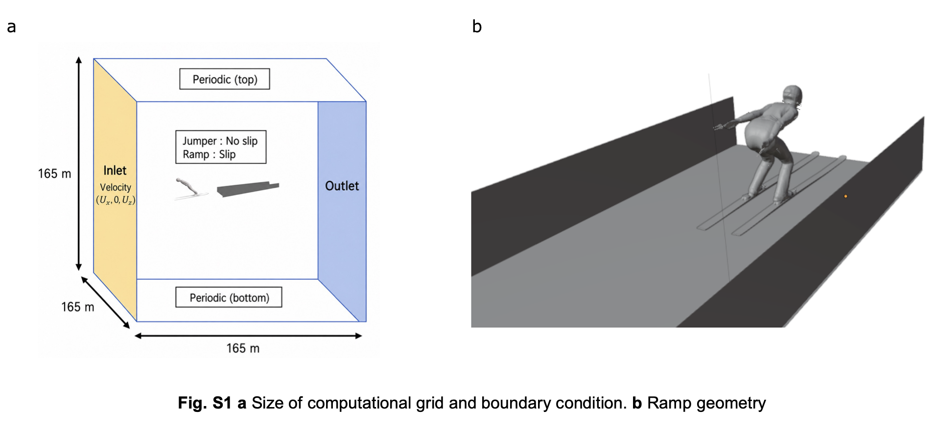
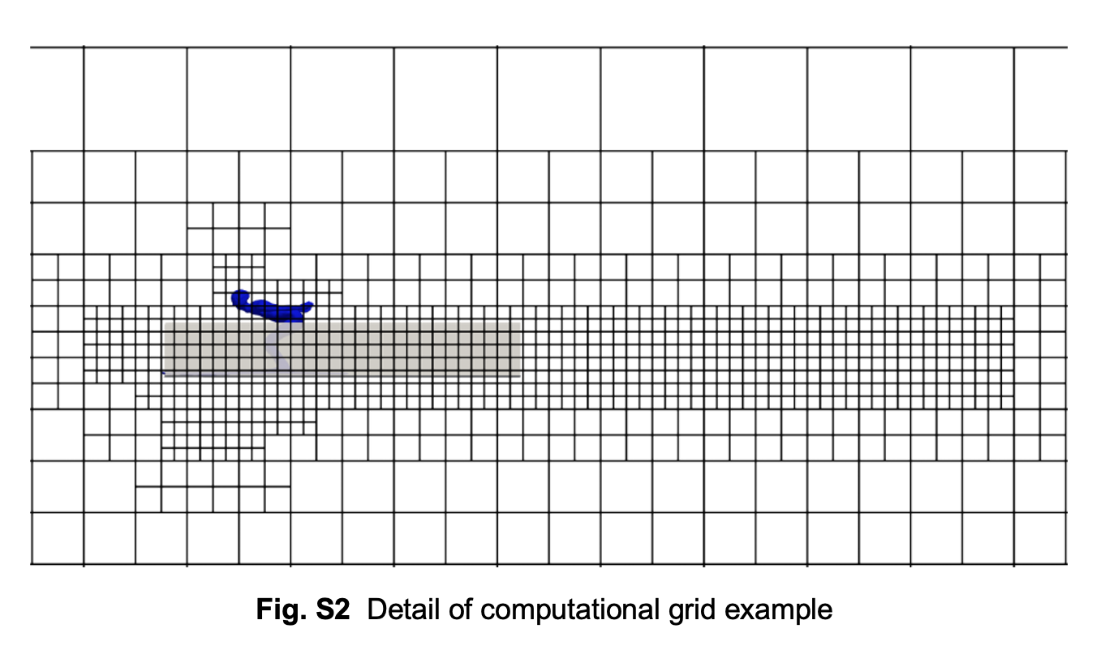
References
- Ueno T, Ishihara T, Yamamoto K (2026) Identification and classification of kinematically effective early flight postures in ski jumping. Sports Biomechanics 1–25. https://doi.org/10.1080/14763141.2026.2649472
- Jansson N, Bale R, Onishi K, Tsubokura M (2019) CUBE: A scalable framework for large-scale industrial simulations. The International Journal of High-Performance Computing Applications 33(4): 678–698. https://doi.org/10.1177/1094342018816377
- Boris JP, Grinstein FF, Oran ES, Kolbe RL (1992) New insights into large eddy simulation. Fluid Dynamics Research 10(4–6): 199–228.
- Grinstein FF, Margolin LG, Rider WJ (Eds.) (2007) Implicit Large Eddy Simulation: Computing Turbulent Fluid Dynamics. Cambridge University Press.
- Nakahashi K (2003) Building-cube method for flow problems with broadband characteristic length. In Armfield S, Morgan P, Srinivas K (Eds.) Computational Fluid Dynamics 77–81. Springer, Berlin Heidelberg.
- Bale R, Patankar NA, Jansson N, Onishi K, Tsubokura M (2020) Stencil Penalty approach based constraint immersed boundary method. Computers & Fluids 200: 104457.
- Bhalla APS, Bale R, Griffith BE, Patankar NA (2013) A unified mathematical framework and an adaptive numerical method for fluid-structure interaction with rigid, deforming, and elastic bodies. Journal of Computational Physics 250: 446–476.
- Yamamoto K, Nishino T, Bale R, Shimada T, Miyamoto N, Tsubokura M (2022) Numerical study of transient aerodynamic forces acting on a ski jumper considering dynamic posture change from takeoff to landing. Sports Biomechanics 1–15. https://doi.org/10.1080/14763141.2022.2154256.

