Supplementary Material
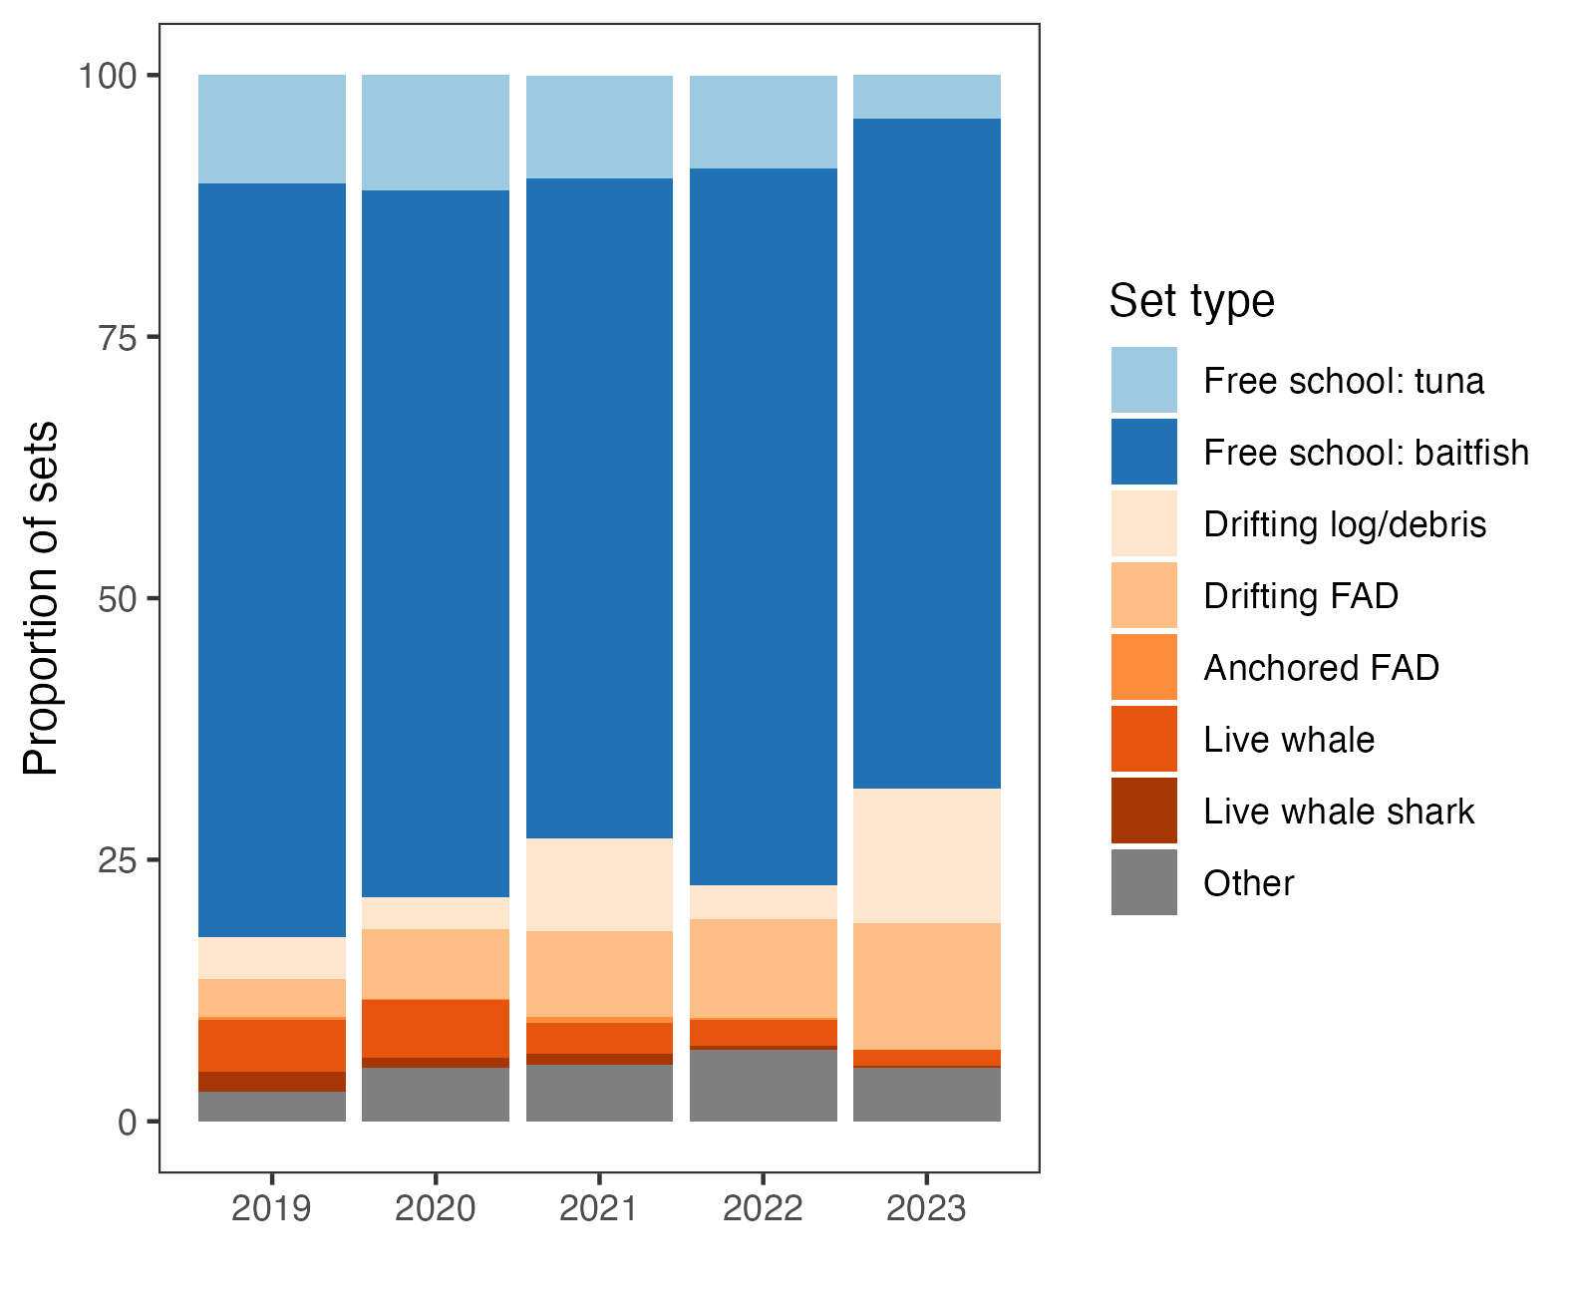
Figure S1: Proportional use over time of the eight set types recorded by observers in the FIA-PNG purse seine fleet. Codes 8 and 9 were not clearly defined in the WCPFC observer handbook and were combined into “Other” for this analysis.

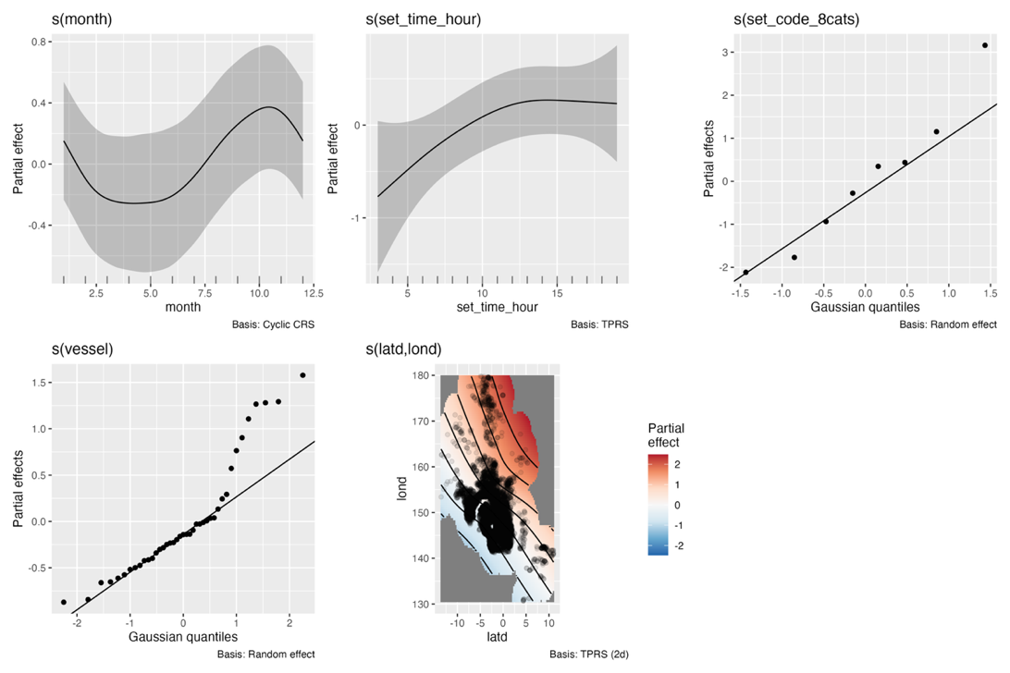
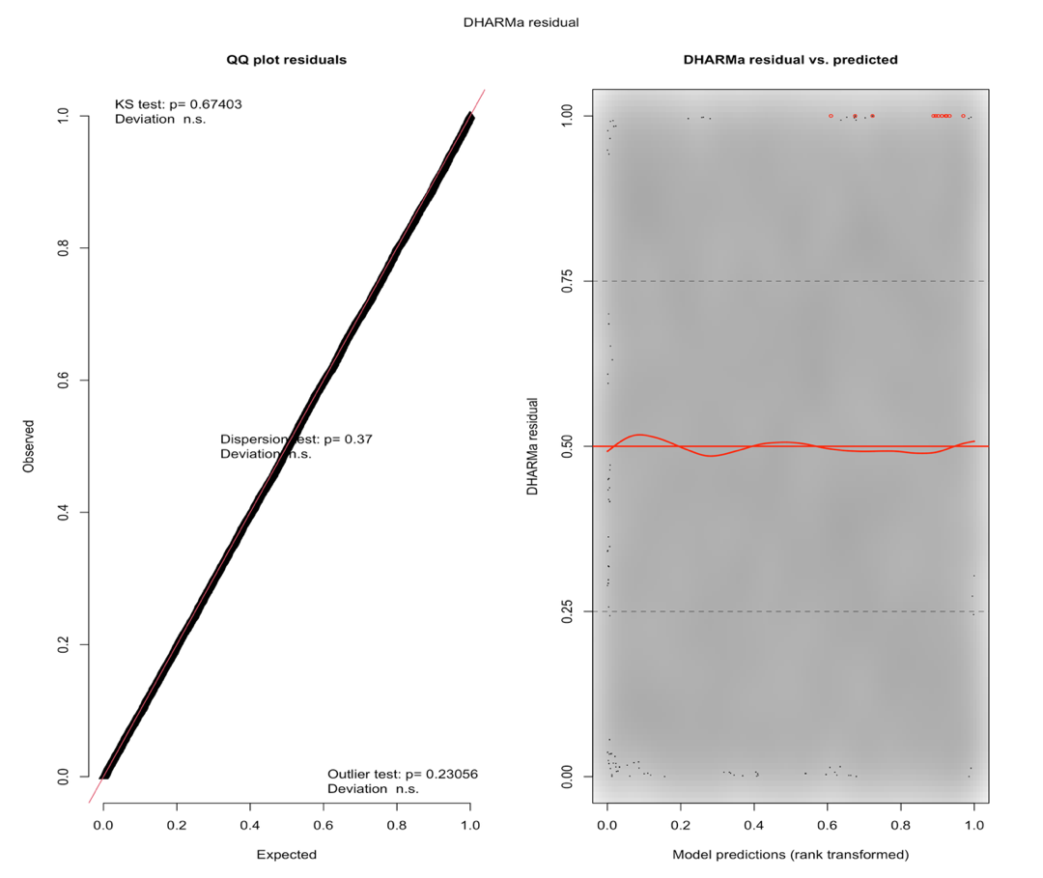
Figure S2: Smoothed-term estimates and diagnostic plots for the generalized additive model (GAM) of baleen whale bycatch. The response variable is the combined count of humpback (Megaptera novaeangliae), Bryde’s (Balaenoptera edeni), sei (Balaenoptera borealis), blue (Balaenoptera musculus), minke (Balaenoptera acutorostrata), and unidentified baleen whales. DHARMa diagnostics include quantile-quantile (Q-Q) plots of simulated residuals and residuals versus predicted values. Shaded areas of the smoothed term plots represent 95% confidence intervals and rug marks indicate the distribution of observations, where s(month)= circular smooth of the numeric month of the year; s(set time hour)= Hour setting began, rounded to 1 decimal place; s(set code 8cats= 8 categories of associated and unassociated set types, modelled as a random effect; s(vessel)= Vessel identity as a random effect; s(Latd, lond)=2D spatial smooth of the latitude and longitude recorded at the start of the purse seine set.

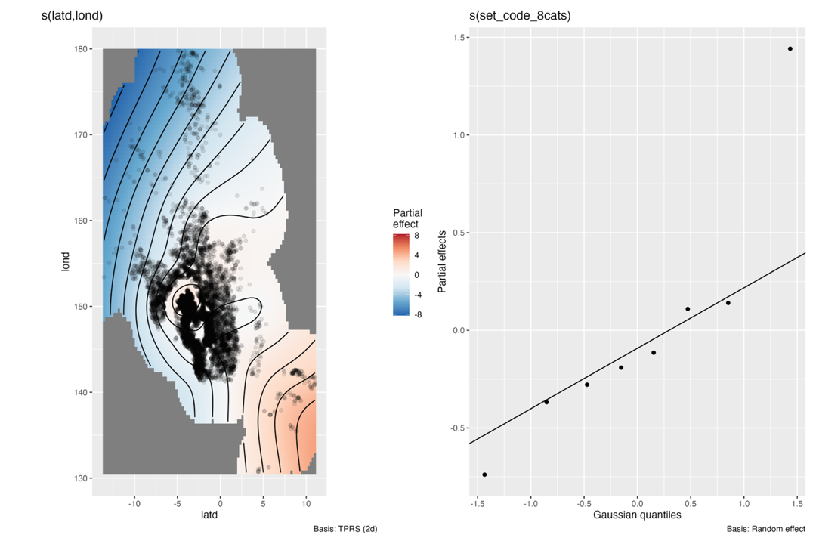
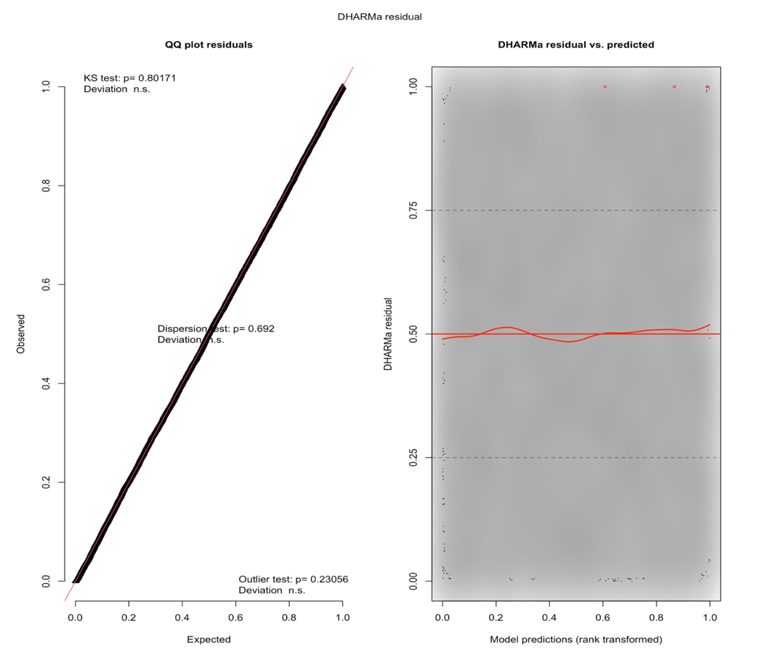
Figure S3: Smoothed-term estimates and diagnostic plots for the generalized additive model (GAM) of small to medium sized dolphin bycatch. The response variable is the combined count of bottlenose Tursiops truncatus, common Delphinus delphis, Indo-Pacific bottlenose (Tursiops aduncus), pantropical spotted (Stenella attenuate), spinner (Stenella longirostris), rough-toothed Steno bredanensis, and striped dolphins (Stenella coeruleoalba). DHARMa diagnostics include quantile-quantile (Q-Q) plots of simulated residuals and residuals versus predicted values. Shaded areas of the smoothed term plots represent 95% confidence intervals and rug marks indicate the distribution of observations, where s(Latd,lond)=2D spatial smooth of the latitude and longitude recorded at the start of the purse seine set. Set code 8cats= 8 categories of associated and unassociated set types, modelled as a random effect.
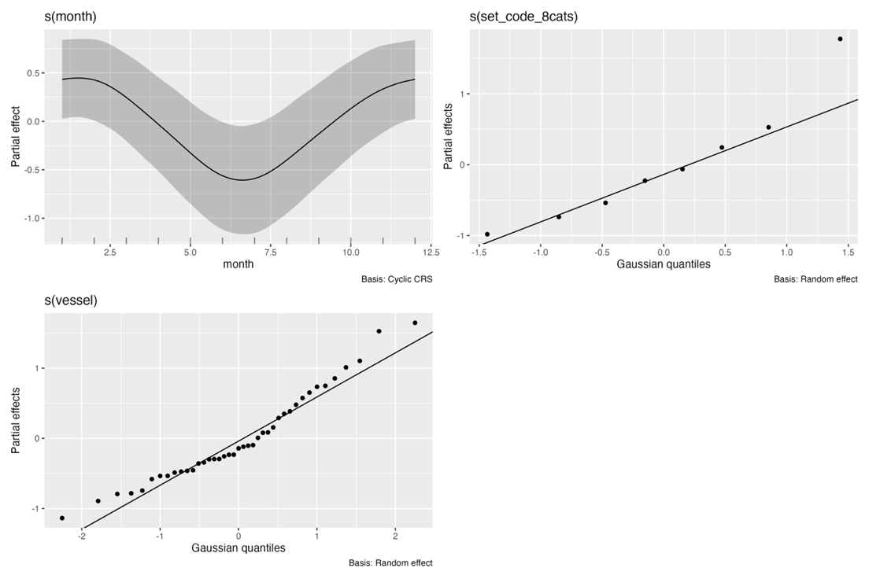
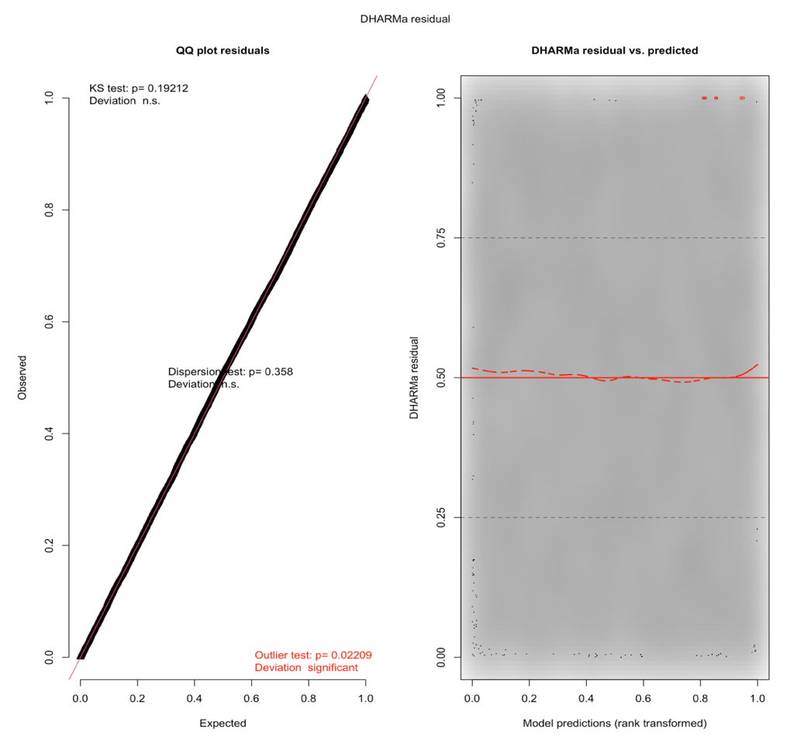
Figure S4: Smoothed-term estimates and diagnostic plots for the generalized additive model (GAM) of bycatch counts of false killer whale (Pseudorca crassidens). DHARMa diagnostics include quantile-quantile (Q-Q) plots of simulated residuals and residuals versus predicted values. Shaded areas of the smoothed term plots represent 95% confidence intervals and rug marks indicate the distribution of observations, where s(month) = circular smooth of the numeric month of the year; s(set code 8cats = 8 categories of associated and unassociated set types, modelled as a random effect; s(vessel) = Vessel identity as a random effect.
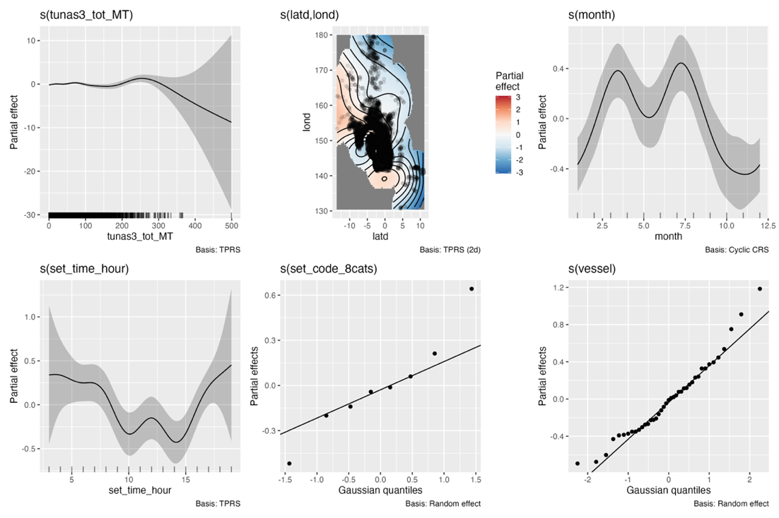
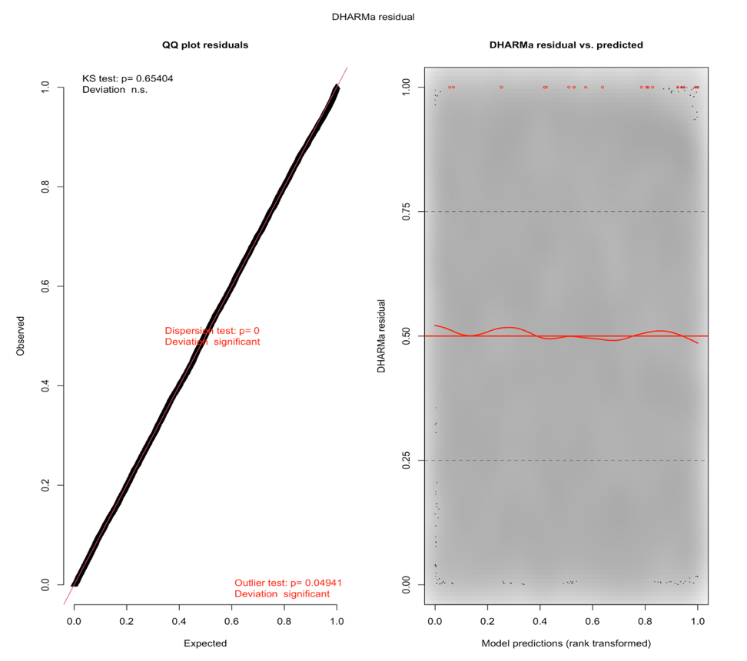
Figure S5: Smoothed-term estimates and diagnostic plots for the generalized additive model (GAM) of mobulid bycatch. The response variable is the combined count of Manta birostris and unidentified Mobulidae. DHARMa diagnostics include quantile-quantile (Q-Q) plots of simulated residuals and residuals versus predicted values. Shaded areas of the smoothed term plots represent 95% confidence intervals and rug marks indicate the distribution of observations, where s(tunas3_tot_MT) = combined catch weight (tonnes) of yellowfin (Thunnus albacares), skipjack (Katsuwonus pelamis), and bigeye tuna (Thunnus obesus); s(Latd, lond) = 2D spatial smooth of the latitude and longitude recorded at the start of the purse seine set; s(month) = circular smooth of the numeric month of the year; s(set time hour) = Hour setting began, rounded to 1 decimal place; s(set code 8cats = 8 categories of associated and unassociated set types, modelled as a random effect; s(vessel) = Vessel identity as a random effect.
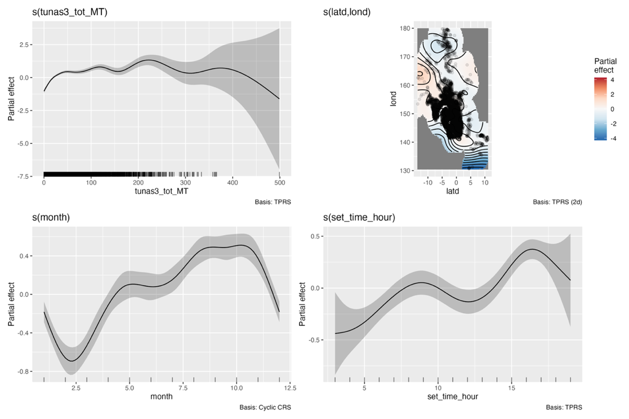
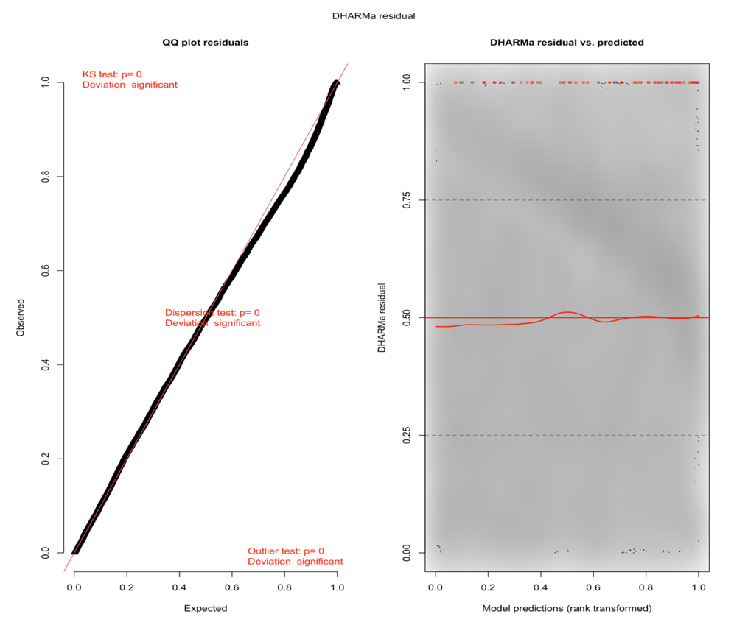
Figure S6: Smoothed-term estimates and diagnostic plots for the generalized additive model (GAM) of sea turtle bycatch. The response variable is the combined count of green (Chelonia mydas), olive ridley (Lepidochelys olivacea), hawksbill (Eretmochelys imbricata), loggerhead (Caretta caretta), leatherback (Dermochelys coriacea), and flatback turtles (Natator depressus). DHARMa diagnostics include quantile-quantile (Q-Q) plots of simulated residuals and residuals versus predicted values. Shaded areas of the smoothed term plots represent 95% confidence intervals and rug marks indicate the distribution of observations, where s(tunas3_tot_MT) = combined catch weight (tonnes) of yellowfin (Thunnus albacares), skipjack (Katsuwonus pelamis), and bigeye tuna (Thunnus obesus); s(Latd, lond) = 2D spatial smooth of the latitude and longitude recorded at the start of the purse seine set; s(month) = circular smooth of the numeric month of the year; s(set time hour)= Hour setting began, rounded to 1 decimal place.
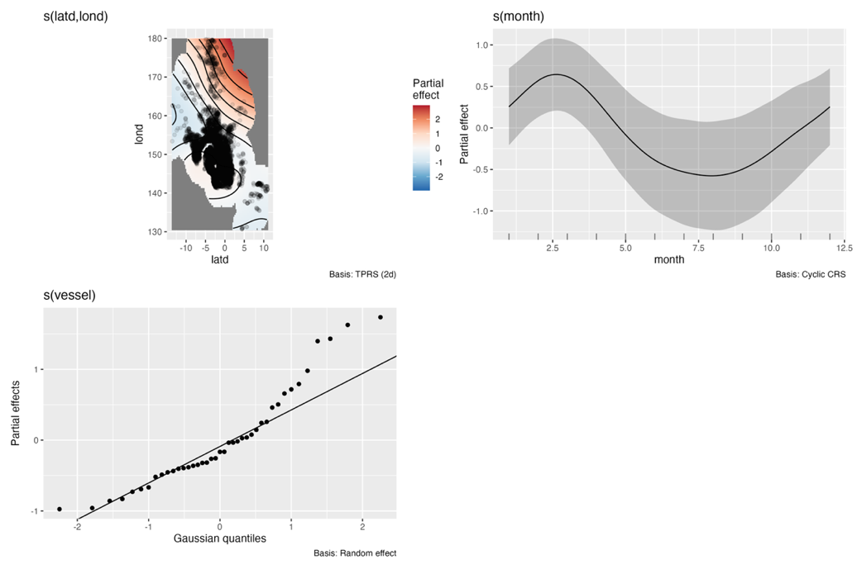
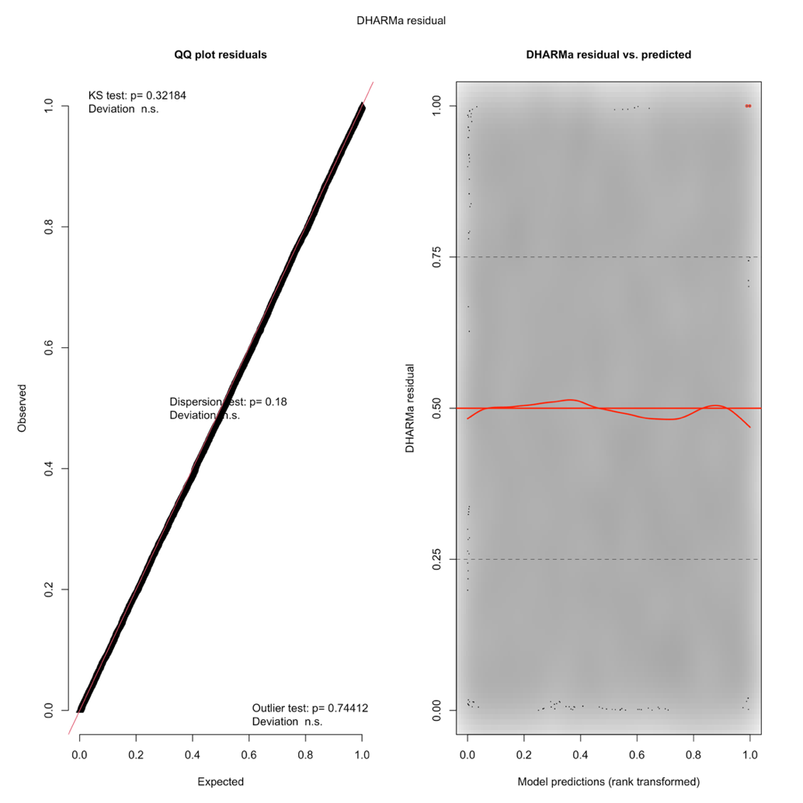
Figure S7: Smoothed-term estimates and diagnostic plots for the generalized additive model (GAM) of silky shark (Carcharhinus falciformis) bycatch, modelled as total catch weight (tonnes). DHARMa diagnostics include quantile-quantile (Q-Q) plots of simulated residuals and residuals versus predicted values. Shaded areas of the smoothed term plots represent 95% confidence intervals and rug marks indicate the distribution of observations, where s(tunas3_tot_MT) = combined catch weight (tonnes) of yellowfin (Thunnus albacares), skipjack (Katsuwonus pelamis), and bigeye tuna (Thunnus obesus); s(Latd, lond) = 2D spatial smooth of the latitude and longitude recorded at the start of the purse seine set; s(month) = circular smooth of the numeric month of the year; s(set time hour)= Hour setting began, rounded to 1 decimal place.
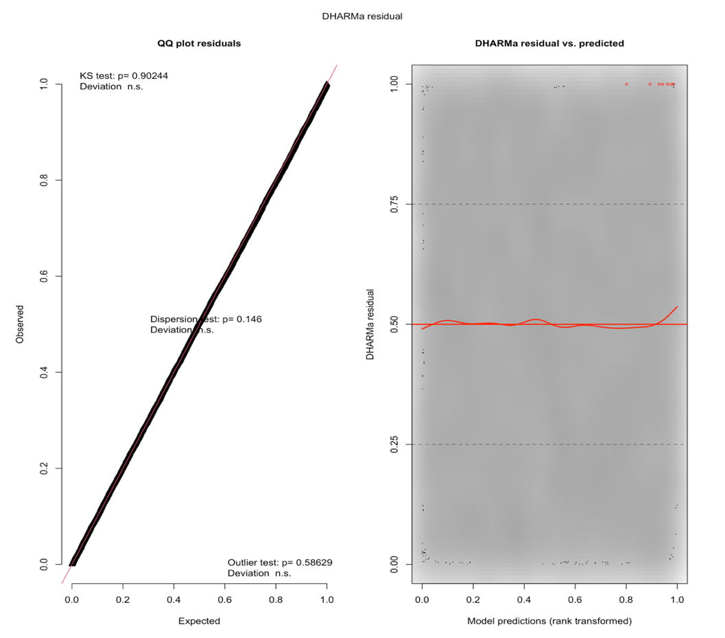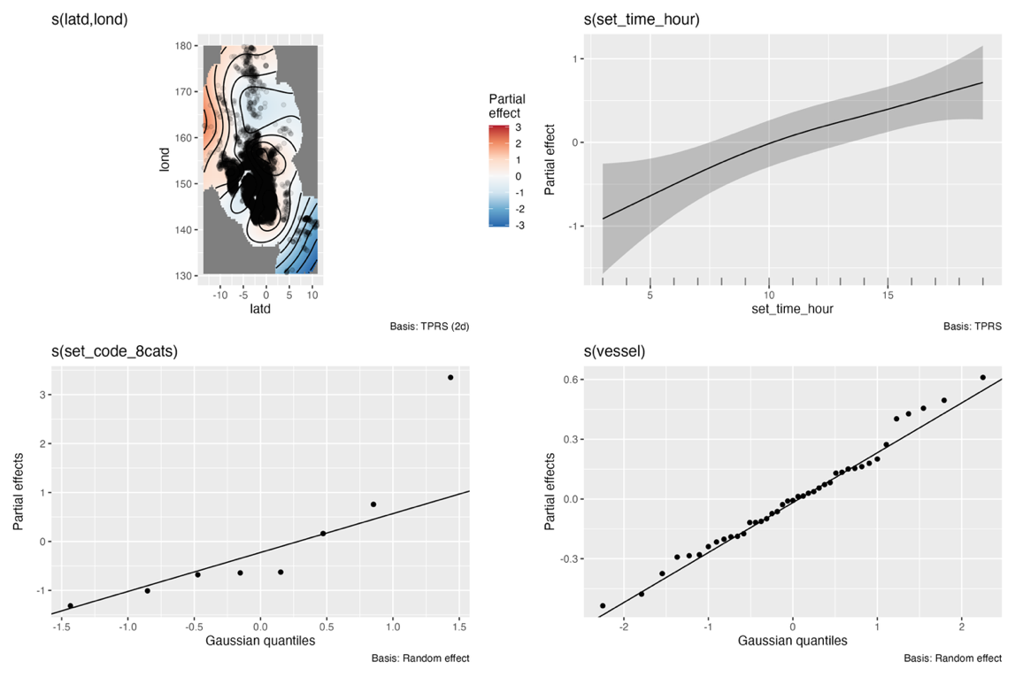
Figure S8: Smoothed-term estimates and diagnostic plots for the generalized additive model (GAM) of whale shark (Rhincodon typus) bycatch, modelled as counts. DHARMa diagnostics include quantile-quantile (Q-Q) plots of simulated residuals and residuals versus predicted values. Shaded areas of the smoothed term plots represent 95% confidence intervals and rug marks indicate the distribution of observations, where s(Latd, lond) = 2D spatial smooth of the latitude and longitude recorded at the start of the purse seine set; s(set time hour) = Hour setting began, rounded to 1 decimal place; s(set code 8cats = 8 categories of associated and unassociated set types, modelled as a random effect; s(vessel) = Vessel identity as a random effect.
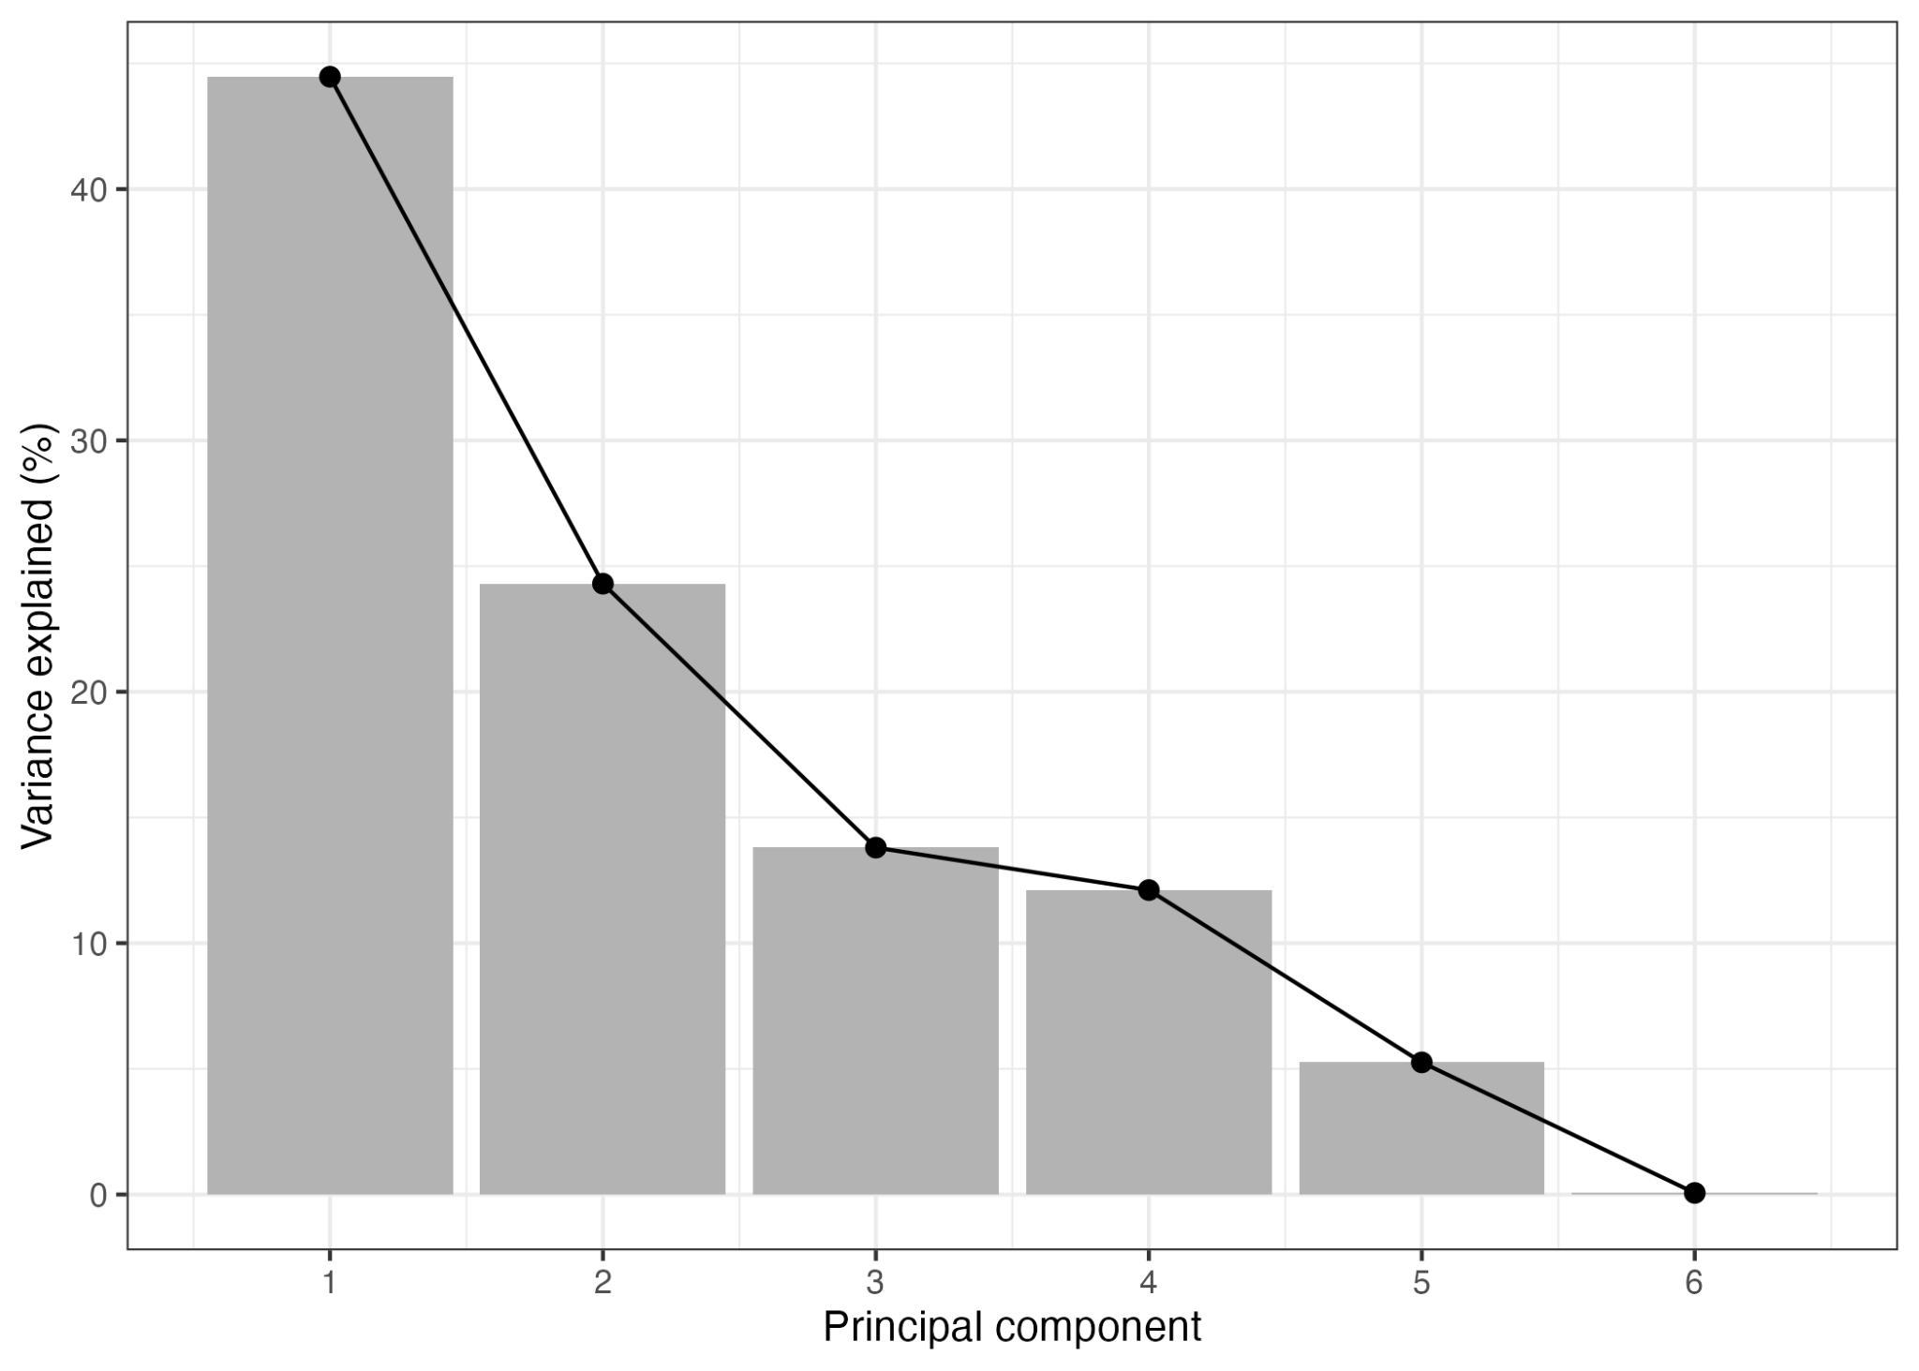
Figure S9: Scree plot showing the proportion of variance explained by each principal component from a principal component analysis (PCA) of the coefficients for the set type effects from the final generalized additive model (GAM) for each bycatch taxon, excluding sea turtles. The first two principal components explained 68.8% of the total variation, indicating that most variation among set types in their bycatch assemblages was captured by the first two axes.
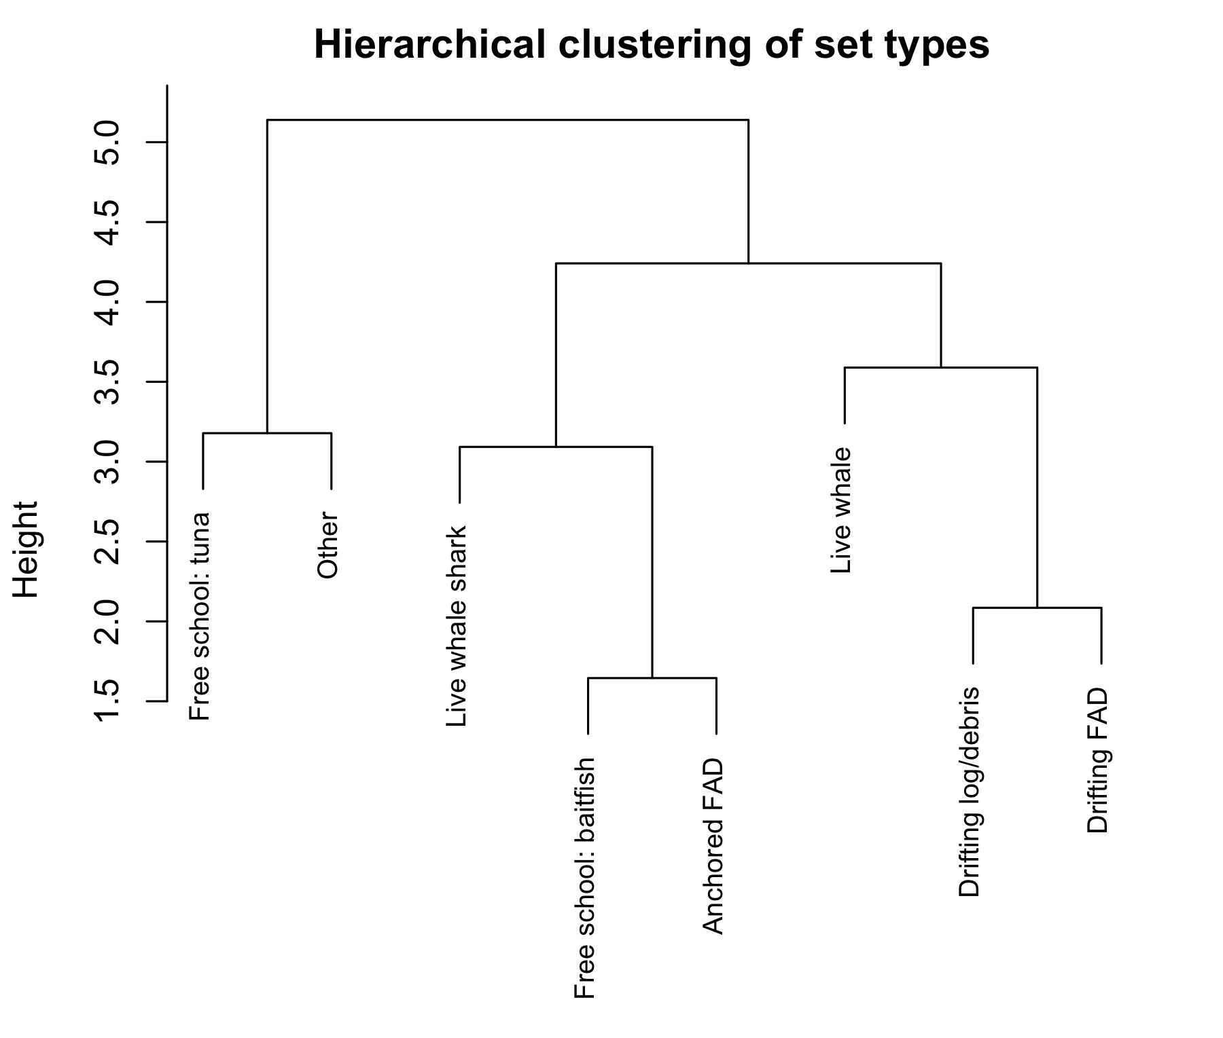
Figure S10: Dendrogram of hierarchical clustering of set types based on taxon-specific set type effect coefficients estimated from generalized additive models (GAMs). For each bycatch taxon, random effect coefficients for the set-type factor were extracted and assembled into a set type by species matrix. Sea turtles were not included because the set type factor was not significant. Principal component analysis (PCA) was applied to this matrix, and Euclidean distances among set types were calculated using all principal component scores and clustered using Ward's minimum variance method (Ward.D2). Branch heights indicate relative dissimilarity among set-type effect profiles across species.

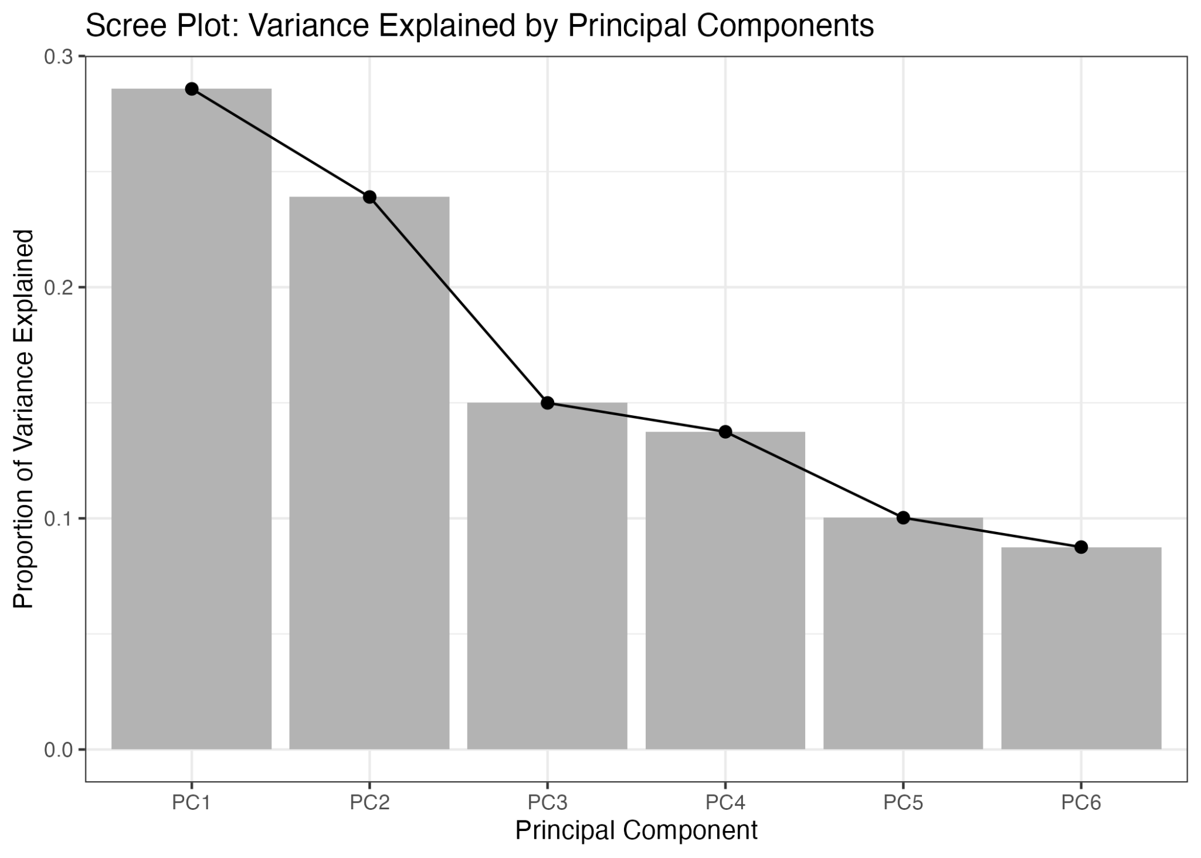
Figure S11: Scree plot showing the proportion of variance explained by each principal component from a principal component analysis (PCA) of vessel-specific random effect coefficients estimated from the final generalized additive models (GAMs) for each bycatch taxon, excluding dolphins. The first two principal components explained 52.5% of the total variation in vessel effect profiles, indicating that they captured much of the variation among vessels in taxon-specific bycatch patterns, although substantial additional variation was present in higher order components.

