Supplementary data

Spatial characterisation of the reproductive tract microbiota indicates high prevalence of microbial driven aetiology in preterm prelabour rupture of the fetal membranes (PPROM)

Tanweer O. Beleil^{1,2}, Sherrianne Ng^{1,2}, Richard G. Brown ^{1,2}, Erika Hudacova² Michal Punčochář³, Yun S. Lee^{1,2} Gonçalo DS Correia^{1,2}, Malko Adan¹, Lynne Sykes^{1,2,4}, Nicola Segata³, Phillip R. Bennett^{1,2} and David A MacIntyre^{1,2,5*}
¹March of Dimes Prematurity Research Centre, Imperial College London, UK
²Section of Pregnancy, Parturition and Prematurity, Institute of Reproductive and Developmental Biology, Department of Metabolism, Digestion and Reproduction, Imperial College London
³CIBIO, University of Trento, Italy
⁴The Parasol Foundation Centre for Women's Health and Cancer Research, St Mary's Hospital, Imperial College Healthcare NHS Trust, London, UK
⁵Robinson Research Institute, Adelaide University, Australia.

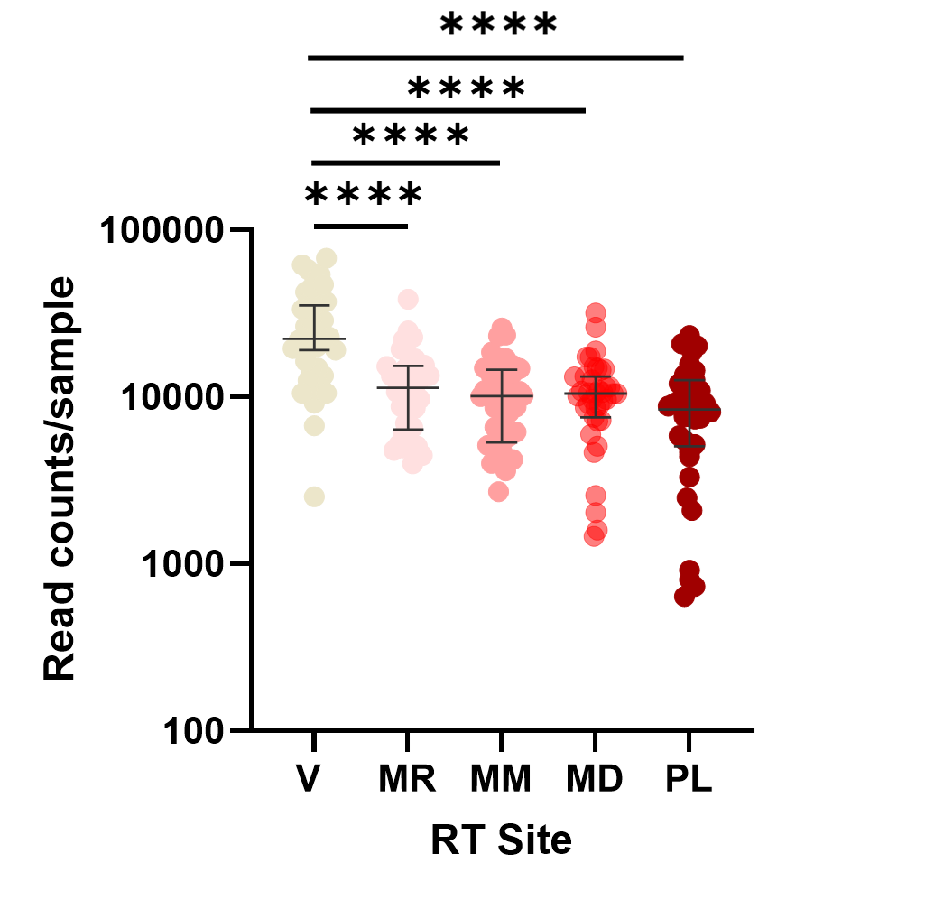
Supplementary Figure 1. Read count per sample at different reproductive tract (RT) sites including the vagina (V), fetal membranes (FM, at rupture (MR), mid (MM) and distal sites (MD)), placenta (PL). The read count of vaginal samples was significantly higher than FM and placenta samples (P= <0.0001, Mann-Whitney test)

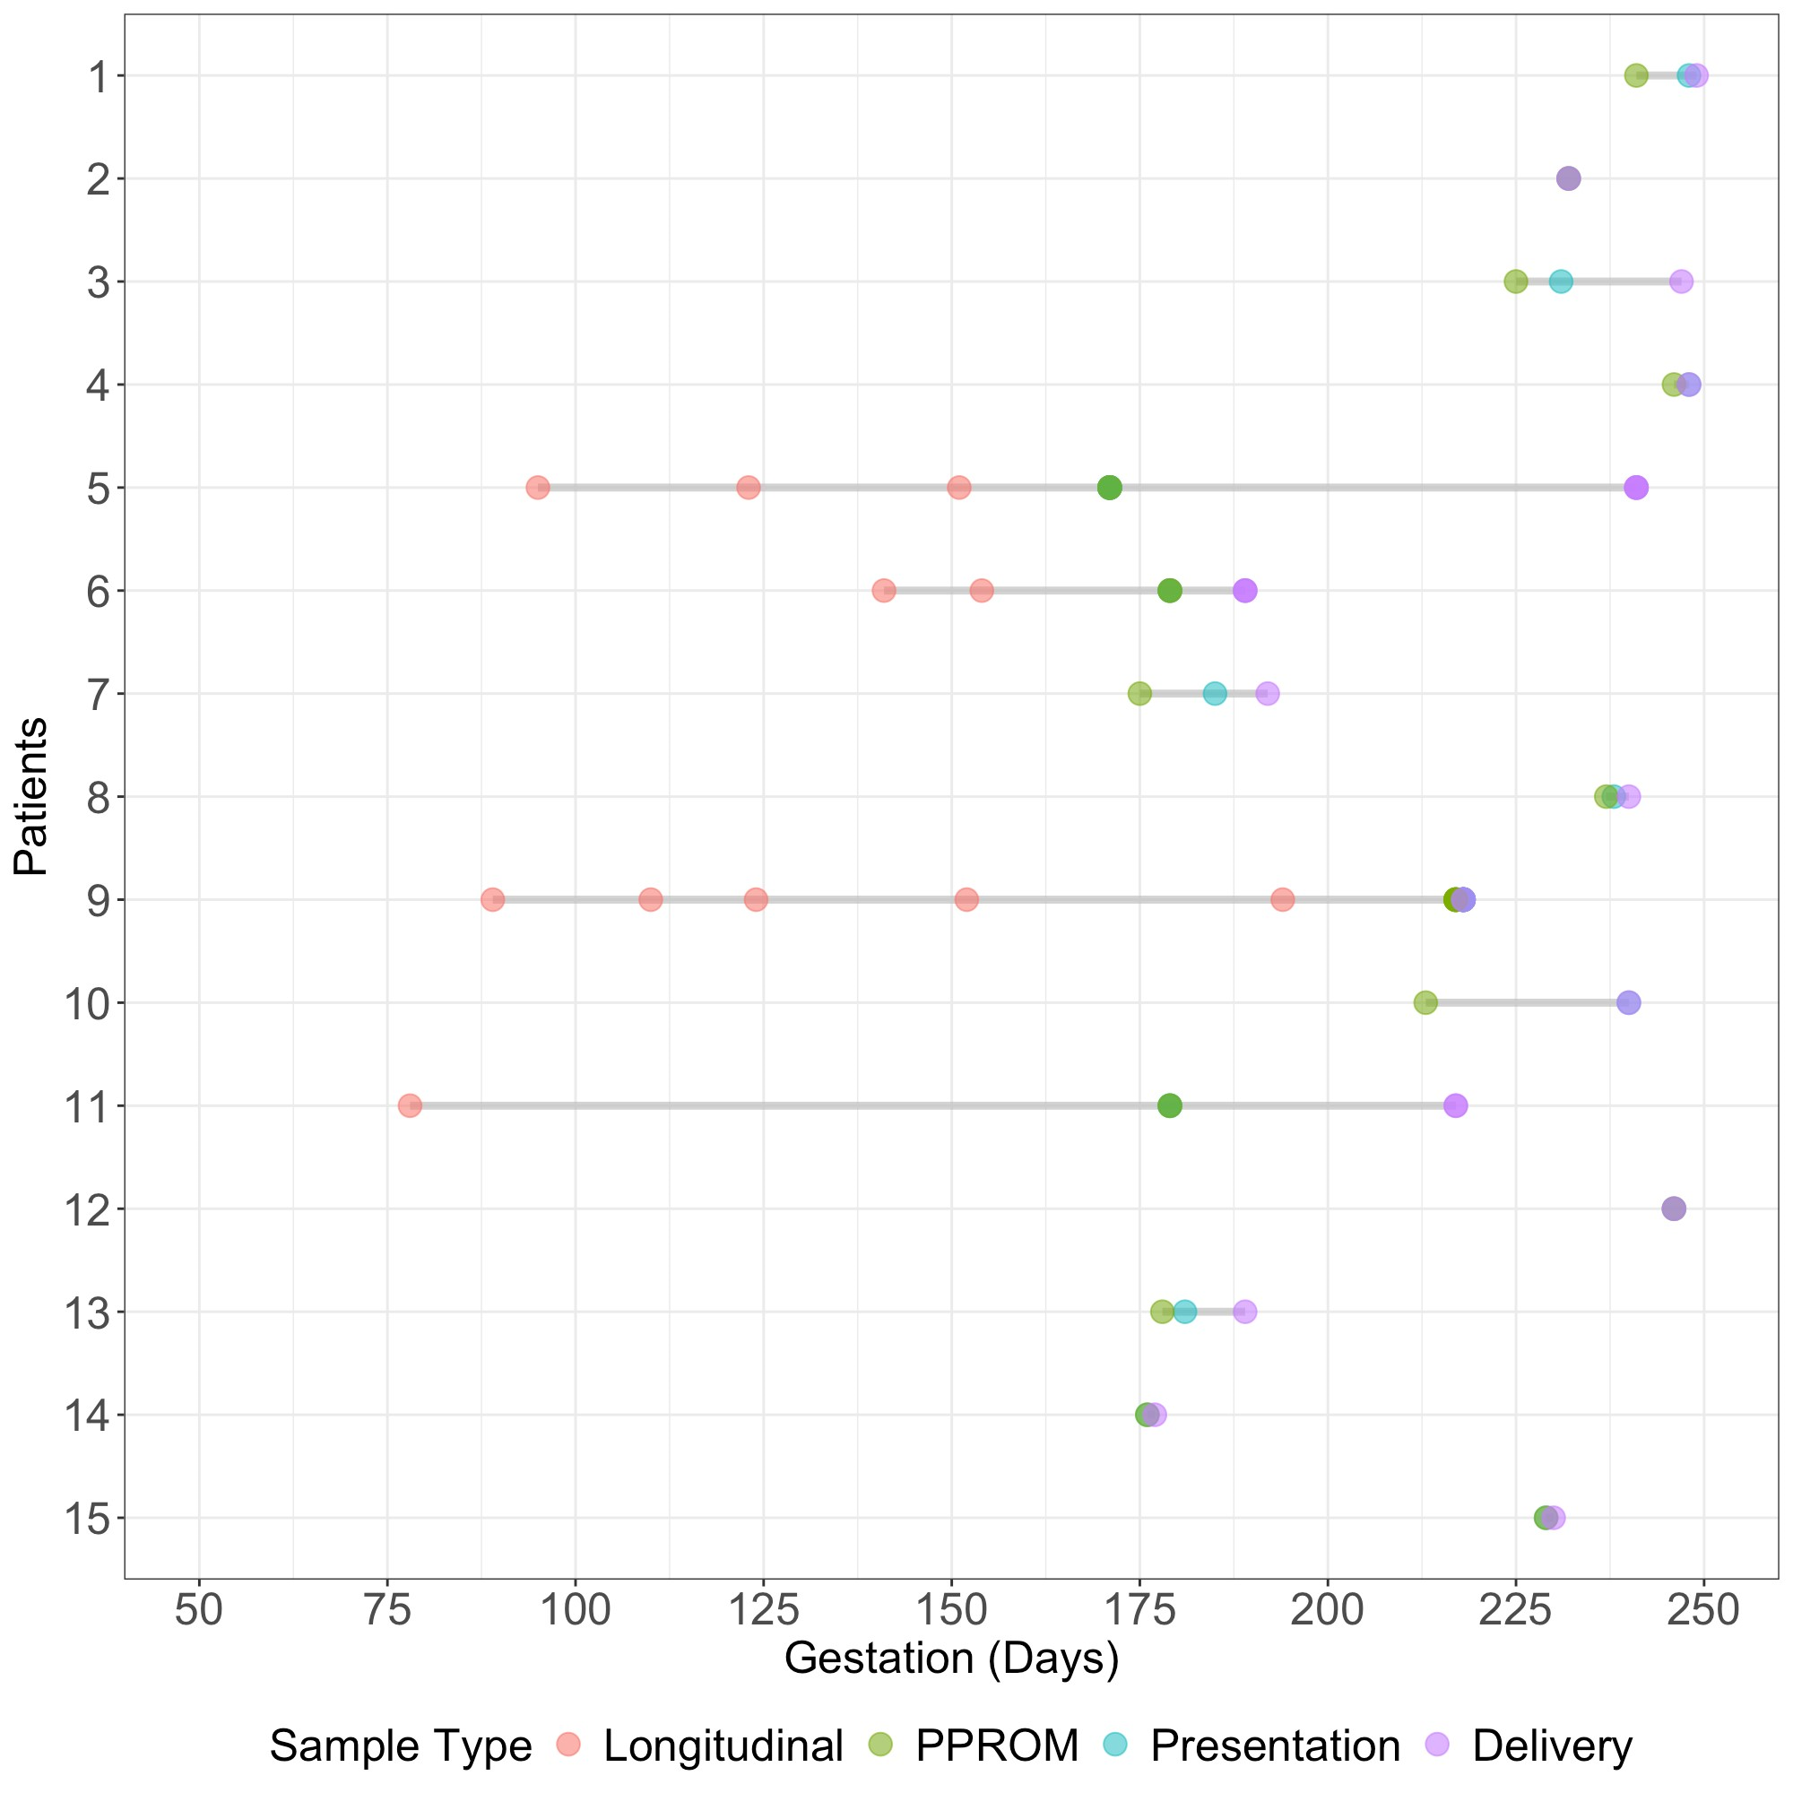

Supplementary Figure 2. Dumbbell plot showing gestational age at sampling and delivery of patients with PPROM (n=15). For most patients, vaginal swabs were collected at presentation with ruptured membranes, before tissue sampling at delivery. Four patients had longitudinal sampling of the vagina during pregnancy.

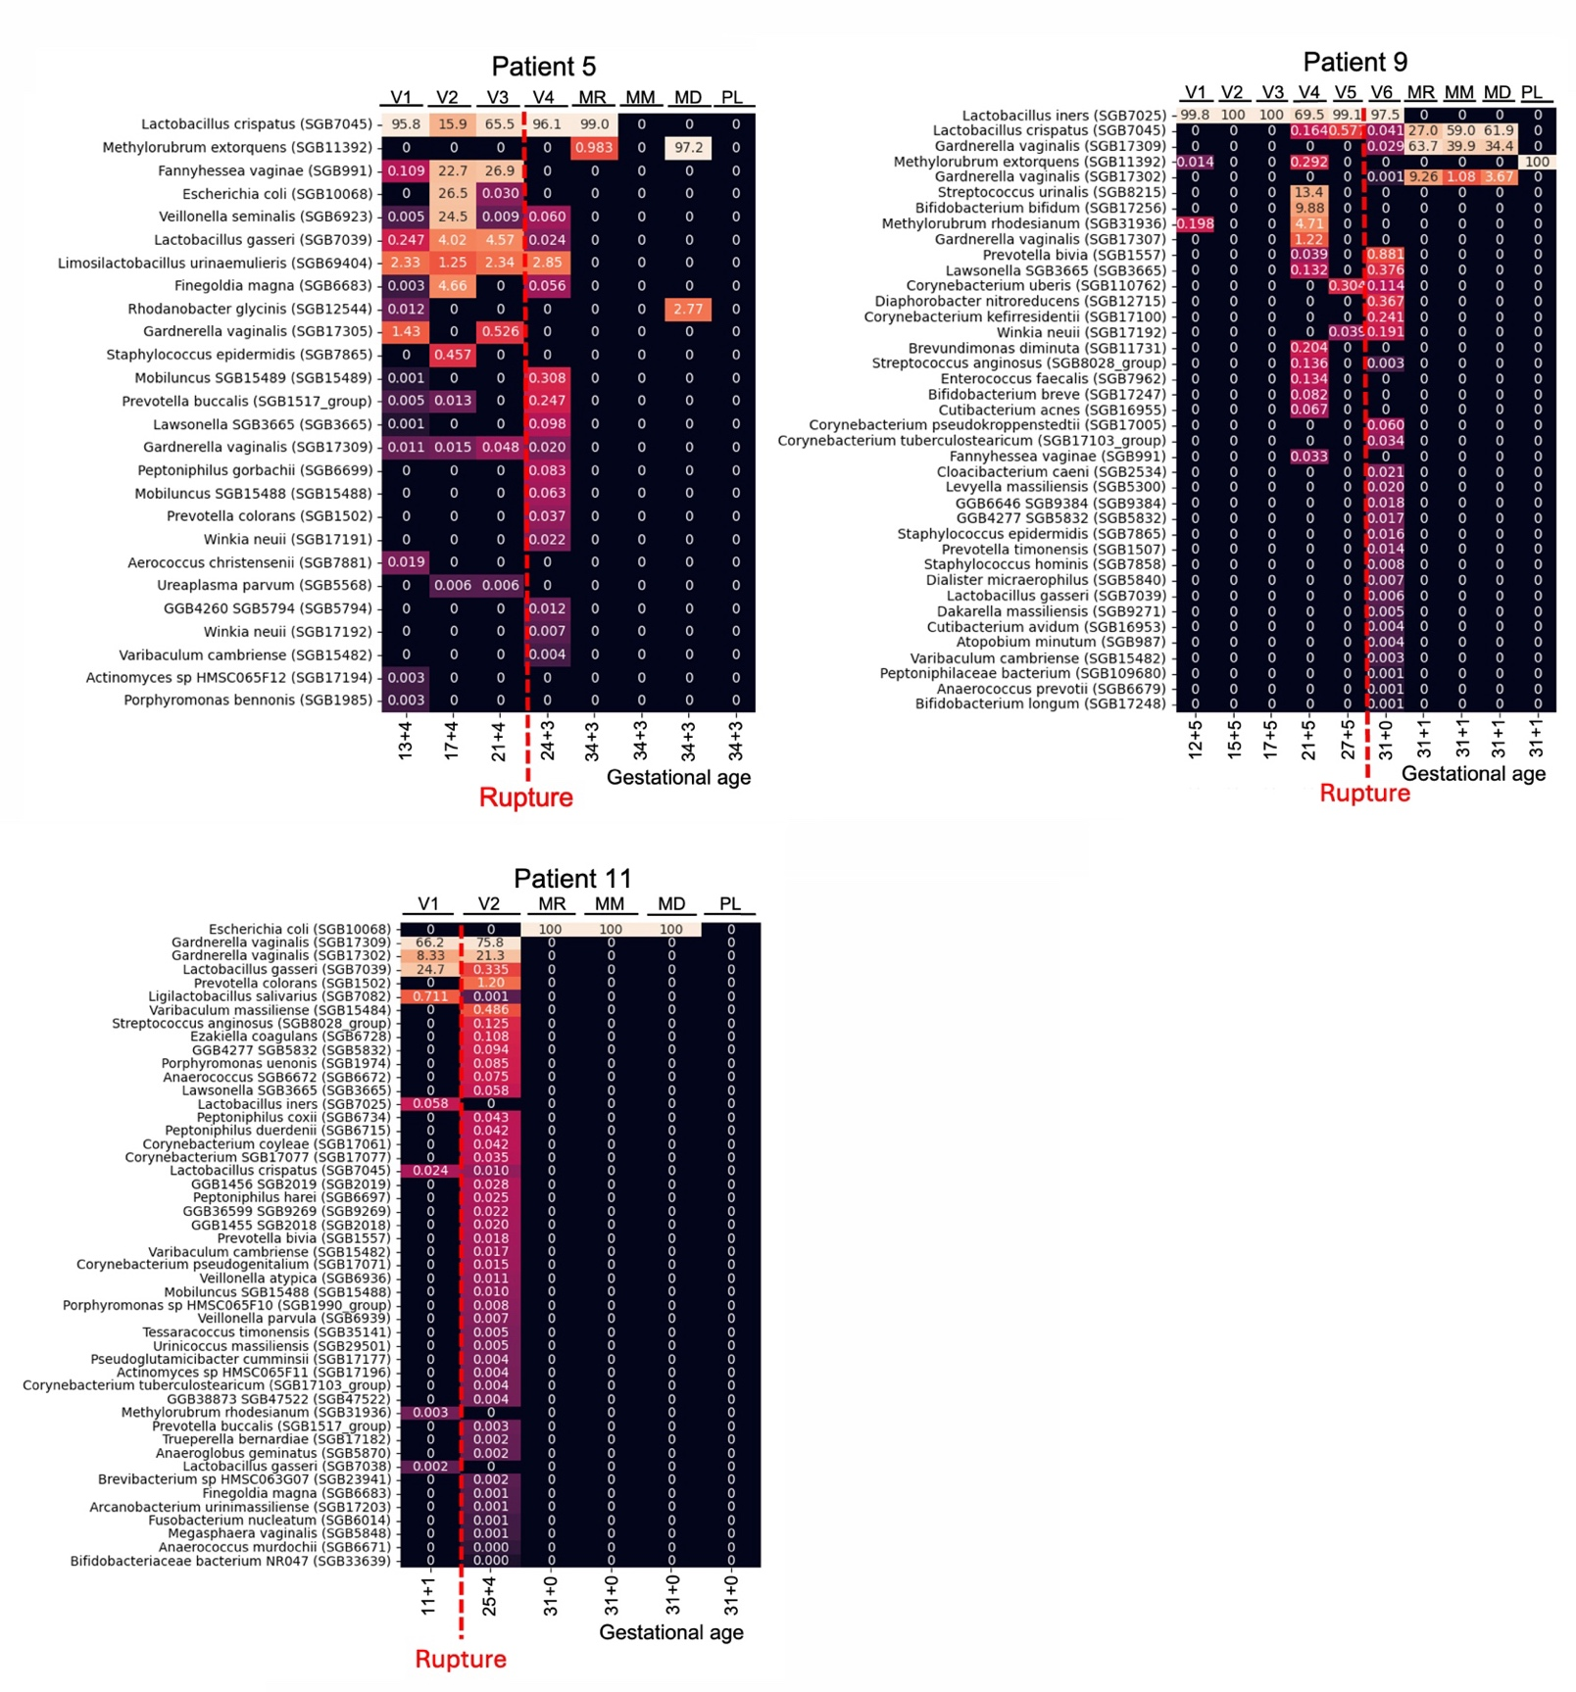

Supplementary Figure 3. Shotgun metagenomics-based bacterial composition of patient 6 (2v382), patient 5 (2v074), patient 11 (2v283) and patient 9 (2v306) samples, from vagina (V), fetal membranes at rupture site (AR), mid-site (AM), distal site (AD) and the placenta (PL). MetaPhlAn with stat_q = 0.1 (more sensitive than default 0.2). In all patients the last vaginal time-point (after the rupture) consistently shows influx of multitude of species in all patients. FM contained strains that were also detected in some cases in the vagina prior to rupture. Apart from the well-documented microbiome kit contaminant, Methylorubrum extorquens, no bacterial detection was observed in placental samples.

