Landscape integrity eclipses local effects of floral resource availability on bumble bee (Bombus spp.) abundances in a water-limited island ecosystem

Supplemental Materials

Landscape Ecology
Andrew D. F. Simon*,
School of Environmental Studies, University of Victoria
Brian M. Starzomski
School of Environmental Studies, University of Victoria

* adfsimon@imerss.org

Table 1 Study sites summarized by condition, area, and the number of transects allocated to each site. The number of transects was scaled roughly in proportion to the area surveyed, in attempt to balance a feasible study design with efforts to capture variation in plant community composition and phenology. Logistical issues resulted in an imbalanced study design, with fewer replicates in wet semi-natural communities and more replicates in dry semi-natural communities

Site | Class | Area (ha) | Transects
150 Shopland | dry modified | 0.46 | 6
Crystal Mountain | dry modified | 0.25 | 6
DL14 | dry modified | 4.06 | 8
DL24 | dry modified | 0.60 | 6
Heritage Forest | dry modified | 6.30 | 8
Stockade Hill | dry modified | 3.42 | 7
Bluffs Park | dry semi-natural | 4.16 | 8
Bodega Ridge | dry semi-natural | 2.12 | 7
MLC woodland seep | dry semi-natural | 0.21 | 6
Mount Sutil | dry semi-natural | 5.43 | 8
Mount Sutil coastal meadow | dry semi-natural | 0.57 | 6
Retreat Island | dry semi-natural | 0.14 | 6
Sticks West coastal meadow | dry semi-natural | 0.98 | 6
Tapovan | dry semi-natural | 1.11 | 6
Cable Bay Farm | wet modified | 0.94 | 6
Catkin Forest Farm | wet modified | 0.82 | 6
Dexter’s place | wet modified | 1.69 | 7
Marben Farm | wet modified | 0.87 | 6
Mount Sutil Valley Farm | wet modified | 0.96 | 6
Reeces’ Field | wet modified | 2.55 | 7
Devina swamp | wet semi-natural | 1.83 | 7
Ecological Reserve | wet semi-natural | 4.21 | 8
Great Beaver Swamp | wet semi-natural | 1.26 | 7
Laughlin Lake | wet semi-natural | 0.34 | 6

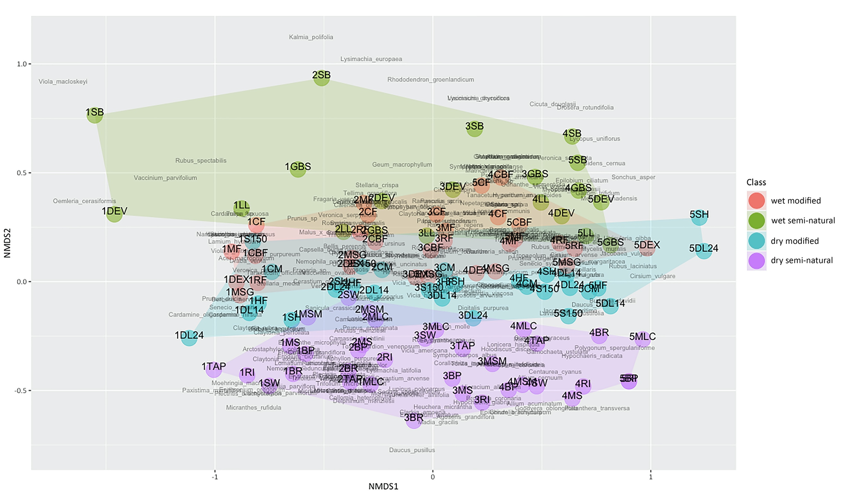
Fig. 1 Ordination plot showing similarities between vegetation communities by site (codified by letters) and sample period (numbers)

