Supplementary Information
Davis et al.

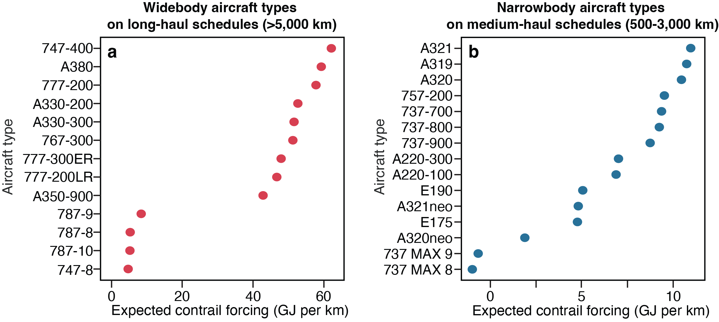
Supplementary Figure 1 | Expected contrail forcing of different aircraft types. Each point is the mean expected contrail forcing per km (GJ km⁻¹) when the same real flight schedules are re-predicted as if flown by each aircraft type, holding route, date and departure time fixed: (a) widebody types on 100,000 long-haul schedules (>5,000 km) and (b) narrowbody types on 100,000 medium-haul schedules (500–3,000 km). Predictions are converted to expected forcing using the mean simulated forcing of 2021 flights in each predicted-percentile bin. Types with low-soot lean-burn engines (787, 747-8, 737 MAX, many A320neo) are predicted to cause far less forcing than other types, including the new A350. These are learned type-level associations that combine engine emissions, cruise altitude and the routes each type typically flies, not isolated engine effects. Only types with more than 50,000 flights in the training data are shown; 95% bootstrap intervals are narrower than the markers

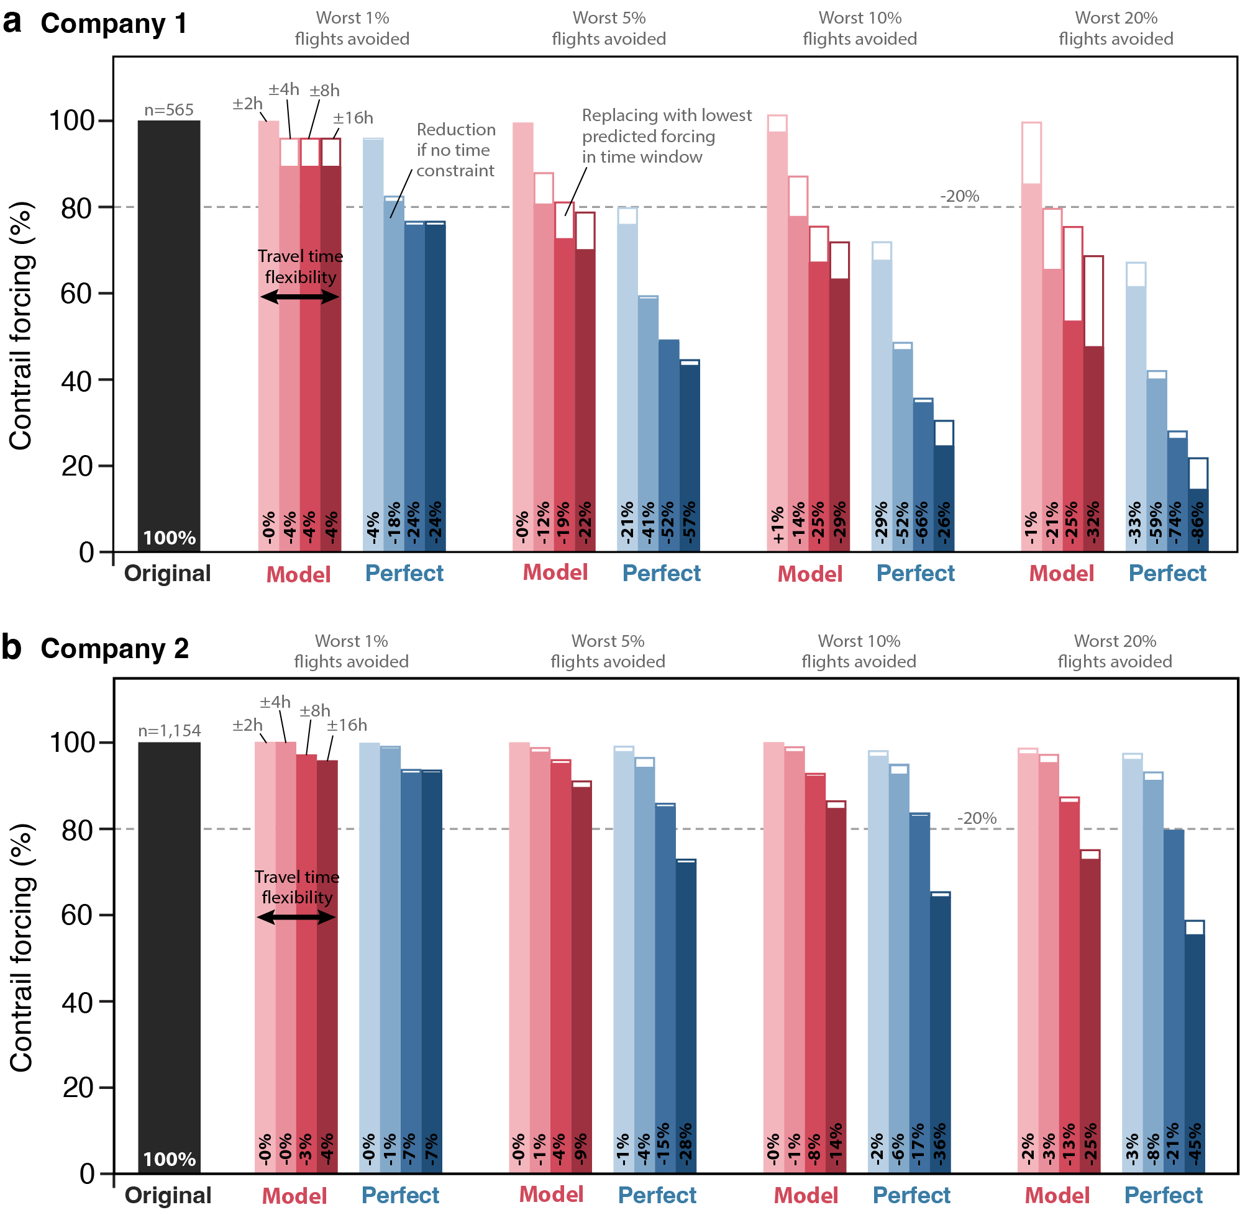
Supplementary Figure 2 | Windowed avoidance by company. Remaining contrail forcing for Company 1 and Company 2 after avoiding the predicted (model) or actual (perfect-foresight) worst K% of flights (K = 1, 5, 10, 20) with same-route replacement within ±2, 4, 8, and 16-hour windows; dashes mark unrestricted substitution. Definitions as in Fig. 4c–f.

Supplementary Table S1 | Aggregate patterns of the 2021 dataset versus independent published findings. Statistics computed over all 22.4 million process-model-labeled 2021 flights (contrail forcing ≈460 EJ).

Pattern | This study (2021 dataset) | Published | Source
Concentration of forcing | worst 2% of flights → 72% of contrail forcing (worst 1% → 51%) | 2% of flights → 80% of 2019 global energy forcing | Teoh et al. 2024 (ref. ¹¹)
Share of flights net-warming | 18% (8% net-cooling) | ~14% form a net-warming contrail | Teoh et al. 2024 (ref. ¹¹)
Night dominance | routes >50% in darkness carry 96% of contrail forcing; daytime flights net +4% | night flights (25% of traffic) contribute 60–80% of forcing | Stuber et al. 2006 (ref. ³¹)
Winter dominance (NH mid-latitudes) | 20% of flights → 34% of contrail forcing; 3.2× summer per-flight mean | winter (22% of traffic) → ~50% of annual forcing | Stuber et al. 2006 (ref. ³¹)
Regional structure | N. America 40% and Europe 22% of contrail forcing; Asia lowest per-km forcing of major regions | net RF largest over Europe and USA; East Asia near global mean (subtropical dryness, lower cruise altitudes) | Teoh et al. 2024 (ref. ¹¹)

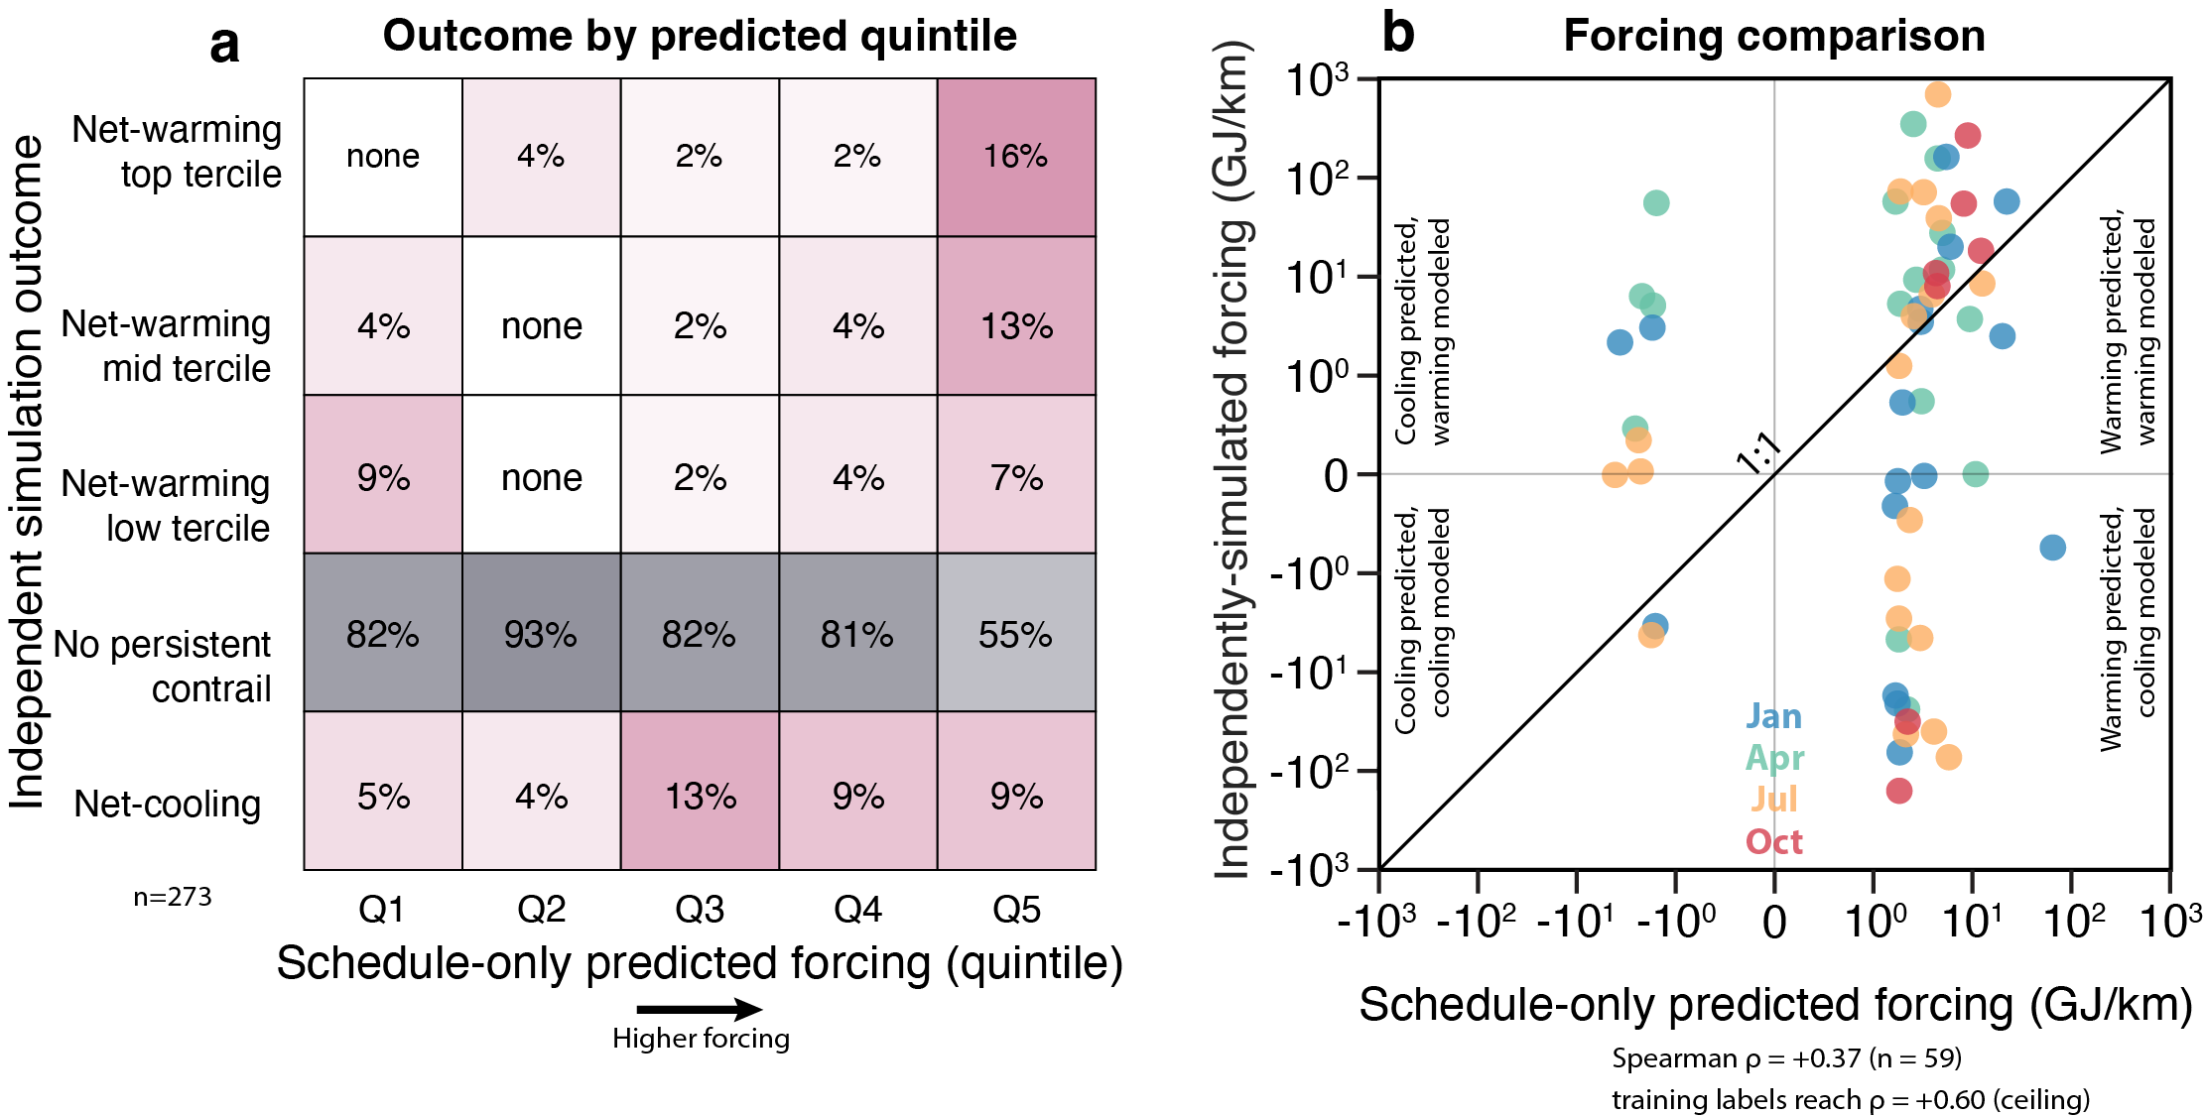

Supplementary Figure 3 | Independent cross-model validation of schedule-only predictions. 273 flights from four seasonal 2021 days (stratified across predicted deciles), re-simulated with an independent tool chain — pycontrails CoCiP14 with 0.5°, 3-hourly ERA5 (ARCO archive) and Poll–Schumann performance — on synthetic great-circle cruise trajectories. (a) Independent outcome versus predicted-forcing quintile (cell: share and count of column). Outcomes form five ordered groups because 78% of flights form no contrail (gray row). Top-quintile flights form net-warming contrails 36% of the time versus 0% for the bottom quintile, while cooling formers show no drift: the model ranks warming, not formation. (b) Independent versus predicted per-km forcing among the 59 contrail-forming flights (GJ per km, symmetric-log): Spearman ρ = +0.37, versus ρ = +0.60 for the training labels themselves, a practical upper limit for any schedule-trained model; vertical spread about the 1:1 line is single-day weather unknowable at booking.

