Table S1. MIC values calculations against K. aerogenes.

isolate # | PEP-38 — 1st MIC | PEP-38 — 2nd MIC | PEP-38 — 3rd MIC | Median PEP-38 MIC |  | PEP-138 — 1st MIC | PEP-138— 2nd MIC | PEP-138 — 3rd MIC | Median PEP-138 MIC
1 | 16 | 16 | 8 | 16 |  | 2 | 2 | 1 | 2
2 | 2 | 4 | 4 | 4 |  | 0,5 | 0,5 | 1 | 0,5
3 | 8 | 16 | 8 | 8 |  | 2 | 1 | 1 | 1
4 | 4 | 4 | 2 | 4 |  | 0,5 | 1 | 1 | 1
5 | 16 | 8 | 16 | 16 |  | 1 | 1 | 2 | 1
6 | 8 | 8 | 8 | 8 |  | 2 | 4 | 4 | 4
7 | 2 | 2 | 4 | 2 |  | 2 | 4 | 2 | 2
8 | 8 | 8 | 8 | 8 |  | 2 | 2 | 2 | 2
9 | 8 | 4 | 4 | 4 |  | 2 | 2 | 2 | 2
10 | 8 | 8 | 8 | 8 |  | 4 | 4 | 2 | 4
11 | 4 | 2 | 4 | 4 |  | 0,5 | 2 | 2 | 2
12 | 4 | 4 | 4 | 4 |  | 4 | 8 | 4 | 4
Median |  |  |  | 6 |  |  |  |  | 2
First quartile (25) |  |  |  | 4 |  |  |  |  | 1
Third quartile (75) |  |  |  | 8 |  |  |  |  | 2,5

Table S2. MIC values calculations against K. pneumoniae.

isolate # | PEP-38 — 1st MIC | PEP-38 — 2nd MIC | PEP-38 — 3rd MIC | Median PEP-38 MIC |  | PEP-138 — 1st MIC | PEP-138— 2nd MIC | PEP-138 — 3rd MIC | Median PEP-138 MIC
1 | 8 | 32 | 16 | 16 |  | 4 | 2 | 4 | 4
2 | 8 | 8 | 8 | 8 |  | 2 | 1 | 1 | 1
3 | 4 | 8 | 8 | 8 |  | 1 | 1 | 1 | 1
4 | 2 | 4 | 4 | 4 |  | 1 | 1 | 1 | 1
5 | 4 | 4 | 4 | 4 |  | 0,5 | 1 | 1 | 1
6 | 4 | 4 | 4 | 4 |  | 2 | 1 | 1 | 1
7 | 4 | 4 | 4 | 4 |  | 4 | 4 | 2 | 4
8 | 4 | 4 | 8 | 4 |  | 4 | 4 | 4 | 4
9 | 8 | 8 | 8 | 8 |  | 2 | 2 | 2 | 2
10 | 16 | 32 | 32 | 32 |  | 8 | 4 | 8 | 8
11 | 32 | 32 | 32 | 32 |  | 0,5 | 0,5 | 0,5 | 0,5
12 | 16 | 8 | 8 | 8 |  | 1 | 2 | 1 | 1
13 | 0,5 | 0,5 | 0,5 | 0,5 |  | 0,25 | 0,25 | 0,5 | 0,25
14 | 2 | 2 | 8 | 2 |  | 1 | 4 | 4 | 4
15 | 8 | 8 | 8 | 8 |  | 2 | 2 | 2 | 2
16 | 4 | 4 | 4 | 4 |  | 4 | 2 | 2 | 2
17 | 8 | 8 | 4 | 8 |  | 2 | 2 | 2 | 2
18 | 16 | 32 | 16 | 16 |  | 2 | 4 | 4 | 4
Median |  |  |  | 8 |  |  |  |  | 2
First quartile (25) |  |  |  | 4 |  |  |  |  | 1
Third quartile (75) |  |  |  | 8 |  |  |  |  | 4

Table S3. MIC values calculations against P. aeruginosa.

isolate # | PEP-38 — 1st MIC | PEP-38 — 2nd MIC | PEP-38 — 3rd MIC | Median PEP-38 MIC |  | PEP-138 — 1st MIC | PEP-138— 2nd MIC | PEP-138 — 3rd MIC | Median PEP-138 MIC
1 | R | R | R | R |  | 4 | 4 | 4 | 4
2 | R | R | R | R |  | 2 | 2 | 4 | 2
3 | R | R | R | R |  | 2 | 4 | 4 | 4
4 | R | R | R | R |  | 2 | 4 | 4 | 4
5 | R | R | R | R |  | 2 | 2 | 4 | 2
6 | R | R | R | R |  | 4 | 4 | 2 | 4
7 | R | R | R | R |  | 2 | 2 | 2 | 2
8 | R | R | R | R |  | 0,5 | 1 | 1 | 1
9 | R | R | R | R |  | 4 | 2 | 2 | 2
10 | R | R | R | R |  | 2 | 2 | 2 | 2
11 | R | R | R | R |  | 2 | 2 | 2 | 2
12 | R | R | R | R |  | 1 | 2 | 4 | 2
13 | R | R | R | R |  | 2 | 2 | 2 | 2
14 | R | R | R | R |  | 2 | 2 | 1 | 2
15 | R | R | R | R |  | 1 | 2 | 4 | 2
16 | R | R | R | R |  | 4 | 4 | 2 | 4
17 | R | R | R | R |  | 4 | 4 | 4 | 4
Median |  |  |  |  |  |  |  |  | 2
First quartile (25) |  |  |  |  |  |  |  |  | 2
Third quartile (75) |  |  |  |  |  |  |  |  | 4

ª R – resistant to 8 μg/ml of PEP-38.

Table S4. Survival proportions (%) in all experimental animal groups.

Days after infecting | Control (n=12) | PEP-36 (n=12) | PEP-38 (n=12) | PEP-137 (n=12)
0 | 100 | 100 | 100 | 100
1 | 66,7 | 91,7 | 66,7 | 91,7
2 | 16,7 | 75 | 41,7 | 66,7
3 | 0 | 66,7 | 8,3 | 50
5 |  | 66,7 | 8,3 | 50

Figure S1. Probability of survival: control vs PEP-36.
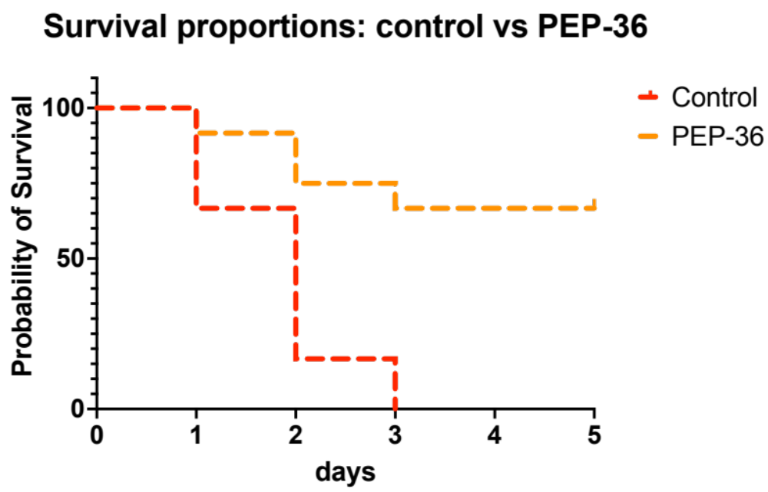

Figure S2. Probability of survival: control vs PEP-38.
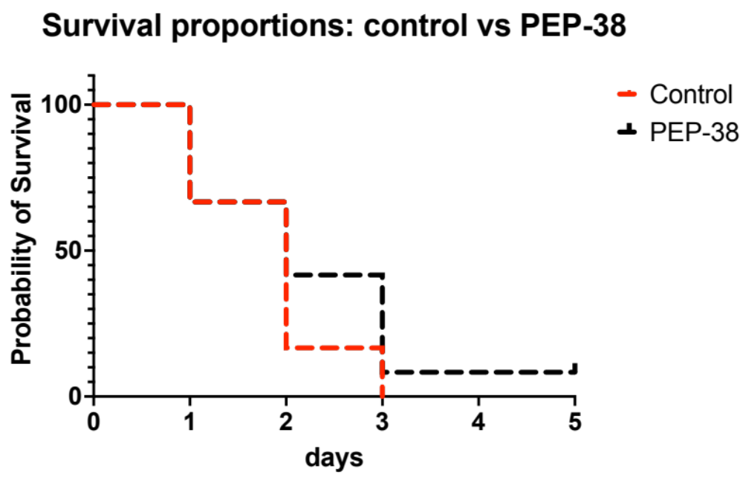

Figure S3. Probability of survival: control vs PEP-137.
