Supporting Information
Physics-Guided Design of Ammonia Decomposition Catalysts with Interpretable Machine Learning
Pragyansh Singh, Jiaqi Yang, Fanglin Che*
Department of Chemical Engineering, Worcester Polytechnic Institute, Worcester, MA 01609, USA.
*Corresponding Author Email: fche@wpi.edu

S1. DFT Methodology Details
S1.1 Surface Models
Six terminations were considered for each Ru and Co metal, the close-packed (0001) basal plane and the stepped (10-10), (10-11), (10-13), (11-21), and (2-1-12) surfaces, each modeled as a p(4×4) supercell slab consisting of four atomic layers, separated by approximately 11 Å of vacuum in the z-direction to strictly prevent spurious interactions between periodic images (Table S1). Figures S1 to S6 show the optimized geometries for the Ru terminations in top and side view. Within each figure, panel (a) depicts the clean, pristine surface with all candidate adsorption sites explicitly indicated with the red dots and corresponding label. The subsequent panels display the corresponding adatom-decorated configurations constructed upon that specific termination. For visual clarity, beige spheres denote the exposed surface atoms of the underlying slab, while blue spheres explicitly denote the introduced metal adatoms.
Table S1. Comparison of surface facets and their energies with existing literature record¹.
Surface Miller Indices | Surface Energy (our model) (eV Å⁻²) | Surface Energy (literature)¹ (eV Å⁻²)
0001 | 0.151 | 0.160
10-11 | 0.176 | 0.180
10-10 | 0.177 | 0.181
10-13 | 0.191 | ----
11-21 | 0.197 | 0.200
2-1-12 | 0.189 | 0.190

The corresponding Co models are not shown separately. The two metals share the hcp lattice, so the Co slabs are constructed on the same six terminations with the same layer count, and site definitions; the structures are isostructural with those in Figures S1-S6 and differ only in the identity of the metal and in the relaxed interatomic distances. Co results are therefore reported in the site tables of Section S1.3 rather than duplicated as figures.

S1.2 Site Nomenclature
Adsorption sites are labeled by their local geometry. On the $\left(0001\right)$ basal plane, the three-fold hollows are geometrically distinguished as fcc or hcp based on the presence/absence of a subsurface atom directly beneath the active centroid. Meanwhile, top denotes the standard atop coordination position.
On the highly stepped terminations, where multiple symmetry-distinct sites belonging to the same coordination class naturally coexist, numerical suffixes are appended to differentiate them. Specifically, br1, br2, etc., denote spatially distinct bridge positions; h1 and h2 denote distinct three-fold hollows; top1 and top2 denote distinct atop positions; and s4 designates the four-fold site formed at the concave base of a step edge.
On adatom-decorated surface models, three additional nomenclatural labels are introduced to describe the novel binding environments created by the adatoms themselves. Here, o_top and o_br denote active atop and bridge positions explicitly formed upon the adatoms, while int denotes the highly coordinated interfacial position situated directly between an adatom and the underlying metal slab.
Finally, the macroscopic adatom configuration itself is identified by the specific parent site(s) the constituent adatom(s) occupy. For instance, the notation "2/16 ML: h1+h1" unambiguously indicates two adatoms placed at symmetry-equivalent h1 hollows, whereas "2/16 ML: hcp+top" indicates an asymmetric mixed-site dimer consisting of one adatom at an hcp hollow and one located at a top site.
S1.3 Adsorption Sites Tested and Sites Obtained
The nomenclature defined above strictly identifies the initial geometric seed positions where the NH fragment was placed prior to DFT relaxation. Importantly, these labels do not dictate the final binding site: the unconstrained NH adsorbate is free to migrate across the surface during geometric optimization. Consequently, the local environment it finally occupies in the fully relaxed structure is classified based on the final atomic geometry, utilizing the coordination analysis detailed in Section S4.1, rather than relying on its initial seed label.
A further consequence is that two distinct placements can converge on the same final site, so the number of distinct sites obtained is not always the number tested. Placements were treated as having converged on the same site when the relaxed classification, the coordination counts, and the generalized coordination number all coincide; binding energy alone is not used as the test, since two genuinely distinct sites can happen to lie within a few meV of one another.
Tables S2 to S8 list, for every evaluated configuration, the specific nomenclature code of each distinct site, its coordination environment in the fully relaxed structure, the number of coordinating slab atoms ($CN_{\text{slab}}$) and proximal adatoms ($CN_{\text{ad}}$), and the resulting binding energy. The final relaxed classification is obtained directly from the optimized geometry utilizing the coordination analysis detailed in Section S4.1. Therefore, the specific code identifies the initial spatial site, while the relaxed classification accurately describes it.
Binding energies are those of the neutral configuration, which provides one value per distinct site. The charged copies share the same site set and are reported as part of the descriptor database rather than here.
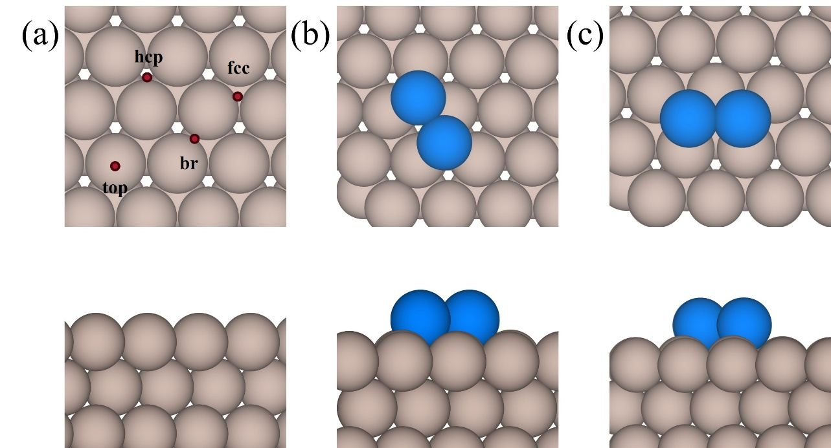
Figure S1. Optimized structures of the Ru(0001) surface in top and side view: (a) clean surface, (b) 2/16 ML with both adatoms at fcc hollows, and (c) 2/16 ML with both adatoms at hcp hollows Candidate adsorption sites are indicated on the clean surface in (a).

Table S2. Distinct NH adsorption sites on Ru(0001). For each adatom configuration the table lists the site code, the coordination environment in the relaxed structure, the number of coordinating slab atoms and adatoms, and the binding energy of the neutral configuration. The corresponding structures of clean and adatom surfaces are shown in Figure S1.
Adatom configuration | Site code | Relaxed coordination | CN slab / ad | BE_NH (eV)
Clean | fcc | three_fold | 3/0 | -5.77
 | hcp | three_fold | 3/0 | -6.18
 | top | top | 1/0 | -4.61
2/16 ML: fcc + fcc | br | three_fold | 3/0 | -5.00
 | fcc | three_fold | 3/0 | -4.44
 | hcp | hollow_1_adatom | 2/1 | -4.64
 | int | bridge_mixed | 1/1 | -4.52
 | o_top | on_top_adatom | 0/1 | -4.05
 | top2 | three_fold | 3/0 | -5.16
2/16 ML: hcp + hcp | br | three_fold | 3/0 | -4.82
 | fcc | hollow_1_adatom | 2/1 | -4.67
 | hcp | three_fold | 3/0 | -4.20
 | int | bridge_mixed | 1/1 | -4.61
 | o_br | bridge_pure_adatom | 0/2 | -4.82
 | o_top | on_top_adatom | 0/1 | -4.08
 | top | bridge_mixed | 1/1 | -4.33
 | top2 | bridge_mixed | 1/1 | -5.02

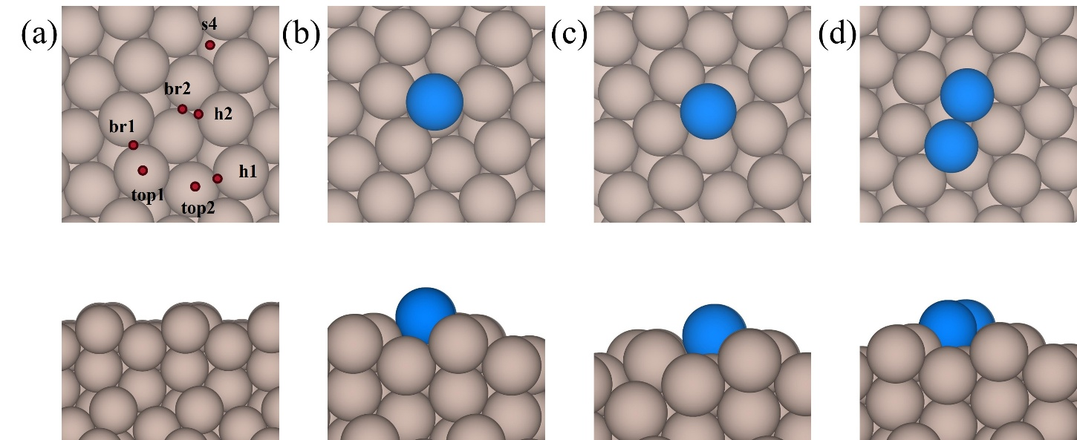
Figure S2. Optimized structures of the Ru(2-1-12) surface in top and side view: (a) clean surface, (b) 1/16 ML with the adatom at the h1 site, (c) 1/16 ML with the adatom at the s4 site, and (d) 2/16 ML with both adatoms at h1 sites.
Table S3. Distinct NH adsorption sites on Ru(2-1-12). For each adatom configuration the table lists the site code, the coordination environment in the relaxed structure, the number of coordinating slab atoms and adatoms, and the binding energy of the neutral configuration. The corresponding structures of clean and adatom surfaces are shown in Figure S2.
Adatom configuration | Site code | Relaxed coordination | CN slab / ad | BE_NH (eV)
Clean | br1 | bridge | 2/0 | -5.00
 | br2 | three_fold | 3/0 | -4.78
 | h1 | three_fold | 3/0 | -5.33
 | h2 | three_fold | 3/0 | -4.78
 | s4 | four_fold | 4/0 | -4.89
1/16 ML: h1 | br1 | hollow_1_adatom | 2/1 | -5.96
 | br2 | hollow_1_adatom | 2/1 | -5.98
 | h1 | hollow_1_adatom | 2/1 | -5.70
 | o_top | on_top_adatom | 0/1 | -4.89
 | s4 | hollow_1_adatom | 2/1 | -5.10
1/16 ML: s4 | h1 | hollow_1_adatom | 2/1 | -4.51
 | int | hollow_1_adatom | 2/1 | -5.30
 | o_top | on_top_adatom | 0/1 | -4.23
 | top | hollow_1_adatom | 2/1 | -5.31
2/16 ML: h1 + h1 | br | hollow_1_adatom | 2/1 | -5.01
 | h1 | hollow_2_adatom | 1/2 | -5.12
 | h2 | hollow_2_adatom | 1/2 | -5.12
 | o_br | bridge_pure_adatom | 0/2 | -4.95
 | o_top | on_top_adatom | 0/1 | -4.21
 | s4 | hollow_1_adatom | 2/1 | -5.07
 | top1 | hollow_1_adatom | 2/1 | -5.43

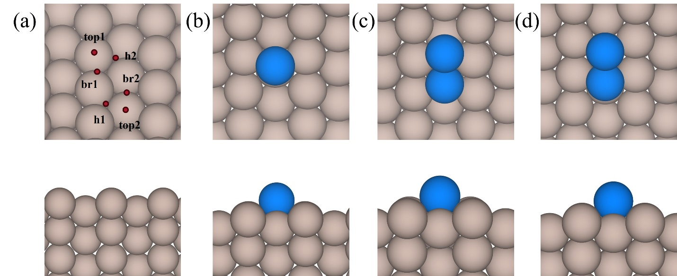
Figure S3. Optimized structures of the Ru(10-10) surface in top and side view: (a) clean surface, (b) 1/16 ML with the adatom at the h2 site, (c) 2/16 ML with both adatoms at h1 sites, and (d) 2/16 ML with one adatom at h1 and one at h2.
Table S4. Distinct NH adsorption sites on Ru(10-10). For each adatom configuration the table lists the site code, the coordination environment in the relaxed structure, the number of coordinating slab atoms and adatoms, and the binding energy of the neutral configuration. The corresponding structures of clean and adatom surfaces are shown in Figure S3.
Adatom configuration | Site code | Relaxed coordination | CN slab / ad | BE_NH (eV)
Clean | br1 | bridge | 2/0 | -4.70
 | h1 | three_fold | 3/0 | -5.10
 | h2 | three_fold | 3/0 | -4.95
 | top1 | bridge | 2/0 | -4.70
1/16 ML: h2 | int | hollow_1_adatom | 2/1 | -4.56
 | o_top | on_top_adatom | 0/1 | -4.00
 | top | hollow_1_adatom | 2/1 | -4.96
2/16 ML: h1 + h1 | br1 | hollow_1_adatom | 2/1 | -5.03
 | br2 | hollow_1_adatom | 2/1 | -4.85
 | h1 | hollow_2_adatom | 1/2 | -5.00
 | o_top | on_top_adatom | 0/1 | -4.26
2/16 ML: h1 + h2 | br | hollow_2_adatom | 1/2 | -4.59
 | o_br | bridge_pure_adatom | 0/2 | -4.91
 | o_top | on_top_adatom | 0/1 | -4.10
 | top1 | hollow_1_adatom | 2/1 | -4.96
 | top2 | three_fold | 3/0 | -4.66

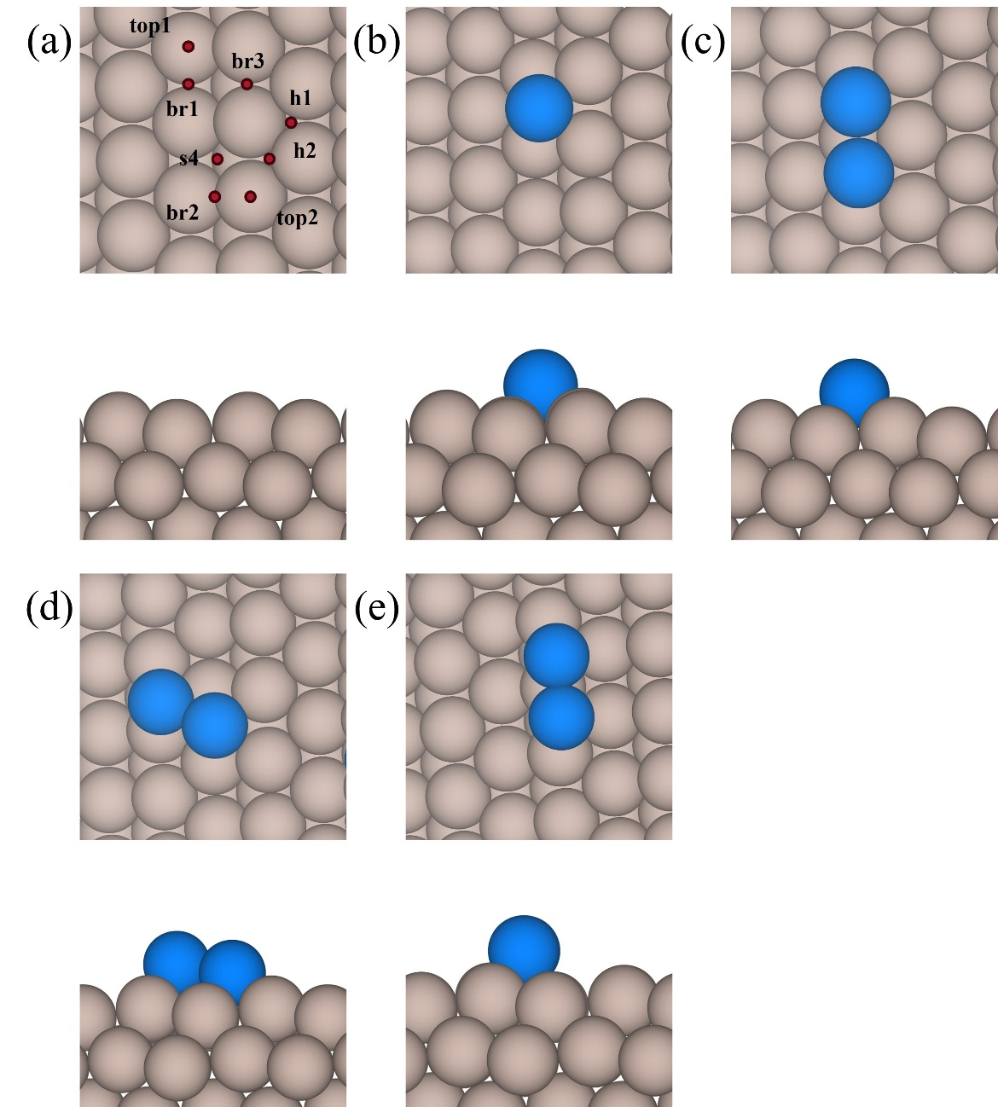
Figure S4. Optimized structures of the Ru(10-11) surface in top and side view: (a) clean surface, (b) 1/16 ML with the adatom at the br1 site, (c) 2/16 ML with both adatoms at h1 sites, (d) 2/16 ML with one adatom at h1 and one at h2, and (e) 2/16 ML with both adatoms at h2 sites.
Table S5. Distinct NH adsorption sites on Ru(10-11). For each adatom configuration the table lists the site code, the coordination environment in the relaxed structure, the number of coordinating slab atoms and adatoms, and the binding energy of the neutral configuration. The corresponding structures of clean and adatom surfaces are shown in Figure S4.
Adatom configuration | Site code | Relaxed coordination | CN slab / ad | BE_NH (eV)
Clean | br2 | bridge | 2/0 | -4.52
 | h1 | three_fold | 3/0 | -5.18
 | h2 | three_fold | 3/0 | -5.38
 | s4 | four_fold | 4/0 | -5.31
1/16 ML: br1 | br | hollow_1_adatom | 2/1 | -4.73
 | h1 | hollow_1_adatom | 2/1 | -5.12
 | o_top | on_top_adatom | 0/1 | -4.14
2/16 ML: h1 + h1 | br1 | hollow_1_adatom | 2/1 | -4.78
 | br2 | three_fold | 3/0 | -4.96
 | h1 | hollow_1_adatom | 2/1 | -4.80
 | o_br | bridge_pure_adatom | 0/2 | -5.10
 | o_top | on_top_adatom | 0/1 | -4.24
 | top | three_fold | 3/0 | -4.81
2/16 ML: h1 + h2 | br1 | hollow_1_adatom | 2/1 | -5.39
 | h1 | hollow_1_adatom | 2/1 | -4.97
 | h2 | three_fold | 3/0 | -4.78
 | o_br | bridge_pure_adatom | 0/2 | -5.04
 | top1 | three_fold | 3/0 | -5.10
 | top2 | bridge_mixed | 1/1 | -4.82
2/16 ML: h2 + h2 | br1 | four_fold_adatom_involved | 2/2 | -4.40
 | br2 | three_fold | 3/0 | -5.19
 | o_br | bridge_pure_adatom | 0/2 | -4.75
 | o_top | on_top_adatom | 0/1 | -4.02
 | top2 | four_fold | 4/0 | -4.76

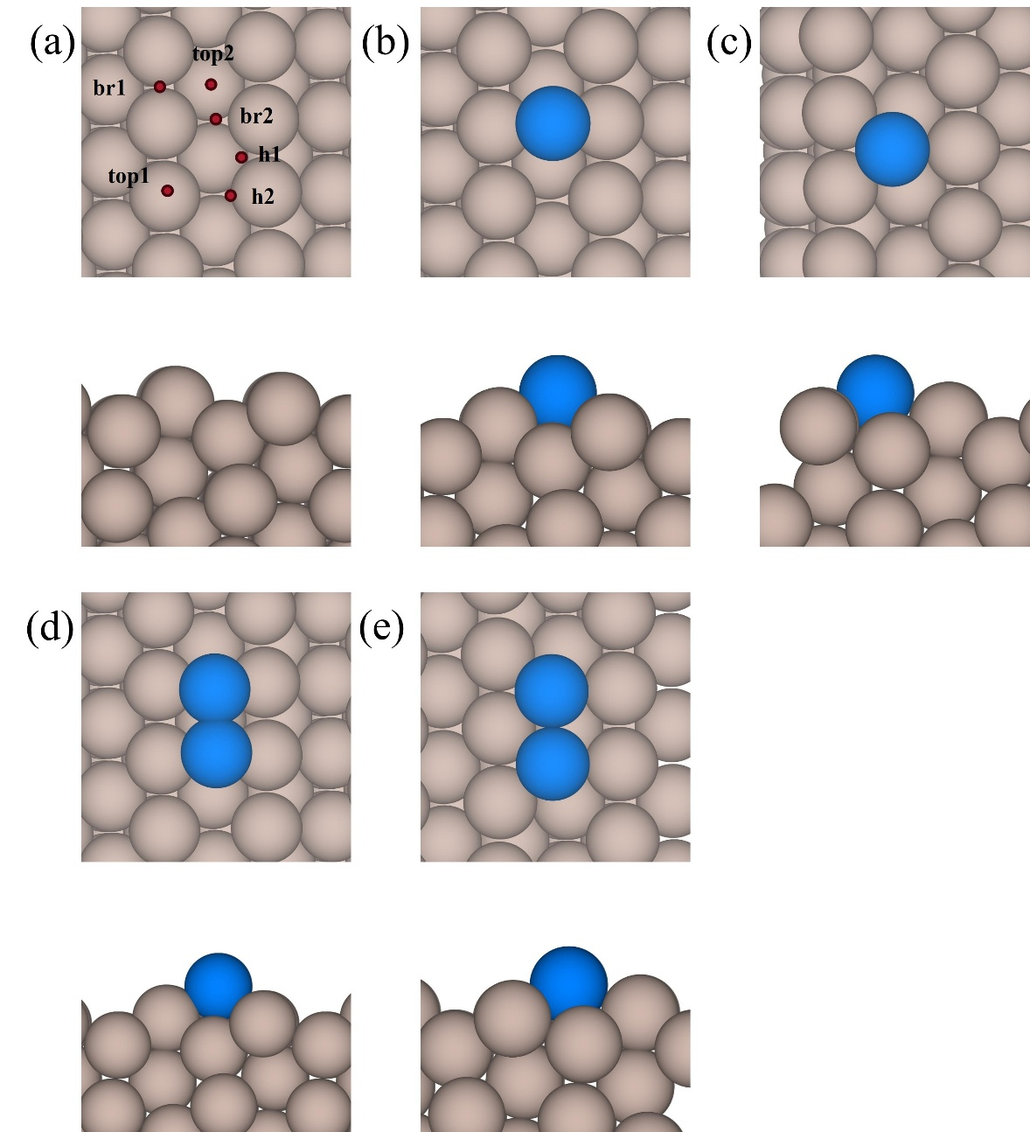
Figure S5. Optimized structures of the Ru(10-13) surface in top and side view: (a) clean surface, (b) 1/16 ML with the adatom at the br2 site, (c) 1/16 ML with the adatom at the h2 site, (d) 2/16 ML with both adatoms at br2 sites, and (e) 2/16 ML with both adatoms at h1 sites.
Table S6. Distinct NH adsorption sites on Ru(10–13). For each adatom configuration the table lists the site code, the coordination environment in the relaxed structure, the number of coordinating slab atoms and adatoms, and the binding energy of the neutral configuration. The corresponding structures of clean and adatom surfaces are shown in Figure S5.
Adatom configuration | Site code | Relaxed coordination | CN slab / ad | BE_NH (eV)
Clean | br1 | bridge | 2/0 | -4.75
 | br2 | four_fold | 4/0 | -4.23
 | h1 | three_fold | 3/0 | -5.07
 | h2 | three_fold | 3/0 | -4.73
 | top1 | top | 1/0 | -4.05
 | top2 | three_fold | 3/0 | -4.60
1/16 ML: br2 | h1 | hollow_1_adatom | 2/1 | -4.98
 | int | bridge_mixed | 1/1 | -5.28
 | o_top | on_top_adatom | 0/1 | -4.23
 | top | bridge_mixed | 1/1 | -5.20
1/16 ML: h2 | br | hollow_1_adatom | 2/1 | -5.11
 | int | hollow_1_adatom | 2/1 | -5.05
 | o_top | on_top_adatom | 0/1 | -4.23
 | top | bridge_mixed | 1/1 | -4.64
 | top2 | top | 1/0 | -3.79
2/16 ML: br2 + br2 | h1 | hollow_1_adatom | 2/1 | -5.97
 | int | bridge_mixed | 1/1 | -5.89
 | o_br | bridge_pure_adatom | 0/2 | -5.06
 | o_top | on_top_adatom | 0/1 | -5.25
 | s4 | hollow_2_adatom | 1/2 | -4.43
2/16 ML: h1 + h1 | br | hollow_1_adatom | 2/1 | -5.16
 | h1 | hollow_1_adatom | 2/1 | -4.76
 | int | hollow_1_adatom | 2/1 | -5.15
 | o_br | bridge_pure_adatom | 0/2 | -4.99
 | o_top | on_top_adatom | 0/1 | -4.24
 | s4 | four_fold_adatom_involved | 2/2 | -5.10

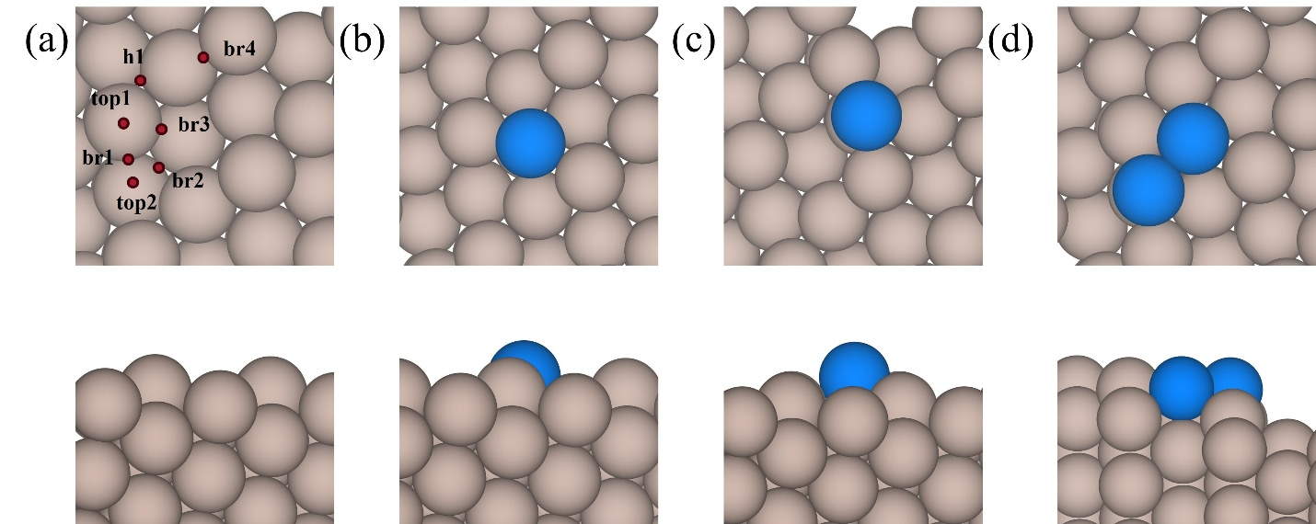
Figure S6. Optimized structures of the Ru(11-21) surface in top and side view: (a) clean surface, (b) 1/16 ML with the adatom at the br3 site, (c) 1/16 ML with the adatom at the h1 site, and (d) 2/16 ML with one adatom at h1 and one at br3.

Table S7. Distinct NH adsorption sites on Ru(11-21). For each adatom configuration the table lists the site code, the coordination environment in the relaxed structure, the number of coordinating slab atoms and adatoms, and the binding energy of the neutral configuration. The corresponding structures of clean and adatom surfaces are shown in Figure S6.
Adatom configuration | Site code | Relaxed coordination | CN slab / ad | BE_NH (eV)
Clean | br2 | three_fold | 3/0 | -4.88
 | br3 | three_fold | 3/0 | -4.74
 | br4 | bridge | 2/0 | -4.99
 | h1 | three_fold | 3/0 | -5.26
1/16 ML: br3 | br | bridge_mixed | 1/1 | -5.08
 | h1 | hollow_1_adatom | 2/1 | -4.95
 | int | hollow_1_adatom | 2/1 | -5.46
 | o_top | on_top_adatom | 0/1 | -4.32
1/16 ML: h1 | br | bridge_mixed | 1/1 | -5.00
 | int | hollow_1_adatom | 2/1 | -4.97
 | o_top | on_top_adatom | 0/1 | -4.20
2/16 ML: h1 + br3 | br | hollow_1_adatom | 2/1 | -4.66
 | int | hollow_1_adatom | 2/1 | -4.96
 | o_br | bridge_mixed | 1/1 | -5.03
 | o_top | on_top_adatom | 0/1 | -4.31

Table S8. Distinct NH adsorption sites on the Co terminations, reported together because the Co dataset samples fewer configurations per termination than the Ru dataset. Columns are as in Tables S2 to S7.
Surface | Adatom configuration | Site code | Relaxed coordination | CN slab / ad | BE_NH (eV)
Co(0001) | Clean | fcc | three_fold | 3/0 | -4.57
Co(0001) |  | hcp | three_fold | 3/0 | -4.43
Co(0001) |  | top | top | 1/0 | -2.66
Co(2-1-12) | 1/16 ML: s4 | top | hollow_1_adatom | 2/1 | -5.01
Co(2-1-12) | 2/16 ML: h1 + h1 | o_br | hollow_2_adatom | 1/2 | -4.95
Co(2-1-12) |  | o_top | four_fold_adatom_involved | 2/2 | -5.15
Co(10-10) | Clean | h1 | three_fold | 3/0 | -4.71
Co(10-10) | 1/16 ML: h2 | int | four_fold_adatom_involved | 3/1 | -4.62
Co(10-10) | 2/16 ML: h1 + h1 | br2 | hollow_1_adatom | 2/1 | -4.57
Co(10-10) | 2/16 ML: h1 + h2 | br | four_fold_adatom_involved | 2/2 | -4.82
Co(10-10) |  | o_top | on_top_adatom | 0/1 | -3.30
Co(10-11) | Clean | br2 | four_fold | 4/0 | -5.29
Co(10-11) |  | h1 | three_fold | 3/0 | -4.85
Co(10-11) |  | h2 | three_fold | 3/0 | -4.95
Co(10-11) | 1/16 ML: br1 | br | hollow_1_adatom | 2/1 | -4.44
Co(10-11) | 2/16 ML: h1 + h1 | br1 | four_fold_adatom_involved | 3/1 | -4.66
Co(10-11) |  | h1 | four_fold_adatom_involved | 3/1 | -4.59
Co(10-11) |  | o_br | bridge_pure_adatom | 0/2 | -4.30
Co(10-11) | 2/16 ML: h1 + h2 | h2 | four_fold | 4/0 | -4.72
Co(10-11) |  | top1 | three_fold | 3/0 | -4.61
Co(10-13) | Clean | top1 | four_fold | 4/0 | -4.81
Co(10-13) | 1/16 ML: br2 | h1 | hollow_1_adatom | 2/1 | -4.52
Co(10-13) | 1/16 ML: h2 | br | hollow_1_adatom | 2/1 | -4.95
Co(10-13) |  | top | hollow_1_adatom | 2/1 | -4.95
Co(11-21) | Clean | br4 | three_fold | 3/0 | -4.79
Co(11-21) | 1/16 ML: br3 | h1 | four_fold_adatom_involved | 3/1 | -4.67
Co(11-21) | 1/16 ML: h1 | int | hollow_1_adatom | 2/1 | -4.97

S2. Microkinetic Model (MKM) Details
S2.1 Thermochemistry and Rate Constants
Thermodynamic and kinetic parameters were generated with the Python Multiscale Thermochemistry Toolbox (pMuTT). Surface species were treated within the harmonic-oscillator approximation, with all 3N vibrational modes obtained from DFT frequency calculations in which only the adsorbate degrees of freedom were displaced. Gas-phase species (NH₃, N₂, H₂) were treated as ideal gases with translational, rotational, vibrational, and electronic contributions to the partition function. Enthalpies, entropies, and Gibbs free energies were evaluated for a temperature range of 300-1000 K and exported as NASA polynomials for use in Cantera.
Forward rate constants were obtained from TST and fitted to the modified-Arrhenius form for use in Cantera. (Equation S1), and reverse rate constants were obtained from the corresponding equilibrium constants so that thermodynamic consistency is enforced across the mechanism. Adsorption and desorption steps were treated with collision theory (Equation S2).
$$k_{f}=AT^{b}e^{(-\frac{E_{a}}{RT})}$$ | (S1)
$$k_{f}=\frac{γ}{Γ_{tot}^{m}}\sqrt{\frac{RT}{2πW}}$$ | (S2)
Where b = 1 in Arrhenius equation, whereas γ is sticking coefficient with value of 0.5, $Γ_{tot}^{m}$ is the total molar site density mentioned in next section, and W is molecular weight of the gaseous molecule.
S2.2 MKM parameters
A set of eight coupled ordinary differential equations were solved iteratively with Cantera python package to determine the steady-state solution of rates (Table S9) and the evolution of the fractional surface coverage for each species (θᵢ) (Equations S3-S10), which account for the net consumption and production rates of all gas-phase and surface intermediates.
Table S9. Reaction network and corresponding rate equations for the elementary steps involved in ammonia cracking.
Chemical Equations | Rate Equations
NH₃(g)+* ↔NH₃* | $$r_{1}=k_{f1}p_{NH3}θ_{*}-k_{r1}θ_{NH3}$$
NH₃*+*↔NH₂*+H* | $$r_{2}=k_{f2}θ_{NH3}θ_{*}-k_{r2}θ_{NH2}θ_{H}$$
NH₂*+*↔NH*+H* | $$r_{3}=k_{f3}θ_{NH2}θ_{*}-k_{r3}θ_{NH}θ_{H}$$
NH*+*↔N*+H* | $$r_{4}=k_{f4}θ_{NH}θ_{*}-k_{r4}θ_{N}θ_{H}$$
2N*↔N₂*+* | $$r_{5}=k_{f5}θ_{N}^{2}-k_{r5}θ_{N2}θ_{*}$$
N₂*↔N₂(g)+* | $$r_{6}=k_{f6}θ_{N2}-k_{r6}p_{N2}θ_{*}$$
2H*↔H₂*+* | $$r_{7}=k_{f7}θ_{H}^{2}-k_{r7}θ_{H2}θ_{*}$$
H₂*↔H₂(g)+* | $$r_{8}=k_{f8}θ_{H2}-k_{r8}p_{H2}θ_{*}$$

$$\frac{{dθ}_{NH3}}{dZ}=r_{1}-r_{2}$$ | (S3)
$$\frac{{dθ}_{NH2}}{dZ}=r_{2}-r_{3}$$ | (S4)
$$\frac{{dθ}_{NH}}{dZ}=r_{3}-r_{4}$$ | (S5)
$$\frac{{dθ}_{N}}{dZ}=r_{4}-2r_{5}$$ | (S6)
$$\frac{{dθ}_{N2}}{dZ}=r_{5}-r_{6}$$ | (S7)
$$\frac{{dθ}_{H}}{dZ}=r_{2}+r_{3}+r_{4}-2r_{7}$$ | (S8)
$$\frac{{dθ}_{H2}}{dZ}=r_{7}-r_{8}$$ | (S9)
$$θ^{*}=1-∑θi$$ | (S10)
Additional microkinetic model parameters, which are given as input, are shown in Table S10. The steps to estimate the site density of surface Ru$(10\overline{1}3)$ is given below,
$$Surface Density_{Ru}= \frac{1}{Catalyst Area*N_{A}}=\frac{\frac{mol}{{cm}^{2}}}{90.34*{10}^{-16}*6.022*{10}^{23}}=1.83E-10 mol/{cm}^{2}$$
To calculate the abyv (Catalyst area/volume) parameter, the bulk density and specific area information of a typical catalyst is based on experiment data²,
$$abyv_Ru=Density\left(\frac{gm}{{cm}^{3}}\right)*Specific area\left(\frac{{cm}^{2}}{gm}\right)=12.37*40*{10}^{4}=4.94E6{ cm}^{-1}$$

Table S10. MKM input parameters.
Parameter | Values
Pressure (p0) | 1 atm
Linear velocity (v0) | 60 cm/min
Feed composition | 100 % NH₃ (g)
Ru Density | 12.37 g/cm³
Specific Area | (30 to 50) E4 cm²/g
Surface Density (Ru) | 1.83 E-10 mol/cm²
Catalyst area/volume (abyv) (Ru) | 4.94 E6 (cm⁻¹)
Temperature Range | 673 - 750 K
Electric Field Range | 0 to -0.4 V/Å
Conversion | 0.001

S2.3 Turnover Frequency (TOF)
To obtain kinetic parameters, the MKM was executed within a low conversion regime of around 0.1%. A gradient descent optimization framework was utilized to identify the PFR length necessary to achieve the target conversion, as detailed in Equations S11-S14. Assuming conversion is a function of length, the algorithm sought to minimize the loss function relative to the target (Equation S12). The gradient of conversion with respect to reactor length was computed via the central difference method using a step size h (Equation S14), allowing for the iterative refinement of the length parameter (Equation S11).
$L_{new}=L_{now}-α*grad$ | $$(S11)$$
$$loss= {(X-X_{target})}^{2}$$ | $$(S12)$$
$$grad=\frac{d(loss)}{dL}=2(X-X_{target})\frac{dX}{dL}$$ | $$(S13)$$
$$\frac{dX}{dL}=\frac{X\left(L+h\right)-X(L-h)}{2h}$$ | $$(S14)$$
The loss function, defined as the squared error, was minimized using the Adam optimization algorithm. This method was selected to allow for dynamic adjustment of the learning rate (α) during the iterative updates of the reactor length (L_{reactor}). Once the optimal reactor length (L_{reactor}) was determined, the turnover frequency (TOF, s⁻¹) was calculated as a function of the target conversion and residence time (Equation S15).
$$TOF= \frac{C_{NH3,in\left(g\right)}-C_{NH3,out\left(g\right)}}{τ*C_{NH3,in\left(s\right)}*catalyst\left(\frac{area}{volume}\right)}$$ | $$(S15)$$
Calculations were simplified by substituting reactor volume with length, and volumetric flow with linear velocity, based on the assumption of a uniform reaction profile across the cross-sectional area. This simplification allows for a straightforward evaluation of reactor performance, where residence time (τ) is calculated using Equation S16. The υ_{o} was kept constant at 60 cm/min while varying reactor length to obtain the targeted low conversion. The conversion value was chosen on trial and error basis to make sure the ODE solver is converging correctly.
$$τ=\frac{L_{reactor}}{υ_{o}}$$ | $$(S16)$$

S2.4 Degree of rate control
The degree of rate control calculation (Equation S17) allows the estimation of importance of every step in the reaction mechanism through the MKM.
$$X_{RC,i}=\frac{k_{i}}{r}\left( \frac{dr}{{dk}_{i}} \right)= \frac{dlnr}{{dlnk}_{i}}= \left( \frac{dlnr}{d(\frac{{-G}_{i}^{‡}}{RT})} \right)$$ | $$(S17)$$

S2.5 Binding-Energy Scan
To construct the activity volcano, BE_{NH} was treated as a continuous parameter and scanned from approximately -5.11 to -3.64 eV at each of the eight temperature-field conditions. The scan grid was non-uniform: a median spacing of 0.05 eV was used across the full range, refined to 0.01-0.02 eV within the high-activity plateau so that its edges could be located precisely, and coarsened to 0.15 eV in the strong- and weak-binding tails where the TOF changes by orders of magnitude between adjacent points. Between 23 and 32 points were evaluated per condition, giving 212 steady-state solutions in total. At each value of BE_{NH}, the reaction energy and the activation barriers of the steps that form and consume NH* were adjusted in the MKM. All other parameters were held at their DFT-derived values, so that the resulting profile isolates the effect of NH binding strength alone.
S2.6 The Definition of TOF Target Window
The resulting TOF profiles rise steeply on the strong-binding side, saturate over a broad interval, and collapse at the weak-binding extreme. Within the saturated region the TOF varies by less than 1%, which makes the location of the numerical maximum, or volcano peak unreliable as a design target. This is evident in the data itself: across the eight conditions the argmax wanders between -4.06 and -3.90 eV.
We therefore defined the target for each condition as the BE_{NH} interval over which the TOF remains at or above 99% of its maximum for that condition. These intervals are plotted as horizontal bars in Figure S7. The upper (weak-binding) edge is highly reproducible, spanning only -3.89 to -3.81 eV across all eight conditions, whereas the lower edge is more variable, ranging from -4.54 to -4.31 eV, with the narrowest interval occurring at 673 K under -0.4 V/Å. Averaging the interval boundaries over the eight conditions gives the condition-robust target window of -4.47 to -3.84 eV used throughout the main text.
Figure S7 makes the robustness of this window explicit. Peak TOF varies from 32.9 s⁻¹ at 673 K and zero field to 2.73 × 10⁵ s⁻¹ at 750 K and -0.4 V/Å, close to four orders of magnitude, yet the intervals over which that activity is realized overlap almost completely. The binding-energy target is therefore a property of the reaction mechanism rather than of any particular operating point, which is what justifies using it as a fixed objective for the structure screening that follows.
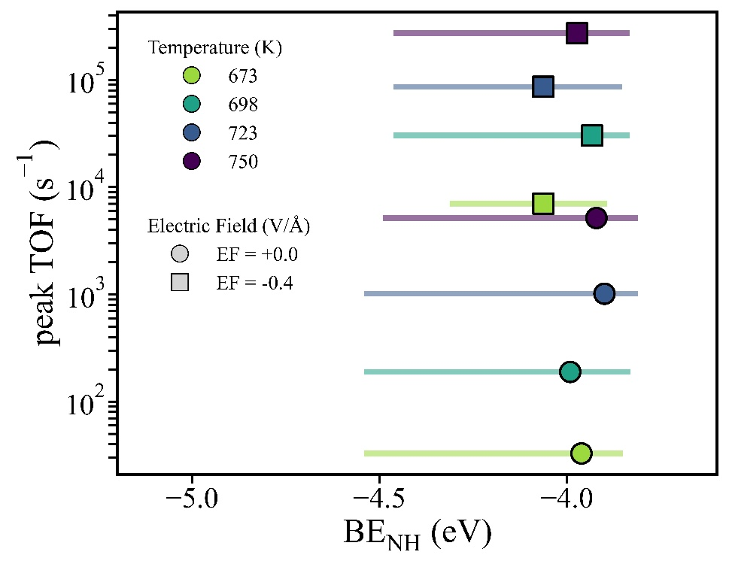
Figure S7. Condition-robustness of the NH binding-energy target. Each horizontal bar spans BE_{NH} interval over which the turnover frequency remains at or above 99% of its maximum for that condition; the marker on each bar locates the binding energy at which the maximum itself occurs. Marker colour denotes temperature and marker shape denotes applied field, with each bar drawn at the peak TOF of its condition on the logarithmic vertical axis.
S3. Machine-Learning Methodology
S3.1 Datasets and Partitioning
Two partitioning protocols were used. For the algorithm comparison of Section S3.2, the Ru dataset alone was split 80/20 into training and test partitions using a single fixed random seed. For the cross-metal model of Section S3.4, the 80% Ru training partition was augmented with 17% of the Co dataset, and the resulting model was evaluated separately on the held-out 20% of Ru and the remaining 83% of Co. The small Co training fraction is deliberate: rather than testing zero-shot transfer, this protocol evaluates whether a descriptor representation established predominantly from Ru can be adapted to a second metal using a comparatively small amount of metal-specific data, which is the regime of practical interest when extending the descriptor set to a new element.
Not every site converged at every charge state. Of the ten charge copies generated for each of the 119 distinct Ru sites, 1,132 reached the electronic and ionic convergence criteria and are retained; the remainder failed to converge and were discarded, so a small number of Ru configurations are represented at fewer than ten charge states. The Co set is complete, with all ten charge copies of each of its 27 distinct sites retained (270 entries).
S3.2 Comparison of Regression Algorithms
Five algorithms were benchmarked on identical feature matrices drawn from the Ru dataset, so that the comparison isolates the effect of model class rather than of data or featurization. Linear and ridge regression were fitted directly to the raw descriptors. The support-vector regressor was preceded by standardization to zero mean and unit variance within a single pipeline, since its radial-basis kernel is sensitive to feature scale; the tree ensembles are invariant to monotone rescaling of individual features and were fitted to raw values. Hyperparameters are listed in Table S11.
Table S11. Model settings used for the Ru-only algorithm benchmark.
Model | Hyperparameters | Preprocessing
Linear | Ordinary least squares; no regularization | None
Ridge | α = 1.0 | None
SVM | RBF kernel; C = 1.0; ε = 0.1 | Standardization (zero mean, unit variance)
Random forest | 200 trees; unrestricted depth; minimum 2 samples per split; minimum 1 sample per leaf | None
XGBoost | 650 estimators; learning rate 0.05; maximum depth 4; subsample 0.8; colsample_bytree 0.8; squared-error objective | None

S3.3 Hyperparameter Selection
XGBoost hyperparameters were selected by exhaustive search over the grid in Table S12, comprising 432 combinations. The globally selected configuration consists of 650 estimators, a learning rate of 0.06, a maximum tree depth of 4, a row subsampling ratio of 0.8, and a column subsampling ratio by tree (colsample_bytree) of 0.8.
The emergence of shallow trees and aggressive subsampling from the grid search is highly consistent with optimal regularization strategies for a dataset of this scale. Restricting the maximum depth to 4 limits each individual learner to interactions among at most four descriptors, forcing the ensemble to recover higher-order functional structure through the boosting process rather than relying on individually complex, potentially overfitted trees.
The Ru-only benchmark in Section S3.2 used a learning rate of 0.05, whereas hyperparameter optimization for the cross-metal model selected 0.06. Finally, early stopping was strictly enforced with a patience of 50 rounds during model training, meaning the effective number of trees utilized in the final models is generally smaller than the 650 upper limits permitted.
Table S12. Hyperparameter search and selected settings for the cross-metal model used in subsequent interpretation and screening.
Hyperparameter | Values searched | Selected
n_estimators | 500, 600, 650, 700, 750, 800 | 650
learning_rate | 0.04, 0.05, 0.06, 0.07 | 0.06
max_depth | 3, 4, 5 | 4
subsample | 0.6, 0.8, 1.0 | 0.8
colsample_bytree | 0.8, 1.0 | 0.8
Total combinations | 432 per partition | —
S3.4 Cross-Metal Adaptation and Evaluation Protocol
The model used for all downstream screening and interpretation was trained on the combined 80% Ru and 17% Co partition. The data is partitioned at fixed seed number, and the reported errors are those of that run.
S3.5 Interpretability Analyses
SHAP (SHapley Additive exPlanations) values were computed utilizing the exact tree-ensemble algorithm (TreeSHAP). This implementation natively returns exact Shapley values for tree-based models, strictly avoiding the sampled approximations necessitated by general, model-agnostic estimators. These values were evaluated over the union of the training, Ru test, and Co test partitions. The combined dataset was used only for post-hoc SHAP interpretation and was not used for model training or selection.
Local structural attributions were subsequently computed using LIME (Local Interpretable Model-agnostic Explanations) configured in regression mode. For this analysis, continuous descriptors were strictly left discretized, a fixed random seed was enforced to ensure reproducibility, and the full training feature matrix was utilized as the background reference distribution. Local explanations were generated separately for the synthetic screening candidates falling inside the optimal kinetic-informed target window, and for those falling outside it.
S3.6 Attribution Behavior of θ_{NH}
In the SHAP summary (Figure 4), θ_{NH} is the only descriptor whose attributions extend to large values of both signs. This comes from a small subset of configurations, not from a systematic dependence of BE_{NH} on tilt. Because θ_{NH} is an outcome of relaxation rather than a prescribed input, many configurations relax to an upright NH. Of the 1,402 configurations, 120 (8.6%) lie within 2° of the surface normal (θ_{NH} ≈ 0°), and this subset accounts for most of the variance in the θ_{NH} attribution. Three-quarters of these near-upright configurations lie on the close-packed Ru(0001) and Co(0001) terminations. There, the site symmetry aligns NH with the surface normal whether it occupies a top, fcc or hcp site.
Within this subset, θ_{NH} is effectively constant, while BE_{NH} spans the full range of the database (-6.57 to -2.12 eV). The descriptor therefore carries no physical information that distinguishes these configurations. However, the tree ensemble can still split on residual sub-degree differences in θ_{NH} and use them as a proxy for other configurational differences. This produces large attributions of either sign that do not reflect a genuine tilt effect. By contrast, near-upright configurations on adatom-decorated and stepped surfaces, whose binding energies lie close to the database mean, receive θ_{NH} attributions below 0.13 eV in magnitude.
This artifact affects the attribution, not the predictive performance, and none of the conclusions in the main text depend on it. Removing θ_{NH} from the descriptor set changes the Ru test MAE by only 0.002 eV and leaves the Co test MAE within the seed-to-seed variation reported in Section S3.4.
S4. Descriptor Definitions
Every configuration, whether fully DFT-relaxed or algorithmically generated, was converted into a fixed, twelve-dimensional descriptor vector via a single, unified featurization routine. This ensures that the training and screening feature spaces remain identical by construction. The descriptor set is logically partitioned into three distinct categories: the local binding environment, adatom-driven lateral interactions, and the global electronic and geometric state of the surface slab. Comprehensive definitions for all twelve features are tabulated in Table S13.
Table S13. Definitions of the twelve descriptors used to featurize each NH-adsorption configuration.
Descriptor | Definition | Regime
CN_{slab} | Number of slab metal atoms within the metal–N cutoff of the nitrogen atom. | Local
CN_{ad} | Number of metal adatoms within the metal–N cutoff of the nitrogen atom. | Local
GCN_{site} | Sum of Γ over the atoms constituting the binding site, scaled by the CN_max of that site order (Table S8). | Local
θ_{NH} | Angle (°) between the N–H bond vector and the surface normal (+z); 0° denotes an upright NH. | Local
Prox₁ | Inverse distance (Å⁻¹) from N to the nearest metal adatom; zero when no adatom is present. | Adatom
Prox₂ | Inverse distance from N to the second-nearest adatom; zero when fewer than two adatoms are present. | Adatom
Prox_{ad1-ad2} | Inverse separation between the two adatoms nearest to N; zero when fewer than two adatoms are present. | Adatom
GCN_{ad1} | Γ of the nearest adatom, scaled by the CN_max of its own coordination order. | Adatom
GCN_{ad2} | Γ of the second-nearest adatom, defined analogously. | Adatom
Coverage | Number of adatoms divided by sixteen, the number of top-layer atoms in the p(4×4) cell. | Global
Surface energy | Calculated surface energy of the facet (eV Å⁻²), assigned per termination from Table S1. | Global
Charge | Net cell charge (|e|); negative denotes added electrons, positive a deficit relative to the neutral cell. | Global

S4.1 Coordination Conventions and Distance Cutoffs
Coordination within the featurizer was evaluated using fixed, element-specific distance cutoffs (Table S14) rather than the d_{FNN}-scaled cutoffs used during structure generation. This choice keeps the descriptor definitions invariant as the lattice expands or contracts under charge: a cutoff tied to the measured nearest-neighbor distance would drift with the structure it is meant to describe, so the same physical environment could receive different coordination numbers at different charge states. All distances were evaluated under the minimum-image convention.
The absolute coordination number ($CN_{i}$) of any given metal atom is defined as the total number of metal atoms located within the predefined metal-metal cutoff, counting base slab atoms and adatoms alike. The active binding site of the adsorbate is explicitly defined as the subset of metal atoms lying within the established metal-N distance cutoff from the nitrogen atom. Partitioning this set based on whether each coordinating member belongs to the underlying 64-atom slab or is an added adatom directly yields the two discrete coordination descriptors: $CN_{\text{slab}}$ and $CN_{\text{ad}}$.
This identical partitioning scheme also dictates a categorical site label: such as top, bridge, three-fold hollow, four-fold hollow, and their respective adatom-containing variants, assigned based on the total number of coordinating atoms and the specific subset of those that are adatoms. While these categorical labels are utilized for dataset reporting and for the site-resolved analysis detailed in Section S6, they are explicitly withheld from the machine learning model. Instead, the model receives only the quantitative $CN_{\text{slab}}$ and $CN_{\text{ad}}$ integer values. Consequently, no rigid, human-defined site taxonomy is imposed upon the regression task. Out of the thirteen possible categorical labels generated by this scheme, ten are observed within the Ru database and eight within the Co database.
Table S14. Distance cutoffs used in the featurization routine.
Cutoff | Ru (Å) | Co (Å)
Metal-metal (coordination shell) | 2.80 | 2.535
Metal-N (binding-site membership) | 2.20 | 2.10
N-H (adsorbate identification) | 1.20 | 1.20

S4.2 Generalized Coordination Numbers
The generalized coordination number (GCN) extends the basic coordination count by weighing each nearest neighbor according to its own degree of embedding. This allows the descriptor to reliably distinguish between active sites that share identical primary coordination numbers but differ in their extended geometric environments. For each metal atom $i$, the featurization routine first accumulates the standard coordination numbers ($CN_{j}$) of all its first-shell neighbors:
$$Γ_{i}=\sum_{j∈\text{FNN}\left(i\right)}{C}N_{j}$$ | $$(\text{S18}\text{)}$$
The generalized coordination descriptor for a specific binding site is then defined as the sum of $Γ_{i}$ over all metal atoms constituting that site, scaled by a reference value ($CN_{\text{max}}$) characteristic of the site's coordination order:
$$GCN_{\text{site}}=\frac{\sum_{i∈\text{site}}{Γ_{i}}}{CN_{\text{max}}}$$ | $$\text{(}\text{S19}\text{)}$$
The adatom descriptors, $GCN_{\text{ad1}}$ and $GCN_{\text{ad2}}$, are computed identically for the first- and second-nearest adatoms, respectively. Each is scaled by the $CN_{\text{max}}$ appropriate to its own coordination order, thereby quantifying how strongly each adatom is anchored to the underlying slab. Following standard literature conventions, the GCN is scaled to remain commensurate with raw CN values, rather than strictly normalized to a unit interval, ensuring that a fully embedded environment logically returns a value approximating the bulk coordination number.
For a single-atom (top) site, this definition reduces exactly to the generalized coordination number as originally formulated by Calle-Vallejo et al.^{3, 4} For higher-order sites, however, our algorithmic implementation diverges slightly in its bookkeeping: the present definition sums $Γ$ over each member atom independently. Consequently, a neighbor shared between two member atoms contributes once for each member, whereas the original formulation counts the union of nearest neighbors exactly once. This distinction represents a fixed mathematical transformation of the exact same underlying geometry. Because it is applied identically across both the training and screening sets, it does not bias or affect the ML regression. This methodological detail is stated explicitly here to ensure that the exact descriptor values deposited in the published data files can be perfectly reproduced by future researchers.
Reference $CN_{\text{max}}$ values are established in the literature solely for top, bridge, and three-fold hollow sites. To extend this descriptive scheme to the higher-order sites that organically arise on stepped terminations, $CN_{\text{max}}$ was computationally derived as the total number of distinct first-shell neighbors of the site’s member atoms (excluding the members themselves) for a site completely embedded within a bulk-like environment. When applied to the three known cases, this geometric construction returns 12, 18, and 22, perfectly reproducing the literature values and firmly validating the procedure prior to its extension (Table S15). This foundational analysis was performed on a Ru slab and carried over identically to Co. This transfer is physically justified because both metals share the hcp topology that dictates these nearest-neighbor counts. Where a given site order admits more than one geometric arrangement, CN_{max} varies slightly between them: a coplanar four-fold site gives 26 while a stepped arrangement of three coplanar atoms plus one raised atom gives 27, and the three five-fold arrangements tested give 30, 30, and 29. The coplanar value was adopted for each order, so that a single reference applies to all sites of a given coordination. In practice only sites up to five-fold occur in the database, so the six-fold entries of Table S15 are reported for completeness rather than used.
Table S15. Reference coordination numbers CN_{max} used to scale the generalized coordination number, obtained by counting the distinct first-shell neighbors of the site’s member atoms in a bulk-like environment. The top, bridge, and three-fold values reproduce those established in the literature.
Site order | Arrangement | CN_max | Status
1 | Top | 12 | Matches literature
2 | Bridge, same layer | 18 | Matches literature
3 | Two same layer, one raised | 22 | Matches literature
4 | Four same layer (coplanar) | 26 | Adopted for all four-fold sites
4 | Three same layer, one raised | 27 | Not adopted; differs by one unit
5 | Five same layer | 30 | Adopted for all five-fold sites
5 | Four same layer, one raised | 30 | Not realized in database
5 | Three same layer, two raised | 29 | Not realized in database
6 | Four same layer, two raised | 34 | Adopted; not realized in database

S4.3 Adatom Proximity Descriptors
Lateral interactions with surface adatoms are encoded through three inverse-distance descriptors. ${\text{Prox}}_{1}$ and ${\text{Prox}}_{2}$ are defined as the reciprocals of the distances from the adsorbed nitrogen atom to the nearest and second-nearest adatom, respectively. ${\text{Prox}}_{\text{ad1-ad2}}$ is the reciprocal of the spatial separation between those same two adatoms, ensuring that lateral adatom-adatom interactions are explicitly represented alongside the primary adatom-adsorbate interactions. Each metric evaluates to exactly zero when the corresponding adatom is absent.
The inverse mathematical formulation is crucial for rendering this zero physically meaningful. As the spatial separation grows without bound ($d→∞$), the proximity metric converges smoothly to zero-the exact value organically assigned to the bare, clean surface. Consequently, no-adatom surface natively emerges as the continuous mathematical limit of the adatom-covered state, rather than requiring ad hoc handling as an isolated boundary case. Attempting to encode this same physical information using raw interatomic distances would necessitate assigning arbitrary, unphysical placeholders (e.g., extraordinarily large dummy values like 99 Å) for absent adatoms, thereby introducing severe, artificial discontinuities into the machine learning feature space at zero coverage.
S4.4 Global and Geometric Descriptors
Four descriptors characterize the configuration. Coverage is the number of adatoms divided by sixteen, the number of top-layer atoms in the p(4×4) cell, and therefore takes the values 0, 1/16, and 2/16 ML. Surface energy is the calculated value for the facet, assigned per termination from Table S1. Charge is the net charge imposed on the periodic cell by varying the total electron count, following the sign convention that a negative value denotes added electrons and a positive value a deficit relative to the neutral cell; the implementation and the compensating background are described in the main text. θ_{NH} is the angle between the N-H bond vector, evaluated under the minimum-image convention, and the surface normal (+z), so that an upright NH returns 0°.
S5. Generation of the Screening Structure Library
The density functional theory (DFT) training database, comprising 1132 Ru and 270 Co configurations, was constructed independently and is not a direct product of this pipeline. The same algorithmic approach was applied to both metals, differing only in the element-specific parameters detailed in Table S16. Notably, no external structural priors-such as lattice constants, predefined site lists, or symmetry operations were supplied. Instead, all geometric quantities were derived directly from the input slab, ensuring the procedure remains applicable to any surface termination.

S5.1 Interatomic Distance Scale and Coordination Numbers
The first-nearest-neighbor distance ($d_{\text{FNN}}$) establishes the length scale for all subsequent geometric evaluations and is measured directly from each slab rather than assumed from bulk lattice constants. All interatomic distances within a 4.0 Å cutoff were evaluated under periodic boundary conditions. The value of $d_{\text{FNN}}$ was assigned as the median of distances shorter than $1.25d_{\text{min}}$, where $d_{\text{min}}$ represents the shortest pairwise distance in the unit cell. Employing the median of the first-neighbor shell, rather than $d_{\text{min}}$ itself, prevents a single artificially compressed pair (e.g., at a step edge) from disproportionately skewing the length scale for the entire slab.
Subsequently, the coordination number ($CN_{i}$) of atom $i$ was defined as the total number of metal atoms located within a radius of $1.2d_{\text{FNN}}$. This cutoff encompasses the complete first coordination shell while strictly excluding second-shell neighbors in both hcp and fcc metals, correctly returning the expected bulk value of 12 for fully embedded atoms.
S5.2 Identification of Surface Atoms
Surface atoms were identified by satisfying two simultaneous criteria: under-coordination relative to the bulk ($CN_{i}<12$) and spatial localization within a vertical threshold ($z_{\text{window}}$) relative to the highest atom in the slab. Both conditions are strictly necessary for accurately characterizing stepped terminations. Relying solely on a height criterion would inadvertently exclude the lower terraces of a step, which host precisely the under-coordinated B5-type environments of interest. Conversely, relying solely on a coordination criterion would erroneously include under-coordinated atoms artificially fixed at the bottom of the slab, which are not exposed to the vacuum.
S5.3 Enumeration of Adsorption Sites
Adsorption sites were enumerated via Delaunay triangulation of the surface-atom positions projected onto the $xy$ plane. To enforce periodicity, the surface-atom set was replicated over a 3 × 3 grid of in-plane lattice translations prior to triangulation. Only simplices containing at least one vertex from the central image were retained, ensuring that sites spanning the cell boundary were generated exactly once. A simplex was accepted only if all three of its edges were shorter than $1.30d_{\text{FNN}}$. This edge filter effectively removes the spurious long-edge triangles that Delaunay algorithms inevitably produce across step edges, vacancies, and the convex hull of the surface-atom set.
Three site classes were extracted from the accepted triangulation: top sites at each surface-atom position, bridge sites at the midpoint of each accepted edge, and three-fold hollow sites at each accepted centroid. Bridge and hollow sites were keyed by their rounded Cartesian coordinates, ensuring that an edge or triangle shared between periodic images contributed to a single distinct site. Hollow sites were further classified as hcp or fcc by checking for a subsurface atom directly beneath the centroid, defined as an atom lying more than $Δz_{\text{hcp}}$ below the centroid and within a lateral distance of $0.6d_{\text{FNN}}$. Centroids featuring such an atom were labeled hcp, while those without were labeled fcc.
Finally, symmetry-equivalent sites were-collapsed using a geometric fingerprint comprising the site class, a sorted tuple of the coordination numbers of its member atoms, and the site height rounded to 0.1 Å. Two sites sharing an identical fingerprint occupy geometrically indistinguishable environments within the slab and were thus represented by a single entry. This deduplication step successfully reduces the full triangulation of a complex termination (e.g., a $p\left(4×4\right)$ cell) down to the minimal set of distinct environments enumerated, and it is applied identically to both clean and adatom-adsorbed slabs.
S5.4 NH Placement
The nitrogen atom was placed on the vacuum side of each site, equidistant at $D_{\text{NM}}$ from all coordinating atoms of that specific site and displaced along the local site normal rather than the global surface normal. This distinction is highly consequential on stepped facets: displacing N along the global $z$-axis from a tilted three-fold site brings it into bonding range of only the two uppermost atoms (degenerating the hollow into a bridge), whereas the local-normal construction preserves the intended three-fold coordination and reproduces three equal N-metal distances.
The three site classes were handled as follows. At a top site, N was displaced vertically by D_{NM}. At a bridge site, N was placed on the perpendicular bisector of the metal–metal bond, within the plane containing the bond axis and the vertical direction, at a height √(D_{NM}² − (L/2)²) above the midpoint; the site was rejected when L/2 ≥ D_{NM}, since no position can then satisfy both bonds. At a three-fold hollow, N was placed above the circumcenter of the triangle, offset by √(D_{NM}² − R_{c}²) along the unit normal oriented into the vacuum, where R_{c} is the circumradius. Hollows were rejected when R_{c} ≥ D_{NM} (too open to bond all three atoms at the target distance), when the three member atoms were collinear, and when the vertical component of the unit normal fell below 0.20, which removes pseudo-hollows formed on near-vertical step walls where the "site" faces sideways into the step rather than into the vacuum.
Every accepted N position was subsequently tested for shadowing against a 3 × 3 in-plane tiling of the metal positions. If any non-coordinating metal atom lay closer to N than $D_{\text{NM}}-0.10$ Å, the site was discarded. This step effectively eliminates sites that the triangulation algorithm reports as exposed, but which are physically blocked by an overhanging step atom. Hydrogen was placed at a fixed N-H distance of 1.026 Å in five initial orientations: upright along the vertical axis and tilted by 22.5° and 45° about both the $x$ and $y$ axes. This sampling strategy supplies the spread in $θ_{\text{NH}}$ that the downstream tilt descriptor encodes. For each tilted orientation, both azimuthal senses were evaluated, and the first configuration to clear a minimum H-metal separation threshold ($h_{\text{min}}$) was accepted. If neither azimuthal direction cleared this threshold, that specific orientation was dropped while the others were retained. The completed NH fragment was finally wrapped rigidly back into the unit cell along the in-plane lattice vectors, leaving the $z$-coordinate unchanged, to ensure N and H remained correctly bonded across the cell boundary.
Table S16. Geometric parameters of the structure-generation protocol. Values were seeded from relaxed reference NH-adsorption structures for each metal.
Parameter | Ru | Co | Role
N-metal distance D_NM (Å) | 1.95 | 1.86 | Target N coordination distance
N-H distance D_NH (Å) | 1.026 | 1.026 | Fixed adsorbate bond length
Tilt orientations (°) | 0, 22.5, 45 | 0, 22.5, 45 | About x and y; samples θ_NH
Minimum H-metal distance h_min (Å) | 1.30 | 1.21 | Rejects H merged into the surface
Shadowing tolerance (Å) | 0.10 | 0.10 | Rejects sites blocked by step atoms
Minimum hollow normal z-component | 0.20 | 0.20 | Rejects near-vertical pseudo-hollows
Surface z-window (Å) | 1.4 | 1.3 | Height criterion for surface atoms
CN cutoff factor (× d_FNN) | 1.2 | 1.2 | First coordination shell
Delaunay edge tolerance (× d_FNN) | 1.30 | 1.30 | Maximum accepted triangle edge
hcp/fcc depth Δz_hcp (Å) | 0.50 | 0.47 | Subsurface-atom test below centroid
Adatom dimer window (× d_FNN) | 1.20 | 1.20 | Maximum adatom–adatom separation
NH–adatom coupling window (x d_FNN) | 2.20 | 2.20 | Maximum site–adatom separation

S5.5 Adatom Placement
Metal adatoms were placed exclusively at the fcc and hcp hollow sites of the clean surface, utilizing the same equidistant local-normal construction described above, but with the target distance set to the first-nearest-neighbor distance ($d_{\text{FNN}}$) instead of $D_{\text{NM}}$. Consequently, the feasibility and shadowing tests applied to the nitrogen placements were identically applied to adatom placements. An adatom was accepted only if it could bond to all three hollow-site atoms at the target metal–metal distance. Restricting adatoms to three-fold hollows enforces the physical requirement that a stable adatom be at least four-fold coordinated (once its own internal bonds are counted) and strictly excludes the physically implausible top- and bridge-bound adatoms that an unconstrained enumeration would otherwise generate.
Upon the successful placement of the first adatom, its index was appended to the surface-atom set, all coordination numbers were recomputed over the newly decorated slab, and the site enumeration procedure (Section S5.3) was repeated. As a result, mixed slab-adatom bridge and hollow sites emerge naturally in the site list rather than requiring manual definition. Furthermore, the coordination numbers of the three surface atoms directly beneath the adatom increase accordingly, thereby allowing the downstream features to automatically register this localized change in the embedding environment.
The second adatom was subsequently drawn from the hollow sites of this updated list, subject to a strict dimer constraint: its parent site was required to lie within $1.20d_{\text{FNN}}$ of the first adatom. This constraint was re-verified against the final adatom–adatom separation after placement, as the geometric construction inherently shifts the adatom off its parent centroid. Without this proximity constraint, two mutually distant adatoms would merely reproduce two independent single-adatom environments, contributing no meaningful lateral interaction for the ${\text{Prox}}_{\text{ad1-ad2}}$ descriptor to encode. The resulting decorated slabs correspond to adatom coverages of 1/16 and 2/16 monolayers (ML) within the $p\left(4×4\right)$ supercell.
Finally, on these decorated slabs, the NH fragment was placed only at sites lying within $2.20d_{\text{FNN}}$ of at least one adatom. This coupling window ensures that every adatom-containing candidate structure genuinely probes an NH–adatom interaction; placing NH at sites far from the adatoms would otherwise yield local environments geometrically indistinguishable from the clean surface, despite nominally carrying a "covered" label in the dataset.
S5.6 Geometry Acceptance Criteria
Because the screening structures are featurized exactly as built (i.e., prior to DFT relaxation), each generated configuration was subjected to a rigorous geometric validation. This step enforces minimum separation thresholds (floors) below which an unrelaxed seed could not realistically correspond to a physically meaningful adsorption state. These distance floors were empirically derived from the closest approaches observed within the fully relaxed DFT reference structures for each respective metal.
A structure was rejected (Table S17) if any of the following held. (i) The metal count was inconsistent with the fixed 64-atom slab plus zero, one, or two adatoms. (ii) The atom ordering did not place N immediately after the metal block and H immediately after N, which would indicate a malformed file rather than a bad geometry. (iii) The shortest H-slab or H-adatom distance fell below the corresponding floor, indicating that the hydrogen had been seeded into the surface. (iv) The shortest distance from N to a non-coordinating metal atom fell below the shadowing floor. For the last test, the coordinating shell was defined as those metal atoms within 1.05D_{NM} of N, matching the placement construction, which puts member atoms at exactly D_{NM}; all remaining metal atoms are treated as non-coordinating. All distances were evaluated under the minimum-image convention applied in the two in-plane directions only, leaving z open, as appropriate for a slab.
Table S17. Minimum-distance floors applied to unrelaxed generated structures.
Criterion | Ru (Å) | Co (Å) | Rejection label
Shortest H-slab distance | 1.59 | 1.50 | H_merge_slab
Shortest H-adatom distance | 1.79 | 1.70 | H_merge_adatom
Shortest N-non-coordinating metal distance | 2.44 | 2.33 | N_shadowed

S5.7 Charge Inclusion
Because system charge enters the descriptor vector as a global parameter and does not alter the underlying, unrelaxed structural geometry, each accepted configuration was replicated across a predefined set of charge states by modifying only the charge descriptor. Two distinct screening datasets were constructed from an identical foundation of 6,609 accepted structures.
The first, a charge-biased library, applies five negative charge states ($-1$ to $-5 |e|$). This specific range exploits the bond-weakening trajectory previously identified via SHAP analysis, yielding a total of 33,045 candidates. The second, an unbiased baseline library, spans seven symmetric charge states ($+3$ to $-3 |e|$) and comprises 46,263 candidates.
Because the two libraries share the same structural basis, the difference in qualifying fraction arises from the different charge-state distributions rather than differences in structural sampling. The comparative analysis of these two datasets is detailed in Section S6.
S6. Extended Screening Analysis
The screening library of Section S5 was passed through the trained model and each candidate labeled as qualifying or not according to whether its predicted BE_{NH} falls within the target window of -4.47 to -3.84 eV. This section reports on the analyses supporting the treatment of the three descriptors as design levers in the main text.
S6.1 Charge as an Independent Lever
As established in Section S5.7, the two screening libraries share an identical structural basis, differing exclusively in their charge states. Consequently, differences in screening outcomes between the two libraries arise from the different charge-state distributions rather than differences in structural sampling.
Over the structurally unbiased, symmetric charge range of $+3$ to $-3 |e|$, 24.4% of the 46,263 baseline candidates successfully fell within the target binding-energy window (Figure S8). In stark contrast, evaluating these exact same geometries over the negatively biased charge range ($-1$ to $-5 |e|$) drove 50.7% of the 33,045 candidates into the target window. By rationally exploiting the specific bond-weakening trajectory previously identified via SHAP analysis, we increased the qualifying fraction from 24.4% to 50.7%, corresponding to a 2.08-fold enrichment.
This enrichment illustrates why explicit system charge provides an actionable electronic descriptor within the present computational framework. Because charge can be varied independently of the structural descriptors, its effect can be evaluated while holding the underlying geometry fixed. In contrast, geometric descriptors such as GCNsite emerge from the atomic configuration and therefore cannot generally be varied independently without modifying the surface structure.The inherent limitations of tuning these purely geometric properties are quantitatively explored in Sections S6.3 and S6.4.
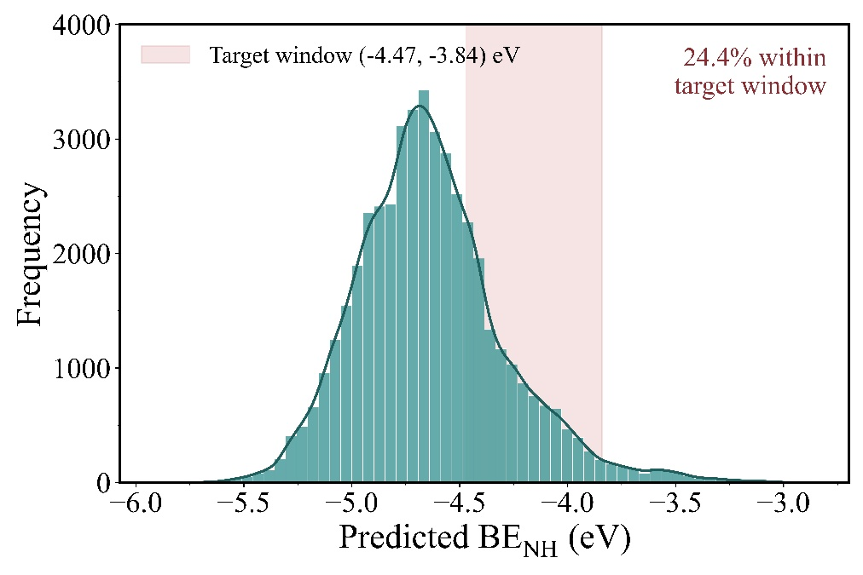
Figure S8. Distribution of predicted NH binding energies over the unbiased screening library (+3 to −3 |e|, 46,263 candidates). The shaded band marks the target window of -4.47 to -3.84 eV, within which 24.4% of candidates fall. The distribution peaks near -4.7 eV, reflecting the intrinsic tendency of these surfaces to over-bind NH.
S6.2 Consistency of Local Attributions
Local structural attributions were computed for every candidate within the charge-biased library, comprising 16,749 qualifying and 16,296 non-qualifying structures, utilizing all twelve descriptors for each local explanation. Each explanation was systematically generated using default setting of 5000 perturbations to ensure the statistical convergence of the local linear model.
The mean absolute attribution per descriptor was found to be similar between the two populations. Furthermore, this local analysis reproduces the top 3 global SHAP feature-importance ordering in both sub-populations, with $GCN_{\text{site}}$, charge, and surface energy emerging as the dominant leading features (Figure S9), even though their relative ordering differs.
This structural consistency demonstrates that the surrogate model applies a unified, continuous physical attribution logic throughout the entire configurational space, rather than relying on a distinct, localized rule set exclusively near the target binding-energy window. This crucial observation firmly establishes the physical premise for interpreting the descriptor effects detailed below as fundamental thermodynamic properties successfully captured by the model as a whole.
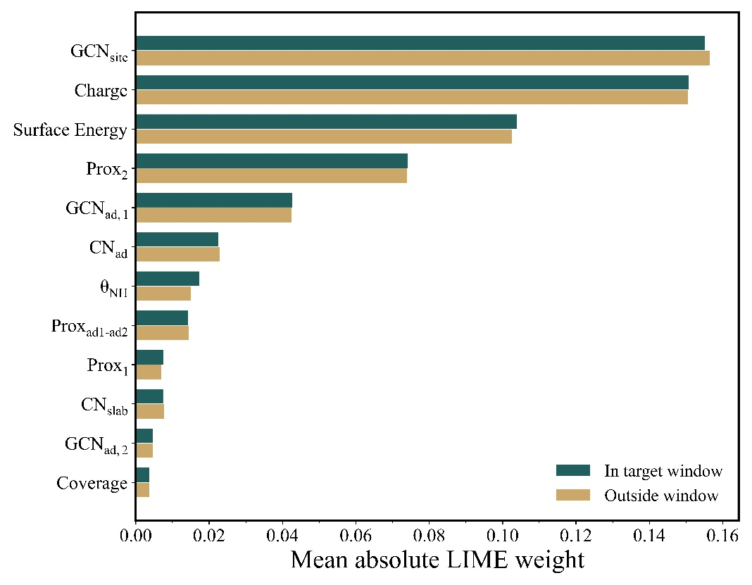
Figure S9. Mean absolute LIME attribution per descriptor, computed separately for candidates inside the target window (n = 16,749) and outside it (n = 16,296).
S6.3 Site Type and Adatom Coverage
Resolved by site type and pooled over both metals, the qualifying fraction spans 25% to 73% about the overall value of 50.7% (Figure S10); resolved by metal as well, the spread is wider, from 30.5% for Ru bridge sites to 84.8% for Co four-fold sites (Table S18). While this success rate does not scale monotonically with absolute coordination number, one rigorous physical regularity persists throughout the dataset: at every fixed coordination order, adatom-containing site variants successfully qualify strictly less often than their pristine, pure-slab counterparts. Top sites give 59% against 55% for on-top-adatom; bridge sites 49%, against 38% mixed and 25% pure-adatom; three-fold sites 46%, against 41% for both one- and two-adatom hollows; and four-fold sites 72% against 69% with an adatom involved.
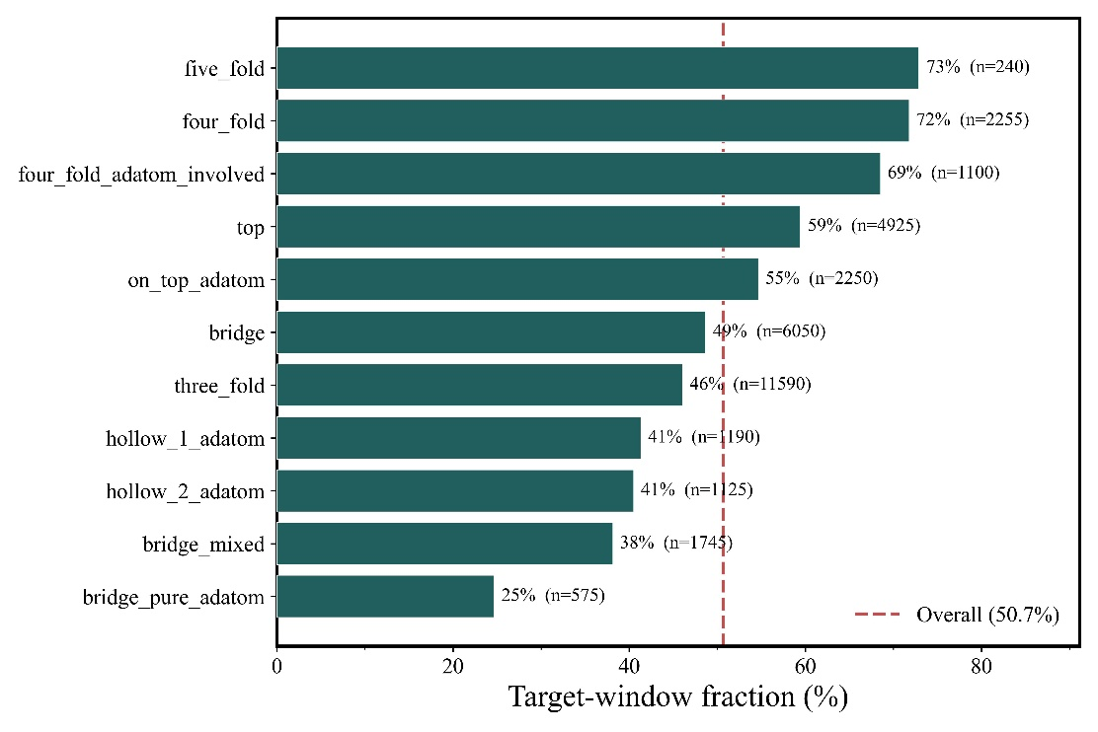
Figure S10. Target-window fraction resolved by site type across the charge-biased library, with the number of candidates per type in parentheses and the overall fraction of 50.7% marked.
The same effect appears directly in the adatom count (Figure S11). Clean surfaces qualify at 51.7% and single-adatom surfaces at 50.6%, values close enough to the overall fraction to be indistinguishable from it, whereas adatom dimers fall to 36.6%. Adatom decoration is therefore neutral at low coverage and detrimental once two adatoms are present, rather than uniformly inconsequential.

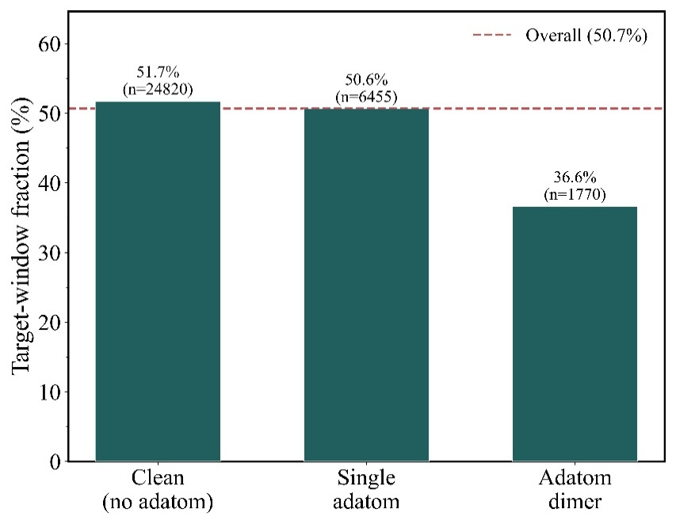
Figure S11. Target-window fraction by adatom counts: clean surfaces, single adatoms, and adatom dimers. The dashed line marks the overall fraction of 50.7%.
S6.4 Coupling Between Surface Energy and Site Coordination
The two geometric descriptors were examined jointly by cross-tabulating the qualifying fraction over surface energy and site coordination. The analysis is performed separately for each metal (Figure S12). This separation is necessary rather than cosmetic: the surface energies of the Co terminations lie almost entirely below those of the Ru terminations, so binning surface energy across the pooled library produces groups that are nearly coincident with metal identity, and the resulting trend cannot be attributed to surface energy. Within each metal, surface energy is grouped by facet so that each bin contains a stated set of terminations.
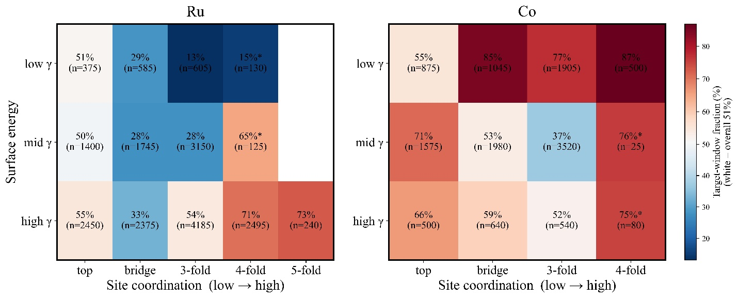
Figure S12. Target-window fraction across surface energy and site coordination, shown separately for Ru (left) and Co (right). Colour is centred on the overall fraction of 50.7%, with red above and blue below, and the scale is shared between panels. Surface energy is grouped by facet within each metal: for Ru, low γ = (0001) and (10-11), mid γ = (10-10) and (2-1-12), high γ = (10-13) and (11–21); for Co, low γ = (0001) and (10-10), mid γ = (10-11) and (10-13), high γ = (11-21).
When resolved in this manner, surface energy exhibits no universal, cross-metal directional trend. For Ru, the qualifying fraction scales positively with surface energy, rising from 27.1% in the low-$γ$ group to 33.5%, and finally to 54.0% in the high-$γ$ group. Conversely, for Co, the trend runs entirely opposite: the qualifying fraction peaks in the low-$γ$ group at 75.6%, before falling to 49.1% and 59.6% at higher energies. Furthermore, the thermodynamic influence of one geometric descriptor is never strictly independent of the other. For example, within the Ru dataset, shifting the surface energy leaves the qualifying fraction of low-coordination sites almost unchanged (top sites: 51%, 50%, 55%; bridge sites: 29%, 28%, 33%), while simultaneously driving a massive variance in three-fold hollow sites (surging from 13% to 54%).
The qualifying fraction across varying coordination orders is strictly governed by where each structural population's mean energy sits relative to the target thermodynamic window, rather than by the absolute coordination number (Table S18). On Ru, the bridge and three-fold populations yield mean predicted binding energies of $-4.52$ and $-4.49$ eV. Because these values fall below the strong-binding lower boundary of the target window ($-4.47$ eV), only the outermost weak-binding tails of these statistical distributions manage to qualify. In contrast, the four- and five-fold populations are centered squarely inside the optimal window at $-4.37$ and $-4.39$ eV.
Taken together, these results show that surface energy and local site coordination jointly influence the accessible NH* binding-energy distribution, with their effects depending on the underlying metal and structural environment. In contrast, explicit charge provides an independently variable electronic descriptor that offers a more direct means of shifting predicted NH* binding within a given structural configuration.
Table S18. Qualifying fraction, mean predicted binding energy, and mean GCN_{site} by site coordination within each metal, over the charge-biased library. Site types are collapsed onto their coordination order, so that adatom-containing variants are grouped with their pure-slab counterparts.
Metal | Coordination | Candidates | Qualifying (%) | Mean BE_{NH} (eV)
Ru | top | 4,225 | 52.7 | -4.235
Ru | bridge | 4,705 | 30.5 | -4.523
Ru | three-fold | 7,940 | 40.7 | -4.493
Ru | four-fold | 2,750 | 67.6 | -4.374
Ru | five-fold | 240 | 72.9 | -4.392
Co | top | 2,950 | 65.5 | -4.012
Co | bridge | 3,665 | 63.3 | -4.324
Co | three-fold | 5,965 | 51.3 | -4.456
Co | four-fold | 605 | 84.8 | -4.312

S7. DFT Validation of Screened Candidates
Nineteen qualifying candidates were drawn from the screening library and their binding energies recomputed with the DFT settings of the main text. All are Ru, and they span four terminations, both adatom configurations, four charge states, and all four generated site classes; the full list is given in Table S19.
Because the surrogate model descriptors were explicitly evaluated on unrelaxed, as-built geometries, this DFT validation was purposefully performed under a constrained relaxation protocol. Specifically, the entire NH fragment and any surface adatoms were strictly frozen in all degrees of freedom at their algorithmically generated seed positions. Meanwhile, the remaining underlying slab atoms were permitted to relax normally, subject to the standard constraint fixing the bottom two atomic layers. Immobilizing the active adsorbate perfectly preserves the exact spatial geometry from which the original descriptors (e.g., $GCN_{\text{site}}$, adatom proximity) were derived. Consequently, the resulting DFT energy corresponds directly to the exact structure that was featurized, rather than to a completely relaxed, geometrically distinct configuration.
Table S19. Screened candidates selected for DFT validation. Site class is assigned during structure generation; all candidates carry adatoms, so the corresponding featurized site types are the adatom-containing variants.
# | Facet | Structure | Site class | Adatoms | Charge (|e|)
1 | Ru(10-13) | ad2_1495 | bridge | 2 | -4
2 | Ru(2-1-12) | ad2_0130 | top | 2 | -3
3 | Ru(10-13) | ad2_1477 | top | 2 | -2
4 | Ru(10-13) | ad2_0816 | top | 2 | -2
5 | Ru(10-13) | ad2_2520 | top | 2 | -4
6 | Ru(10-10) | ad1_1180 | bridge | 1 | -4
7 | Ru(10-13) | ad1_2006 | top | 1 | -2
8 | Ru(10-13) | ad1_1815 | hcp hollow | 1 | -4
9 | Ru(10-13) | ad1_2075 | bridge | 1 | -4
10 | Ru(10-13) | ad1_2150 | hcp hollow | 1 | -4
11 | Ru(10-10) | ad2_1030 | bridge | 2 | -5
12 | Ru(10-13) | ad2_0625 | bridge | 2 | -3
13 | Ru(2-1-12) | ad1_0446 | bridge | 1 | -5
14 | Ru(10-10) | ad1_0125 | bridge | 1 | -2
15 | Ru(11-21) | ad1_0109 | hcp hollow | 1 | -3
16 | Ru(10-13) | ad2_1320 | bridge | 2 | -2
17 | Ru(11-21) | ad2_0245 | hcp hollow | 2 | -3
18 | Ru(10-10) | ad1_0160 | fcc hollow | 1 | -5
19 | Ru(10-10) | ad2_1080 | fcc hollow | 2 | -4

REFERENCES.
1. Tran, R.; Xu, Z.; Radhakrishnan, B.; Winston, D.; Sun, W.; Persson, K. A.; Ong, S. P. Surface energies of elemental crystals. Scientific Data 2016, 3, 160080. doi:10.1038/sdata.2016.80.
2. Fang, H.; Wu, S.; Ayvali, T.; Zheng, J.; Fellowes, J.; Ho, P.-L.; Leung, K. C.; Large, A.; Held, G.; Kato, R.; Suenaga, K.; Reyes, Y. I. A.; Thang, H. V.; Chen, H.-Y. T.; Tsang, S. C. E. Dispersed surface Ru ensembles on MgO(111) for catalytic ammonia decomposition. Nature Communications 2023, 14, 647. doi:10.1038/s41467-023-36339-w.
3. Calle-Vallejo, F.; Martínez, J. I.; García-Lastra, J. M.; Sautet, P.; Loffreda, D. Fast prediction of adsorption properties for platinum nanocatalysts with generalized coordination numbers. Angewandte Chemie (International ed. in English) 2014, 53, 8316-9. doi:10.1002/anie.201402958.
4. Calle-Vallejo, F.; Tymoczko, J.; Colic, V.; Vu, Q. H.; Pohl, M. D.; Morgenstern, K.; Loffreda, D.; Sautet, P.; Schuhmann, W.; Bandarenka, A. S. Finding optimal surface sites on heterogeneous catalysts by counting nearest neighbors. 2015, 350, 185-189. doi:doi:10.1126/science.aab3501.

