Table 2. Molecular Target Predictions for bioactive molecules identified from B. leachii extract using Molinspiration and Swiss Target Prediction
Name | Target prediction  (Molinspiration) | Target prediction  (Swiss Target Prediction)
Hectochlorin | GPCR ligand -0.09  Ion channel modulator -0.46  Kinase inhibitor -0.46  Nuclear receptor-ligand -0.18  Protease inhibitor 0.10  Enzyme inhibitor -0.08 | 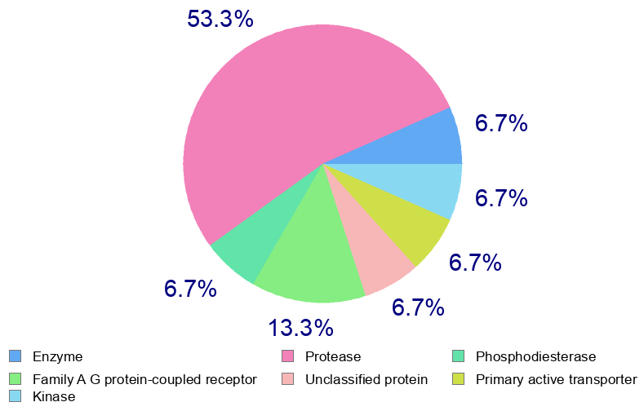
Malyngamide X | GPCR ligand 0.19  Ion channel modulator -0.44  Kinase inhibitor -0.42  Nuclear receptor-ligand -0.29  Protease inhibitor 0.46  Enzyme inhibitor 0.01 | 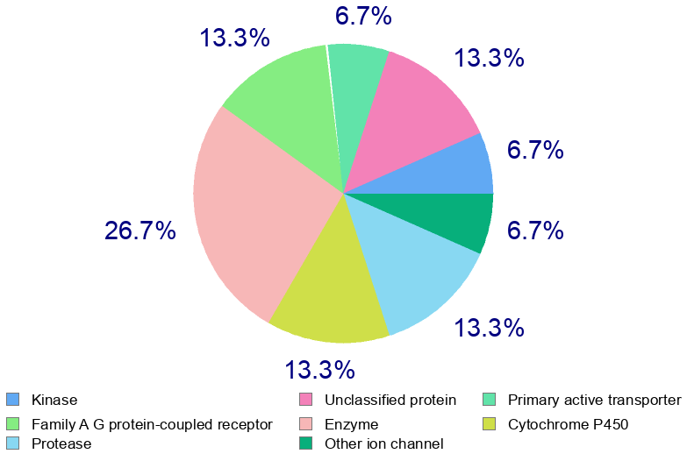
Malyngamide S | GPCR ligand 0.17  Ion channel modulator 0.24  Kinase inhibitor -0.28  Nuclear receptor ligand 0.23  Protease inhibitor 0.32  Enzyme inhibitor 0.32 | 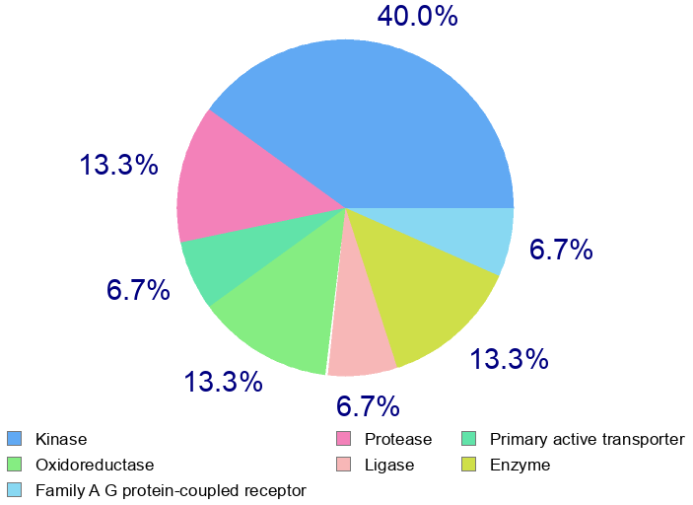
Bursatellin | GPCR ligand 0.04  Ion channel modulator -0.22  Kinase inhibitor -0.36  Nuclear receptor-ligand -0.21  Protease inhibitor 0.01  Enzyme inhibitor 0.32 | NA
Lyngbyatoxin A | GPCR ligand 0.49  Ion channel modulator 0.20  Kinase inhibitor 0.42  Nuclear receptor ligand 0.06  Protease inhibitor 0.36  Enzyme inhibitor 0.35 | 