Cybersecurity Challenges in AI-Enabled Car Rental Systems: Protecting Digital Booking, Fleet Management, and Customer Data

OW. Samuel

Abstract
The rapid digitalization of car-rental services has transformed booking, customer verification, demand prediction, fleet monitoring, predictive maintenance, and automated customer support. However, the integration of artificial intelligence (AI), Internet of Things (IoT), enterprise resource planning (ERP) systems, cloud platforms, and connected-vehicle technologies has simultaneously expanded the cybersecurity attack surface of car-rental operations (Mohammed, 2026; Suaprae et al., 2026; Potdar & Parikh, 2025). This article examines the cybersecurity challenges associated with AI-enabled car rental systems, focusing on risks to customer identity information, payment data, location records, booking information, telematics, application programming interfaces (APIs), cloud infrastructure, and AI models. A literature-based analytical approach was employed to synthesize evidence from recent research on AI-enabled car rental management, smart tourism, IoT-based fleet management, digital trust, and AI adoption. The analysis identifies interconnected cybersecurity challenges involving data privacy, unauthorized access, API vulnerabilities, connected-vehicle threats, AI-related risks, and weaknesses across digitally integrated enterprise systems. Based on these findings, the article develops a layered protection framework that integrates cybersecurity controls, AI governance, privacy protection, secure system architecture, and human oversight. The analysis indicates that cybersecurity in AI-enabled car rental systems should be addressed as a multidimensional organizational and technological challenge rather than solely as a conventional IT-security concern.

Keywords
Artificial Intelligence; Car Rental Systems; Cybersecurity; Fleet Management; Customer Data Privacy; Internet of Things; Digital Booking

1. Introduction
1.1 Background of AI-Enabled Car Rental Systems
The car-rental industry has evolved from physical reservations and manual vehicle allocation to computerized reservation systems, online booking platforms, mobile applications, connected fleets, and increasingly AI-enabled rental ecosystems. This transformation has expanded the role of technology across booking, customer verification, recommendation, fraud detection, dynamic pricing, vehicle tracking, predictive maintenance, and fleet optimization. AI is also being incorporated into customer-service processes and travel operations, enabling more automated and data-driven interactions (Mohammed, 2026; Talukder & Muhsina, 2024; Soundarya et al., 2025). Contemporary rental platforms can integrate customer management, vehicle inventory, reservations, payments, and centralized information through ERP-based architectures (Suaprae et al., 2026). Consequently, car rental is increasingly becoming an interconnected digital service rather than a transaction limited to vehicle reservation.
1.2 Digital Transformation and the New Cybersecurity Surface
Digital integration also creates a broader cybersecurity surface. A modern rental ecosystem may involve booking APIs, mobile applications, cloud databases, payment gateways, ERP systems, AI services, IoT sensors, GPS, telematics, vehicle interfaces, employee accounts, and external service providers. Each component can introduce vulnerabilities or become a pathway to other interconnected resources. AI and IoT-supported fleet management further increase technological interdependence by connecting vehicles, operational platforms, and analytical systems (Mahor et al., 2023; Potdar & Parikh, 2025). Therefore, cybersecurity must address not only individual applications but also the interactions among enterprise systems, connected vehicles, data infrastructures, and third-party technologies.
1.3 Why Customer Data Requires Particular Protection
Customer data represents a particularly important security concern because rental transactions can require extensive personal and transactional information. Such information may include names, addresses, telephone numbers, driver's-license details, payment information, rental histories, and vehicle-use or location data. Connected rental vehicles can introduce additional privacy concerns because infotainment systems may retain GPS destinations, telephone numbers, call and message records, contacts, or other information from a customer's connected device after the vehicle is returned (Federal Trade Commission, 2023). The combination of rental records and connected-vehicle information therefore creates a significant concentration of personally identifiable and behavioral data that requires appropriate privacy and security controls.
1.4 AI Creates New Security Risks
AI introduces security risks that extend beyond conventional application vulnerabilities. AI-enabled rental systems may be exposed to adversarial manipulation, poisoned training data, sensitive-information disclosure, prompt injection, excessive permissions, and AI-assisted fraud. The OWASP 2025 guidance identifies prompt injection, sensitive-information disclosure, supply-chain vulnerabilities, data and model poisoning, improper output handling, and excessive agency among significant risks affecting generative-AI and LLM-based applications (OWASP, 2025). These risks become particularly relevant when AI systems are connected to booking platforms, customer databases, operational tools, or vehicle-management systems. AI security must consequently address both the protection of the underlying infrastructure and the integrity of models, data, inputs, outputs, and automated decisions.
1.5 Research Gap
Existing research frequently examines automotive cybersecurity, AI security, IoT security, smart tourism, or digital car-rental systems as separate technological domains. Research on smart tourism emphasizes technological innovation and digital transformation (Fatema et al., 2024; Soundarya et al., 2025), while IoT and AI research examines connected fleet-management capabilities (Potdar & Parikh, 2025). Similarly, digital car-rental research has addressed integrated management architectures (Suaprae et al., 2026). However, there remains a need to connect these perspectives specifically to the AI-enabled car-rental business process, where booking, customer data, AI services, enterprise systems, and connected vehicles operate as an integrated ecosystem.
1.6 Purpose and Research Objectives
This article aims to critically examine cybersecurity challenges emerging from AI-enabled car-rental systems and develop a layered framework for protecting digital booking, fleet-management infrastructure, and customer data. The study therefore seeks to: (RO1) identify cybersecurity vulnerabilities in AI-enabled digital booking systems; (RO2) examine cybersecurity risks associated with AI-supported fleet management and connected vehicles; (RO3) examine threats to customer and rental data; (RO4) analyze AI-specific security threats; (RO5) identify appropriate cybersecurity controls and governance mechanisms; and (RO6) develop an integrated cybersecurity framework for AI-enabled car-rental systems. Accordingly, the study addresses five questions concerning threats to booking systems, vulnerabilities in AI-enabled fleet management, customer-data risks, applicable cybersecurity controls, and the integration of AI governance with cybersecurity architecture. NIST's AI Risk Management Framework similarly emphasizes managing AI risks across the AI lifecycle through governance, mapping, measurement, and management, providing a useful basis for the integrated approach adopted in this study (NIST, 2023).
2. Methodology
2.1 Research Design
This study adopts a structured literature review, thematic analysis, and cybersecurity threat-mapping approach to examine security challenges in AI-enabled car-rental systems. Rather than collecting primary empirical data, the study synthesizes evidence from research on car-rental digital transformation, artificial intelligence, IoT and fleet management, connected-vehicle cybersecurity, smart tourism, privacy, and cybersecurity and AI-governance frameworks. This approach is consistent with recent automotive cybersecurity reviews that use systematic literature analysis to classify threats, security controls, and research themes (Abreu et al., 2025; Luo et al., 2021).
2.2 Source Selection
The literature base begins with the 10 core publications supplied for this study, covering AI-enabled car-rental transformation, ERP-based rental management, blockchain, AI governance, tourism technology, IoT, AI-enabled fleet management, and AI adoption (Mohammed, 2026; Suaprae et al., 2026; Geronasso, 2026; Shafik, 2026; Fatema et al., 2024; Mahor et al., 2023; Talukder & Muhsina, 2024; Soundarya et al., 2025; Potdar & Parikh, 2025; Moharrak et al., 2024). Additional scholarly and authoritative sources are incorporated to address automotive cybersecurity, threat analysis and risk assessment, connected-vehicle security, privacy, AI security, and cybersecurity governance. These include recent systematic reviews, NIST cybersecurity and AI frameworks, OWASP AI-security guidance, ISO/SAE 21434, NHTSA automotive cybersecurity guidance, and ENISA threat-analysis materials (NIST, 2023, 2024; OWASP, 2025; ISO, 2021; NHTSA, 2022; ENISA, 2025). This combination provides both domain-specific evidence and established cybersecurity guidance.
2.3 Inclusion Criteria
Sources were included when they addressed one or more of the following: AI applications, cybersecurity, connected vehicles, IoT and fleet management, customer-data privacy, smart tourism, digital booking, enterprise systems, cybersecurity frameworks, threat analysis, or AI governance. Priority was given to literature published between 2020 and 2026, reflecting the rapid development of AI-enabled mobility and digital rental technologies. Earlier foundational standards and studies were retained where they provide established cybersecurity principles or methodological foundations, such as automotive threat analysis and vehicle cybersecurity engineering (Luo et al., 2021; ISO, 2021).

2.4 Thematic Coding
Following source selection, the literature was thematically coded according to the principal technological and cybersecurity components of an AI-enabled rental ecosystem. The coding framework distinguishes between operational processes, technological infrastructures, data assets, governance requirements, and protective mechanisms. The resulting codes were BKG (digital booking), FLT (fleet management), DAT (customer data), VEH (connected vehicles), AI (artificial intelligence), IOT (Internet of Things), API (APIs and cloud integration), PAY (payment systems), PRIV (privacy), GOV (governance), HUM (human factors), and DEF (security controls). This thematic structure enables evidence from different research domains to be compared within a common analytical framework. Similar thematic classification has been used in automotive cybersecurity reviews to organize authentication, blockchain, intrusion detection, V2X, network operations, and security operations research (Abreu et al., 2025).
2.5 Threat Analysis Framework
The study maps identified threats across three interconnected security layers. Layer 1, Digital Booking, encompasses websites, mobile applications, APIs, payment systems, and customer accounts. Layer 2, Enterprise/Fleet Management, covers ERP platforms, AI analytics, databases, GPS, IoT infrastructure, and telematics. Layer 3, Vehicle/Physical Environment, includes connected vehicles, electronic control units (ECUs), sensors, communication systems, and vehicle-generated data. This layered approach reflects automotive threat-analysis research emphasizing structured threat identification and risk assessment rather than treating vulnerabilities as isolated technical problems (Luo et al., 2021; Abreu et al., 2025). It also aligns with ISO/SAE 21434, which addresses cybersecurity risk management throughout the lifecycle of road-vehicle electronic and electrical systems (ISO, 2021). NIST CSF 2.0 further provides a general organizational structure for identifying, assessing, and managing cybersecurity risk (NIST, 2024).

Table 1. Cybersecurity Threat Taxonomy for AI-Enabled Car Rental Systems
System Area | Major Threat | Potential Impact | Recommended Control
Digital booking | Account takeover | Fraudulent bookings and unauthorized transactions | Multi-factor authentication (MFA)
Booking API | API abuse | Unauthorized data exposure or manipulation | API authentication and authorization
Payment | Payment fraud | Financial loss and transaction compromise | Tokenization and transaction monitoring
Customer database | Data breach | Privacy loss and identity exposure | Encryption and access control
AI chatbot | Prompt injection | Unauthorized disclosure or manipulated responses | Input/output filtering and access controls
AI model | Data poisoning | Incorrect or manipulated decisions | Model validation and data-integrity controls
Fleet platform | Unauthorized access | Fleet disruption or operational compromise | Role-based access control (RBAC)
GPS/telematics | Location-tracking abuse | Privacy violations and surveillance risks | Data minimization and encryption
Connected vehicle | Remote exploitation | Vehicle-security or safety consequences | Network segmentation and secure communications
IoT sensors | Device compromise | False or manipulated fleet information | Device authentication and integrity monitoring
ERP | Privilege escalation | Operational disruption and unauthorized access | Least privilege and privileged-access management
Third-party API | Supply-chain attack | Compromise of connected services | Vendor security assessment and continuous monitoring
The taxonomy provides the analytical bridge between the literature review and the subsequent discussion of cybersecurity challenges. In particular, it recognizes that threats can propagate across organizational and technological boundaries. For example, compromise of a booking API may expose customer data, while weaknesses in fleet-management infrastructure may affect connected vehicles and operational decision-making. This interconnectedness supports the study's central premise that cybersecurity for AI-enabled car rental requires layered protection rather than isolated controls. NIST's AI Risk Management Framework similarly emphasizes managing AI-related risks across the design, development, deployment, and evaluation lifecycle, while the OWASP LLM guidance identifies AI-specific risks such as prompt injection, sensitive-information disclosure, supply-chain weaknesses, and data or model poisoning (NIST, 2023; OWASP, 2025).

3. Literature Review
3.1 AI Transformation in the Car-Rental Industry
The car-rental industry is increasingly being shaped by artificial intelligence (AI), automation, and data-driven digital services. AI-enabled applications can support automated customer service, booking assistance, personalized recommendations, customer verification, demand forecasting, fraud detection, and operational decision-making. Mohammed (2026) demonstrates that AI is increasingly framed within public discourse surrounding the U.S. car-rental industry as part of broader service transformation and innovation; importantly, this media-analysis evidence describes industry discourse rather than documenting cybersecurity incidents. Within digital tourism, AI assistants can also support travel operations and customer interactions, while broader tourism research identifies analytics and intelligent technologies as important components of smart tourism development (Talukder & Muhsina, 2024; Soundarya et al., 2025; Fatema et al., 2024). For car-rental organizations, this transformation creates opportunities for efficiency but simultaneously increases dependence on interconnected digital infrastructures.
3.2 ERP-Based Digital Rental Systems
ERP-based systems further illustrate the technological integration occurring within contemporary car-rental operations. Suaprae et al. (2026) describe an ERP-based smart car-rental management architecture that integrates customer management, vehicle inventory, booking, payment processing, and centralized data management. Such integration can reduce fragmentation and support more efficient coordination of rental activities. However, the concentration of multiple business functions within a connected platform also creates a cybersecurity concern: compromise of a central system may affect several operational processes simultaneously. Consequently, greater integration can produce greater operational efficiency while also increasing the potential consequences of unauthorized access, data compromise, privilege escalation, or system disruption. The security of ERP-based rental systems therefore needs to be considered as part of the wider cybersecurity architecture rather than as an isolated enterprise-software concern.
3.3 AI and Fleet Management
AI and IoT technologies are increasingly relevant to fleet-management activities, including predictive maintenance, vehicle tracking, anomaly detection, sensor analytics, demand forecasting, dispatching, and fleet optimization. Potdar and Parikh (2025) demonstrate the relevance of AI and IoT integration to smart fleet-management frameworks, while Mahor et al. (2023) highlight the broader role of AI and IoT technologies in intelligent monitoring and security applications. AI-supported analytics can allow rental operators to process large volumes of vehicle and operational data and use these data to improve fleet utilization and maintenance decisions (Soundarya et al., 2025). Nevertheless, the same connectivity that enables these capabilities can introduce additional security dependencies. Fleet platforms may rely on sensors, wireless communications, cloud services, APIs, and vehicle-generated data, creating multiple points at which data can be manipulated or systems can be disrupted. Automotive cybersecurity research therefore increasingly treats connected vehicles as complex cyber-physical systems requiring systematic threat identification and risk assessment (Luo et al., 2021; ISO, 2021).
3.4 IoT and Connected-Vehicle Security
The integration of IoT devices and connected vehicles expands the cybersecurity boundary beyond conventional information systems. GPS receivers, telematics units, sensors, cellular communications, vehicle-to-cloud connections, application interfaces, and electronic control systems may collectively contribute to a connected rental ecosystem. Consequently, a vulnerability in one component can potentially create pathways toward other systems or data resources. Luo et al. (2021) emphasize the importance of systematic threat analysis and risk assessment in connected and autonomous vehicle environments, reflecting the increasing complexity of automotive electronic and communication architectures. Automotive cybersecurity engineering similarly requires security to be considered throughout the vehicle lifecycle, including cybersecurity requirements, risk assessment, verification, validation, and monitoring (ISO, 2021). For rental organizations, this means that protecting the web-based booking environment alone is insufficient. Security must extend across IoT devices, telematics, communication channels, cloud infrastructure, vehicle systems, and the interfaces connecting these components.
3.5 Customer Privacy in Smart Tourism
The expansion of digital tourism technologies has increased the importance of privacy and security because tourism platforms routinely process information about individuals, transactions, preferences, movements, and service usage. Geronasso (2026) emphasizes the significance of trust within technologically transformed hospitality and tourism environments, while Fatema et al. (2024) and Soundarya et al. (2025) describe the increasing technological intensity of smart tourism. Within such environments, privacy concerns can influence users' perceptions of trust and willingness to adopt digital services. Gong and Schroeder's systematic review further indicates that data privacy and security have received comparatively limited attention within smart-tourism research, suggesting a need for stronger research connecting technological adoption with privacy and security considerations. Similarly, Tiwari et al. associate perceived privacy and security risks with trust and technology acceptance in smart-tourism environments. These findings are particularly relevant to car rental because digital rental ecosystems can combine identity, payment, booking, location, and vehicle-use information.
3.6 Blockchain and Trust
Blockchain has also been proposed as a technology capable of strengthening trust in digitally mediated tourism and hospitality transactions. Geronasso (2026) discusses blockchain's potential to support transformation and trust within tourism environments. In an AI-enabled car-rental context, blockchain could potentially contribute to transaction integrity, decentralized identity mechanisms, tamper-evident records, and auditability. However, blockchain should not be regarded as a complete cybersecurity solution. It does not automatically protect insecure endpoints, stolen credentials, compromised APIs, malicious insiders, vulnerable IoT devices, or manipulated AI models. Its value therefore depends on the security of the surrounding systems with which blockchain interacts. Blockchain can strengthen particular trust and integrity mechanisms, but it must operate as one component within a broader cybersecurity architecture.
3.7 AI-Specific Cybersecurity Risks
AI-enabled rental systems introduce security risks that are not fully captured by conventional network and application-security controls. Shafik (2026) highlights the importance of automation, fairness, and human-AI interaction when AI is incorporated into organizational decision processes. At the technical level, AI applications can be exposed to prompt injection, whereby manipulated inputs influence an AI system's behavior; data poisoning, in which malicious or corrupted information affects training or retrieval processes; and sensitive-information disclosure, where AI systems expose information available through their connected data sources. Excessive agency presents another concern when an AI agent receives permissions that allow it to perform actions beyond what is necessary for its intended function. NIST's AI Risk Management Framework treats AI security and resilience, privacy, accountability, transparency, and other trustworthiness characteristics as lifecycle considerations (NIST, 2023). OWASP guidance similarly identifies prompt injection, sensitive-information disclosure, supply-chain vulnerabilities, data and model poisoning, and excessive agency among significant risks for generative-AI applications (OWASP, 2025). These risks are particularly important when AI systems are connected to customer databases, booking platforms, fleet-management tools, or operational APIs.
3.8 Cybersecurity Governance
Effective protection therefore requires governance mechanisms alongside technical controls. The NIST AI Risk Management Framework (AI RMF) organizes AI risk management around four functions: Govern, Map, Measure, and Manage, with governance operating across the AI lifecycle (NIST, 2023). The NIST Cybersecurity Framework 2.0 (CSF 2.0) provides a broader organizational structure through Govern, Identify, Protect, Detect, Respond, and Recover (NIST, 2024). Automotive environments can additionally draw on ISO/SAE 21434 for vehicle cybersecurity engineering and UNECE Regulations R155 and R156 for cybersecurity and software-update management. Together, these approaches support a shift from isolated technical protection toward continuous cybersecurity risk management.
3.9 Literature Gap
The reviewed literature demonstrates substantial research activity in automotive cybersecurity, AI security, IoT, smart tourism, fleet management, and digital transformation. However, these areas are frequently examined as distinct technological or disciplinary domains. Automotive cybersecurity research concentrates on connected-vehicle threats, while AI-security research focuses on model and application risks; smart-tourism literature emphasizes digital services, privacy, and trust; and car-rental research increasingly examines AI-enabled management and digital platforms (Suaprae et al., 2026; Potdar & Parikh, 2025; Soundarya et al., 2025). Comparatively less attention has been directed toward AI-enabled car-rental systems as an integrated cybersecurity ecosystem. The principal research gap therefore exists at the intersection of AI, car rental, digital booking, fleet management, connected vehicles, customer privacy, and cybersecurity. Addressing this intersection provides the foundation for examining cybersecurity as a system-wide rather than isolated technological problem.

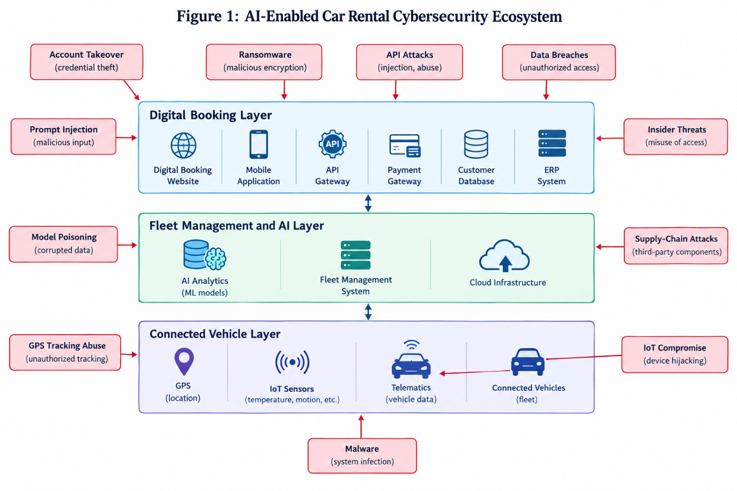
Fig 1: AI-Enabled Car Rental Cybersecurity Ecosystem

4. Problem Statement
4.1 Core Problem
The increasing adoption of artificial intelligence, cloud computing, IoT, ERP platforms, and connected-vehicle technologies provides substantial operational benefits for car-rental organizations. These technologies can improve booking efficiency, customer service, fleet utilization, predictive maintenance, and data-driven decision-making (Mohammed, 2026; Suaprae et al., 2026; Potdar & Parikh, 2025). However, these benefits also increase organizational dependence on interconnected digital infrastructure. The fundamental problem is therefore not simply that car-rental companies can be targeted by cyberattacks. Rather, the integration of AI, cloud systems, booking platforms, customer databases, IoT devices, telematics, and connected vehicles creates a distributed attack surface in which compromise of one component may affect multiple interconnected systems and operational processes.
4.2 Specific Security Problems
Five interconnected security problems are particularly significant. First, digital booking vulnerabilities can expose customer accounts, payment processes, and APIs to credential theft, unauthorized access, fraud, and data manipulation. Second, AI model vulnerabilities create risks involving prompt injection, data poisoning, sensitive-information disclosure, and excessive AI permissions (NIST, 2023; OWASP, 2025). Third, fleet-management vulnerabilities can arise from insecure IoT devices, cloud platforms, databases, GPS systems, and telematics used to monitor and optimize vehicles. Fourth, customer-data exposure creates privacy risks because rental systems may process identity, payment, booking, location, and vehicle-use information (Geronasso, 2026; Soundarya et al., 2025). Fifth, connected-vehicle vulnerabilities extend cybersecurity risks into vehicle communication networks and electronic systems. Broader cybersecurity evidence reinforces the scale of these challenges: Verizon's 2025 Data Breach Investigations Report analyzed more than 22,000 security incidents and 12,000 confirmed breaches, identifying credential abuse, vulnerability exploitation, third-party involvement, and social engineering among important breach-related patterns (Verizon, 2025).
4.3 Research Problem Gap
Although existing research provides important knowledge about automotive cybersecurity, AI security, IoT protection, smart tourism, and digital rental systems, these areas are often examined independently. This creates a research gap concerning the security of the integrated AI-enabled car-rental ecosystem. Consequently, cybersecurity research needs to move beyond isolated controls for individual applications and toward an integrated car-rental cybersecurity architecture capable of protecting booking systems, enterprise platforms, AI models, customer data, IoT infrastructure, fleet-management systems, and connected vehicles simultaneously. Such an approach should combine technical safeguards with privacy protection, AI governance, risk management, and human oversight.

5. Results
Because this study is based on a structured review and thematic synthesis rather than primary empirical data, the results presented in this section are interpreted as synthesized findings from the reviewed literature. The findings demonstrate that cybersecurity risks in AI-enabled car-rental systems are distributed across booking applications, enterprise infrastructure, AI services, fleet-management technologies, connected vehicles, and customer-data environments.
5.1 Finding 1: Digital Booking Is a High-Value Attack Surface
The synthesis indicates that digital booking systems represent a high-value attack surface because they combine customer accounts, authentication mechanisms, reservation databases, APIs, and payment processes within customer-facing applications. As car-rental organizations increasingly rely on online and mobile booking, attacks such as credential stuffing, account takeover, automated bot activity, API abuse, and fraudulent transactions can directly affect both customers and business operations. The integration of booking, customer management, and payment functions within digital rental platforms further increases the potential consequences of compromise (Suaprae et al., 2026). Therefore, digital booking should not be treated merely as a front-end application. It should be regarded simultaneously as a customer-facing service and critical business infrastructure, requiring controls such as multi-factor authentication, API security, bot detection, secure session management, encryption, and continuous monitoring.
5.2 Finding 2: AI Adds a New Layer of Cybersecurity Risk
The literature synthesis further indicates that AI introduces risks beyond conventional application and network vulnerabilities. AI-enabled rental systems may process customer requests, analyze operational information, generate recommendations, or interact with other enterprise systems. Consequently, prompt injection can manipulate AI behavior, poisoned data can influence model outputs, and excessive permissions can allow AI agents to perform unauthorized actions. Sensitive information may also be disclosed when AI systems have access to customer or operational databases. AI-generated errors or hallucinations can additionally produce incorrect recommendations or decisions when outputs are not appropriately validated (Shafik, 2026). The OWASP GenAI security guidance identifies prompt injection, sensitive-information disclosure, data and model poisoning, supply-chain vulnerabilities, and excessive agency as important AI application risks (OWASP, 2025). AI security must therefore incorporate model validation, access restrictions, monitoring, input/output controls, and human review.
5.3 Finding 3: Fleet Management Expands the Attack Surface
A third synthesized finding is that AI-enabled fleet management creates a continuous chain of technological dependencies: GPS → telematics → sensors → cloud infrastructure → fleet dashboard → AI decision system. Each component can generate or transmit information required for vehicle monitoring and operational decision-making. IoT and AI-based fleet-management research demonstrates the increasing integration of connected technologies for monitoring, optimization, and predictive functions (Mahor et al., 2023; Potdar & Parikh, 2025). However, compromise of these components could result in incorrect vehicle-status information, manipulated maintenance records, false location information, fleet disruption, unauthorized access, or operational downtime. Connected-vehicle cybersecurity research similarly emphasizes that increasing connectivity creates multiple communication and system interfaces requiring systematic threat assessment (Luo et al., 2021). Fleet cybersecurity must consequently protect both individual devices and the communication pathways linking them.
5.4 Finding 4: Customer Data Is Distributed Across the Ecosystem
The review also indicates that customer information is not confined to a single database. Depending on the architecture, data can be distributed across booking platforms, payment systems, ERP applications, mobile applications, CRM systems, cloud databases, GPS infrastructure, and connected-vehicle systems. This distribution increases the number of locations where sensitive information may be accessed, transferred, stored, or exposed. Smart-tourism literature similarly identifies privacy, security, and trust as important considerations in increasingly data-intensive tourism environments (Geronasso, 2026; Fatema et al., 2024; Soundarya et al., 2025). Connected rental vehicles introduce an additional privacy dimension because vehicle infotainment and connected systems may retain personal information, including location information and information synchronized from users' mobile devices, after a rental period ends (Federal Trade Commission, 2023). Data minimization, encryption, retention controls, access management, and secure deletion are therefore important throughout the rental lifecycle.
5.5 Finding 5: Security Must Be Lifecycle-Based
A further finding is that cybersecurity and AI governance should be incorporated throughout the technology lifecycle rather than introduced only after a system has been deployed. The NIST AI Risk Management Framework provides four core functions—Govern, Map, Measure, and Manage—for organizing AI risk management (NIST, 2023). Applied to car-rental systems, governance establishes responsibility and policies; mapping identifies the AI systems, data, users, dependencies, and potential risks; measurement evaluates security and trustworthiness; and management supports the prioritization and treatment of identified risks. This lifecycle perspective is particularly important because AI models, connected vehicles, software dependencies, and operational requirements can change over time. Similarly, automotive cybersecurity engineering emphasizes managing cybersecurity risks across the vehicle lifecycle rather than treating security as a one-time implementation activity (ISO, 2021).

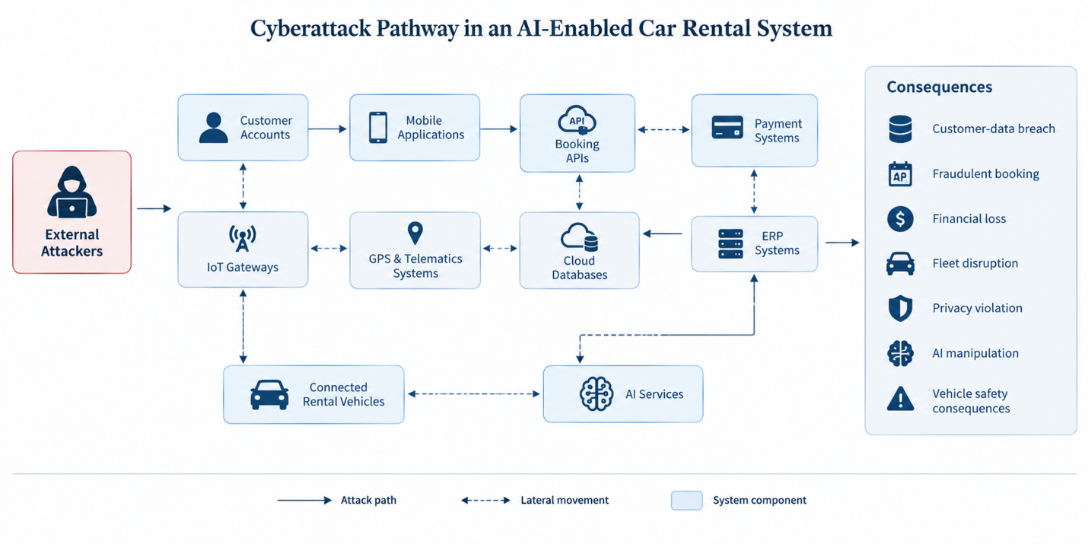
Fig 2: Cyberattack Pathway

5.6 Finding 6: Human Oversight Remains Necessary
Finally, the synthesized literature indicates that increased automation does not eliminate human responsibility. Employees, fleet managers, cybersecurity personnel, customer-service teams, system administrators, and AI operators remain important to the secure operation of rental ecosystems. Human personnel must interpret AI-generated alerts, investigate anomalies, manage access privileges, respond to incidents, and intervene when automated decisions produce uncertain or inappropriate outcomes. AI-supported fleet and maintenance systems may improve operational efficiency, but their outputs still require appropriate organizational interpretation and oversight (Potdar & Parikh, 2025; Shafik, 2026). Human oversight is therefore not an alternative to automation but a complementary security mechanism. Effective AI-enabled car-rental cybersecurity should combine automated detection and response with clearly defined human accountability, escalation procedures, staff training, and governance responsibilities.

Table 2. AI-Enabled Car Rental Attack Surface Matrix
Component | Data/Function | Threat | Consequence | Protection
Mobile app | Customer identity | Credential theft | Account takeover | MFA
Website | Booking | Bot/API attack | Fraud | WAF/API security
Payment gateway | Payment data | Payment fraud | Financial loss | Tokenization
ERP | Operational data | Privilege abuse | Business disruption | RBAC
AI chatbot | Customer interaction | Prompt injection | Data disclosure | AI guardrails
AI model | Predictions | Data/model poisoning | Incorrect decisions | Model monitoring
GPS | Location | Tracking abuse | Privacy loss | Encryption and access control
Telematics | Vehicle status | Data manipulation | Fleet disruption | Authentication and integrity monitoring
IoT sensors | Vehicle information | Device compromise | False data | Device authentication and security
Cloud | Centralized data | Misconfiguration | Mass data exposure | Cloud security controls
Connected vehicle | Vehicle systems | Remote attack | Safety/security risk | Network segmentation
Employee account | System access | Phishing | Unauthorized access | MFA and security training

Overall, the synthesized findings demonstrate that the cybersecurity problem is systemic rather than isolated. Digital booking, AI applications, enterprise systems, fleet technologies, customer data, and connected vehicles form an interconnected security environment. Protection therefore requires coordinated controls across technological layers, supported by lifecycle-based governance and continuous human oversight.

6. Limitations
6.1 Literature-Based Design
This study uses a structured literature review, thematic analysis, and cybersecurity threat mapping rather than empirical testing of an operational car-rental platform. Consequently, the identified threats and controls represent a synthesis and analytical interpretation of existing evidence, rather than direct measurements of vulnerability frequency, attack success rates, or security performance within a specific commercial rental system.
6.2 Data Availability
Detailed cybersecurity information from commercial car-rental companies is often not publicly available. Organizations may not disclose complete information concerning security incidents, system architectures, AI configurations, vulnerabilities, third-party dependencies, or internal cybersecurity assessments. This limits the extent to which publicly available literature can represent the full security conditions of individual rental operators.
6.3 Rapid Technological Change
AI technologies, connected-vehicle architectures, cybersecurity threats, regulatory requirements, and digital rental platforms are developing rapidly. New AI capabilities and attack techniques may therefore emerge after the literature examined in this study. Similarly, cybersecurity standards and regulatory requirements can change as technologies mature. Consequently, some technical recommendations presented in this study may require periodic reassessment and updating.
6.4 Generalizability
The findings should not be assumed to apply uniformly across all car-rental organizations. Security requirements may differ according to organizational size, technological maturity, business model, and regulatory environment. Multinational rental companies, independent operators, peer-to-peer platforms, and organizations operating under different national regulatory frameworks may therefore face different cybersecurity conditions and risk profiles.
6.5 Citation and Evidence Limitations
The study distinguishes between documented evidence, analytical interpretation, the proposed cybersecurity framework, and recommendations for future research. Sources are used to support documented claims, while interpretations are explicitly presented as findings from the literature synthesis. Similarly, proposed security mechanisms are presented as analytical recommendations rather than empirically validated solutions unless supporting evidence demonstrates their effectiveness. This distinction is necessary to maintain methodological transparency and avoid overstating conclusions derived from a literature-based design.

7. Discussion
7.1 Interpreting the Integrated Risk
The synthesized findings indicate that cybersecurity in AI-enabled car-rental systems is fundamentally systemic rather than confined to individual applications. The different components of the rental ecosystem are interconnected through data, APIs, cloud infrastructure, enterprise platforms, and communication networks. Consequently, compromise of one component may create security consequences beyond the initially targeted system. For example, compromise of a booking platform could expose customer accounts, reservation information, payment details, and identity information. Similarly, compromise of a fleet-management platform could expose GPS information, vehicle status, maintenance records, and operational schedules. An attack affecting the AI layer could potentially influence recommendations, automated decisions, customer interactions, or operational workflows. This interconnectedness does not mean that compromise of one component will necessarily compromise every connected system; rather, it demonstrates why security architecture must account for dependencies between components. The finding extends the concerns identified in connected-vehicle cybersecurity research to the specific operational context of car rental (Luo et al., 2021; Abreu et al., 2025).
7.2 Digital Transformation Creates a Security Paradox
An important implication of the findings is a digital-transformation security paradox: the same integration that makes car-rental services smarter and more efficient can also create additional dependencies and attack surfaces that require protection. AI-supported booking, centralized ERP platforms, IoT-enabled fleet monitoring, cloud services, and connected vehicles allow organizations to coordinate information more effectively (Suaprae et al., 2026; Potdar & Parikh, 2025). However, greater connectivity means that security failures must be considered across system boundaries rather than within individual applications. This should not be interpreted as evidence that digitalization inherently causes cybersecurity breaches. Instead, digital transformation changes the structure of dependencies and consequently changes the way cybersecurity risks must be managed. The security objective is therefore not to reduce integration but to ensure that integration is accompanied by appropriate authentication, segmentation, monitoring, governance, and resilience mechanisms.
7.3 Comparison with Existing Automotive Cybersecurity Research
The findings are consistent with established automotive cybersecurity research emphasizing the complexity created by connected vehicles. Luo et al. (2021) demonstrate the importance of systematic cybersecurity analysis in connected and autonomous vehicle environments, where vehicles incorporate internal networks, communication technologies, sensors, and external services. Similarly, Abreu et al. (2025) identify major research themes in connected and autonomous-vehicle cybersecurity, including authentication, blockchain, intrusion detection, V2X security, and security operations, while highlighting the continuing need for stronger real-world validation. The present study extends these concerns into the rental-business context. Unlike research focused primarily on the vehicle itself, an AI-enabled rental ecosystem begins before the vehicle is collected and continues after it is returned. Booking platforms, payment systems, customer databases, fleet-management applications, telematics, and connected vehicles collectively form the security environment. The rental organization therefore represents an important intermediate context linking automotive cybersecurity with enterprise and consumer cybersecurity.
7.4 Comparison with Smart Tourism Research
The findings also complement research on cybersecurity and privacy in smart tourism. Smart-tourism literature identifies privacy, security, trust, and technology acceptance as important considerations in digitally mediated tourism services (Gong & Schroeder; Tiwari et al.; Fatema et al., 2024; Soundarya et al., 2025). The car-rental context introduces an additional dimension because customers interact simultaneously with digital services and a physical connected vehicle. A customer may provide personal information during booking, make a digital payment, interact with an AI-enabled service, and subsequently operate a vehicle equipped with GPS, telematics, sensors, or connected infotainment systems. This creates a broader data and cybersecurity environment than that associated with a conventional online tourism transaction. The implication is that privacy protection should extend beyond websites and booking databases to the entire customer journey, including vehicle use, data transfer, retention, and post-rental data deletion.
7.5 AI Security Requires More Than Traditional Cybersecurity
The findings further demonstrate that conventional cybersecurity controls, although necessary, are insufficient on their own for AI-enabled rental ecosystems. Firewalls, antivirus software, encryption, access control, and network monitoring remain important defensive measures, but AI systems introduce additional concerns involving model behavior, training and retrieval data, inputs, outputs, permissions, and model integrity. Prompt injection, data poisoning, sensitive-information disclosure, excessive agency, and other AI-specific risks require controls designed around the AI lifecycle (OWASP, 2025; NIST, 2023). Consequently, AI-enabled rental systems require model validation, adversarial testing, data lineage and integrity controls, prompt-injection protection, access restrictions, model monitoring, output validation, and human oversight. NIST's AI RMF reinforces this lifecycle perspective through its Govern, Map, Measure, and Manage functions, indicating that AI risk management should continue throughout system development and deployment rather than occur as a single security checkpoint (NIST, 2023). AI security should therefore complement rather than replace conventional cybersecurity.
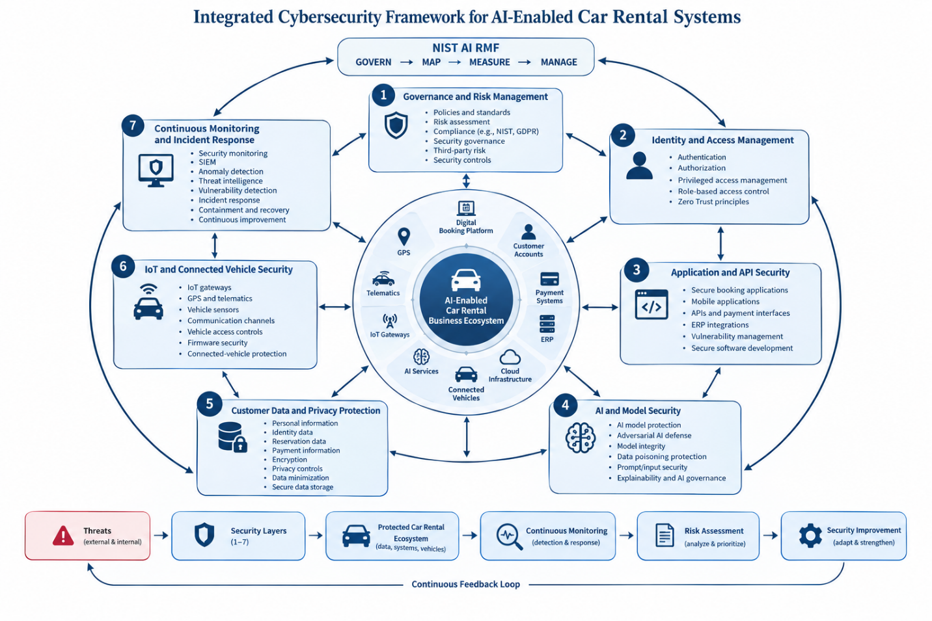
Fig 3: Integrated Cybersecurity Framework

7.6 Proposed Integrated Security Framework
Based on the synthesized findings, this study proposes a seven-layer cybersecurity framework for AI-enabled car-rental ecosystems. The framework is a conceptual synthesis derived from the literature and established cybersecurity guidance; it is not presented as empirically validated.
Layer 1 — Governance establishes AI governance, cybersecurity policies, data-governance requirements, risk-management procedures, and third-party/vendor controls. This layer determines organizational accountability and ensures that security requirements are incorporated into technology acquisition and deployment.
Layer 2 — Identity protects users, employees, administrators, applications, and devices through multi-factor authentication, role-based access control, least privilege, and privileged-access management.
Layer 3 — Application protects booking websites, mobile applications, APIs, and enterprise applications through secure development, input validation, web application firewalls, API security, vulnerability assessment, and penetration testing.
Layer 4 — AI addresses model-specific risks through model validation, prompt-injection protection, adversarial testing, model monitoring, output validation, and appropriate explainability and human-review mechanisms.
Layer 5 — Data protects customer and operational information through encryption, tokenization, data minimization, controlled retention, access monitoring, and secure deletion.
Layer 6 — Vehicle/IoT protects connected vehicles, sensors, telematics, and other devices through device authentication, network segmentation, secure firmware, intrusion detection, and secure over-the-air software updates.
Layer 7 — Monitoring provides continuous visibility through security information and event management (SIEM), security operations centre (SOC) capabilities, anomaly detection, incident response, and continuous security monitoring.
The framework reflects the central finding that no individual security control can adequately protect an ecosystem spanning digital booking, AI, enterprise infrastructure, customer data, IoT, and connected vehicles. Instead, protection should operate across multiple layers, with governance and monitoring extending throughout the technology lifecycle.

Table 3. Proposed Cybersecurity Control Framework
Risk Area | Preventive Control | Detective Control | Response
Account takeover | MFA | Login-anomaly detection | Account lockdown
API attack | Authentication and rate limiting | API monitoring | API isolation
Data breach | Encryption | Data-loss-prevention monitoring | Breach response
AI prompt injection | Input filtering and guardrails | AI-behavior monitoring | Block/review request
Model poisoning | Trusted datasets and data validation | Model-drift monitoring | Retrain/revalidate
Insider threat | Least privilege | Audit logging | Audit logging
IoT attack | Device authentication | Intrusion detection | Device isolation
Vehicle attack | Network segmentation | Vehicle intrusion detection | Safe-state response
Ransomware | Backups and network segmentation | Endpoint monitoring | System recovery
Third-party breach | Vendor security assessment | Continuous monitoring | Supplier isolation
Privacy violation | Data minimization | Data-access logging | Data deletion/remediation

Taken together, the discussion supports a shift from application-specific cybersecurity toward ecosystem-level cybersecurity. This is particularly important because AI-enabled car rental combines characteristics of e-commerce, enterprise information systems, smart tourism, IoT, and connected-vehicle environments. The proposed framework consequently treats cybersecurity as a continuous organizational responsibility involving technology, data, AI, vehicles, third parties, and human decision-makers.

8. Conclusion
8.1 Summary of Findings
This study examined cybersecurity challenges emerging from the increasing integration of artificial intelligence, digital platforms, cloud services, IoT, and connected vehicles within car-rental operations. The analysis indicates that AI is transforming car-rental services by supporting booking, customer interaction, demand prediction, verification, fleet optimization, and predictive maintenance (Mohammed, 2026; Suaprae et al., 2026; Potdar & Parikh, 2025). However, these capabilities also expand the cybersecurity environment. Digital booking systems create application, API, authentication, and identity-related risks, while integrated fleet-management platforms introduce vulnerabilities involving IoT devices, GPS, telematics, and cloud infrastructures. Connected vehicles further extend cybersecurity into the cyber-physical domain, where digital compromise may affect vehicle operations and safety. AI introduces additional risks involving model manipulation, prompt injection, data poisoning, excessive system permissions, and sensitive-information disclosure. At the same time, the extensive collection and movement of customer, payment, identity, booking, and location data create significant privacy and compliance requirements. Consequently, cybersecurity must address the entire interconnected rental ecosystem rather than individual technologies in isolation.
8.2 Theoretical Contribution
The principal theoretical contribution of this study is an integrated perspective connecting AI cybersecurity, automotive cybersecurity, smart tourism, and digital car-rental systems. Rather than treating booking platforms, fleet-management systems, connected vehicles, customer databases, and AI applications as independent technological components, the study conceptualizes the car-rental ecosystem as a connected cybersecurity environment. This perspective provides a basis for understanding how vulnerabilities in one component can create security consequences across interconnected business, digital, and cyber-physical systems.
8.3 Practical Implications
For car-rental organizations, the findings indicate that cybersecurity should be incorporated into technology deployment and operational management rather than treated solely as an IT function. Organizations should implement multi-factor authentication (MFA), apply zero-trust principles, encrypt sensitive information, strengthen API authentication and authorization, and segment IoT, telematics, and vehicle networks. AI systems should undergo security testing, model validation, continuous monitoring, and controlled access. Secure over-the-air (OTA) update mechanisms should protect connected vehicles throughout their operational lifecycle. Organizations should also establish tested incident-response and recovery procedures and continuously train employees against phishing, credential theft, social engineering, and other human-centered threats. NIST Cybersecurity Framework (CSF) 2.0 can provide an organizational cybersecurity structure, while the NIST AI Risk Management Framework (AI RMF) can support the identification, measurement, management, and governance of AI-related risks.
8.4 Future Research
Future research should move beyond literature-based analysis toward empirical examination of cybersecurity within operational car-rental environments. Studies could investigate commercial digital rental platforms, AI-powered booking agents, vehicle telematics, rental-company security operations centers (SOCs), customer perceptions of privacy, AI attack simulations, penetration testing, ransomware resilience, AI-driven intrusion detection, and secure digital identity mechanisms. Research should also examine how cybersecurity controls perform under realistic multi-stage attacks involving booking systems, enterprise platforms, cloud infrastructure, and connected vehicles. A particularly valuable direction would be a penetration-testing experiment comparing traditional and AI-enabled car-rental architectures, allowing researchers to identify differences in attack surfaces, vulnerabilities, detection capabilities, and recovery requirements.
8.5 Final Conclusion
The future of car rental is not simply about making booking and fleet operations more intelligent. It is about making those intelligent systems trustworthy, resilient, privacy-preserving, and secure throughout their entire lifecycle. AI-enabled transformation can deliver substantial operational and customer benefits, but these benefits depend on cybersecurity being embedded across applications, data, AI models, IoT infrastructure, connected vehicles, and organizational processes.

Reference
- Mohammed, Salami Abdul. "How the US Car Rental Industry Talks About Innovation: A Multi-Source Media Analysis of AI-Enabled Service Transformation." International Journal of Research and Innovation in Social Science 10.5 (2026): 3119-3125.
- Suaprae, Phanintorn, et al. "Design and Implementation of an ERP-Based Smart Car Rental Management System for Digital Tourism Platforms." 2026 IEEE International Conference on Cybernetics and Innovations (ICCI). IEEE, 2026.
- Geronasso, Mahala. "Traveling on blockchain: rethinking trust and transformation in hospitality and tourism." Journal of Hospitality and Tourism Horizons (2026): 1-17.
- Shafik, Wasswa. "AI-Enabled Claims Management: Automation, Fairness, and Human-AI." Ethical Artificial Intelligence in the Insurance Industry: Balancing Efficiency, Fairness, and Risk (2026).
- Fatema, Kaniz, et al. "Technological advancements and innovations in the tourism industry: driving sustainable tourism." (2024).
- Mahor, Vinod, et al. "IoT and artificial intelligence techniques for public safety and security." Smart urban computing applications. River Publishers, 2023. 111-126.
- Talukder, Mohammad Badruddoza, and Kamarun Muhsina. "AI assistants for tour and travel operation." Generating entrepreneurial ideas with AI. IGI Global Scientific Publishing, 2024. 292-320.
- Soundarya, M., et al. "Artificial intelligence in tourism." Advancing smart tourism through analytics. IGI Global Scientific Publishing, 2025. 41-64.
- Potdar, Prathamesh R., and Swapnil M. Parikh. "Internet of things (IoT) and artificial intelligence (AI) enabled framework for smart fleet management." OPSEARCH (2025): 1-33.
- Moharrak, Moayad, Nguyen Phong Nguyen, and Emmanuel Mogaji. "Business environment and adoption of AI: Navigation for internationalization by new ventures in emerging markets." Thunderbird International Business Review 66.4 (2024): 355-372.

