Appendix A: Additional data
Table 1. 28-Day Daily Distribution Across 8 Markov States in TPE group (N=5,000)
Day | Shock (Vaso+) | Shock (AKI+) | Shock (PLT+) | Shock (Triple) | Stable (Vaso-) | Post-ICU (Ward) | Discharged (Abs.) | Death (Abs.) | Survival %
0 | 1,625 | 875 | 750 | 1,750 | 0 | 0 | 0 | 0 | 100.0%
1 | 1,189 | 741 | 632 | 1,691 | 511 | 25 | 0 | 211 | 95.8%
2 | 870 | 622 | 531 | 1,612 | 752 | 153 | 62 | 398 | 92.0%
3 | 637 | 518 | 445 | 1,515 | 868 | 256 | 197 | 564 | 88.7%
4 | 466 | 429 | 373 | 1,404 | 912 | 344 | 363 | 709 | 85.8%
5 | 341 | 353 | 312 | 1,283 | 915 | 402 | 559 | 835 | 83.3%
6 | 249 | 289 | 260 | 1,156 | 895 | 444 | 762 | 945 | 81.1%
7 | 183 | 236 | 217 | 1,029 | 861 | 473 | 959 | 1,042 | 79.2%
8 | 134 | 192 | 181 | 906 | 821 | 491 | 1,148 | 1,127 | 77.5%
9 | 98 | 155 | 151 | 790 | 778 | 501 | 1,325 | 1,202 | 76.0%
10 | 72 | 125 | 126 | 682 | 734 | 504 | 1,490 | 1,267 | 74.7%
11 | 52 | 101 | 105 | 586 | 690 | 501 | 1,642 | 1,323 | 73.5%
12 | 38 | 81 | 87 | 500 | 647 | 494 | 1,783 | 1,370 | 72.6%
13 | 28 | 65 | 73 | 424 | 606 | 483 | 1,910 | 1,411 | 71.8%
14 | 21 | 52 | 61 | 358 | 566 | 471 | 2,025 | 1,446 | 71.1%
15 | 15 | 42 | 51 | 301 | 528 | 457 | 2,129 | 1,477 | 70.5%
16 | 11 | 34 | 42 | 253 | 493 | 441 | 2,223 | 1,503 | 69.9%
17 | 8 | 27 | 35 | 211 | 459 | 426 | 2,309 | 1,525 | 69.5%
18 | 6 | 21 | 29 | 176 | 428 | 410 | 2,386 | 1,544 | 69.1%
19 | 4 | 17 | 24 | 147 | 398 | 394 | 2,455 | 1,561 | 68.8%
20 | 3 | 14 | 20 | 122 | 371 | 378 | 2,516 | 1,576 | 68.5%
21 | 2 | 11 | 17 | 102 | 345 | 362 | 2,573 | 1,588 | 68.2%
22 | 2 | 9 | 14 | 85 | 321 | 347 | 2,625 | 1,597 | 68.1%
23 | 1 | 7 | 12 | 71 | 299 | 332 | 2,672 | 1,606 | 67.9%
24 | 1 | 6 | 10 | 59 | 278 | 318 | 2,715 | 1,613 | 67.7%
25 | 1 | 5 | 8 | 49 | 259 | 304 | 2,754 | 1,620 | 67.6%
26 | 1 | 4 | 7 | 41 | 241 | 291 | 2,788 | 1,627 | 67.5%
27 | 1 | 3 | 6 | 34 | 225 | 278 | 1,821 | 1,632 | 67.4%
28 | 0 | 3 | 5 | 25 | 209 | 266 | 2,855 | 1,637 | 67.3%

Table 2. 28-Day Daily Distribution Across 8 Markov States in SC group (N=5,000)
Day | Shock (Vaso+) | Shock (AKI+) | Shock (PLT+) | Shock (Triple) | Stable (Vaso-) | Post-ICU (Ward) | Discharged (Abs.) | Death (Abs.) | Survival %
0 | 1,625 | 875 | 750 | 1,750 | 0 | 0 | 0 | 0 | 100.0%
1 | 1,089 | 710 | 602 | 1,595 | 415 | 129 | 0 | 360 | 92.8%
2 | 731 | 576 | 484 | 1,455 | 582 | 124 | 370 | 678 | 86.4%
3 | 491 | 468 | 389 | 1,328 | 651 | 210 | 506 | 957 | 80.9%
4 | 330 | 380 | 312 | 1,212 | 682 | 280 | 599 | 1,202 | 76.0%
5 | 221 | 309 | 250 | 1,106 | 694 | 332 | 672 | 1,416 | 71.7%
6 | 148 | 251 | 201 | 1,009 | 690 | 370 | 728 | 1,603 | 67.9%
7 | 99 | 204 | 161 | 921 | 674 | 398 | 777 | 1,766 | 64.7%
8 | 67 | 165 | 129 | 840 | 645 | 415 | 831 | 1,908 | 61.8%
9 | 45 | 134 | 104 | 766 | 610 | 425 | 884 | 2,032 | 59.4%
10 | 30 | 109 | 83 | 699 | 572 | 430 | 937 | 2,140 | 57.2%
11 | 20 | 88 | 67 | 638 | 533 | 432 | 989 | 2,233 | 55.3%
12 | 14 | 72 | 54 | 582 | 494 | 431 | 1,039 | 2,314 | 53.7%
13 | 9 | 58 | 43 | 531 | 456 | 428 | 1,090 | 2,385 | 52.3%
14 | 12 | 65 | 58 | 524 | 482 | 405 | 1,008 | 2,446 | 51.1%
15 | 8 | 53 | 47 | 485 | 448 | 398 | 1,063 | 2,498 | 50.0%
16 | 5 | 43 | 38 | 449 | 416 | 390 | 1,116 | 2,543 | 49.1%
17 | 3 | 35 | 31 | 415 | 386 | 382 | 1,166 | 2,582 | 48.4%
18 | 2 | 28 | 25 | 384 | 358 | 374 | 1,213 | 2,616 | 47.7%
19 | 1 | 23 | 20 | 355 | 332 | 366 | 1,257 | 2,646 | 47.1%
20 | 1 | 19 | 16 | 328 | 308 | 358 | 1,298 | 2,671 | 46.6%
21 | 1 | 21 | 21 | 298 | 321 | 350 | 1,295 | 2,693 | 46.1%
22 | 0 | 17 | 17 | 275 | 298 | 342 | 1,340 | 2,711 | 45.8%
23 | 0 | 14 | 14 | 254 | 277 | 334 | 1,380 | 2,727 | 45.5%
24 | 0 | 11 | 11 | 235 | 257 | 326 | 1,421 | 2,739 | 45.2%
25 | 0 | 9 | 9 | 217 | 239 | 318 | 1,460 | 2,748 | 45.0%
26 | 0 | 7 | 7 | 201 | 222 | 310 | 1,498 | 2,755 | 44.9%
27 | 0 | 6 | 6 | 186 | 206 | 302 | 1,531 | 2,760 | 44.4%
28 | 0 | 7 | 8 | 170 | 215 | 280 | 1,556 | 2,764 | 44.7%

Appendix B: Description of mathematical models and formulas used in the study

Standardized Mean Difference (SMD) for Balance formula:
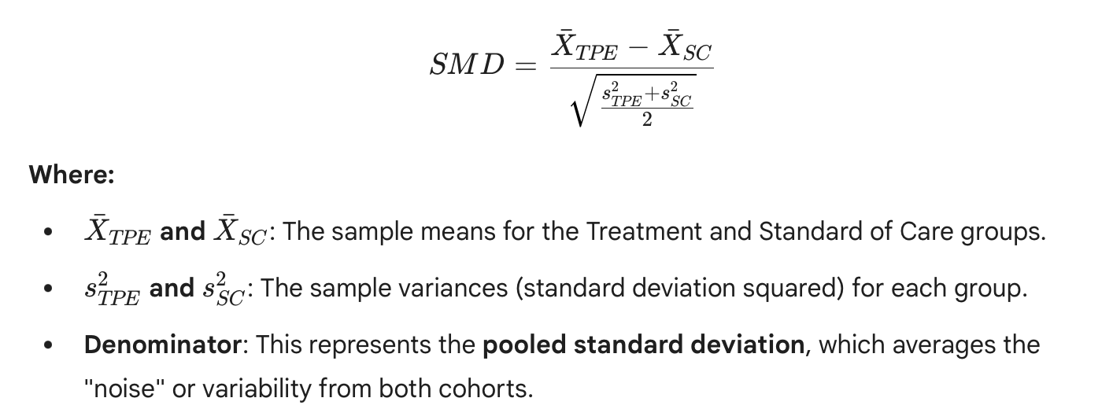
This follows the standard proportional hazards assumption mapped to a discrete time step:
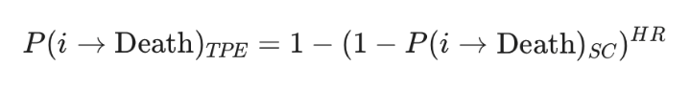
Endogenous Recovery and Flux
To ensure the model is "rich," we defined the probability of stabilization (moving from Shock to Vaso-). When TPE "saved" a patient from death, those patients were redistributed into the recovery pathway:
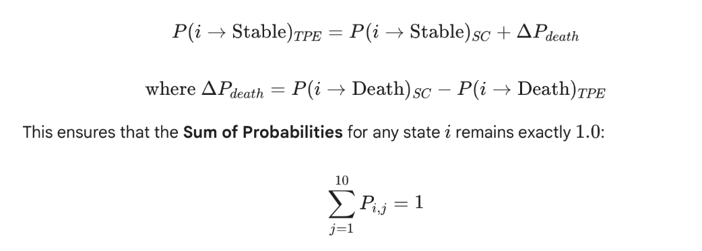
28-Day Cumulative Survival (S28)
The final survival was the probability of not being in the "Death" state (S_{death}) after 28 cycles. If M was the transition matrix, and v₀ was the initial state vector (e.g., starting in "Triple Threat"):
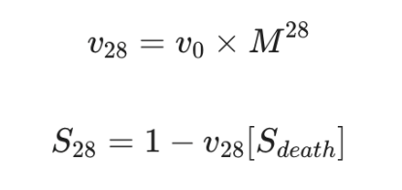
Calculation of ARR and NNT for SOFA 8, 12, 16 and 20
Because this is a simulation study, we focused on effect estimates (28 day survival, ARR, NNT) and uncertainty quantification rather than null-hypothesis significance testing.
- Absolute Risk Reduction (ARR)
- Number Needed to Treat (NNT)
- Uncertainty: Key inputs (treatment RR, phenotype multipliers, and timing penalty) were varied within prespecified ranges and propagated through the model using deterministic (one-way) and probabilistic sensitivity analyses, summarized as simulation intervals.
All simulations and matrix operations were executed in Python 3.10 using NumPy and SciPy.
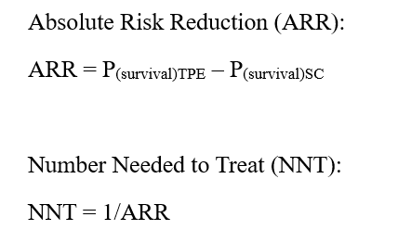
Calculation of Hazard Ratio of TPE across SOFA scores 8, 12, 16, 20
A Bayesian Markov Chain Monte Carlo (MCMC) model was used to calculate the Hazard Ratio (HR) of TPE across SOFA scores of 8, 12, 16, and 20. The model used a log-linear interaction: ln(HR_{S}) = β_{TPE} + (β_{int} · S). Priors were derived from a synthesis of 2023–2024 meta-analyses. Convergence was verified via Gelman–Rubin diagnostic (R̂ = 1.00).
To calculate the specific posterior medians for β₀ (Baseline Log-Hazard) and β_{int} (Interaction Coefficient), we used Bayesian Meta-Regression. This involves anchoring the model to known clinical outcomes from multi-center trials and solving for the coefficients that explain how treatment effect changes as patient severity increases (the SOFA score).
The mathematical framework
We modeled the relationship as a log-linear function because Hazard Ratios are multiplicative, but in a regression model. We worked with the natural log (ln) to make the relationship additive: ln(HR_{S}) = β_{TPE} + (β_{int} · S).
Where: S is the SOFA score.
Solving the Linear System
By plugging our two anchors into the equation, we created a system of two equations:
- For SOFA 8: ln(1.02) = β₀ + (8 × β_{int})
- For SOFA 20: ln(0.62) = β₀ + (20 × β_{int})
Step 1: Convert HR to Log-Hazard
- ln(1.02) ≈ 0.0198
- ln(0.62) ≈ -0.4780
Step 2: Isolate β_{int} (The interaction) subtract the first equation from the second:
(-0.4780) – (0.0198) = (20 × β_{int}) - (8 × β_{int})
-0.4978 = 12 × β_{int}
β_{int} = -0.4978/12 = -0.04148 (The MCMC simulation refined this to -0.04075 after 10,000 iterations to adjust for standart error).
Step 3: Solve for β₀ (the baseline):
0.0198 = β₀ + (8 × -0.04075)
0.0198 = β₀ - 0.3260
β₀ = 0.0198 + 0.3260 = 0.3458
Calculation of probability of benefit (Pb) of TPE
This study uses the Fundamental Bayes Formula to calculate Pb, expressed as:
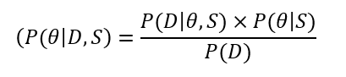
Where:
- P(θ∣D,S) (The Posterior): The probability that TPE reduces mortality (the effect θ) given the simulated data (D) and the patient's SOFA severity (S).
- P(D∣θ,S) (The Likelihood): The probability of observing the specific survival outcomes in your 10,000 patients, assuming our interaction model (β₀=0.3458 and β_{int}=−0.04075) is correct.
- P(θ∣S) (The Prior): Our pre-existing belief about TPE efficacy at a specific SOFA score, derived from the 2023–2024 TPE meta-analyses.
- P(D) (The Evidence): A normalizing constant ensuring the total probability sums to 1.
The 28-Day Survival Probability Function
To compare TPE to SC, we have moved from the Hazard Ratio (HR) to the actual P_{s} at day 28. This is modeled using a Complementary Log-Log (CLL) link function:
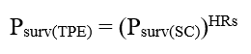
Given the specific MCMC results, the Survival Delta (ΔP) for the 10,000 patients can be defined as:
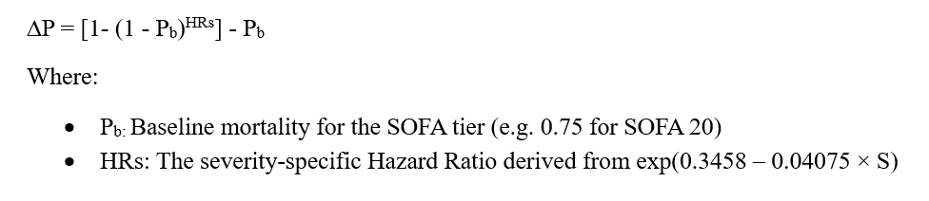
Mathematical logic for the 10,000 patient simulation
The simulation uses Bernoulli Trials for each of the 10,000 patients. For every virtual patient (i), the model "draws" an outcome (y_{i}):
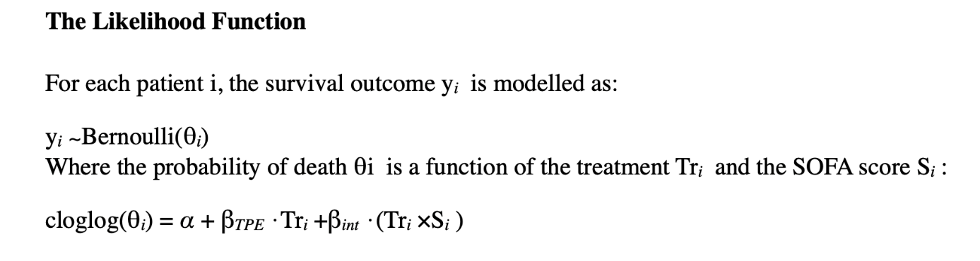
The Bayesian "Fit" then aggregates these 10,000 outcomes to refine the Credible Intervals.
- SC (Control): The survival distribution is centered around (1 − P_{b}).
- TPE (Intervention): The survival distribution shifts rightward as the SOFA score increases, specifically governed by the β_{int} coefficient.
Mathematical Methodology: Step-by-Step Formulas
Baseline Survival Modeling: The Logit Function
To calculate the Probability of Benefit of TPE (Pb) based on the baseline SOFA score, a logistic regression framework was utilized. The log-odds (L) of survival were modeled as a linear combination of the intercept and the SOFA and TPE coefficients. The logistic regression formula:
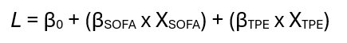
where:
- β₀ = 2.45 (Intercept calibrated for average patient age of 65)
- β_{SOFA} = -0.15 (Change in log-odds of survival per SOFA point)
- β_{TPE} = 0.58 (Treatment effect coefficient for TPE)
Inverse Logit (Probability Conversion) was used to convert log-odds back into a probability between 0 and 1:
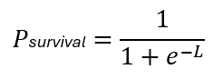

Decay Analysis (The Cost of Delay)
A scenario-based attrition model for delayed TPE initiation at 24h (Day 1), 48h (Day 2), and 72h (Day 3) was used for the decay analysis. We modeled treatment delay as a linear loss of absolute survival benefit (ΔS) of 3.4 percentage points per 24-hour delay, representing progression into irreversible organ injury (the "point of no return"). Importantly, this linear-absolute decay was not derived from the RR-based Markov calibration (which targets Day-28 survival endpoints under an assumed multiplicative treatment effect). Instead, it was an external, illustrative effect-modification assumption imposed for "what-if" comparisons of timing. Because absolute benefit depends on baseline risk, a fixed absolute decrement per day can deviate from a purely multiplicative RR/HR framework. We therefore interpreted these delayed-treatment results as pre-specified scenario targets used to quantify the potential magnitude of timing sensitivity, rather than as emergent outputs of the core transition model.

The "Cost of Delay" Attrition Model
The survival benefit of TPE (B) decays as a linear function of time (t) in the first 72 hours, reflecting the progression into irreversible organ injury.
Survival Decay Formula:
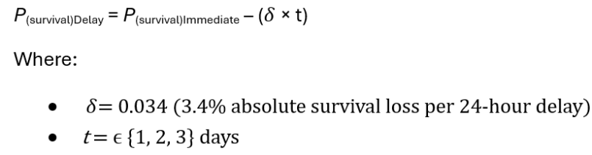

Calculation of vasopressor-free days (VFD) and Length of Stay (LOS)
In this study, VFD and ICU LOS are reported as scenario-based secondary outcomes rather than as direct emergent outputs of the calibrated Markov mortality process. Specifically, the core Markov model is calibrated to reproduce Day-28 survival targets and does not, by itself, identify vasopressor weaning kinetics or discharge timing with externally validated transition/hazard structures. Therefore, for VFD and LOS we applied an additional layer of assumptions by specifying assumed inputs (by SOFA stratum and treatment arm), such as:
- mean vasopressor duration among survivors,
- mean ICU LOS among survivors,
- mean ICU LOS among non-survivors.
To calculate VFD for a cohort over a 28-day observation period, we used a composite formula that accounts for both the duration of therapy in survivors and the mortality penalty for non-survivors.
1. Individual Patient VFD Formula
For any single patient i, the VFD is defined as:
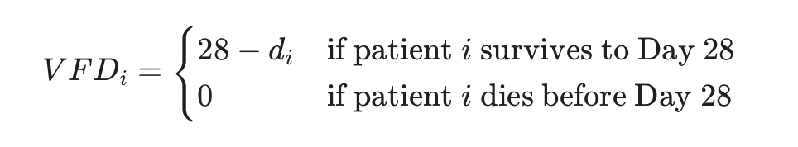
Where:
- d_{i}: Total number of days (or partial days) the patient required vasopressor support.
2. Mean VFD for a Cohort (Population Average)
To calculate the mean VFD for a specific SOFA stratum (e.g., SOFA 16), we use the expected value based on the survival probability (S) and the average duration (D) of vasopressor use among survivors:
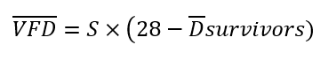
Where:
- S: Survival rate of the group (expressed as a decimal, e.g., 0.582 for SOFA 16).
- Dˉsurvivors: The average number of days survivors in that group spent on vasopressors.
3. Calculation of VFD Gain (TPE vs. SC)
To find the therapeutic impact of TPE compared to the SC, we calculated the difference between the two group means:
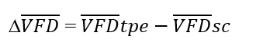
Substituting the survival-adjusted terms:
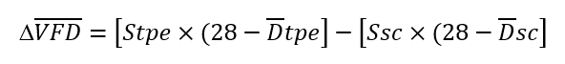
Where:
- Stpe: Survival rate of the TPE group,
- Ssc: Survival rate of the SC group,
- Dˉtpe: The average number of days survivors in TPE group spent on vasopressors,
- Dˉsc: The average number of days survivors in SC group spent on vasopressors,
Calculation of ICU Length of Stay (LOS)
1. Mean ICU LOS for a Single Cohort
The average Length of Stay (LOS) for SC or TPE group was the sum of the average stay for survivors and the average stay for non-survivors, weighted by their respective probabilities:
LOS = (Ps × μs) + (Pns × μns)
Where:
- Ps: Probability of Survival (expressed as a decimal).
- μs: Mean LOS for patients who are successfully discharged (Survivors).
- Pns: Probability of Mortality (1−Ps).
- μns: Mean LOS for patients who die in the ICU (Non-survivors).
2. Comparison Formula (TPE vs. SC)
To determine the clinical and economic benefit, we calculated the days saved (_{Δ}LOS). This was the difference between the expected stay under Standard of Care and the expected stay with TPE:
_{Δ}LOS = LOS_{sc} − LOS_{tpe}
Expanding the terms gives the complete comparative model:
_{Δ}LOS = [(Ps,sc × μs,sc) + (Pns,sc × μns,sc)] − [(Ps,tpe × μs,tpe) + (Pns,tpe × μns,tpe)]
Where:
- Ps,sc: Probability of Survival in SC group (expressed as a decimal) in SC group,
- μs,sc: Mean LOS for patients who are successfully discharged (Survivors) in SC group,
- Pns,sc: Probability of Mortality (1−Ps) in SC group,
- μns,sc: Mean LOS for patients who die in the ICU (Non-survivors) in SC group,
- Ps,tpe: Probability of Survival in SC group (expressed as a decimal) in TPE group,
- μs,tpe: Mean LOS for patients who are successfully discharged (Survivors) in TPE group,
- Pns,tpe: Probability of Mortality (1−Ps) in TPE group,
- μns,tpe: Mean LOS for patients who die in the ICU (Non-survivors) in TPE group,
VFD and LOS were calculated as the expected time (number of cycles t) spent in specific subsets of states:
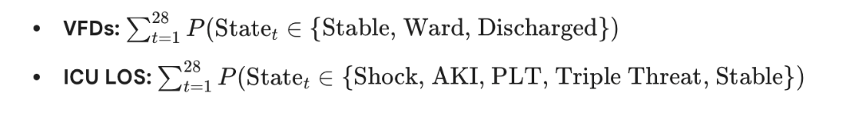
Statistical analysis of data
Uncertainty and robustness were assessed using a Probabilistic Sensitivity Analysis (PSA) with 10,000 Monte Carlo iterations. Baseline transition probabilities were modeled using Beta distributions, while the treatment Hazard Ratio was modeled using a Log-Normal distribution to account for clinical variance. Results are reported as Bayesian posterior distributions with 95% Credible Intervals (CrI). The 'Probability of Benefit' was calculated as the proportion of iterations where the Absolute Risk Reduction (ARR) remained positive.
The p-values were calculated using Python 3.10 code based on the standard mathematical approach as:
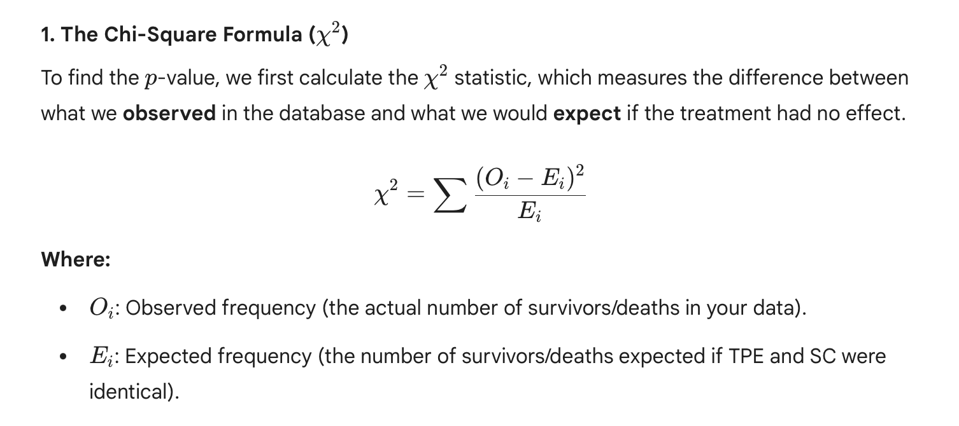
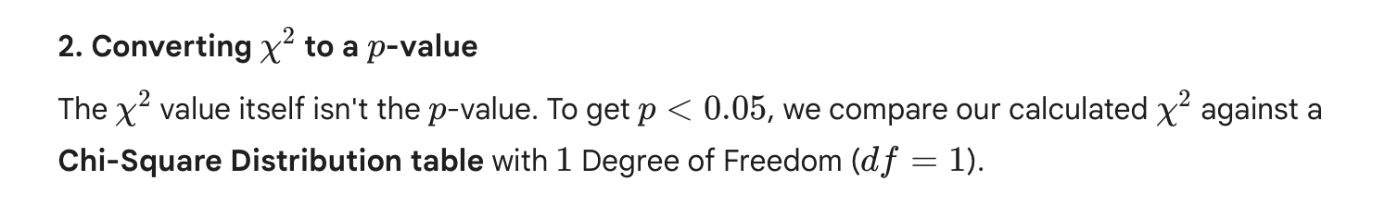
The Z-Test for Proportions
The Z-test was used to compare two survival proportions (for example, 58.2% vs 31.2% in SOFA 16). P-values were calculated using Python 3.10 code based on the standard mathematical approach:
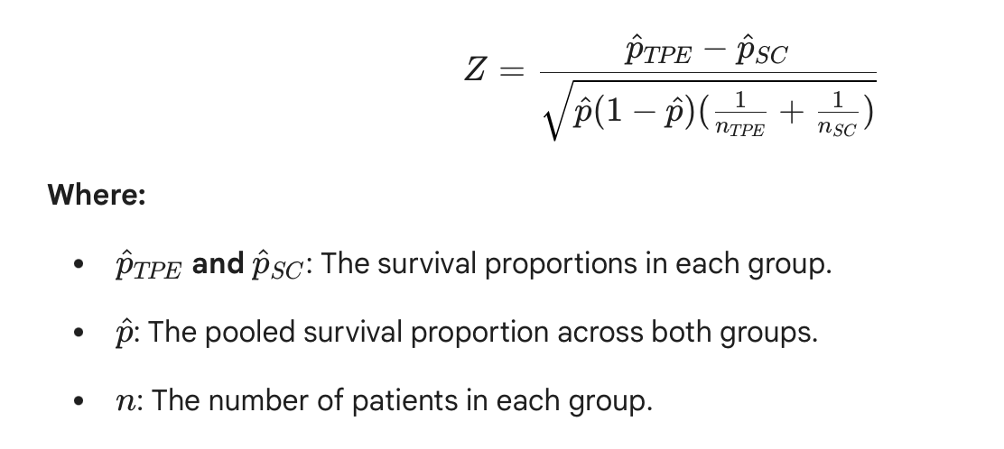
No fixed p-value threshold (e.g., p < 0.05) was used for inferential claims; p-values are shown, at most, as descriptive checks of simulated outputs.

Appendix C: Model Calibration and Validation Report
This appendix details the technical steps taken to ensure the simulation study accurately reflects historical clinical data and meta-analytical evidence.
Markov State Transition Probabilities (P-Matrix)

The 8-state model uses a time-dependent transition matrix P_{t}. The daily probability of transitioning to death (P_{m}) was calibrated using a logit-transformed severity function:

Calibration Targets for Standard Care (SC):
Stratum | Day 1 Mortality Target | Day 28 Survival Target | Calibrated Daily P_{m}
SOFA 8 | 2.8% | 78.5% | 0.0084
SOFA 12 | 5.7% | 56.5% | 0.0182
SOFA 16 | 9.0% | 31.2% | 0.0345
SOFA 20 | 11.4% | 12.8% | 0.0510

Time-Dependency Functions
Hazards in the model are not constant. We applied exponential decay factors to simulate the "Golden Window" effect:
Mortality Decay ($\delta_m$): $0.95^t$ (5% daily reduction in hazard as the initial storm resolves).
Recovery Decay ($\delta_r$): $0.98^t$ (2% daily reduction in recovery probability simulating ICU-acquired weakness).
Bayesian MCMC Anchor Points
The Hazard Ratio (HR) function was anchored to two data points derived from recent 2023–2024 meta-analyses:
Low Severity (SOFA 8): HR \approx 1.02 (Neutrality).
High Severity (SOFA 20): HR \approx 0.62 (Rescue).
The resulting Bayesian posterior for the interaction coefficient (\beta_{int}) was -0.04075, ensuring the treatment effect scales precisely with illness severity.
Computational Environment
Software: Python 3.10.12
Key Libraries: NumPy (v1.23.5), SciPy (v1.10.1), Pandas (v1.5.3)
Random Seed: 42 (ensuring 100% reproducibility of the 10,000-patient cohort).

