Host genotype and macro-chromosomal inversions influence gene expression and microbiome assembly in a complex holobiont

SUPPLEMENTARY FIGURES

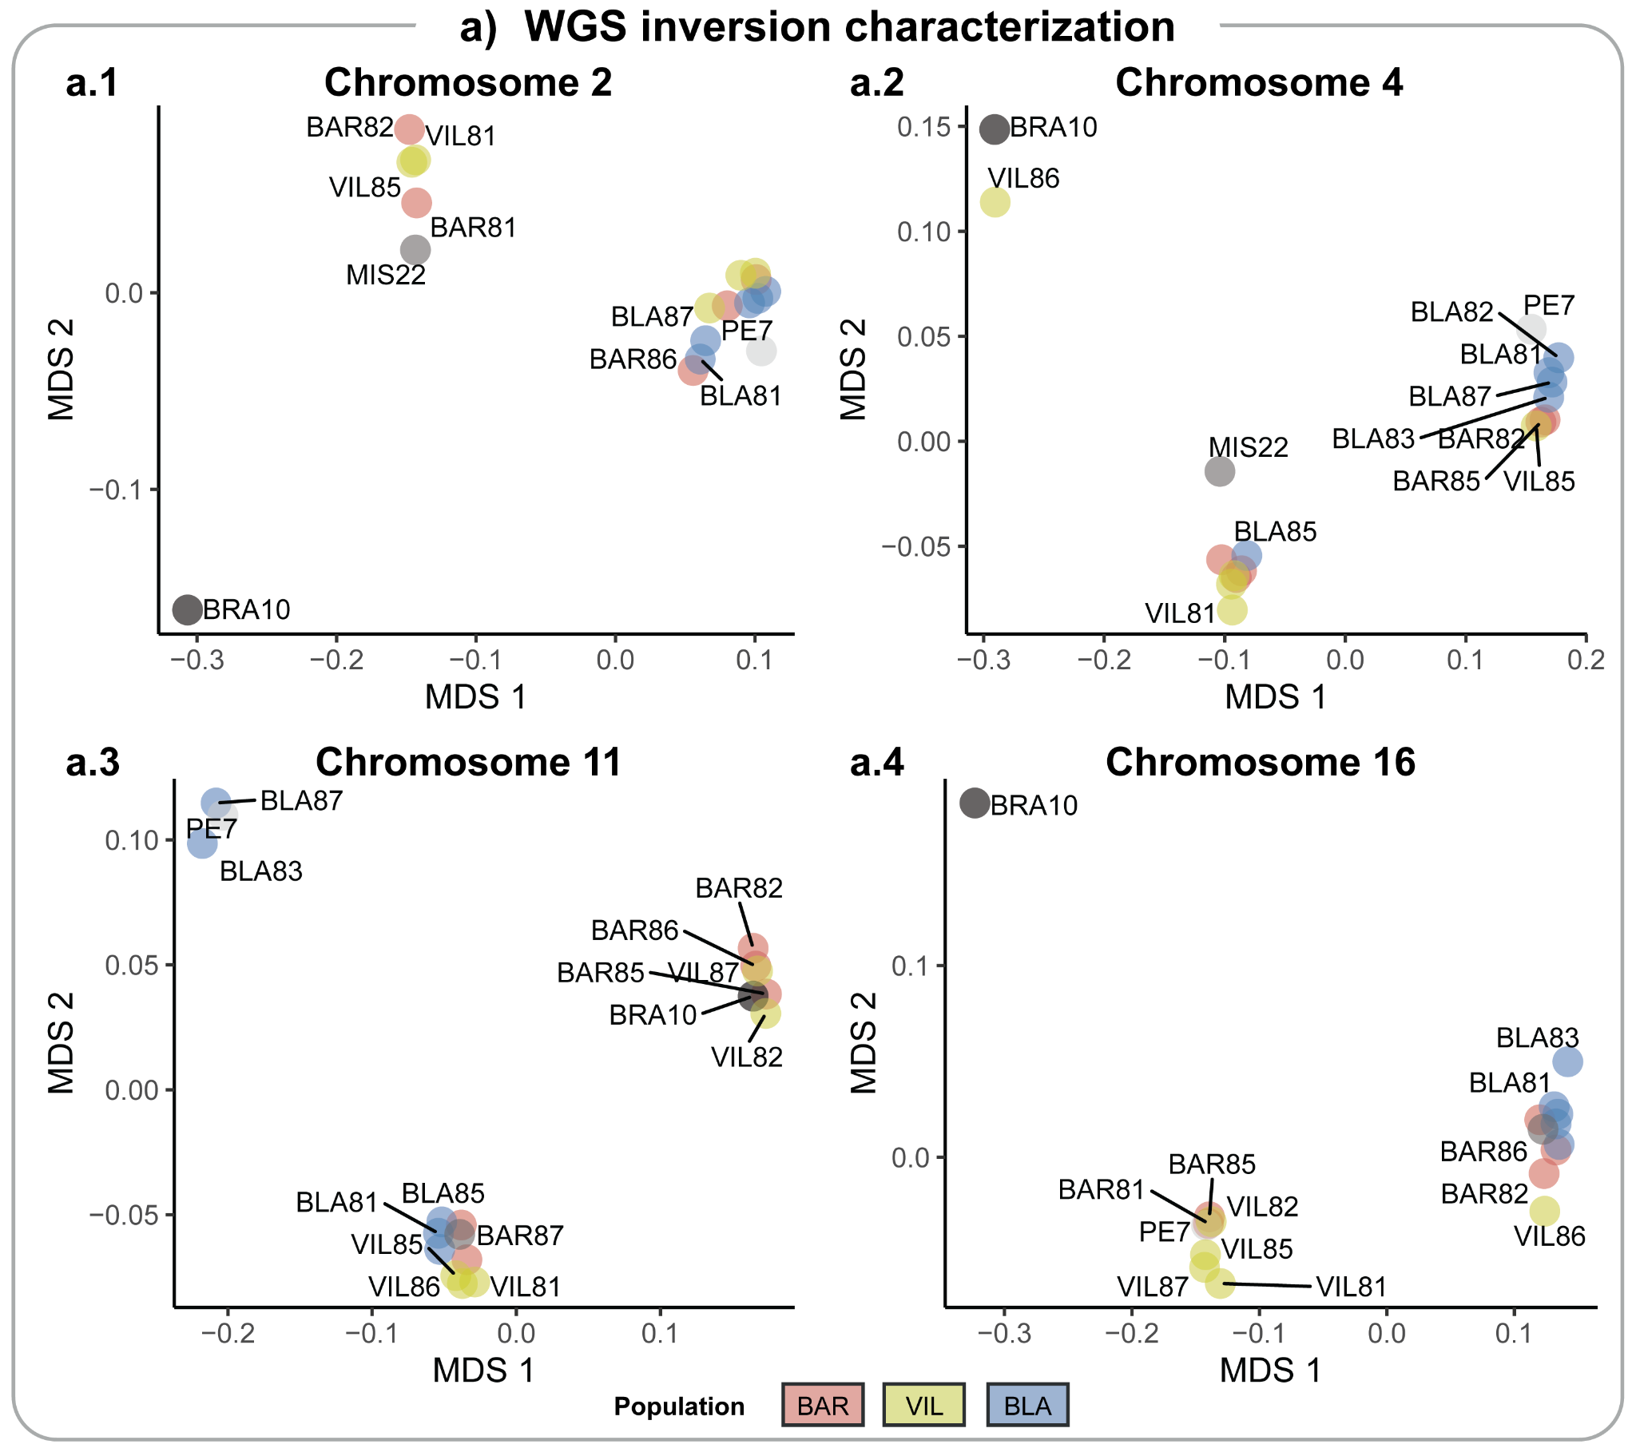
Figure S1 | a) Identification of inversions using MDS analyses for Chr2 (a.1), Chr4 (a.2), Chr11 (a.3), and Chr16 (a.4). Each cluster in the first axis corresponds to a karyotype arrangement. The samples are colour coded by locality and the reference samples with known karyotype are coded in greyscale.

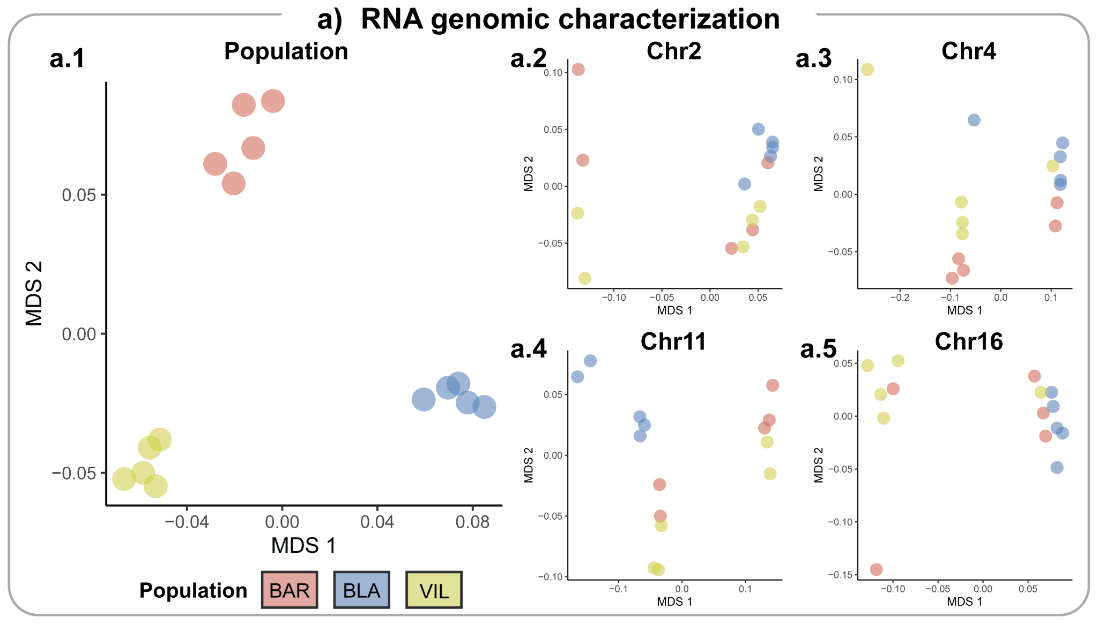
Figure S2 | a) Genetic differentiation based on SNP genotyping from RNAseq data for the 15 S. plicata samples. Multidimensional scaling (MDS) of individuals with SNPs from chromosomes without inversions (a.1), Chr2 (a.2), Chr4 (a.3), Chr11 (a.4), and Chr16 (a.5).

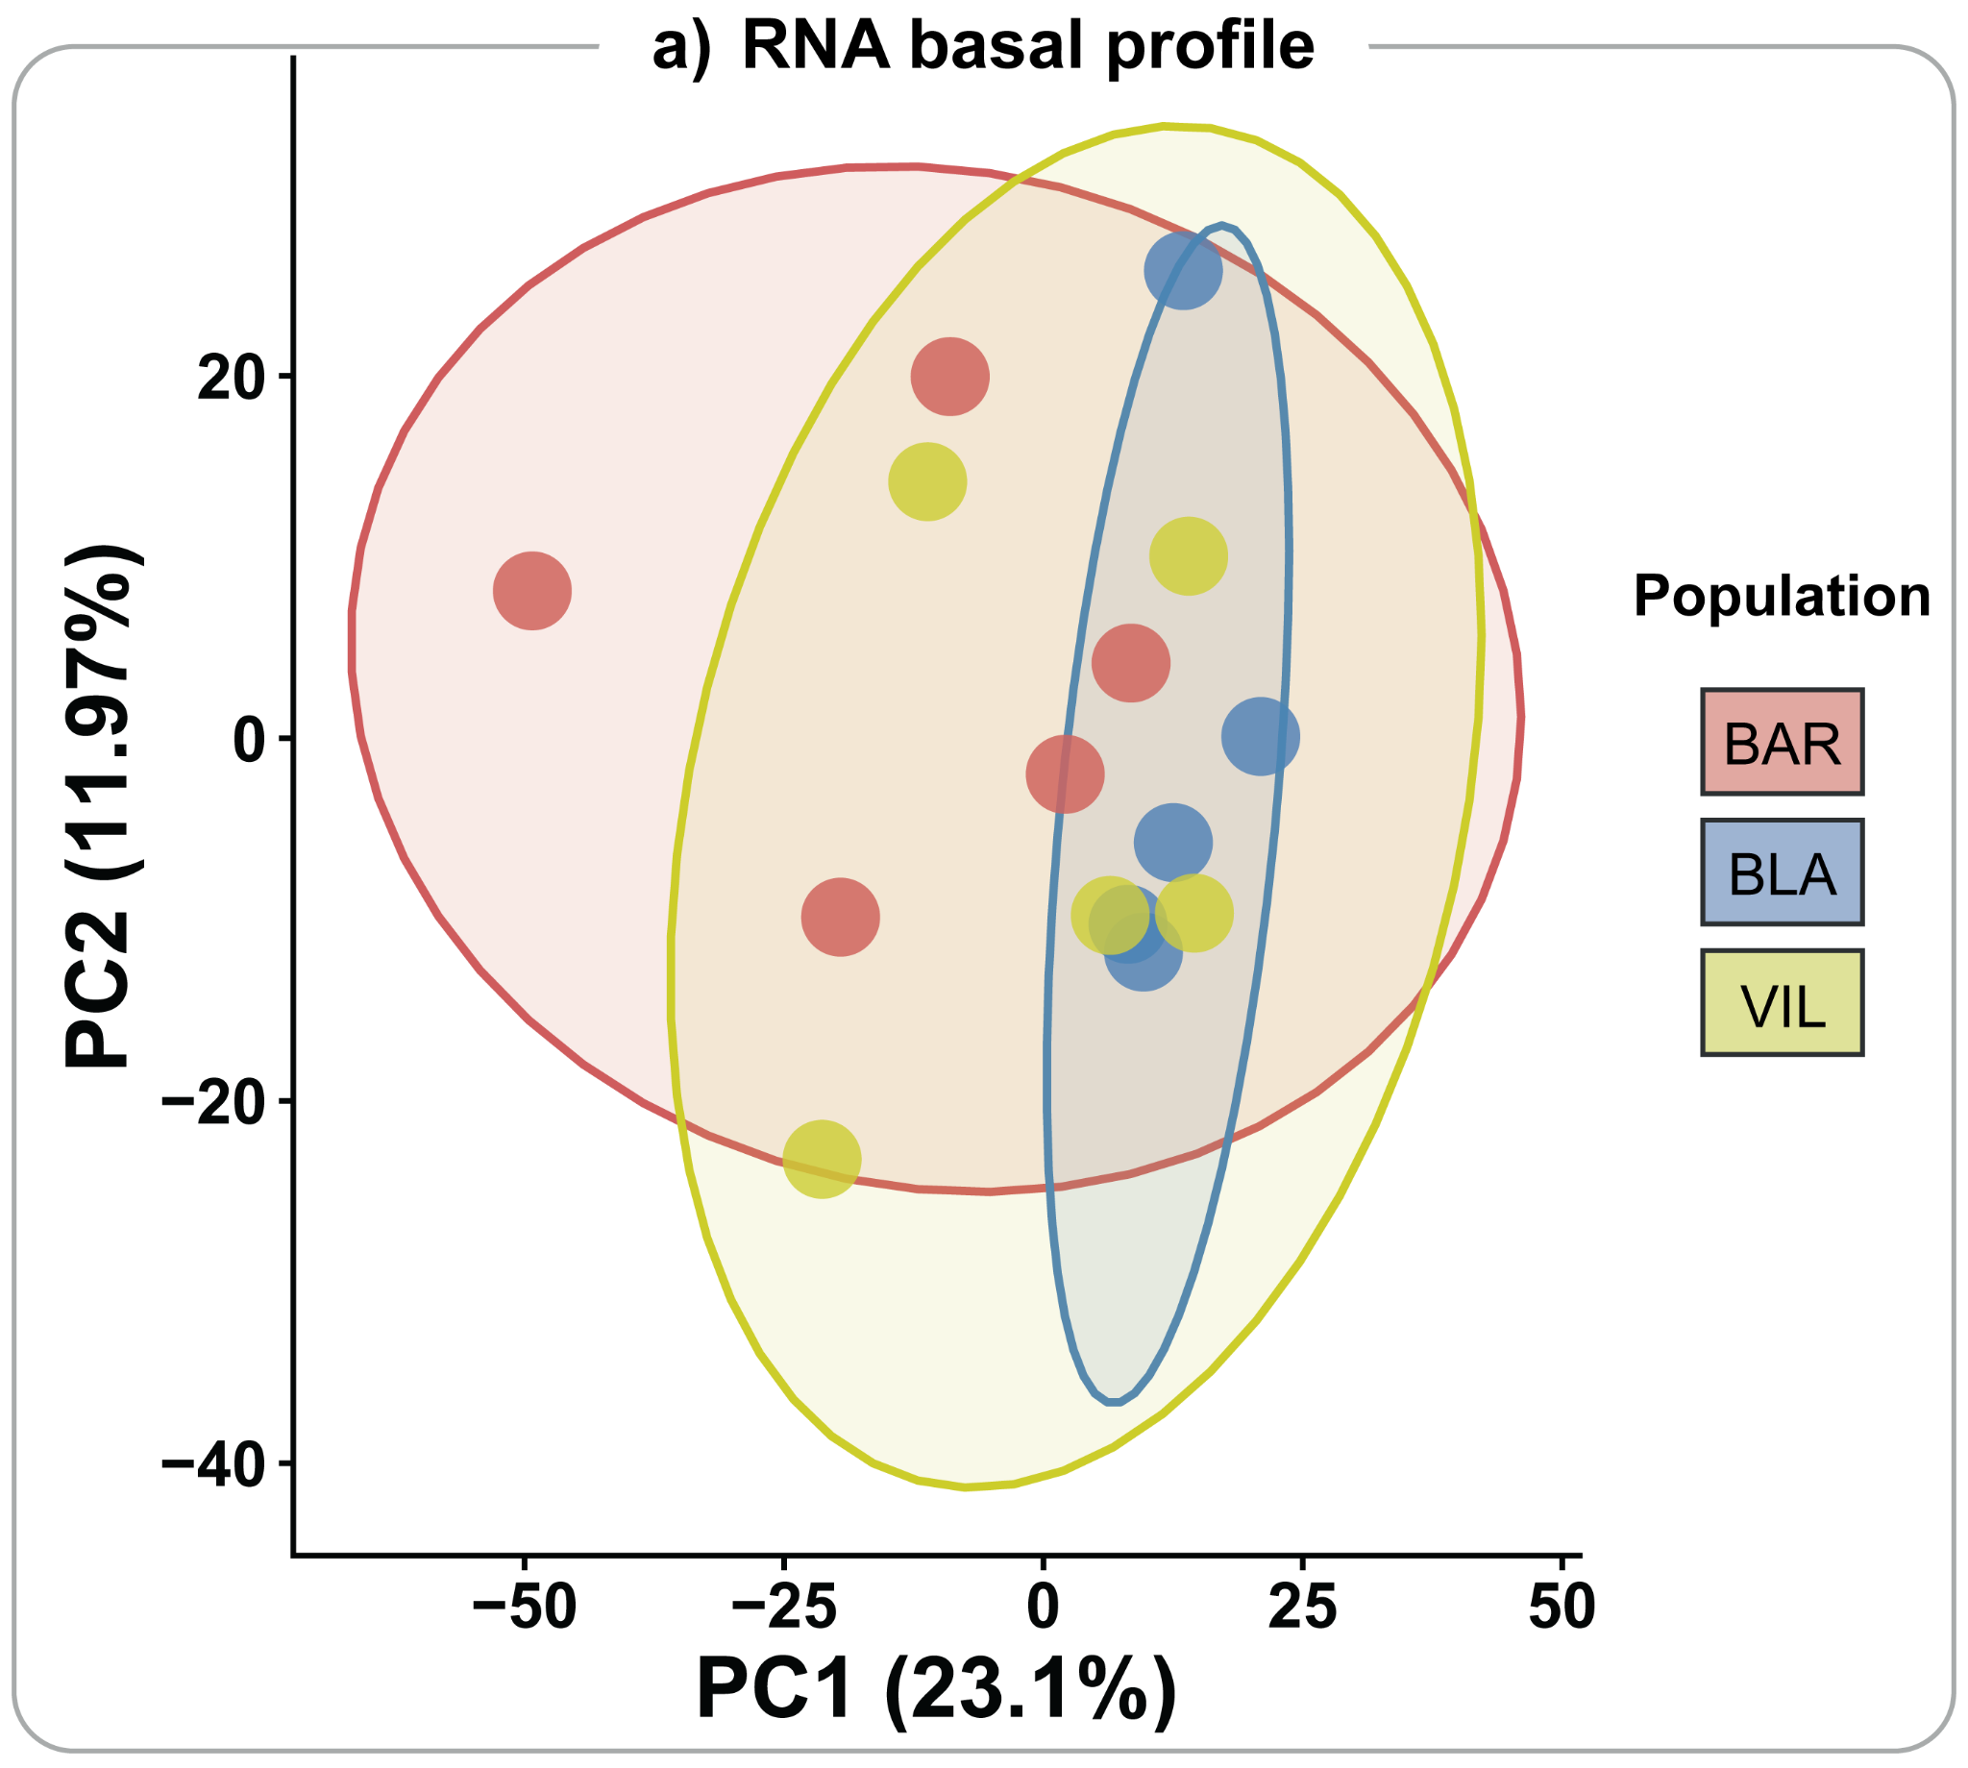
Figure S3 | a) Transcriptome expression for S. plicata samples using all RNAseq data.

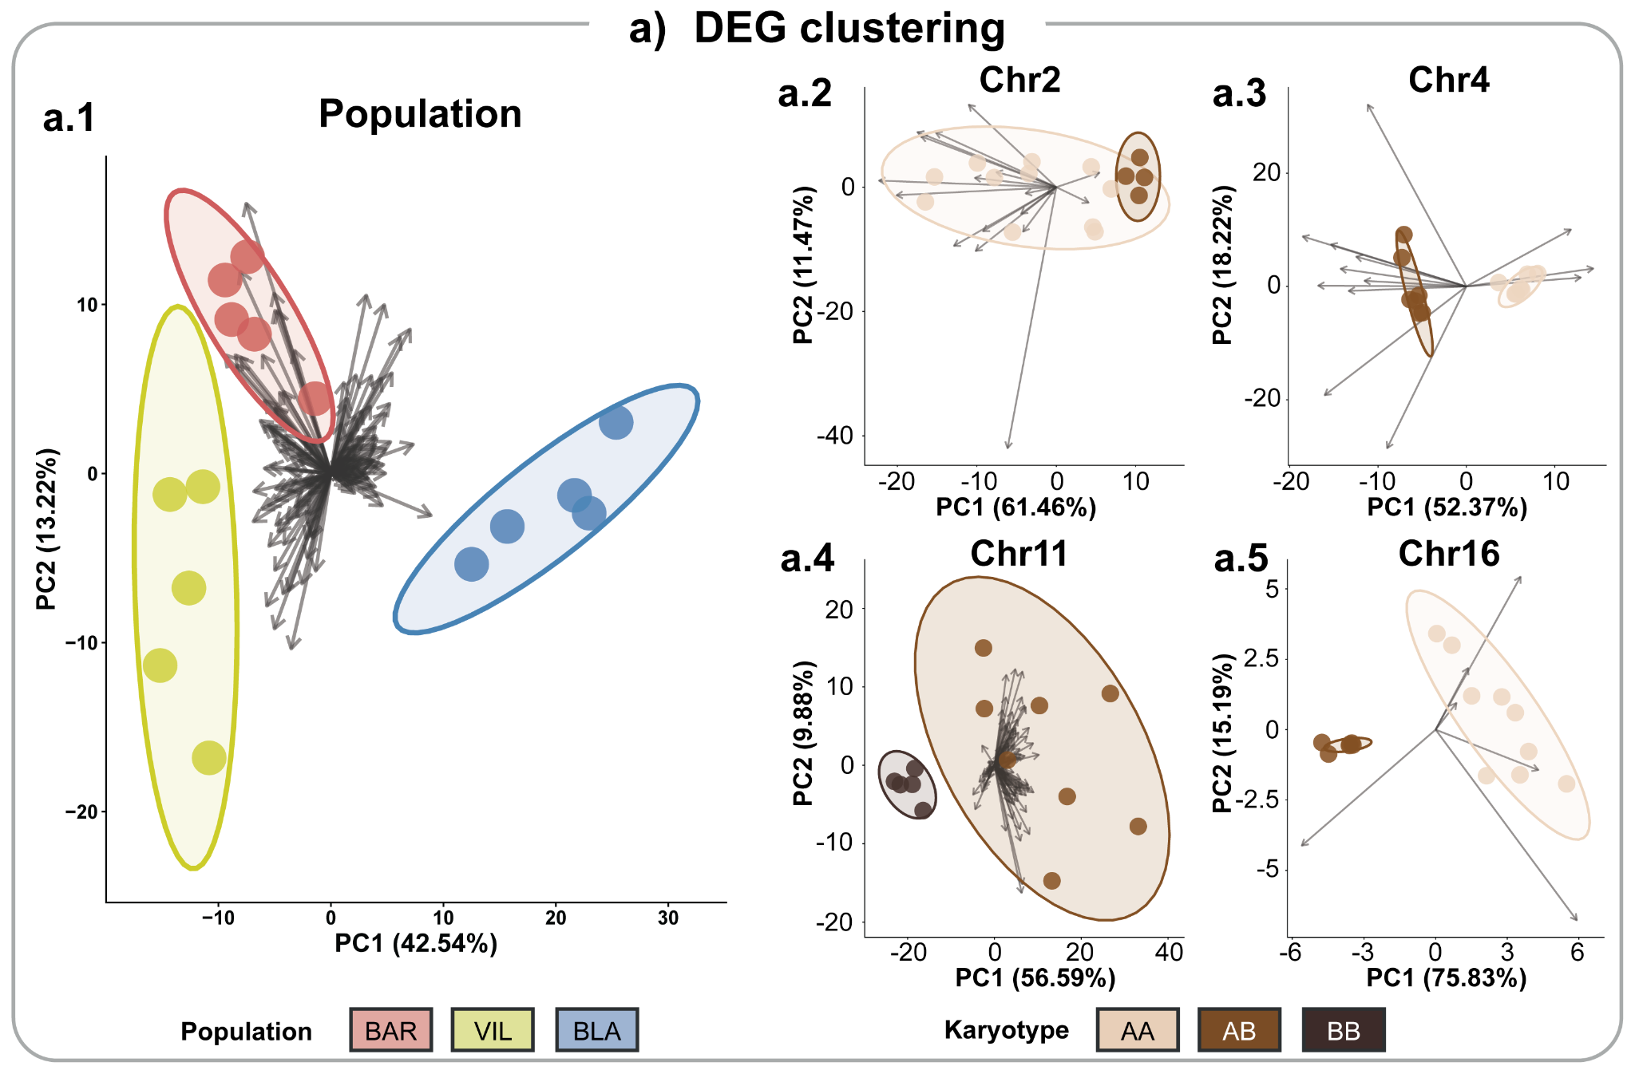
Figure S4 | a) Differential expression patterns of S. plicata represented as vectorised PCAs for the Population model (a.1), the Chr2 model (a.2), the Chr4 model (a.3), the Chr11 model (a.4), and the Chr16 model (a.5). Note that each arrow corresponds to the weight of a differentially expressed gene on the PCA.

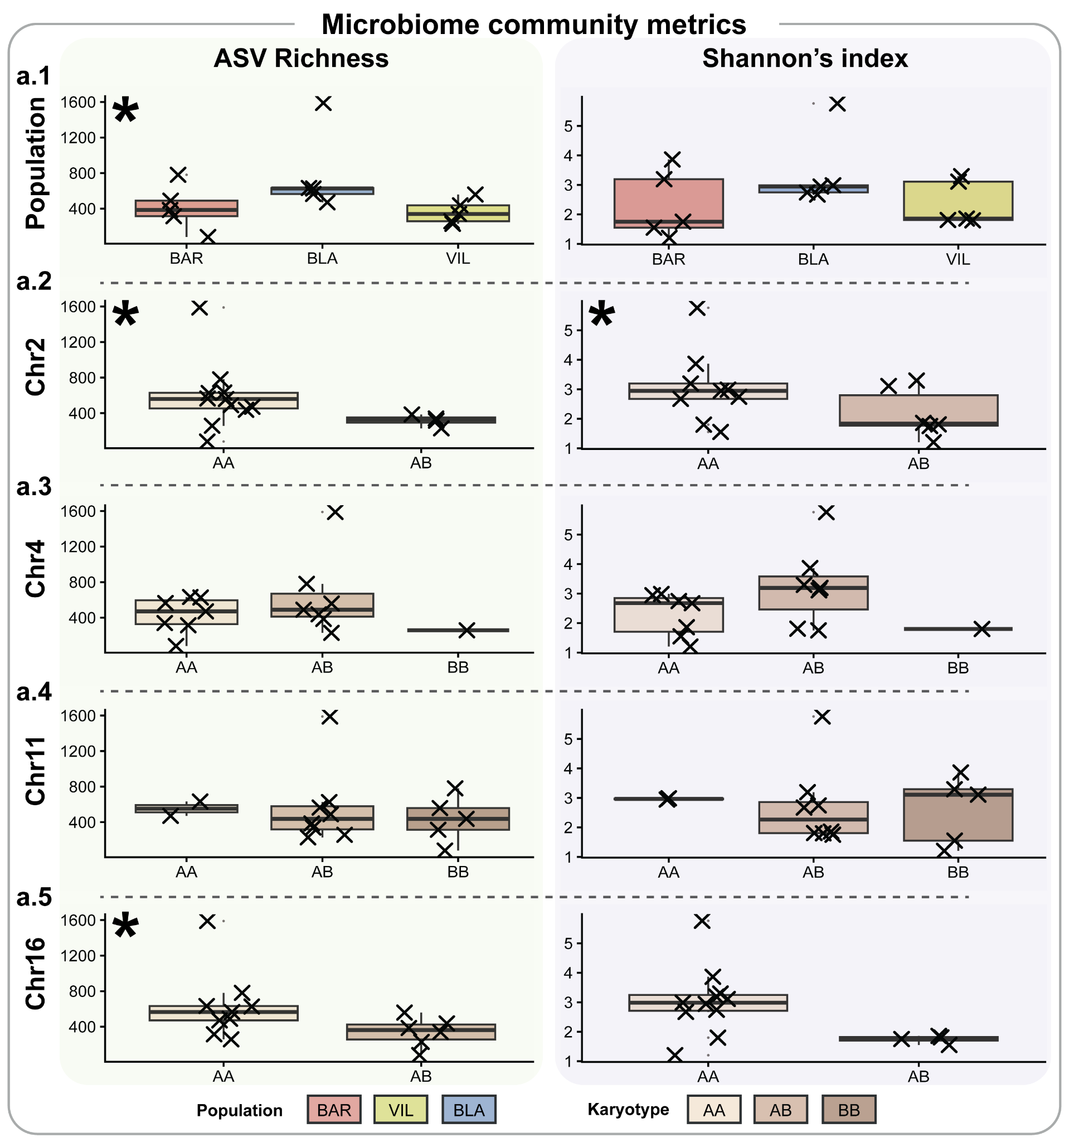
Figure S5 | Alpha diversity across populations and karyotypes. Boxplots show ASV richness (left column) and Shannon’s diversity index (right column) for samples grouped by Population (a.1) and karyotype for Chr2 (a.2), Chr4 (a.3), Chr11 (a.4), and Chr16 (a.5). Boxes indicate interquartile ranges with medians. Asterisks in the top-left corner of each panel indicate significant differences among represented groups.
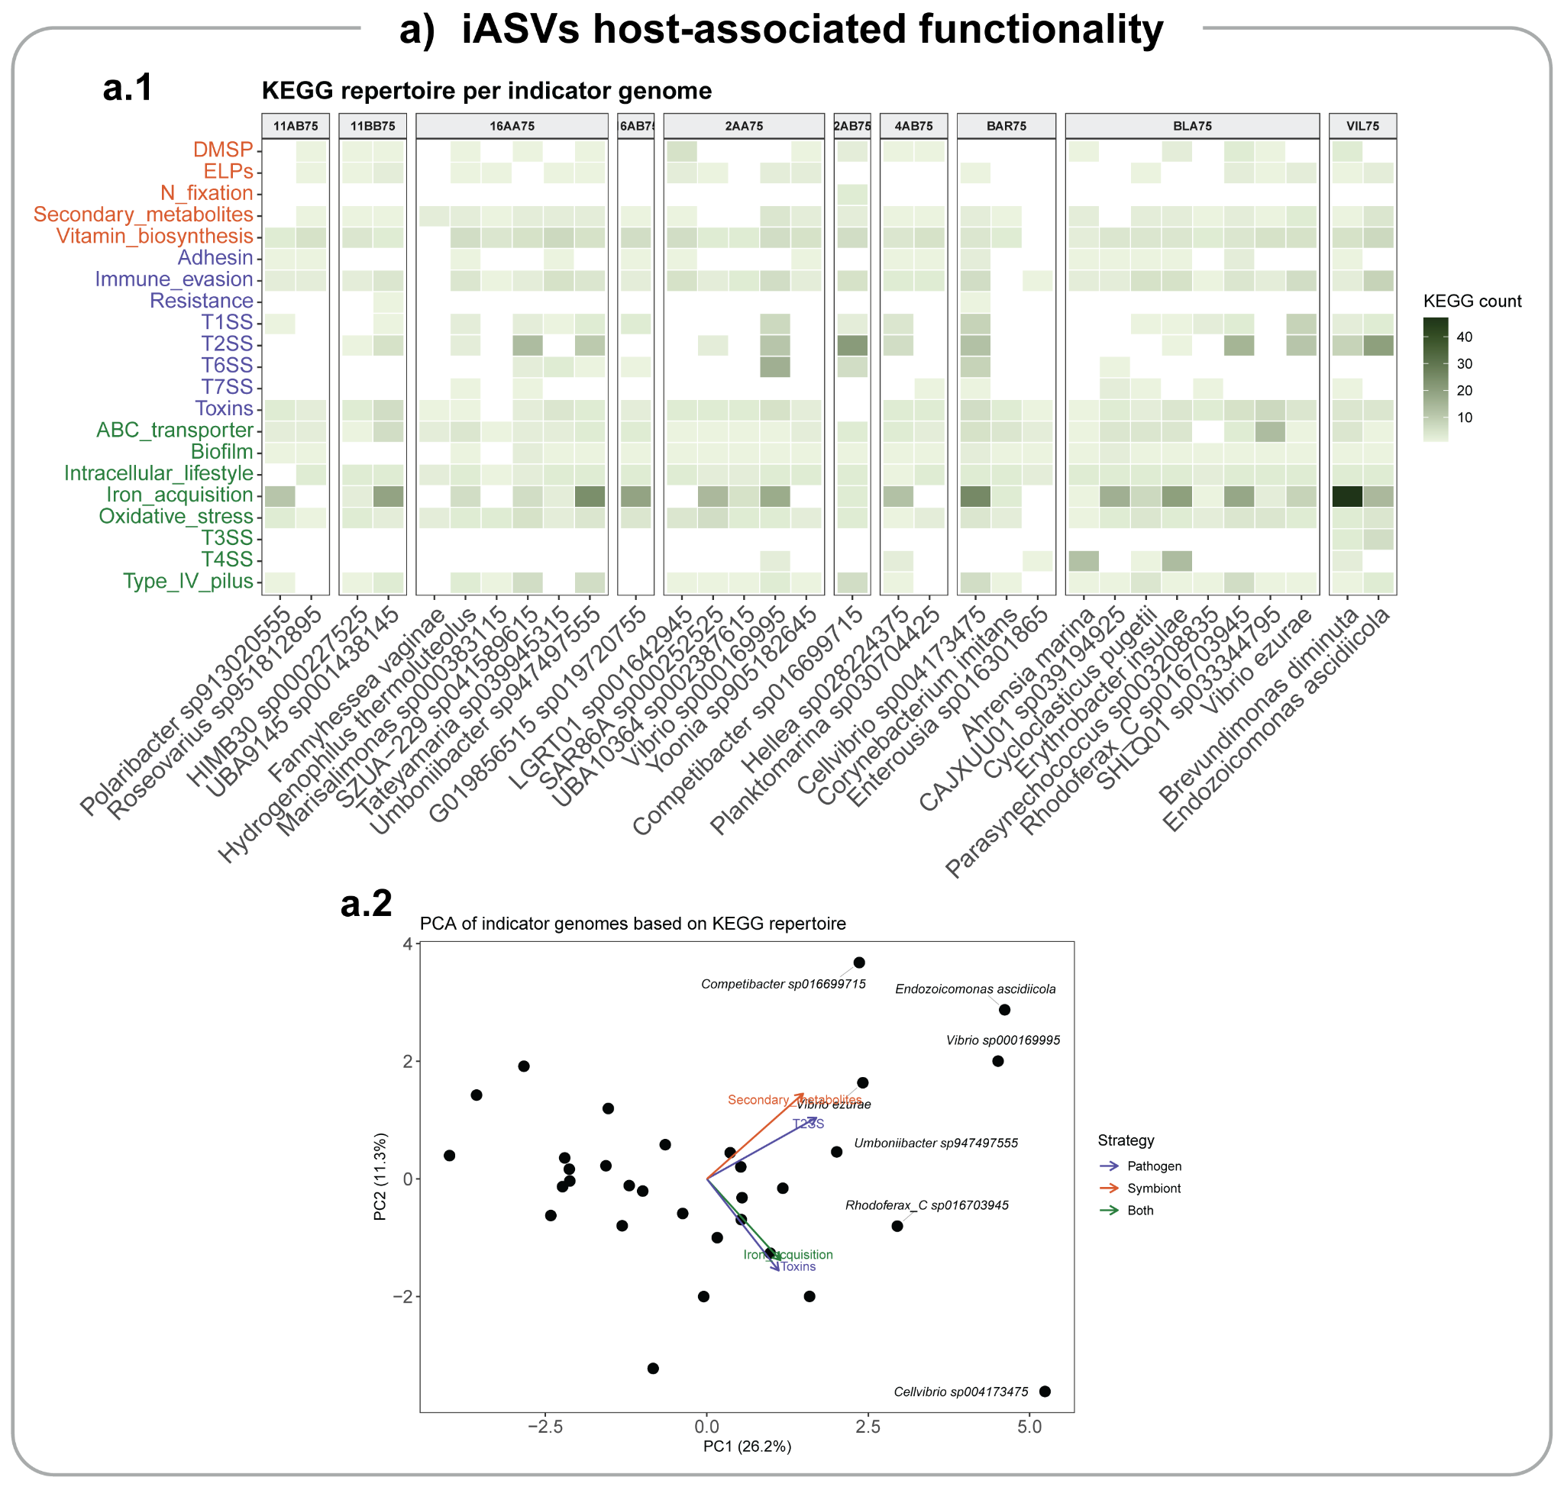
Figure S6 | a) Host-associated functions of iASV bacteria. a.1) KEGG repertoire of iASVs whose genome could be recovered through GTDB. KEGG names in red correspond to symbiont lifestyle functions, KEGG names in blue correspond to parasitic and or pathogenic functions, and KEGG names in green correspond to host-dependent (symbiont and pathogen) lifestyle functions. a.2) Principal components analysis (PCA) based on the presence of KEGGs involved in microbial interactions with the host, representing the functional gene composition of iASVs with a representative GTDB genome.
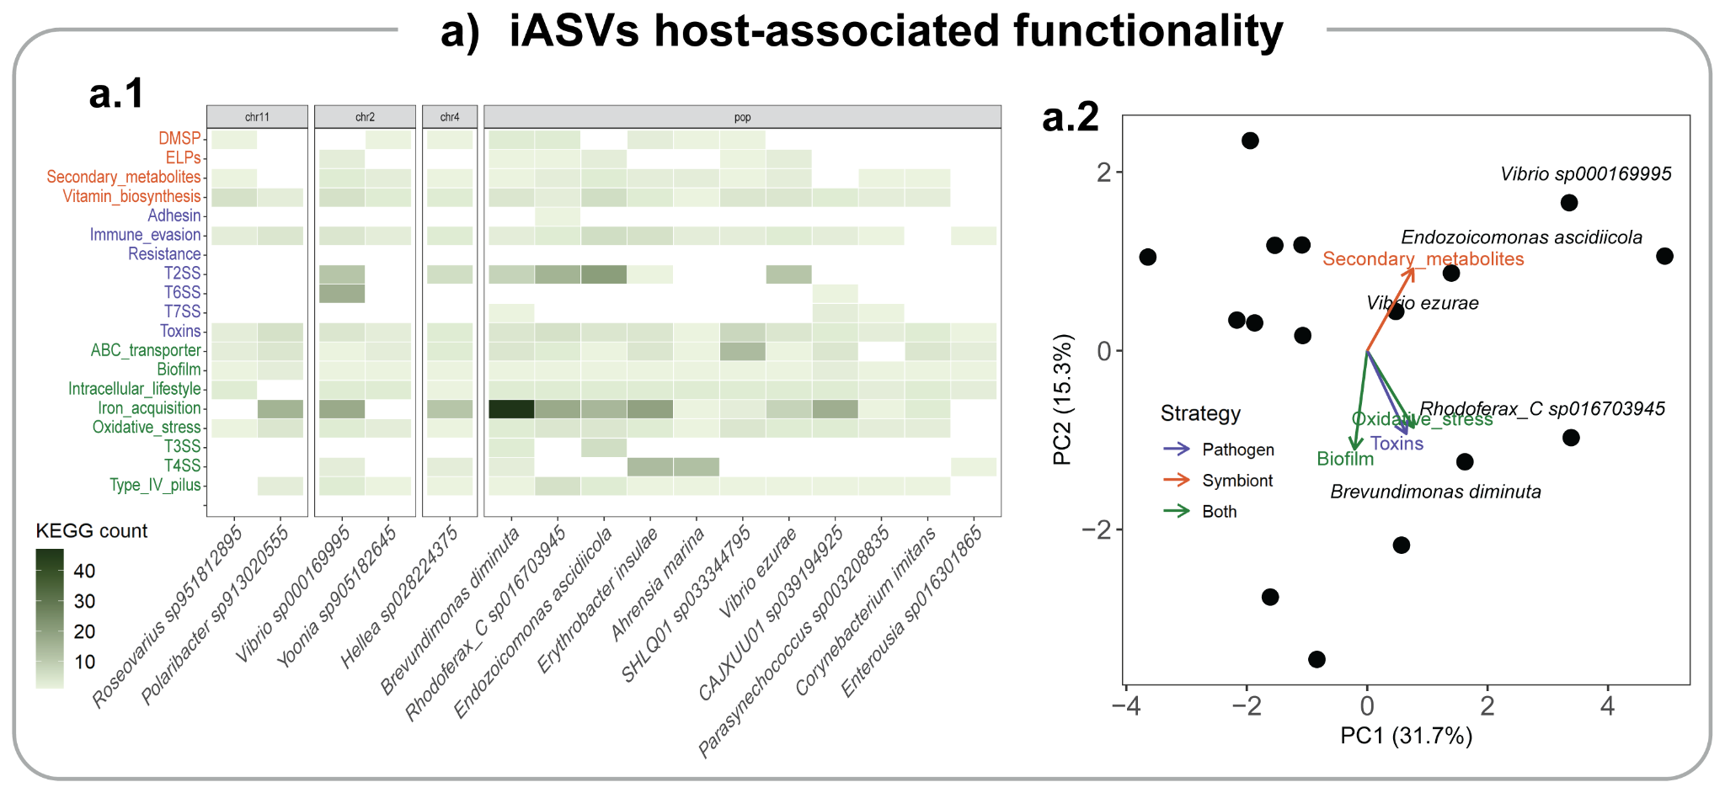
Figure S7 | Host-associated functions of the iASVcorrelated with DEGs. a.1) KEGG repertoire of iASVs whose genome could be recovered through GTDB. KEGG names in red correspond to symbiont lifestyle functions, KEGG names in blue correspond to parasitic and or pathogenic functions, and KEGG names in green correspond to host-dependent (symbiont and pathogen) lifestyle functions. a.2) Principal components analysis (PCA) based on the presence of KEGGs involved in microbial interactions with the host, representing the functional gene composition of representative genomes of correlated iASVs.

