Supplementary Table 1. Chemical properties of pod husk, cocoa litter, poultry manure, biochar, and compost in Year 1 (2022/2023) and Year 2 (2023/2024) (in brackets)
Composition | Materials
Composition | Pod husk | Cocoa litter | Poultry manure | Biochar | Compost -RP | Compost +RP
pH | 7.45 (7.48) | 6.54 (6.58) | 7.68 (7.54) | 10.22 (10.24) | 7.60 (7.57) | 7.06 (7.28)
Organic carbon (%) | 30.52 (30.41) | 30.72 (30.42) | 25.33 (24.78) | 38.34 (39.11) | 27.85 (28.04) | 26.34 (26.85)
Organic matter (%) | 52.62 (52.44) | 52.96 (54.13) | 43.67 (42.72) | 66.10 (67.43) | 48.01 (48.34) | 45.41 (46.29)
Total N (%) | 1.12 (1.16) | 1.02 (1.07) | 2.95 (2.90) | 0.97 (1.01) | 2.05 (2.07) | 2.62 (2.66)
Total P (%) | 0.61 (0.65) | 0.24 (0.25) | 2.97 (3.12) | 1.50 (1.57) | 3.63 (3.72) | 5.17 (5.45)
Total K (%) | 5.16 (5.44) | 3.35 (3.79) | 2.51 (2.47) | 11.56 (14.21) | 7.64 (7.76) | 7.73 (7.91)
Total Ca (%) | 0.52 (0.55) | 2.64 (2.73) | 1.68 (1.66) | 0.65 (0.67) | 1.47 (1.50) | 0.54 (0.67)
Total Mg (%) | 0.44 (0.46) | 0.32 (0.35) | 0.97 (0.95) | 0.54 (0.55) | 2.29 (2.38) | 3.02 (3.25)
Total Na (%) | 0.38 (0.40) | 0.28 (0.31) | 4.29 (3.87) | 0.48 (0.50) | 0.93 (0.95) | 0.77 (0.87)
Lignin (%) | 24.80 (24.68) | 12.23 (12.02) | 6.26 (6.37) | 17.82 (17.61) | 10.17 (11.23) | 11.03 (11.72)
Polyphenol (%) | 4.98 (4.73) | 2.44 (2.67) | 1.23 (1.30) | 3.57 (3.48) | 2.03 (2.13) | 2.27 (2.21)
Cellulose (%) | 34.10 (33.96) | 31.41 (30.26) | 13.72 (13.98) | 30.55 (30.13) | 29.24 (28.66) | 29.67 (28.81)
C: N ratio | 27.25 (26.22) | 31.67 (29.39) | 8.59 (8.20) | 36.17 (38.72) | 13.59 (13.84) | 10.05 (10.15)

Supplementary Table 2. Selected initial soil physical properties in the study areas, the moist and dry semi-deciduous zones of Ghana at 0 – 30 cm depth. Values are means ± standard error of means (SEM) of three replicates
Eco-zone | Shade system | Bulk density  (g cm⁻³) | Soil water  (vol. %) | Texture
Moist semi-deciduous | No shade | 1.44 ± 0.23 | 28.99 ± 2.31 | Sandy loam
Moist semi-deciduous | Medium shade | 1.39 ± 0.41 | 34.10 ± 2.77 | Sandy loam
Dry semi-deciduous | No shade | 1.49 ± 0.11 | 20.96 ± 3.15 | Loamy sand
Dry semi-deciduous | Medium shade | 1.46 ± 0.26 | 24.58 ± 2.50 | Loamy sand

Supplementary Table 3. Initial soil MBC, MBN, and MBP in the study areas, the moist and dry semi-deciduous zones of Ghana at 0 – 15 cm depth. Values are means ± standard error of means (SEM) of three replicates
Eco-zone | Shade system | MBC | MBN | MBP
Eco-zone | Shade system | (mg kg⁻¹)
Moist semi-deciduous | No shade | 59.41 ± 3.41 | 31.13 ± 1.76 | 22.34 ± 1.34
Moist semi-deciduous | Medium shade | 68.12 ± 4.22 | 51.89 ± 2.84 | 30.58 ± 1.77
Dry semi-deciduous | No shade | 34.06 ± 2.53 | 20.76 ± 0.88 | 14.10 ± 0.69
Dry semi-deciduous | Medium shade | 42.60 ± 2.66 | 25.94 ± 1.35 | 24.81 ± 1.10

Supplementary Table 4. Selected initial soil chemical properties in the study areas, the moist and dry semi-deciduous zones of Ghana at 0 – 30 cm depth. Values are means ± standard error of means (SEM) of three replicates
Eco-zone | Shade system | pH | SOC  (%) | Total N  (%) | Avai. P  (mg kg⁻¹) | Exch. K⁺ | Exch. Ca²⁺ | Exch. Mg²⁺ | Exch. Na⁺ | CEC
 |  |  |  |  |  | (cmol₍₊₎ kg⁻¹ soil)
Moist semi-deciduous | No shade | 4.38 ± 0.67 | 1.19 ± 0.06 | 0.14 ± 0.01 | 5.80 ± 0.52 | 0.09 ± 0.00 | 4.37 ± 0.38 | 1.60 ± 0.07 | 0.04 ± 0.00 | 6.09 ± 0.32
Moist semi-deciduous | Medium shade | 4.99 ± 0.82 | 1.77 ± 0.10 | 0.31 ± 0.01 | 8.00 ± 0.26 | 0.15 ± 0.01 | 3.85 ± 0.21 | 1.65 ± 0.11 | 0.07 ± 0.00 | 5.72 ± 0.48
Dry semi-deciduous | No shade | 5.48 ± 0.33 | 0.93 ± 0.02 | 0.09 ± 0.00 | 7.49 ± 0.76 | 0.09 ± 0.00 | 2.97 ± 0.44 | 1.13 ± 0.20 | 0.04 ± 0.00 | 4.23 ± 0.35
Dry semi-deciduous | Medium shade | 6.94 ± 0.51 | 1.84 ± 0.21 | 0.17 ± 0.01 | 10.43 ± 1.03 | 0.71 ± 0.02 | 7.44 ± 0.93 | 3.22 ± 0.26 | 0.03 ± 0.00 | 11.39 ± 0.56

Supplementary Table 5a. Effect of shade and soil amendment on soil pH, SOC, N, P, and exchangeable bases in the moist semi-deciduous zone. Values are means ± standard error of means (SEM) of three replicates
Shade system | Year 1 (2022/2023)
Shade system | pH | SOC | Total N | Ava. P | Exch. K⁺ | Exch. Ca²⁺ | Exch. Mg²⁺ | Exch. Na+ | CEC
Shade system | (%) |  |  | (mg kg⁻¹) | (cmol₍₊₎ kg⁻¹)
No shade | 4.99 ± 0.09ª | 1.70 ± 0.09^{b} | 0.29 ± 0.02ª | 11.79 ± 1.13ª | 0.16 ± 0.01ª | 4.88 ± 0.11ª | 2.12 ± 0.11ª | 0.11 ± 0.01ª | 7.27 ± 0.18ª
Medium shade | 5.28 ± 0.08ª | 2.16 ± 0.08ª | 0.38 ± 0.01ª | 14.10 ± 1.02ª | 0.20 ± 0.01ª | 5.31 ± 0.26ª | 2.22 ± 0.10ª | 0.14 ± 0.01ª | 7.87 ± 0.32ª
Amendment
T1 | 4.63 ± 0.15^{c} | 1.40 ± 0.15^{c} | 0.21 ± 0.03^{c} | 7.00 ± 0.72^{c} | 0.13 ± 0.01^{b} | 4.14 ± 0.10^{b} | 1.59 ± 0.04^{b} | 0.06 ± 0.00^{b} | 5.92 ± 0.08^{b}
T2 | 4.62 ± 0.06^{c} | 1.75 ± 0.06^{b} | 0.35 ± 0.02^{b} | 12.69 ± 0.72^{b} | 0.19 ± 0.02ª | 5.26 ± 0.18ª | 2.13 ± 0.11ª | 0.13 ± 0.01ª | 7.72 ± 0.22ª
T3 | 5.30 ± 0.14^{b} | 2.12 ± 0.14ª | 0.36 ± 0.02^{ab} | 13.86 ± 0.84^{b} | 0.21 ± 0.02ª | 5.20 ± 0.22ª | 2.38 ± 0.15ª | 0.14 ± 0.01ª | 7.93 ± 0.26ª
T4 | 5.51 ± 0.11^{ab} | 2.16 ± 0.11ª | 0.36 ± 0.03^{ab} | 12.80 ± 0.80^{b} | 0.19 ± 0.02ª | 5.77 ± 0.47ª | 2.38 ± 0.16ª | 0.13 ± 0.00ª | 8.45 ± 0.40ª
T5 | 5.59 ± 0.13ª | 2.23 ± 0.13ª | 0.40 ± 0.01ª | 18.38 ± 1.42ª | 0.19 ± 0.02ª | 5.11 ± 0.16^{ab} | 2.37 ± 0.04ª | 0.15 ± 0.01ª | 7.81 ± 0.19ª
Shade*Amendment (p-value) | 0.08 | 0.15 | 0.09 | 0.84 | 0.42 | 0.08 | 0.56 | 0.79 | 0.11
 | Year 2 (2023/2024)
No shade | 5.15 ± 0.10ª | 1.81 ± 0.13^{b} | 0.33 ± 0.03^{b} | 13.91 ± 1.31^{b} | 0.21 ± 0.02ª | 5.46 ± 0.16ª | 2.34 ± 0.13ª | 0.20 ± 0.04ª | 8.21 ± 0.26ª
Medium shade | 5.32 ± 0.12ª | 2.34 ± 0.12ª | 0.41 ± 0.02ª | 16.44 ± 1.32ª | 0.25 ± 0.02ª | 5.71 ± 0.38ª | 2.53 ± 0.14ª | 0.14 ± 0.01ª | 8.63 ± 0.50ª
Amendment
T1 | 4.56 ± 0.18^{c} | 1.34 ± 0.18^{c} | 0.21 ± 0.03^{c} | 7.02 ± 0.80^{c} | 0.12 ± 0.01^{c} | 3.98 ± 0.27^{c} | 1.56 ± 0.05^{c} | 0.24 ± 0.10ª | 5.91 ± 0.31^{c}
T2 | 4.57 ± 0.04^{c} | 1.84 ± 0.04^{b} | 0.37 ± 0.02^{b} | 13.88 ± 0.86^{b} | 0.23 ± 0.02^{b} | 5.42 ± 0.13^{b} | 2.41 ± 0.09^{b} | 0.15 ± 0.02ª | 8.20 ± 0.13^{b}
T3 | 5.50 ± 0.29^{b} | 2.33 ± 0.29ª | 0.41 ± 0.03^{ab} | 17.53 ± 0.93^{ab} | 0.29 ± 0.02ª | 5.77 ± 0.10^{ab} | 2.82 ± 0.09ª | 0.15 ± 0.00ª | 9.03 ± 0.17^{ab}
T4 | 5.79 ± 0.22ª | 2.37 ± 0.22ª | 0.41 ± 0.02^{ab} | 17.53 ± 0.82^{ab} | 0.26 ± 0.03^{ab} | 6.52 ± 0.39ª | 2.59 ± 0.18^{ab} | 0.15 ± 0.01ª | 9.52 ± 0.38ª
T5 | 5.75 ± 0.23^{ab} | 2.49 ± 0.23ª | 0.46 ± 0.01ª | 19.90 ± 1.57ª | 0.26 ± 0.02^{ab} | 6.25 ± 0.38^{ab} | 2.77 ± 0.11ª | 0.16 ± 0.01ª | 9.44 ± 0.43ª
Shade*Amendment (p-value) | 0.07 | 0.20 | 0.06 | 0.64 | 0.16 | 0.07 | 0.77 | 0.06 | 0.06

Supplementary Table 5b. Effect of shade and soil amendment on soil pH, SOC, N, P, and exchangeable bases in the dry semi-deciduous zone. Values are means ± standard error of means (SEM) of three replicates
Shade system | Year 1 (2022/2023)
Shade system | pH | SOC | Total N | Ava. P | Exch. K⁺ | Exch. Ca²⁺ | Exch. Mg²⁺ | Exch. Na⁺ | CEC
Shade system | (%) |  |  | (mg kg⁻¹) | (cmol₍₊₎ kg⁻¹)
No shade | 5.62 ± 0.07^{b} | 1.26 ± 0.07^{b} | 0.23 ± 0.02ª | 12.34 ± 1.05ª | 0.18 ± 0.02^{b} | 5.40 ± 1.04ª | 1.84 ± 0.11^{b} | 0.10 ± 0.00ª | 7.50 ± 1.08ª
Medium shade | 6.71 ± 0.05ª | 2.03 ± 0.05ª | 0.27 ± 0.02ª | 14.06 ± 0.87ª | 0.80 ± 0.03ª | 7.70 ± 0.21ª | 4.03 ± 0.15ª | 0.11 ± 0.01ª | 12.60 ± 0.32ª
Amendment
T1 | 5.99 ± 0.19^{b} | 1.38 ± 0.19^{c} | 0.13 ± 0.02^{d} | 8.59 ± 0.64^{c} | 0.36 ± 0.13^{b} | 4.70 ± 0.94ª | 2.17 ± 0.49^{b} | 0.04 ± 0.01^{b} | 7.30 ± 1.54^{b}
T2 | 5.95 ± 0.20^{b} | 1.48 ± 0.20^{c} | 0.23 ± 0.01^{c} | 11.89 ± 0.45^{bc} | 0.49 ± 0.14^{ab} | 6.00 ± 1.04ª | 2.91 ± 0.43ª | 0.10 ± 0.02ª | 9.50 ± 1.61^{ab}
T3 | 6.27 ± 0.18ª | 1.67 ± 0.18^{b} | 0.28 ± 0.00^{b} | 13.78 ± 1.19^{ab} | 0.50 ± 0.17^{ab} | 5.60 ± 1.01ª | 3.09 ± 0.49ª | 0.11 ± 0.01ª | 9.30 ± 1.69^{ab}
T4 | 6.31 ± 0.16ª | 1.83 ± 0.16ª | 0.28 ± 0.02^{b} | 14.55 ± 1.46^{ab} | 0.52 ± 0.15ª | 5.60 ± 0.93ª | 3.21 ± 0.54ª | 0.13 ± 0.00ª | 9.40 ± 1.58^{ab}
T5 | 6.34 ± 0.15ª | 1.86 ± 0.15ª | 0.33 ± 0.01ª | 17.17 ± 1.18ª | 0.56 ± 0.13ª | 10.90 ± 1.40ª | 3.31 ± 0.56ª | 0.13 ± 0.01ª | 14.90 ± 2.57ª
Shade*Amendment (p-value) | 0.14 | 0.08 | 0.93 | 0.75 | 0.12 | 0.45 | 0.65 | 0.21 | 0.47
 | Year 2 (2023/2024)
No shade | 5.76 ± 0.12^{b} | 1.46 ± 0.12^{b} | 0.28 ± 0.03ª | 15.57 ± 1.31ª | 0.22 ± 0.03^{b} | 3.93 ± 0.23^{b} | 2.13 ± 0.16^{b} | 0.11 ± 0.04ª | 6.38 ± 0.37^{b}
Medium shade | 6.74 ± 0.08ª | 2.20 ± 0.08ª | 0.30 ± 0.02ª | 17.54 ± 1.25ª | 0.96 ± 0.05ª | 8.04 ± 0.21ª | 4.20 ± 0.18ª | 0.11 ± 0.01ª | 13.31 ± 0.41ª
Amendment
T1 | 5.82 ± 0.21^{b} | 1.36 ± 0.21^{b} | 0.20 ± 0.06^{b} | 8.79 ± 0.52^{c} | 0.38 ± 0.13^{d} | 4.74 ± 0.96^{b} | 2.07 ± 0.48^{b} | 0.04 ± 0.00^{c} | 7.23 ± 1.55^{b}
T2 | 5.83 ± 0.19^{b} | 1.49 ± 0.19^{b} | 0.25 ± 0.02^{ab} | 14.71 ± 0.59^{b} | 0.53 ± 0.15^{c} | 6.36 ± 0.95ª | 3.16 ± 0.42ª | 0.10 ± 0.01^{b} | 10.15 ± 1.52ª
T3 | 6.48 ± 0.20ª | 1.98 ± 0.20ª | 0.31 ± 0.02^{ab} | 18.36 ± 1.25ª | 0.61 ± 0.19^{bc} | 6.17 ± 0.94ª | 3.44 ± 0.50ª | 0.13 ± 0.00^{ab} | 10.35 ± 1.59ª
T4 | 6.55 ± 0.14ª | 2.09 ± 0.14ª | 0.33 ± 0.01^{ab} | 19.53 ± 1.00ª | 0.68 ± 0.19^{ab} | 5.98 ± 0.91ª | 3.52 ± 0.48ª | 0.14 ± 0.01ª | 10.32 ± 1.55ª
T5 | 6.53 ± 0.13ª | 2.22 ± 0.13ª | 0.38 ± 0.01ª | 21.39 ± 0.99ª | 0.73 ± 0.17ª | 6.66 ± 0.97ª | 3.61 ± 0.53ª | 0.15 ± 0.01ª | 11.16 ± 1.65ª
Shade*Amendment (p-value) | 0.28 | 0.28 | 0.37 | 0.78 | 0.06 | 0.99 | 0.92 | 0.64 | 0.96
T1= no amendment; T2= mineral fertilizer alone; T3= mineral fertilizer + biochar; T4= ½ mineral fertilizer + compost without rock phosphate; T5= ½ mineral fertilizer + compost with rock phosphate; Means ± SEM with different letters in a column are significantly different at 0.05 significant level (p < 0.05)
Supplementary Table 6. Effect of shade and soil amendment on soil MBC, MBN, and MBP in the moist and dry semi-deciduous zones for two growing seasons. Values are means ± standard error of means (SEM) of three replicates
Shade system | Moist eco-zone
Shade system | Year 1 (2022/2023) |  |  | Year 2 (2023/2024)
Shade system | MBC | MBN | MBP | MBC | MBN | MBP
Shade system | (mg kg⁻¹)
No shade | 60.69 ± 1.84^{b} | 37.43 ± 1.39^{b} | 25.45 ± 2.06^{b} | 65.44 ± 2.98^{b} | 45.98 ± 2.87^{b} | 28.54 ± 2.87^{b}
Medium shade | 70.51 ± 2.18ª | 58.14 ± 2.17ª | 35.97 ± 2.56ª | 78.15 ± 3.04ª | 68.15 ± 3.04ª | 39.71 ± 3.04ª
Amendment
T1 | 59.27 ± 1.76^{c} | 35.59 ± 2.38^{d} | 23.48 ± 1.77^{c} | 60.15 ± 0.94^{d} | 37.22 ± 3.92^{d} | 25.78 ± 1.73^{d}
T2 | 63.11 ± 2.27^{c} | 59.00 ± 4.29^{c} | 36.56 ± 2.62^{bc} | 71.11 ± 2.22^{c} | 83.84 ± 2.61^{c} | 44.40 ± 1.61^{c}
T3 | 70.06 ± 2.48^{b} | 60.92 ± 4.49^{bc} | 38.49 ± 2.82^{b} | 89.39 ± 3.46^{b} | 86.8b ± 4.41^{bc} | 47.36 ± 2.28^{bc}
T4 | 75.38 ± 2.20ª | 63.73 ± 3.92^{ab} | 41.29 ± 2.17^{ab} | 98.30 ± 2.39ª | 91.37 ± 4.95^{ab} | 51.93 ± 3.00^{ab}
T5 | 77.69 ± 2.72ª | 66.68 ± 4.33ª | 44.24 ± 2.60ª | 102.54 ± 4.66ª | 95.61 ± 4.51ª | 56.17 ± 2.39ª
Shade *Amendment (p-value) | 0.57 | 0.16 | 0.30 | 0.20 | 0.06 | 0.07
 | Dry eco-zone
Shade system | Year 1 (2022/2023) |  |  | Year 2 (2023/2024)
No shade | 36.42 ± 2.71^{b} | 25.63 ± 2.04^{b} | 18.76 ± 2.20^{b} | 40.69 ± 2.45ª | 30.83 ± 2.41ª | 22.29 ± 2.13ª
Medium shade | 49.82 ± 1.87ª | 35.96 ± 1.94ª | 27.42 ± 2.05ª | 53.95 ± 2.57ª | 38.90 ± 2.59ª | 34.36 ± 3.42ª
Amendment
T1 | 36.23 ± 2.73^{c} | 27.24 ± 1.31^{d} | 16.37 ± 0.69^{d} | 38.44 ± 0.80^{c} | 32.12 ± 0.81^{c} | 19.58 ± 1.54^{d}
T2 | 48.10 ± 0.98^{c} | 44.28 ± 1.78^{c} | 26.74 ± 1.82^{c} | 52.29 ± 1.63^{b} | 61.80 ± 2.58^{b} | 38.27 ± 1.15^{c}
T3 | 51.75 ± 0.80^{b} | 53.10 ± 1.89^{bc} | 33.56 ± 1.56^{bc} | 72.33 ± 1.50^{b} | 64.01 ± 1.77^{ab} | 40.47 ± 2.18^{bc}
T4 | 70.93 ± 0.68ª | 56.94 ± 1.90^{ab} | 38.40 ± 1.49^{b} | 89.59 ± 1.36ª | 64.27 ± 1.36^{ab} | 50.73 ± 1.81^{ab}
T5 | 73.07 ± 1.03ª | 59.42 ± 1.01ª | 43.88 ± 1.22ª | 93.96 ± 1.53ª | 68.64 ± 1.53ª | 55.10 ± 1.62ª
Shade *Amendment (p-value) | 0.07 | 0.76 | 0.69 | 0.51 | 0.27 | 0.26
T1= no amendment; T2= mineral fertilizer alone; T3= mineral fertilizer + biochar; T4= ½ mineral fertilizer + compost without rock phosphate; T5= ½ mineral fertilizer + compost with rock phosphate; Means ± SEM with different letters in a column are significantly different at 0.05 significant level (p < 0.05)
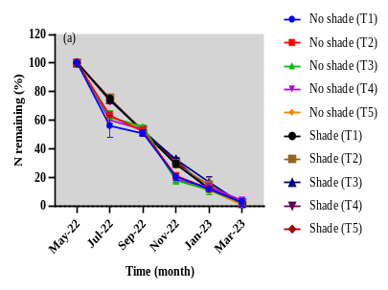
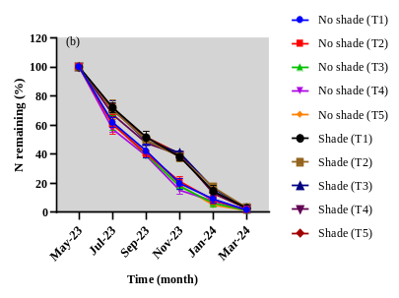
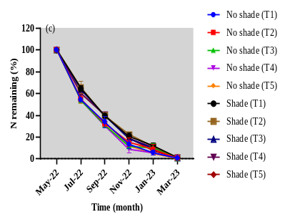
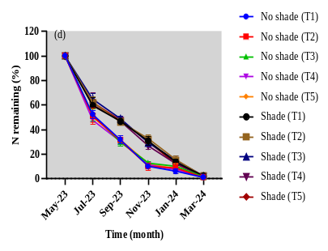

T1= no amendment; T2= mineral fertilizer alone; T3= mineral fertilizer + biochar; T4= ½ mineral fertilizer + compost without rock phosphate; T5= ½ mineral fertilizer + compost with rock phosphate; Error bars = standard error of means (SEM)
Supplementary Fig. 1. Effect of shade system and soil amendment on the release of nitrogen in the moist (a (2022/2023) and b (2023/2024)) and dry (c (2022/2023) and d (2023/2024)) semi-deciduous zones
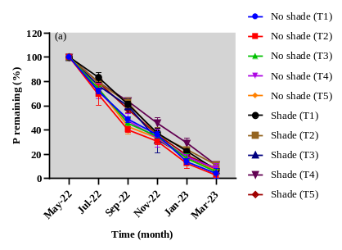
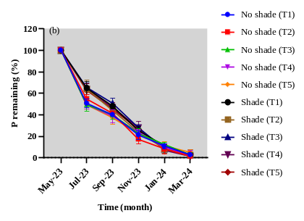
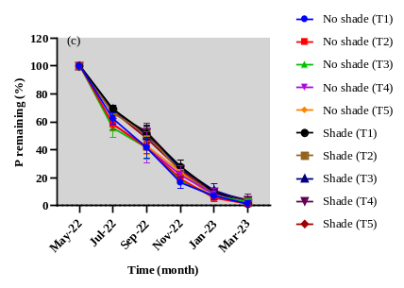
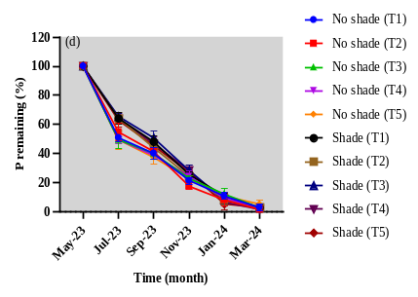

T1= no amendment; T2= mineral fertilizer alone; T3= mineral fertilizer + biochar; T4= ½ mineral fertilizer + compost without rock phosphate; T5= ½ mineral fertilizer + compost with rock phosphate; Error bars = standard error of means (SEM)
Supplementary Fig. 2. Effect of shade system and soil amendment on the release of phosphorus in the moist (a (2022/2023) and b (2023/2024)) and dry (c (2022/2023) and d (2023/2024)) semi-deciduous zones

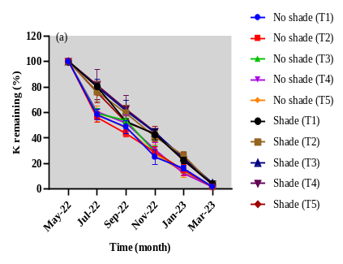
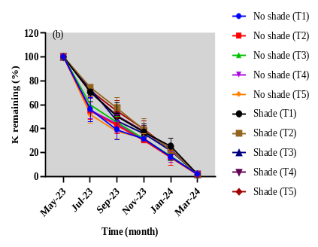
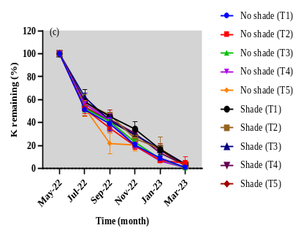
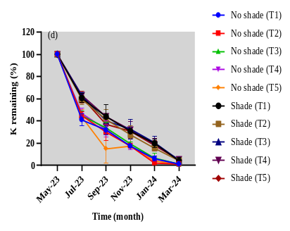

T1= no amendment; T2= mineral fertilizer alone; T3= mineral fertilizer + biochar; T4= ½ mineral fertilizer + compost without rock phosphate; T5= ½ mineral fertilizer + compost with rock phosphate; Error bars = standard error of means (SEM)
Supplementary Fig. 3. Effect of shade system and soil amendment on the release of potassium in the moist (a (2022/2023) and b (2023/2024)) and dry (c (2022/2023) and d (2023/2024)) semi-deciduous zones

Supplementary Table 7. Effect of shade system and soil amendment on N, P, and K use efficiencies in the moist and dry semi-deciduous zones for two growing seasons. Values are means ± standard error of means (SEM) of three replicates
Shade system | Moist eco-zone
Shade system | Year 1 (2022/2023) |  |  | Year 2 (2023/2024)
Shade system | NUE | PUE | KUE | NUE | PUE | KUE
Shade system | (%)
No shade | 42.90 ± 3.99ª | 14.12 ± 0.74^{b} | 50.80 ± 3.87ª | 59.60 ± 4.67ª | 14.34 ± 0.93^{b} | 33.40 ± 4.90ª
Medium shade | 43.50 ± 3.75ª | 23.26 ± 1.49ª | 33.00 ± 6.38ª | 62.70 ± 2.93ª | 20.39 ± 1.09ª | 48.30 ± 6.45ª
Amendment
T1 | - | - | - | - | - | -
T2 | 48.50 ± 5.97ª | 17.45 ± 2.92^{ab} | 39.60 ± 7.53ª | 59.10 ± 4.06^{ab} | 15.27 ± 2.32^{b} | 33.60 ± 8.66^{b}
T3 | 45.20 ± 3.71ª | 18.75 ± 2.68^{ab} | 36.90 ± 5.68ª | 60.80 ± 8.50^{ab} | 16.41 ± 1.25^{b} | 39.10 ± 10.06^{b}
T4 | 37.10 ± 3.84^{b} | 16.60 ± 2.11^{b} | 44.50 ± 10.23ª | 56.00 ± 2.93^{b} | 16.45 ± 1.37^{b} | 36.50 ± 8.08^{b}
T5 | 42.10 ± 7.32^{ab} | 21.95 ± 2.36ª | 46.60 ± 10.13ª | 68.90 ± 4.48ª | 21.33 ± 1.76ª | 54.30 ± 6.35ª
Shade * Amendment (p-value) | 0.87 | 0.96 | 0.34 | 0.53 | 0.49 | 0.89
 | Dry eco-zone
Shade system | Year 1 (2022/2023) |  |  | Year 2 (2023/2024)
No shade | 43.40 ± 4.55ª | 12.03 ± 1.26^{b} | 37.80 ± 4.38ª | 62.60 ± 5.31ª | 13.31 ± 0.93ª | 21.30 ± 4.65^{b}
Medium shade | 29.30 ± 3.69ª | 13.15 ± 0.79ª | 25.60 ± 5.72ª | 57.80 ± 3.16ª | 12.90 ± 0.79ª | 30.50 ± 3.24ª
Amendment
T1 | - | - | - | - | - | -
T2 | 39.30 ± 6.61ª | 10.48 ± 1.27^{b} | 27.80 ± 7.18ª | 65.60 ± 6.30ª | 11.45 ± 1.42^{b} | 21.20 ± 2.80^{b}
T3 | 38.80 ± 8.13ª | 12.37 ± 1.00^{ab} | 34.60 ± 5.45ª | 60.20 ± 5.17^{ab} | 13.04 ± 0.98^{ab} | 24.90 ± 6.33^{b}
T4 | 34.10 ± 7.50^{b} | 12.56 ± 1.41^{ab} | 30.70 ± 11.92ª | 51.20 ± 4.73^{b} | 12.24 ± 0.72^{ab} | 24.30 ± 6.41^{b}
T5 | 33.10 ± 4.33^{b} | 14.94 ± 1.76ª | 33.80 ± 5.37ª | 63.70 ± 7.71ª | 15.69 ± 1.15ª | 33.20 ± 7.32ª
Shade * Amendment (p-value) | 0.25 | 0.49 | 0.69 | 0.85 | 0.40 | 0.41
T1= no amendment; T2= mineral fertilizer alone; T3= mineral fertilizer + biochar; T4= ½ mineral fertilizer + compost without rock phosphate; T5= ½ mineral fertilizer + compost with rock phosphate; Means ± SEM with different letters in a column are significantly different at 0.05 significant level (p < 0.05)

