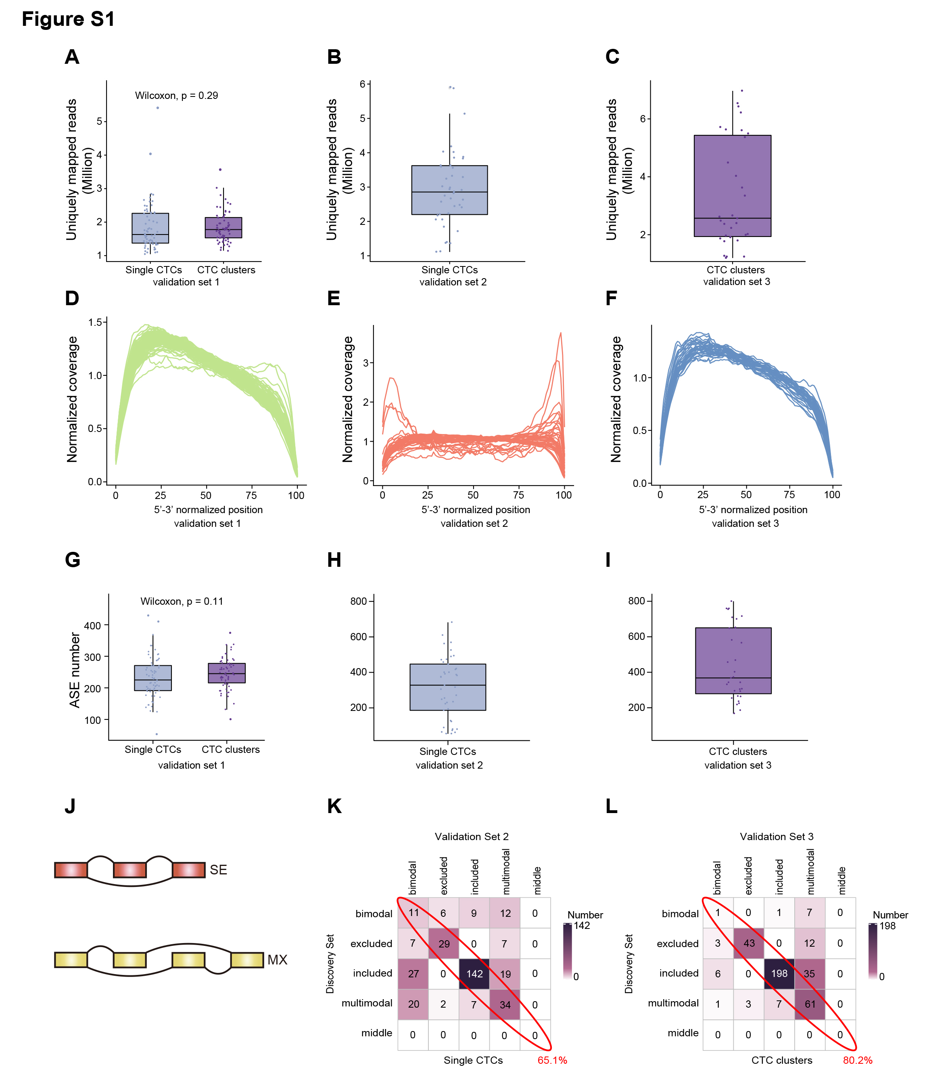
Figure S1 | Further validation of the robustness of detected AS events. (A-C) Boxplot showing uniquely mapped reads for single CTCs and CTC clusters from validation set 1 (A), validation set 2 (B), validation set 3 (C). (D-F) The normalized coverage of reads from scRNA-seq libraries from validation set 1 (D), validation set 2 (E), validation set 3 (F). (G-I) Boxplot showing the number of AS events detected for each cell from validation set 1 (G), validation set 2 (H), validation set 3 (I). (J) Schematic diagrams of SE and MXE, each box indicates one exon. (K) Heatmap showing the consistency of modalities assigned to AS events in single CTCs from discovery set and validation set 2. (L) The consistency of modalities assigned to AS events in CTC clusters from discovery set and validation set 3.
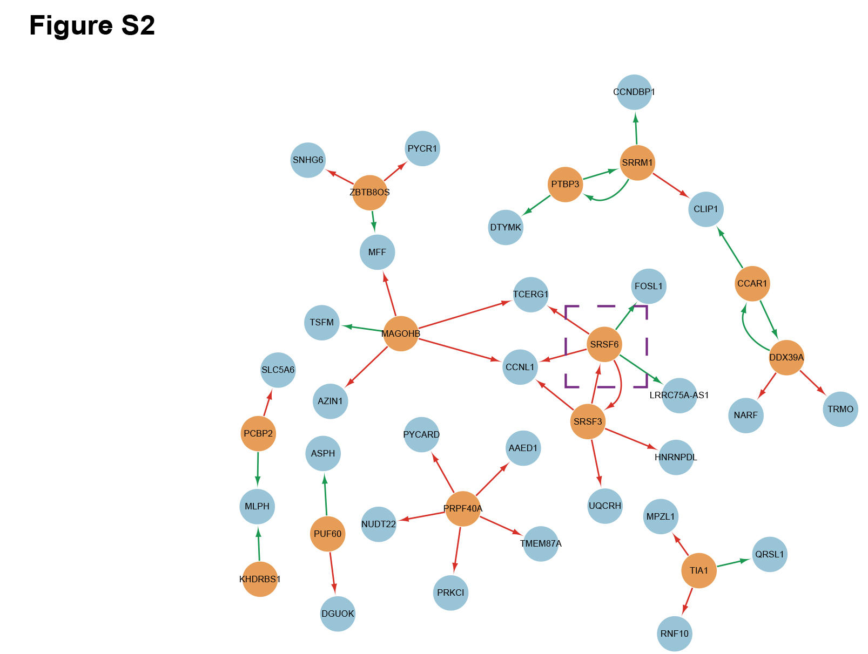
Figure S2 | Validation of the regulatory effects of differentially spliced gene that participate in “RNA splicing” on differential AS events between single CTCs and CTC clusters.
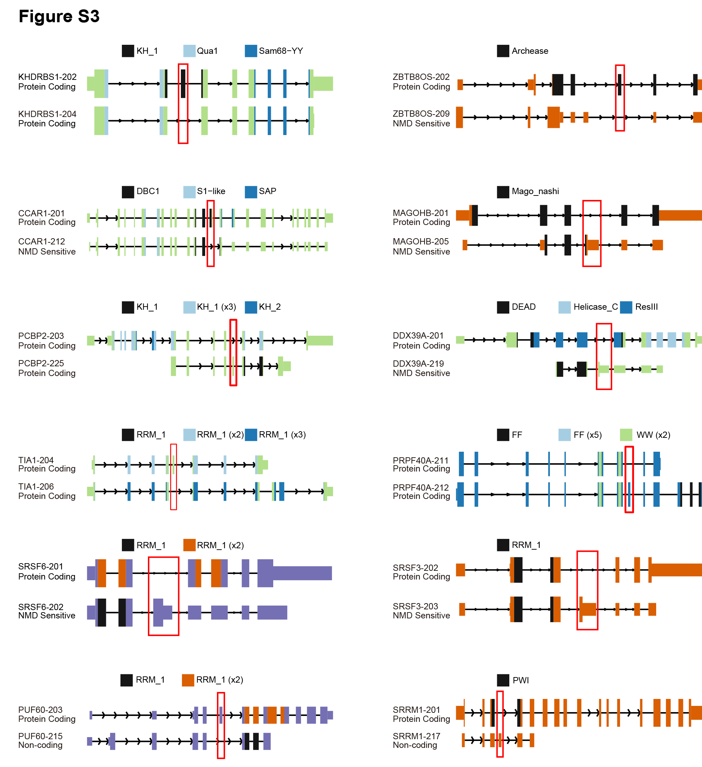
Figure S3 | Schematic plots showing the change of protein-coding abilities or the functional domains of 12 differentially spliced genes that participate in “RNA splicing”.
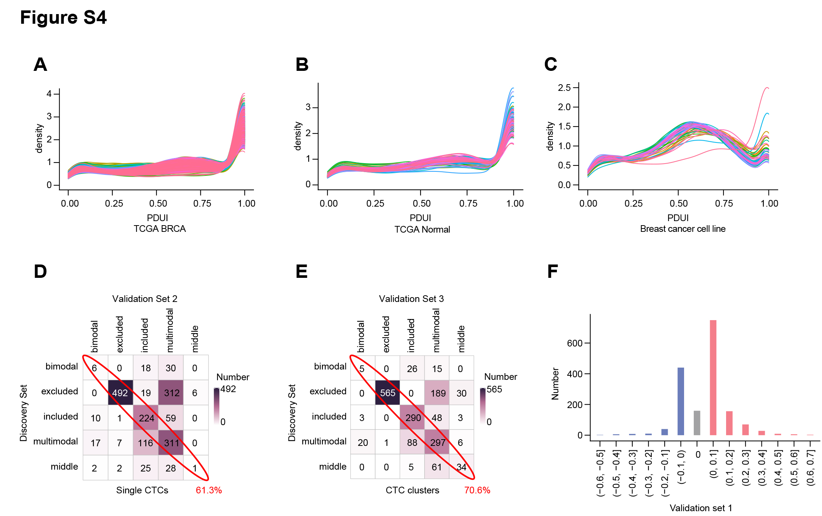
Figure S4 | Further validation of the robustness of modalities assigned to APA events.
(A-C) Distribution of PDUI values of each sample in TCGA primary breast cancers (A), TCGA normal breast tissues (B), and breast cancer cell lines (C). (D) Heatmap showing the consistency of modalities assigned to APA events in single CTCs from discovery set and validation set 2. (E) The consistency of modalities assigned to APA events in CTC clusters from discovery set and validation set 3. (F) Bar plot showing that CTC clusters exhibited global lengthening of 3’ UTRs in validation set 1.
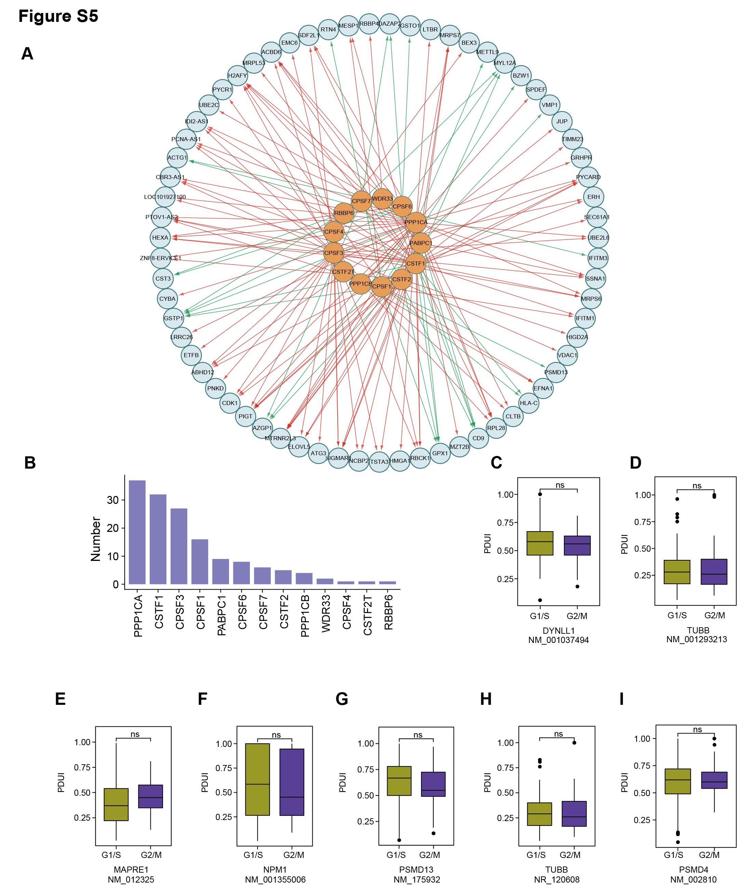
Figure S5 | Validation of the regulatory effects of core APA factors on differential APA events. (A) Network derived from the other three validation datasets showing the differential APA events regulated by the expression of core APA factors. (B) Bar plot derived from the other three validation datasets confirming that PPP1CA regulated the greatest number of differential APA events. (C-I) PDUI values of other six genes involved in “regulation of cell cycle G2/M phase transition” were not associated with the cell cycle status.

